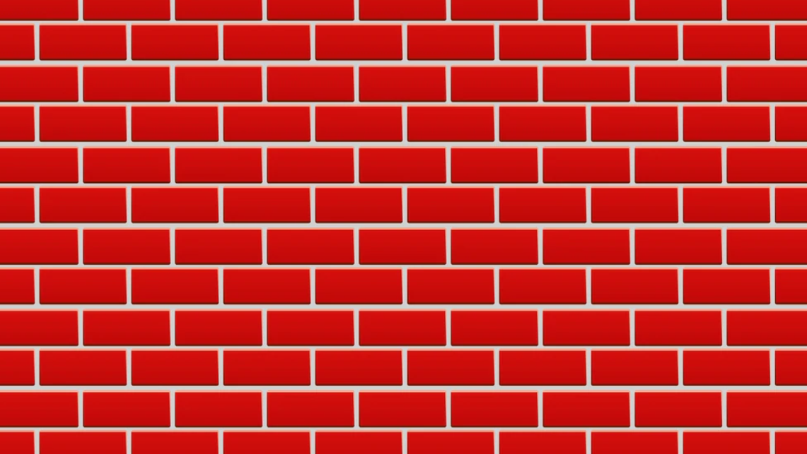

Write a procedural texture using the GLSL shading language to simulate the repeating brick-work pattern of a “Brick wall”. Apply your procedural texture to a single quad using the GraphicsTemplate provided. Your program should allow the user to specify the size and spacing of the bricks, as well as the colours of the bricks and mortar.

You are given 30 minutes to download and familiarize yourself with the GraphicsTemplate program, two hours to write your procedural texture shader, and 30 minutes to zip up and upload your solution to moodle.

