EXAMINATION SOLUTIONS
(to accompany the examination paper sent to the external examiner
but NOT to be seen by students)

Programme: | BEng Computer Systems & Electronics and  HND/C Electronics Engineering | Level: | 4
Module: | Analogue Electronics
Author: | M Vanstone | Page: | 1 of

Q | Question | Marks
1a)  b)  .......  2)  ........  3)  ........  4)  ......  5)  .......  6) | R = 100k, C = 20μF, Supply voltage V_{S} = 10V , capacitor voltage = V_{C} and t = 4secs  And V_{C} = V_{S} . e ^{- ( t/RC )} )  τ = R x C = 100k x 20x10x10⁻⁶ = 2seconds  Hence V_{C} = 10. e ^{- (4/2 )} )  Therefore V_{C} = 10. e ⁻ ⁽² ⁾ ), = 10. (0.135)  Hence V_{C} = 1.35 V  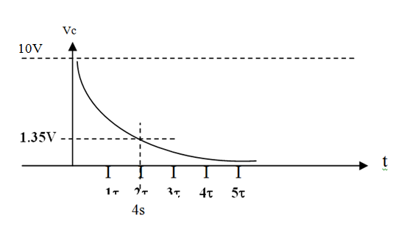  .................................................................................................................................  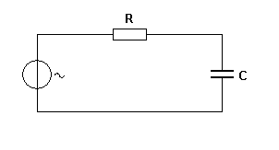  1nF  10k  Vin  Vout  0dB  -3 dB  f_{c}  $f_{C }=\frac{1}{\left(2 x π x R x C\right)}= \frac{1}{\left(2 x π x 10k x 1 x {10}^{-9}\right)}= 15.$159 kHz  The graph shows how the output of the filter is a maximum ( 100 % or 0 dBs) for low frequencies, however, as the input frequency reduces then the output voltage rises. At the cut-off frequency (f_{c} = 15.159 kHz) the output has dropped to 70.7% of its maximum value i.e. -3dBs.  ............................................................................................................................  i) A Trivalent atom has ....three......... valence electrons. ii) n type semiconductor has an excess of ..negative........ charges. iii) Pure Silicon is known as ....Intrinsic............. silicon. iv) .Extrinsic...... semiconductors have added impurities. V) An alternative name for a pn junction is a ....diode..........  It is possible that some answers could have alternatives to those shown.  ............................................................................................................................  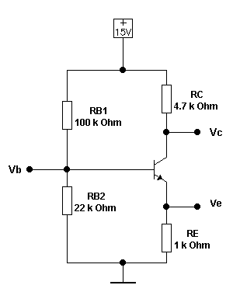  $\left(V_{b}=\left(\frac{R_{B2}}{R_{B1}+R_{B2}}\right)×15= \left(\frac{22k}{22k+100k}\right)×15= 2.7V approx.\right)$  V^{cc}  Assume Vbe = 0.7V  Therefore $V_{e}= V_{b }- V_{be }=2.7-0.7= 2V$  I_{e} = I_{c} = V_{e}/R_{e} = 2 / 1k = 2 mA  Therefore V_{c} = V^{cc} – ( I_{c}x. R_{c} ) = 15 – ( 2mA x 4.7K) = 5.6V  ..............................................................................................................................................  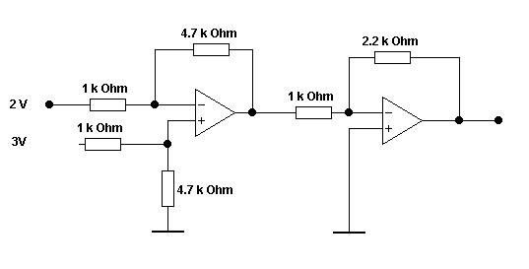  Using Eqn 3 to determine Vx.  Vx  $Vx=\left[\left(\frac{R_{x}}{R_{y}}\right)×\left(V1-V2)\right)\right]$ hence Vx = $\left[\left(\frac{4.7k}{1k}\right)×\left(3-2 )\right)\right]$ = 4.7V  Using equation 2 to determine Vy, the overall output.  $Vout= \left[\left(-\frac{R_{x}}{R_{y}}\right)×vin\right]$ hence $Vout= \left[\left(-\frac{2.2k}{1k}\right)×4.7\right]$ = - 9.4 V  ......................................................................................................................  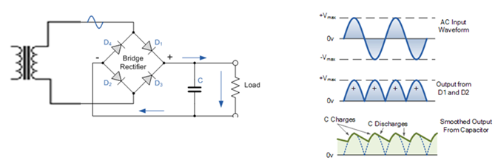  The circuit shown is a simple unregulated, filtered power supply. A mains transformer would normally drop its secondary voltage down to a safe, low voltage which drives the bridge rectifier shown.  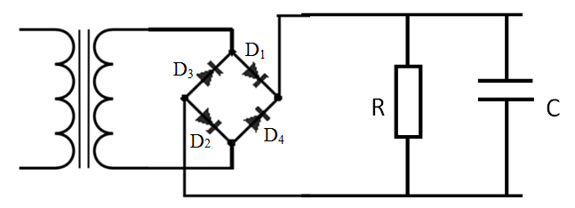  On the positive half cycle of the input D₁ andD₂ conduct and steer the current through R_{L} from right to left. On the alternate half cycle diodes D₃ and D₄ conduct and again steer current through R_{L.} This provides R_{L} with unidirectional pulses of current providing an unregulated, nett DC output. | 1  2  2  ..........  2  1  2  ..........  1  1  1  1  1  ............  1.5  0.5  1  1  1  ..........  2.5  2.5  .........  2  1  2

