Gŵyl y Fro – Festival of the Heartland: Event Strategic Planning and Delivery

Student Name and Number: Ioana Bucura 2246646
Assignment: Planning and Delivering an International Meeting/Event
Module: International Meetings Management BMIH6007
Lecturer Name: Kathryn Roberts
Table of Contents

1. Introduction 3
2. The Event Cycle 3
3. Event Concept 4
4. Aim and Objectives of the Event 5
5. Event Management 6
6. Event Budget 9
7. Industry Trends / Issues / Impacts 10
8. Situational and Cultural Considerations 12
9. Conclusion 14
10. References 15

1. Introduction
Year of Croeso 2025 was launched in January 2025 by Visit Wales as a flagship tourism marketing campaign focused on offering a warm Welsh welcome. It is a nationwide celebration of Welsh identity, hospitality, and culture, inviting international and domestic visitors to experience the best of Wales. The one-day cultural festival “Gŵyl y Fro” (Welsh for “Festival of the Vale/Region”) has been designed to support this campaign by highlighting pride in Wales’s unique culture and arts, boosting tourism, and bringing economic benefits to the region. The event is positioned as an opportunity to improve Wales’s global image and celebrate its heritage (Gov.Wales, 2025).

The festival will take place on the shores of Bala Lake in Snowdonia, a scenic, Welsh-speaking area that allows visitors to immerse themselves in Wales’s landscape and culture. This authentic venue choice is intended to enhance the overall visitor experience (Thomas et al., 2017; Yen, 2023).

2. The Event Cycle
The Event Cycle is a systematic process for managing an event from the initial idea through to delivery and post-event evaluation (Manuylenko and Shebzukhova, 2021). It provides a strategic framework to ensure nothing is overlooked and improvements are made at each stage (Bowdin et al., 2023). For Gŵyl y Fro, the key stages are:

- Stage 1: Concept Development – The one-day Welsh cultural festival was aligned with Visit Wales’s 2025 Year of Croeso campaign to give it a unique cultural theme and purpose (Gov.Wales, 2025; Visit Wales, 2025).
- Stage 2: Planning – Detailed planning commenced by securing the venue, obtaining permits, drafting the budget, organising resources, and preparing contingency plans to manage risks (Haupt, 2021).
- Stage 3: Marketing – The event is promoted via digital and traditional channels to attract a broad audience (Kumar, 2021), emphasising its authentic Welsh experience.
- Stage 4: Delivery – On the event day, the planned programme of Welsh cultural performances, food and craft stalls, and interactive workshops is executed. Staff and volunteers manage attendee flow and safety, coordinating responses to any on-site issues (Struniawski, 2024).
- Stage 5: Evaluation – Post-event, feedback is collected to assess whether objectives were met and to identify improvements (Manuylenko and Shebzukhova, 2021).

3. Event Concept
The concept of Gŵyl y Fro is rooted in creating a memorable experience rather than just staging an event. According to the Experience Economy theory, staging unique experiences adds value beyond a standard service and has been linked to tourism sustainability frameworks (Chang, 2018; Aransyah, 2025). In this case, the festival offers an immersive Welsh cultural experience that visitors will find authentic and unforgettable. By engaging multiple senses (music, language, food, scenery), the event aims to create lasting memories that set Wales apart as a destination (Chang, 2018). This focus on experiences is an economic opportunity that can make Wales more attractive as a tourist destination.

In practical terms, the event concept translates into a full-day programme showcasing “the heart of Welsh culture.” The schedule includes live music and dance performances, storytelling sessions, craft workshops, and local cuisine tastings (Figure 1). The festival’s title “Festival of the Heartland” reinforces its focus on local identity and pride (Thomas et al., 2017). By presenting authentic, visitor focused interactions, the concept ensures that each guest feels a personal connection to Welsh culture.

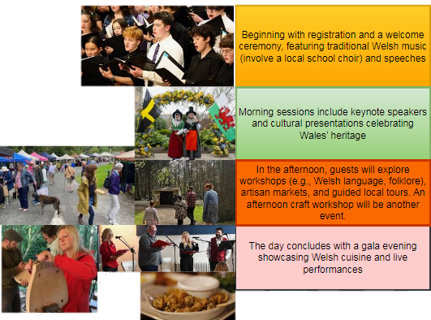

Figure 1: Event Concept (Full Itinerary)
(Source: Researcher)

4. Aim and Objectives of the Event
The overarching aim of Gŵyl y Fro is to establish and promote Wales’s identity as a cultural tourism destination by celebrating the festival as “the heart of Welsh culture.” Through authentic, interactive experiences, the event seeks to enhance visitors’ perceptions of Wales and showcase the nation’s cultural treasures on a global stage (Chang, 2018).

From this aim, several key objectives are defined for the festival (Figure 2):
- Increase visitor attendance: Attract a high number of domestic and international visitors to Bala for the event.
- Achieve positive attendee satisfaction: Ensure that guests have an enjoyable experience, reflected in positive feedback and high satisfaction levels (Gallarza and Gil Saura, 2020).
- Generate economic benefits: Boost the local economy and achieve a financial surplus for the event.

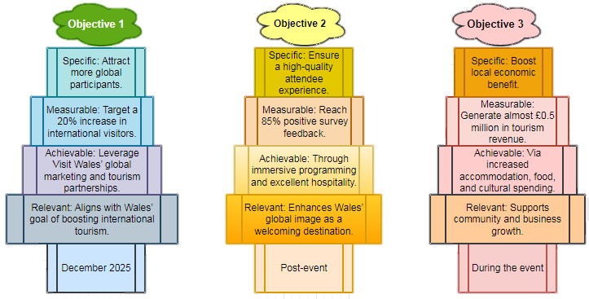
Figure 2: SMART Plans for Objectives
(Source: Researcher)

5. Event Management
Effective event management for Gŵyl y Fro requires close attention to operational details, stakeholder engagement, and cultural sensitivity. On the operational side, the Bala Lake venue was chosen for its cultural significance and scenic value, enhancing authenticity. Permissions were obtained and services like waste management, first aid, and security arranged. Stakeholder engagement is also critical: following stakeholder theory, the team considers all parties affected by the event, guests, staff, community, sponsors, and seeks to meet their needs (Mahajan et al., 2023), valuing local community input and volunteers and recognising sponsor contributions.

Cultural competence among the event staff is essential given the international scope. Applying Hofstede’s cultural dimensions theory, the management team will include bilingual staff and volunteers who understand Welsh culture and language, as well as the needs of international visitors (Żemojtel-Piotrowska and Piotrowski, 2023). This approach aligns with the festival’s inclusive ethos, helping overseas guests feel the Welsh croeso (welcome) in their own language. Inclusivity measures also involve providing accessible facilities (e.g. ramps, accessible toilets, signage in both Welsh and English) so that people of all backgrounds and abilities can enjoy the event.

The team also used project management tools like Gantt charts to schedule tasks and assign responsibilities (Wadhwa, 2024), with regular checklists and meetings to ensure key milestones (e.g. booking performers, confirming suppliers) were met on time (Bowdin et al., 2023).

Resource procurement for the event emphasises local partnerships and sustainability. Local caterers and food vendors will operate stalls, adding authentic regional flavour while supporting the local economy. Equipment and supplies (tents, stage, sound systems) are being sourced through local companies where possible. A ticketing platform will handle registrations, and an event mobile app or social media page will be used to engage guests with updates and feedback.

Sustainability principles are integrated into management decisions in line with the triple bottom line approach (Nogueira et al., 2023). This means implementing fair labour practices and volunteer appreciation (people), minimising environmental impact (planet), and aiming for financial viability (profit). For example, the team will reduce waste (encouraging reusable bottles, recycling) and provide a shuttle bus from the nearest train station to reduce car usage. These initiatives demonstrate responsible resource management alongside the event’s economic aims (Aransyah et al., 2025).

Another aspect of management is marketing the event, guided by the 4Ps marketing mix (Product, Price, Place, Promotion) (Kumar, 2021). Gŵyl y Fro’s marketing strategy aligns each “P” with its goals: the product is the unique cultural experience, the price is kept low to encourage attendance, the place is the distinctive Bala Lake setting, and promotion leverages the Year of Croeso branding with multi-channel outreach (Štreimikienė and Ahmed, 2021) (Figure 3). Aligning the marketing mix with the event’s objectives helps the organisers reach the target audience and deliver the promised experience.

On the day of the festival, dozens of staff and volunteers will handle operations (parking, admissions, stage management, information). A safety officer will liaise with emergency services while the security team controls the crowd. Training and briefings ensure the team can calmly handle incidents like lost children, medical needs, or unruly behaviour (Struniawski, 2024).

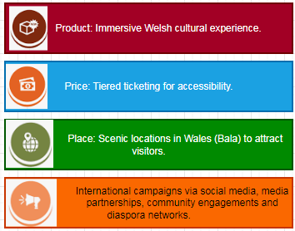
Figure 3: Marketing management through 4Ps marketing mix
(Source: Researcher)

6. Event Budget
Financial planning for the festival was informed by the initial feasibility study and aims to balance accessibility with sustainability. Projected income for Gŵyl y Fro is about £20,600. Major funding will come from grants (including support from Visit Wales’s Event Wales program) contributing around £10,000 (Visit Wales, 2025), and local sponsorships (£5,000), with additional revenue from vendor stall fees (£3,000) and other small streams (merchandise, raffles). The event will be free to attend with a suggested £2 voluntary donation per attendee (about £1,600 if 800 people contribute) to help offset costs (Damiasih, 2024).

Table 1: Projected Income Sources and Estimates
Income sources | Income (£) (Approx)
Grants (e.g. Event Wales funding) | 10,000
Sponsorships | 5,000
Ticket donations | 1,600
Vendor charge | 3,000
Other income (e.g. merchandise) | 1,000
Total | 20,600

Table 2: Projected Expenditure Breakdown
Expenditure sources | Cost (£) (Approx)
Venue and site facilities | 3,000
Equipment sourcing | 5,000
Marketing expenses | 1,500
Operations | 4,000
Entertainment | 2,000
Miscellaneous and Contingency | 2,500
Total | 18,000

Projected expenditure is approximately £18,000. Key expenses include venue/site facilities, equipment, operations, marketing, and entertainment, with a contingency fund of about £2,500 (around 14% of the budget) for unforeseen costs. These expenses are kept reasonable by using local suppliers and an open air venue (minimising infrastructure needs), leveraging free digital marketing channels, and relying on volunteers for many roles.

With income around £20.600 and costs around £18,000, the event is expected to break even or achieve a small surplus. Any surplus can be reinvested into future events or local community projects, aligning with the festival’s community oriented mission. Importantly, this financial plan achieves the objective of generating economic benefits without relying on high ticket prices, thereby keeping the festival accessible to all.

To manage finances, the organising team will implement sound budgeting and control practices. Expenses will be closely tracked against the budget to avoid overspending (Manuylenko and Shebzukhova, 2021), and a post-event financial report will compare projected figures to actual outcomes to identify areas for improvement or additional revenue in the future (Kaya and Kaya, 2023).

7. Industry Trends / Issues / Impacts
Sustainability is a dominant trend in the tourism and events industry. By 2024, nearly 80% of global travellers considered sustainable practices important when selecting destinations (Statista, 2025). In response, events like Gŵyl y Fro must integrate environmental and social responsibility to meet visitor expectations and policy goals (Hinton, 2024; Arbolino et al., 2021).
The festival addresses this by reducing single use plastics, using biofuel-powered generators, and encouraging shuttle bus use over car travel. These measures reflect triple bottom line thinking, balancing environmental care, economic viability, and community engagement (Nogueira et al., 2023; Aransyah et al., 2025).

Risks remain, including volunteer shortages, technical failures, and low attendance. To mitigate these, contingency plans involve backup staff from local groups, spare equipment, and programme flexibility (Haupt, 2021; Kaya and Kaya, 2023).

Additionally, Gŵyl y Fro fosters cultural sustainability by ensuring inclusivity through bilingual signage, accessible facilities, and community-led performances (Figure 4). These actions promote a meaningful, responsible experience aligned with ethical and strategic tourism standards (Yen, 2023; Gallarza and Gil Saura, 2020).
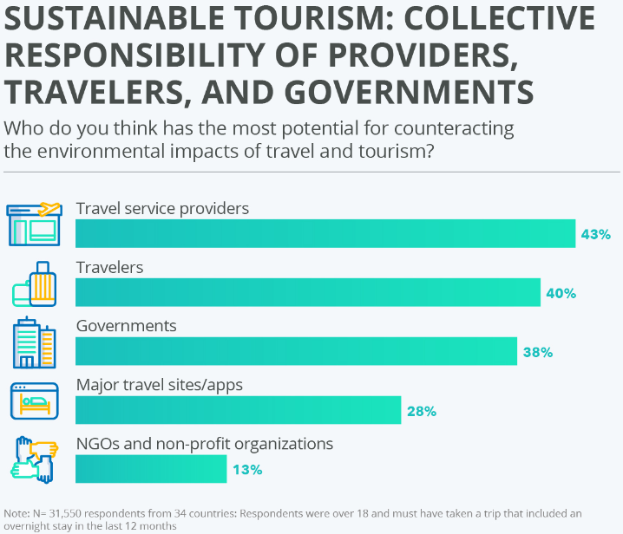

Figure 4: Tourism and event sustainability responsibilities of different stakeholders
(Source: Hinton, 2024)

8. Situational and Cultural Considerations
The success of Gŵyl y Fro depends on understanding the situational context and cultural considerations surrounding the event.

From a situational perspective, market research indicates favourable conditions for a cultural festival in Wales. The UK’s heritage tourism market is projected to grow significantly in the coming years (Grand View Research, 2025), indicating rising interest in authentic cultural experiences, a trend that bodes well for Gŵyl y Fro. Additionally, government support for the tourism sector (GOV.UK, 2021), along with Wales’s Year of Croeso initiative, have created a positive environment for launching this festival.

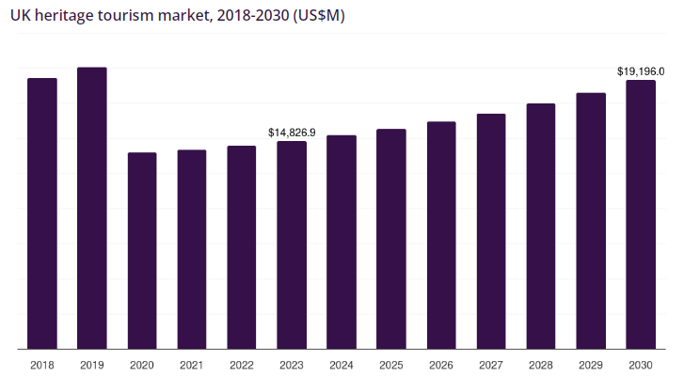
Figure 5: Heritage tourism market growth forecast
(Source: Grand View Research, 2025)

Cultural considerations are at the heart of the event. Gŵyl y Fro is designed to showcase Wales’s unique language, traditions, cuisine, and artistic heritage, extending a warm Welsh welcome to all (Yen, 2023). A key cultural goal is inclusivity: the festival is open to people of all backgrounds (“everyone is welcome”), and bilingual signage and program materials (in Welsh and English) will be used to eliminate language barriers (Żemojtel-Piotrowska and Piotrowski, 2023).

Engaging the local community of Bala is both culturally respectful and strategic. Local organisations (schools, youth groups, cultural societies) are involved, grounding the festival in the community and ensuring authentic content. These collaborations foster local ownership and give visitors a chance to interact with residents and learn about Welsh culture, enhancing the sense of place.

A brief SWOT analysis highlights the event’s internal strengths and weaknesses and the external opportunities and threats (Figure 5).
- Strengths: unique cultural theme aligned with a national campaign; local community support; scenic location.
- Weaknesses: a new, untested event; limited initial funding; no established reputation yet.
- Opportunities: growing interest in cultural tourism; the Year of Croeso promotion provides a ready market; potential to become an annual event if 2025 is successful.
- Threats: competition from other summer events in Wales; unpredictable weather or lingering travel concerns that could affect attendance.

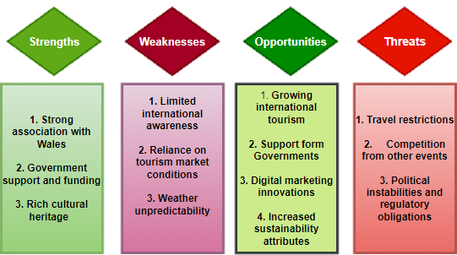
Figure 5: SWOT analysis
(Source: Researcher)

Understanding these factors allows the team to maximise strengths while addressing weaknesses and threats. By being mindful of the situational and cultural context, the planning is more robust and culturally appropriate, increasing the likelihood of a positive reception.

9. Conclusion
The Gŵyl y Fro event merges theory with practical planning to deliver an authentic cultural experience aligned with the Year of Croeso 2025. By applying the Event Cycle, Experience Economy, stakeholder theory, Hofstede’s dimensions, and triple bottom line, the festival ensures inclusivity, sustainability, and strong stakeholder engagement.

The financial strategy balances accessibility with control, while SWOT analysis enhances preparedness. If executed effectively, Gŵyl y Fro will both celebrate Welsh identity and support Wales’s profile as a cultural tourism destination, with the potential to become a valued annual event rooted in local pride and national promotion.

10. References
Aransyah, M.F., Hermanto, B., Muftiadi, A. and Oktadiana, H., 2025. Exploring sustainability-oriented innovations in tourism: insights from ecological modernization, diffusion of innovations, and the triple bottom line. Cogent Social Sciences, 11(1), p.2447396.
Arbolino, R., Boffardi, R., De Simone, L. and Ioppolo, G., 2021. Multi-objective optimization technique: A novel approach in tourism sustainability planning. Journal of Environmental Management, 285, p.112016. https://doi.org/10.1016/j.jenvman.2021.112016
Bowdin, G.A., Allen, J., Harris, R., Jago, L., O'toole, W. and McDonnell, I., 2023. Events management. Routledge. https://www.taylorfrancis.com/books/mono/10.4324/9781003044963/events-management-glenn-bowdin-johnny-allen-rob-harris-leo-jago-william-toole-ian-mcdonnell
Chang, S., 2018. Experience economy in hospitality and tourism: Gain and loss values for service and experience. Tourism management, 64, pp.55-63. https://doi.org/10.1016/j.tourman.2017.08.004
Damiasih, D., 2024. Interrelation Between Tourism Destination Financial Management and Tourist Experiences: Qualitative Approach to Literature. Atestasi: Jurnal Ilmiah Akuntansi, 7(2), pp.1214-1223. https://doi.org/10.57178/atestasi.v7i2.932
Gallarza, M.G. and Gil Saura, I., 2020. Consumer value in tourism: a perspective article. Tourism Review, 75(1), pp.41-44. https://www.emerald.com/insight/content/doi/10.1108/tr-06-2019-0227/full/html
GOV.UK, 2021. The Tourism Recovery Plan. Available at: https://assets.publishing.service.gov.uk/media/60c239a8e90e074397d8c8b0/Tourism_Recovery_Plan__Web_Accessible_.pdf [Accessed 7 June 2025].
Gov.Wales, 2025. International Delivery Plan. Available at: https://www.gov.wales/sites/default/files/publications/2025-04/international-delivery-plan.pdf [Accessed 7 June 2025].
Gov.Wales, 2025. Visit Wales invites world to feel the 'hwyl' in 2025. Available at: https://www.gov.wales/visit-wales-invites-world-feel-hwyl-2025#:~:text=The%20'hwyl'%20concept%2C%20part%20of%20the%202025,collaboration%20with%20the%20creative%20industries%20in%20Wales [Accessed 7 June 2025].
Grand View Research, 2025. UK Heritage Tourism Market Size & Outlook, 2024-2030. Available at:https://www.grandviewresearch.com/horizon/outlook/heritage-tourism-market/uk#:~:text=The%20UK%20heritage%20tourism%20market,revenue%20generating%20type%20in%202023. [Accessed 7 June 2025].
Haupt, B., 2021. The use of crisis communication strategies in emergency management. Journal of Homeland Security and Emergency Management, 18(2), pp.125-150. https://www.degruyter.com/document/doi/10.1515/jhsem-2020-0039/html
Hinton, T., 2024. Sustainable Tourism: Collective Responsibility of Providers, Travelers, and Governments. Available at: https://www.statista.com/chart/32241/collective-responsibility-of-sustainable-tourism/ [Accessed 7 June 2025].
Kaya, E. and Kaya, M.C., 2023. The role of contingency theory for tourist destinations management. Tourist Destination, 1(1), pp.25-32. https://www.researchgate.net/profile/Muhammet-Kaya-23/publication/376168130_The_role_of_contingency_theory_for_tourist_destinations_management/links/656b441a3fa26f66f4479168/The-role-of-contingency-theory-for-tourist-destinations-management.pdf
Kumar, P., 2021. Digital marketing in hospitality and tourism. University of South Florida (USF) M3 Publishing, 17(9781732127593), p.3. https://digitalcommons.usf.edu/m3publishing/vol17/iss9781732127593/3/
Mahajan, R., Lim, W.M., Sareen, M., Kumar, S. and Panwar, R., 2023. Stakeholder theory. Journal of Business Research, 166, p.114104. https://doi.org/10.1016/j.jbusres.2023.114104
Manuylenko, V.V. and Shebzukhova, M.A., 2021. Theory for financial controlling in corporations in the modern environment. Universal Journal of Accounting and Finance, 9(4), pp.773-782. https://www.academia.edu/download/74353146/UJAF23_12224347.pdf
Nogueira, E., Gomes, S. and Lopes, J.M., 2023. Triple bottom line, sustainability, and economic development: What binds them together? A bibliometric approach. Sustainability, 15(8), p.6706. https://doi.org/10.3390/su15086706
Statista, 2025. Sustainable tourism in the United Kingdom - statistics & facts. Available at: https://www.statista.com/topics/13400/sustainable-tourism-in-the-united-kingdom/#topicOverview [Accessed 7 June 2025].
Statista, 2025. Sustainable tourism worldwide - statistics & facts. Available at: https://www.statista.com/topics/1916/green-tourism/#topicOverview [Accessed 7 June 2025].
Štreimikienė, D. and Ahmed, R.R., 2021. Corporate social responsibility and brand management: Evidence from Carroll’s pyramid and triple bottom line approaches. Technological and Economic Development of Economy, 27(4), pp.852-875. https://journals.vilniustech.lt/index.php/TEDE/article/view/14520
Struniawski, J., 2024. CROWD MANAGEMENT DURING MASS EVENTS. Zeszyty Naukowe, (89), p.2. https://publisherspanel.com/api/files/view/2427630.pdf
Thomas, B., Thomas, S. and Powell, L. (2017). THE DEVELOPMENT OF KEY CHARACTERISTICS OF WELSH ISLAND CULTURAL IDENTITY AND SUSTAINABLE TOURISM IN WALES. Scientific Culture, 3(1). https://www.researchgate.net/profile/Brychan-Thomas/publication/330565005.pdf
Visit Wales, 2025. Funding support for culture and sport events in Wales. Available at: https://industry.visitwales.com/funding-support-culture-and-sports-events-wales [Accessed 7 June 2025].
Visit Wales, 2025. 2025: Year of Croeso. Available at: https://industry.visitwales.com/get-involved/visit-wales-themed-year-campaigns/year-croeso [Accessed 7 June 2025].
Wadhwa, K., 2024. The Role of Gantt Chart in the Project Management. https://www.theseus.fi/handle/10024/865913
Yen, D., 2023. Leveraging folklore and fantasy to promote small destinations: the case of Visit Wales Journal of Policy Research in Tourism, Leisure and Events, 2023 (Doctoral dissertation, Leeds Beckett University). https://www.researchgate.net/profile/Nigel-Morgan-2/publication/374228809_Leveraging_folklore_and_fantasy_to_promote_small_destinations_the_case_of_Visit_Wales/links/651466b9cce2460b6c3928f7/Leveraging-folklore-and-fantasy-to-promote-small-destinations-the-case-of-Visit-Wales.pdf
Żemojtel-Piotrowska, M. and Piotrowski, J., 2023. Hofstede’s cultural dimensions theory. In Encyclopedia of sexual psychology and behavior (pp. 1-4). Cham: Springer International Publishing. https://doi.org/10.1007/978-3-031-08956-5_1124-1.pdf

