Amanda Sims P151044
Surface Pattern Design
Research Practices – M5X01571
Formulating my question for dissertation.

Word count: 2048

My three key words or areas of interest are migraine with aura, optical illusions and colour. In particular my research will focus on how these can affect vision and, in turn, how this can affect artists and designers in their artistic endeavours and the production of their work. I have chosen these words as they are meaningful to me because I get migraine on a regular basis, the migraines have an effect on my vision and there are some colours that can trigger a migraine for me. While migraine can have an incredibly negative affect and be incredibly painful and long lasting, I am trying to focus more on the positive aspects of this condition when it comes to the production of my own artwork. I am interested in how other artists and designers are affected and whether they view migraine as a positive or negative experience. Has their condition influenced the way in which they work?
Migraine is defined in the Oxford Dictionary (Elliot et al, 1997) as ‘mi:grem/ noun recurrent throbbing headache often with nausea and visual disturbance.’ Personally, I do not experience nausea however I do experience the visual disturbance. I also experience the throbbing headache that can last for several days.
In the article ‘Art and Migraine: Researching the Relationship Between Artmaking and Pain Experience’ Vick and Sexton-Radek (2009: 115) define several categories of symptoms for migraine sufferers. They state, ‘In addition to the cardinal features of head pain and nausea, migraine sufferers also experience a wide array of neurological symptoms’. These, they continue, include, ‘vertigo, hypersensitivity to sound and light, and visual disturbances’. Further, these ‘phenomena’ are said to include ‘blurred vision or blindness in all or part of the visual field (hemianopia), seeing scintillating flashes of light (scotoma), seeing serrated circles or arcs of light (fortification spectra), seeing objects as larger or smaller than normal (metamorphopsia), seeing objects up-side-down (inversion), and distorted perceptions of motion as well as more elaborate visual hallucinations.’ (Vick and Sexton-Radek, 2009: 115). The article also lists ‘double or multiple images (visual preservation) and changes in color [sic], contrast, or depth perception’. These are helpful categories of symptoms which I intend to use in my research. These are helpful indicator of the way in which many other people can be affected.
It is these visual phenomena that that indicate the ‘difference between the two main subtypes of migraine. “Classic” migraine features the “aura” consisting of visual and other neurological symptoms (such as numbness in the arms and face and expressive dysphasia) that precede the onset of pain.’ (Vick and Sexton-Radek, 2009: 115). The article continues ‘The “common” migraine, experienced by 75% of sufferers, occurs without the aura’ (Vick and Sexton-Radek, 2009: 115). Personally, I have been experiencing ‘classic’ migraine for more than 25 years. There are times when the results of the visual disturbances (aura) can be fascinating and rather beautiful, it is the long-lasting pain that comes with or follows the aura, that negates sensations.

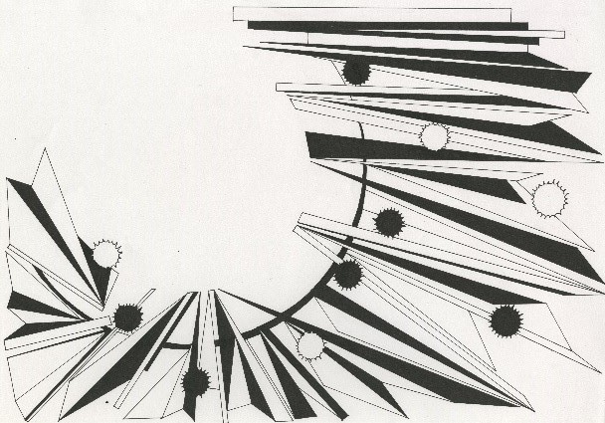 | Fig. 1 Aura 1 – Amanda Sims.  This is one of my representations of migraine aura, these are the ‘scotoma’ and ‘fortification spectra’ as described by Vick and Sexton-Radek in their article.
I want to start by looking at the phenomena of the visual experiences experienced through migraine. I want to give a person who does not suffer with ‘classic’ migraine an indication of how vision can be affected, how things can appear to be and how things can, sometimes, be beautiful. I will try to replicate this using optical illusions, optical art work and the work of artists who, I understand, could have experienced migraine themselves.
Through research so far, I have discovered that several famous artists may also have suffered with migraines, ‘Art and Migraine: Researching the Relationship Between Artmaking and Pain Experience’ Vick and Sexton-Radek (2009: 117) states that ‘Articles documenting or speculating on the impact of migraines on artistic output have been written’ Vick and Sexton-Radek (2009: 117) indicate a ‘diverse collection of artists including Hildergard of Bingen, Georgio de Chirico, Pablo Picasso, Georgia O’Keeffe, and the contemporary artist Sarah Raphael and others’. I have not yet found any conclusive evidence as to whether migraine is documented or speculated in any of the artists named here. However, looking at the work of Georgia O’Keeffe I can see indicators that would give the impression of classic migraine.
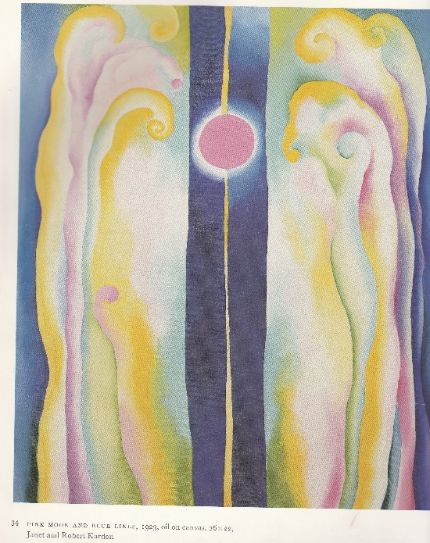 | Fig. 2 Pink Moon and Blue Lines  Through personal experience of a variety of migraine visuals, this melting, merging and flowing of colour is something I have observed. In writing of Georgia O’Keeffe, Cowart comments ‘her art allows us to remember things she has seen, experienced, or sensed, images grounded in authenticity’ (Cowart, Hamilton and Greenough 1987:2). Cowart also notes ‘In her art, fleeting effects of natural phenomena or personal emotion become symbols, permanent points of reference.’ (Cowart, Hamilton and Greenough 1987:2).
The language Cowart uses in these quotes, and, on occasion, throughout his introduction to ‘Georgia O’Keeffe: Art and Artist’ (Cowart, Hamilton and Greenough 1987:1 – 6) does appear to support the possibility of classic migraine. Cowart writes ‘Contrasts of the near and far, both in time and space, distinguish O’Keeffe’s art. She has no aerial perspective, but treats everything in focus, ignoring impressionistic values, the actual envelope of the air, or the limits of human (and even mechanical) vision.’ (Cowart, Hamilton and Greenough 1987: 2-3). To me this would indicate the possible neurological symptoms as described in ‘Art and Migraine: Researching the Relationship Between Artmaking and Pain Experience’ Vick and Sexton-Radek (2009).
In his introduction to the book ‘Optical Art, Theory and Practice’, Parola (1969: 10 - 11) informs us that the ‘foundation’ of optical art is ‘non-objective perceptual response’ Parola continues it ‘is abstract and consists of geometric forms, mechanical patterns, screens, and target effects.’ (Parola 1969: 10). With regard to ‘pattern’ Parola writes of op art that ‘It may be described as multiplicity of simplicity’ and that some artists may ‘produce implied movement into space by varying the density of the pattern.’ (Parola 1969: 10). Parola adds ‘Color [sic] is not a necessary function of perceptual transformation, illusion, or optical discrepancy. Startling results can be obtained through the use of black, white, and grey.’ (Parola 1969: 11). Parola also states that the ‘high contrast of black and white often conveys the feeling of complementaries [sic] and provides powerful results that would not be as effective in color [sic]’ (Parola 1969: 11).
My understanding of these introductory notes by Parola is that, op art can appear to be quite simplistic in its design with geometric shapes and repeat pattern playing tricks on the observers’ eyes. Although colour plays a key role in art, it is not always necessary to use in order to obtain the best results or desired outcomes when portraying movement in an image. The position of geometric lines and patterns with changes in density can create the illusion of movement. This can be illustrated through the following images taken from ‘Optical Art, Theory and Practice’, (Parola 1969: 36 – 37) when looking at ‘perspective’ and ‘illusion’.
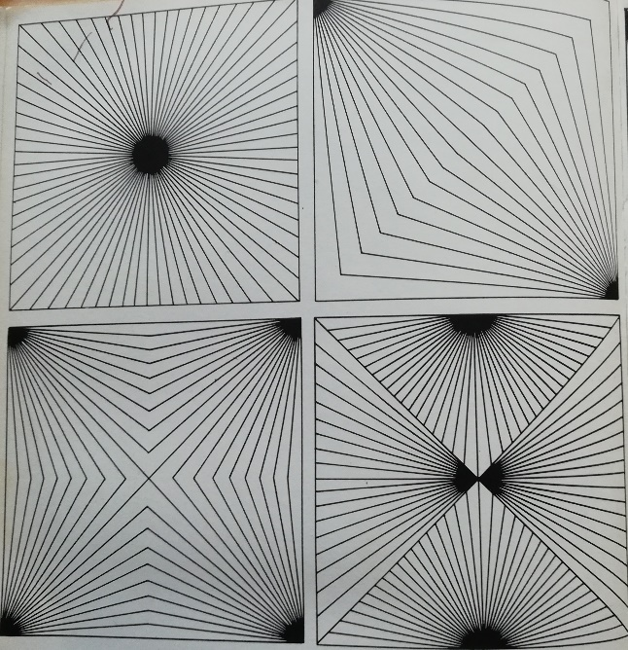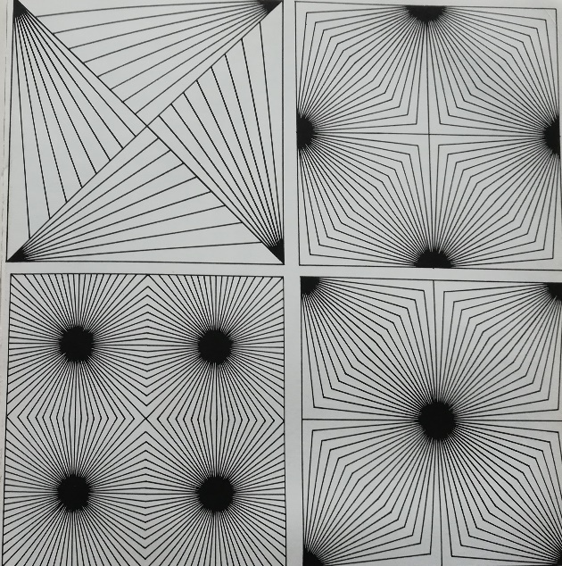
Fig. 3 ‘Optical Art, Theory and Practice’, Parola (1969: 36 – 37)

The visual phenomena can also be seen in some of the works of Bridget Riley. A review from the New Statesman noted in Bridget Riley, Paintings and Related Work (Wiggins, Bracewell and Prather, 2010: 19), starts ‘No painter, dead or alive’ and continues ‘has ever made us more aware of our eyes than Bridget Riley’. The following paragraph informs us that ‘the truth’ of this ‘pronouncement’ would be ‘self-evident to anyone who has stood in front of a painting by Riley – from any period in her career – and accepted its invitation to look and see. Each painting comprises its own closed circuitry of movement and form, refining our perception to pure sensation, beyond intellect.’ (Wiggins, 19).
While this statement applies to work that was exhibited at ‘the Hayward Gallery, London, in 1971’ (Wiggins, Bracewell and Prather 2010: 19), equally it can be applied to all of the Bridget Riley images within the book ‘Bridget Riley, Paintings and Related Work’ for the exhibition of the same name at the National Gallery, London, November 2010 to May 2011.
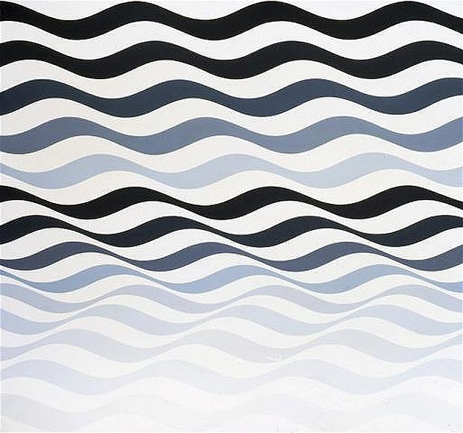 | Fig. 4 Bridget Riley Arrest 3, 1965  The simple tones of blue, near black and grey and the wave pattern in this piece give the illusion of movement. The pattern of the waves changes direction towards to lower portion of the image, this then creates a chevron effect and enhances the sense of movement.
While black, white and grey may produce the best results when portraying the desired illusion of movement and depth perception, I find that the starkness of these colours can create stress on my eyes and be a trigger for migraine. The colours in ‘Arrest 3’, I find far more pleasant and are colours that I would prefer to use in my own work as these are less likely to trigger a migraine.
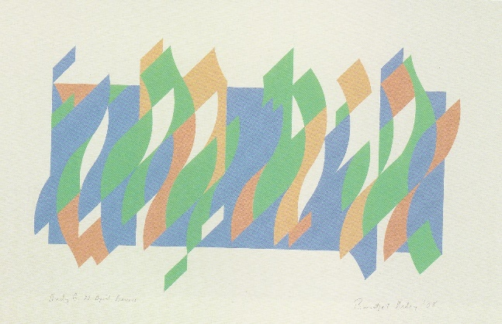  Fig. 5 Bridget Riley, Study B, 22 April Bassacs, 2008 | 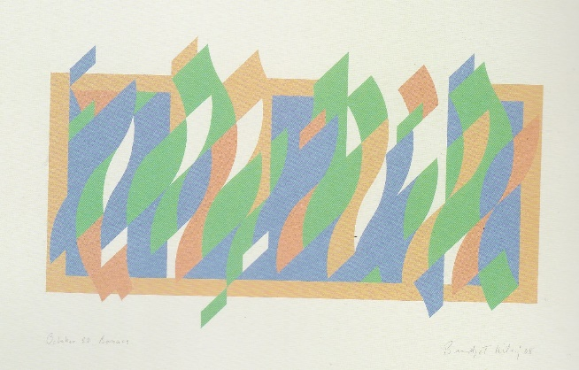  Fig. 6 Bridget Riley, October 22nd Bassacs, 2008.
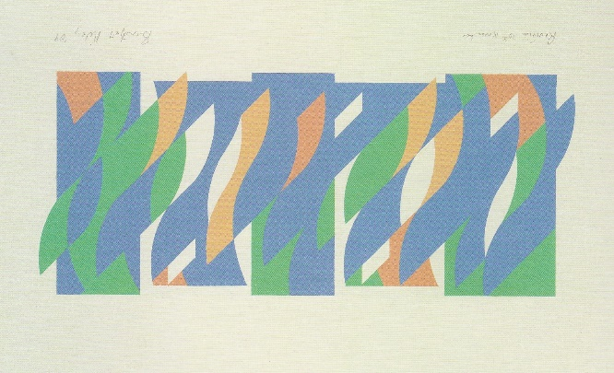  Fig. 7 Bridget Riley, Revision 10th November 2009 | 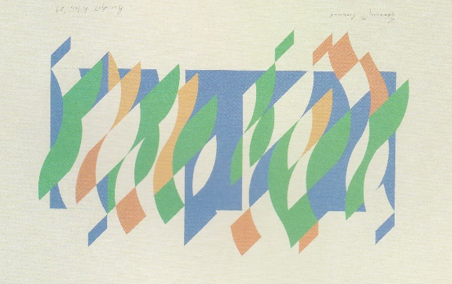  Fig. 8 Bridget Riley, Jan 7th Cornwall, 2009

Bridget Riley is an abstract artist who portrays the illusion of movement in her art both in monochrome, (with the blues, near black and grey) and in colour as illustrated in the gouache on paper studies above. In 1995 Riley said ‘I think Abstract art should try to be as resourceful and as expressive as the great figurative art of the past’ (Wiggins, Bracewell and Prather, 2010: 9). This is important because Riley uses abstraction, taking a form and reducing it to curves and minimal lines to produce work. Abstract art has a role, and its role is equal to that of the great masters.
This leads to my final key word, colour. My reading has shown that research around colour is extensive but there are many variables that need to be considered when trying to establish the effect that colour could have. A painter with a particular flair for colour and colour relationships, Paul Gauguin, said ‘By trial and error, color [sic] can be used to evoke a visceral reaction antecedent to words.’ (Zelanski and Fisher, 2006: 37). This suggests that the visual impact of colour can have an emotional and / or a physiological effect even before a word is spoken, and that it is only through the repeated action of mixing colours that we can succeed in obtaining a reaction, desired or otherwise. They go on to divide colours into categories of association ‘the colors of fire – reds, yellows, oranges – with warmth’ (Zelanski and Fisher, 2006: 37). and describing ‘the coolness of greens and blues’ (Zelanski and Fisher, 2006: 38).
My reading also indicates that colour can evoke an emotional or physiological effect, and that the effects can vary from person to person. There can also be an issue of personal preference. ‘Not only have we inherited cultural associations, but we also respond to colors in individual ways.’ (Zelanski and Fisher, 2006: 42). The emotional effects to assorted colours have also been defined however, ‘Such associations are rather common, but on the other hand cannot be considered absolute’ (Zelanski and Fisher, 2006: 45). For example, ‘Red: vitality, strength, warmth, sensuality, assertion, anger, impatience’ while ‘Turquoise: mental calmness, concentration, confidence, refreshment and ‘Indigo / violet: spirituality, intuition, inspiration, contemplation, purification’ (Zelanski and Fisher, 2006: 44 - 45). My personal preference is toward hues of blues and purples or turquoise and indigo, I find these colours more calming while bright, vivid colours can trigger a migraine.
The link between migraine, optical illusion and colour is that, a migraine with aura can create the optical illusions through an ‘array of neurological symptoms’. These symptoms can create the geometric patterns that become optical illusions. Migraine sufferers can have an aversion to light and colour, migraines can also be responsible for the creation of colour, light and colour can be a trigger for migraine. In this way these key words can all be intertwined.
Having researched my key words so far, this leads me to ask the question how do the symptoms of migraine affect those who make imagery and the readings of the audiences of visual imagery. Does it impact on makers and art and their audiences?

BIBLIOGRAPHY
Batchelor, D. [ed] (2008) – Colour, Documents of Contemporary Art. London: The MIT Press
Cowart J., Hamilton J. and Greenough S. (1987) – Georgia O’Keeffe. Art and Letters. Canada: Little, Brown and Company Ltd
Elliott, J. with Knight, A. and Cowley, C. [eds] (1997) – The Oxford Paperback Dictionary and Thesaurus. Kent: Mackays PLC
Gardner, H. (1982) – Art, Mind, and Brain. A cognitive approach to creativity. United States of America: Basic Books
Granziera, C., DaSilva, A.F.M., Snyder, J., Tuch, D.S., and Hadjikhani, N. (2006) ‘Anatomical Alterations of the Visual Motion Processing Network in Migraine with and without Aura’ - PLoS Medicine Open Access Volume 3 Issue 10 e402 (October): pp 1915-1921
Hoffman, D.D. (1998) – Visual Intelligence, how we create what we see. London: W. W. Norton & Company Ltd.
Krauss, R.E. (1993) – The Optical Unconscious. London: The MIT Press
Mannoni L., Nekes W., and Warner M. (2004) – Eyes, Lies and Illusions. The Art of Deception. London: Hayward Gallery Publishing
Parola R. (1969) – Optical Art Theory and Practice. New York: Reinhold Book Corporation
Rothenstein, J. and Gooding M. [eds] (1999) – The Playful Eye, an album of visual delight. London: Redstone Press
Thurston, J.B. and Carraher, R.G. (1966) – Optical Illusions and the Visual Arts. New York: Van Nostrand Reinhold Company
Vick, R.M. and Sexton-Radek, K. (2009) ‘Art and Migraine: Researching the Relationship Between Artmaking and Pain Experience’ – Art Therapy: Journal of the American Art Therapy Association 26(3) pp. 114-123
Wiggins, C., Bracewell, M. and Prather, M. (2010) – Bridget Riley, Painting and Related Work. London: Yale University Press
Zelanski, P. and Fisher, M.P. (2006) – 5th Ed – Color. New Jersey: Pearson Education, Inc.

Figures
Figure 1 Aura 1 – Amanda Sims. Drawing made by the author.
Fig. 2 Pink Moon and Blue Lines, 1923, oil on canvas 26 x 22 in Cowart J., Hamilton J. and Greenough S. (1987) – Georgia O’Keeffe. Art and Letters. Canada: Little, Brown and Company Ltd. Plate 34
Figure 3 ‘Optical Art, Theory and Practice’, Parola R. (1969) – Optical Art Theory and Practice. New York: Reinhold Book Corporation. Pp. 36 – 37
Figure 4 ‘Bridget Riley Arrest 3, 1965, acrylic on linen,175 x 192 cm, Gallery of Modern Art, Glasgow’ Wiggins, C., Bracewell, M. and Prather, M. (2010) – Bridget Riley, Painting and Related Work. London: Yale University Press. Pp. 47.
Figure 5 Bridget Riley, Study B, 22 April Bassacs, 2008. Gouache on paper 61.6 x 93.3cm Private collection in Wiggins, C., Bracewell, M. and Prather, M. (2010) – Bridget Riley, Painting and Related Work. London: Yale University Press Pp. 60,61
Figure 6 Bridget Riley, October 22nd Bassacs, 2008 Gouache on paper 61.5 x 94.5 cm Private collectionin Wiggins, C., Bracewell, M. and Prather, M. (2010) – Bridget Riley, Painting and Related Work. London: Yale University Press Pp. 60,61
Figure 7 Bridget Riley, Revision 10th November 2009 Gouache on paper 58.3 x 92.7 cm Private collection in Wiggins, C., Bracewell, M. and Prather, M. (2010) – Bridget Riley, Painting and Related Work. London: Yale University Press Pp. 60,61
Figure 8 Bridget Riley, Jan 7th Cornwall, 2009 Gouache on paper 61.5 x 95.5 cm Private collection in Wiggins, C., Bracewell, M. and Prather, M. (2010) – Bridget Riley, Painting and Related Work. London: Yale University Press Pp. 60,61

