PERSONAL PORTFOLIO
of
Pavlin Grancharov

Professional Career Development

Table of Contents
Introduction 3
Lifeline-Explanation and Examples 3
Self-Motivation 5
Learning Styles 6
Visual, Auditory, Kinaesthetic learning styles 6
Honey and Mumford learning style 8
Kolb’s Learning Style 8
Personal Swot Analysis 9
Johari Window 10
Deployment and practical aplication 11
Personal Development Plan 14
Conclusion and Recommendation 15
Reference list 16

Introduction
Personal Portfolio means introduce “About Me”, which is an online treasure of individual. It may be include lifeline of me, my background, samples of work, and completed projects in the past which will be a better explanation for any clients or any organization as an advantage. In this portfolio I am going to discuss about my lifeline achievement that belongs to the UK.
In my Portfolio I am going to write about my Life line and reflect on my gained skills by
now. I will introduce my level of motivation, although I will explain different learning styles
including: visual, auditory, kinaesthetic learning style, Honey and Mumford and Kolb’s
learning styles. Moreover, I will go through Jo Hari window by giving explanation
about it and related to my work and study. I will finish this Portfolio with my Personal development plan; conclusion and some recommendation will be given.

Lifeline-Explanation and Examples
Personal Background
Research information can be found out through the analysis from by background, which is as follows:
- Current Position- Currently my work and job field as a fitter. From past 8 years this is my preferable job. In this job field, specifically my work field is steel erector in a meal fitter, concentrate on balcony fitting; I have made different types of balustrades, handrails, ramps in staircase work. Severely making glass panels and decorations of the interior of a building is also my work.
- My previous job experience- After finished my schooling with radio and TV technology qualification, I have started working as a bartender in Bulgaria which is a European Continent. It was a 5 years experience in first job. In between that time Agricultural economy offered me for an academic experience. It has to be noted that to live in the UK always my dream and wanted for this so much. In year 2006, my dream will come true in the UK and finally started my first job which is carpet and window cleaning. Until this current job, window cleaning and carpet cleaning was my daily work in the UK (Illeris, 2018).
- Background and Professional life- Since I have started my work as a metal fitter in a construction industry, so much things and several courses, trainings gained through this job and such related courses are Manual handling, working upon heights, harness training, face fit mask test, NVQ(level-2) from steel erector. On the other hand, it has been noticed to be involved in railway work for personal track safety (PTS) purpose. In this profession, one should remind different things and have to follow instructions, careful about plans and accuracy. As a steel erector for working outdoors always to be physically fit and comfortable working at height places. In this job health and safety issues can arise so must be aware of them and have a mindset for practical/field work (Kolb, 2014).
According to my Lifeline analysis high-points are my strengths and low points are my weakness. Discussing about lifeline explanation with examples:
High points in life-
- Finishing high school, my first job gives me a moneywise independency and self-independence after the army.
- My goal is to finish Business management degree and started new degree of construction management.
- During job and much work-experience my strengths on work field also grown up. It has noticed that, positive thinking, team working, honesty, hard-working, patience, reliability, ability to communicate successfully, good in problem solving has been added into my strengths and value added in my career (Based on the perspectives of Illeris, 2018).
- After grooming myself finally several high points in my life came across. After getting a good paying job, I was able to buy my first car and that was one of my best achievements in life. From then my family and friends are getting support from me. After that in the UK my higher education continued throughout life (Messineo et al. 2019).
- Low points in life-
For achieving success several barriers are came towards my dream career.
- I have not done my agriculture degree because I came in UK.
- Such of those are my parents got divorced and for that agricultural economy degree could not be completed for financial disastrous.
- One of my failure started when breaking up with 14 year relationship in last year, but at that time some true friends are remaining who are giving me back up from this condition.
- When on a holiday from my job I felt very sad to lose my uncle and grandfather in between two days. Furthermore, after a few years later my grandparents who cared for me so much are dead and my mental condition has been totally broke down for frustration.
Life Summary-
Apart from that my weaknesses have been noticed during working as professional which are low time management capacity, fear of public speaking and self criticism. Though above low points are as barrier in my career but that motivates me more and started another course in Construction Management. And according to my current study, my plan to become a Site Manager in a renowned construction industry and it is my future ambition and dream profession in life (Based on ideas of Boud et al. 2013).

Self-Motivation
Knowing my strengths and weak points, drawing a picture about my future position in mind and become successful was my only motivation in my work. Sometimes, imagining myself in a good professional Site manager and victory of small goals makes me more concentrated and potential to achieve my final goal. I always like to challenge myself and follow my dreams that the main motivation for my work. Be patient; always fight back against fears and through several dreams such as an example, dreaming about falling from a height and for that reason always terrified to going up on high rise buildings these are self-motivation for me.
When I involve me into work, started facing fears and firstly do Bujie jump from 120 m height. As it has been seen that work suitable for me so I start this kind of job several times and jumping on a Paraglide from 1000 m and then before a couple of weeks ago I have done a skydiving from 3500 m and now I am feel lot more self-confident for doing such kind of jobs.

Learning Styles
Briefly describe Learning Style
Learning style can be defined as understanding the process which has to learn by every student. It can be different styles along with some tips for incorporating their needs into my lesson plans. It can be classified as VARK model of learning styles consist of Visual, Aural, Verbal and Kinaesthetic models and other than those logical, mathematical, interpersonal and intrapersonal learning styles. It is required for me in daily activities on that job, curriculum and final assessment basis on a project. As per on academic degree, when in construction management and agricultural economy studies, individual learning style is helpful for me whom am depend on emotional, environmental and cognitive factors (cyberphysics.co.uk, 2019).
Sometimes in education, classroom management strategy of an examples verbal instructions and manipulation of clock noted for individual learning styles through which way students are absorbed, comprehended and retains information from any organization.

Visual, Auditory, Kinaesthetic learning styles
One of the most acceptable understandings of learning styles among students can be categorized as Visual or Spatial learners, Aural or Auditory-Musical learners and Physical or Kinaesthetic learners has been summarized as VARK model of student learning. Neil Fleming who is an educational theorist has been acronym this model.
- Visual learning style- Visual learners are generally preferred to use images, maps and graphical presentation. Moreover, when I am dreaming about my future and set future goals and imagine myself by achieving victory in my life which is Site Manager in the Construction Industry. To understand new information, this learning style helped me a lot for visualization.
- Auditory learning style- As my strength is that I am able to communicate successfully, so auditory learning style is best for me to understand new content through listening and speaking with myself. I have got benefitted several times from aural learners and this study technique. During study in UK, re-read from my notes and assignment loudly give me correct pronunciation. I have explained my notes to my fellow many times with the help of this aural learning style, which has helped me in achievement of my goals (Messineo et al. 2019).
- Read and Write learning style- It has been helpful when I am in school and college for my agricultural economy and construction management degree. This learning style helped me to translate abstract concepts into words and essays during study.
- Kinaesthetic learning style- This is the most effective learning style in my case study. It is based on real life examples, some practical applications and abstract concepts regarding my work. As I completed radio and technology course, so this learning style helped me in Redo lab experiments. When I am working as Fitter I could utilize that plans, pictures and photographs of models easily with physical or kinaesthetic swot strategies.
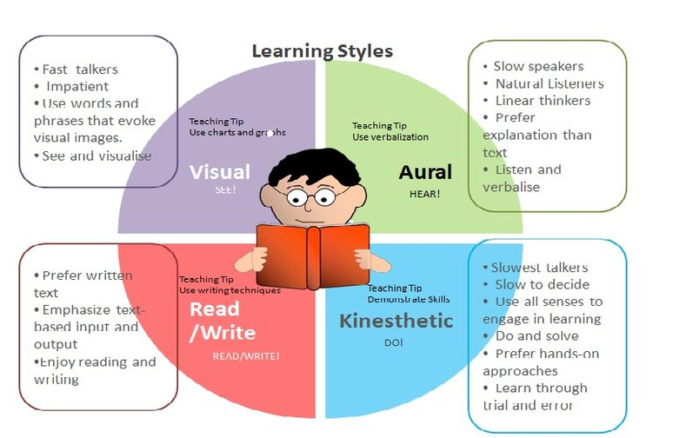
Figure 1: VARK model
(Source: cyberphysics.co.uk, 2019)

Honey and Mumford learning style
Activist, Reflector, Theorist and Pragmatist is different types of learning styles developed by Honey and Mumford. Further Kolb’s work has been based on their (Henry & Mumford) work and Kolb has been used different words to describe that learning style cycles into four parts such as follows:
- Activist- During my study, I enjoy working with my colleagues in job and when any doubt click on my mind my co-workers are accommodates. As I am good at problem solving and a positive thinker, so I am always influenced by Activists and this theory.
Reflectors- Reflectors are able to stand back on me and observed me all-time through this I would get time to think and investigate before commenting about any material or other work. When my family condition was bad I get inspired from them and reviewed when has happened before (Based on Kolb, 2014).
- Theorists- For adapting concept and logical complexity in work theorists are always helped me to rationalize and synthesize. Theorists are good at asking thinking problematic question in a disciplined approach. They are not the same with other group members with people who have different learning styles.
- Pragmatists- For current need and topic, pragmatists are helpful in learning style with clear practical advantages given by expert feedback. It is beneficial for me when I am working at industry.

Kolb’s Learning Style
In addition to describing four circles of life events Kolb has been introduced several experimental theories in his cycle. Through which I have learnt many things during my job. Kolb’s learning style or theory has been worked with an internal cognitive process.
From the above learning styles it has been useful for my career and lifetime achievement goals. Furthermore, Kolbe’s have been introduced a learning cycle benefitting from above learning styles. To learn effectively from these learning styles I have to move around this cycle for my future goals by maintaining and repeating this steps such as Experiencing from past organization, reviewing my mistakes and correct them and then finally conclude with a favourable planning as project outcomes ( As per perspective of Kolb, 2014).
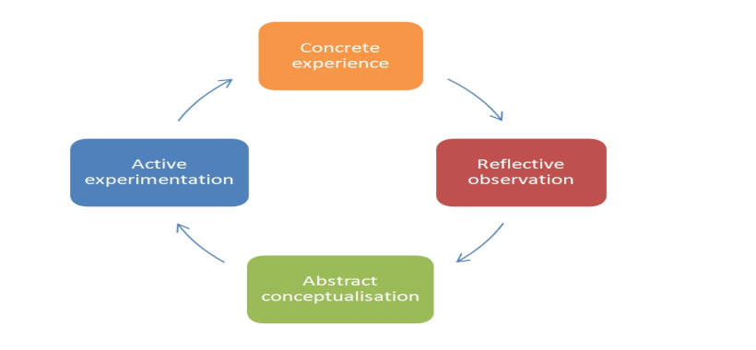
Figure 2: Kolb's model
(Source: cyberphysics.co.uk, 2019)

Personal Swot Analysis
Personal Swot analysis has been defined as Strength, Weakness, Opportunity and Threat (SWOT) analysis of a person and identifying it. SWOT analysis is a common tool that has been used in professional world to evaluate past, present and future position of any organization and for an individual in pursuit of their career goals in the future. T. In this job it has been noticed that, personal swot analysis making most of my talents and opportunities bring for a company. SWOT analysis with a tabular form have described below.
Strengths
- Positive thinking is one of the main strengths that have helped to complete any task without effectively.
- Reliable characteristic as well as honesty of a person is helpful for getting trust from management.
- Another important characteristic of a person is hard working
- Communication has important significance for any person
- Other strength is to solve problem within a team. Apart from that a person should be patient

Weaknesses
- Time should be managed properly, it is a weakness
- Lack of skill in public speaking is one of the biggest weakness
- Another weakness is self criticism as this can reduce motivation of a person
Opportunities
- As the job possibilities of fitter is increasing, opportunity of this job role is also increasing (Messineo, Allegra and Seta, 2019).
- Opportunities are mainly taking advantages from a new job which might in state of economy
- Working experiences in different countries can help to be more flexible
- For a growing industry, if there any new technology developed then that will be beneficial for any person or employee.
Threats
- There are more people is getting interested in this job role and this is increasing competition
- Through this assessment it has been noticed that for achieving dream job have to do a course equal with this school and have to put a lot of effort on both fields
- Several family goals are the biggest distraction and external danger for the goals.
Analysis
Through SWOT analysis, several outcomes have been determined. As for popular methods is to turn negative outcomes into positive, in other words have to convert my weaknesses into straights or threats into opportunities with a creative mindset and by growing skills. So, these actions have to take to track my progress and for a better result. A person needs to develop themselves continuously for competing with other people. In this way, they can overcome their threats. Apart from that time should be managed properly by making proper plan.

Johari Window
Johari Window is basically a technique which has been used to help people to understand among themselves and outsiders. In this assessment, Johari window has been introduced for developing self awareness in table below (lifecoachingcentre.co.uk, 2015). 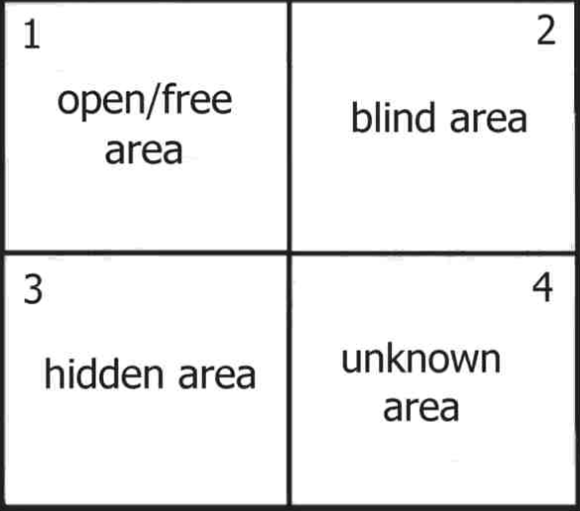

Figure 3: Johari window
(Source: Influenced by Illeris, 2018)
 | Known to self | Not known to self
Known to others | - This section describes the information about a person such as attitude, feelings (Messineo, Allegra and Seta, 2019).  - In public self actually what others see in me is actually me. Comfort zone for work has been referable. | - This section is for other people, they can describe about the person that the person do not know about themselves  - Means what others see in me I couldn't found that on me. Such as others look at my failure as success. It can be related when I am studied in agricultural economy.
Unknown to others | - Hidden area represents the section that is not known by other person yet the person know about themselves  - It is the information about me that I know which is, did not finish my agricultural economics degree in time but other people don’t know this. | - These are the talents that is not known by person and other person also do not know  - Some undiscovered things which others as well as me could not find myself when working as a fitter or carpet and window cleaners in the UK.
Table 1: Johari Window
(Source: life coaching centre.co.uk, 2015)
Thus Johari Window is a self-reflection tool for me and also guiding tools to develop my career, to set short and long term goals during study.

Deployment and practical application

- Subject in my high school was TV technology and radio. After that in Bulgaria, agricultural economy was my subject.
- Though it was good domain for me, it was not possible for me to get a degree in agriculture economics and this unfinished degree in my life has become a low point. Though this degree was not completed by me, there is a plan for completing this degree in the future.
- Currently my job role is meal fitter in an organization and this is my dream for grow my career in this organization. Previously, my job was bartending in a bar. 5 years work in the bar was helpful for me and there were lots of things that were learned by me in the bar. All of the learning in the bar helped me in real life. Those learning have been discussed below (Boud et al. 2013).
Subject related concept that was helpful handling real life situation for bar trending job
As bartending is a customer service job, this helped me to handle customer and helped to know about people and their behaviour. Different customer has different behaviours such as someone is rude, some is impatient. As a bartender is was my duty to handle the entire customer with care so that they do not feel bad. Job in the bar makes me more patients. This skill has helped me in future to deal with people. This even help I in real life and my patient’s skill has improved.
In today's world, multitasking has positive significance and bartending has helped be to increase my multitasking skills. In the bar, different type types are there and most importantly all the tasks required to finish within the time. People in the bar are impatient; they can’t wait for 2 minutes after ordering. I have learned to handle multiple customers at the same time. Even quick math skill of me has increased as it is important to calculate bill within no time.
There are lots of ethics in the bar so working in the bar, job ethics within has grown. This is not only applicable; it has a positive impact on my real life, as I become more responsible person. In the bar lots of people come and this helped to increase my network.
Flexibility is the best thing that has been learned by me in the bar. There were tight schedule in the bar and it has helped me to adopt that schedule. Even it is possible for me to take a nap in a crowded place (Boud et al. 2013).
Deployment method in meal fitter company
Communication is one of the most important skills that have been learned by me in meal fitting organization. It is important to work on coordination in this situation that has helped to increase communication skills. This company works for balcony fitting, ramps, handrails, balustrades. In this situation, lack of communication can lead to serious accident.
Apart from communication, technique is the key in this industry. It is recommended that, technique must be adopted by the employees for completing the job perfectly without meeting any accident.
Hard work is the ultimate solution for any real life problem. This job has a significant impact on my life. In fitting and meal fitting industry job is not easy. Every employee in the industry needs to give their 100 per cent to complete their job. It is also recommended in this industry to manage time. Time management skills have improved and real life time management also improved. Employees in this organization try to work as much as they can today so that work pressure for tomorrow can be reduced. As this is a team work, lack of performance of single employees can affect the whole project.
Chance of accident is high in this type of industry and for that more security steps should be taken. Employees including me become more serious about security in real life too. This job demands to work on railway track that is the most dangerous site for any work. We need to be conscious while working in the railway track. We need to work perfectly without any error and at the same time we need to be careful about rail. In this situation, personal track safety (PTS) training helped me a lot. Outdoor work in uncomfortable situation has helped me to work outside of my comfort zone. This has increased my willpower to overcome my weakness. I was afraid of height. This job inspired me to overcome this fear. For that purpose, I challenged myself and performed skydiving form 3500m height. My fear about height has completely gone after this incident.
My perspective towards life has changed after working this industry. As accident is very common in this industry, those accidents in the workplace have helped me learn about the importance of life. We, all the employees in this industry live our life every moment.

Personal Development Plan
Because of my study and during work I have set many goals for changing the path of my life. As an example of Short term goal in a next 3-4 months is to finish successfully my current course (Skills for the workplace) and book myself for another course related to construction management.
For a Middle term goal goals in the next 2 years, is to get a Bachelor degree of my current study and attach few more courses to support my career in construction management.
In a Long term goal (3-5 years) I want see myself in a strong managerial position of a construction industry and I am motivated to change my status from single to happily married with kids in my own house in UK (Based on perspectives of Illeris, 2018).
Communication of me has been improved and the importance of communication has been realized by me. It has helped to make an efficient and effective team. In an organization, a team plays most important factors. Communication between different members in the team can increase team bonding. Working in a team, I have improved my problem solving skills. My strategy is to find out more than one solution for an issue and among those solutions to find the best one. This strategy is used by me in real life to solve my practical problem (spooch.dk, 2003).


Figure 4: Communication skill
(Source: Illeris, 2018).

My weakness was time management and I worked hard to overcome this problem. It is learned by me that it is important to subdivide the main task. It is also true that, start the day early can be helpful for managing time.
Public speaking is one of the greatest fears of most of the people including me. Getting feedback and analyse it is a great way to improve public speaking. Apart from public skills, this technique has also helped me to accept criticism. Practice is the one and only solution for improving public speaking. Speech from speaker has helped to improve my public speaking skills. Now it is not a problem for me to speak in front of public (spooch.dk, 2003).
Personal Development Plan (PDP) has been identified by Second edition of The Study Skills Handbook written by © Stella Cottrell 1999, 2003. With the help of this I have made many good friends in college and also get a good degree from University. Through this book I have learnt that,
- Developing skills to finding a good job for me.
- I have learnt to work better with my colleagues.
- I know more about myself and develop my personality.
- I have learnt to how to maintain a balance among work, friendship and family.
- According to my perspective, thinking and reasoning will be better analysis for finding a solution.
- I have developed my creativity into my works.

In workplace I have always find out for interest things through which I could enjoy my livelihood (spooch.dk, 2003).Positive thinking helped me to become a better person. All the generation suffer heart broken problem and heartbroken was also my problem when we broke out 14 years long relationship. In this situation positive thinking works best for me. Though it feels like the end of life after a breakup, positive thinking helped me to realize that there are more in this World that just one person. In that phase I learned the importance of positive thinking.
Reliability skills are important and this skill has been adopted by me in this company. Now people trust me more and my level of self satisfaction has been increased dramatically.
Hard work can be the most important factor in my future. Hard work is directly related to personal development. Personality development is possible with hard work. As my dream is to get married and have kids, my hard work must have impression on my kids. Kids notice everything and try to intimate those things. It will be good for my kids to develop their character for every early age. Most of the important life lesson has been learned by me form this organization. This skill includes responsibility, problem solving, self control. This skill is important for my real life hobbies; healthy relationship has a positive impact on these. In this situation, honesty is also important (Based on the ideas of Messineo et al. 2019).

Conclusion and Recommendation
It is concluded that personal portfolio is important for professional development. In the portfolio, resume, academic certificates, weakness, strength is included. In this project personal background, life line has been explained. Learning style along with the self motivation technique has been explained in this project. Several learning styles are there such as auditory, visual, kinaesthetic learning that has been discussed in this project. This personal portfolio has been made with the help of several models such as SWOT model, Kolb’s model of learning. Deployment method along with the personal development process has been described in the project. According to myself, this portfolio presentation would be suggested for better future assessment and it could be similarities in some cases for other people’s perspective. As I know that, Johari window and Personal Development plan is fixed for all and minor changes as per their daily livelihood. Thus I recommended this portfolio analysis for future assessment.

Reference list
Books
Boud, D., Keogh, R., & Walker, D. (2013). Reflection: Turning experience into learning. Routledge.
Illeris, K. (Ed.). (2018). Contemporary theories of learning: learning theorists... in their own words. Routledge.
Kolb, D. A. (2014). Experiential learning: Experience as the source of learning and development. FT press.
Messineo, L., Allegra, M. And Seta, L., 2019. Self-reported motivation for choosing nursing studies: a self-determination theory perspective. BMC Medical Education,
Websites:
lifecoachingcentre.co.uk, (2015) Johari Window – Developing Self Awareness Viewed on 5 August 2019 <http://lifecoachingcentre.co.uk/johari-window-developing-self-awareness/>
cyberphysics.co.uk, (2019) Honey and Mumford's variation on the Kolb system Viewed on 5 August 2019 <https://www.cyberphysics.co.uk/MBTI/Honey&Mumford1.htm>
spooch.dk, (2003) The Study Skills Handbook Second Edition Stella Cottrell viewed on 22 August 2019<http://www.spooch.dk/Lib1/Soft%20Skills%20ebooks/Study%20Skills%20Handbook.pdf>

