MA (Education)
Module: Leading Effective Learning and Teaching (Pedagogy)
Module Code: M7X01462

SECTION ONE
A consideration of the opportunities and challenges for the development of a pedagogy to deliver a curriculum for Wales (Successful Futures) including:
- A review of relevant research and literature which has:
- informed your professional practice including an introduction to your current role, and
- opportunities and challenges that should be considered by practitioners/ schools/ educational settings when developing a pedagogical approach to the Curriculum for Wales (Successful Futures).

Wales wisely recognised the importance of the crucial need for an educational reform in 2014 by initiating a fundamental review of curriculum and assessment arrangements in Wales, the review, carried out by Professor Graham Donaldson, resulted in the product of the document, ‘Successful Futures’ (2015).
Paramount to the future of developing young learners in Wales within an educational paradigm is the centrality of a curriculum that is underpinned by four overarching ‘core purposes’, proposed by Professor Graham Donaldson within Successful Futures. Wales’ future reformed curriculum will enable all children and young people to develop as:
‘Ambitious, Capable learners, ready to learn throughout their lives’
‘Enterprising, creative contributors, ready to play a full part in life and work’
‘Ethical, informed citizens ready to be citizens of Wales and the world’
‘Healthy, confident individuals, ready to lead fulfilling lives as valued members of society’
(Donaldson, 2015, p.31)
In recent years, curriculum reform and design nationally have incorporated a focus on developing overarching learner capacities or competencies. Scotland and New Zealand are two examples of countries that have central capacities or competencies at the heart of their curriculum, and now Wales is following suit. From my own point of view, the four core purposes that are focal to Wales’ reformed curriculum will undoubtedly impact on the pedagogical approach that practitioners and schools explore. A challenge in itself, is the importance of gaining a deep layer of understanding, at all levels, of the four core purposes to assist with the realisation of a new curriculum. If this understanding is lacking it is likely that schools will be unable to fully transpire true curriculum intentions.
The document, Successful Futures (2015) proposes sixty-eight recommendations for the future landscape of education in Wales, all of which were accepted in full by Welsh Government. Out of the sixty-eight recommendations, three focus on educational pedagogy as a result of Professor Graham Donaldson outlining twelve pedagogical principles in an entire chapter that illustrates the importance of the interdependency between the overarching purposes of the curriculum and pedagogy. As a classroom practitioner it is satisfying that curriculum proposals have acknowledged that pedagogy should be, and requires to be, a focus. Professor Graham Donaldson states, ‘…the curriculum will depend ultimately on what happens in classrooms’ and ‘Taking full account of the implications for pedagogy, therefore, will be vital if the recommendations of this review are to have the intended positive impact on learning and achievement’ (Donaldson, 2015, p.63).
Professor Graham Donaldson (2015) states his first pedagogical principle as the development of learners within four core purposes, with this and attention on an education that meets the needs for the 21st, and what will later become the 22nd Century world, as two factors to maintain in our foresight being pivotal as we move forward. Educational practitioners, again, at all levels should embrace the opportunities that we currently face to finally transform education in Wales, in my opinion, we are bridging the gap between the way in which we face and adjust its infrastructure, content and approach. Radically improving the future prospects of all young learners.
Exploiting the need to consider approaches to pedagogy is an essential response to Professor Graham Donaldson’s recommendations. For professionals, keeping abreast with pedagogical approaches and developments is not necessarily a challenge in my opinion as, ‘the science of teaching’, as some refer to as pedagogy, is a consistent feature in the media and there is a plethora of educational documents and academic texts for teachers to consult. Personally, I now believe that ‘educators’ produce much guidance and literature to support the work of schools, yet the way in which schools and educators have been absorbed with the ‘how’ teaching ‘happens’ and ‘how’ we evolve teaching has failed, in my eyes, to notice the ‘for what?’ aspect. I mean, considering why are we truly in search for a ‘suited’ pedagogical approach or curriculum design, this to me is the challenge, to ensure that all professionals explore the purpose of what a transformed education is actually for. The work of Hannon (2017) has been an instrumental on this matter. Hannon (2017) believes that education should be, and has to be, about enabling young people to ‘thrive’ in a rapidly transforming world. Hannon (2017) discusses in depth the need for educators, including political leaders, to be confronted due to barely even beginning to even acknowledge the way in which education is required to connect young people with the realities and experiences of today’s world, including how education should accost with conviction what is on the horizon, that we know of, in our world. Titling the book, ‘Thrive’ intensified the message that Hannon (2017) is intent on relaying, it is based upon one main theory; there are four main interdependent levels that enable an individual to thrive. These four interdependent levels are: global, societal, interpersonal and intrapersonal.
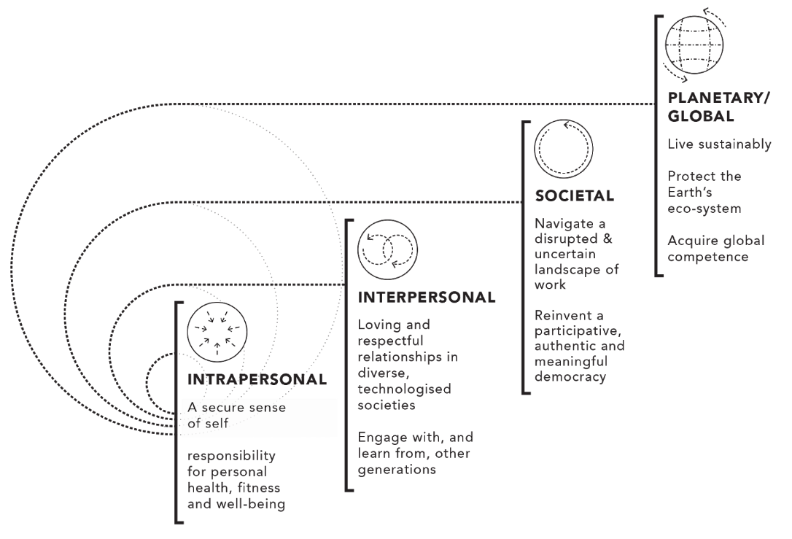

Figure 1: Four Interdependent Levels to Thrive as proposed by Hannon (2017)

Hannon (2017) presents four interdependent levels that illustrate how one can ‘thrive’ in tomorrow’s world. These four levels combine the ability to respond to globalisation, environmental, technological and relational pedagogy. This model sets the precedence for pitching a new case of purposes for education to adhere to. ‘Being college and career ready is nowhere near good enough’ (Hannon, 2017, p.12). Hannon is an expert advisor to the OECD (Organisation for Economic Cooperation and Development) and an influential contributor to the World Summit on Innovation in Education (WISE), this year I was privileged to listen to Hannon at an event as a keynote speaker. It was Hannon that challenged my thinking and ignited a new viewpoint about the true and wider meaning of Wales’ curriculum reform. Having listened intently to Hannon’s perspective and urgency to pave the future way for young learners provided me with a further dimension to the education system that Wales must surely create, including how all schools in Wales should engage with these ideals to influence pedagogical practice.
In May 2018 Estyn published a document ‘Curriculum Innovation in Primary Schools’, it identifies examples of good practice that already exist in Wales during the interim period of curriculum reform. I was drawn to the way that Estyn stated, ‘Schools provide opportunities for teachers to improve their skills through effective pedagogy’ (Estyn, 2018, p.7). The document continued to highlight that schools, where practice and culture is good, are even more so aware of the value that educational research can have. I am a practitioner in Wales in a primary school, School A, that has a developing proactive culture with regards to professional learning to ensure that curriculum reform developments are recognised, welcomed and positively engaged with therefore I consider it refreshing that Estyn recognise this practice as almost ‘essential’. However, Priestly (2015) points out that there is a challenge that some teachers can face and that engagement with research and teacher autonomy may not always be realistic in one of his blog entries. Priestly (2015) explains that teachers are a product of their working environment and if true curriculum engagement is to be enabled then school leadership systems must be on board and lay the pathway for it to translate into practice. Stenhouse (1975) echoes this, in fact some time ago, that all leaders should see to it that teachers gain opportunities to participate and lead initiatives innovatively that impact on a school’s pedagogical practices. Having previously spent three years of my career working for a consortium and visiting a large number of schools, I very much understand the variance that can exist between schools, including how leadership styles and beliefs vary. To illustrate this, recently I visited school B, located in Southwest Wales, and School C, located in South Wales and there was a significant difference between each school’s approach to professional learning. School B had various PLC’s (Professional Learning Community) that were engaged in pedagogical research, the headteacher had allocated school budget funds to facilitate an outside agency training specific members of staff to be ‘Impact Coaches’ that would support and mentor each PLC. Comparatively, in School C professional learning and teacher autonomy was lacking. Having spoken to members of staff in School B and C, it was an obvious that the teachers in School B certainly felt a sense of empowerment. This illustration of practice in School B and C leads me to highlight the importance of engagement with professional learning to ensure pedagogy and practice are empowering. I hold the same ideals as Powley (2018), who has redefined pedagogy as ‘Powerful Pedagogy’, meaning that pedagogy should not be viewed as a mere tick list of strategies to be used by practitioners and schools. The addition of the word ‘Powerful’ has been included to present a clear view that Powley (2018) has; practitioners should be increasingly more so knowledgeable regarding pedagogy to ensure they are empowered to operate with a thorough understanding, resulting in the ability to make effective choices regarding their practice. This approach is favoured rather than applying techniques with mere perfunctory and with only a superficial grasp of them. In my opinion all schools should engage with pedagogical approaches that meet the needs of each school setting. This to me is essential, rather than applying a ‘set of’ pedagogical approaches.
I hold a Senior Leadership position for the role of ‘Curriculum Development and Transformation’ in School A, I joined the school in September 2017. In addition, I pride myself in being a full-time classroom practitioner. School A is a one form entry Primary School in a deprived area of Wales, the area and community that the school serves has been previously ranked consistently as one of the most deprived areas in the Welsh Index of Multiple Deprivation. Furthermore, unemployment levels within this area continue to remain significantly high. In October 2017 School A faced a full Estyn Inspection, the outcome being one that placed the school in a category of ‘Estyn Review’; there were significant areas for development. This has had an impact that has resulted in ‘rapid’ progress being made over the course of a year to ensure standards have risen in many aspects of the school’s system. I believe that School A over the course of a year has faced scrutiny from more accountability systems and measures that a school not placed in Estyn Review would have to face and it is very much a self-improving school.
Passionately, I embrace the opportunities to lead and develop School A through curriculum reform to make certain that all pupils receive an enriching curriculum that ensures breadth, balance, continuity and progression for every pupil through engagement with Successful Futures and its intent of pedagogical approaches – the pedagogy that ensures pupils in School A ‘thrive’.
The deprived area that my own setting serves is a factor that has influenced my opinion and illustrated the importance of pedagogical principles being complimentary to the context of an educational setting and life circumstances of its young pupils. I regard Wales’ curriculum reform an enabler of this ideal to come into fruition for all schools in Wales. Furthermore, I share this perspective with Watson (2018) who also believes that when an educational system is geared towards being hierarchical and performance based it limits the freedom and connectivity for teachers to react to the social challenges and educational needs they encounter within their community.
‘They must be able to build relationships within the community to be able to identify educational needs and then be able to respond, drawing on high levels of professional skill, knowledge, autonomy and collaboration, by implementing appropriate curricula and classroom approaches.’ (Watson, 2018, p.24)
Furthermore, Watson (2018) defines the concepts of ‘Social’ and ‘Cultural’ capital throughout the chapter, thus encouraging a curriculum offer and its pedagogical approach to build all pupils’ social and cultural capital. To explain simply, a curriculum offer that builds ‘social capital’ is one that offers pupils access to others who broaden their possibilities and choices. ‘Cultural’ capital is the ability to build knowledge, including a critical outlook of culture to enable pupils to interact with others and think broadly. Reflecting, the curriculum offer in my setting, School A, should incorporate the ability to build pupils’ social and cultural capital. The school community exists in a place where learners do not have a range of broad and balanced experiences, rarely leaving the geographic area in itself, therefore, it feels an obvious incorporation of approach for School A and is also in line with the beliefs of Alexander (2008) who acknowledges that a school’s community will influence its pedagogy. This also satisfies the sixth pedagogical principle that Donaldson (2015) proposes, that ‘good teaching and learning creates authentic contexts for learning’ (Donaldson, 2015, pg67). Waters (2013) reinforces this, he implies that in the last twenty years there has been an increase in pressure for schools to enforce systems through the implementation of more and more accountability measures in an effort to ensure schooling works to provide equality and mobility. However, Waters (2013) is explicit and certain pointing out that the problem itself is an unjustified ideal that we expect schools to approach a wide range of diverse pupils the same. This cannot be so. One can postulate that a pedagogy and approach in a school setting should, at the very least, be targeted towards a responsive formula with a high emphasis on relational pedagogy. I favour the opinion of Waters (2013) in his statement, ‘If the balance has tipped towards outcomes, accountability and the market, then our hopes for our young people become distorted.’ (Waters, 2013, p.33).
With a firm and cemented agreement from many parties across Wales that the country has a very prosperous future with a reformed curriculum that is enabling ‘21st and 22nd Century ready’ learning I will continue to examine in more detail the specific pedagogical principles that Professor Graham Donaldson (2015) proposes that I feel require development and exploration in my own setting, School A.
Donaldson (2015) presents the tenth pedagogical principle as ‘Good teaching and learning encourages children and young people to take increasing responsibility for their own learning’ (Donaldson, 2015, p69). Within the Estyn report that my own setting, School A, received following a full inspection it stated,
‘However, across the school, many pupils lack independence in learning and are too reliant on adults for support when carrying out tasks and activities. They do not have a sufficient vocabulary to help them to discuss their learning and the progress they make.’
(Estyn, 2017, p.5)
The tenth pedagogical principle is in line with the impression that Estyn fed back to my school within the Estyn report. However, personally, I think pedagogical principle two that Donaldson (2015) proposes is linked, if not interdependent, to this tenth principle. Pedagogical principle two:
‘Good teaching and learning challenges all learners by encouraging them to recognise the importance of sustained effort in meeting expectations that are high but achievable for them’ (Donaldson, 2015, p.64)
Metacognition and mindset are elements that Professor Graham Donaldson pays attention to within chapter five of Successful Futures when discussing pedagogical principles two and ten. Metacognition refers to an individual understanding how learning happens, including how to manage, monitor and direct their learning. Dweck (2012) signifies mindset as an essential resilience required to accomplish, including the change of outlook that one might have. There is a body of evidence based on theory and practice regarding how metacognition impacts positively on learning. In Australia the Project for the Enhancement of Effective Learning (PEEL) was founded in 1985 and evidenced that performance in schools increased as learners increasingly so discussed and noticed their own learning as Northfield (1992) has discussed. Similarly, Hattie (2016) presents the idea of metacognitive behaviours being developed within schools as the basis of ‘Visible Learning’ and presents many examples of schools that have implemented metacognitive strategies into the culture of their schools with success. In agreement, Claxton (2002) advocates that creating a learning climate is just as crucially important as learning knowledge in itself, by cultivating the right habits and attitudes it ensures that learners are able to face challenges and learn at a more rapid improved pace. Claxton (2002) presents ‘Four Rs’ of learning power; resilience, resourcefulness, reflectiveness and reciprocity. Furthermore, in April 2018 the publication of the document ‘Metacognition and Self-regulated Learning’ by the Education Endowment Foundation is in my opinion crucial for educators, the document outlines seven recommendations for schools. I think this published document is indicative of the prevalence that metacognition should have within schools today. When visiting School B, I was fortunate to witness a ‘Pupil Learning Review’ (PLR) taking place between a teacher and pupil, in which, the stage of the pupils learning was discussed in addition to the metacognitive strategies that the pupil felt they should develop to support their learning. This was a school that placed metacognition as one of the focal points in order to develop excellent learning dispositions that would in turn raise standards.
A challenge for developing growth mindset and metacognition is the risk that some schools will fail to recognise its importance and the need for training for all staff members, Hattie (2016) places the emphasis on the collective responsibility at a whole school level, meaning that the role of school leaders is critical to the success in implementation. The word implementation also highlights another area of weakness that schools may fall into; metacognition should not be an ‘add-on thing’ that schools do, I believe this is a high risk. Schools must foster an understanding that metacognition and mindset are strategies that should be ‘combined’ into already existing practice, I see it as strategies that in my own setting (School A) will enhance the learning experience for pupils. I favour the way that Waters (2013) discusses curriculum approaches and view his ideals as a sensible approach to metacognition and mindset:
‘That balance between the attitudes and attributes children need, the skills we want them to acquire and the knowledge and understanding we seek to develop needs to be kept in sync, so there is a sensible blend to the learning experience.’
(Waters, 2013, p.274)
‘Assessment for Learning’ (AfL) is the seventh pedagogical principle that Professor Graham Donaldson discusses, in fact, AfL is discussed in more than one chapter in Successful Futures (2015). Professor Graham Donaldson leads us to the impression that he recognises formative assessment methods to be more preferable than summative assessment. There is much research that supports the concept of AfL within a learning culture (Gadsby, 2012; Griffith, 2014; Hattie and Yates, 2014; William, 2018). The new Professional Standards for Teaching and Leadership, statutory from September 2018 across Wales, incorporate a focus on Assessment for Learning as part of effective pedagogy, thus in my eyes, executing attention to its importance. However, alternatively and with my agreement Gadsby (2012) and Fletcher-Wood (2018) both highlight what could become an increasingly common challenge. Gadsby (2012) warns of the ‘AfL buffet’, meaning that many teachers claim to be using many ‘strategies’ transparently, such as using traffic lighting systems and other strategies that can be listed, rather than AfL being used as an integral part of effective teaching and learning. The foundations and fundamental work that Black and William (1998) with regards to effective AfL are perhaps at risk of being ‘lost’, therefore it is imperative that schools explicitly explore the true pedagogy and power that AfL can have on the quality of learning. Within my setting, School A, there is a great variance in terms of how AfL is approached, what I have discussed is a true picture to my own setting; practitioners either have a firm grasp of using AfL to support and move learning forward, whereas on the other hand some practitioners ‘brush the surface’ with its use. It is essential that professional development and learning that is based on engagement with research and rich professional discussions take place to counteract the threat of AfL not permeating effective practice as it was intended to.
The eleventh pedagogical principle is ‘Good teaching and learning supports social and emotional development’ (Donaldson, 2015, p.69) and this is very relevant to the context of School A, again, the deprived area that the school serves brings with it a challenge and our evaluation and knowledge of our pupils and the area that they live in informs us that we need to work particularly hard to develop a good sense of wellbeing in all of our pupils. As I have previously discussed, our pupils lack resilience, motivation, effort and independence in their learning, this is related to low wellbeing. Teacher and pupil relationships is a crucial starting point. Hattie (2003) presents in the diagram below the impact that teacher and pupil relationships can have.
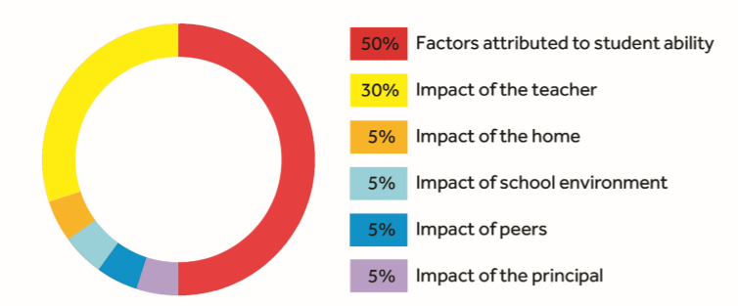

Figure 2: Factors impacting on the variation in learner achievement (Hattie, 2003)

Highlighting the 30% significance of teacher impact evidenced by Hattie (2013) from my perspective would contribute towards the 50% of student ability. Teacher and pupil relationships are paramount to establishing the conditions for learning, what a teacher does, why they do it and how a teacher performs are all factors underpinned by fostering excellent relationships with pupils that are intrinsically linked to pupil performance. A report produced by the OECD (2013) confirms this notion, that teachers are reactive to pupils’ emotional wellbeing. I resonate with the ideals of Sherrington (2017) who presents the ideal curriculum as a ‘Learning Rainforest’, as illustrated in figure three.

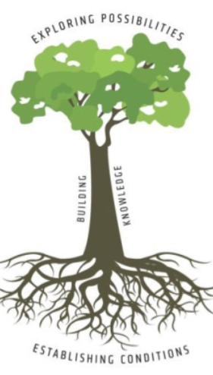

Figure 3: The ‘Learning Rainforest’ metaphor based on the ideals of Sherrington (2017)

The component parts of the tree that Sherrington (2017) uses as a metaphor to present the ideal curriculum approach are significant to practice that I think is a valid approach within my own setting, School A. The roots of the tree represent the conditions for learning, including wellbeing, culture, environment and learner dispositions (metacognition and mindset). The trunk of the tree refers to the building of discrete knowledge and skills to enable learners to flourish within the canopy of the tree to explore possibilities. ‘Each one supports the others; none exist without the others’ (Sherrington, 2015, p.11) and I am passionate that this ideal representation is what I believe School A should strive for and imagine that many of Professor Graham Donaldson’s pedagogical principles would be enabled within this model.
Essentially, all practitioners in School A are committed to pupils’ wellbeing, however, a challenge will be that with accountability measures, such as demands to achieve outcomes and levels, these should not steer or overload the curriculum balance and priority over pupil wellbeing. However, on the other hand the new curriculum does create more autonomy and less input regulations for schools, therefore schools are enabled to appropriately and sensibly make decisions based on what pupils require in each unique setting. This is reinforced, as Professor Graham Donaldson states, ‘Pedagogy that supports social and emotional aspects of learning is important across every aspect of the curriculum…’ (Donaldson, 2015, p.70).
To conclude, the pedagogical principles, that could be deemed as ambiguous, proposed by Professor Graham Donaldson should ignite many rich professional discussions across Wales, with the desired impact that schools will ‘sense-make’ these principles and develop future pedagogy and practice based on the needs of their own setting. However, I reiterate what Donaldson (2015) has said, a combination of approaches would be most effective.

SECTION TWO
STRATEGIC PLAN FOR CURRICULUM REFORM IMPLEMENTATION
SWOT (Strengths, Weaknesses, Opportunities and Threats) Analysis
School A Context
The school has previously existed on delivering a curriculum using a well-known published scheme. New management members, including a new Headteacher, ALNCO (Additional Learning Needs Co-ordinator) and myself were appointed within the last eighteen months into the school and have collectively identified the need to develop the curriculum to ensure that the curriculum is moving forward to ensure that our pupil curriculum offer is 21st and 22nd Century directed, including implementing some of the ideals proposed by Donaldson (2015) within Successful Futures. At the time of creating the SWOT analysis the ‘safety net’ of the previously used published scheme was used less radically for one term; teachers in School A had been encouraged to use the published scheme less rigidly by successfully incorporating pupil voice into their curriculum and beginning to plan within the six AOLEs (Areas of Learning and Experience).
The following SWOT analysis has been created with the prospect of transforming and developing the curriculum so that it meets ‘Successful Futures’ requirements.

Strengths | Weaknesses
- All staff have the interests and wellbeing of pupils at the heart of everything they do.  - Most staff are developing a keen interest in and are beginning to ask questions about curriculum reform.  - Two teaching staff members are joining School A for a new academic year.  - The ALNCo in the school is heavily involved in the Health and Wellbeing AOLE so will ensure curriculum development knowledge is shared – advantageous position.  - Competent, innovative and forward-thinking LAST (Leadership and Support Team) who embrace teacher autonomy. | - Lack of knowledge of wider staff in the school regarding curriculum developments.  - Pupils in the school have a low baseline entry and have limited experience of using pupil voice to steer the direction of the curriculum.  - Pupils in the school lack positive learner dispositions; a lot of groundwork will be necessary to embed this culture.
Opportunities | Threats
- Opportunities for professional learning and to be more collaborative as a staff team.  - To become familiar with and engage with the new statutory Professional Standards for Teachers and Leaders.  - To encourage staff members to engage with other schools within and outside of the cluster, particularly Pioneer schools.  - Ignite a new approach and enthusiasm in all staff. | - Accountability measures and external parties monitoring the school due to ‘Estyn Review’ category with regards to recommendations.  - Long term staff sickness tendencies as there have been in the last twelve months.  - Staff competency to be able to deliver a rich pedagogical curriculum offer.  - Too much change and lack of confidence may impact on staff wellbeing, particularly those members who lack confidence.

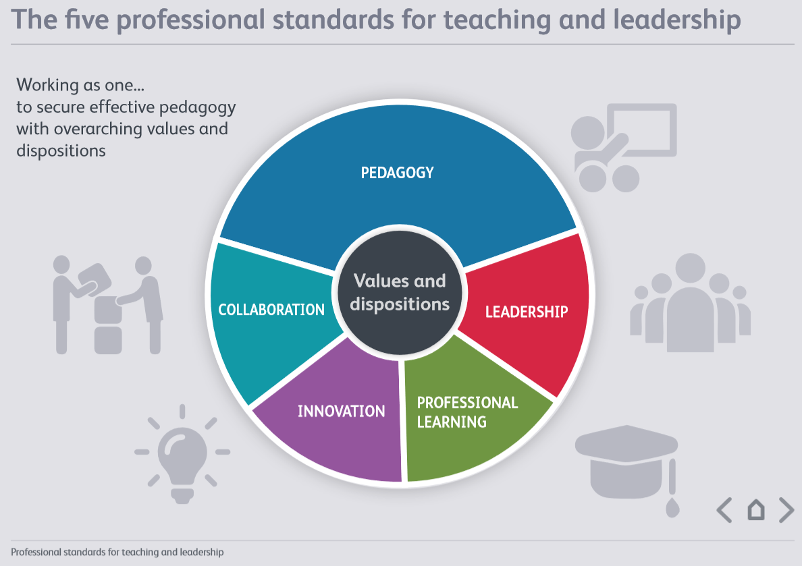
The following strategic plan is based on the needs-analysis of School A’s setting and pupil needs. I have linked each objective in the strategic plan to the new Statutory Professional Standards for Teaching and Leadership as I believe practice and pedagogy should be in-line with these standards. It is important to note that the new Professional Standards have been created to support and steer curriculum reform in Wales.

Figure 4: Professional Standards for Teaching and Leadership in Wales, the five areas within the standards are identified.
Source: (Government, n.d.)

Objective 1:
To ensure teachers plan an authentic curriculum with the inclusion of pupil voice that has the four core purposes at its heart. The curriculum will ensure learners’ experiences and life skills are enhanced.
Impact on pupils and learning outcomes… | Link to new statutory Professional Standards for Teaching and Leadership… | Link to curriculum Core Purposes… | Link to chapter five of Successful Futures (2015); Pedagogical Principles…
Pupils self-confidence will increase as a result of pupil voice inclusion.  Pupils social and cultural capital will be enhanced.  Learning will be enhanced as a result of pupil-led learning. | Pedagogy  - Refining Teaching  - Advancing Learning  - Influencing Learning  Innovation  - Evaluating the impact of changes in practice. | A rich curriculum offer will develop learners within all four core purposes.  Learners will develop as: -  - Ambitious, capable learners.  - Healthy, confident individuals.  - Ethically informed citizens.  - Enterprising, creative contributors. | 1, 2, 3, 4, 5, 6, 8, 9, 10, 11, 12.
Justification:
This new approach will require a mindset shift for both pupils and teachers. The following infographic guidance will be provided as a visual of support, almost acting as if it is an aide memoire for teachers to steer the direction for their approach to Medium Term Planning.
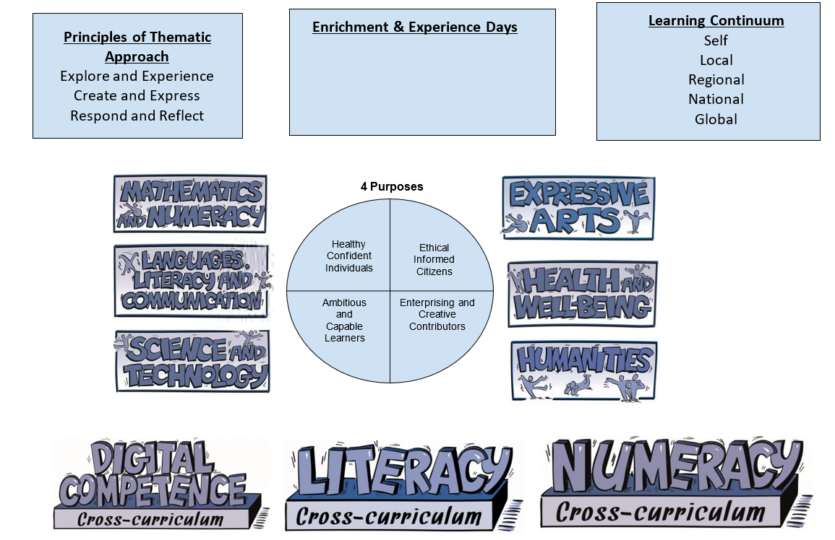

Figure 5: Visual guidance to support teachers with Medium Term Planning approach.

In School A we are trying to design a curriculum in a legislative state of flux between statutory 2008 skills and the futuristic vision of Success Futures. It is much easier for teachers to revert to a published curriculum scheme; however, this does not satisfy the need to encourage teacher autonomy or the inclusion of pupil voice.
The approach to the curriculum in School A will be through exploration of ‘themes’. As pedagogical principle one presented in Successful Futures (2015) states, all learning should be consistently targeted towards developing learners within the core purposes. This will stay true to School A’s approach; thematic studies will be central to the purposes. Through authentic planned learning experiences pupils will develop knowledge, skills and personal attributes within the six Areas of Learning and Experiences (AOLEs). In addition, the three cross curricular responsibilities will be provided attention to ensure that pupils apply these skills within the AOLEs. Pedagogical principles eight and nine support this.

The aim is that pupils will lead a ‘thematic’ curriculum, meaning ‘themes’ will be designed as the route for learning. The theme can be partly initiated by teachers with the pupils, or if competent to, pupils will create a theme. This is based on the opinions of Clarke (2014) who advocates that pupils should be involved in the planning process of their learning. Recognising that pupils in School A need to develop independence in their learning the inclusion of pupil voice seems an obvious and important inclusion as a way to develop pupil confidence.
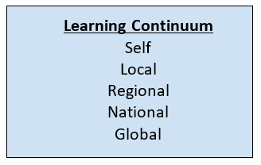

It was noted by Estyn following a full inspection of School A that, ‘Pupils’ knowledge and understanding of the wider world are underdeveloped. This means they do not make links between learning in different parts of the curriculum.’ (Estyn, 2017, p.5). This is something that as a school we have recognised as well as Estyn. The ‘Learning Continuum’ that is a component part of the infographic in figure five is initiated from the ideals of Hannon (2017) to ensure that all thematic studies as part of our curriculum offer links to the pupils themselves, working outwards from local to regional, national and then globally to ensure purposeful learning and how this links to cultural and global issues.
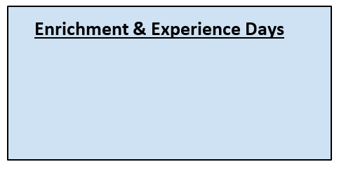

Whilst visiting School C I was informed of the way in which their school offers ‘immersion’ and ‘enrichment’ days linked to their topic, this affords pupils further opportunities to receive enhanced experiences that add another dimension to their learning journey. In light of this I aim to implement this inclusion in my own setting, School A. By building pupil social and cultural capital as examined by Watson (2018) I believe enrichment and experience days will be a positive focal point in which we can aim to enable this to happen. The work of Waters (2013) also echoes this sentiment,
‘Above all, the curriculum needs to meet the children’s experience in the way we match time to their need, so that they get a deep and immersive as well as regular frequent learning where they revisit concepts in authentic ways’ (Waters, 2013, p.275).
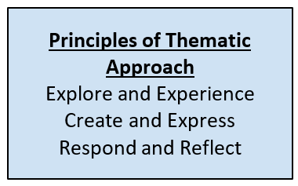
Finally, the incorporation of the principles of the thematic approach component has been designed from inspiration upon hearing these principles presented by a Pioneer representative from the Expressive Arts AOLE at a curriculum reform conference I attended. During the conference I heard how through Expressive Arts pupils should be provided with opportunities to: explore and experience; create and express; respond and reflect. As I listened to this route of approach it resonated with me that this could be true to our school thematic approach to learning and is a good basis for building knowledge.

As previously stated, the school has existed by delivering its curriculum using a published scheme, this new approach that will be implemented and introduced to staff as a result of a well-planned professional development experience.

Objective 2 (linked):
- To establish a metacognition PLC (Professional Learning Community) through collaborative engagement in research. The intention is to create a behaviour for learning policy and whole-school approach.
- To introduce Pupil Learning Reviews across the school that entail a focus on metacognitive learner dispositions.
Impact on pupils and learning outcomes… | Link to new statutory Professional Standards for Teaching and Leadership… | Link to curriculum Core Purposes… | Link to chapter five of Successful Futures (2015); Pedagogical Principles…
Pupils will be more resilient, resourceful, reflective and reciprocal.  Pupils will be able to recognise themselves as a learner and know the capacities of learning behaviours. | Pedagogy  - Advancing Learning  Collaboration  - Working with in-school colleagues  - Supporting and developing others  - Enabling improvement  Professional Learning  - Wider reading and research findings  - Professional networks and communities  - Continuing professional learning  Innovation  - Developing new techniques  - Evaluating the impact of changes in practice  Leadership  - Leading colleagues, projects and programmes | Learners will develop as: -  - Ambitious, capable learners.  - Healthy, confident individuals. | 1, 2, 4, 7, 10, 11
Justification:
Developing a mind to learn within our pupils is essential, however, this can only be achieved when all professionals understand the pedagogy behind required learning behaviours and the impact that it can have. There is a plethora of evidence to confirm the value in metacognitive strategies, including, Claxton (2002) and Hattie (2016). In addition, Fadel (2016) presents metacognition as an important factor as part of the ‘Four Dimensions of Learning’ within The Centre for Curriculum Redesign Foundational White Paper.
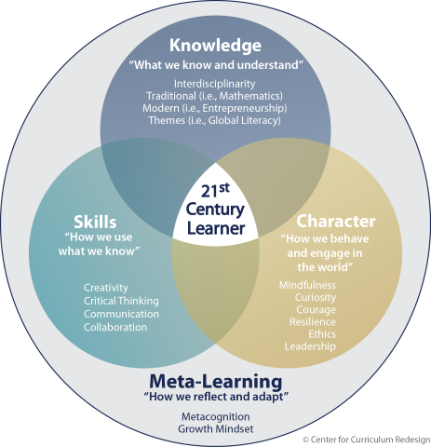

Figure 6: Fadel (2016) presents the ‘Four Dimensions of Learning’

The fourth dimension of ‘Meta-Learning’ is one that is described by Fadel (2016) as the overarching dimension that is related to the three others. The ‘Meta-Learning’ dimension includes qualities of metacognition as well as growth mindset, relating to how pupils’ dispositions to learning and their image as a learner.
Therefore, a Professional Learning Community (PLC) will be established consisting of myself (in the capacity of leadership), teaching professionals, teaching assistants and a link governor. The staff at School A do not have experience of working within a collaborative environment or any history with research engagement, therefore it will be necessary to ensure systems are in place to support this, a starting point will be to engage with the Critical Collaborative Professional Enquiry (CCPE) model (Drew, 2016). One of the key principles set out in Successful Futures is to provide a curriculum that is evidence based, this reform moves away from prescriptive orders and therefore critical enquiry is a necessary.
The CCPE model has three distinct phases. Phase one is ‘Focusing’, this involves deriving an area of interest to initiate and engage with academic research and reading to then create a conceptual framework to inform the enquiry and establish a plan to ‘interrupt’ and change current practice. This leads to the second phase of the CCPE model; ‘Interrupting’. The second phase incorporates enacting the devised plan designed in phase one and collecting evidence to evaluate the impact that the interruption has. Finally, the third phase, ‘Sense-making’ involves collaboration to critically analyse and interpret the evidence collected. At this point there is also potential to modify the conceptual framework devised in phase one as a result of findings, this then escalates to the point in readiness to share findings within a wider field. This is a model that I foresee as a basis for all enquiry based professional learning in School A.
Capitalising on the good practice witnessed during a visit to School B, and by initiating a positive learner disposition culture within School A, I propose the inclusion of termly PLR’s (Pupil Learning Review) taking place between pupils and teachers. In these reviews the teacher and pupil will review the stage of the pupil’s learning and next steps for development, although attention will also be focused on discussing the pupil’s disposition to learning and how the pupil requires support to develop metacognitively.

Objective 3:
To increase collaboration between teachers by establishing triads to evaluate the impact of the curriculum pupil offer; in addition, linking the process to monitoring progress in learning behaviours across the school.
Impact on pupils and learning outcomes… | Link to new statutory Professional Standards for Teaching and Leadership… | Link to curriculum Core Purposes… | Link to chapter five of Successful Futures (2015); Pedagogical Principles…
Pupils will continually receive an enhanced curriculum offer. | Pedagogy  - Refining Teaching  - Advancing Learning  - Influencing Learning  Collaboration  - Seeking advice and support  - Working with in-school colleagues  - Supporting and developing others  - Enabling Improvement  Professional Learning  - Continuing professional learning  Innovation  - Evaluating the impact of changes in practice | A rich curriculum offer will develop learners within all four core purposes.  Learners will develop as: -  - Ambitious, capable learners.  - Healthy, confident individuals.  - Ethically informed citizens.  - Enterprising, creative contributors. | 1, 2, 3, 4, 5, 6, 7, 8, 9, 10, 11, 12
Justification:
Successful Futures is designed to create a culture of ‘Teacher Agency’, however, the history of School A has meant that teaching staff have ‘grown up’ in a culture of high levels of prescription and accountability. Priestly (2015) believes that ‘Teacher Agency’ cannot be demanded and therefore professional learning is key to teachers in School A owning and understanding curriculum development. The Professional Standards for Teaching and Leadership are not statutory in Wales until September 2018, they were however released for exploration in September 2017. School A have been proactive and have engaged through exploration the Professional Standards for a year.
The forward focus for School A is to avoid prescriptive published schemes and create an authentic curriculum offer that is suited to the needs of our pupils. Objective one of this strategic plan explains this approach. It is my belief that for quality transformation of our curriculum and for sustainability then all practitioners need to be part of the process when evaluating impact. Therefore, I have designed and created the concept of a ‘Teacher Takeover’. I propose that staff form collaborative triad groups that will form the basis of this initiative. Once a new curriculum approach has been implemented for a term I recommend that teachers ‘take over’ another class and work with the pupils in that class to evaluate the quality of the curriculum offer. The School as a Learning Organisation model was one of the catalysts for this idea.

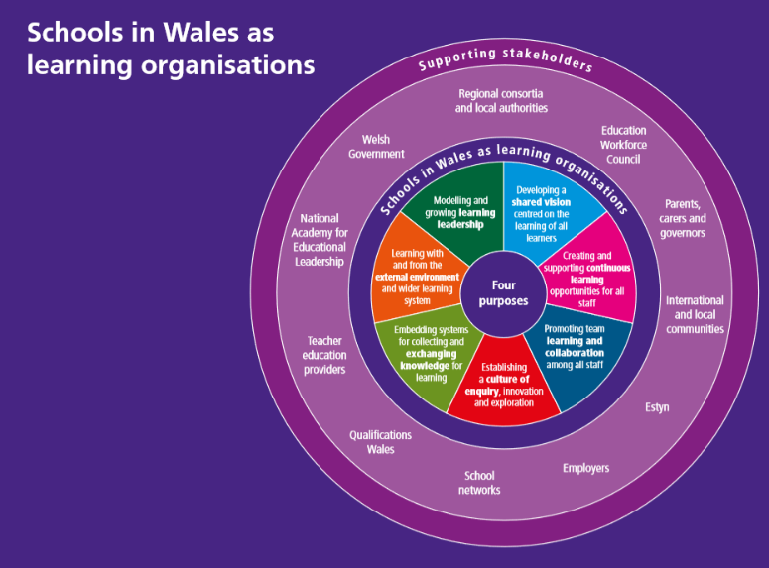

Figure 7: SLO, Schools as Learning Organisations in Wales, Welsh Government (2017)

Concentrating on the segments of the model ‘Embedding systems for collecting and exchanging knowledge for learning’ and ‘Promoting team learning and collaboration among staff’ (Welsh Government, 2017) is the main propelling factor in the Teacher Takeover initiative. The idea of evaluating another professional’s curriculum offer would mean the process is unbiased and judgements are made from an outsider’s point of view, enabling collaboration and support. The professional would be making judgements regarding the following: -
- The quality of learning experiences and opportunities for pupils to develop the central core purposes
- The quality of authentic learning experiences created and how much input pupils have had in designing them
- How well the breadth of opportunities has allowed pupils to develop an appropriate range of skills and knowledge
- How learning opportunities have allowed pupils to gain enriching experiences that are not confined to the classroom; including how these have developed pupils sense of wellbeing
- How well the curriculum offer has been responsive to pupil needs, socially and emotionally
- Pupil learner dispositions comparatively to their prior learning and bank of learning experiences
The Teacher Takeover would mean that teachers are making constructive judgments in another classroom that would then pave the way for collaboration to take place. This collaboration would involve teachers feeding back findings and supporting one another to continually enhance future curriculum offer, a result of collaboration and quality professional discussions. I have created the following infographic to support dialogue and direction of exploration for teachers to use during the process.
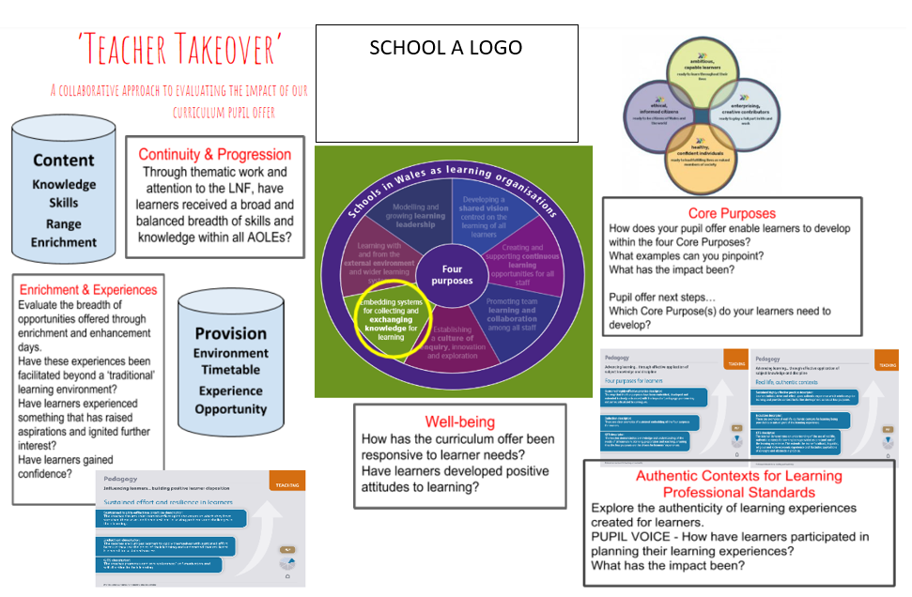
Figure 8: Infographic created to support collaboration in School A.

Pollard (2014) states that ‘With the right leadership and support, learning is particularly effective in the workplace and through participation in collaborative activities with other teachers’ (Pollard, 2014, p.109). The ‘Teacher Takeover’ summons this notion into realisation.

SECTION THREE
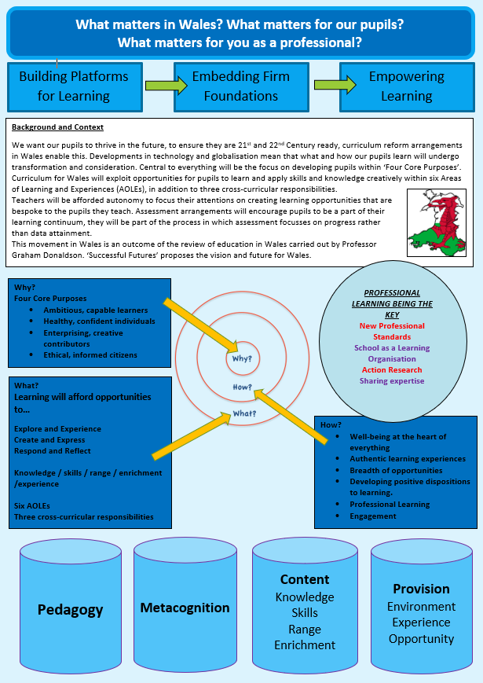
CONSTRUCTION OF AN ACADEMIC POSTER TO ENGAGE COLLEAGUES IN A DIALOGUE ABOUT CURRCIULUM FOR WALES

RATIONALE
I created my academic poster based on research, theory and ideas I gleaned during the process of academic reading and engagement with Successful Futures.
The title of the academic poster that I produced, ‘What matters in Wales? What matters for our pupils? What matters for you as a professional?’ was intended to raise questions in a reader’s mind. I used the phrase ‘what matters’ as this is a significant component part of the new curriculum; each Area of Learning and Experience (AOLE) is composed of ‘What Matters’ statements, these statements link intrinsically with the four core purposes of the curriculum and support the organisation of intended disciplinary knowledge, skills and experiences for each one. Combined together, the varied What Matters statements encompass the breadth of each AOLE. I purposefully repeatedly used the phrase ‘what matters’ as I thought it a clever choice to include vocabulary associated to Curriculum for Wales. Additionally, it is my belief that the new curriculum reform that we exist in really does ‘matter’, there will be a significant impact on all practitioners, pupils, families, communities and on the future itself across Wales.
There are three text boxes that work with the inclusion of arrows that lead from one text box to the other, these text boxes include the following statements: -
- Building Platforms for Learning
- Embedding Firm Foundations
- Empowering Learning
In School A my job role and the basis for which I am a well-respected member of the Leadership and Support Team (LAST) is to lead and transform curriculum development. I view this as, initially, a three-year progressive transformation. I have projected this due to the low baseline that School A is starting from. As previously discussed within my strategic plan, professional learning has been neglected and there has been a heavy over-reliance on prescription. Therefore, the baseline of curriculum transformation and development is one that is what I would deem as ‘a blank canvass’ to start from, a starting point that needs embracing. With this in mind I consider the first stage of engagement and transition as how we will build successful platforms for learning, much needed platforms, practitioners in School A will develop these platforms collectively with knowledge. Pollard (2014) also acknowledges that the development of values and understanding among teachers is more than important than the change that happens in itself. From my perspective this means that for long lasting, yet evolving transformation to take place, in terms of curriculum design, pedagogy and a newly formed approach to promoting professional learning would lead to the requirement of embedding this, hence the inclusion of the second statement ‘Embedding Firm Foundations’. Lastly, within the initial focussed time-frame, it is forecasted that School A would reach a point at which having transformed the curriculum offer and it exists in a pupil and staff learning culture leads to the third statement on the professional poster, ‘Empowering Learning’. This is an explanation for the three statements with use of arrows to present the design of transformation intended for School A.
The largest body of text on the academic poster is the text box titled ‘Background and Context’, I intended to provide even the most novice of professional with the most essential information, acting almost as if it were a summary of the most critical information regarding Curriculum for Wales, Successful Futures. The first word, a plural pronoun, ‘we’ was used to created a sense of togetherness; collective passion and collective responsibility. The first sentence continues to remind practitioners of the ‘why’, the responsibility that we have to prepare our pupils for a developing world, sentiments echoed by Hannon (2017), Sherrington (2017) and Waters (2013), to name just a few. It is my belief that practitioners should continually keep a future vision in mind when engaging with curriculum development. Key information regarding the core purposes, AOLEs and cross-curricular responsibilities are provided within the body of text. If practitioners are acutely aware of these mentioned elements the academic poster will act to reinforce this information, however, if practitioners are unaware the poster will either act to engage a reader further or possibly intimidate a reader as a result of their lack of knowledge. Furthermore, a lack of passion or resistance to change will deter the direction that practitioners are reactive to the poster. The text also stipulates the key knowledge that one should at least know as a basis, including that of assessment arrangements and the key individual, Professor Graham Donaldson, who has significantly begun to transform education in Wales.
A major shift is necessary in School A, professional learning needs to permeate everything, including how this will support further engagement with curriculum reform. The poster sets about doing this by highlighting this with some examples of how this can transpire; engagement with Professional Standards, ensuring School A develops as a learning organisation, action research and embedding a culture of discussing pedagogy and sharing expertise. Using this poster in School A will be welcomed and many professional discussions will be launched as a result. From another perspective, if the poster were to be used more widely and received in a setting that does not promote professional learning, this poster would have little impact.
The main section of the poster is the use of a ‘why? How? and what?’ model, the objective of using this model was to direct reader’s attention to the answers of these three questions, with a real focus on why, what and how we will achieve this collectively in School A. Basing ‘why’ on the same ideals of Donaldson (2015) that curriculum intentions should be geared around developing learners within the four core purposes, the ‘why’ is re-iterating this so that the curriculum provides a learning journey with the four purposes in our line of sight.
The ‘how’ firstly points out an enduring factor for School A, well-being, the need to acknowledge that the social and personal influences of our pupils need great attention. Robertson and Dale (2009) present the notion that perhaps schools need to look further than social challenges being a distraction, but rather using these challenges as ‘powerful sources’ for learning and a good starting point when designing the curriculum. This is a rationale for the inclusion of how as a school we need to focus on providing authentic and rich experiences, in addition to incorporating metacognitive strategies and dispositions within our learners. As stated in section two, the strategic plan.
The ‘what’ element of the poster functions to state the principles in approach to thematic learning in School A, with the inclusion of skills, knowledge, wider skill range, experience and enrichment being listed to provide a visual representation of how these components should be developed through the six AOLEs and three cross-curricular responsibilities. The aim is that rather than thinking about what ‘topic’ to teach, rather it should be based on the reflection of what knowledge, skills and attributes pupils require to be successful in their futures, as favoured by Priestly (2015).
Visual representations of four key pillars (cylinders) are included on the poster to summarise the unique approach that School A are exploring and developing at this current time within curriculum reform. The pillars aim to act as a summary and be an assisting force during rich professional discussions.
Potential barriers to the poster not being a success are again, the lack of existing knowledge that a practitioner may have, the lack of support for professional engagement within a school, resistance to change and lack of passion including a varying range of staff competencies. It is necessary that a collective vision and responsibility, at all levels, is taken to ensure that engagement and professional development are existing and ongoing factors in any educational establishment.

