
comprehensive business intelligenc system design and analysis


Word count:3,662

Business intelligence (BI) systems have become essential tools within the retail industry, where organisations must continuously analyse large volumes of operational and historical data to remain competitive. Retail environments generate data through point of sale (POS) systems, online transactions, and customer interactions. All of it will be captured, integrated, and transformed to help support effective decision making. As retailers increasingly rely on data strategies to optimize sales performance and enhance inventory control meaning that a well-structured BI system is crucial for this. The proposed BI design uses a combination of an enterprise data warehouse (EDW) and data marts to balance performance, scalability, and analytical functions such as online analytical processing (OLAP), ensuring that users across the organisation have access to clean, consistent, and reliable data. The system also incorporates extract, transform, load (ETL) processes, data mining tools, and data visualization platforms being Power BI to deliver actionable insights that align with the operational and strategic needs of retail organizations. Them allowing retailers to identify purchasing patterns, forecast demand, and monitoring key performance indicators (KIPs) and allowing them to respond to market changes. At the same time, the BI system must uphold standards for data security and quality management, as the accuracy and protection of retail data influence decision making, customer trust, and business performance, with measures like access control, intrusion detection systems (IDS), and master data management (MDM) play a role in maintaining data integrity and safeguarding sensitive information form misuses or breaches. However, only some of the ideas that were proposed could be conducted since the data that was given was only a limited amount.

This design of a Business intelligence (BI) system will be tailored to retail industry, and it will focus on the pervious and operational data to support sales optimization, inventory control, marketing analytics, and executive reporting. These factors being combined will create a warehouse with functional data marts to balance control and performance since data marts will be a quick and a way to speed up implementation according to (Inmon, W.H. 1997) however the source also implies that using data marts as a way to speed up implementation can meaning skipping the foundation for a data warehouse leading to serious long-term problems. So, what can be used is a mix of enterprise data warehouse and data marts. Enterprise data warehouse is good for the BI system because it can use past and current data from the business according to (Golombek, M. 2025) and the data marts will focus on sales and inventory. which these two should be able to support online analytical processing (OLAP), one benefit of enterprise data warehouses is because they store and share data which is need for BI systems, and by getting data from multiple sources will allow users to access integrated and cleansed data efficiently which can help decision making for future references (Chen, E.T. 2012). The benefit of a data mart is that they will be able to provide focused specific repositories of data that support type of functions of analysis which allows more efficient and decision making and that it allows relevant information quickly without having navigate the entire data warehouse according to (Atkinson, P. 1999). So, with these being mixed it can function as way to keep and sort data from sales and inventory and with knowledge of past and current data it can predict what the business might need in the future. For data sourcing for a retail industry one key point would be point of sale (POS), this would be items purchased, price, discounts, promotions, time and date of purchase, the stores’ location and payment methods according to (Budiarti, R.P.N. and Kamila, F.I.R. 2024), they can also get data from online purchases if they have an online store, they could also get key data related to products, suppliers and customers, through customer reviews and competitors to compare prices with them which could help them understand what demand they need or possible make any discounts and recognize a pattern (Aktas, E & Meng, Y 2017), and when the data is gathered it will be able to provide the insight it has gained for the data that has been collected. Once data is sorted there will be extract, transform, load (ETL) where it takes the raw data that is has been given, then cleans and reshapes to the business need then loads the data into a central repository to the data warehouse for analysis (Khan, B. et al. 2024), and when this process is finished it will allow easy access to the data that is need for business which is necessary for BI system since this will make it have trustworthy insights and without ETL it will make the BI tools inconsistent because of the raw data. With clean and integrated warehouse, retailer can use online analytical processing (OLAP) to support fast, flexible analysis, and allows users shift through large datasets to examine trends such as sales performance and inventory availability across store networks because of it is able to use the data for strategic decision making (Wang, J., Kourik, J.L. and Maher, P.E. 2011). One of the requirements for BI in retail is the ability to visualize large datasets, such as daily sales and online browsing behaviour and that Power BI is a strong and useful tool due to the user-friendly interfaces, and advanced visualization capabilities, and direct connectivity to warehouses (Tirupati et al. 2023). This platform enables the user to explore data interactively and be able to build dashboards to keep track of KPIs (key performance indicator) such as sale performance and inventory turnover and can also monitor key criteria in real time. For retail organizations with diverse teams like a regional manager and marketing analysts, Power BI empower nontechnical users to perform self service analytics without depending heavily on it, which could mean that because of how simple it is to use it doesn’t matter how much experience you need to use it and still get want you for it. Another need in retail is efficient handling of large volume transactional data, they can get this data from POS records and many other methods of gaining data and BI tools alone can’t process or model such volumes which is why data mining is essential for them and (Uddin et al. 2020) says that they are “one of the most essential tools for gathering information from different datasets”. One example of a data mining tool is RapidMiner since it is well suit for retail data mining tasks because it is a construction of predictive models such as decision tree, logical regression, and random forest to evaluate how product attributes like style, colour, material, and size impact sales performance, this enable retailer to gain actionable insights for inventory optimization and targeted marketing, this is would support decision making processes in retail management (Nai-chieh et al. 2025), but the reason I do not talk about power BI for data mining is because it if more analytical tool than mining and will be using to show the data. Data mining platforms are also capable of clustering, classification, and association rule mining help retailers uncover buying patterns and cross sales opportunities, which can help retailers understand customer behaviour in different ways theses techniques could reveal patterns in purchase data that retailers can use to increase sales. A primary strategy for data security in retail is enforcing comprehensive access control and that it plays a significant role in protecting data and physical assets by adding conventional security measures (Saeed et al. 2020), and one way they can keep this safe is by using intrusion detection systems (IDSs) this will act as an additional layer of defence by alerting security to potential unauthorised access, which can enable prompts to the threat. This function helps close security gaps that traditional access control will not be able to address make a point of the need for active monitoring and rection to detect intrusions to limit unauthorized access (Nhlanhla Boyfriend Wilton Mlitwa and Birch, D. 2011), meaning that only employees will only have the needs to access that data for their functions needed. A quality management that can help with retail and is a foundational strategy is the implementation of master data management and what it does is that it is focused on improving the value and quality of an organization’s most critical data assets, such as customer data by creating a shared trusted view of this data across the enterprise (Vilminko-Heikkinen, R. and Pekkola, S. 2017). This could mean that it will fix any inconsistencies that would grow through BI dashboards and reports by reducing the number of manual data entries (Foote, K.D. 2023).

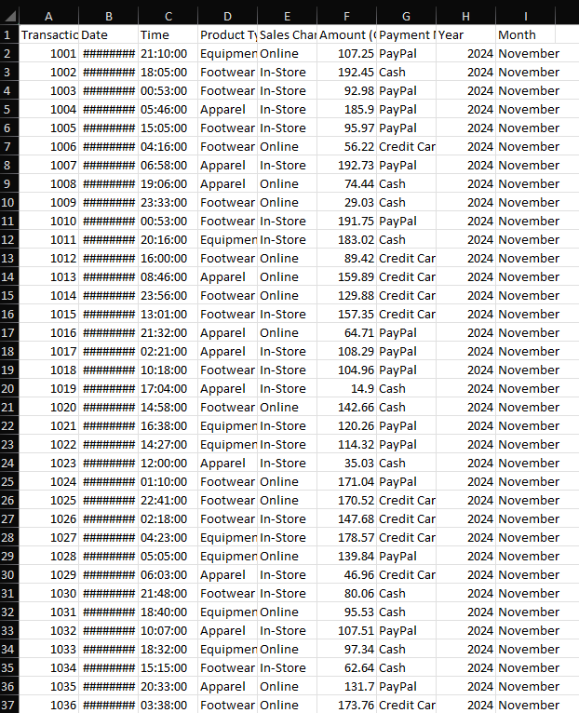
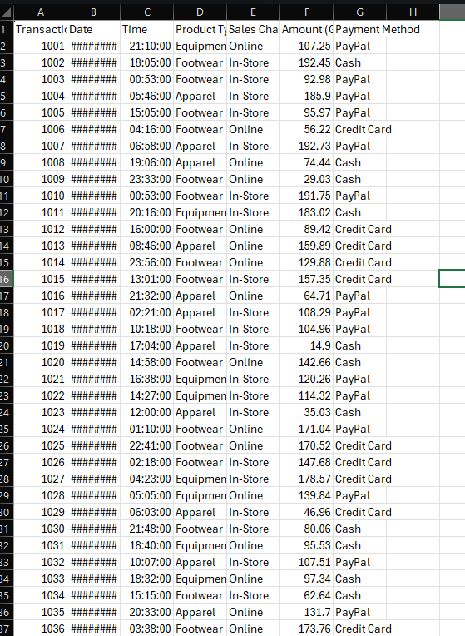
Since the university had already collected the data, it was unnecessary to demonstrate how the data processing was conducted. However, what can be discussed is how the data could of have been collected for the data warehouse and that excel will be the warehouse in this example, and that what will be used is power BI to show the data visually. The data could have been collected through one of the main strategies in retail which is POS what is mentioned above, and what is suggested is that this would be items purchased, price, discounts, promotions, time and date of purchase, the stores’ location and payment methods, however what the data shows is only items purchased, time and date of purchase, and the payment methods as well the amount paid. The data is now stored as raw data which can serve as the foundation for the BI system and now will be used as a source for transformation, analysis, and visualization.
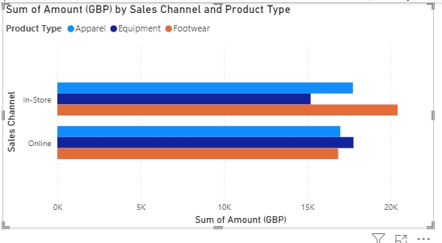
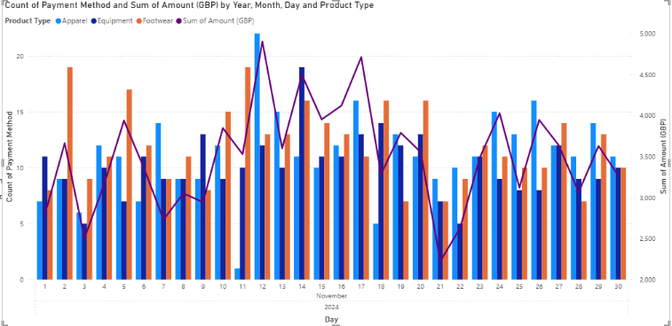
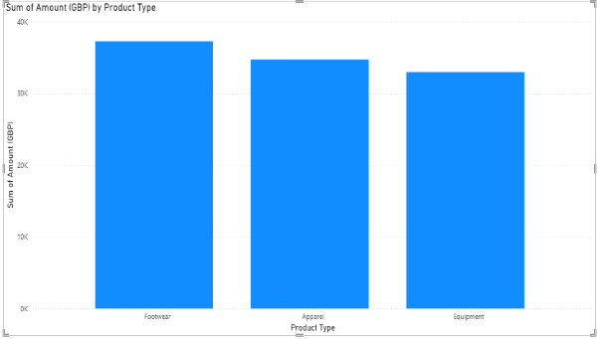
To show data warehousing processes the data has been integrated and transformed and this transformation ensures consistency, removes inaccuracies, and structures data for analytical consumption and in this excel sheet it has made a clearer by adding month and year and removing the exact dates because in most cases the day does not matter why purchases has happened, but will care more about the months mainly due to the months like December of July, since these month are seasonal months. These types of transformations simulate ETL process used in data warehouse this is important because it allows BI system to integrate and preparing data for analysis and decision making (Sreemathy, J. et al. 2021), also making the data more cleans so it can easily be analysed and when it is transformed making it more consistent while making it compatible with the existing data. Making it easier users to use since all they need to due now is to analyses it so they can make predictions for next year or month and make decisions on if they should keep items or change to different ones, also showing what KPIs they need to focus on and one of them could be trying to increase sales in for equipment since it made the least amount of money. Analytical processing is central to BI, enabling users to discover patterns, generate insights, and support strategic decisions making (Watson, H.J. and Wixom, B.H. 2007). This is where Power BI will be able to show the use of PivotTable and since the data is from excel it cannot preform complex association rule mining and so using PivotTable will be a simplified model to explore relationships between product types and sales amounts. By grouping sales by product type, it becomes possible to work out which categories are frequently purchased and which produce the most revenue. We can use clustering since the products are close in sales which can show us and identify the high-performance product, the mid-range, and low demand categories. With the data that is presented it can help stakeholders determine stock priorities, and promotional focus areas which can be used to forecast demand for the products by “associating their descriptive parameters with these clusters” according to (Kirsners, A et al. 2010). Prediction is demonstrated through trend-based insights rather than statistical forecasting, because by incorporating the continuity and consistency due to previous developments into decision-making processes and that trend based insights might provide a contextual layer that supports confidence in operational decision making which statistical forecasts may lack (Fehrenbacher, D.D., Ghio, A. and Weisner, M. 2023). Which could mean that it cannot give mangers a sense of real world reasons behind them when using statistical forecasts because they can feel abstract and disconnected for the day to day operations, which can apply to this data since it only shows the month of November and that will not be enough for a forecast. So, what we can do with the data is use it for trend-based insights since it can provide context making it more trust worthy, and understandable for manger since it shows patters like the rise of demand for holiday season or even declines in sales for certain product categories, which can help them make confident decision making. One of the key functions of a BI system is the clear communication of insights through visual reporting they do this because it facilitates faster, more dependable and fact based decision making in business environments, this helpful since it allows interpret complex data according to (Biagi, V., Patriarca, R. and Di Gravio, G. 2022), since the data that has been provide is not an years amount it makes it easier to interpret it since the data only shows product type making it easy to understand to see which one is performing the better than the others in that month, it can also give visual comparisons to see how much of a difference of which product performed better, which they then can prioritize it by possibly stocking more of the highest performing product or maybe try to improve the other products.
The proposed BI system for the retail industry can demonstrate potential strategic, operational and analytical value, it is able to do this by using enterprise data warehouse as the authoritative of historical and operational data, this let the BI system be able to ensure that consistency and reliability across analytical processes according to (Nambiar, A. and Mundra, D. 2022), this can support strategic insights like long term sales trends and customer purchasing behaviour which will helps mangers understand why because EDW use multiple sources like POS and online transactions to allow analytics that would normally be fragmented and that would give them capabilities to use pas and current data. However, one challenged that EDW face is that the complexity of extracting, transforming, and loading (ETL) data from multiple sources, which normally involves data cleansing and transformation to ensure consistency and usability which might affect response times and might possibly make data more complex than it initially started with (Alkhubouli, M.A. et al. 2024), which can make it hard for mangers to understand the analytic data and could possible change how it will look visually creating confusion on what they need make changes to products since the response time might be affected it will change on what insights they need. One other challenge faced by the BI system is the quality inconsistencies form the data since in POS, online stores and customer sources can lead to errors, missing values and duplicates, without strong master data management (MDM), theses inconsistencies might flow into the BI system and affect the accuracy of insights because if there isn’t enough data from different sources it will make it hard to create clear polices and responsibilities according to (Uboh, U.V. 2025), with a mix of data it will affect the insights making hard for them to make a decision since if they have the wrong information they could possible make a mistake that could loss the company profit or restock the wrong product. A possible limitation faced by the BI system is the limited data to create a predictive accuracy since there is no historical data to provide, this is because the data that was given only has one month of purchase which will limit the predictive accuracy and to get a good prediction is to have data that is at least 12 months old, the best
insight to get from this data is trend based because it might be able to aid short term decisions but will have limited predictive power again because of the limited amount of data that has been given and due to the lack of data it will affect the how meaning full insights will be, is what could be gathered from (Karami, A. and Igbokwe, C. 2025). One business developments that is faced by retail is consumer behaviour, new products, and competitive pressures, the system’s OLAP capabilities support this by allowing flexible sales patterns and inventory turn over and when strategies change like physical stores and online stores the EDW can add new categories of analysis in the future without having to break the existing structure this is because of schema evolution techniques, which allows data warehouses to adapt to changing user requirements and data sources without having to complete redesign from scratch according to (Subotic, D., Poscic, P. and Jovanovic, V. 2014) which can help with the current data that we have since if they are able to expand of it they will not have to change the data warehouse which can help them later on since with enough data they will be able to have forecasting and more accurate predictions giving them better insights. One other business development they can adapt to is trend based insights which has been highlighted above, they are able to do this because it can provide contextual understanding that mangers can rely on during uncertainty, since they will be able to see which product had the highest performance and allow them to continue to invest into that product till they see changes in performance, they can do this with google trends since they are not limited to one product and could build advertisement for having that which product that they have that could be trending since it has been used before in “high-frequency indicators of economic policy of uncertainty” according to (Pratap, B. and Priyaranjan, N. 2023), so it can also be used by manger or companies to see what is trending to help them make decisions. One of the ethical issues relates to data privacy. Since the BI system will collect sensitive information like purchase history, payment methods, and behavioural patterns, even if the goal is to optimise the business, the use of personal data can rise the risk of violating consumer rights if the organization does not follow privacy laws and ethical expectations, such as unauthorized access to personal information can negatively impact consumer trust according to (Chatterjee, et al .2021), this might happen because BI system might make a detailed behavioural profiles of customers and when someone gains access who is not authorized they can cause harm by seeing any personal information like credit card details or any personal information that could be sold to other companies to see what behaviours you have when shopping, one possible way of fixing this could be that the BI system should incorporate privacy by design principles to avoid legal breaches. Another critical issue of data minimisation is that in the proposed BI system it benefits from data collection from product preferences, transaction details and inventory patterns, however ethical governance requires that only the data that is necessary for the intended analytical purpose should be collected, since with only necessary amount of data it will help the concerns of privacy and security and that collecting that essential data can minimize the exposure to vulnerabilities according to (Amama, U.D. et al. 2024) and that over data collection can create unnecessary risks, which could mean that if organizations keep personal data in large volumes for a long period of time and increase the amount of harm if there is a potential data breach meaning that customers might need to change their information creating a lack of trust.
In conclusion the design of the proposed business Intelligence (BI) system demonstrates how retail organizations can leverage integrated data warehousing, analytical processing, and advanced data mining to strengthen decision making, operational efficiency, and long term, strategic planning. By using a mix of enterprise data warehouse (EDW) with subject- specific data marts, the system provides both the stability of a centralized historical repository and the speed needed for focused analysis in areas such as sales and inventory. The use of ETL processes ensures that raw data is transformed into clean, consistent, and trustworthy information, creating a foundation on reliable analytics and reporting are built. Tools such as Power BI and RapidMiner enhance theses capabilities by enabling interactive visualization, pattern discover, and user-friendly insights that support both technical and non-technical retail stakeholders. However, there are some challenges that are faced to make sure the systems effectiveness, one issue is data quality being that that inconsistencies originating from multiple operational sources which shows the importance of implementing a strong master management (MDM) practice. This is essential for maintain accuracy across dashboards, KPIs, and analytical outputs. Additionally, the complexity of ETL operations, when integrating multiple data sources, could lead to delays or increased data processing effort, which must be carefully managed to avoid limiting the value of analytics. Also limitations in predictive accuracy, particularly when historical data is insufficient since with the data that was given only showed a month worth of data and since there is only a month worth of it also limits long term data to support any forecasting models. In the analysis shows that the critical role of ethical and security consideration in BI system design since they need to manage sensitive customer and transactional data making strong access control systems and privacy principles essential for safeguarding information. Overall, the proposed BI system provides framework capable of supporting operation, analytical, and strategic functions within a retail environment. It can possibly integrate diverse data sources, deliver insights, and adapt to evolving business needs positions it as a valuable tool for enhancing competitiveness and responsiveness in the retail sector.

Reference list:
Aktas, E & Meng, Y (2017), ‘An exploration of big data practices in retail sector’, Logistics, vol. 1, no. 2, article 12, available at: https://www.mdpi.com/2305-6290/1/2/12 (Accessed: 6 December 2025)
Alkhubouli, M.A. et al. (2024) ‘Enhancing Data Warehouses Security’, International journal of advanced computer science & applications, 15(3). Available at: https://doi.org/10.14569/IJACSA.2024.0150358. (Accessed: 7 December 2025)
Amama, U.D. et al. (2024) ‘Data Engineering and Privacy Challenges in Loyalty Card Programs: Insights from Retail, Banking, and Hospitality’, Asian Journal of Advanced Research and Reports, 18(11), pp. 340–357. Available at: https://doi.org/10.9734/ajarr/2024/v18i11800. (Accessed: 7 December 2025)
Atkinson, P. (1999) ‘Performance 3: rather than attempting to implement a full-blown data warehousing strategy, Vancouver Hospital and Health Services Centre is taking a tactical approach to improving operational efficiency and quality of service by implementing a series of data marts containing “cubes” of data structured for particular functions and types of analysis’, CIO Canada, p. 24. Available at : https://www.proquest.com/docview/217445836/fulltext/50715ACF4ADC44CCPQ/ (Accessed: 6 December 2025)
Biagi, V., Patriarca, R. and Di Gravio, G. (2022) ‘Business Intelligence for IT Governance of a Technology Company’, Data (Basel), 7(1), p. 2. Available at: https://doi.org/10.3390/data7010002. (Accessed: 7 December 2025)
Budiarti, R.P.N. and Kamila, F.I.R. (2024) ‘Transformative Implementation of Android-Based Point of Sale System at Shafira’s Buffet Stall’, E3S web of conferences, 482, p. 2002. Available at: https://doi.org/10.1051/e3sconf/202448202002. (Accessed: 6 December 2025)
Chatterjee, S., Chaudhuri, R. and Vrontis, D. (2021) ‘Examining the global retail apocalypse during the COVID-19 pandemic using strategic omnichannel management: a consumers’ data privacy and data security perspective’, Journal of strategic marketing, 29(7), pp. 617–632. Available at: https://doi.org/10.1080/0965254X.2021.1936132. (Accessed: 7 December 2025)
Chen, E.T. (2012) ‘Implementation issues of enterprise data warehousing and business intelligence in the healthcare industry’, Communications of the IIMA, 12(2), p. 39. Available at: https://www.proquest.com/docview/1518253370 (Accessed: 6 December 2025)
Fehrenbacher, D.D., Ghio, A. and Weisner, M. (2023) ‘Advice Utilization From Predictive Analytics Tools: The Trend is Your Friend’, The European accounting review, 32(3), pp. 637–662. Available at: https://doi.org/10.1080/09638180.2022.2138934. (Accessed: 7 December 2025)
Foote, K.D. (2023) ‘What Is Master Data Management and Why Is It Important?’, DATAVERSITY. Available at: https://www.dataversity.net/articles/what-is-master-data-management-and-why-is-it-important (Accessed: 6 December 2025).
Golombek, M. (2025) What Is an Enterprise Data Warehouse? [online]. Available at: https://www.exasol.com/hub/data-warehouse/enterprise-edw/ . (Accessed: 6 December 2025).
Inmon, W.H. (1997) ‘Does your datamart vendor care about your architecture?’, Datamation, 43(3), p. 105. Available at: https://www.proquest.com/docview/220221390/fulltext/8CFFAB80160E4B47PQ/ (Accessed: 6 December 2025)
Karami, A. and Igbokwe, C. (2025) ‘The impact of big data characteristics on credit risk assessment’, International journal of data science and analytics, 20(5), pp. 4239–4259. Available at: https://doi.org/10.1007/s41060-025-00753-8. (Accessed: 7 December 2025)
Khan, B. et al. (2024) ‘An Overview of ETL Techniques, Tools, Processes and Evaluations in Data Warehousing’, Journal on big data (Henderson, Nev.), 6(1), pp. 1–20. Available at: https://doi.org/10.32604/jbd.2023.046223. (Accessed: 6 December 2025)
Kirsners, A., Kulesova, G. and Borisovs, A. (2010) ‘Demand Forecasting Based on the Set of Short Time Series’, Rīgas Tehniskās universitātes zinātniskie raksti. Scientific proceedings of Riga Technical university. 5. Sērija, Datorzinātne, 44(IT and Management Science), pp. 130–130. Available at : https://www.proquest.com/docview/914157147 (Accessed: 7 December 2025)
Nai-Chieh Wei, An-Yu, G. and Liao, T.-J. (2025) ‘A Rapid Miner-Based Data Mining Study on Consumer Behavior in Apparel Retail’, Pacific Business Review International, 18(1). Available at : https://www.proquest.com/docview/3243963678 (Accessed: 6 December 2025)
Nambiar, A. and Mundra, D. (2022) ‘An Overview of Data Warehouse and Data Lake in Modern Enterprise Data Management’, Big data and cognitive computing, 6(4), p. 132. Available at: https://doi.org/10.3390/bdcc6040132. (Accessed: 7 December 2025)
Nhlanhla Boyfriend Wilton Mlitwa and Birch, D. (2011) ‘The role of intrusion detection systems in electronic information security’, Journal of engineering, design and technology, 9(3), p. 296. Available at: https://doi.org/10.1108/17260531111179915. (Accessed: 6 December 2025)
Pratap, B. and Priyaranjan, N. (2023) ‘Macroeconomic effects of uncertainty: a Google trends-based analysis for India’, Empirical economics, 65(4), pp. 1599–1625. Available at: https://doi.org/10.1007/s00181-023-02392-z. (Accessed: 7 December 2025)
Saeed, H.S., Abdul-Jabbar, S.S., Mohammed, S.G., Abed, E.A. & Ibrahem, H.S. (2020) ‘Access Control Security Review: Concepts and Models’, Solid State Technology, 63(6). Available at: https://solidstatetechnology.us/index.php/JSST/article/view/4399 (Accessed: 6 December 2025).
Sreemathy, J. et al. (2021) ‘Overview of ETL Tools and Talend-Data Integration’, in International Conference on Advanced Computing and Communication Systems (Online). IEEE, pp. 1650–1654. Available at: https://doi.org/10.1109/ICACCS51430.2021.9441984. (Accessed: 6 December 2025)
Subotic, D., Poscic, P. and Jovanovic, V. (2014) ‘Data Warehouse Schema Evolution: State of the Art’, in Conference proceedings. Varazdin: Faculty of Organization and Informatics Varazdin, p. 18. Available at: https://www.proquest.com/docview/1629617964 (Accessed: 7 December 2025)
Tirupati, K.K., Joshi, A., Singh, S.P., Chhapola, A., Jain, S. & Gupta, A. (2023) ‘Leveraging Power BI for Enhanced Data Visualization and Business Intelligence’, Universal Research Reports, 10(2), pp. 676–711. Available at: https://www.researchgate.net/publication/384342904_Leveraging_Power_BI_for_Enhanced_Data_Visualization_and_Business_Intelligence (Accessed: 6 December 2025)
Uboh, U.V. (2025) Retail Industry Master Data Management and Service-Oriented Architecture Implementation: Basic Action Research. ProQuest Dissertations & Theses. (Accessed: 7 December 2025)
Uddin, M. I., Ahmed, T., Islam, A.H.M. S., Raz, R., Ahmed, T. & Islam, A.H.M. S. (2020) ‘Application and Analysis of Retail Inventory Using Data Mining Techniques’, Global Journal of Computer Science and Technology, 20(G2), pp. 27–33. Available at: https://computerresearch.org/index.php/computer/article/view/1902 (Accessed: 6 December 2025).
Vilminko-Heikkinen, R. and Pekkola, S. (2017) ‘Master data management and its organizational implementation’, Journal of enterprise information management, 30(3), pp. 454–475. Available at: https://doi.org/10.1108/JEIM-07-2015-0070. (Accessed: 6 December 2025)
Wang, J., Kourik, J.L. and Maher, P.E. (2011) ‘IDENTIFYING CHARACTERISTICS AND ROLES OF OLAP IN BUSINESS DECISION SUPPORT SYSTEMS’, Journal of business and educational leadership, 3(1), p. 90. Available at : https://www-proquest-com.ezproxy.uwtsd.ac.uk/docview/1458266495 (Accessed: 6 December 2025)
Watson, H.J. and Wixom, B.H. (2007) ‘The Current State of Business Intelligence’, Computer (Long Beach, Calif.), 40(9), pp. 96–99. Available at: https://doi.org/10.1109/MC.2007.331. (Accessed: 6 December 2025)

