MODULE TITLE: Academic and Employability Skills
MODULE CODE: BMSK4001
LEVEL: 04
STUDENT NAME: Iffat Alam
STUDENT ID: 1707070
MODULE LECTURE’S NAME: Sylvia Hoffmann

Contents
Introduction 1
Learning from the module and improving academic skills & employability 2
Academic writing, skills and employability 2
Academic research methodology 2
The impact on research methodology on skills and employability 4
Skill gap identification and self-assessment 4
Personal SWOT analysis 5
Personal development plan 6
Conclusion 8
References 8

Introduction
Academic and employability skills are very significant for improving the future career path for a learner because they add feathers in the personal and professional skill sets. Academic writing and research skills support the learner in order to incr4ease his knowledge on various issues of academic research such as research strategies, choices of methodologies, analysis techniques etc that boost the employability skills of a person. That is why the purpose of this study is to assess and reflect on the skills that I have learnt from the module of academic and employability skills.

Learning from the module and improving academic skills & employability
I have learned about different aspects of academic research and techniques that boost the academic skills and employability of me. That is because most of the companies require academic research techniques and reporting knowledge in the staffs so that the company can get effective and clear reports of performance that works as a method and channel of communication. The learning from the module regarding improving academic skills and employability is explained in the following-

Academic writing, skills and employability
Academic writing, skills and employability are closely connected to each other because the knowledge of academic writing enhance the skill set of a learner and thus enhance the employability of a person. However, from the study, I have learned about different aspects of academic writing such as academic writing styles, reporting styles, word choice, referencing methods etc. That is why I have learned how to prepare and present a formal academic writing to the reporting authority. Therefore, this skill will enhance my future career in by boosting my employability (Spitzberg, 2010). I have learned about various sources of academic journals and articles which support academic writing with providing relevant data and information. That is because one research laid the ground for future research by leaving the gap of analysis and research. So, I have learned how to access different sources of academic writing for information. Academic writing skills enhance my capabilities in order to present them clearly and consciously which is very vital for any origination. Moreover, the skill has enabled me to access the MIS of the organisation so that the database of the organisation can be managed effectively. I have learned about how to make a critical analysis of a project through academic writing skills because one significant part of this writing is to analyse an issue critically by providing for and against argument (Ghandour, 2014). In addition, I have learned how to bring out a solution from a particular set of problems or a specific problem by analysing the facts and information. That is why it has enabled my problem-solving skills. In order to increase the credibility of writing and a situation, it is significant to access and add sources and citations of renowned academicians. That is why I have learned how to use sources as references in the writing effectively.

Academic research methodology
Academic research methodologies are significant for developing skills and employ abilities. As a learner, I have to learn about different aspects of academic writing such as writing style, formatting, presentation, uses of sources and so on. However, from this study of academic research and employability, I have learned about different aspects of academic research methodologies. I have learned what research methodologies are perfect for what type of research and how to choose an effective strategy from the strategies.
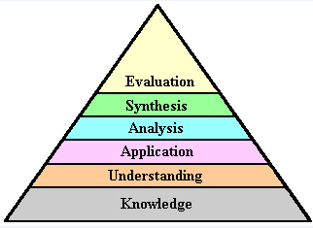
Steps of Academic Research Writing
Source: (Ilot, 2017)

A primary research methodology is one in which the researcher conducts research based on primary sources of Data. However, I have learned about different sources of primary data and analytical methods regarding primary research. However, the primary data can be obtained from the personal interview of the respondents, questionnaires, face to face observations etc. On the other hand, I have I have learned about secondary research methodology from the study which is conducted based on secondary data (Fletcher, 2016). However, secondary data sources include the data that is collected from websites, journals, published articles, internet etc. In addition, the study also teaches me how to conduct high-quality research based on the nature of the data which may be qualitative or quantitative. That is why it has boosted my skills of conducting high-quality research and enabling my capabilities of making a problem-solving decision.

The impact on research methodology on skills and employability
Selection and implementation of an effective research methodology are imperative in order to carry out academic research in the organisational context. However, in the organisation, I have to be asked in order to conduct an academic research on a particular issue. In this case, academic research methodologies can support me in different ways. However, primary research methodologies will support me in order to conduct primary and secondary research that will increase my reporting skills and employability. It will enable me in order to collect primary data from a variety of sources for the organisation for which the research is being conducted. In addition, I will be enabled to access to a source of secondary data if secondary research is applicable in the organisational context (Wegener, 2012). However, I have learned about effective presentation and organisation of the research data which has enhanced the communication skills. In addition, the analysis of the research data has increased my analytical skills. So, from the above discussion, it is clear that the application of research methodology has increased my skills from ad diverse sources and employability in the organisation.

Skill gap identification and self-assessment
Skill gap analysis and identification of weakness in the skill set is an imperative tool that supports a learner in order to identify the capabilities that he has and the opportunities where he has to improve.
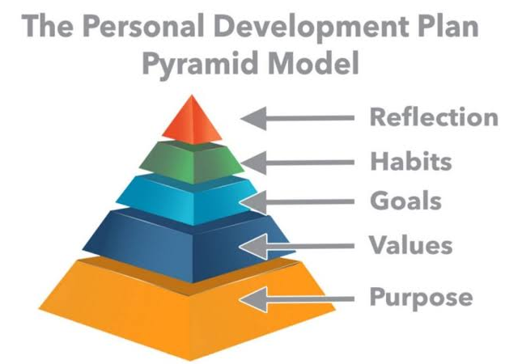
Figure: Personal development plan
Source: (Kraushar, 2014)
However, self-assessment and skill gap analysis are significant for boosting the skills and employability. The skill gaps are analyzed using personal SWOT analysis and development plan. The SWOT analysis and development plan are given in the following sections.

Personal SWOT analysis
A personal SWOT analysis is a powerful tool used in skill gap analysis that supports a person in order to assess personal strengths, Weakness, opportunities and threats. My personal SWOT analysis is given here in the nest section(Chell and Athyde, 2011).
Strengths  Good academic records  Time management skills  Technological adaptability  Strong analytical skills  Self-motivated  Stress management skill | Weakness  Introvert  Overconfident  Decision taker  Communication barrier
Opportunities  Management skills  Organisation capabilities  adaptability | Threats  The emergence of newer complex technologies  Competitive employment  Work life imbalances

Table: Personal SWOT analysis
Strengths: Strengths are the potentials that I have in me which will assist me in order to go a long way in future. From my personal analysis of strengths, I have found that I have good academic records and backgrounds which will take me to a long way in my professional life. Moreover, I have time management skills and so, I can complete the task in time and deliver the project within the time period (Bäckström and Gustafsson, 2017). Strong and effective technological capabilities and adaptability will support me in order to face the challenges of upcoming technologies. In addition, I have strong analytical skills and stress management skills which will support me in order to analyze any complex situation and manage my stresses that evolve from the work life. Furthermore, I am very much self-motivated and self-confident and that is why I can complete any task with confidence and motivation.
Weakness: Along with the strengths, I have a set of weakness that I have identified in me and they have a huge influence in moderating my career. The weaknesses that I have identified include that I am introvert in nature and less openness to share my views and ideas with others. For this reason, I always remain reserve in my that will cause a problem in near future in my career (Chawhall, 2013). Moreover, I am overconfident and decision taker in nature because I love to strict any decision what has been taken and don’t prefer to change them either. In addition, I have a weakness in communicating keeping eye contact.
Opportunities: I have a set of opportunities in order to develop who will increase my chance of being successful in my career. I have opportunities to improve my organisation power and management skills so that I can enhance my skill set. In addition, I have the opportunity to increase technological capabilities and adaptability with changing and dynamic situations.
Threats: Threats are the potential risks and challenges that I have to face in my career path. However, I have to face challenges from the emergence of newer technologies that are upcoming. Moreover, I have to face challenges because the current employment structure is very competitive in nature. On the other hand, I have to face challenges in managing my work life balances because it will cause potential problems in the workplace and family life.

Personal development plan
From the above analysis of skill gap and SWOT, It is clear that I have some gaps in skill sets that will have potential impact in decreasing my employability. My personal development plan is given in the following-
SL | Skills to be improved | How to improve | Duration
1 | Communication skills | Communicate with different stakeholders related to the employment | 3 months
2 | People engagement skill | Engage in sharing views and ideas and enjoying gathering | 2 months
3 | Work-life balance | Managing work life by completing office work in the office | 6 months
4 | Technological adaptability | Being aware of the newer technology and training on upcoming technology | 3 months
5 | Participative decision tactics | Making a decision based on the participation of team members and colleagues | 3 months.

However, from my career action plan, it is evident that I will enhance my communication skills by maintaining communication with stakeholders that are related to my employment field. Moreover, I will increase my people engagement skills by sharing views and ideas with others from nest 2 months. My work life imbalances will be managed by following systematic work-life balances for the next 6 months. My technological adaptability will be enhanced by training for 3 months. In addition, my decision-making capabilities including others will be enhanced in the workplace for the next 3 months. This action plans will support me in my future career to develop and grow.

Conclusion
Academic writing skills and employability are closely connected because they will assist me in the workplace in order to present a report following appropriate reporting strategies. In addition, different research methodologies will also support me in order to conduct academic and organisational research using appropriate resources and citations styles. It is significant to identify the gap in the skill set of me because it helps to find out where to improve and that is why I can develop my skills in order to face the current competitive employment opportunities. In this case, Personal SWOT analysis can play a vital role to find out the gap in the skill set. However, the career action plans will improve my skill sets and employability.

References
Bäckström, S. and Gustafsson, M. (2017). Skill, Drill, and Intelligent Performance: Ryle and Intellectualism. Journal for the History of Analytical Philosophy, 5(5).
Chell, E. and Athayde, R. (2011). Planning for uncertainty: soft skills, hard skills and innovation. Reflective Practice, 12(5), pp.615-628.
Fletcher, A. (2016). Applying critical realism in qualitative research: methodology meets method. International Journal of Social Research Methodology, 20(2), pp.181-194.
Ghandour, A. (2014). Identifying Dimensions of Business Continuity Plan from Common Expressions among Business Continuity Professionals. International Journal of Business Administration, 5(3).
Gröppel-Wegener, A. (2012). Developing Academic Writing Skills in Art and Design through Blogging. Journal of Academic Writing, pp.85-94.
Ilott, I. (2017). The Research Assessment Exercise: A Personal SWOT Analysis. British Journal of Occupational Therapy, 60(4), pp.167-168.
J. Crawhall, R. (2013). Time to Innovate: Reflections and Recommendations on Time Management for Innovation Managers. Technology Innovation Management Review, 3(9), pp.13-19.
Kraushar, P. (2014). Practical Business Development — What Works, What Does Not. Marketing Intelligence & Planning, 4(4), pp.3-13.
Spitzberg, B. (2010). Communication competence as knowledge, skill, and impression. Communication Education, 32(3), pp.323-329.

