Electrical and Electronic Principles Coursework
Joseph Samuel Roan
(2411525)

L4 Electrical & Electronic Principles
ACDA4006

Table of Contents
- Abstract…………………………………………………………………………………………………………… PG4
- Introduction……………………………………………………………………………………………………. PG4
  - What are Circuits?........................................................................................PG4
    - AC Circuits…………………………………………………………………………………….. PG4
    - DC Circuits…………………………………………………………………………………….. PG4
  - In what Cases are Circuits used?.................................................................. PG4
    - Electrical Devices…………………………………………………………………………… PG4
    - Industrial Machinery………………………………………………………………………PG4
    - Home Appliances……………………………………………………………………………PG4
    - Medical Equipment………………………………………………………………………..PG4
  - What is the Theory behind this report………………………………………………………. PG5
  - Overview of what the Report will cover…………………………………………………….. PG5
- Proteus – Setup and Results……………………………………………………………………………..PG6
  - What is Proteus…………………………………………………………………………………………. PG6
  - Proteus Setup……………………………………………………………………………………………. PG6
  - Readings for Proteus…………………………………………………………………………………. PG7
    - Maximum VLC on Proteus……………………………………………………………… PG7
    - Q Factor on Proteus………………………………………………………………………. PG8
    - -3db Value on Proteus…………………………………………………………………… PG9
    - Table of Results from Proteus……………………………………………………….. PG9
    - Line Graph on Proteus…………………………………………………………………… PG10
- Breadboard – Setup and Results……………………………………………………………………….PG11
  - What is a Breadboard………………………………………………………………………………… PG11
  - Breadboard Setup……………………………………………………………………………………… PG11
  - Readings for Breadboard…………………………………………………………………………… PG12
    - Maximum VLC on Breadboard………………………………………………………. PG12
    - Q Factor on Breadboard………………………………………………………………… PG12
    - -3db Value on Breadboard…………………………………………………………….. PG13
    - Half Power Readings …………………………………………………………………… PG13
    - Table of Results on Breadboard…………………………………………………….. PG13
    - Line Graph from Breadboard Results…………………………………………….. PG14
    - Half Power Points…………………………………………………………………………. PG14
- Calculations the author worked out………………………………………………………………… PG15
  - Maximum VLC on the authors calculations………………………………………………… PG15
  - Q Factor according to the authors Calculations…………………………………………. PG15
- Discussion – Results Explained………………………………………………………………………… PG16
  - Describe and Explain the Results……………………………………………………………….. PG16
  - What do the Results Show?......................................................................... PG16
  - Why does this happen?............................................................................... PG16
    - Breadboard Losses………………………………………………………………………… PG16
    - The Quality of the Circuit………………………………………………………………. PG16
- Practical Skills Developed Throughout this task……………………………………………….. PG17
  - Assembly of a Breadboard Circuit……………………………………………………………… PG17
  - Use of Testing Equipment………………………………………………………………………….. PG17
- Conclusion………………………………………………………………………………………………………. PG17
- References………………………………………………………………………………………………………. PG18
Table of Figures
Figure 1 – Circuit Designed on Proteus……………………………………………………………….. PG6
Figure 2 – Digital Oscilloscope……………………………………………………………………………. PG6
Figure 3 – Digital Signal Generator……………………………………………………………………… PG7
Figure 4 – Largest VLC Value on Proteus…………………………………………………………….. PG7
Figure 5 – Calculations for Q Factor on Proteus………………………………………………….. PG8
Figure 6 – Graph Filtered to calculate F1 and F2 Values on Proteus…………………….. PG9
Figure 7 – Proteus Results Table…………………………………………………………………………. PG9
Figure 8 – Line Graph of Proteus Result……………………………………………………………… PG10
Figure 9 – Breadboard Test Setup ………………………………………………………………………. PG11
Figure 10 – Calculations for Q Factor on Breadboard………………………………………….. PG12
Figure 11 – Graph Filtered to calculate F1 and F2 Values on the Breadboard………. PG12
Figure 12 – Table of Results for Breadboard……………………………………………………….. PG13
Figure 13 – Line Graph from Breadboard……………………………………………………………. PG14
Figure 14 – Calculations for the Maximum VLC…………………………………………………... PG15
Figure 15 – Calculations for the Q Factor……………………………………………………………. PG15

- Abstract

Throughout this task the author completed a practical laboratory exercise. This task consisted of creating a circuit, simulating the circuit and collecting results. The frequencies used in the task, were chosen as where the highest VLC happens, which in this case was around 5000Hz. Therefore, several frequencies close to 5000Hz were recorded. This was completed on the Proteus Software and on a Breadboard. Additionally, the author included the calculations they worked out as a reference. The results varied, this was because of losses occurred in the breadboard and not every frequency could be simulated on Proteus.

- Introduction

  - What are Circuits? – Circuits are a ‘Loop through which a current can flow’, they are powered by batteries, as they give energy, so the circuit can function [1]. The circuit works by the electrons flowing from the negative side of the power source to the positive, then returning to the Power source [1]. There are 3 basic components, they are, resistors, inductors and capacitors [2]. The Circuits come in two forms they are:

    - AC Circuit – AC is an abbreviation for ‘Alternating Current’. This is called this because when in a waveform it is in a ‘sinusoidal’ over a period of time [3].

    - DC Circuit – DC is an abbreviation for ‘Direct Current’. This is when the current has a ‘Constant Magnitude’ [4].

  - In what cases are Circuits Used? – Circuits are used in a number of different ways, for example:

    - Electrical Devices – Circuits are extremally important in Electrical devices, as they can help in powering the devices and making it functional. [5]

    - Industrial Machinery – Circuits are used heavily in industry. As they can control machinery, which will affect the whole operation. [5]

    - Home Appliances – A lot of home appliances require circuit to function, as they can control several parts of the appliances. [5]

    - Medical Equipment – Circuits are used in lots of medical equipment, as they help functionality [5]. This is needed in the medical field as it can cost people lives.

  - What is the Theory behind this report? – The theory being used in this report is general Mathematics that is used within Electrical Engineering, as its crucial for any electrical engineer to be able to solve this mathematically [6]. And that as Frequency Increases the Attenuation will, however this is only to a point, as after it reaches the highest point the attenuation will decrease, similar to the rate of increase.

  - Overview of what the Report will cover – The rest of this report will cover the setup and Findings the author received from various methods of Testing voltage at different frequencies of the Circuit they have designed. It will also cover how the author received their results, as well as what they mean. This report also covers how this Practical Task has developed their Practical skills.

- Proteus – Setup and Results

  - What is Proteus? – Proteus is a software that allows users to create a PCB layout and PCB Schematic. In conjunction with this, using Proteus, users can test the PCB’s they designed, using various tools [7]. These tools for testing are mentioned in Paragraph 3.2.

  - Proteus Setup – On Proetus, the author followed the method outlined by the lecturer, therefore they created a circuit on Proteus, shown in Figure 1. This included a Signal generator and Oscilloscope. These parts are key, as they are the parts that are used to take the readings. The author set the signal generator to a 2Vpk-pk, they did this when they were taking the readings for 100Hz. After they set this, they didn’t change it, as it would make the other readings incorrect. The author then took all of the readings that they found appropriate, with the highest reading being 20KHz. The Digital Oscilloscope shows the readings taken from the data inputted into the Signal Generator, this is shown below in Figure 2. The Digital Signal Generator is where a user can input the appropriate data needed to get the test results, e.g. Frequency and Input Voltage, this is shown below in Figure 3.
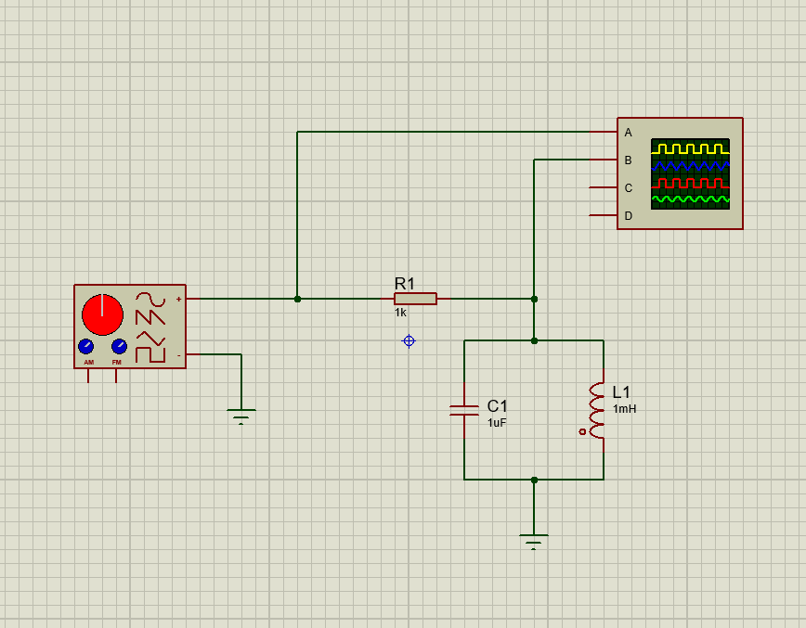

Figure 1 – Circuit Designed on Proteus
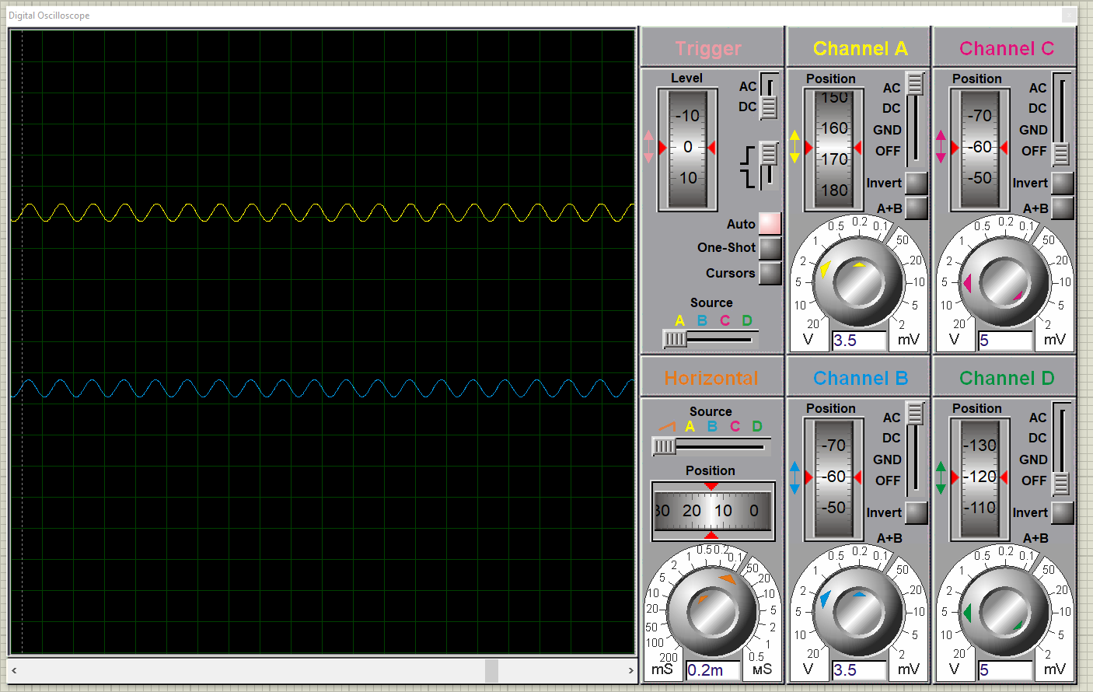

Figure 2 – Digital Oscilloscope
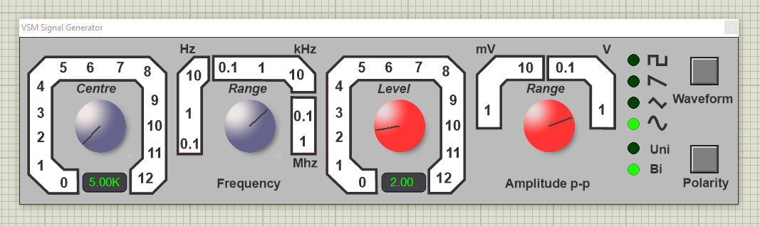

Figure 3 – Digital Signal Generator

  - Readings for Proteus

    - Maximum VLC on Proteus – With a peak to peak of 2V the maximum was 5000KHz, this is where it had the largest VLC. This is Shown below in Figure 4.

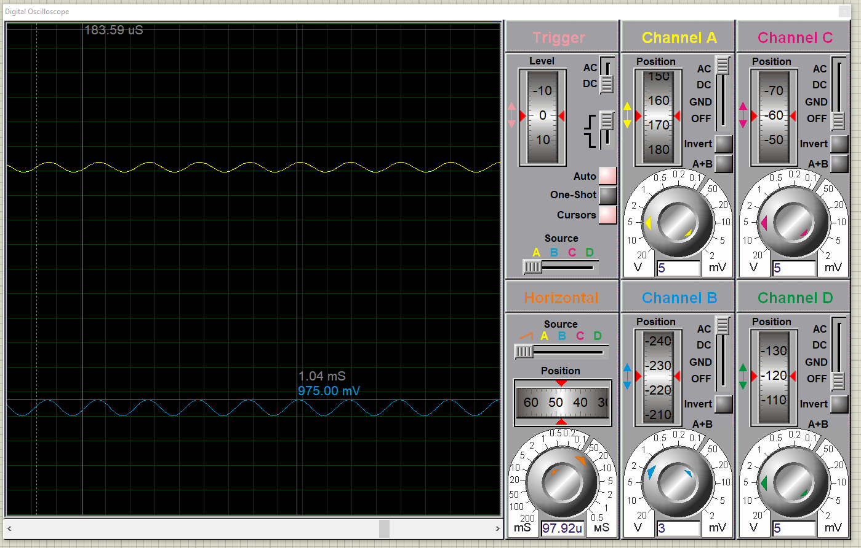

Figure 4 – Largest VLC Value on Proteus

    - Q Factor on Proteus – The authors Q Factor was 14.43, The calculations for this are shown below in Figure 5. The author calculated the Band width (BW) as, at -3 for F1 the author had 4850 and for F2 the author had 5150. So, 5150 – 4800 = 350 (F2 – F1 = BW). The author was able to get the F1 and F2 values from taking a line graph they created and filtering it to zoom in. This is shown below in Figure 6.

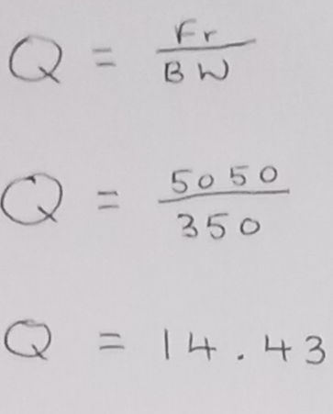

Figure 5 – Calculations for Q Factor on Proteus
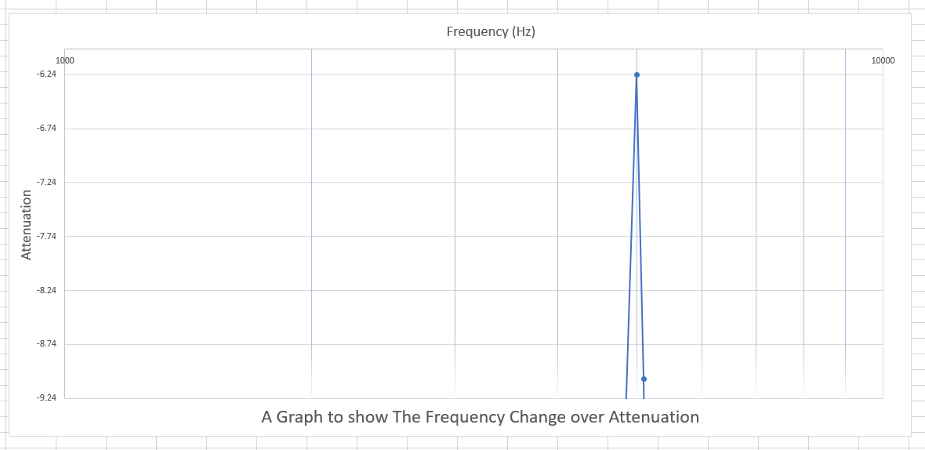
Figure 6 – Graph Filtered to calculate F1 and F2 Values on Proteus

    - -3db Value on Proteus – The -3db for this was -20.22. This was as the authors maximum value was -6.24. and 3 x -6.24 = -20.22.

    - Table of Results from Proteus – The author created a table from the results they took at different frequencies. This is shown below in Figure 7.

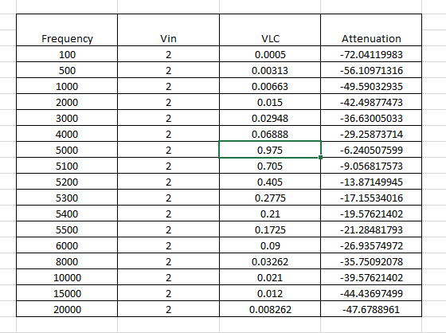

Figure 7 – Proteus Results Table
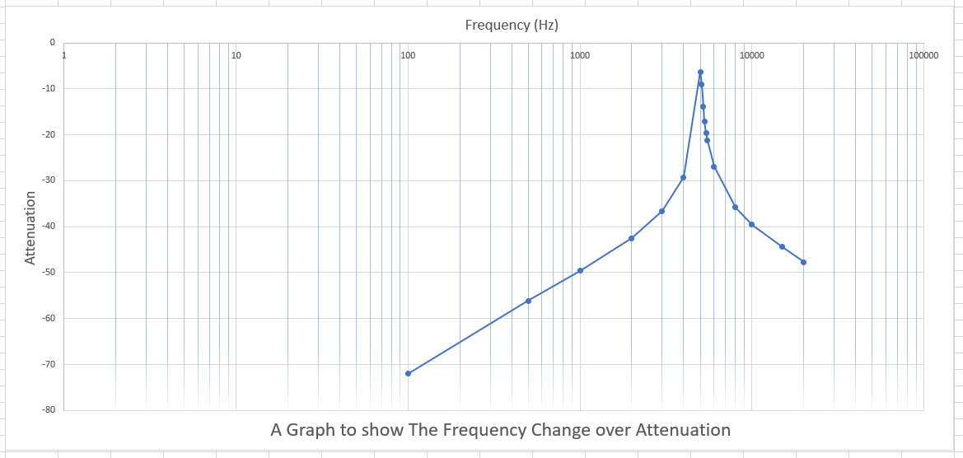
    - Line Graph on Proteus – From the Proteus results table (Figure 7) the author created a line graph, this line graph is shown below in Figure 8.

Figure 8 – Line Graph of Proteus Result

- Breadboard – Setup and Results

  - What is a Breadboard? – A breadboard is a piece of equipment that is used for simulating electrical circuits. This piece of equipment allows the users to re-use the item several times, unlike a normal circuit board, as there is no need for soldering and the parts and wires can be removed. However, it does normally specify that the contacts can lose efficiency over time, especially if being used frequently. [8]

  - Breadboard Setup – The author created the breadboard by using the circuit that they created on proteus and using the parts and wires supplied to them, they placed the parts on the breadboard, then using wires, connecting them, making sure that the wires are connected in fully, as short as possible and were connected in the right orientation for the part of the breadboard they were on. After the author created the circuit, using a function generator and oscilloscope they hooked up the breadboard to the equipment. The Test Setup is shown below in Figure 9. The author then changed the values so they could take their readings. To do this, the author adjusted the Input Voltage Value, until their peak to peak was at 2.00 V and then increased the frequency, until they got to the visual peak. This value isn’t as accurate as working it out, as they are relying on their eyes to see the highest point. Not even including the losses they will occur throughout this, see section 6.3.1 for the explanation on breadboard losses.

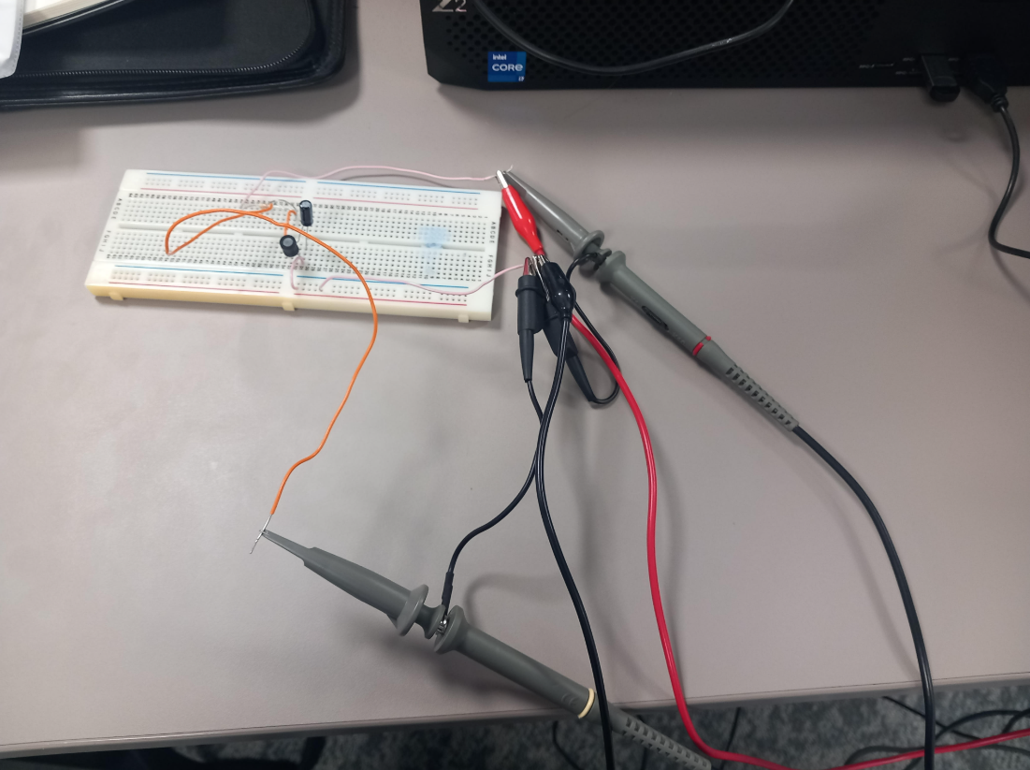

Figure 9 – Breadboard Test Setup

  - Readings for Breadboard

    - Maximum VLC on Breadboard – On the Breadboard with a peak to peak of 2V the maximum was 5.10KHz (5106 Hz). As when the frequency (Hz) increased the peak-to-peak value decreased in size. The author calculated these values by creating the circuit using a breadboard.

    - Q Factor on Breadboard – The authors Q Factor was 16.58, The calculations for this are shown below in Figure 10. The author calculated the Band width (BW) as, for F1 the author had 4850 and for F2 the author had 5150. So, 5150 – 4850 = 300 (F2 – F1 = BW). The author was able to get the F1 and F2 values from taking a line graph they created and filtering it to zoom in. This is shown below in Figure 11.

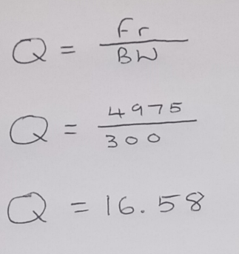

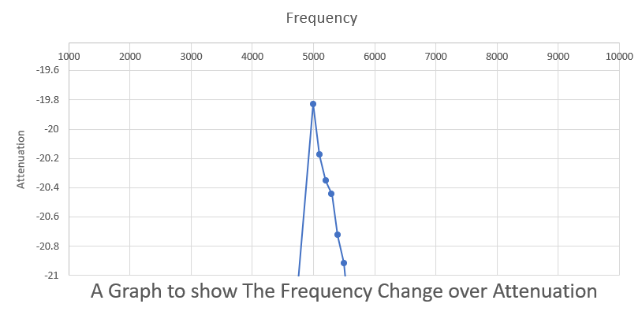
Figure 10 – Calculations for Q Factor on Breadboard

Figure 11 – Graph Filtered to calculate F1 and F2 Values on the Breadboard

    - -3db Value on Breadboard – The -3db for this was -59.46. This was as the authors Highest value for annotation was -19.82. and 3 x -19.82 = -59.46

    - Half Power Readings – On the breadboard the values that were outputted were a lot lower than the author expected. The 1st Half Power Reading was 4000, with a VLC of 0.116V. The 2nd Half Power Point was 6100, with a VLC of 0.112. These readings aren’t exactly half of the Maximum, however due to the losses it was the closest that could be reached, the reasons for this are covered in Paragraph 6.3.1.

    - Table of results on Breadboard – The author created a table from the results they took at different frequencies. This is shown below in Figure 12.

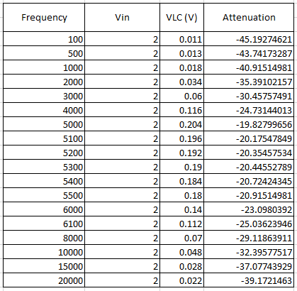

Figure 12 – Table of Results for Breadboard

    - Line Graph from Breadboard Results – From the results table for the breadboard (Figure 12) the author created a line graph, this line graph is shown below in Figure 13.

Figure 13 – Line Graph from Breadboard

    - Half Power Points – The 1st half power point, the frequency is 4000Hz, the VLC is 0.116. The 2nd half power point was 6100 and the VLC is 0.112. The VLC is slightly different, as a result of using the Oscilloscope, because when adjusting the frequencies it will not have an exact amount, these were the closest that the author could get to.

- Calculations the author worked out

  - Maximum VLC on the authors calculations – Through the authors calculations with a Peak to Peak of 2V the Maximum VLC was 5032.92 Hz. The author calculated this, as shown below in Figure 14.
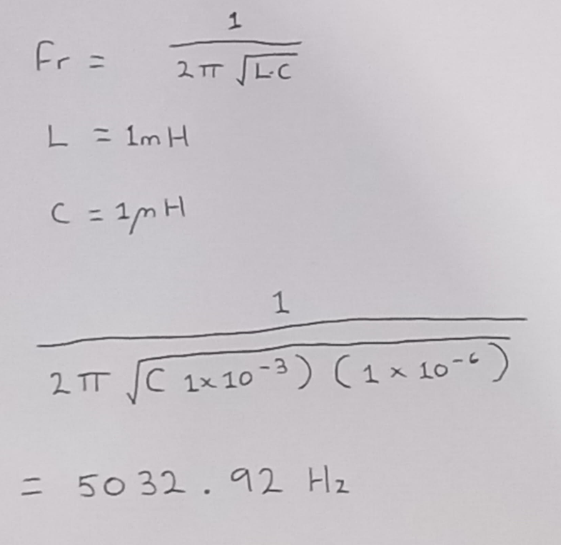

Figure 14 – Calculations for the Maximum VLC

  - Q Factor according to the authors Calculations – Through the authors calculations, they calculated the Q Factor. The Q Factor was 31.623. The author calculated this, as shown below in figure 15.
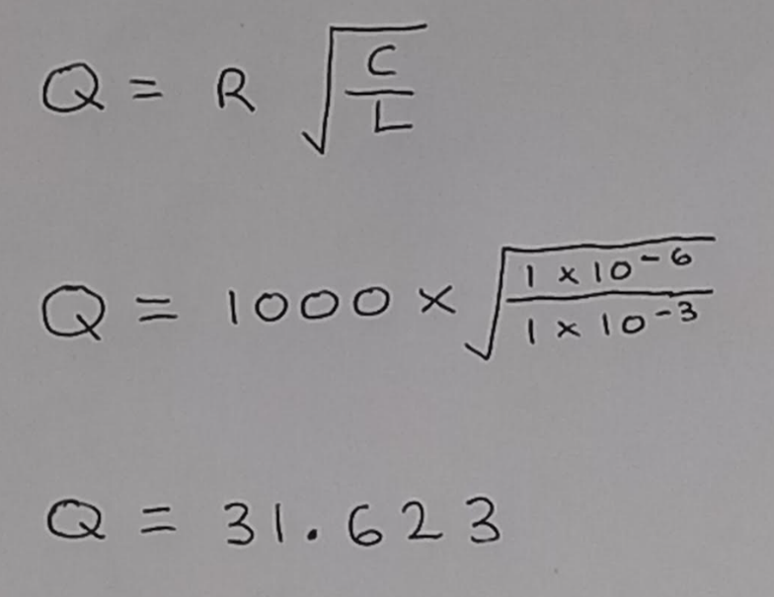

Figure 15 – Calculations for the Q Factor
- Discussion – Results Explained

  - Describe and Explain the Results – The results received throughout the task, were accurate. This is the opinion of the author, as they all had similar corelations/ratios in their results. The results did differ, and were not all the same, as shown in the graphs and tables. However, there was going to be some variation in the results. This explanation will be covered under section 6.3.

  - What do the Results Show? – The results from this task show that the Highest Frequency Value before the decrease / Highest Value of Attenuation, was around 5000Hz. Also, the rate of attenuation is similar on the increase to what it is on the decrease, as shown by the Line Graphs constructed throughout with the results from the tests conducted. The results also show a drop in voltage on the breadboard, which occurs due to losses within the breadboard, the explanation for the breadboard losses is covered in section 6.3.1.

  - Why does this happen? – There are several reasons for why the author had those results and Findings. Some of the reasons are as follows:

    - Breadboard Losses – A reason for the variation in results to the breadboard and the other methods is the Breadboard losses. This happens because of some components added to a circuit e.g. ‘Ferrite ceramic’, if this is added to the coil’s core the inductance is increases majorly, in some cases by 100X [9]. Additionally, another reason for losses is that the breadboard can overheat, which can in some cases cause it to melt, which is why it is recommended the current be at 1A [10]. With this restricted current, this can lead to losses.

    - The Quality of the Circuit – The quality of a circuit is expressed via the ‘Q’ factor, the Q-Factor is determined by the bandwidth, so the larger the band width the lower the quality and vice versa [11]. Therefore, if the bandwidth of a circuit is larger than the Q-Factor will be lower than its counterparts. Which will cause variation in results.

- Practical Skills Developed Throughout this task

Throughout This task the author has learned and developed several practical skills. These Practical skills in some cases can help them in their role as an Apprentice Design Engineer, throughout their future career. Also, some of these skills developed could also help them in their future studies. Some of the Skills are as follows:

  - Assembly of a Breadboard Circuit – The ability to Assemble a breadboard circuit is useful for an electrical engineer, as they can provide a prototype for a project that is cheap and easy to make, therefore is a cost-effective method of prototyping [12]. Before the undertaking of this task, the author had previously constructed a breadboard Circuit for testing. However, this task gave the author more in-depth knowledge of the assembly, as well as background knowledge surrounding this, via classroom lectures. This task therefore helped develop the authors ability to assemble a breadboard circuit.

  - Use of Testing Equipment – The ability to test a component, circuit or any electrical item is an important thing for any electrical engineer to know, as it can identify issues/errors with the electrical component, check its effectiveness and ensure safety [13]. Previous to this task the author had tested a Breadboard Circuit. This task gave the author a further insight on testing and the equipment, as via classroom lectures, the author gained knowledge of how to set up the different testing equipment. As the equipment used in this test were different models to the ones the author had previously used.

- Conclusion

In this experiment, it has been determined that all of the different methods have different results. The Method that had the most similar results to the real calculations was Proteus. This is because it is an accurate online method of Testing. It also found that, the theory was correct, as shown by the Graphs of attenuation (Figure 8 and Figure 13), as the frequency increases the attenuation increases, however after reaching the highest point, the attenuation will decrease, this decrease will be at the same level of the increase.

References

[1] | M. Hemmings, “What is a Circuit?,” Sparkfun Education, 6 November 2019. [Online]. [Accessed 5 January 2025].
[2] | D. Chattopadhyay and P. Rakshit, “Basic Circuit Elements,” in Fundimentals of Electric Circuit Theory, New Delhi, S Chand And Company Limited, 2000, p. 1.
[3] | D. Dugdale, in A.C. Circuits. In: Essentials of electromagnetism, Palgrave, London, Macmillan Physical Science Series, 1993, p. 231.
[4] | J. A. Svoboda and R. C. Dorf, “Electrical Circuits and Current,” in Introduction to Electrical Circuits, Dan Fowley, 2013, p. 3.
[5] | P. K, “26 Types Of Circuits And Their Uses,” ElectronicsHub, 2 September 2024. [Online]. [Accessed 5 January 2025].
[6] | C. Paul, “Basic Definitions and Laws,” in Fundamentals of Electric Circuit Analysis, John Wiley & Sons. Inc, 2001, p. 1.
[7] | Proteus, “PCB Design and Circuit Simulator Software - Proteus,” Proteus, 1 December 2023. [Online]. [Accessed 1 January 2025].
[8] | EMS, “How Does A Breadboard Work： The Importance In Building Electric Circuits,” EMS, 13 November 2024. [Online]. [Accessed 1 January 2025].
[9] | E. Bogatin, in Bogatin's Practical Guide to Prototype Breadboard and PCB Design, Norwood, Massachusetts, Artech House, 2021, p. 338.
[10] | APDahlen, “Breadboard Current Limitations with Terminal Block Alternatives,” DigiKey, 8 November 2023. [Online]. [Accessed 8 January 2025].
[11] | DigiKey, “Q Factor and Bandwidth of a Resonant Circuit,” DigiKey. [Online]. [Accessed 8 January 2025].
[12] | R. Mitchell, “What are Breadboards and Their Uses,” Maker Pro, 25 September 2018. [Online]. [Accessed 4 January 2025].
[13] | R. Ogle, “Circuit Testing and Verification: How to Effectively Use Oscilloscopes and Analyzers?,” ElectroViz, 10 November 2023. [Online]. [Accessed 4 January 2025].

