International Hotel Management

Marketing Essentials

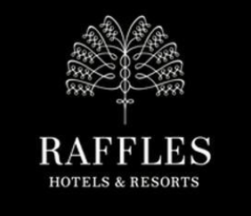VS 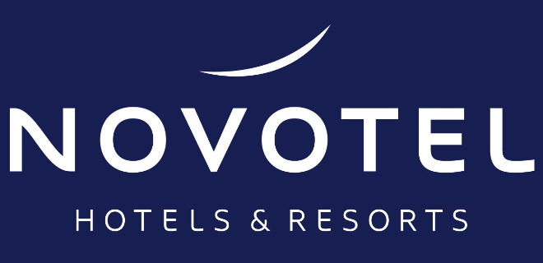
A Comparison of the marketing methods of two multi - national hotel chains
Name: Maria Mihaela Hirs
Student ID Number: 2226556
Module Title: Marketing Essentials BMIH4005
Name of Lecturer: Scott James
The essay includes a comparison of Raffles and Novotel to compare the marketing methods and also strategies applied at these two hotels. Raffles hotels and Resorts of Singaporean origin is a chain of luxury type hotels that was established in the year 1887 which eventually started developing internationally in the late part of the 1990s (Raffles.com, 2023). Ever since year 2015, it is part of Accor. On the other hand, Novotel, of French origin is a mid - scale hotel brand that is owned by Accor (Novotel.accor.com, 2023). It was created in the year 1967 and has maintained as a pillar of the Accor multi – brand based strategy with 559 properties across 65 nations.
The marketing strategy used at Raffles is differentiation based focused strategy to target customers of the upscale strata of the society. This is a successful strategy as the niche target market is wealthy and offers to contribute towards the business profit thereby adding to the growth potential. The customers are rich and do not consider to change their hotel choice when they are provided with all amenities at Raffles.
As Novotel caters to the middle strata of the society, the marketing plan has extensive use of digital means to reach out to more people, have higher engagement with the people and build enhanced brand awareness.
The brands have been compared based on the following theories, frameworks and models:
A situational analysis that demonstrates the SWOT and PESTLE of both brands to compare their prevalent means and strategies.
A comparison of the marketing mix applied at both hotels.
The STP analysis for both brands to understand the nuances of segmenting, targeting and positioning at Raffles and Novotel.
To understand the micro environment for Raffles and Novotel, it is required that the strengths, weaknesses, opportunities and threats are understood first. At Novotel, the strengths include the hotel chain being present across segments with a high and active network being present (Onsardi and Arkat, 2020). The business model is such that it can be patronised by people across income groups with guest interaction making them feel welcome at all times. Through the loyalty program, Novotel offers high customer loyalty scope with the hospitality experience being digitalised (C and NS, 2017). Raffles on the other hand has a strong history in regard to development and is a highly sought after premium hotel. The brand name is strong with methods being developed for improving profitability of the chain.
The weaknesses of Novotel are manifold; firstly, it loses out considerable amount of business to online competitors such as Oyo and Airbnb (Chang, 2017). The focus is on franchising to cut costs thus the chain lacks in attention with over emphasis on the parent brand to other sub brands. On the other hand, at Raffles, the weaknesses of the business is that the presence in the market is low such as the Japanese market where there is potential but no presence of the hotel (Rafflessingapore.com, 2021). Raffles also misses out on the first move benefit in a lot of aspects of business as old methods are used and the competitors use new approaches.
The opportunities for Novotel is that there is potential growth in regard to the emerging economies such as Africa and Asia. These are prominent tourist destinations with high surge of tourists thereby adding to the business potential (Dianan, Setijanti and Cahyadini, 2021). On the other hand, for Raffles, through advertising, the business has potential for improving profitability, sales and adding to the awareness of customers. Advanced technology is utilised thereby reducing per unit cost, lowering expense and catering to the customers who are cost delicate.
Novotel faces threats from competitors such as Hilton, Starwood and others while for Raffles, the government regulations pose as threat along with the level of competition in the market (Ferguson and Smith, 2014). As there is rapid competitive presence in the market, fast modification in regards to technology has made it possible to add to the success of the business.
To understand the macro environment of the two hotels, the analysis of the PESTEL framework has been beneficial. For Raffles, political factors impact the performance of the business such as rigorous policies for disposal of solid waste (Rafflessingapore.com, 2021). The business re sell the non – re – usable for meeting the political requirements. Economically, the business performance considers customer awareness about eco – friendly products, as the pricing at Raffles is high, the costing for the business automatically goes up (Jaclyn and Shirin, 2022). Socially, working women prefer conserving products hence at Raffles, re – usable items are preferred over cloth. The US has a higher disposable income level thus management of additional cost is possible where cloth is replaced by re – suable means. Technologically, as the market has high competition, research and development has been done to cater to the technological needs. Environmentally, as bio degradable plastic is used, the ecological communities criticize the business (Raffles.com, 2023). Plastic used by the hotel triggers pollution and health hazards. Therefore, recycling is encouraged and efforts are made for using reusable items. Legally, the Disposal Strong Waste Act – 1976 limits the use of plastic along with pressure to use equipment and technique that is environmental friendly.
Novotel on the other hand has to consider political factors such as government stability, taxation policies, competitive regulation and trade blocks for ensuring the business is earning profits (Waida, 2020). Economic factors that impact the business are inflation rates, interest rates, trends of consumer spending and trends associated with unemployment. Social factors such as demography, employment, family size, education and health consciousness impact the business (Novotel.accor.com, 2023). Technological factors like use of technology, internet penetration, investment on research and development and also the use of social media impact the business. Environmentally, recycling, waste management, green consumption, investment in renewable energy are effective in making strategic business decisions while legally, the laws for health and safety, employment and anti – discrimination effect the business (Schuh, Wetterney and Vogt, 2020).
In terms of products, Novotel offers mid - scale hotel experiences to the customers while Raffles offers luxury and upscale experiences. Pricing for Raffles is on the higher end as the hotel is a luxury brand while for Novotel it is mid - range where people across income groups can access the services (Raffles.com, 2023). Novotel and Raffles both are present worldwide while promotion for both chains ensure effective utilisation of social media, print, digital means and also word of mouth. This ensures promotion has effective reach and the businesses are propagated for higher earning of revenue, business generation and adding to the loyal customer base for the business (Novotel.accor.com, 2023).
Novotel has different means of marketing such as advertorials, mailers, event and banners. Furthermore, there are a network of strategies as well as connections that are used for promoting the services. Raffles on the other hand uses platforms like the website, Instagram stories, Facebook advertisement, Twitter and so on along with the constant use of bloggers and influencers to engage with the niche audience. Therefore, it is noted that while Novotel focuses on visual marketing using traditional means, in comparison Raffles uses differentiation based focus strategy through digital media for targeting the upscale customers.
Segmentation wise, Raffles being a high end chain caters to celebrities, sports personalities, corporate travellers and the higher end of the economic class (Butters and Hubbard, 2019). Such individuals have high spending power and seek the best service when travelling. Novotel on the other hand caters to the middle class or middle strata of the society therefore is more affordable in comparison and caters to the needs of different economic classes.
Targeting wise, the strategy of Raffles is differentiation bases and focused on the upscale customers. (Feng, 2022). Such a strategy is successful as the target market by nature is niche and wealthy enough to contribute to the profits of the business thereby offering good potential for growth. The customers are rich and if satisfied with the services, would not look for an alternative. In case of Novotel, the target market is the accommodation sector for four-star category through psychographic and demographic strategies (Waida, 2020). According to demography, aspects of income are used therefore directed towards businesses and the representatives. Since family income is different from business travellers, therefore Novotel offers accommodation free of cost to children below 16 years and who stay with grandparents or parents.
Positioning wise, both the hotels have global presence and across several countries therefore based on the local regions, the marketing strategies are incorporated. While Raffles is a 5-star luxury hotel, Novotel is a mid - scale 4.5-star hotel that offers intuitive space permitting the customers to make the most of what matters the most to them (Butters and Hubbard, 2019). It is important to ensure there is space for slow paced living and the chain offers to the hotels a blend of pleasure and business with an experience that is flawless.
Through the Perpetual Positioning Map, it is possible to comprehend the position of Ritz Carlton in comparison to the other market players. The business is a service provider that offers premium services at high price and does not compromise on quality. W Hotels is among the main competitors for Ritz Carlton along with Edition.
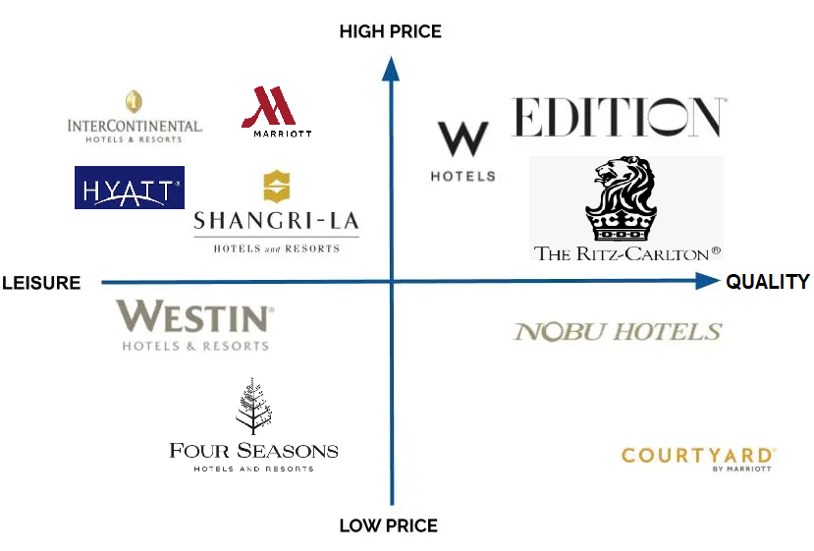
Source: (Waida, 2020)
Hence it is observed that Novotel uses intuitive spacing thereby permitting time for what is of utmost importance. It is believed by the hotel that space should be left for slow living and hence offers to the guests a blend of pleasure and business for an experience that is flawless. Therefore, in comparison, Raffles on the other hand believes in online campaign of environmental strategies through Instagram where challenges, infographics and quizzes are designed for educating the society.
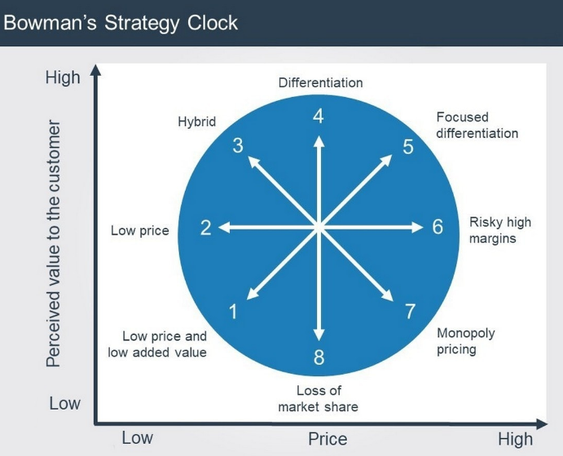
Source: (Jaclyn and Shirin, 2022)
Using the Bowman’s Strategic Clock, the competition prevalent can be understood. As stated in the diagram above.
Raffles is a premium hotel with 5-star rating while Novotel is a mid – scale hotel with 4.5-star rating. Raffles of Singapore and Novotel of France both belong to the Accor Group but are distinct in their marketing; the clientele of Raffles is more niche while Novotel is considered as more affordable therefore for different income groups.
While Raffles has been in the market longer than Novotel, and is famous in the luxury hotel sector, Novotel has a more mass connection due its mid – scale presence thereby ensuring it has a long and growing customer base that is loyal making affordability a benefit for a mid – scale hotel at times over a luxury brand.
The essay provides an insight into the macro and micro environment of both the hotels with due segmentation, targeting and positioning being discussed. While the products offered by the hotels are in general similar, it is services where each chain leave their mark.
Observing the above information, it is recommended for both hotels to, have transparency in communication; the stakeholders need to have information of what marketing strategies are being used, their success levels and their areas of improvement. Ensure there are periodic review of strategies; especially with the advent of digitalisation, the reach of traditional marketing means has significantly decreased; all these factors need to be reviewed and applied accordingly with the changes in time. Compare different marketing strategies and emphasize on those that achieve higher success rate

Reference

Butters, R.A. and Hubbard, T. (2019) Industry structure, segmentation, and competition in the U.S. Hotel Industry. doi:10.3386/w26579.
C, A. and NS, G. (2017) ‘Testing and verification of the zero-price effect in touristic products’, Journal of Hotel & Business Management, 06(01). doi:10.4172/2169-0286.1000159.
Chang, T.C. (2017) ‘Heritage Boutique Hotels as “experienscapes”: Three Views from Singapore’, Asian Journal of Tourism Research, 2(1). doi:10.12982/ajtr.2017.0003.
Diana, T.W., Setijanti, P. and Cahyadini, S. (2021) ‘Application of Bioclimatic architecture concept in Novotel Suite Surabaya’, IPTEK Journal of Proceedings Series, 0(6), p. 66. doi:10.12962/j23546026.y2020i6.8936.
Feng, J. (2022) ‘Market segmentation in tourism and Hotel Industry’, Proceedings of the 2022 7th International Conference on Financial Innovation and Economic Development (ICFIED 2022). doi:10.2991/aebmr.k.220307.368.
Ferguson, M. and Smith, S. (2014) ‘The changing landscape of Hotel Revenue Management and the role of the hotel revenue manager’, Journal of Revenue and Pricing Management, 13(3), pp. 224–232. doi:10.1057/rpm.2014.11.
Jaclyn, N. and Shirin, C. (2022) ‘Singapore: Legal response to covid-19’, The Oxford Compendium of National Legal Responses to Covid-19. doi:10.1093/law-occ19/e30.013.30.
Novotel.accor.com (2023) Book a hotel for a family holiday or business trip. Available at: https://novotel.accor.com/a/en/offers/novotel-family.html (Accessed: 24 May 2023).
Onsardi, O. and Arkat, F. (2020) The effect of transformational leadership style and work spirit on employee performance at Raffles City Hotel bengkulu Indonesia. doi:10.31219/osf.io/gtw9z.
Raffles Hotel Singapore - Luxury Singapore Suites - packages (2021) Raffles Singapore. Available at: https://www.rafflessingapore.com/offers-packages/ (Accessed: 24 May 2023).
Raffles Hotels - Luxury Hotels & Resorts (2023) Raffles website – new window. Available at: https://www.raffles.com/ (Accessed: 24 May 2023).
Schuh, G., Wetterney, T. and Vogt, F. (2020) ‘Customer need-based product positioning for disruptive innovations’, Proceedings of the International Conference on Culture Heritage, Education, Sustainable Tourism, and Innovation Technologies. doi:10.5220/0010308103000307.
Tan, Y. (2017) ‘Hotel-specific, industry-specific and macroeconomic determinants of profitability in London hotel industry: Structure-conduct-performance or efficient-structure hypothesis?’, SSRN Electronic Journal. doi:10.2139/ssrn.2943487.
Waida, M. (2020) Hotel target market: How to find the best customers, Social Tables. Available at: https://www.socialtables.com/blog/hotel-sales/best-hotel-target-market/ (Accessed: 24 May 2023).
Welcome to the Novotel Hotels website ll (2023) Novotel. Available at: https://novotel.accor.com/a/en/usa.html (Accessed: 24 May 2023).

