Coursework: Report
BA (Hons) Business Management
Data Handling & Business Intelligence
LCBB5014
Student name: Marian Emil Budica
Student id:2312379
Lecturer name: Ihsan Ul Haq

Table of Contents
1. Introduction 3
2. Data Cleaning and Preparation 3
1. Handling Missing or NaN Values: 3
2. Standardisation of Date and Time Formats: 4
3. Descriptive Statistics and Summary 4
4. Trend Analysis and Visualisation 9
5. Statistical Analysis using SPSS 12
Hypothesis Testing: 12
Correlation Analysis 12
Regression Analysis 13
6. Insights and Recommendations 15
References 17
Appendices 18

1. Introduction
The main purpose behind drafting this report is to examine the delivery performance and explore the key operational factors that influence efficiency and customer satisfaction by making use of the delivery dataset. This dataset highlights information related to a large sample of delivery records, which include variables like delivery time, characteristics of delivery personnel like age and ratings, road traffic density, weather conditions, type of vehicle, as well as order-based attributes. These variables also offer a comprehensive viewpoint about both internal and external factors which influence the delivery operations.
In this relation, the key objective behind this analysis is to provide meaningful insights with the help of a structured data analysis technique. This involves different processes like data cleaning as well as preparation, which help in ensuring data accuracy and consistency. The analysis is followed by descriptive statistics that help to summarise key patterns within the dataset. Adding further, trend analysis and visualisation are also performed for exploring the relationships between delivery time, traffic conditions, and weather. In the end, statistical testing with the use of SPSS is performed, which involves tests like correlation, regression, and one-way ANOVA. These tests help to examine relationships and achieve data-driven conclusions.

2. Data Cleaning and Preparation
The main goal behind cleaning the DHB Dataset in Excel, is to ensure data consistency, accuracy, and completeness to execute a reliable downstream analysis.

1. Handling Missing or NaN Values:
Initially, in its raw format, the dataset comprised of several "NaN” entries. These entries were stated in both numerical and categorical columns. For handling numerical columns like Delivery_person_Age and Delivery_person_Ratings, the imputation method is applied using the MEDIAN () function in Excel. Under this, missing and invalid data are replaced with the median value related to the respective column. The median is selected over the average to avoid the skewing impact of extreme outliers. Moreover, the categorical columns like Road_traffic_density, Weather, and City, the missing values are imputed with the help of Mode, which is the most frequent value in a dataset. The MODE.SNGL() function or logic of Excel is used for this. This helped to preserve the natural distribution of operational conditions without performing an artificial alteration to the dataset's size or reducing the valuable rows.

2. Standardisation of Date and Time Formats:
There are significant inconsistencies found in the time-related fields named as Time_Orderd and Time_Order_picked. Some of these values were stored in the standard time formats, like "20:30". However, the other values were stored as raw decimal fractions like "0.916666667”. This is a common artefact found in the Excel-based time formatting. Thus, for standardising these values, I converted these raw fractions into a uniform HH:MM format. For instance, the 0.916666667 became 22:00 using custom formatting rules. Moreover, the Order_Date column is strictly formatted to YYYY-MM-DD using TEXT () function of Excel. This helps to eliminate any discrepancies in terms of mixed regional date such as DD:MM and MM: DD.

3. Descriptive Statistics and Summary

Descriptive Statistics
 | N | Minimum | Maximum | Mean | Std. Deviation
Delivery_person_Age | 11399 | 15 | 50 | 29.54 | 5.672
Delivery_person_Ratings | 11399 | 1.0 | 6.0 | 4.636 | .3366
Valid N (listwise) | 11399
Table 1
It is obtained from Table 1 that the descriptive statistics offers useful insights regarding the delivery performance as well as related operational conditions. For numerical variables such as Delivery_person_Age it is obtained that a mean value of 29.54 years is obtained with values ranging between a minimum of 15 and a maximum of 50. This helps in interpreting that there is a relatively young workforce with medium levels of variation (SD = 5.672). In an equivalent manner, for the variable, Delivery_person_Ratings, a high average of 4.636 out of 6 is obtained, with a minimum of 1.0 and a maximum of 6.0 value. This helps in understanding that impressive performance is observed among the delivery personnel, with low variation as SD = 0.3366.

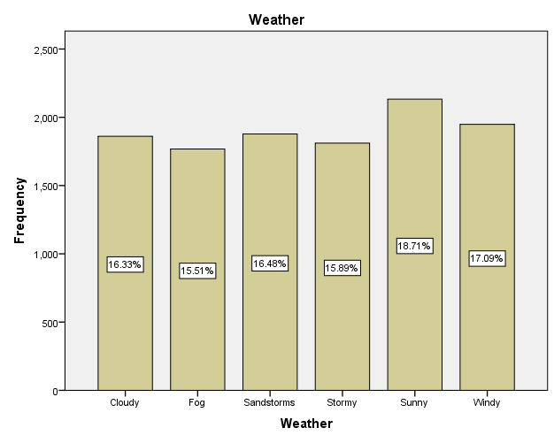
Figure 1

Weather
 |  | Frequency | Percent | Valid Percent | Cumulative Percent
Valid | Cloudy | 1861 | 16.3 | 16.3 | 16.3
Valid | Fog | 1768 | 15.5 | 15.5 | 31.8
Valid | Sandstorms | 1878 | 16.5 | 16.5 | 48.3
Valid | Stormy | 1811 | 15.9 | 15.9 | 64.2
Valid | Sunny | 2133 | 18.7 | 18.7 | 82.9
Valid | Windy | 1948 | 17.1 | 17.1 | 100.0
Valid | Total | 11399 | 100.0 | 100.0
Table 2
Moreover, the analysis of categorical variables also helps to understand a common pattern in delivery conditions. For the Weather variable in Table 2, the distribution is balanced fairly. However, the Sunny conditions tend to be most frequent (18.7%). This is followed by Windy conditions (17.1%) and Sandstorms conditions (16.5%). In addition to this, Fog is observed in a least common manner (15.5%). Thus, it is interpreted that deliveries are performed under diverse environmental conditions. This may ultimately affect the overall efficiency.
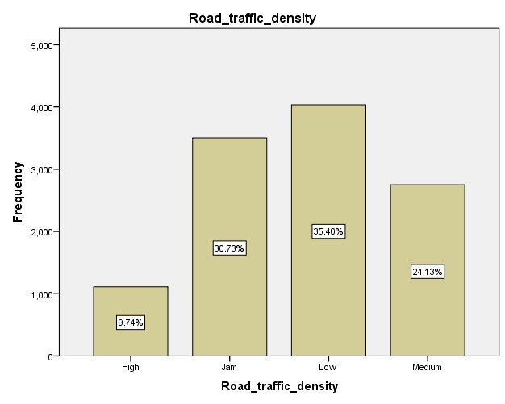
Figure 3
Road_traffic_density
 |  | Frequency | Percent | Valid Percent | Cumulative Percent
Valid | High | 1110 | 9.7 | 9.7 | 9.7
Valid | Jam | 3503 | 30.7 | 30.7 | 40.5
Valid | Low | 4035 | 35.4 | 35.4 | 75.9
Valid | Medium | 2751 | 24.1 | 24.1 | 100.0
Valid | Total | 11399 | 100.0 | 100.0
Table 3
Apart from this, in relation to the Road_traffic_density, Low traffic is identified to be at a high scale, estimated to 35.4%. This is followed by Jam traffic conditions, accounting to 30.7%, Medium (24.1%), and High traffic conditions, which account to 9.7%. Therefore, the findings help to understand that while a large number of deliveries are performed under positive traffic conditions, there is still a sizeable proportion of deliveries which experience congestion, which may influence the delivery time.
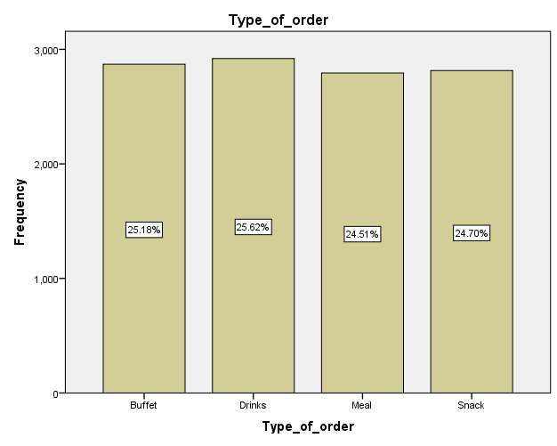
Figure 4

Type_of_order
 |  | Frequency | Percent | Valid Percent | Cumulative Percent
Valid | Buffet | 2870 | 25.2 | 25.2 | 25.2
Valid | Drinks | 2920 | 25.6 | 25.6 | 50.8
Valid | Meal | 2794 | 24.5 | 24.5 | 75.3
Valid | Snack | 2815 | 24.7 | 24.7 | 100.0
Valid | Total | 11399 | 100.0 | 100.0
Table 4
In addition to this, Type_of_order variable in table 4, is evenly distributed across diversified categories, where Drinks orders are leading, accounting to 25.6% of the total orders. This is closely followed by Snack, Buffet, and Meal types of orders. Hence, a balanced order type suggests that no single type of order dominates the overall operations.
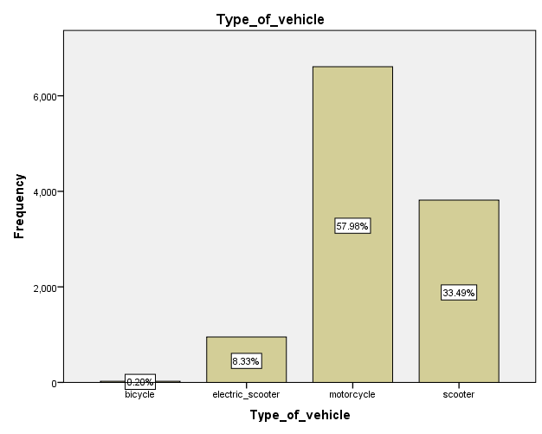
Figure 5
Type_of_vehicle
 |  | Frequency | Percent | Valid Percent | Cumulative Percent
Valid | bicycle | 23 | .2 | .2 | .2
Valid | electric scooter | 950 | 8.3 | 8.3 | 8.5
Valid | motorcycle | 6609 | 58.0 | 58.0 | 66.5
Valid | scooter | 3817 | 33.5 | 33.5 | 100.0
Valid | Total | 11399 | 100.0 | 100.0
Table 5
Furthermore, in the context of Type_of_vehicle, in table 5, it is obtained that Motorcycles are the primary mode of delivery, which is used by 58.0%. This is followed by scooters, which are used by 33.5%. However, the Electric scooters (8.3%) and Bicycles (0.2%) reflect a minimal usage. This indicates dependence on fast and motorised transport for achieving high efficiency.

4. Trend Analysis and Visualisation
The visualisations obtained from the Excel-generated charts and graphs highlight clear patterns regarding how delivery time is affected by both weather conditions and road traffic density. It also helps in understanding the temporal trends related to performance.

Figure 6

Figure 7
Based on the time-series chart prepared for average delivery time, it is found that delivery durations change in about every 10 to 10.5 minutes. This involves minor spikes that go above 11 minutes. Moreover, the linear trend line seems to be relatively flat. This indicates that there is no significant long-term improvement or decline in delivery efficiency under the observed time. However, it is found that there is a short-term volatility, which implies that external factors like weather and traffic are likely to change these fluctuations. In an equivalent way, delivery ratings are consistently high, reaching about 4.6 and 4.7. However, the presence of a slight downward trend indicates that there is a marginal customer dissatisfaction, which is related to delays.

Figure 8

Figure 9
In addition to this, the weather impact chart also states a clear relationship between environmental conditions and delivery time. It is obtained that adverse conditions like storms, fog, and sandstorms are related to a moderately high delivery time as compared with more stable weather conditions. In addition to this, sunny conditions also indicate the highest average delivery time, which seems to be counterintuitive. This can help in understanding that weather alone cannot determine delays. However, the weather interacts with rising demand or traffic under clear weather. This also highlights the Weather Paradox, revealing that on "Sunny" days, kitchens get bottlenecked due to high volumes of dine-in customers. These customers compete with delivery orders. Apart from this, severe weather eradicates dine-in traffic, which allows the kitchen to function in the form of an efficient "ghost kitchen" which is solely focused on fulfilling service deliveries.
Moreover, the traffic density chart indicates that there is a stronger and more consistent relationship, as when traffic congestion rises, delivery time also rises in a significant manner. Traffic jam-related conditions also generate the longest delivery times. This is followed by low and medium traffic. This helps to understand that traffic congestion tends to be a primary determinant of delivery-related efficiency. Hence, the traffic paradox can be understood from the findings as it reveals that high traffic is in correlation with peak meal hours. During the rushes, kitchens are completely occupied and well-staffed and perform with high efficiency. This results in slightly faster preparation time as compared with off-peak or "Low" traffic hours when kitchens tend to operate with fewer staff members.
5. Statistical Analysis using SPSS

Hypothesis Testing:
Weather compared with Ratings

Test of Homogeneity of Variances
Delivery_person_Ratings
Levene Statistic | df1 | df2 | Sig.
11.878 | 5 | 11393 | .000
Table 6
ANOVA
Delivery_person_Ratings
 | Sum of Squares | df | Mean Square | F | Sig.
Between Groups | 4.330 | 5 | .866 | 7.664 | .000
Within Groups | 1287.261 | 11393 | .113
Total | 1291.591 | 11398
Table 7
In order to determine whether or not the weather affects customer satisfaction, a one-way ANOVA is performed that helps to compare Delivery_person_Ratings across diverse Weather conditions.
In this context, the applied test identified a statistically significant difference in the customer ratings on the basis of weather (F (5, 11393) = 7.66, p < .001). However, the considered effect size may be small; this relationship helps in affirming that environmental conditions do not affect the ways in which customers give ratings to their delivery workers.

Correlation Analysis
Use of the Pearson correlation analysis is justified for the identification of linear relationships between the following operational variables.

Correlations
 |  | Delivery_person_Age | Delivery_person_Ratings | Delivery_location_distance | Traffic_Density
Delivery_person_Age | Pearson Correlation | 1 | -.055** | .004 | -.016
Delivery_person_Age | Sig. (2-tailed) |  | .000 | .663 | .094
Delivery_person_Age | N | 11399 | 11399 | 11399 | 11399
Delivery_person_Ratings | Pearson Correlation | -.055** | 1 | -.024* | -.037**
Delivery_person_Ratings | Sig. (2-tailed) | .000 |  | .012 | .000
Delivery_person_Ratings | N | 11399 | 11399 | 11399 | 11399
Delivery_location_distance | Pearson Correlation | .004 | -.024* | 1 | -.046**
Delivery_location_distance | Sig. (2-tailed) | .663 | .012 |  | .000
Delivery_location_distance | N | 11399 | 11399 | 11399 | 11399
Traffic_Density | Pearson Correlation | -.016 | -.037** | -.046** | 1
Traffic_Density | Sig. (2-tailed) | .094 | .000 | .000
Traffic_Density | N | 11399 | 11399 | 11399 | 11399
**. Correlation is significant at the 0.01 level (2-tailed).
*. Correlation is significant at the 0.05 level (2-tailed).

Table 8
Age and Ratings: There is a statistically significant, very weak, and negative correlation between the variables like Delivery_person_Age and Delivery_person_Ratings, where r is -0.055 and p < .001. This helps in interpreting that as the age of the rider increases, customer ratings decline at a very slight rate.
Traffic and Distance: There lies a significant, however weak negative correlation between the Traffic_Density and Delivery_location_distance as r = -0.046 and p < .001. This helps to understand that longer delivery routes have a slightly lower chance of being assigned or accepted during the time of high traffic density.

Regression Analysis
Model Summary
Model | R | R Square | Adjusted R Square | Std. Error of the Estimate | Change Statistics
 |  |  |  |  | R Square Change | F Change | df1 | df2 | Sig. F Change
1 | .072ª | .005 | .005 | .3358 | .005 | 19.593 | 3 | 11395 | .000
a. Predictors: (Constant), Traffic Density, Delivery_person_Age, Delivery_location_distance
Table 9
In relation to this, a multiple linear regression was performed to determine the predictors related to Delivery_person_Ratings, under the variable set named Age, Traffic Density and Delivery Distance, which are considered as independent variables. The overall regression model is found to be statistically significant, as F (3, 11395) = 19.59 and p < 0.001.
ANOVAª
Model |  | Sum of Squares | df | Mean Square | F | Sig.
1 | Regression | 6.628 | 3 | 2.209 | 19.593 | .000^{b}
1 | Residual | 1284.963 | 11395 | .113
1 | Total | 1291.591 | 11398
a. Dependent Variable: Delivery_person_Ratings
b. Predictors: (Constant), Traffic_Density, Delivery_person_Age, Delivery_location_distance

Table 10
Coefficientsª
Model |  | Unstandardized Coefficients |  | Standardized Coefficients | t | Sig.
 |  | B | Std. Error | Beta | t | Sig.
1 | (Constant) | 4.762 | .018 |  | 263.604 | .000
1 | Delivery_person_Age | -.003 | .001 | -.056 | -5.972 | .000
1 | Delivery_location_distance | -7.202E-6 | .000 | -.025 | -2.687 | .007
1 | Traffic_Density | -.013 | .003 | -.039 | -4.184 | .000
a. Dependent Variable: Delivery_person_Ratings
Table 11
However, the predictive potential of this model is highly weak as R-Square is 0.005. This helps to understand that only 0.5% of the variance is observed in ratings. Thus, after examining the individual predictors, it is found that higher age (B = -0.003, p < .001), large travel distance (B = -0.000007, p = .007), and a high traffic density (B = -0.013, p < .001) impose a negative impact on the customer ratings. Despite the prevalence of statistical significance, which gets largely driven by the massive sample size (N=11,399), the practical and real-world usefulness for the prediction of a specific rider's rating tends to be marginal.

6. Insights and Recommendations
The analysis helps to understand several key insights about the delivery performance. Firstly, delivery time is relatively stable with the passage of time, but short-term fluctuations are strongly affected due to external factors like traffic density and weather conditions. It is also found that the traffic congestion is the most critical determinant, where delivery times increase progressively from low traffic to traffic jam-based conditions. Moreover, while adverse weather moderately raises the delivery time, the unexpected delay during sunny conditions highlights a “weather paradox,” where high customer demand and kitchen congestion affect the delivery efficiency. Furthermore, the customer ratings are consistently high. However, the statistical analysis reveals that factors like age, traffic, and distance have a minimal and negative impact.
Based on the above findings, several recommendations can be proposed. The route optimisation systems need to include the real-time traffic data for avoiding the congested routes, specifically during peak hours (De Souza et al., 2016).
Moreover, dynamic resource allocation, like raising the staff members or prioritising delivery orders during the time of high demand or sunny weather, can minimise the kitchen bottlenecks (Thompson, 2024). In addition to this, vehicle selection strategies need to focus on increasing the use of motorcycles and scooters to perform faster navigation during heavy traffic. Moreover, predictive analytics is also suggested for the anticipation of delays under diversified weather and traffic conditions.
However, this analysis seems to be limited due to the weak predictive potential of regression outcomes and potential data imputation-related bias. In this direction, future research can include demand patterns, real-time GPS data, and operational variables such as restaurant workload for improving accuracy and decision-making.

References:
De Souza, A.M., Yokoyama, R.S., Maia, G., Loureiro, A. and Villas, L. 2016. Real-time
path planning to prevent traffic jam through an intelligent transportation system. In 2016
IEEE symposium on computers and communication (ISCC), pp. 726-731.
Gheorghe, C. and Soica, A. 2025. Revolutionizing urban mobility: A systematic review of
AI, IoT, and predictive analytics in adaptive traffic control systems for road networks.
Electronics 14(4), p.719.
Thompson, S. 2024. Full House, Short Staff: Strategies for Restaurant Success. eBookIt.
com.

Appendices
Appendix 1: One-way ANOVA test

Descriptives
Delivery_person_Ratings
 | N | Mean | Std. Deviation | Std. Error | 95% Confidence Interval for Mean |  | Minimum | Maximum
 |  |  |  |  | Lower Bound | Upper Bound | Minimum | Maximum
Cloudy | 1861 | 4.663 | .2764 | .0064 | 4.650 | 4.675 | 3.5 | 5.0
Fog | 1768 | 4.659 | .2716 | .0065 | 4.646 | 4.671 | 3.5 | 5.0
Sandstorms | 1878 | 4.617 | .3105 | .0072 | 4.603 | 4.631 | 3.5 | 5.0
Stormy | 1811 | 4.618 | .3002 | .0071 | 4.604 | 4.632 | 3.5 | 5.0
Sunny | 2133 | 4.642 | .4788 | .0104 | 4.622 | 4.663 | 1.0 | 6.0
Windy | 1948 | 4.616 | .3056 | .0069 | 4.603 | 4.630 | 3.5 | 5.0
Total | 11399 | 4.636 | .3366 | .0032 | 4.630 | 4.642 | 1.0 | 6.0

Multiple Comparisons
Dependent Variable: Delivery_person_Ratings
Tukey HSD
(I) Weather_NUM | (J) Weather_NUM | Mean Difference (I-J) | Std. Error | Sig. | 95% Confidence Interval
 |  |  |  |  | Lower Bound | Upper Bound
Cloudy | Fog | .0039 | .0112 | .999 | -.028 | .036
Cloudy | Sandstorms | .0453* | .0110 | .001 | .014 | .077
Cloudy | Stormy | .0447* | .0111 | .001 | .013 | .076
Cloudy | Sunny | .0204 | .0107 | .393 | -.010 | .051
Cloudy | Windy | .0465* | .0109 | .000 | .015 | .078
Fog | Cloudy | -.0039 | .0112 | .999 | -.036 | .028
Fog | Sandstorms | .0415* | .0111 | .003 | .010 | .073
Fog | Stormy | .0408* | .0112 | .004 | .009 | .073
Fog | Sunny | .0165 | .0108 | .645 | -.014 | .047
Fog | Windy | .0426* | .0110 | .002 | .011 | .074
Sandstorms | Cloudy | -.0453* | .0110 | .001 | -.077 | -.014
Sandstorms | Fog | -.0415* | .0111 | .003 | -.073 | -.010
Sandstorms | Stormy | -.0007 | .0111 | 1.000 | -.032 | .031
Sandstorms | Sunny | -.0249 | .0106 | .177 | -.055 | .005
Sandstorms | Windy | .0011 | .0109 | 1.000 | -.030 | .032
Stormy | Cloudy | -.0447* | .0111 | .001 | -.076 | -.013
Stormy | Fog | -.0408* | .0112 | .004 | -.073 | -.009
Stormy | Sandstorms | .0007 | .0111 | 1.000 | -.031 | .032
Stormy | Sunny | -.0242 | .0107 | .212 | -.055 | .006
Stormy | Windy | .0018 | .0110 | 1.000 | -.029 | .033
Sunny | Cloudy | -.0204 | .0107 | .393 | -.051 | .010
Sunny | Fog | -.0165 | .0108 | .645 | -.047 | .014
Sunny | Sandstorms | .0249 | .0106 | .177 | -.005 | .055
Sunny | Stormy | .0242 | .0107 | .212 | -.006 | .055
Sunny | Windy | .0261 | .0105 | .132 | -.004 | .056
Windy | Cloudy | -.0465* | .0109 | .000 | -.078 | -.015
Windy | Fog | -.0426* | .0110 | .002 | -.074 | -.011
Windy | Sandstorms | -.0011 | .0109 | 1.000 | -.032 | .030
Windy | Stormy | -.0018 | .0110 | 1.000 | -.033 | .029
Windy | Sunny | -.0261 | .0105 | .132 | -.056 | .004
*. The mean difference is significant at the 0.05 level.

Delivery_person_Ratings
Tukey HSD^{a,b}
Weather_NUM | N | Subset for alpha = 0.05
Weather_NUM | N | 1 | 2
Windy | 1948 | 4.616
Sandstorms | 1878 | 4.617
Stormy | 1811 | 4.618
Sunny | 2133 | 4.642 | 4.642
Fog | 1768 |  | 4.659
Cloudy | 1861 |  | 4.663
Sig. |  | .161 | .422
Means for groups in homogeneous subsets are displayed.
a. Uses Harmonic Mean Sample Size = 1892.870.
b. The group sizes are unequal. The harmonic mean of the group sizes is used. Type I error levels are not guaranteed.

