NAME: Muhammad Ansaar Khalid
STUDENT NUMBER: 2130064
MODULE: LCMB7000
LECTURER: Dr Gladius Kulothungan
COURSE: Master’s in business administration
SUBMISSION DATE: 10/09/2022
TITLE: Human Resource Assessment 1

Table of Contents
1. Current State of Labor Market in The UK 2
1.1. Employment Rate 2
1.2. Unemployment Rate 2
1.3. Effects of Immigrants on the Current Labor Market of UK 3
2. Emerging Changings in HR Strategies in Post-COVID 4
2.1. Introduction 5
2.2. Post COVID, the Working Environment Changed 5
2.3. Small Workplaces to Increase Productivity 6
2.4. Less Expenses and Cost-Cutting 6
2.5. Role of HR in Post-COVID Scenario 8
3. Emerging Changings in HR Strategies in Post-Brexit 8
3.1. Workforce Planning by Employee Retention 8
3.2. Workforce Benefits 9
3.3. Compensation Benefits 9
3.4. Work in Collaboration 10
3.5. Strategies can be Implemented in the Post-Brexit 11
4. Conclusion 11
5. References 13

Current State of Labor Market in The UK
The labor market is still recovering, as seen by a quarterly advancement rate and a decline in the rate of unemployment, according to the most recent Labor Force Survey (LFS) estimates for the period of November 2021 to January 2022. Macroeconomic stagnation has somewhat increased throughout the quarter.

Employment Rate
The UK rate of employment climbed from 75.6% to 75.7% throughout the course of the quarter. The rise in the rate of employment over the most recent three months was mostly driven by full-time workers. Although it sharply declined during the COVID-19 epidemic, the percentage of part-time workers has been rising from April to June 2021. Nevertheless, despite declines brought on by the COVID-19 epidemic, the number of independent contractors continues to be minimal.
According to the most recent forecast, pay rolled workers will have increased by some 275,000 each month, reaching a record-high of 29.7 million.

Unemployment Rate
During the quarter, the unemployment rate fell by 0.2 percentage points to 3.9%, although the rate of business stagnation rose by 0.1 points to 21.3%. The rise in business stagnation during the COVID-19 epidemic compared to the prior three months was purely caused by people between the ages of 16 and 24. Nevertheless, since early 2021, the proportion of 16–24-year-olds who are unemployed or underemployed has been declining, with recent rises in economic stagnation being driven by individuals in the 50–64 age group. Inadequate government commodity supply (Alesina et al., 1997; Gomes et al., 2016), increased inequalities, and a poorer degree of confidence and participation in community events may also be associated with them (Alesina et al., 2016b).

Effects of Immigrants on the Current Labor Market of UK
The talents of immigrants, the abilities of the host workforce, and the features of the host economy all play a significant role in how immigration affects the labor market. If industry and labor demands are able to react to the rise in labor supply, they are also highly variable over the short and long terms.
The labor supply is impacted by immigrants since it expands the labor force in some economic sectors. At the same time, when consumer preferences for some products and services increase due to immigration, there will undoubtedly be a rise in the need for workers. To put it another way, while migration may make it harder to find employment in some industries, it can also lead to the creation of brand-new positions.
The extent to which immigrants possess skills that can replace or supplement those of current employees will determine the initial short-term effects of immigrants on salaries or jobs (e.g., Borjas 1995). Immigrants are anticipated to increase competition for employment and temporarily lower salaries when migrant employees are used to replace current employees. The degree to which dropping salaries promotes unemployment in the organizational culture.
Second, immigration has the potential to boost both the supply and demand for labor, which will result in more employment being created. This is due to the "lump of labor fallacy," which holds that the economy's employment rate is not constant. Businesses may enhance production in industries that utilize migrant labor because migrant customers raise consumer spending (e.g., in agriculture or care sectors).
Not all economic reactions to immigrants require adjustments in employment and income levels. Other modification processes include at least two more (Dustmann, Glitz and Frattini 2008). One is that immigrants might alter the range of products and services manufactured in a state, which would then modify the labor market in terms of industries and occupations. An increase in the immigration of unskilled laborers, for instance, could increase the production (supply) of specific goods and services that heavily rely on this type of labor. If the industry grows, demand may rise as well, which would raise salaries once more.
Similar to immigrants, some items' production (provision) technologies may shift (services). For instance, the immigration of capable people may promote creativity and the acceptance of more competent techniques that would have an impact on labor consumption once more. The features of the economy determine how much investment and labor supply react to immigration. Labor demand may fluctuate more gradually throughout economic downturns than it does throughout boom periods.

Emerging Changings in HR Strategies in Post-COVID
Organizational reforms that were required to maintain the ongoing organizational functioning were compelled by the COVID-19 situation to take place. Due to its impact on the productivity of the rest of the company, work performance appears to be a significant determinant in deciding such continuation. COVID-19 has produced a scenario where 50% of the workers may be unable to operate in a small space of time (Gourinchas, 2020).
Because of the COVID-19 crisis's adverse effects on workers, which included anxiety and a lack of safety, structuring and maintaining work performance was difficult for firms. In an effort to recover from the external downturn, businesses have begun to restart (Major &Machin, 2020), in the middle of this continuing disease outbreak, with incredible regulations and unique operations (such as physical distance from the worksite) that nobody can foresee when that will cease (Shaw, Main, Findley, Collie, Kristman, & Gross, 2020). Experts in human resource management (HRM) are playing a larger role in developing HRM plans that will effectively change perceptions towards the workplace and improve work performance in these challenging circumstances.


Introduction
The managerial function known as human resources management (HRM) is responsible for recruiting, inspiring, and retaining both individuals and groups within the organization. It involves individuals who work in corporations. Developing managerial infrastructure to ensure that a worker's potential is utilized properly to achieve the goals of the organization is known as human resource management (Aswathappa, 2017). According to Noe, Hollenbeck, Gerhart, and Wright (2007), HRM is involved in the policies, procedures, and processes that influence workers' emotions, behaviors, and productivity.
Workers are, without a doubt, a useful resource for modern corporations. By carrying out the responsibilities assigned to them, employees contribute to the conceptual, tactical, and functional levels of the company's objectives, which in turn affect how well each department performs. The worldwide COVID-19 epidemic had a great impact on how workers were managed. Companies were forced to modify their working strategies due to the spread of the COVID-19 virus because it was necessary to stop moving people around and improve societal isolation in order to reduce the cause of exposure. To enable work from home, companies have to reorganize their procedures.

Post COVID, the Working Environment Changed
The field of ecological economics reflects apprehension. The abrupt decline in the economy in terms of the shutdown has shaken the whole corporate sector. The foundation of interactions, including secure positions and workforce employment, is the workplace (ILO, 2020). In the present situation, it is required of the setup to create effective rules to keep their existing workforce and lessen the influence of pay policies to prevent salary reductions or discontinuance. Workers must also be more helpful and efficient at this difficult time by embracing any new policies introduced by businesses to boost business until things stabilize.

Small Workplaces to Increase Productivity
Small workplaces located inside of workers' houses will become commonplace in the post-COVID era. Working strategies in the corporate world have significantly modified the cause of the COVID-19 crisis. In fact, the majority of businesses have adopted working from home and mandated that their staff work remotely in order to support corporate sustainability (Aitken-Fox et al., 2020a, 2020b; Gourinchas, 2020; Koirala&Acharya, 2020).
Mini-offices or work-from-home rooms will soon be present in private residences. Companies could try to set up practices that increase efficiency and productivity remotely as a way to get ready for this kind of workplace environment. Individuals will benefit from their increased productivity and this work process.


Less Expenses and Cost-Cutting
In addition to increasing efficiency and goal-achieving focus, this may result in fewer annual leaves. The corporation may reduce costs by operating large corporate divisions or divisions more efficiently. By using less electricity, telephone, and infrastructure repair, WFH will save on office operational expenses. Because they are operating in a virtual environment, the workers will become more focused on connecting with the entire group, which will increase productivity. In order to provide entertainment for all workers, companies won't need large car parks and cafés. Through the implementation of new HR rules, this cost-cutting could benefit employee health and safety.
One likely scenario for the future is that choices taken during and after the recession result in decreased affluence, a slowdown, increased inequality, and rigid boundaries. Alternately, it's possible that the actions taken in response to this collapse result in a boom in effectiveness and creativity, stronger industry, wiser administration at all stages, and the development of a reconfigured globe (Chandramana, Sudeep B, 2020).
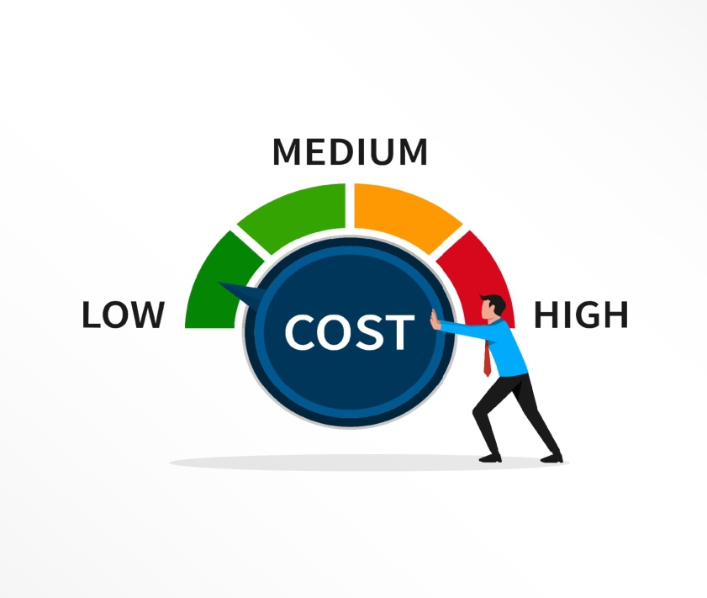

Role of HR in Post-COVID Scenario
Organizations must make numerous changes to their business strategy and operating procedures in order to operate effectively after COVID-19. For them to survive this difficult time, worker involvement is more important than ever. They might experience feelings of loneliness, doubt, ignorance, etc. In this situation, HR specialists' ability to effect change becomes vital. Social distance is being introduced and practiced, making it challenging to establish conventional methods of procedure, rules, and interactions, which presents a new problem for HR professionals.
In order to reduce expenses and try to maintain their enterprise, companies that were having financial issues as a result of the disease outbreak down-skilled by limiting the recruiting efforts of high-skill jobs more so than low-skill employment (Campello, Kankanhalli, &Muthukrishnan, 2020); they also decided to freeze or reduce all recruiting efforts; or they terminated their staff members (Campello, Kankanhalli, &Muthukrishnan, 2020; Giupponi&Landais, 2020).
A company's human resources will be its lifeblood when all of these difficulties are taken into account, thus they must manage the post-COVID scenario with great care and dedication. Above everything, this pandemic's "personnel element" is the main focus of these issues, which has caused a radical change in the function of HR since COVID.

Emerging Changings in HR Strategies in Post-Brexit

Workforce Planning by Employee Retention
Despite the fact that 7% of the employment in the UK is presently made up of EU citizens, data from the Recruitment and Employment Confederation (REC) indicates that after Brexit, there may be a decline in the number of EU citizens who opt to engage in these positions. Recruitment agencies are concerned about having to fill these jobs with UK applicants, but they have recently had modest success doing so for low- or moderate-level jobs, though the reason is that UK employees are highly qualified, reluctant, or otherwise unable to perform the duties due to disability or require attention, or because they are highly qualified but not interested in the job. To adjust the performance targets to the current reality of businesses and people, management examines and readjusts the performance measurement system with the assistance of HRM professionals (AM et al., 2020).

Workforce Benefits
The best salaries Jobs aren't usually at the greatest firms; in fact, one-third of workers rank compensation benefits as their top criteria for choosing a new employer. Comparable forms of data and methods of operation are common throughout businesses. However, benefit plans can be tailored to the preferences and requirements of both regular and temporary workers because they are not subject to external pressures. One of the most well-liked employee perks is flexible workplace hours. Other common worker perks include work-life balance rules, vacation bonuses, exercise programs, and savings. It has encouraged management's innovation and HRM professionals' ability to migrate from conventional face-to-face socializing techniques like conferences, meals, and short breaks (Carnevale&Hatak, 2020).

Compensation Benefits
A competitive compensation package can draw in new hires and make current workers feel engaged, appreciated, and driven at work. This increases employee engagement and loyalty and boosts employee retention.
Employee benefits also assist in creating an atmosphere at work that is upbeat and lively and promotes success for all workers. Encourage teamwork and mutual support among employees, and empower them to make choices and adjustments as part of the process of developing a strong workplace environment. Workers can solve difficulties and come up with new ideas thanks to autonomy and freedom, which also boosts their confidence in them and their position in the organization going forward. They would also feel less stressed and have more faith in the company if you kept in touch with them (Hamouche, 2020). Employee retention can be quickly and permanently improved by a favorable business environment, which can also be used to recruit new employees.
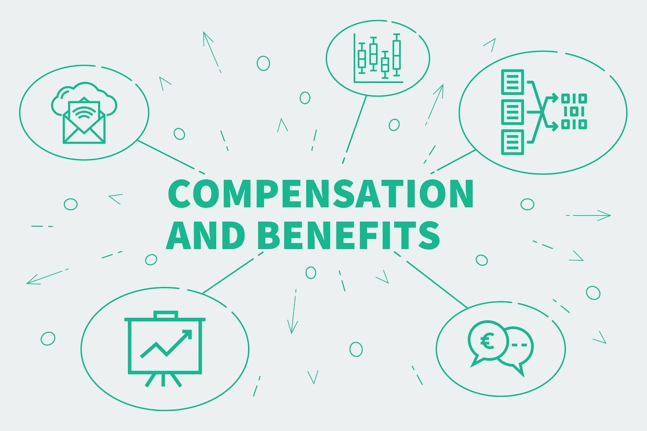

Work in Collaboration
To determine what your corporate world has to offer prospective workers, collaborate with other businesses, trade organizations, and professional organizations. You should also work with your local colleges and universities to showcase instances of workers who are happy in their jobs and instances of career advancement that started with low-skill positions. Furthermore, to promote social support and cooperation between workers, it is necessary to create and sustain a coherent environment that promotes relationships and interactions (Lund et al., 2021).
A worldwide recruiting firm may keep offering streamlined hiring services to companies with locations across the UK, Europe, and the rest of the world irrespective of the specifics of the Brexit negotiations.


Strategies can be Implemented in the Post-Brexit

- To determine which workers, if any, may be impacted by the new regulations, companies should conduct an audit of their staff. Workers who have resided in the United Kingdom for at least six years may be eligible for British citizenship, which may have financial repercussions for both the individual and the organization. This audit is crucial. Companies may have traditionally been based on the same talented international employees. While the effect of Brexit on hiring is still unclear,
- Explore your alternatives and the support that businesses can offer to their staff by digging deeper.
- Even when there is no new information, engage with the staff. Rumors, a decline in attitude, and disinterest can all result from poor interaction.
- If the company wishes to hire large groups of people, it should make plans for a longer on-boarding period.
- Form a task group that includes HR as a major participant to assist in bringing together skills and abilities for the group's sector. The working group might operate as an advisory group for the firm's top executives and aid in interaction.

Conclusion
It would have been difficult in the normal course of business, but the COVID and Brexit have provided managers with a unique opportunity to pause and reflect. Numerous businesses may be forced by the epidemic crisis to develop new working practices in order to stay in operation and improve their ability to adopt new technologies. Subsequent regular periods will likewise use this strategy in addition to the shutdown time. Technology-based and decentralized, the modern workplace makes use of these two concepts. Leaders of the digital age are more likely to endure and adapt. While there is a chance for cost savings, workforce diversity, and quick organizational evolutionary iteration, sustainability depends on having a strong organizational culture.
In reaction to the emergence of the COVID and the issue of Brexit, many businesses have chosen to conduct their work digitally. This has highlighted how crucial it is for businesses to be resilient and agile enough to adopt group communication technologies and processes. HR should adopt a more human-centric strategy in the post-COVID and post-Brexit environments, where workers must modify how they operate. Maintaining work engagement and increasing productivity and efficiency is a major job for human resource professionals. They are required to acquire new abilities, build new knowledge, and disrupt certain outdated processes as a result of the necessity for them to become more flexible.

References
- Borjas, G. (1995): “The Economic Benefits from Immigration.” The Journal of Economic Perspectives 9, no. 2 3-22.
- Borjas, G. J., R.B. Freeman, and L.F. Katz. (1997) “How Much Do Immigration and Trade Affect Labor Market Outcomes?” Brookings Papers on Economic Activity 1: 1-90.
- Dustmann, C., T.Frattini, and I. P. Preston. (2012) “The Effect of Immigration along the Distribution of Wages.” Review of Economic Studies 80, no 1 145-173.
- Dustmann, C., F. Fabbri, and I. Preston. (2005) “The Impact of Immigration on the British Labour Market.” Economic Journal 115, no. 507 F324-F341.
- Gourinchas, P. -O. (2020). Flattening the pandemic and recession curves. Mitigating the COVID Economic Crisis: Act Fast and Do Whatever, 31, 1–227.
- Major, L. E., &Machin, S. (2020). Covid-19 and social mobility. Centre for Economic Performance, London School of Economics and Political Science, (No.004).
- Shaw, W. S., Main, C. J., Findley, P. A., Collie, A., Kristman, V. L., & Gross, D. P.. (2020). Opening the workplace after COVID-19: What lessons can be learned from return-to-work research?.Journal of Occupational Rehabilitation, 30, 299–302.
- ILO. (2020). Working conditions. Retrieved from http://www.ilo.ch/global/topics/working-conditions/lang--en/index.htm.
- Aitken-Fox, E., Coffey, J., Dayaram, K., Fitzgerald, S., Gupta, C., McKenna, S., & Wei Tian, A. (2020a). COVID-19 and the changing employee experience. LSE Business Review. Retrieved from https://blogs.lse.ac.uk/businessreview/2020/06/24/covid-19-and-the-changing-employee-experience/.
- AM, E. N., Affandi, A., Udobong, A., &Sarwani, S. (2020). Implementation of human resource management in the adaptation period for new habits. International Journal of Educational Administration, Management, and Leadership, 1, 19–26.
- Gourinchas, P. -O. (2020). Flattening the pandemic and recession curves. Mitigating the COVID Economic Crisis: Act Fast and Do Whatever, 31, 1–227.
- Campello, M., Kankanhalli, G., &Muthukrishnan, P. (2020). Corporate hiring under Covid-19: Labor market concentration, downskilling, and income inequality (No. w27208). National Bureau of Economic Research.
- Carnevale, J. B., &Hatak, I. (2020). Employee adjustment and well-being in the era of COVID-19: Implications for human resource management. Journal of Business Research, 116, 183–187.
- Lund, S., Madgavkar, A., Manyika, J., Smit, S., Ellingrud, K., Meaney, M., & Robinson, O. (2021). The future of work after COVID-19. Retrieved from https://www.mckinsey.com/featured-insights/future-of-work/the-future-of-work-after-covid-19.
- Aswathappa, K. (2017), Human Resource Management: Text and Cases, New Delhi: Tata McGraw-Hill Publishing Company Ltd.
- Hamouche, S. (2020). COVID-19 and employees’ mental health: Stressors, moderators and agenda for organizational actions. Emerald Open Research, 2(15), 15. doi: 10.35241/emeraldopenres.13550.1.
- Noe, R.A., Hollenbeck, J.R., Gerhart, B., and Wright, P.M. (2007), Human Resource Management, New Delhi: Tata McGraw-Hill Publishing Company, India.
- ChandramanaSudeep B. (2020), Sustainable Business Practices for the Post-Covid Age, Socio-Economic Repercussions of Covid-19 Pandemic, Victorious Publishers, New Delhi, India, ISBN: 978-93-87294-40-0, pp 35-46

