Marketing Plan

Module code: BMIH4005

Student name: Andreea Stefania Moldoveanu

Student ID: 2221408

Table of Contents
Introduction 3
Situation Analysis 4
Objectives 7
Strategy 8
Tactics 9
Action 9
Control 10
Conclusion 11
Reference List 12

Introduction
Premier Inn, UK's leading hotel brands having more than 72,000 rooms and 800 hotels with a growing presence worldwide. The hotel brand is currently the key market player and best-known hotel brand as it is reported that brand awareness of Premier Inn is at 93% in the UK (Kunst, 2023). Ranging from en-suite bathrooms to super luxury beds Premier Inn undoubtedly has the best room features available to its valuable customers. Relating to the brand, the key purpose of the marketing plan is to create a communications strategy for the brand in the context of market opportunities such as rising usage of social media. Tools such as SOSTAC will actively be used to develop and structure the overall marketing plan.

Situation Analysis
5 C`s
Company
Strengths | Weaknesses
- High brand image  - Vast product and service portfolio  - More than 72,000 rooms and 800 hotels | - Limited global presence  - Controversies related to refund  - Issues with maintaining hygiene
Opportunities | Threats
- Technological advancements  - Diversification of business | - Intense competition  - Economic uncertainties
Table 01: “SWOT analysis”
Source (created by the learner)
As per SWOT analysis, Premier Inn has a high brand image across its operating regions with the brand overall having high levels of rooms and hotels which aid in understanding the overall strength of the brand (Premier Inn, 2023). The weaknesses of the company typically include a lack of hygiene facilities for customers and has been reported that the company has been accused of refusing to refund customers under strict lockdowns. Premier Inn can have the opportunity to enter new markets and have technological developments in its business operations. However, the company can experience threats emerging from competition in the market, and economic uncertainties.
Customer
Segmentation: Premier Inn considers psychographic segmentation to study customers and segments as per their psychographic characteristics such as interest, and attitudes towards their hotel room purchases (Solas, 2023).
Targeting: The brand typically targets customers related to business travellers, families and tourists individually as per their psychographic characteristics focused on comfort, quality and value of the hotel rooms.
Competitors

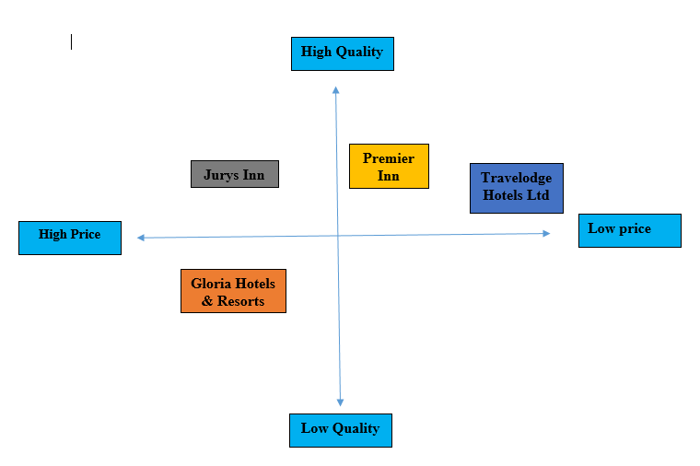
Figure 01: Perceptual Mapping
Source (created by the learner)
Collaborators
Research shows that the Premier Inn with the support of WhiteBread had an ongoing investment of £25 million for direct online channels (Doggrell, 2020). This reflects the company's ability and practice of conducting B2B relationships with the objective of collaborating with online platforms and driving sales. Premier Inn works with several travel management companies and Hotel booking agencies which reflects the partnerships of the business. Moreover, the objective behind partnership includes offering vast connectivity for customers.
Climate
Factors | Elements | Impacts
Political | Brexit | It has resulted in impacting the business services of Premier Inn across the EU region. Additionally, it is reported that hotel rooms of Premier Inn had 40% falls due to Brexit uncertainty (The Guardian, 2019).
Economic | Inflation rate | The inflation rate in the UK is projected to be 6.7 in August 2023 a notable decrease from 6.8%. (Gooding, 2022). Such a decrease in the inflation rate is a great opportunity for the business to have an increase in sales of hotel rooms.
Social | Trend over online purchases | Customers are driven by online purchases leading to an opportunity for the brand to increase its online operations and have growth in online bookings.
Technology | Internet penetration rate | It is reported that 97.8% of the total UK population will be internet users in 2023 (Kemp, 2023). This data reflects an opportunity for the brand to have an increase in its online bookings as the population are more aware of internet/ online facilities in hotel booking.
Legal | Legal laws and requirements | The brand has to significantly consider legal requirements as placed in the Employability Right Act 1996 while treating its employees and avoid any legal implications in the business.
Environment | Practice of sustainability | As per the government, the brand has to actively consider the Environment Act 2021 to contribute towards maintaining the sustainability of the business and achieve national sustainability goals.
Table 02: PESTLE analysis
Source (created by the learner)
Marketing Mix
Product: Ranging from en-suite bathroom to super luxury bed Premier Inn undoubtedly has the best room features available to its valuable customers. Additionally offers a vast range of hospitality products and services.
Price: The concept and practice of value-based pricing strategy is actively followed by the Premier Inn which aims at providing customers with great value for money.
Place: The brand has over 800 hotels through which its products and services are distributed. Also has an online website and channels to suit online bookings (Premier Inn, 2023).
Promotion: The company uses various promotion channels such as television, and digital media to promote the brand and its offerings.

Objectives
Specific | Measurable | Attainable | Relevant | Time frame
To increase the global presence of the brand by 10% | Measured through the use of Net Promoter Score to analyse the recommendation of brand between -100 and +100 score. | It is attainable through defined social media communication strategy. | It is relevant as it can aid the brand in overcoming the weakness of a limited global presence. | 2 to 3 months
To obtain a new customer base | Measured through Churn rates. | It is attainable through a defined social media communication strategy. | It is relevant as it can aid the brand to increase the customer base and overall sales. | 2 to 3 months
Table 03: SMART objectives
Source (created by the learner)

Strategy
Considering Ansoff Matrix strategies,
Market penetration: It involves selling already acquiring products into the already operating market with the objective of increasing sales (Zugay and Zakaria, 2023). It involves a low amount of risk as the business does not need any heavy investment.
Market development: It typically deals with the concept of selling existing products into new markets to cater to different customer segments. It involves the least risk as it does not require significant investment but can face entry barriers.
Product development: It includes introducing new products into existing markets with the aim of increasing product sales. Additionally have high risks as the business is required to heavily invest in key area such as research and development.
Diversification: This strategy involves developing new products and introducing to new markets generally having the highest risks of all as the business is required to invest heavily in capital, market entry and research and development (Zugay and Zakaria, 2023).
Out of all Premier Inn can follow the concept of market development wherein the company can foster its products and services into new markets typically at a global level which will enable the company to achieve set objectives, gain a position in new markets, and increase its sales and brand awareness.
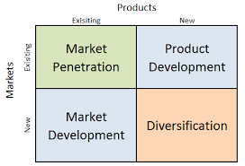
Figure 02: Ansoff Matrix Strategies
Source (Zugay and Zakaria, 2023)

Tactics
Communication mix is typically utilised in which the company will utilise various digital communication methods such as social media and so on. Since the company lacks a global presence the usage of social media platforms such as Facebook to promote its products and services can aid in reaching out to new customers overseas (Herawati et al., 2022). Eventually aids in overcoming the internal issue of limited presence through the practice of social media communication strategy. It is to be noted that the company utilises different communication channels such as television, and digital media to convey its brand message, offerings and overall brand. The multi-channel approach of the company aids the company to reach wider audiences.

Action
“Tasks” | “Start date” | “End date” | “Duration in days”
Conduct market research | “15/Aug/2023” | “21/Aug/2023” | “7”
Segment customers | “22/Aug/2023” | “28/Aug/2023” | “7”
Targeting customers | “29/Aug/202” | “4/Sep/2023” | “7”
Develop promotion channels | “5/Sep/2023” | “11/Sep/2023” | “7”
Monitoring | “12/Sep/2023” | “18/Sep/2023” | “7”
Further improvisation | “19/Sep/2023” | “25/Sep/2023” | “7”
Table 04: “Work-Based Structure”
Source: (Self created)
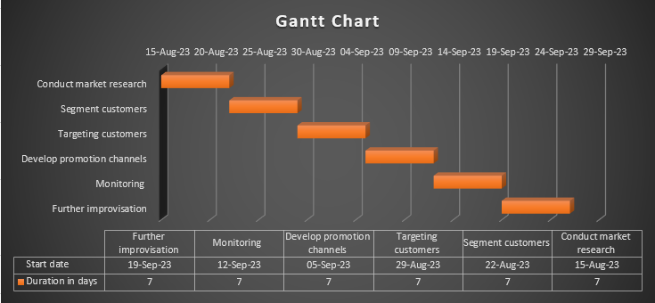
Figure 03: Gantt Chart
Source: (created by the learners)

Control
The success of a marketing plan will be measured through the use of KPI tools such as ROI or Return of investment, Cost per Conversion, Conversion rate and so on. ROI will be used in which it involves calculating the overall profit earned after the investment (Taherdoost, 2023). The expressed percentage will enable the company to measure and understand the success and effectiveness of the marketing plan.

Conclusion
Summarising the above report it can be said that the Premier Inn, one of the top hotel brands can effectively communicate with targeted audiences through the use of a social media strategy. The usage of such a strategy will enable the company to communicate with different customer segments and can even promote the business offerings through social media platforms.

Reference List
Doggrell, K. (2020) Whitbread looks to drive B2B, Hotel Management. [Online]. Available at: <https://www.hotelmanagement.net/financing/whitbread-looks-to-drive-b2b> [Accessed on: 6th October 2023].
Gooding, P. (2023) Consumer price inflation, UK: August 2023, Consumer price inflation, UK - Office for National Statistics. Office for National Statistics. [Online]. Available at: https://www.ons.gov.uk/economy/inflationandpriceindices/bulletins/consumerpriceinflation/august2023#:~:text=The%20slight%20easing%20in%20the,of%2011.1%25%20in%20October%202022> [Accessed on: 6th October 2023].
Herawati, A.F., Yusuf, M., Cakranegara, P.A., Sampe, F. and Haryono, A., (2022). Social Media Marketing In The Promotion Of Incubator Business Programs. Jurnal Darma Agung, 30(2), pp.623-633.
Kemp, S. (2023) Digital 2023: The United Kingdom - DataReportal – Global Digital Insights, DataReportal. DataReportal – Global Digital Insights. [Online]. Available at: <https://datareportal.com/reports/digital-2023-united-kingdom#:~:text=Kingdom%20in%202023-,There%20were%2066.11%20million%20internet%20users%20in%20the%20United%20Kingdom,percent)%20between%202022%20and%202023> [Accessed on: 6th October 2023].
Kunst, A. (2023) Premier Inn brand profile UK 2022, Statista. [Online]. Available at: https://www.statista.com/forecasts/1335699/premier-inn-hotels-brand-profile-in-the-uk [Accessed on: 6th October 2023].
Premier Inn, P. (2023) About us Premier Inn. [Online]. Available at: https://www.premierinn.com/gb/en/why.html [Accessed on: 6th October 2023].
Solas, S., (2023). Enhancing customer satisfaction through implementation of meaningful leisure activities. Case: Hotel F6, Helsinki.
Taherdoost, H., (2023). Analysis and Performance Measurement in E-Business. In E-Business Essentials: Building a Successful Online Enterprise (pp. 351-378). Cham: Springer Nature Switzerland.
The Guardian (2019). Premier Inn owner says Brexit uncertainty has hit bookings Guardian News and Media. [Online]. Available at: <https://www.theguardian.com/business/2019/apr/30/premier-inn-owner-brexit-bookings-whitbread-london#:~:text=Premier%20Inn%20owner%20Whitbread%20has,among%20business%20travellers%20outside%20London> [Accessed on: 6th October 2023].
Zugay, B. and Zakaria, R., (2023). Ansoff Matrix.

