Michelle Kimberley Peña Ubardine

My Digital Life
Smart Phone (Samsung Galaxy)
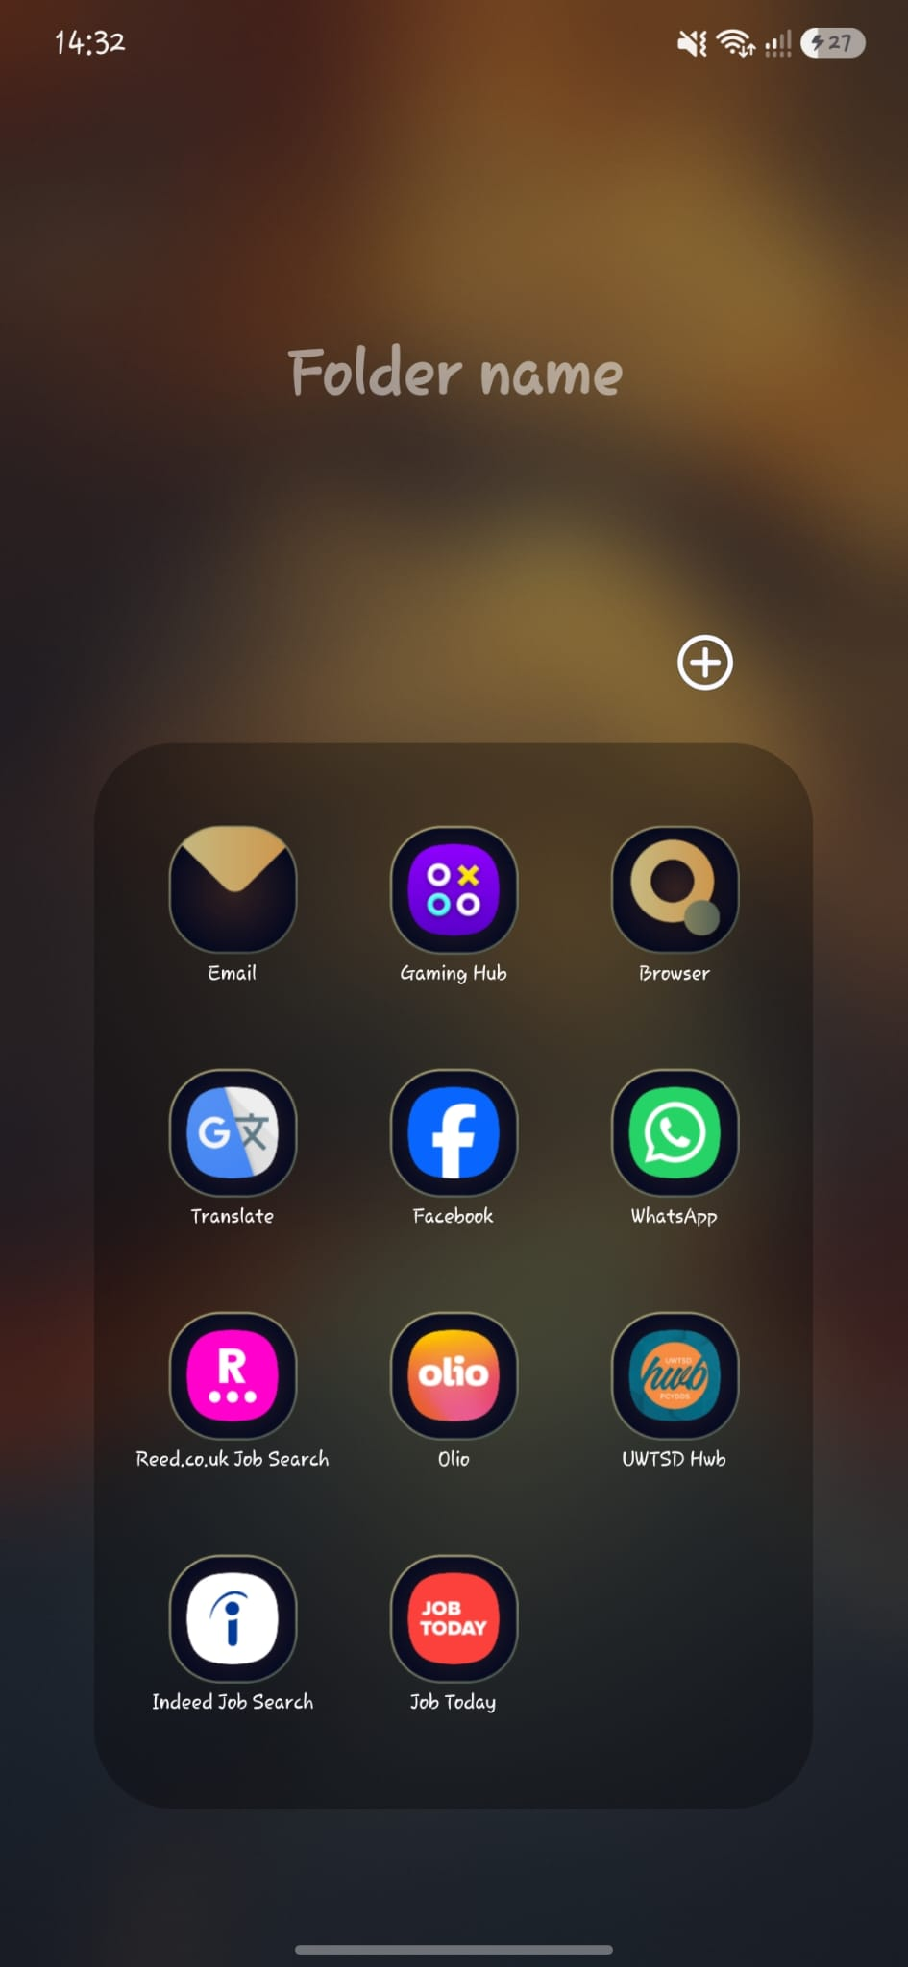
My Smart Phone it’s useful tool for my digital life, I use it to stay connected with what’s happening on the world and around me, it has so many Apps very useful that can make my life a bit easier.
One of the apps what I’m using the most at this moment its Olio App, I believe isn’t very popular between the people, but more people are discovering it.
This App it is useful for find a good deals or free food. There is some food store where the food it’s about to expire, because they don’t want to waste the food, they can lower the prices, therefore the people can have a food cheaper. In case you are not able to afford food there it’s a part on the app where you can get free food closest to your location, there it’s a community where people go to some stores and take the food that couldn’t be sold and are about to expire, there is someone in charge to look for this food and then they post a photo on the app and the availability so the people can go and grab it.
Another App useful for me its WhatsApp, I use it to relate to my closest people, it helps me to be aware if there it’s any important problem with them.
It also helps me to relate to other important things, for example when I am looking for a Job the employers can reach me easily from there.
Laptop (VICTUS)
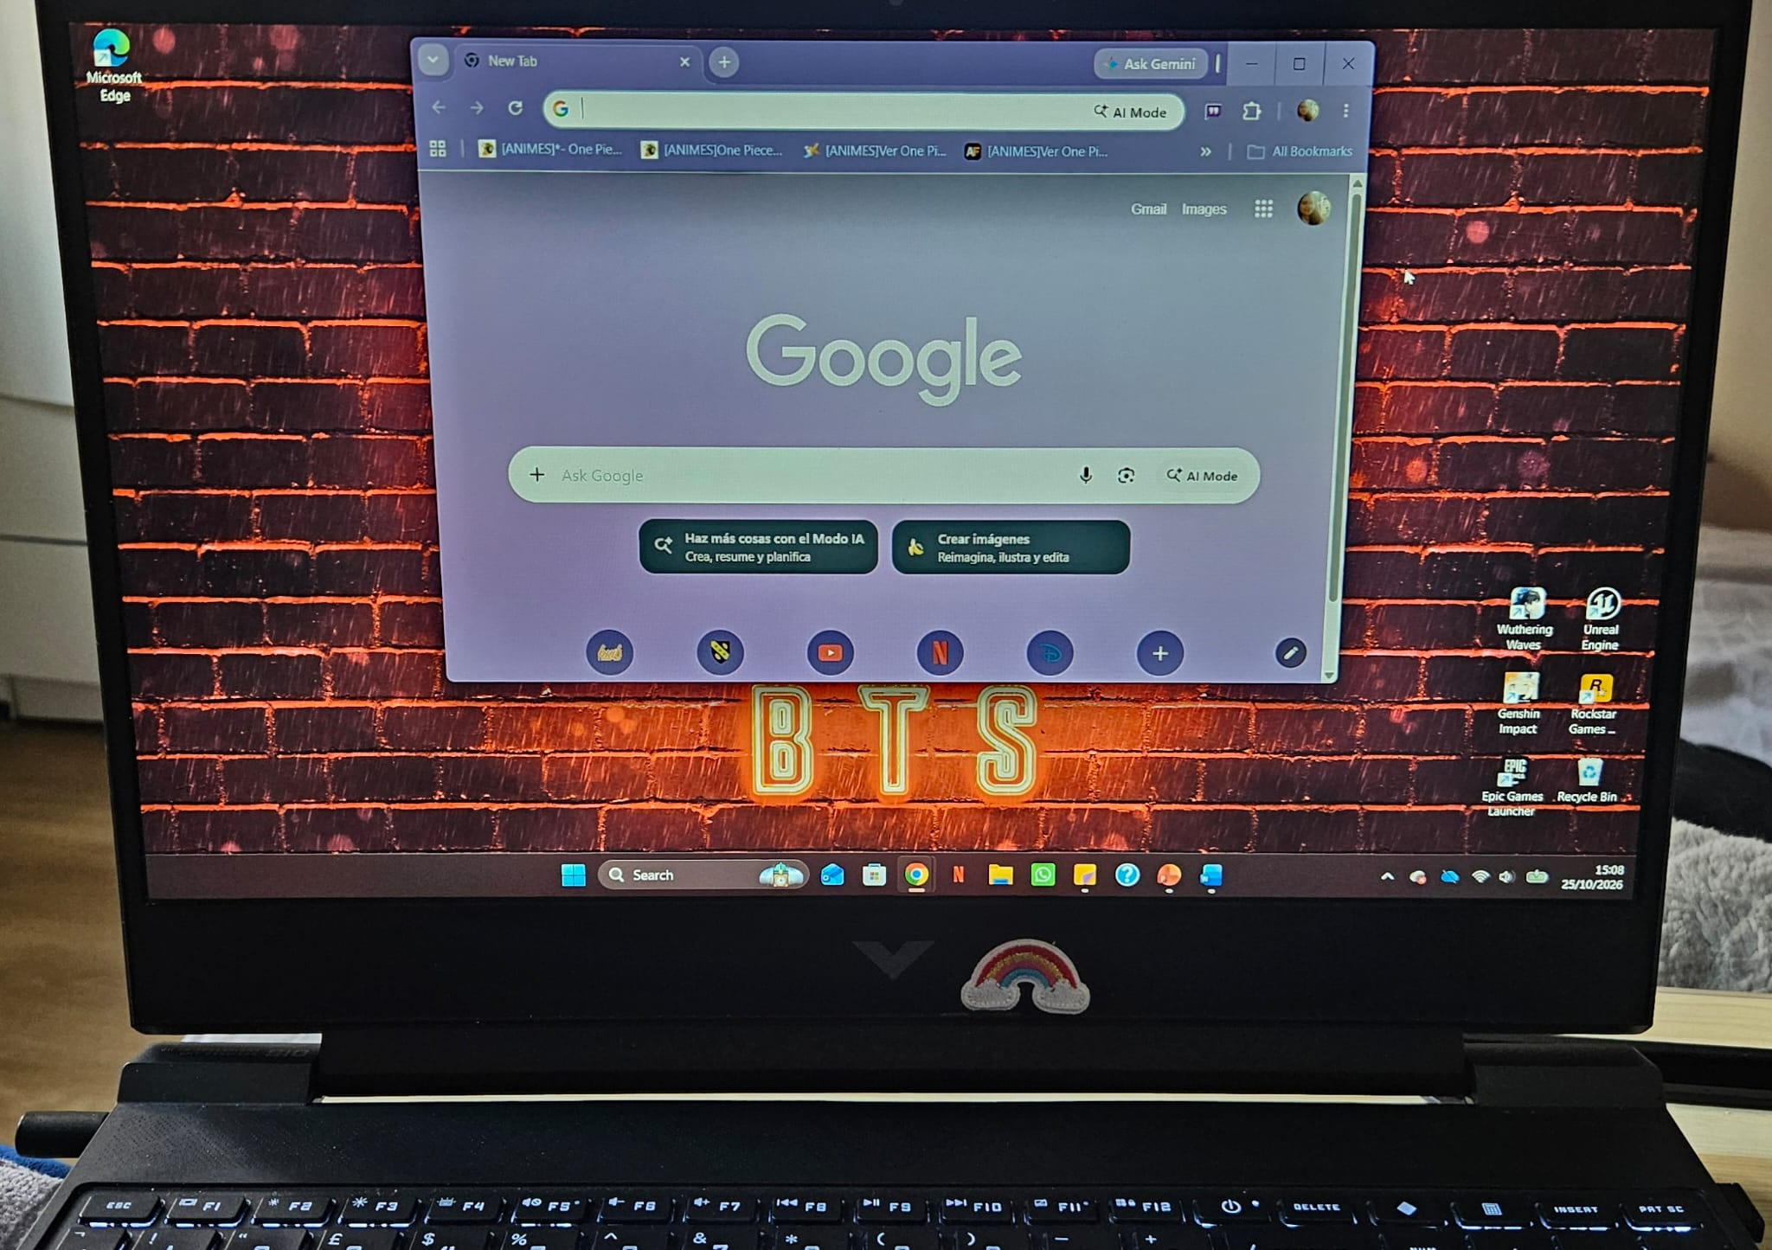
I have a hybrid laptop, that’s means I can use it to play video games, for work or study and it helps me to be updated with my Digital Skills, and with the understanding and improving the new technologies;
One of the reasons I use my laptop and was the main reason before start university was for entertainment. I like to play videogames I was spending hours playing, it doesn’t seams very important but with that, I learned how to type a bit faster, I also learned the important of the updates on my laptop and if my laptop isn’t working fast or if its frozen can be for that, it helps me to be confident when I need to use it and try and it challenges my fast understanding for the commands.
Another of the reasons I use my laptop it is for search information, I use Google Chrome for anything I need to search, this is a very important tool and with the help of this one I was able to search and look information for example to make my Settle Status, it helps me to understand witch pages are important to apply or with other was not related or important information, I understand there it’s a lot of information on the world and being able to identity what it’s real it makes easy to find what are you looking for, sometimes I search for recipes or when I don’t know how to do something or even to find locations when I am lost with Google Maps.

Microsoft Office
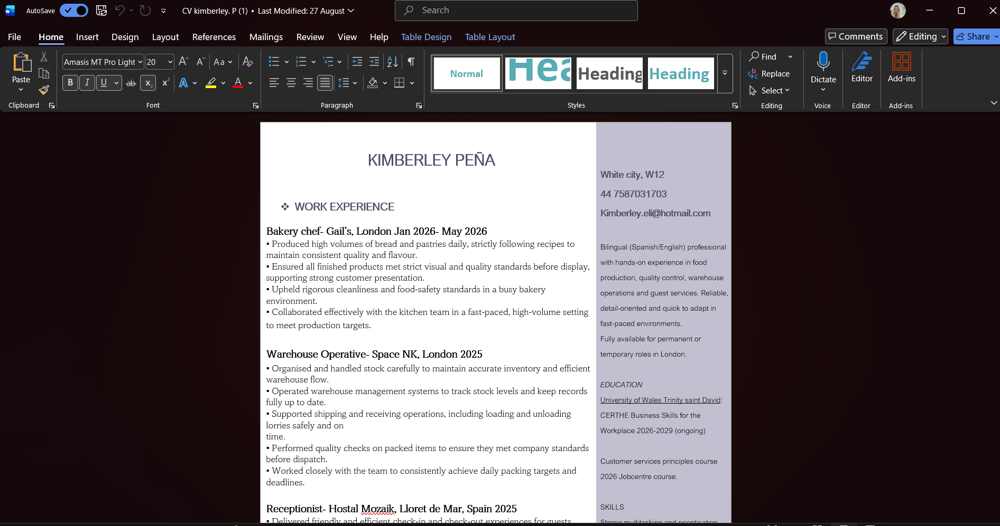
One Digital tool Very important it is Microsoft Office, and it is challenging for me, but I also know how important it is, I do not have much to say about this App, but I still wanted to mention, because it is important.
I really spend a lot of time trying to understanding Microsoft Word, I mostly use it to build my Curriculum Vittae; create or modify it, learning how it works, I’ll go improving it by the time, I know how to change the style or change the size, I recently learn how to remove the space between the lines, how to adds images or photos and how to change the design of the document, I still have a lot more to learn about Word, my knowledge it’s basic, I know it’s been updating and changing by the years, I can defend myself in this area but there it’s much more to learn.
Another of the App I use it frequently it’s Microsoft Outlook, I really use it daily, it helps me to be updated with my new emails, I can send e receive emails, and I can move it into categories or flag them into important, and because I am recently looking for a job the employers can contact me by email if they need it, I also receive new offers if I am subscribe or interest in something, it also help me to learn how to send a email polite and confident and attach files when I need to.
There it’s so much more in Microsoft Office thar I need to improve and learn, I would like to learn how to use Excel and also Power Point and be more confident with all these tools which are very important for work, study or for use them for personal reasons.
The HWB App
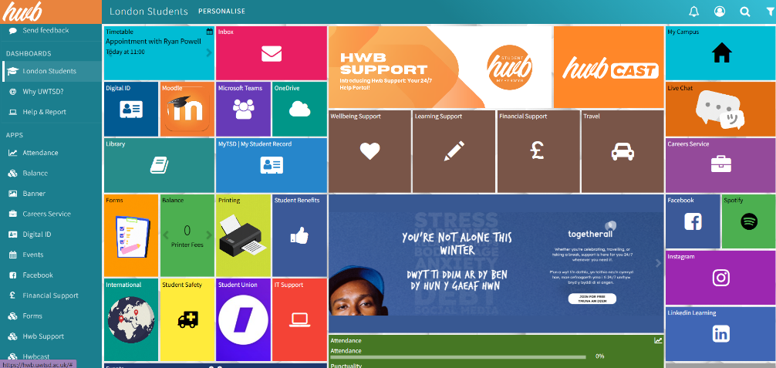
I use the hwb App every week since I started the course, that’s important to me because it keeps me updated with everything I need for the university, it helps me to see my timetable or any appointment at the university, it also has Outlook so I can receive and send emails, and it has Student Support, Wellbeing Support, One Drive, Moodle which will helps me with the understanding of the classes, the assignments, and if I miss any class. Moodle it’s something new for me and I find it a bit challenging because there is so much new information inside and different ways to learn, and sometimes it is a bit confusing for me, but I feel confident about learning more about this App.

eBooks (GOOGLE PLAY BOOKS)
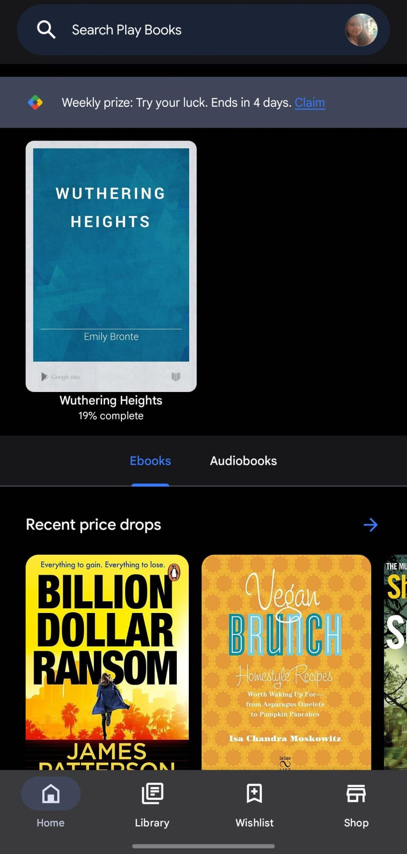
A different way to read it’s with an eBook, I like to read and I find this App with Google Play, I can download for free or buy the books that I’m interested or with a lower price, i can add Bookmark or even read it aloud witch also help with the learning of the English language. In this app I can even have Audiobooks those are interesting to have when you are busy, and you don’t have time to read.
Earbuds
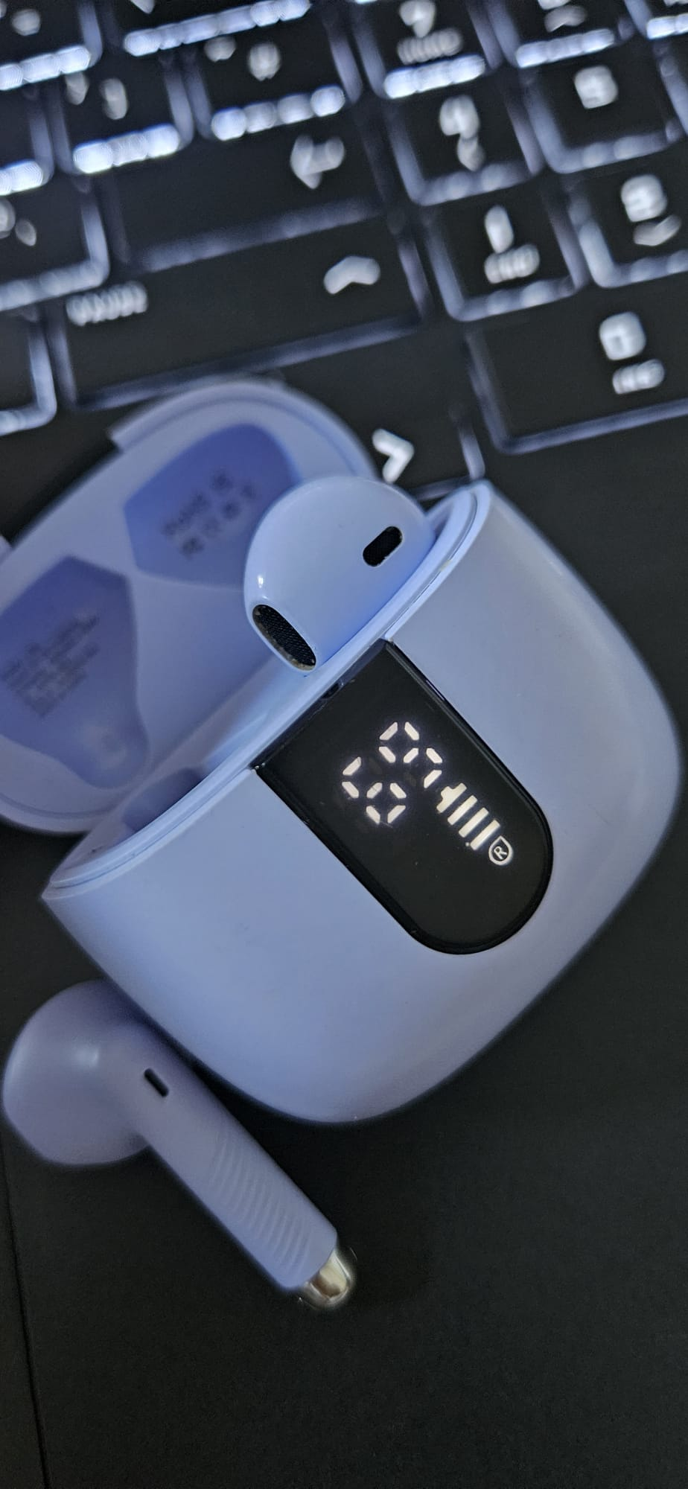
I am a person who loves music, and with this device I can hear music everywhere, it gets connected by Bluetooth on my phone or laptop, with those i can play music or receive a call, it has a microphone so the people can hear you while you wear them, on terms of music, i can play a song and pause it, and get to the next one, and when I am in a call I can answer or hang out, it has an small screen that shows the level of the battery and easy to understand how it works, it is small and easily portable.

My Short Reflection

Digital skills are important for me because I use my Digital life everyday with different purposes, I check my Outlook to check my emails; I check my cv in my document Word and search in google to find information.
I feel confident using my Digital Skills and my Digital devices, and I really enjoy it, I like to use my laptop to download and play videogames, and I really love to be able to go outside and listen to music with my Earbuds
I would also like to improve my skills in a more professional way, I feel this will be more challenge for me because there it’s plenty of things I still don’t know, for example how to use Excel or Power Point, and I just know the basic of Microsoft Word, and so many more that I feel challenge it, but I also know how necessary are them to be updated with the industry and to don’t stay behind.

Submission Checklist
Before you submit, please check:
​​​ ☒ I added 4–6 screenshots
☒ I wrote short sentences for each screenshot
☒ I wrote my short reflection
☒ My work is my own
☒ My file opens correctly
​​☒ My file opens correctly

