Cover Letter

Afzal Munna
Winchester House, 11 Cranmer Rd, London SW9 6EJ
a.munna@uwtsd.ac.uk
Dear Mr. Afzal,

We write to you to bring your attention to our new venture in organic food produce. URBfarm aims to bring low cost, organic vegetables to Inner-City London consumers by using the Hydroponic method. Hydroponics is the practice which enables farms to grow crop without the use of soil, instead it cultivates plants in nutrient-rich water. We have mastered this process and in doing so are now able to mass produce with minimal cost.
One of our main objectives is to increase the shelf life for fresh produce and we do this by providing a farm-to-consumer service. Our goods are all grown within containers located within Inner-City London meaning the produce reaches the consumer in its freshest possible state.
We have a fully structured team who are skilled across many departments within the organisation. Our crops offer a higher yield than growing in soil, so much so by 40% per sq ft.
URBfarm is a customer focussed business with good ethics and we are confident that we can make a huge, positive impact on the current market. We would welcome the opportunity to present our business plan to you, therefore please feel free to contact us at your earliest convenience.
Sincerely,
URBfarm

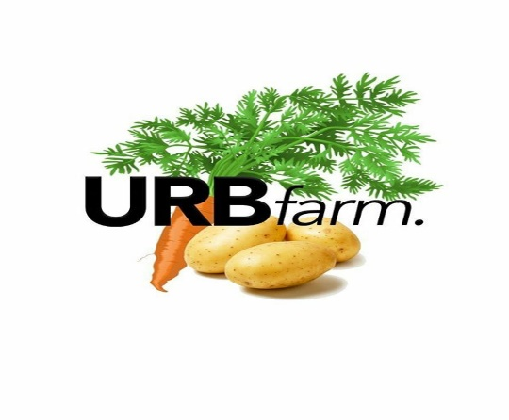

Student 1
URBfarm is a hydroponic farming site consisting of 40ft containers, fitted with a state-of-the-art system used in growing leaf vegetables. The site is in a disused car park in Shoreditch London, where our first 3 crops will be spinach, kale and watercress.
Our objective is to bring better tasting and fresher produce to the consumer by drastically lowering the farm-to-consumer travel time by 99.5%. Also, by doing this we can reduce produce costs by 30-70%.
At present the major supermarkets offer fresh produce, that are one to two days old by the time it gets to the consumer. Due to being grown in a field this produce is subject to the elements and need chemical pesticides to deter insects.
With URBfarm we only use water to grow our produce and with it being grown in a container it needs no pesticides and is 100% organic.
URBfarm has the potential to grow by 400% in the next 1-2 years, by opening two more sites in London and one in each major city around the UK eg. Bristol, Birmingham, Manchester and Liverpool.
Even though the large supermarkets could replicate URBfarm on a larger scale, with us being the first we will be the market pioneer in the UK.
The set-up cost of a site is estimated at £4050, broken down as followed:
2 Containers £2200
1 Water Tank £150
Pipes £700
Lighting £250
Wood Fittings £250
Growing Basket & Fittings £500

A survival budget of £1133 per month, broken down as followed:

Rate £150
Salary £200
Rent £300
Telephone/Internet £50
Contents Insurance £100
Marketing/Advertisement £150
Distribution £150
Wrapping bags (1000 units) £33

The survival budget will fall after 3 months to £983 as a result of cutting marketing and advertisement costs.

Table of Contents
ALL (Student 1, 2, 3, 4 and 5)
Ismail Fasesan - . I am responsible for writing the financial plan of our business. Our business is urban farming, this is an agricultural business. It has always been my plan to go into farming. Back in Nigeria, I have five acres of land which is full of mangoes, oranges, cashew and other exotic fruits. I am also into vegetables like carrots, cucumber and other nourishing vegetables, so this business with my colleagues just come across as extension of my business in Nigeria. I had Advance Diploma in Business Administration, this relate to financial and business management, so this is in line with managing Urban Farming. I have also work as a bookkeeper for a period of five years, so I have adequate knowledge and experience to be the Financial Accountant of the business. My lack of knowledge of hydroponic farming is a bit of concern but I will do more research on google and you tube.
Shaker Ahmed - I am undertaking the role for operations in our business plan on URBfarm. I am suitable for this role as I have many years of experience in the food and hospitality industry, I have worked in numerous restaurants since the age of 16 as my father owned a chain of restaurants and diners. Working in the heart of central London, I have gained a lot of knowledge of how fast paced and eagerly critiqued customers’ expectations are to be met. I have also worked in the property industry for the period of 4 years which gives me exceptional abilities to guide the real estate needs for our business and to assist with decisions for future locations. Through many trips to my home country in Bangladesh, I have been able to obtain a lot of knowledge and training in the farming sector as my grandfather owns many ranches and farms.
Marilou Santillan – I am responsible in distribution and strategy of this business plan. I covered the 7 Ps which are Product, Place, Price, Promotion, People, Process and Physical evidence. I have many transferable skills which I applied in this business plan, such skills are I.T. , good communication both oral and written, good attitudes and behaviour towards customers, time management and good personal attributes in working environment. I completed management course training in my work place which is at Ibis Hotel, London. I also worked in account department as a sales ledger administrator at Sovereign Company in Egham for more than 4 years. Overall, I coordinate with my team member to workout with this business plan.
Jerome Longmore – I was appointed to lead on Marketing for the URBfarm business plan. I have previously worked within the direct marketing sector which enabled me to adopt many of the marketing methods used to develop our marketing strategy. I have excellent communication skills which assisted me when approaching the general public to obtain market research. I have a Level 3 in Agricultural Development and therefore have a good understanding of the hydroponics method of growing produce. I have also worked 2 years at Rural Agricultural Development Association (RADA), where I was responsible for contacting farmers and negotiating the purchases of livestock and food products.

- Business Description and History
Short Term Objectives - To provide low cost, organic vegetables to consumers within London
Medium Term Objectives – Expand the number of products from 3 to 10 and become a market leader within our sector
Long Term Objectives - Establish a site in 7 major UK cities

- Business Structure

Student 2
- Product and Services
This refers to an item or items the business plans to offer to customers. The products should seek to fulfil an absence in the market or fulfil customer demand for a greater number of products already available. Before they can prepare an appropriate campaign marketers need to understand what products are being sold, how it stands out from the competitors, whether the product can also be paired with a secondary product or product line and is there a substitute product on the market.
URBfarm offer 3 main products at present (This could potentially expand throughout the duration of the business). The 3 main products are Kale, Watercress and Spinach which were selected as they require minimal maintenance, are light in weight and therefore fit nicely into the growing container and all 3 fall within the top 10 nutritious leaf vegetables.
URBfarm will operate 7 days per week (excluding bank holidays) from several large high street markets including Borough Market, Camden Market and Spitalfields Market. URBfarm will also distribute to small London based restaurants.

- Market Analysis and Needs
Companies use market analysis to gather relevant information which generally relates to the industries, customers, competitors and other market variables. The information collected is used to support critical business decisions relating to sales, purchases and other key elements.
As one of the main components of a business plan its results are used to identify opportunities and risks within that market.
Our market analysis results confirmed our original thoughts that although consumption of heathy leaf vegetables is high, the quality of the produce upon consumption has lost nearly 50% of nutrients and in some case has lost all nutritional value. The main reasons for the reduction in nutrition is due to the pesticides, herbicides and the duration of transit. Our business will eliminate or reduce these elements, resulting in highly nutritious produce.

Your target customers
- Within London there are 840,000 vegetarians and 600,000 vegans in the UK. The number of vegans has quadrupled since 2014 and expected to double in the next year. Also, on URBfarms radar at a later date would be the 152 vegan’s restaurant located in London.
- URBfarm aims to target health conscious customers, this will include Vegans, Vegetarians and organic eaters. Our product will bring fresh produce to those living or working within metropolitan cities.
- URBfarm provides fresh, local produce which provides a longer shelf life than imported produce. Produce grown on a rural farm must go through lengthy process. Each item needs to be picked, transferred to storage, quality controlled (washed and clipped), packaged, boxed, transported to a supermarket and then made available to the consumer. URBfarm can not only remove a number of these stages but can also reduce the transportation time as its containers are located in Inner-city London. Our produce will not be transferred to storage, will not require washing (as no pesticides are used) and will be boxed without individual packaging. Shortening this process alone retains an extra 20% of nutrients in comparison to rural farms.

Companies need to consider the unit cost price and distribution expenses when setting the sells price mark for their products. Competing products within the marketplace also need to be considered before a price mark can be agreed. Once all of this has been considered, the company then needs to ensure that the price mark is suffices the expectation and affordability of its target consumers.
URBfarm aims to be an affordable healthy option. To ensure our pricing is affordable we researched national supermarket chains and set our prices between 30-70% cheaper. URBfarm can comfortably offer these prices as our local produce approach eliminates importation costs.
Your market and competition
To understand our market, we have conducted online research which has advised us that a high number of the London population are converting to organic/healthy eating options each year. Online surveys and social media polls told us that over 60% of the sample would choose to eat healthier, local produce should the prices be lower than those currently offered by national supermarket chains.
URBfarm conducted product quality testing, which confirmed that URBfarm produce products had a shelf life which exceeded those of the national supermarket chains by 60% and contained no pesticides.

Competitor Analysis using the SWOT format
Competitor 1 - TESCO
Strengths  - Established organisation with over 3,960 stores within the UK | Weakness  - Fresh produce must travel from farm, to warehouse and then to store
Opportunity  - Funds available to replicate URBfarm on a large commercial scale | Threats  - Ability to cut prices  - Already have a large client base

Competitor 2 - ALDI
Strengths  - Cheap produce  - Established organisation with over 870 stores in the UK | Weakness  - Fresh produce must travel from farm, to warehouse and then to store
Opportunity  - Ability to replicate URBfarm internationally throughout their stores | Threats  - Already have a large client base

Your Company - URBfarm
Strengths  - Less than one-hour travel time from farm to shelf  - 60% longer shelf life than national supermarket chains  - Better, fresher tasting produce | Weakness  - Small operation  - Targeting a niche market
Opportunity  - Room to expand the number of products produced  - To develop a ready-to-go brand including smoothies, salad pots etc | Threats  - Possibility of being replicated

- Marketing and sales plans
Marketing as a discipline involves all the actions a company undertakes to drawing in customers and maintaining relationships with them. Networking with potential or past clients is part of the work too, and may include writing Thank you emails, playing golf with prospective clients, returning calls and emails and meeting with clients for coffees or a meal. At its most basic level, marketing seeks to match a company’s products and services to customers who want access to those products. Marketing products to customers ultimately ensures profitability.
Products, price, place and promotion are the 4 P’s of marketing. They collectively make up the essential mix a company needs to market a product or service. Neil Borden popularised the idea of the marketing mix and the concept of the 4 P’s in the 1950’s.
URBfarm will develop an information only website, which will provide product details, location of sales outlets, ethos and ethics. URBfarm will advertise via social media, leaflets and flyers, newspapers and mini billboards. We will host promotional events aimed at potential consumers which will also include sample booths.
URBfarm has a simple but affected sales plan. We aim to provide direct sales throughout the large scale, high street markets in London. We also have a strategy which has been developed to drive mass sales by targeting small local restaurants.
Three of our key promotional activities that will help meet our business objectives:
- Instagram – Allows us to physically display our produce and process of growth. Has the ability to conduct market research via Instagram polls and surveys. Exposes the business to potential collaboration opportunities, we also later use the paid advertising option for a wider customer reach.

- Sample Booths – Enables us to capture immediate feedback and customer reactions by providing them with a sample. This feedback will include information relating to taste, freshness and appearance. We can also apply the at farm expos in new city.
- Website – Helps with direct traffic between URBfarm and the consumer. Easy to update and provide current information. Ability to offer promotions and competitions.

Student 3
- Operations
Supplier / Relationship 1
Organisation  Mr-FotherGills – Seed Supplier | Relationship Status  We will make certain that our relationship with this supplier will be maintained appropriately as they are one of the leading seed suppliers of the UK.
Service provided  Mr-FotherGills provides the most reliable and price efficient seeds in the country. Compared with other competitors, they are fast, efficient and low cost as their prices are 40% lower than other retailers. | Key terms of relationship  Our objective is to stay with this supplier unless they give us a reason not to.  URBfarm aims to increase the purchase of their supplies as our business expands.
Other operational considerations
As a starting business at first, we do not intend to employ staff as we have closely calculated that there is not a need to. From the commence of the business, us four partners will each be given direct instructions and roles to cover the maintenance of operations for the initial first 3 months. This is due to the fact our business contains equipment, machinery and labour which are easily maintainable and not time consuming. Through thorough research and background information we have obtained knowledge and training of operating machinery and the preparation of produce. There will be a rota which will be divided amongst the four of us. This along with teamwork, we will be able to run our operation smoothly, however we have made sure to have replacements in place if there were to be any discrepancies for example, if one of us is unable to fulfil a duty we must communicate with every other partner to make sure everyone involved is aware of the issue, then decide who can replace the role for the time being. This as mentioned, is temporary as it is only for the first 3 months of the business commencing. URBfarm aims to minimise labour costs by reducing the number of staff employed as machinery and produce operations are of low maintenance. Our first site which contains two 40ft contains will require just one person to be able to run all operations within a 24hour time period. This number of staff will ultimately need to increase as we expand our business to its full potential in the near future.
How many staff do you currently employ?
As mentioned above, our business will not initially employ any staff. The duties which must be carried out for the duration of each month are: Changing of the water pump every two weeks as the water we are using will be recycled, thorough cleaning of pipes used for growth every two weeks even though we will not be using any soil, cutting and sealing of produce once growth cycle has ended every 4 days, safety check of all appliances once a month, organising and labelling stock for deliveries every 48 hours. The lighting we will be using for our hydroponic farming will need to be operating 20 hours each day and will not be in use for the remaining 4. This will be conducted by an automated lighting system which will save both time and labour. For the first 3 months, all of the roles listed above will be distributed amongst us four partners, we have considered travel expenses and have included this to ‘others and salary as well as cost of seeds which will be at £1.15 for 400 seeds from Mr-FotherGills LTD to our personal survival budget. However, after the first 3 months have passed and we have seen a growth in the organisation, we have decided that all duties listed above can be carried out by an employee at the rate of the salary.
Where does or will your business operate from?
Our business initially will operate from two 40ft containers within a carpark, which through thorough research we have found to be the most sustainable and cost-effective sites. Maintenance of the containers will be low in comparison to a warehouse or operating from farmland. Within the containers we will have a small office which will include a computer, printer and telephone. Our business operations will all run from these containers as we have access to them 24 hours and they are local to all four partners. Upon expansion of the business we may consider large scale warehouses as long as they are in close proximity to the central of the main UK cities. All sites including our containers in the carpark must be tall in height as the pipes we will be using in production will all be vertical to maximise produce and minimise space. URBfarm aims to be in close reach to our consumers in order to reduce transit length and keep our produce as fresh as possible. This will give us an inevitable advantage to our competition whose distribution process is very lengthy as they often travel from the outskirts of the UK and or other countries. The negative of running our operations through a site in the centre of London is traffic and delays in transportation, however the positive outweighs this as we are reducing travel time by more than 80% through our site already being in close proximity to our consumers. Handling customer queries via email and telephone will also take place on site as there is access to our business hotline and website. Should there be any possible issues with network providers or suppliers, there must be a backup generator on site in place to tackle the problem.
What laws or regulations have you considered for your business and/or industry?
Produce of URBfarm will be labelled certified by the Soil Association founded in 1946 by scientists, farmers and nutritionists which certifies more than 70% of the UK’s organic produce and is the frontier of the British Organic Movement. These certifications must comply with the regulations set by the UK Register of Organic Food Standards – UKROFS, which confirms guidelines are met with European and International standards. “By law, produce which is classed as organic, must show a certification symbol or number” (politics.co.uk, 2018). As URBfarm does not use soil, our produce will be 100% organic with no use of fertiliser or pesticides making meeting standards and regulations a whole lot easier. URBfarm aims to be as echo-friendly as possible by using recyclable water, bio-degradable wrapping bags and energy saving lighting systems. Our objectives for the future as our business expands will be to decide on locations and sites which benefit to our goal of being an echo-friendly and sustainable organisation. We hope to meet our target market criteria by satisfying our customers needs with fresh, organic and low-cost produce.
What insurance do you currently have in place or do you intend to put in place for your business?
All contents within the URBfarm organisation will be insured through Simply Business Contents Insurance Provider, this is essential as our equipment, machinery and furnishings are vital to our business. “Contents insurance gives us the peace of mind that our business can continue as of normal if there were to be any theft, damages or loss” (simplybusiness.co.uk, 2020). Before the business commencing we have compared many content insurance provers and have found SimplyBusiness to be the most efficient and cost effective as their starting covers are from just £6.81 per month, URBfarm will need to insure the following contents: water tank, piping, lighting, computer, printer, and telephone. Additional peace of mind the organisation will have is the security of the carpark which has 24-hour gated access which allows those only with passes to be permissible. In the near future, as our organisation expands and funds increase, we will take measure to insure all sites have full contents insurance in addition to safety and security measures for the running of all operations. We aim to provide employees with a pension and OTE benefits.

Student 4
Distribution Strategy for URBfarm
Marketing and distribution are two very important factors for getting brands and organisations recognised and invested in by relevant consumers and companies such as supermarkets, and sell our products, to help our business profit and grow. This section covers our marketing and distribution goals and how we want to carry it out to achieve these goals. It takes into consideration who are target audience are, how we will tackle potential issues such as competitors, and how we will use our budget and make profit. I will use 4Ps The Marketing Mix theory by E. Jerome McCarthy (1960) that was later updated in 1981 to 7ps: product, place, price, promotion, people, processes and physical evidence. Even though this theory was been introduced over 40 years ago, we have found it to be a valuable guideline for our marketing and distribution plan and we have considered technological advances in line with this theory.
Our business plan is URBfarm.
This is a hydroponic farming site consisting of 40ft containers, fitted with a state-of-the-art system used in growing leaf vegetables. The site is located in a disused car park in Shoreditch, London, where our first three crops will be spinach, kale and watercress. Our key selling point is sustainability and freshness of our products that will be made readily available for our consumers throughout London. We have allocated a total of a £300 budget for both marketing and distribution with hopes that this will be cut after three months when URBfarm is up and running. By the next one to two years we hope to have grown by 400%, increasing our distribution to other major cities around the UK such as Bristol, Birmingham, Manchester and Liverpool.
Product: Hydroponic farming site consisting of 40ft containers, fitted with a state-of-the-art system used in growing leaf vegetables. This will be located in a disused car park in Shoreditch, London, where our first three crops will be spinach, kale and watercress. Our key selling point is sustainability and freshness of our products that will be made readily available for our consumers throughout London.

Placement: Location plays a key role in our marketing and distribution plan. The URBfarm site is located in a disused car park in Shoreditch, London. This will be our main site to expose our products to the local area of Shoreditch. We have chosen Shoreditch as it is a busy but diverse location. Located near Liverpool Street and Bank, it is an area exposed to commuters from all around England that commute into London. It is also a tourist location with artistic attractions like Brick Lane. Finally, it is also a relatively residential areas bordered with other residential areas of East London such as Whitechapel, Shadwell and Bethnal Green. These factors make it a perfect spot to be recognised by potential consumers.
Even though we have our main URBfarm site in Shoreditch, our main target audience will be supermarkets around inner-city London. This is because we cannot afford to only sell our products in one location as it will not bring us enough profit. By making sure they are sold in inner-city London locations only makes sure our products can reach customers in fresh condition. When selling through retailers as opposed to selling direct, this channel must be treated as a group of customers. We have learned to understand their needs to deliver strong marketing programs. We have chosen to sell our products at URB farm to selective supermarkets, we will not be trying to get our products in every supermarket. Instead, we will be choosing carefully: which supermarkets are lacking in sustainable vegetable products? It is likely to be in smaller, more local supermarkets such as Tesco Express and Sainsbury Local because larger supermarkets have a wider range of products. It is unlikely that URBfarm will be noticed. By choosing supermarkets with limited range of vegetables, URBfarm brand will be able to stand out and have a better chance of being sold to consumers. This will be our method of tackling potential competitors. This way everyone’s revenue and profit will be maximised in the process.
Price: We have taken into mind the target audience when looking at the price. The price we have for supermarkets and retailers will be cheaper per item as it will be sold to them in bulk. We will provide a new bulk of vegetables weekly because this is the life of the fresh produce. We will form agreement to have 50% share of the profit of URBfarm products sold in selected supermarkets. However, in the main branch in Shoreditch, we will price the vegetables as £1 per kilogram. This will make it affordable for the consumers without losing us profit. We will take note of the price each week and whenever possible, we will increase the price to make more profit. For example, if many customers purchase one type of vegetable like kale, we can put the price of the kale up by 10% to 20% to make to £1.20 per kilogram.
Promotion: To promote URBfarm and get it well recognised by the wider public, we will be using posters, flyers and online platforms such as social media and a brand website. We will be focusing mainly on online platforms as to print too many posters and flyers for advertising will be both expensive and going against our sustainability ethos. We will choose the placement of our posters and flyers effectively, placing them where they can be noticed by consumers easily. In modern day, the internet has proved to be accessible and widely used by a variety of people including businesses. We will be using this to our advantage by creating social media platforms and an URBfarm website where we can show our products, connect with customers and overall, establish our brand to be one that cares for their products as well as their consumers. For example, if customers have questions about our products or our company, we can instantly respond online. We can also use it to introduce our products to people if they have not heard about URBfarm. This will be very useful for making URBfarm accessible a lot of different audiences who are interested in vegetables.
People: As we have chosen to sell URBfarm products in selected supermarkets that already exist, paying these workers are less of our worries. However, to get URBfarm up and running in our Shoreditch main branch, we will need a group of workers to help with distribution and purchase of consumers. At the moment, we have three key workers who are scheduled to work at the main branch in Shoreditch. This will be enough for the meantime to transport the vegetables into the branch, get them prepared and displayed for customers ready to buy, and to be present when customers are there to buy and purchase, for example if they need to ask questions. This will also require training for the workers as they need to have excellent knowledge of the products, company ethos and generally how to work in the Shoreditch branch. We will be designing our own website using Squarespace (www.squarespace.com), the leading online website designer. It provides templates of websites which will give us freedom with to build our own website and saves us from hiring an external web designer. The profit we make will go directly towards our workers and we will increase their pay whenever possible to make sure they stay with us and can earn a living.
Processes: Processes is an important part of distribution so distribution channels should be taken into consideration. A distribution channel is the ‘conduit from product to customer in its simplest form… the theory of distribution channels states that each company in the channel must charge enough to pay expenses and leave profit. Knowing where you are in the channel helps you understand you’re your costs and your mark-up needs.’ For our business plan, we have chosen to have a £150 budget on distribution. This will be used to help distribute products to consumers.
Our main distribution will be online and delivery services. This will help with reaching and increasing our consumers. However, because we want to make sure our sustainable ethos is followed, we will have to make sure that deliveries are only within Inner-city London. This means it can be transported with low emissions and low carbon footprint. We can work with delivery service channels such as Deliveroo that will help get our produce directly from our Shoreditch site to all around London. To reach our goal of growing by 400% in 1 to 2 years, we will need to set up a similar system in other major UK cities. This will need to be heavily researched again considering location and consumers.
Physical evidence: We have tried and tested the hydroponic farming method and have found it to be sustainable and reliable. We have physical products which are the vegetables: kale, watercress and spinach. We understand that this may be limited as we are only growing three main crops at the moment, but we hope to be able to grow a wider variety of crops and will be using our time to develop new sustainable ways to do so. We will continue to test growing other vegetable products so that we can expand our range and increase profit.
To summarise, our marketing and distribution plan has used the updated version of The Marketing Mix theory by E. Jerome McCarthy (1960) of the 7ps: product, place, price, promotion, people, processes and physical evidence. We have covered each process in relation to URBfarm. We are confident that our £300 budget will be enough to start off our sustainable brand as we will make profit from the very beginning which we will invest towards our workers and expansion of the URBfarm organisation.

Student 5
- Financial Plan
Sources of Finance
Hydroponic agricultural farming is a lucrative business that do not require much to set it up, we aim to take advantage of the fact that not many people are into it in London. So we plan to start by contributing the sum of £2000 each, with five of us that we make up to £10,000.00. This will be our initial capital to start the business. Our plans for the future is involved the family of members by asking them to invest in the business. By doing that, we are hoping to raise enough capital to support the business. For instance, if we could raise £10000.00 from the family to add to the initial sum of £10,000.00, then we could end up with £20000.00 as working capital. We could also ask family members to invest in the company by turning their contribution to equity, there by having shares in the business. In the future, we aim to involve the bank, this will be by approaching them for loan that may be needed to run the business. As we are planning to expand in the future, we aim to also approach the investor to seek for capital to support our business. We could say that for supporting our business we are prepared to give 5% in return for contributing £50,000.00 to the business. As a way of generating cash, we could lease some of our fixed assets rather than buying them outrightly. This could release some more needed cash for the business. In the long run, we merge the business with similar one in the city of London as a way of expanding the frontier of the business. These are very ambitious plans, which can be put in place as soon as it is possible to do so. But for now we should be alright with the initial equity of the sum of £10,000.00.

Personal Survival Budget
Rate £150
Salary £200
Rent £300
Telephone/int £50
Contents insurance £100
Marketing/dis £150
Advertising/others £150
Raping bags £33

Total £1,133
This is the sum needed to run the business on a monthly basis. Our PSB as listed above, comprises of business rate of £150 per month, this is cheap because we are using container and the owner of the carpark took account of the fact that we are not using much space, so he apportion that amount for us. The salary of the sum of £200 per month is actually a maintenance money for all the members. We plan to use the money for transport and other minor expenses. To cut the cost of our operation we do not intend to employee any member of staff for now. The rent of £300 per month is possible because we are making use of the car park to minimise our cost. Telephone/internet expenses is £50 per month. We have had to shop around before settling for this one. Content insurance £100. Our precious assets are very important to the smooth running of the business and that is why we are allocating an ambitious sum for insurance. Marketing & Distribution. The sum of £150 is allocated for it. My colleague will be dealing with it in his report. Just to add that marketing and distribution is an important part of our business as the success of the business depend on proper and effective distribution. Advertising/Other expenses. You will agree with me that advertising play an important role in the smooth running of any business, so larger part of £150 will be for advertising. Other miscellaneous and unforeseen expenses will make use of the rest of the allocation. The sum of £33 per month is meant for wrapping bags of 1000units. This we hope should be enough for the month, but if there is need for more then we can use some amount in advertising.

Cash Flow Statement
Operating Income per month £7,786
Operating cost per month £1,133
Operating profit per month £6,653
Operating profit for the year £79,836

PROFIT AND LOSS ACCOUNT FOR THE END OF THE YEAR.

Turnover £

Sale 93432
Other income ---------
Total Operating income 93432

Expenditure

Cost of goods sold 396
Administrative expenses 13200

Profit Before tax 79836

From the statement above, it shows what our profit and loss account will be for the year. The sum of £93432 is our total sale for the products. There is no other income expected. Expenditure. The cost of the goods sold is £396, that is mainly wrapping bags. Administrative cost is £13200. The total expenditure is the sum of £13596. So our profit before tax is the pretty sum of £79836.

Balance Sheet
ASSETS LIABILITIES
Fixed assets
Container £2,200 Cost of sales £13,596
Water Tank £150 Retain profit £79,836
Pipe £700 Equity £10,000 Lighting £250
Wood fitting £250
Other assets £500
______
Total fixed assets £4050
Current assets
Cash at bank £5950
Cash from sale £93,432
______ _______
£103,432 £103,432
The idea behind balance sheet is for the business owner to know the value of their business. It is also for potential investor to know how well the business is doing, so that they can make informed decision on if it is appropriate to invest or not. The whole objective of balance sheet therefore is to show the financial statement of companies, showing the equity, the assets and liabilities. It is usually prepared yearly, but it could also be done quarterly and half a year. Assets include fixed assets and current assets. Fixed assets include items like property, tools and machineries. Current assets includes items such as cash, marketable securities, dividends, accounts receivable, inventories. Liability will include cost of goods sold, accounts payable, retain profits and equity. The basic account principle is that balance sheet must balance, that is the assets must match the liabilities. All the finances must be fully disclosed and the business must be going concern. That is, it should be run with the objective of making money and should be profitable. With this in mind, our business Urban farming is run with objective of making money for us the owners. Fixed Assets- we have two containers which was bought at the rate of £1100 each. One single water tank cost £150. The pipe that filter water round cost £700.The lighting for the two containers cost a total sum of £250. The wood fittings cost a total of £250. Growing baskets and other items used in the operation cost £500. Our total fixed assets is £4050.Current Assets is the combination of cash at bank of £5950, which the cash remaining from £10,000.00 that we contributed for the business and the cash from goods sold. Liability- Our liability comprises of cost of sale, which is £13596, retain profit before tax which is £79836 and the equity of £10,000.00. Our retained profit is the operating profit as we are not paying tax on profit, otherwise it would have been net profit after tax. Equity sum of £10,000.00 is the amount contributed by the five members. The equity can increase if we choose to put more money into the business. It can also reduce if any member decide to ask for his or her money back.

Sales Forecast
Our sales forecast for the year £93,432

Business Ratio/Break Even Analysis
Our return on investment 798%
This is because we have very low cost of production and so we could generate a lot in short term to break even and to start making money, even if we consider an unforeseen condition that may reduce the profits, there is still room to make a lot of money in this business. This is an investor paradise if we choose to ask for more money from investor.

ALL (Student 1, 2, 3, 4 and 5)

References
politics.co.uk, 2018. Politics.co.uk. [Online]
Available at: https://www.politics.co.uk/reference/organic-farming
[Accessed 13 june 2018].
simplybusiness.co.uk, 2020. simplybusiness.co.uk. [Online]
Available at: https://www.simplybusiness.co.uk/insurance/business-contents/
[Accessed february 2020].
Anon, (2016) Marketing Theories – The Marketing Mix – From 4 P’s to 7 P’s. Professional Academy [online]. Available at http://www.professionalacademy.com/blogs-and-advice/marketing-theories---the-marketing-mix---from-4-p-s-to-7-p-s (accessed: 30 April 2020).

Chaffey, D, (2019) ‘Marketing Models that have stood the test of time’. Smart Insights [online]. Available from: https://www.smartinsights.com/digital-marketing-strategy/online-business-revenue-models/marketing-models/ (accessed: 30 April 2020).

Johnston, K. (2019) ‘The Theory of Distribution Channels’. Azcentral [online]. Available from: https://yourbusiness.azcentral.com/theory-distribution-channels-20931.html (accessed 30 April 2020).

Marketing Guides. (2006) MarketingMo [online]. Available from: http://www.marketingmo.com/strategic-planning/how-to-develop-your-distribution-channels/ (accessed: 30 April 2020).
Image: [online]. Available at: https://www.alibaba.com/product-detail/vertical-farming-hydroponic-commercial-system_60468114526.html (accessed: 30 April 2020).

ALL (Student 1, 2, 3, 4 and 5)
Appendix
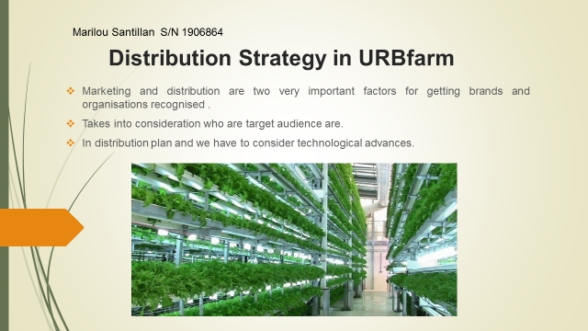



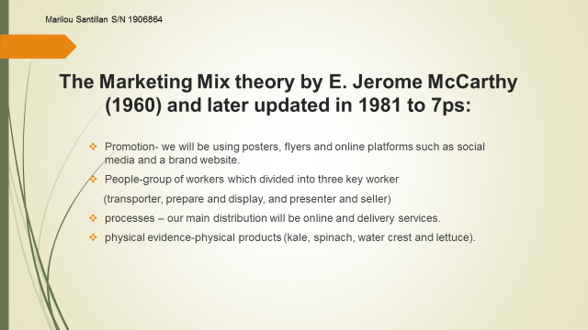


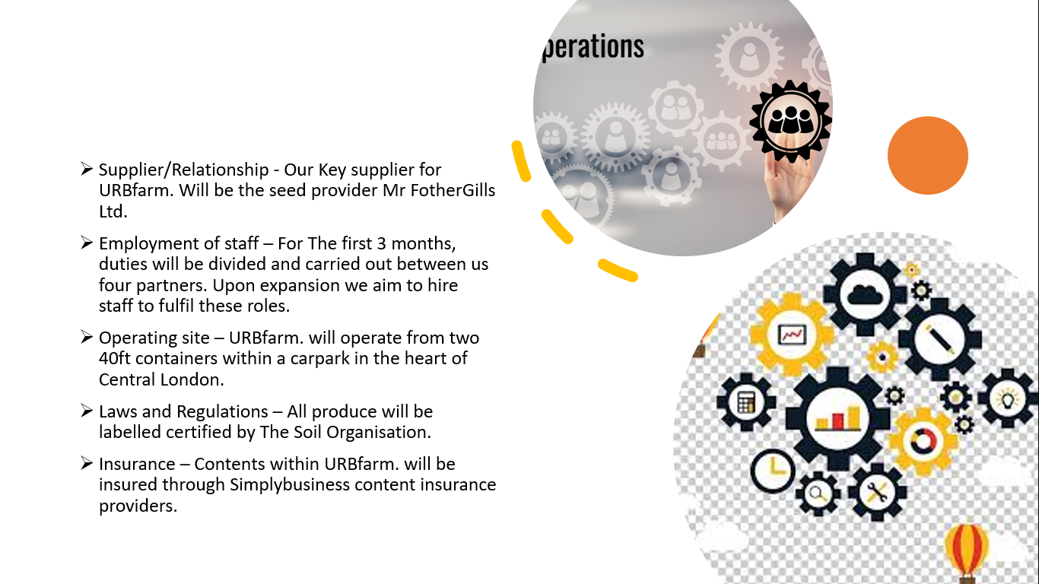

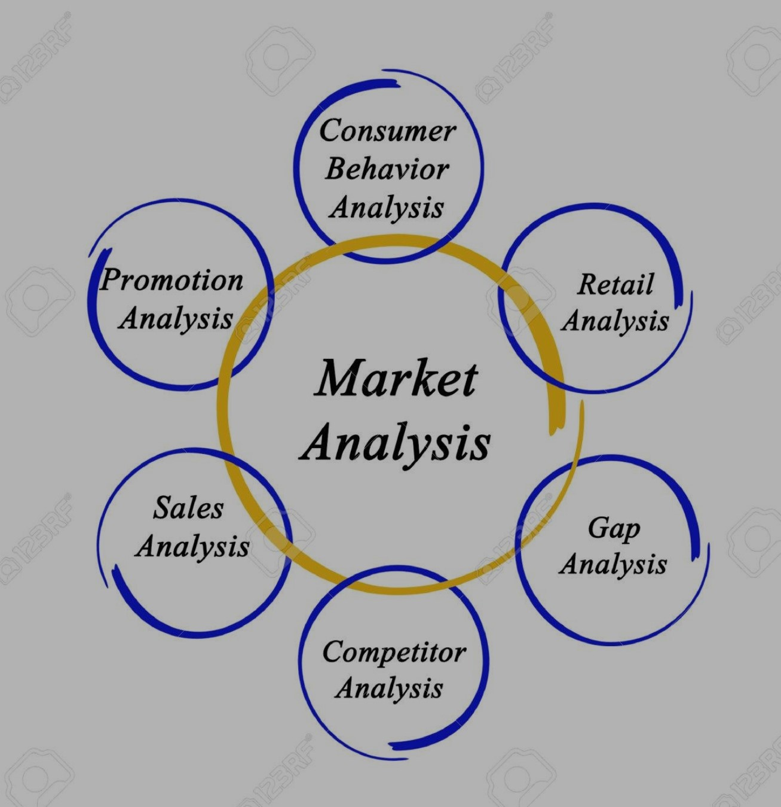


Chaffey, D, (2019) ‘Marketing Models that have stood the test of time’. Smart Insights. (online) Available from: https://www.smartinsights.com/digital-marketing-strategy/online-business-revenue-models/marketing-models/ [accessed 30 April 2020]
Marketing Guides. (2006) MarketingMo. (online) Available from:. http://www.marketingmo.com/strategic-planning/how-to-develop-your-distribution-channels/ [accessed 30 April 2020]
Johnston, K. (2019) ‘The Theory of Distribution Channels’. Azcentral. (online) Available from: https://yourbusiness.azcentral.com/theory-distribution-channels-20931.html [accessed 30 April 2020]

