University of Wales Trinity Saint David
Module: Academic and Employability skills
Module code: BMSW4001_LON
Lecturer: Joanna Walsh
Assignment task: 2
Student: Nevyana Todorova Nikolova
Student number: 2111481

Academic and Employability skills
Self-reflection

Table of Contents
I. Introduction 2
II. Main body 2
1. Summarise 2
A. Definition of Summarised 2
B. How Summarising reflects on my study 2
C. How do I feel now? 3
2. CV writing 3
A. Definition of CV 3
B. CV structure 3
C. How CV writing reflect on my study 3
D. How do I feel now? 4
3. Public speaking and giving presentations 4
A. Definition of presentation 4
B. How Public speaking reflect on my study 4
C. How do I feel now? 5
III. Conclusion 5
IV. References 5

I. Introduction:

This report is a self-reflection of three selected topics from the module Academic and employability skills. The first part summarises and presents what I learned during the learning process, how it reflected on me and how it will help me in the future. The second topic is CV writing and explains the long process of development that my CV has gone through. The third topic is public speaking and is one of the things I need to practice the most to improve, I have developed the least and I have the most challenging time coping. The report will end with a conclusion: I will briefly explain why we learn are important and how it will help us in our plans.

II. Main body

1. Summarise

A. Definition of Summarised:

Summarising is the central meaning and essential thing in the given text, a short statement of the most important thing that interests us. A summarising can be made of any text or excerpt of a text as long as it is long enough to allow meaningful and expressive abbreviations. A summary of a newspaper article, a press release, a textbook lesson, or an appliance instruction can be prepared. The primary purpose of the summary is to briefly and summarise the content of the provided text, making this content in an organic verbal volume. A good summary seeks to concisely but present the general theme of the source and its main subdivisions. The summary does not include any substantive details, minor branches and details of the main topic. From the summary, it should be possible to quickly obtain information about the source's content. The summary must contain a clear wording of the topic source text and brief information about its development.

B. How Summarising reflects on my study?

At the university, in one of the modules, we studied how to summarise; the Lecturer explained summarising and how useful it will be for us if we summarise the text given to us to understand it more easily. I already have experience with summarising because every time I read books, textbooks or articles, I like to emphasise the most important thing that impressed me. The summary is a great technique that helps me in my own words to synthesise and study a topic without having to reread it all over again. Making a summary taught me to structure the content consistently and logically to remember and understand what I have learned quickly. Writing in my own words has improved my vocabulary and made me feel more confident when explaining what I have learned.

C. How do I feel now?

I use summarising; it is beneficial to write my reports and look for the necessary information. It also proved helpful when creating presentations, where the information should be short and synthesised. It takes me longer to summarise a text than I thought, but it is helpful for my future at university.

2. CV writing

A. Definition of CV:

CV is a Latin term curriculum vitae means "course of life" ("development of life"). It is a short-written document of no more than two pages when applying for a job consisting of personal information, work experience, and qualification.

B. CV structure:
- Personal information: Name, Contact details such as an address, phone number, email.
- Qualifications: First, note your high school, additional courses, training, seminars that you have attended in your speciality. It is essential to show your future employer that you are constantly evolving.
- Professional experience - Start with your last job and end with the first by describing your professional experience in detail. What were your main responsibilities, characteristics and achievements.
- Professional skills: This is an integral part of your CV and makes it more attractive to future employers. Here you can include your computer skills, what programs you can work with, how many languages you speak and your driving skills.
- Interests: It is unnecessary to include higher hobbies and interests, but this will make your cv more exciting and give more information about your personal life.
- References: One of the most important things is to have references from previous employers with contact details.

C. How does CV writing reflect on my study?

I have much experience writing a CV, and I first had to write CVs more than ten years ago. I remember the first time it was difficult because I had no professional experience and my CV then was just a few lines - personal information and qualifications. I had no experience and did not know how to fill in the blank and decided to use any of the recommendations in a newspaper article written by a business manager. Who advised us to include information about our responsibilities in our home, personal qualities, and interests. I decided to include more personal information such as personal achievements, hobbies and plans. It was not professional, and it did not look much like a CV, but it was my first time. Over time, I developed professionally and developed my skills in writing a CV. I had decided to work in the UK, and there, the cv format differed from the European/Bulgarian format. My friend advised me to edit and shorten most of the written personal qualities. Over the years, I constantly edited my CV, adding or deleting information that I considered necessary or unnecessary. Although I had experience writing a CV, I always wondered if it was written correctly and what my future employers are looking for because I know everyone is looking for different things. Employers in Bulgaria are different from those in the United Kingdom. Studying at the University of London and studying CV writing in class helped me understand how to structure my cv properly. It is not considered suitable to have a photo and too much personal information in the United Kingdom. You cannot see a separate column for hobbies or interests in most CVs, even though it is a formal CV part. Strictly professionally written and synthesised CV in a specific structure is perceived. The information presented on CV writing at university gave me detailed information and tips on how to improve my CV writing and what employers expect from candidates.

D. How do I feel now?

Of course, my CV will undergo further editing and evolve. Thanks to my experience at the university, I have more clarity and confidence in how to edit a CV. What I learned in class helped me structure properly and stick to the CV required by British employers.

3. Public speaking and giving presentations

A. Definition of presentation:

A presentation is a form of communication, the transmission of text or ideas, impact between a person-presenter and the audience. The presentation gives us students the opportunity to demonstrate understanding and mastery of our topic and explain it to the audience. Carefully prepared presentations and systematic feedback allow us students, to gain experience and enrich their communication skills. Presentations develop many skills: research and synthesis of information, holding and speaking in front of an audience, choosing the appropriate language and confidence. For a good presentation, it is essential to clearly state the main topic, explain it and support it with evidence from other sources. We can help ourselves with small leaflets with keywords to suggest during the presentation but not read all the time. We must adhere to the set time, and it is in our help to practice the presentation with different people or alone in front of the mirror.

B. How does Public speaking reflect on my study?

Speaking in front of people has scared me; since I was a child, it was challenging to speak in front of people. I remember being worried and blushed when I read poems or sang a song at school. In front of me were the school concerts where every student participated. Even when I went out in front of the blackboard or the school stage, I was sweating, panting and forgetting everything I had to say. I forgot my grammar, as they say, black spot; complete horror. Growing up, I began to control and hide my emotions more skillfully in my years and growing up. I know that anxiety and panic do not help me. I thought I had dealt with this problem to some extent, or so I thought until I started studying at the university.
I was very excited to study at the university, and I was looking forward to the modules and the program we will study, while I saw that at the end presentation. I had to present to the Lecturer and almost strangers in English. I already felt anxious and worried before the course started to take on this challenge. The course started; I liked my colleagues, and we even became friends with some of them. The Academic Lecturer was an intelligent woman who spoke French with a rich common culture. The atmosphere in the classroom was cosy, everyone was friendly, and we helped each other. The day of the presentation came, and I felt like a volcano that would erupt; I felt so many emotions at the same time that it was difficult to control. The Lecturer had much patience and did everything possible to predispose us to relax and perform better. My presentation went well; surprisingly, I did not panic much; I was more confident in what I learned in class, the warm atmosphere, and the support of everyone. Although I was happy with myself, I found mistakes, such as reading from my notes and slides, that I should not have made. I realised that I was disappointed and the Lecturer, who said that "this is not exactly a presentation".

C. How do I feel now?

Public speaking is complicated when you are an anxious and shy person. I have always tried to overcome myself and be more confident; I know I need practice and more courage. Lectures at the university help me overcome my weakness and face the problem. I know that I have more presentations ahead, and I will show the best I can in the future.

III. Conclusion:

In this report, we have covered three important topics: a summary that helps us absorb the information given to us, efficiently structure our reports, presentations, and extract the most important things we need from the given text. CV writing is beneficial for our career development; the Lecturer's lectures and class advice helped me understand exactly how to edit my cv in British format and not make mistakes anymore. The last and most difficult for me was public speaking. The things I learned about the presentations at the university gave me confidence that I could do better and overcome my great anxiety to speak in front of people.
Education is essential in everyone's life; the course gives us academically, communication and digital skills. Choosing the right university and course will open many opportunities and give us more confidence to help us in the future. I like the module Academic and Employability skills because I learned a lot of new things like summarising what I will need and essential in my future university studies.

IV. References:

Cottrell, S., 2019. The study skills handbook. 5 ed. London: Red Globe Press.
Godfrey, J., 2013. How to Use to Reading in Your Essays. 2 ed. s.l.:Palgrave Macmillan.
McCombes, S., 2020. How to write a summary. [Online]
Available at: https://www.scribbr.com/citing-sources/how-to-summarize/
[Accessed 05 01 2022].
Smith, J., 2021. How to write a CV. [Online]
Available at: https://www.prospects.ac.uk/careers-advice/cvs-and-cover-letters/how-to-write-a-cv
[Accessed 10 11 2021].
staff, MasterClass, 2020. How to Write a Summary: 4Ttips for Writing a Good Summary. [Online]
Available at: https://www.masterclass.com/articles/how-to-write-a-summary
[Accessed 10 12 2021].

APENDIX

University of Wales Trinity Saint David
Module: Academic and Employability skills
Module code: BMSW4001_LON
Lecturer: Joanna Walsh
Assignment task:1
Student: Nevyana Todorova Nikolova
Student number:2111481

TIME MANAGEMENT
Eisenhower method

Table of Contents

Ⅰ.Introduction: 2
Ⅱ. Main body: 3
1. Definition of time management? 3
A. Why is it essential to plan your time? 3
2. My background/story: 3
3. SWOT analysis: 4
4. Handy tools: 4
A. Definition of Eisenhower method: 5
B. EISENHOWER MATRICS: 6
C. How the method reflects on my time planning? 6
5. Personal development plan: 7
Ⅲ. Conclusion: 7
Ⅳ.References 8

Ⅰ. Introduction:

This report is a self-reflection on the topic of time management, in which we will define what time management is and the valuable tools we can apply in our student and personal life. One of these tools is the Eisenhower method, what I know, how I use it, and whether it helps me in my current lifestyle. The report includes my professional experience as a babysitter: how I manage my time and whether I manage my career and studies at university. SWOT ANALYSIS characterises my strengths and weaknesses and what opportunities open up to me in the future. One of the points in my development plan: how what I learned at University will help us in my future career and business. The last points are a summary and references of my report, how I understand what I learned in class so far, and where I read the information.

Ⅱ. Main body:

1. Definition of time management?

Time management is coordinating and performing the right tasks to have more time to finish all obligations. We minimise stress and increase our productivity, both at work and University. People today live in a very fast-paced and busy world full of problems and responsibilities. We all have twenty-four hours a day, often not enough to do everything. Proper delegation of tasks is not just important but necessary to cope on time, without worry and stress. How the time management module helps me and how to apply what I have learned in the future.

A. Why is it essential to plan your time?

Planning your time is necessary to complete your tasks on time, improve your work and student life, avoid additional stress and anxiety. Good planning time achieve and productive your goals more manageable and more intelligent. Managing your time Improper timing is a common problem for many people. More and more people have difficulty completing their daily tasks. I can firmly say that I have learned to balance my career, student, and personal life.

2. My background/story:

My career in childcare started many years ago; the job of a babysitter is an all-around role. Includes watching over the kids as they sleep, playing games, helping homework, making their food, and helping them get washed and dressed. I professional and personally take on many responsibilities, and organising is essential in my life. My stench of planning comes from experience in childcare, such as problem-solving, multitasking, relationship building with much patience. Time management and scheduling have never been a problem until I start the course. Starting a business course had excited me because I had been postponing this new start in my life for a long time. When I entered the University, I experienced many emotions: fear, confusion and worry about handling the study material. Whether I will fail and study and work together Not long after, I found it more challenging to find time for my daily tasks. I was tired, stressed and quite confused by all the unknown information. I, Miss “Organised”, could not do as well as I expected now; I had a hard time focusing on the study material, I was disappointed in myself. I try to focus on my study tasks and not be distracted, but it is difficult to ignore all my noise. When you decide to stay concentrated, the gardener will cut the grass in the garden, the postman will ring the doorbell, or someone will text me. It is hard to ignore calls from your loved ones, but motivation is the key to everything in life. I was trying to find more ways to manage my time perfectly that why I bought an organiser, pocket calendar and wrote down my tasks to deal with the problem. I pasted sticky notes everywhere not to forget something important. It was difficult for me to plan everything on time, but this is probably not just my problem. Many people have difficulty delegating their tasks. A study of development academy.co.uk (2021) shows that:

- 80% OF PEOPLE DO NOT HAVE A DEDICATED TIME MANAGEMENT SYSTEM.
- 66% OF PEOPLE FEEL THAT THEIR WORK IS UNDER CONTROL MOST OF THE TIME
- 80% OF PEOPLE “WASTE” MORE THAN ONE HOUR EACH DAY ON TASKS AND MEETINGS THAT ARE NOT IMPORTANT TO THEIR ROLE.

3. SWOT analysis:

Strength – patience/work experience

Weakness – struggle with planning

Opportunities – Master’s degree/start business

Threats - business failure
I have always managed my time well to plan and complete all my duties. My strength in planning comes from my work experience and patience with which I solve my problems. It is changed when I started the business course, and I did not have enough time. Not long after, I found it more and more challenging to find time for my work: I was tired, stressed and quite confused. I had to find a solution and deal with the difficulties before me, applying what I learned at University.

4. Handy tools:

Studying at a business course, I got many opportunities to effectively and adequately deal with the trouble associated with delegating tasks. We began to study the module on time management and valuable tools to deal with our busy life. At first glance, something that seemed easy, but in fact, not so easy to apply. So I needed help accurately categorising all my tasks and doing better with their planning without wasting time. One of the tools that impressed me the most was the Eisenhower method.

A. Definition of Eisenhower method:

I had never heard of this method before, I thought about how it could be helpful for me in my future training. Dwight David Eisenhower was an American army general and statesman who served as the 34th President of the United States. Sir Dwight made hard decisions continuously about which of the many tasks he should focus on each day. Eisenhower Matrix or box is a simple tool for considering your daily tasks’ long-term outcomes and concentrating on what will make you most effective. It has four squares/ boxes coloured in different colours. Depending on the combination of these two indicators - “Urgency” and “Importance”, each task or activity that requires our time or attention can be located in one of the quadrants of the following matrix:

B. EISENHOWER MATRICS:
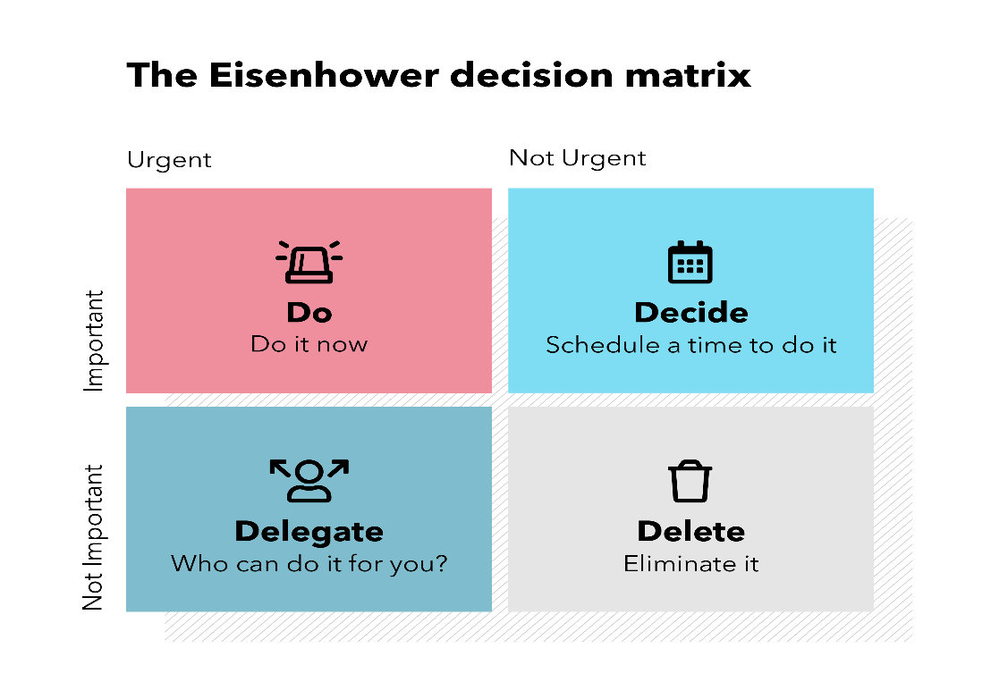
Source: (https://www.spica.com/blog,2021)

- The pink one is your important/urgent tasks:
The first type of urgent and essential tasks you postpone until the last minute. You can reduce it or eliminate them by planning them. It is usually clearly visible and requires our attention tasks. It appears before us, and we must finish them, and if we do not, the consequences are immediate. Do your most important tasks first; those who cannot wait must finish immediately or have a deadline. Therefore, it is good to plan to leave someday or week to deal with this type of “fire adequately”. Moreover, if the situation is particularly urgent and important, you should reorganise all the other tasks that will have to wait. However, keep in mind that if your daily life is filled with such activities, sooner or later, there will be side effects - stress, constant crisis management.
Example: Paperwork/Submit assignment/visit doctor

- Light blue is your essential/not urgent tasks: Quadrant II of the Eisenhower time Management Matrix includes activities and tasks that are slow and important. If you have such tasks, you need to plan your time to complete them. Quadrant II activities are crucial and most strongly related to success, development and achieving high efficiency in professional or personal life. The problem with Quadrant II activities is that we often tend to ignore, postpone, and not do them because they are not urgent. For Quadrant II tasks, it is necessary to plan the time to complete them in an environment without interruption. Otherwise, the tasks from the other quadrants will prevail.
Example: Spend time with your family / Exercising

- Dark blue for your not important/urgent tasks:
Quadrant III of the Eisenhower matrix includes activities and tasks that are urgent and not important. If you have such tasks, you should ideally reject or delegate them. Quite often, the source of Quadrant III tasks for us are other people, colleagues ask for help, some people ask something and expect us to give them information. Others call us on the phone or write us emails. We are constantly invited to meetings and operatives, which creates a sense of urgency.

Example: Help friend with Christmas shopping/Organising your wardrobe

- A grey one for your not important, less urgent tasks:
Quadrant IV of the Eisenhower matrix includes activities and tasks that are slow and unnecessary; if you have such tasks, stop them an hour soon. An excellent example of Quadrant IV activity is checking Facebook news too often or chatting on Messenger or Viber. Such activities unload and distract and eat valuable time without contributing anything to your success or results in any field.
Example: Watch a movie /check social media

C. How the method reflects on my time planning?

I started using the method by dividing my tasks into these four categories, and soon, it had an effect. My duties were correctly in order of importance, I was no longer messy, and I did not panic about having time. I concentrate on what is essential to do during the day. I will continue to use this way of planning to achieve my goals for the future. I know it won not be easy, and it will become more challenging to plan and complete the tasks on time. What I have learned at the University gives me confidence and motivates me to deal with my future studies. Writing daily in the Eisenhower method helped me plan and create my schedule, increase my productivity, and help me stay focused, concentrated, and able to finish my targets.

5. Personal development plan:

The valuable things I learned in class will help me with my future, continuing my education at University. My dream is to study to be a master; I see myself as a university graduate with a successful business. I want to open a children’s play centre, where the kids will have much fun and learn how to take care of plants, flowers, fruits and vegetables. The kids will learn how to cook food and bake bread and cakes. A place full of happiness and positive vibes, I believe that I will have my own family and kids in five years. A family that will make my life happier and full of new emotions. After five years, I see myself as a business lady and an amazing mother. I know that during this time, there will be many changes. I will go through many things, some of which are difficult, but this will make me a stronger person.

Ⅲ. Conclusion:

Scheduling is a complicated and lengthy process; something unexpected will always pop up and confuse your schedule. Completing all tasks for the day is essential, but it is more important to feel happy and satisfied with ourselves in the end. Do not panic that we have found a solution to only half of the tasks for the day. We are human, and we need a break from a long lunch or forget about everything and listen to good music.

Ⅳ. References

Cottrell, S., 2017. Critical thinking skills: effective analysis, argument and reflection. 3 ed. London: Palgrave Macmillan.
Cottrell, S., 2016. Palgrave study skills. 10 ed. London: Richard Pears and Graham Shields.
Cottrell, S., 2019. The study skills handbook. 5 ed. London: Red globe press.
Eales, J., 2016. Time management. The Australian(Canberra,A.C.T), Volume 3, p. 1.
Richardson, B., 2021. Time management Statistics and Facts. [Online]
Available at: https://development-academy.co.uk/news-tips/time-management-statistics-2021-research/
[Accessed 01 12 2021].
Tracy, B., 2020. “Eat that frog!:21 Great ways to stop procrastinating and get more done in less time”. 2 ed. s.l.:Barrett-Koehier .

