

NAME | AIDAH BECKY NAMULI
STUDENT NUMBER | 1912621
MODULE TITLE | DIGTIAL SKILLS AND RESEARCH METHODS
SUBMISSION DATE | 01/SEPTEMBER/2020
LECTURER | DR TERRY WALCOTT

Abstract
The Virtual Learning Environment (VLE) is an organised environment where students can apply for admission over the internet and enrol in classes offered by VLE after their admission. This report confirms how VLE tools are used by professors and students for performing their duties in this studying environment. The advantages and disadvantages of VLE compared to traditional learning plus references evident in the literature review revealing the innovation of virtual learning in United Kingdom in the mid 1980’s. Previous research how research papers regarding virtual learning environments were referred to during this study. Primary data was collected using surveys such as questionnaires and interviews from family members and work colleagues whereas secondary data shall be collected using previous literature. Methodology used two techniques to gather information are quantitative and qualitative researches and these included: survey, one-to-one interviews, e-libraries and internet.

Table of Contents
1 Introduction 4
1.1Aims and Objectives 4
1.2 Scope of the study 5
2 Literature Review 6
2.1 Advantages of Virtual Learning as compared to traditional classrooms 7
2.2 Disadvantages of Virtual learning as compared to traditional classrooms 7
3 Previous Research 8
4 Methodology 9
4.1 Quantitative Research 10
4.2 Survey Questionnaires 10
4.3 Face to face interviews 10
5 Results 11
5.1 Survey questionnaires 11
5.2 Face to face interviews 11
5.3 E-library 11
5.4 Journals/ Articles 12
5.5 Survey Questions 12
6 Conclusion 13
7 Appendices 14
8 References 18

Chapter One

1 Introduction

The academic requirements needed by most employers has pushed very many people to pursue further studies or join higher education (Keller, 2007). Immigrants, especially above the age of 30 years who have been doing low paying jobs, have been seen going back to higher education so that they can be eligible for better paying jobs such as social work, and nursing. These individuals in most cases already have families and thus studying full time would be very difficult; so, most people end up choosing distance learning.
Here in the UK, Open university which has seen so many people globally studying courses they love from their countries and many other countries are practicing distance learning; USA, China, India taking the lead as they have the biggest population.
This year has seen so many changes globally come up in the education and business sector due to the Corona virus pandemic. In the UK, education institutions have seen themselves conducting most of the lessons online due to the lockdown. In addition, most of the people have been very cautious to engage in face to face activities due to the fear of contracting the virus.
The education institutions resorted to using online and zoom classes which has been very beneficial in a way that we have seen students using this opportunity. Lecturers have been in touch with students asking us if we were happy to be studying in online and the overall were positive.

1.1Aims and Objectives

The main aim of this study is to investigate the impact of virtual learning environments on students learning experience.
Previous studies and quantitative research methods such as surveys shall be used to determine the negative and positive impacts virtual learning environments have on student’s learning.
The objectives of this study include the following:
Look at the sources of primary and secondary data and how to analyse it by reviewing existing literature and conducting own surveys using questionnaires and interviews.
Compare the qualitive and quantitative research results using analytical methods such as pie charts and bar graphs.

1.2 Scope of the study

The main emphasis of this study will involve looking at improvement in technology over a period, which has made virtual learning such as online and zoom lessons possible. Primary data shall be collected using surveys such as questionnaires and interviews from family members and work colleagues whereas secondary data shall be collected using previous literature. The data collected shall be analysed using statistical tools such as pie charts and graphs.

Chapter Two

2 Literature Review

The innovation of virtual learning was first implemented in United Kingdom in the mid 1980’s which drew the attention of researchers. With an increase in the number of students going back to higher education as there is room for those who are credible and would like the experience of VLE approach (Barajas & Owen, 2000).
E-learning can be defined as “ Internet technologies used to deliver a broad array of solution that enhance the instructional process” (Poon, 2004). This implies that by using e-learning, it helps to enhance the students learning experience by adding value to the teaching and learning activities.
The Joint Information Systems Committee (2005), defined virtual learning environment as a way of managing E-learning through accessing resources and provision of a delivery mechanism, student tracking, using a set of tools. The set of tools needed for virtual learning to be successful include; hardware and software (see figure 1)
Webinars
Online support
E-learning libraries
Course delivery
Enough and secure Internet
Virtual learning environments
Management
Electronic communication

Course Content and delivery
Figure 1: Tools of Virtual learning by Becky 2020

2.1 Advantages of Virtual Learning as compared to traditional classrooms

- In terms of people with apprehension, they are more efficient and productive when they do not have to face other people which makes virtual learning stress-free. A colleague at work stated that with her anxiety problems, she is more creative and effective in a virtual learning environment.
- Tae et al (2006) noted that VLE has given students flexibility in terms of schedules and individual support since it works around electronic network. Students can decide when to interact with lecturers and other students (in case you require deeper understanding of a topic) when compared to traditional learning environments (Tao, et al., 2006).
- As a student, I have come to terms with virtual education as it has made it possible for me to collaborate and communicate better with my lecturer.
- Costs are measured as benefits, this saves students with their finances in terms of commuting to their respective classes such as buying travel tickets, fuel for those who drive, child maintenance and many more (Posey, 2010). This is an advantage to students as they get to save their money for other purposes of their day to day life.
- Given that some individuals are working students including family life, flexibility is much needed in terms of time therefore with the help of VLE the learning process has become more flexible.

2.2 Disadvantages of Virtual learning as compared to traditional classrooms

- In terms of the concentration ability while studying virtually, this may have a negative impact to a student's learning if the resources required are not readily available (Demain & Morrice, 2012)
- VLE may not favour students with poor learning habits such as low concentration and disinterest in research and low self drive thus leading to poor performance and bad results due to lack of self-discipline.
- Less physical interaction with lecturers and other students may result into student isolation which may impact their mental wellbeing.
- Technical issues in terms of internet and system outage, VLE can reduce the student’s research downtime which may lead to stress and frustration.
- Students may feel they are not getting back enough feedback from their lecturers in VLE and the reverse is true which may lead to misunderstandings and more frustration (Sprague, 2020).
- Social/cultural differences may lead to lack of initiative and confidence from some students to undertake independent learning.

3 Previous Research

Several research papers regarding virtual learning environments were referred to during this study and some of them include:
- M Weller (2007) did a study titled “Virtual learning environments” and he noted that VLE in the present times have been adapted, although it appears not to have been fully used by several higher institutions. He concluded that utilising VLE can inspire individuals to be creative and effective with this specific technology.
- P Demain & J Morrice (2012) did a study titled “The use of Virtual learning environments and their Impacts on academic performance” and they reviewed how student’s use of VLE impacts their academic performance. They concluded that male students benefited more of this setting than their female students.
- Tao et al (2006) did a study titled “Improving training needs assessment processes via the Internet: system design and qualitative study” and they looked at how effectively human resource (HR) function and organisations can develop using “web-based applications” and training. They concluded that for HR professionals to be competent at what they are doing, the system should effectively assess more training modules for their needs.

Chapter Three

4 Methodology

The methodology used throughout this study involved using quantitative and qualitative researches.
Methodology
Quantitative research
Qualitative research
Questionnaires
emails

Surveys
Interviews, Telephone calls

E-Libraries and Internet
Case studies, Observation, Reading articles or journals
Figure 2: Methodology used throughout the study; Namuli, A (2020)

In this study, two methods were used to collect data regarding the impact of Virtual Learning Environments (see figure 2) above. These two methods are further broken down in several categories and they have been explained in detail below.

4.1 Quantitative Research
This involved using survey questionnaires, face to face interviews, telephone calls, emails and texts. Several people were contacted to inquire if they can be part of this study.

4.2 Survey Questionnaires
Ten questions were set using google forms and emails were sent out to 10 people, which included course mates and workmates who had access to internet.

4.3 Face to face interviews
The ten questions set using google forms, five friends from my workplace who attend college and didn’t mind taking part answering the same questions face to face.

4.4 Qualitative method
In this research method, a review of previous research such as journals and articles, documents from the internet and eBooks from the university E-library was used. This involved reviewing previous research, analysing the information and comparing it with the present situation.

Chapter four

5 Results

5.1 Survey questionnaires
On the ten emails sent out, 8 people responded answering all the 10 questions and one person never responded.

5.2 Face to face interviews
Of the ten questions given to five friends from my workplace who attend college and didn’t mind taking part answering the same questions face to face, all questions were answered. 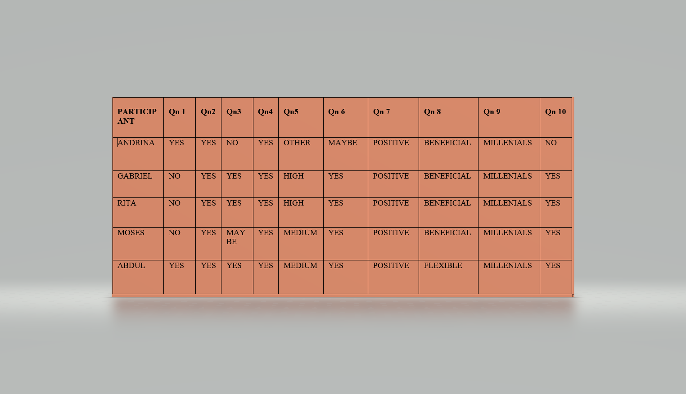

5.3 E-library

Although libraries are currently closed to prevent the spread of coronavirus, students have had the opportunity to still access a variety of resources such as eBooks and audiobooks via e-library.
As a student, digital library has been my source of information during the lockdown which has enabled me to build my capability online, a provision which has offered even other students who had access of internet and teachers valuable the continuity needed.

5.4 Journals/ Articles

Most of the information in this report has been attained from academic journals of different authors and countries, if it was not these giants our researches would not have been possible.
Below are the 10 questions I asked my workmates and fellow students which were responded to by both parties as shown in the results and appendices.

5.5 Survey Questions

- Has virtual learning affected your day to day life? Answering in percentage amongst people asked the above question 75% said they were affected and 25% were ok with the situation.
- In reference to Covid-19 pandemic, have you been affected financially or emotionally? 71.4% were affected by the pandemic and 28.6% were ok with the situation.
- How likely is it that you will recommend other people to take lessons virtually? 8 people responded to this question as shown in the appendices amongst the 10 people who were asked.
- What do you think about the use of technology in the learning process?
37.5% thought it was beneficial, 12.5% that it impacted people and 50% didn’t have a clear opinion.
- How long do you rate the experience with the virtual learning environment?
37.5% were positive,

- Would you like teachers to include Virtual Learning Environment in other lessons while in class? 50% replied maybe, 25% said yes and 25% said no.

- How do you describe the experience with the Virtual Learning Environment in other lessons? 25% were disappointed and 75% were positive about the experience.

- What are the benefits of Virtual Learning Environment process?
50% replied that it’s more flexible, 50% replied that it was beneficial and 12.5% thought that it was ineffective.

- Which generation used technology the most between 2015-2019?
50% thought it was baby boomers and the other 50% said millennials.

- Are you satisfied with your tutor's lesson deliverance?
87.5 % said yes and 25% said no

6 Conclusion

With the coming of modern technology, VLE have been a significant aspect in our education system and has impacted us in every way possible. Although some individuals may find it challenging and would prefer the traditional way of learning, but it is evident that VLE is the new dimension of teaching and learning globally. The internet has played a vital role in our education system enabling us to communicate with our tutors using different platforms such as Microsoft Teams, Zoom and we have all tried to adapt to this transformation.
As students, we have managed to interact with each other and our tutors, however, there have been unenviable challenges to overcome such as technical issues in terms of internet and system outage, low morale from students which may have led to not getting feedback from lecturers in good time causing misunderstandings and more frustration from both sides but the positive impact outweighs the negative.

7 Appendices

Question 1
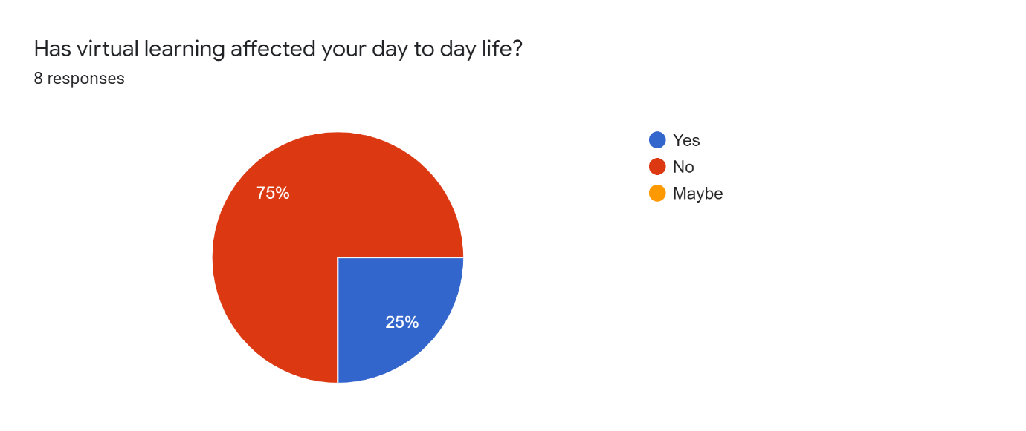
Question 2
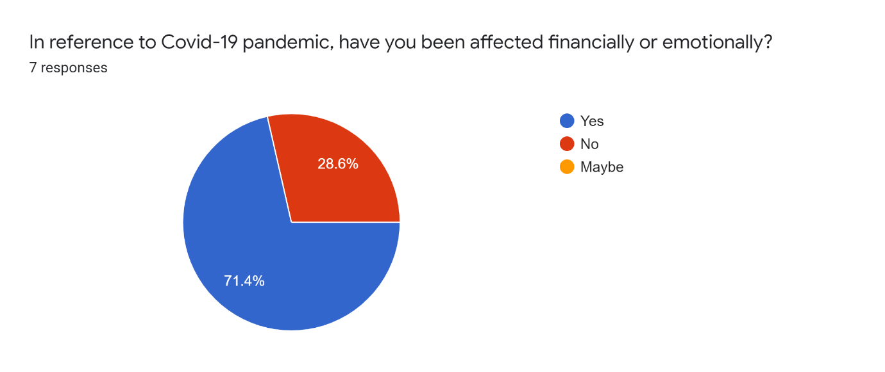

Question 3
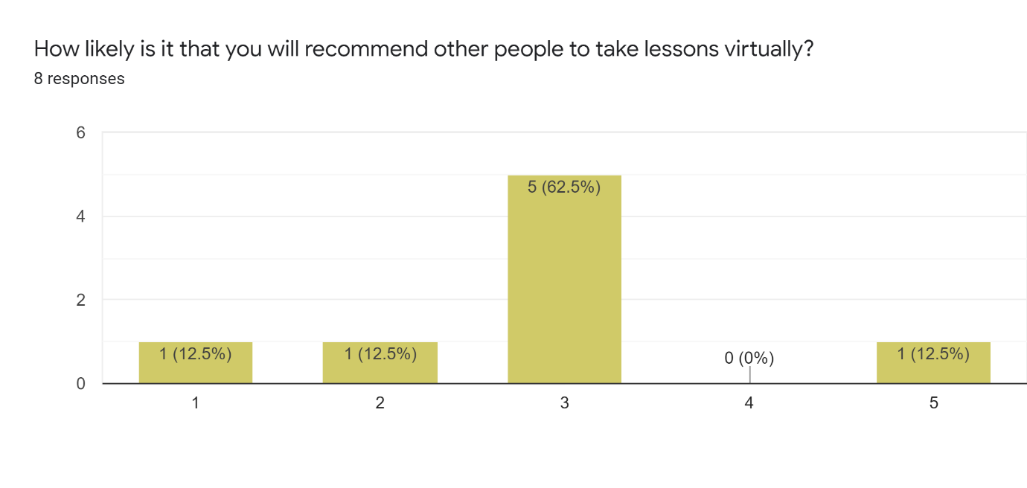
Question 4
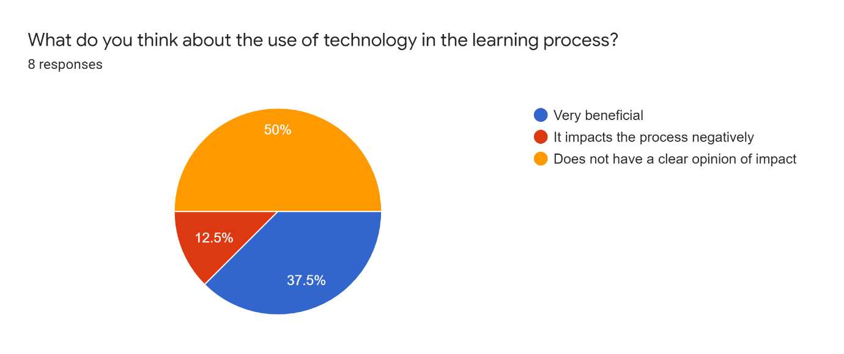

Question 5
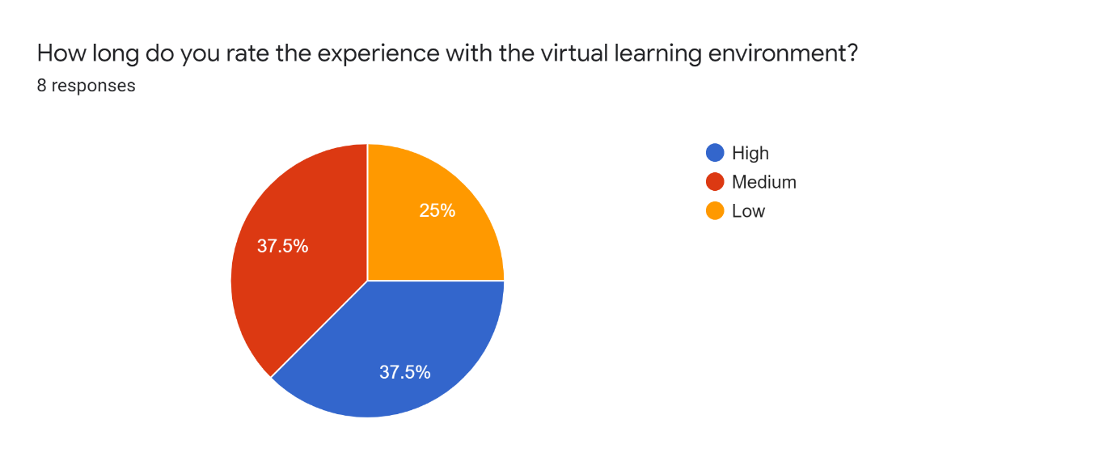
Question 6
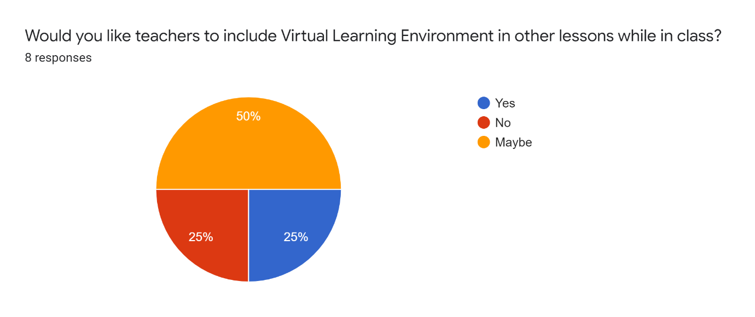

7 Question
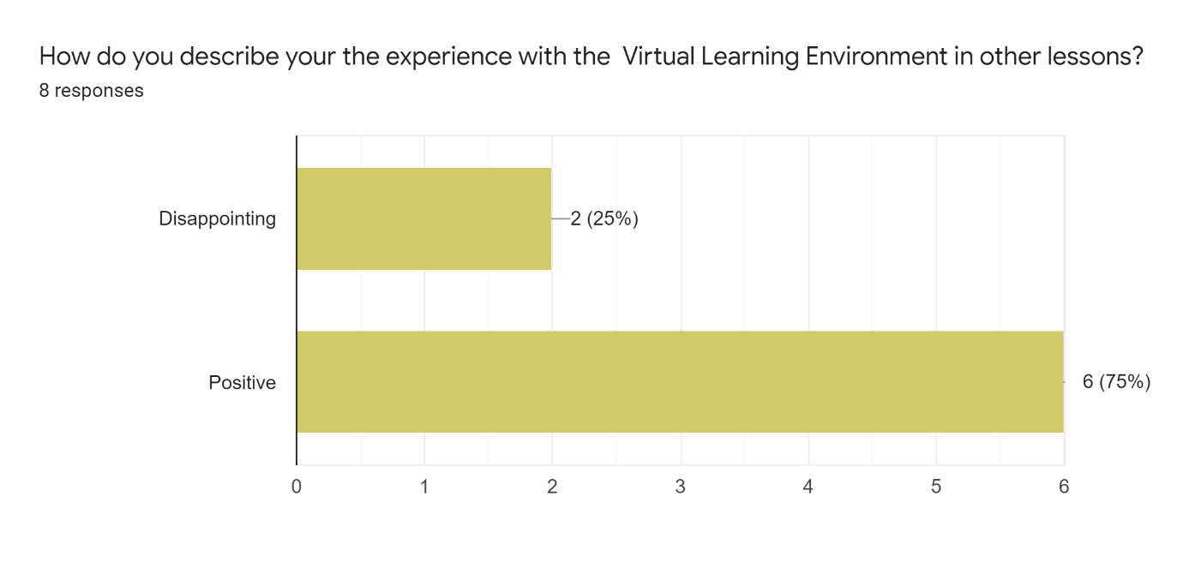
Question 8

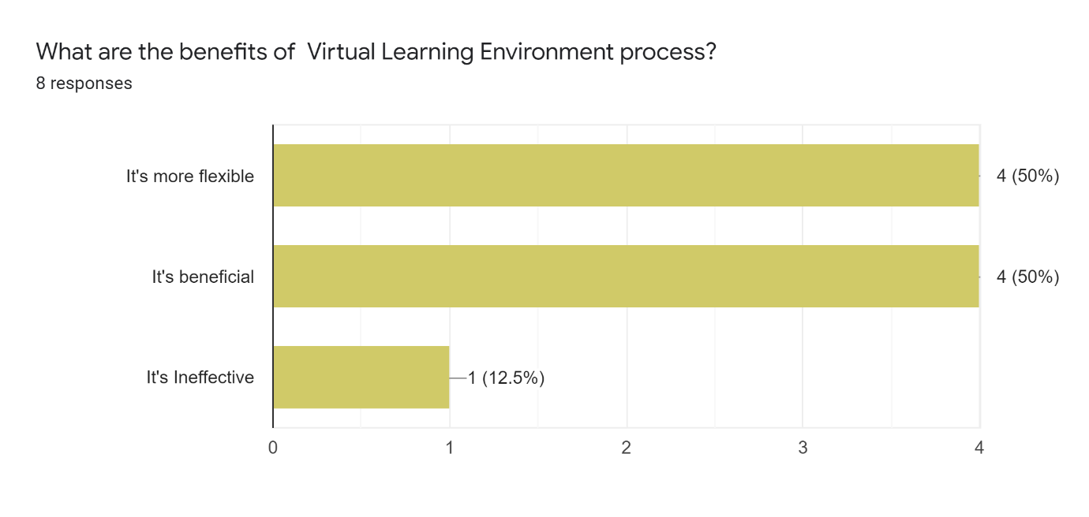

Question 9
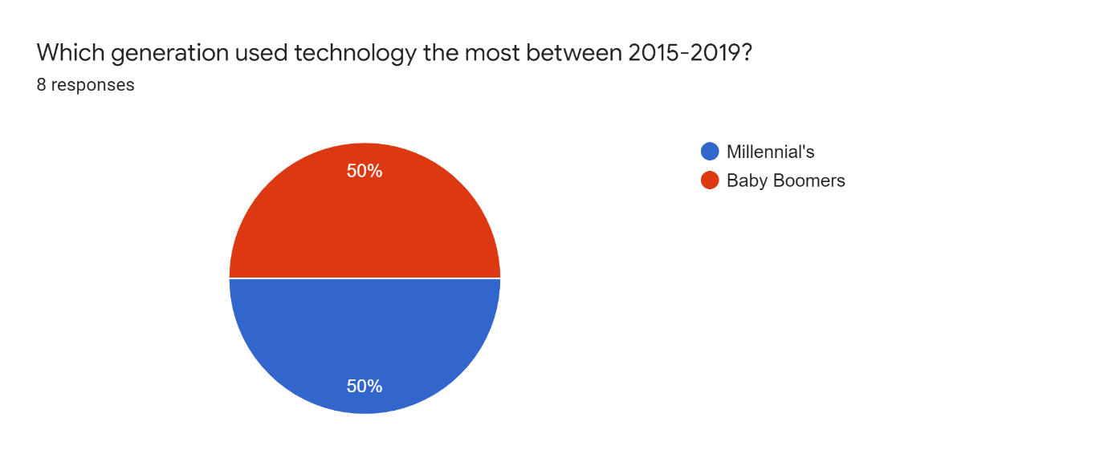
Question 10

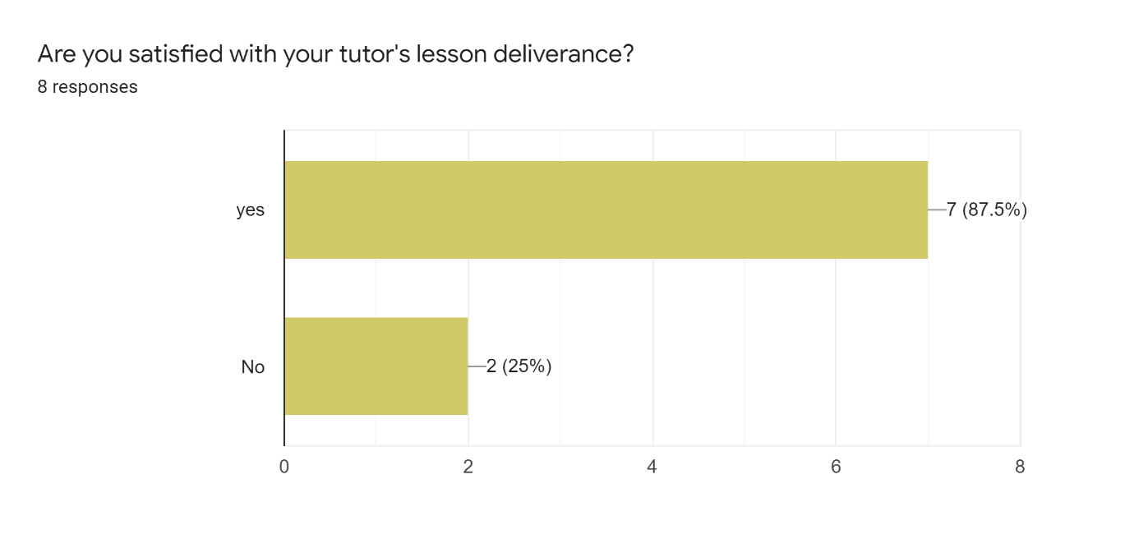

8 References
Barajas, M. & Owen, M., 2000. Implementing Virtual learning enviroment: Looking for holistic approach. journal of Educational Technology & Society, Issue 3, pp. 39-53.
Demain, P. & Morrice, J., 2012. The use of virtual learning environment and their impacts on acamedic performance. Engineering Education; a Journal of higher education academy, 7(1).
Keller, C., 2007. Virtual Learning Environments in Higher Education: A Study of User Acceptance. Institutionen for ekonomisk och industriell utveckling, 21 September.p. 137.
Poon, W. L. a. Y. D., 2004. A study of Web-based learning environment in Malaysia. The international Journal of Educational Management, 18(6), pp. 374-385.
Posey, G. e. a., 2010. Disavantanges of Virtual classroom and Role of the Teacher, Alabama: s.n.
Sprague, E., 2020. A skeptic Assessment of Virtual Learning (Pros and Cons). [Online]
Available at: www.unboxedtechnology.com
[Accessed 23 August 2020].
Tao, Y. H., Yeh, C. & & Sun, S., 2006. Improving Training Needs Assessment Process via the Internet:system design and qualitiative study. Internet Research, 16(4), pp. 427-49.

