
public sectors' ACTIONs in quality education

May 6, 2020
University of Wales Trinity Saint David

Student name: Siping Xue
Student number: 1904774
Module: Corporate Social Responsibility in the Public Sector
Module Code: BMPS6004

Executive summary
SDG4 is quality education, aiming to ensure inclusive and equitable quality education and provide lifelong learning opportunities for all. However, current situations such as extreme poverty, conflicts, gender inequality, marginalisation groups, gap between urban and rural and gap between rich and poor have hindered this progress.

However, public sectors provide financial supports, enforce laws and education as well as monitor their own behaviours to achieve this goal by 2030. Overall, they relieve the lack of educational resources, gender inequality and improve the availability of education. For instance, World Bank invest to improve teachers’ training and teaching infrastructure, most EU countries released legal framework on gender to promote gender equality in education and GPE has allocated $23 million in accelerated funding to support Rohingya refugee.

These actions make progress in enrolment of primary education and girls’ education, with higher ratio of girls in classroom. However, the out-of-school children did decline especially in conflicted countries and poor rural areas, and the quality of primary school remains low. Moreover, the lack of investment on teachers’ training and basic educational infrastructure still need to be solved.

To better achieve SDG4, there are four recommendations for public sectors.
- Emphasise teachers’ quality: Provide teacher’s training and allocate qualified teachers to teach children, and students in advanced and vocational education (McGreal, 2017).
- Improve education policies: Increasing the number of public schools to ensure enrolment of primary and secondary education (Nguyen, et al. 2019).
- Increase investment in education: Fund should be invested to solve the lack of resources and poor school infrastructure.
- Take actions to target marginalised children: Special facility is needed to help disabled and other marginalised children to receive education.
Table of Contents
Executive summary 0
1.0 Introduction 1
2.0 Method 3
3.0 Findings 4
3.1 Lack of Educational Resources 4
3.1.1 Education Problems in LMICs 4
3.1.2 Less Effort in Developed Country 5
3.1.3 World Bank’s Actions 5
3.2 Gender Inequality 6
3.2.1 Austrian Behaviour 6
3.2.2 Afghanistan Behaviour 7
3.3 The Availability of Education 7
3.3.1 Support of Refugee Children 8
3.3.2 DFID Helps Disabled Children in Pakistan 8
4.0 Discussion 9
4.1 Successes 9
4.1.1 the School Enrolment of Primary Education 9
4.1.2 Girls’ Education 10
4.2 Failures 11
4.2.1 Out-of-school Children 11
4.2.2 Lack of Investment in Education 11
4.2.3 the Quality of Primary Education 12
5.0 Conclusion 14
6.0 Recommendations 16
References 18

Table of Figures
Figure 1 School Enrolment of Primary Education 9
Figure 2 Gender Parity Index of More Than 200 Countries 10
Figure 3 Many Countries Fall Short of International Benchmarks on Educational Budgets 12
Figure 4 Children cannot Read or Calculate by the End of Primary School 13

1.0 Introduction
Among the Sustainable Development Goals (SDGs) of UN Global Development proposed in 2015, the fourth goal is quality education, which aims to ensure the inclusive and equitable quality education and provide lifelong learning opportunities for all by 2030 (General Assembly, 2015). Education is a kind of service provided by public sectors, private sectors or individuals, and public sectors fund, manage, and regulate education service allocated for all people (Thurston, et al. 2019).

Based on a fact that less than half of all countries have fulfilled gender parity in secondary education (Plan International, 2020), disabled children are rejected to be educated as they are vulnerable in schools, and some places facing extreme poverty or wars are unable to provide education for students (Latchem, 2018). All those are problems that quality education needs to solve.

Therefore, this initiative aims to guarantee that both boys and girls can obtain preschool education, free primary education and secondary education, and are capable of affording advanced education by 2030 (General Assembly, 2015). Then increase the employment for teenagers and adults significantly, as most people are more literal and are concerned more about sustainable development at that time. Besides, eliminate the gender inequality and improve the availability of education of those disabled people or those in underdeveloped places.

This report conducts with three main topics about quality education, including educational resources, gender inequality and availability of education, to analyse the role of public sectors among those aspects, then discuss the success or failure of this goal until now.

2.0 Method
This report mainly applies with secondary research, involving in certain reports and official websites of both large and small public sectors’ actions targeted to quality education, and aims to research in both low and middle income countries (LMICs) and some developed countries, then judge if they are successful by other indicators.

3.0 Findings
Public sectors include worldwide organisations such as UNESCO, GPE, UNDP, federal and local governments, other private sectors and even individuals are involved in quality education (Thurston, et al. 2019). At present, the top 3 problems of quality education are the lack of educational resources, gender inequality and the availability of education, and the following report discusses the educational contribution of several public sectors.

3.1 Lack of Educational Resources

3.1.1 Education Problems in LMICs
Lack of educational resources such as teaching equipment and teaching staff, mainly results from poverty (World Bank, 2019). According to UNESCO Institute for Statistics (UIS, 2020), in 2016, about 85% of primary school teachers were trained all over the world, but those were only 71% and 61% for Southern Asia and Sub-Saharan Africa respectively. Moreover, the proportion of those primary schools having no electricity or handwashing facilities in LDCs (Least Developed Countries) was less than 40% (UNDP, 2020). At present, 53% of children in LMICs cannot read before they finish primary education and this proportion is as high as 80% in poor countries (World Bank, 2019). Poverty has significantly slowed the process of quality education.

3.1.2 Less Effort in Developed Country
Except for LMICs, some developed countries seem make less efforts on education than before. In the US, 44% of total educational funding is from states, however, the Centre on Budget and Policy Priorities (2020) points out that 34 states fund less on education than before. There are more 14% students accommodating in classroom, and this overcrowding classroom makes both students and teachers stressed. Furthermore, from 2008 to 2016, nearly 300,000 teaching jobs were cut by local school districts, and the regulation of “High quality teacher” was cancelled by ESSA (2020), showing that the federal government made less efforts to train or increase the number of teachers.

3.1.3 World Bank’s Actions
To improve this situation in both LMICs and developed countries, World Bank Group (WBG) focuses on improving teachers’ training and development. WBG has funded to provide top training for teachers, learner preparation and school infrastructure of Indonesia since 2016 (World Bank, 2020), motivating teachers to perform better and improve curriculum. By conducting local research of Indonesia, WBG also collaborated with local governments to propose the strategy of solving poverty. Besides, the electronic tool e-RKS funded by WBG aims to help school planning and budgeting, leading more rational resources allocation (World Bank, 2018).

3.2 Gender Inequality
There is a large gender gap in enrolment, academic performance and continuing education between boys and girls. Studies show that girls are 1.5 times more likely to be out of school (the UIS, 2019), and women make up two-thirds of the 750 million adults without basic literacy skills. Poverty, region isolation, gender-based violence, the lack of political will and traditional attitudes towards women, all lead to the gender inequality in education, thus deprive girls and women of education (Alcott, et al. 2016).

3.2.1 Austrian Behaviour
Since 1993, The Austrian National Equal Treatment Act prohibits any forms of discrimination in employment or education contracts based on gender (European Parliament, 2017), and every two years the government submits a report on the status of gender equality in the national assembly. The state university in Austria became an independent institution since 2002, and are responsible for gender equality policy. In addition, the federal ministry of science, research and economics also conduct gender monitoring, which focusing on girls’ and women’s representation in all fields including education (Guggenberger, 2011). All prove Austrian public sectors require most institutions to involve in gender equality.

3.2.2 Afghanistan Behaviour
Between 1996 and 2001, when Afghanistan was ruled by the Taliban, the status of women declined dramatically and public education for girls was banned. By 2001, female enrolment had dropped from 32% to 6.4%, and 1.5 million children were excluded from school (Niaz, 2019). After the overthrow of the Taliban regime, the Afghan constitution was amended in 2003 to guarantee girls’ education, then total enrolment of girls in primary and secondary schools rose sharply. By 2015, the female-to-male ratio in primary and secondary school enrolment had risen to 69% and 56% respectively. Even so, Afghanistan government points out the constant shortage of full-time girls’ schools, qualified female teachers and resources in schools (Niaz, 2019).

3.3 The Availability of Education
In addition to the shortage of teaching resources and gender inequality, other factors also contribute to educational imbalances, such as the gap between rich and poor, disability, poverty, and geographic location (Reardon, 2011). Nearly half public educational resources are allocated to top 10% students in LMICs (Rose, 2016), thus the overall learning levels remain low, and those poor and marginalised students seldom learn (UNESCO, 2014).

3.3.1 Support of Refugee Children
Education is often severely undermined due to conflict and disaster (GPE, (2019). Globally, 35% of all primary school dropouts, 25% of all junior and junior high school dropouts and 18% of all senior high school dropouts live in conflict-affected areas (Plan International, 2020). To facilitate the education for refugee children, GPE (Global Partnership of Education) collaborates with governments to involve refugees into education sector plans and provide resources to refugee children. Since 2019, GPE has allocated $23 million to support refugee children in Bangladesh, Chad and Cameroon, relieving the negative influence of war (GPE, 2019).

3.3.2 DFID Helps Disabled Children in Pakistan
Except for children in conflicted regions, there are more 150 million disabled children worldwide, who are often denied education. Worth mentioning, DFID provided supports for disabled children in Punjab, Pakistan. DFID has tested ways to help more than 3,000 children with hearing or visual disabilities by screening, providing support tools and building accessible infrastructure. In addition, this project also improves the enrolment and quality of more than 35,000 severely disabled children by establish partnerships with private sectors to open more special schools (Tofaris, et al. 2019).

4.0 Discussion
Focusing on seven sub-target of quality education, this section is to discuss the success or failure of those targets with evidence.

4.1 Successes

4.1.1 the School Enrolment of Primary Education
Providing free primary education is the first sub-target of quality education, and this is an important factor to increase school enrolment (Rose, 2016). According to UNESCO Institute for Statistics (2020), the average gross school enrolment of primary education increased from 88% to 103% worldwide in the past 48 years (see Figure 1), and the total enrolment rate in developing countries has reached 91% in 2015, which shows great improvement. To be specific, Sub-Saharan Africa has seen the largest increase in enrolment of primary school in all developing countries, from 52% in 1990 to 78% in 2012 (UNDP, 2020). All those data show a great success in the school enrolment of primary education.
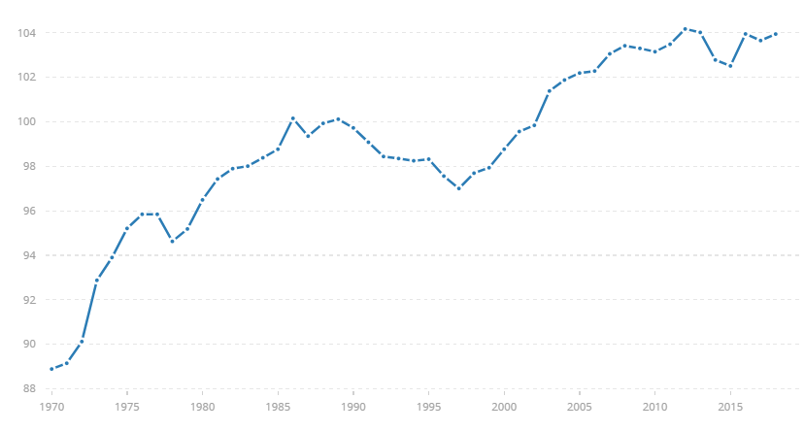
Figure 1 School Enrolment of Primary Education
(UNESCO Institute for Statistics, 2020)

4.1.2 Girls’ Education
The fifth sub-target is to ensure the education of marginalised group including girls’ education. As for girls’ education, UIS (2020) has released an eAtlas (see Figure 2) to highlight the newest data on gender parity. The map shows a huge improvement. South Asia has made the most progress in reducing the gender gap in education. Since 2000, the number of girls without access to education has declined significantly from 205 million to 129 million (UNESCO, 2020), despite large gaps still remain, mainly in Sub-Saharan Africa.
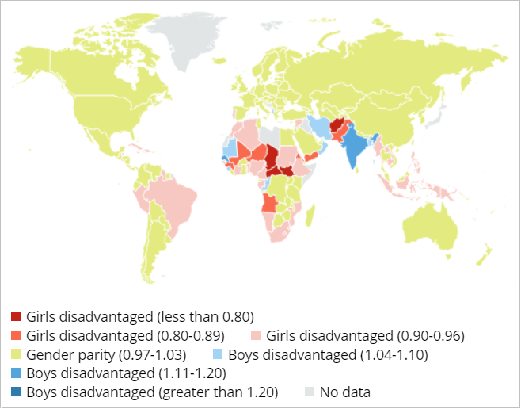
Figure 2 Gender Parity Index of More Than 200 Countries
(source: the UNESCO Institute for Statistics, 2019)

4.2 Failures

4.2.1 Out-of-school Children
However, progress is still difficult in some regions due to poverty and conflicts (Rose, 2016). There is over 35% of children leaving primary school worldwide due to armed conflict (Plan International, 2020), and the urban-rural gap remains wide, as the poorest children are 4 times more likely to drop out than the richest (UNDP, 2020). In this sense, not everyone receives equal education opportunity. Despite the ratio of girls’ education increases, other marginalised groups remain difficult in constant study, which shows failure of the fifth target to some extent.

4.2.2 Lack of Investment in Education
In 2015, 16% of the expenditure in LMICs went to education, a significant portion of public resources (UIS, 2018). However, many countries have not met the funding targets for public education set out in the 2030 programme of action for education yet (Figure 3). Besides, not all money leads to learning, as the waste is high (The International Commission on Financing Global Education Opportunity, 2016b). Moreover, the government expenditure per student on tertiary education reduced from 32% in 2011 to 29% of GDP per capita (UIS, 2018).
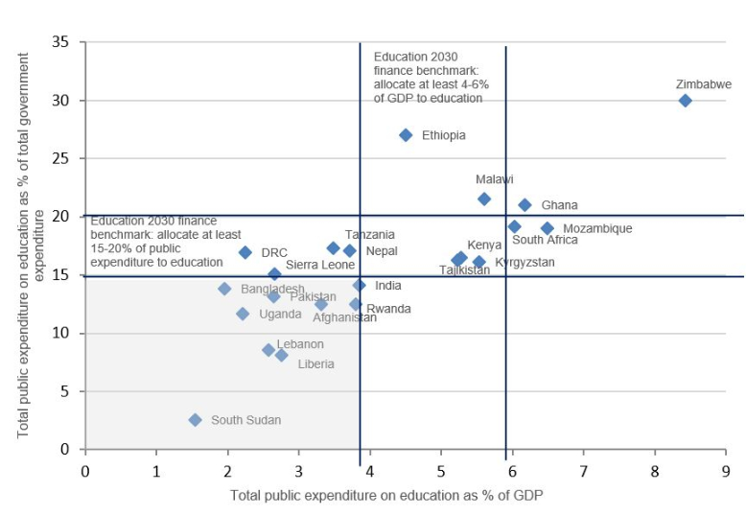
Figure 3 Many Countries Fall Short of International Benchmarks on Educational Budgets
(Source: UNESCO Institute for Statistics, 2018)
Funds should be invested in school infrastructure, scholarships, teachers’ training. However, with the lack of funds, the third, the fourth and the seventh targets remains to be fulfilled. In other words, public sectors seem make less efforts in high quality of advanced education, vocational training or knowledge and skills to promote sustainable development.

4.2.3 the Quality of Primary Education
By the end of primary school, over half children around the world (about 387 million) cannot read or calculate (Wyse, et al. 2019). Figure 4 shows that those uneducated account for over 90% in low income countries and over 75% in middle income countries.
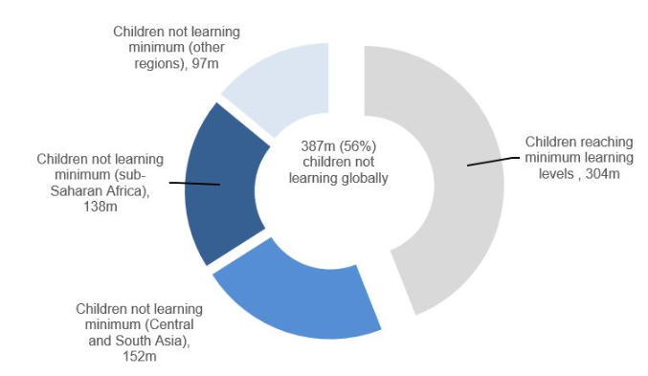
Figure 4 Children cannot Read or Calculate by the End of Primary School
(UNESCO Institute for Statistics, 2017)

This fact indicates that the sixth target of quality education, youth’s ability of literacy and numeracy, is still needs to be improved.

5.0 Conclusion
SDG4 aims to ensure inclusive and equitable quality education and promote lifelong learning opportunities for all. However, the current situations such as extreme poverty, conflicts, gender inequality, marginalisation groups, gap between rich and poor, gap between urban and rural all impede this development (Plan International, 2020). To achieve this goal, public sectors make efforts to provide financial supports, enforce laws and education as well as monitor their own behaviours. Overall, these public sectors help relieve the lack of educational resources, gender inequality and improve the availability of education.

- For educational resources, there are unqualified teachers especially in LMICs, and overcrowding classroom even in developed country, World Bank invest to improve teachers’ training and teaching infrastructure (World Bank, 2019).
- For gender inequality, most EU countries released legal framework on gender. Austrian and Afghanistan also focused on girl’s education and employment in their context (European Parliament, 2017; Niaz, 2019).
- For the availability of education, GPE (2019) has allocated $23 million to support Rohingya refugee and 35,000 disabled children to receive formal education by the support of DFID (Tofaris, et al. 2019).

These actions make sense in girl education and primary education, as overall enrolment of girls and boys both increased, and the ratio of girls also improved. However, the out-of-school children did decline especially in conflicted countries and poor rural areas. Lack of investment on teachers’ training and basic educational infrastructure, low literacy and numeracy still need to be solved (UNDP, 2020; UIS, 2018).

6.0 Recommendations
Based on above findings and discussion, there are four recommendations for public sectors to achieve SDG4.

Emphasise teachers’ quality: The quality of teaching is the most important factor affecting learning in schools (McGreal, 2017), public sectors should support teachers to improve knowledge and skills, select certificated and qualified teachers to teach children.

Improve education policies: Increasing the number of public schools. In addition to universal primary education, the government should also provide universal access to higher education and continue to support primary school fee remission (Nguyen, et al. 2019).

Increase investment in education: It is estimated that developing countries will need to increase annual public spending to $2.7 trillion by 2030 in order to achieve global education goals (The International Commission on Financing Global Education Opportunity, 2016). These funds should be used to address lack of resources, poor infrastructure and meet higher requirements such as school management, performance-based education, flexible curriculums and standardised testing.

Take actions to target marginalised children: Targeted support is needed for the most marginalised children including those in poverty, conflicted regions and gender discrimination. For example, special facility is needed to help disabled children to receive education.

References
Alcott, B., Rose, P. and Sabates, R. (2016). Targeted, Multidimensional Approaches to Overcome Inequalities in Secondary Education: Case Study of Camfed in Tanzania.

ESSA, (2020). Every Student Succeeds Act (ESSA). [Online] Available at: https://www.ed.gov/essa?src=rn[Accessed 5 May 2020].

European Commission (2015), Gender Segregation in the Labour Market and Education in Portugal.[Online] Available at: http://ec.europa.eu/justice/genderequality/files/exchange_of_good_practice_dk/pt_comments_paper_dk_2015_en.pdf. [Accessed 5 May 2020].

European Parliament, (2017). Gender Equality Plans in the Private and Public Sectors in the European Union. [Online] Available at:
https://www.europarl.europa.eu/RegData/etudes/STUD/2017/583139/IPOL_STU(2017)583139_EN.pdf[Accessed 5 May 2020].

General Assembly, (2015). Transforming Our World: the 2030 Agenda for Sustainable Development. [Online] Available at: https://www.un.org/ga/search/view_doc.asp?symbol=A/RES/70/1&Lang=E[Accessed 5 May 2020].

GPE, (2019). Factsheet: Education for Refugee Children. [Online] Available at:
https://www.globalpartnership.org/content/factsheet-education-refugee-children[Accessed 5 May 2020].

Guggenberger, H., Keplinger, M., & Unger, M. (2011). Moving to the Bologna structure: Facing challenges in the Austrian higher education system. In Employability and mobility of Bachelor graduates in Europe (pp. 43-67). Brill Sense.

Latchem, C. (2018). Out-of-School Children and Youth. In Open and Distance Non-formal Education in Developing Countries (pp. 63-75). Springer, Singapore.

Manji, S., Arnold, C. (2015). How Are We Doing and How We Get It Right for Children? Evolution of The Roles of the Public and Private Sector in Early Childhood Care And Education to Achieve EFA Goal 1. [Online] Available at:
https://unesdoc.unesco.org/ark:/48223/pf0000232458[Accessed 5 May 2020].

McGreal, R. (2017). Special Report on the Role of Open Educational Resources in Supporting the Sustainable Development Goal 4: Quality Education Challenges and Opportunities. The International Review of Research in Open and Distributed Learning, 18(7).

Nguyen, T., (2019). Gender Inequality in Education in Northern Midland and Mountainous Area in Vietnam. [Online] Available at: https://hs.kku.ac.th/ichuso/138-ICHUSO-2019.pdf[Accessed 5 May 2020].

Niaz, M. A., (2019) . How to Achieve a Quality, Universal Education. [Online] Available at: https://www.weforum.org/agenda/2019/11/mind-the-learning-gap[Accessed 5 May 2020].

Plan International, (2020). Girls’ Education. [Online] Available at: https://plan-international.org/education/girls-education[Accessed 5 May 2020].

Reardon, S. F. (2011). The Widening Academic Achievement Gap Between the Rich And the Poor: New Evidence and Possible Explanations. Whither Opportunity, 1(1), 91-116.

Rose, P. (2016). Overcoming Inequalities Within Countries to Achieve Global Convergence in Learning Background paper to the International Commission on Financing Global Education Opportunity. The Learning Generation: Investing in Education for a Changing World. New York: The International Commission on Financing Global Education Opportunity.

The Centre on Budget and Policy Priorities, (2017). A Lost Decade in Higher Education Funding. [Online] Available at: https://www.cbpp.org/research/state-budget-and-tax/a-lost-decade-in-higher-education-funding[Accessed 5 May 2020].

Thurston, D., Benjamin G.G., Lisa, N., Andrew, P. (2019). Education and Society: An Introduction to Key Issues in the Sociology of Education. University of California Press.

The International Commission on Financing Global Education Opportunity, (2016). Investment Plan Detail. New York: The International Commission on Financing Global Education Opportunity.

The International Commission on Financing Global Education Opportunity, (2016b). The Learning Generation: Investing in Education for a Changing World. New York: The International Commission on Financing Global Education Opportunity

Tofaris, E., Bari, F., & Malik, R. (2019). Research on Children with Disabilities Influences Education Policy in Pakistan.

UNDP, (2020). Goal 4: Quality education. [Online] Available at:
https://www.undp.org/content/undp/en/home/sustainable-development-goals/goal-4-quality-education.html[Accessed 5 May 2020].

UNESCO, (2014). Teaching and Learning: Achieving Quality for All Education for All Global Education Monitoring Report. Paris: UNESCO.

UNESCO, (2015). Education 2030 Incheon Declaration and Framework for Action: Towards Inclusive and Equitable Quality Education and Lifelong Learning for All. Paris: UNESCO.

UNESCO, (2017). Accountability in Education: Meeting Our Commitments. Education for All Global Education Monitoring Report. Paris: UNESCO

UNESCO Institute for Statistics (UIS), (2017). More Than One-Half of Children and Adolescents Are Not Learning Worldwide. Fact Sheet. Paris: UNESCO

UNESCO Institute for Statistics, (2019). Get the Latest Data on Girls’ and Women’s Education: UIS Releases New Edition of UNESCO EAtlas on Gender Inequality in Education. [Online] Available at:
http://uis.unesco.org/en/news/get-latest-data-girls-and-womens-education-uis-releases-new-edition-unesco-eatlas-gender[Accessed 5 May 2020].

UNESCO Institute for Statistics, (2020). New Methodology Shows that 258 Million Children, Adolescents and Youth Are Out of School. [Online] Available at: http://uis.unesco.org/sites/default/files/documents/new-methodology-shows-258-million-children-adolescents-and-youth-are-out-school.pdf[Accessed 5 May 2020].

Wapling, L. (2016). Inclusive Education and Children with Disabilities: Quality.

World Bank, (2018). Improving Teaching and Learning in Indonesia. [Online] Available at:https://www.worldbank.org/en/country/indonesia/brief/improving-teaching-and-learning-in-indonesia[Accessed 14 May 2020].

World Bank, (2019). Learning Poverty. [Online] Available at:
https://www.worldbank.org/en/topic/education/brief/learning-poverty[Accessed 5 May 2020].

World Bank, (2020). Why Teachers Matter? [Online] Available at:
https://www.worldbank.org/en/topic/teachers#1 [Accessed 5 May 2020].

Wyse, D., & Anders, J. (2019). Primary Education Curricula across the World: Qualitative and Quantitative Methodology in International Comparison. The SAGE Handbook of Comparative Studies in Education, 342.

