

MBA – Master of Business Administration
Banking and Finance
Banking Financial Management and Financial Markets
HSBC PLC HOLDINGS

Student Name: Priyanka Myadari
Student ID: 2223911
Word count: 5000
Table of Contents
Introduction: 2
Key Reforms Enacted by EU Authorities: 3
Key Reforms Enacted by Global Players: 6
Critical Review of Reform Impact: 8
HSBC Holdings plc and Reform Impact: 12
Structural Adjustments for HSBC Holdings plc: 16
Conclusion: 18
References 19

Introduction:
The worldwide implications of the 2008 financial crisis sparked a wave of changes that were aimed at increasing the stability of the financial system so that it could better withstand the occurrence of such crises in the future (Johannes et al. 2018). This paper investigates the extensive legislative and regulatory actions that were enacted as a reaction to the crisis by EU authorities and worldwide financial companies. These changes will affect a variety of aspects, including requirements for capital, risk management, and transparency.
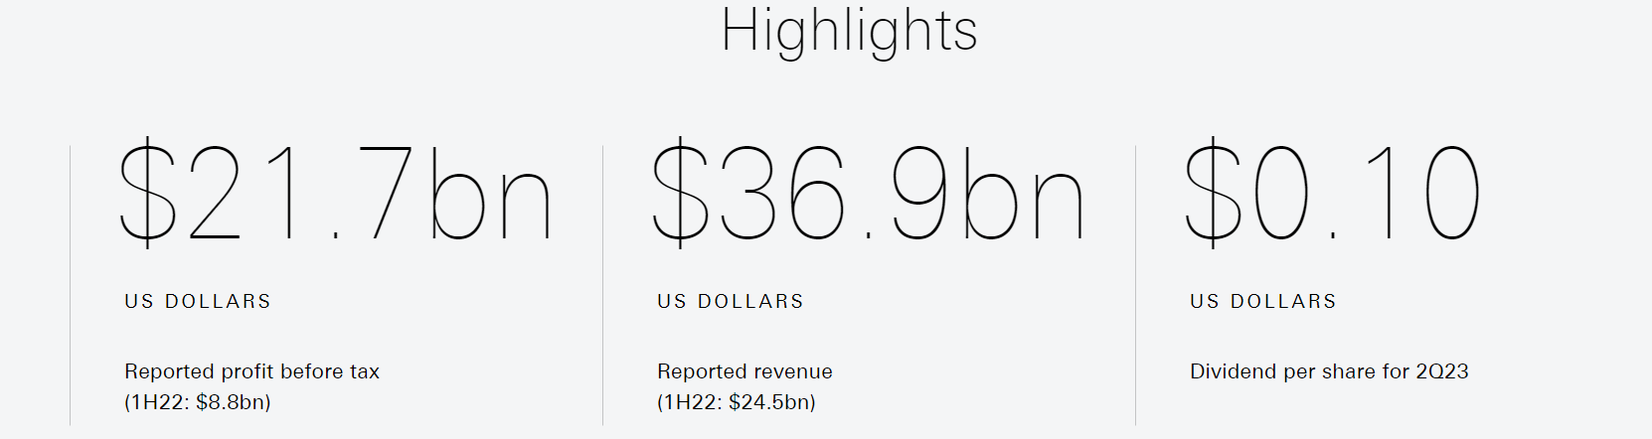
Figure 1: HSBC Holdings Highlights in 2023
(Source: HSBC, 2023)
Figure 1 stated that HSBC has been able to achive $36.9bn revenue in the current fiscal year along with 21.7bn USD profit before tax and 0.10$ dividend per share. The investigation will analyse how the aforementioned changes may affect HSBC Holdings plc in addition to the international monetary system as a whole (Frame, 2022). HSBC's dedication to ethical business practises, which can be seen in the diverse efforts it has undertaken and the community contributions it has made exemplifies the company's agility in the face of shifting regulatory environments (Simona, 2015). The insights that were acquired from this research helped pave the way for suggestions on possible structural modifications that might better align the operations of HSBC with these post-crisis reforms.

Key Reforms Enacted by EU Authorities:
In the aftermath of the 2008 financial crisis, the authorities in the European Union (EU) decided to undertake a major reform of financial rules in order to improve the stability and resiliency of the financial system. In this part, the most important changes that were put into effect are discussed (Johannes et al. 2018). These reforms address fundamental problems with risk management, capital sufficiency, transparency, and consumer protection.
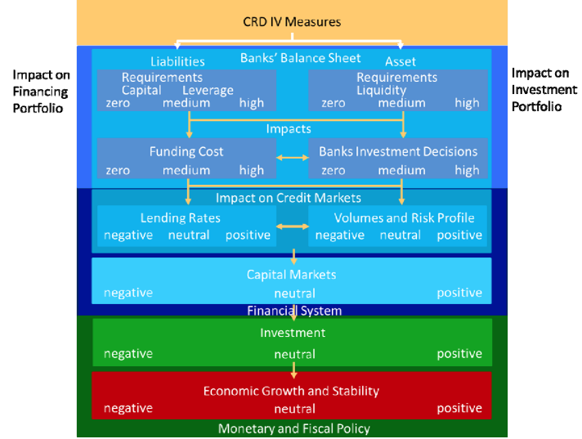
Figure 2: Impact of CRD IV measures
(Source: European Parliament, 2011)
The mitigation of possible adverse effects on investments and economic development might be achieved by the reduction of CRD IV's impact on banks' funding costs, as well as the ability of banks to transfer higher financing costs to their consumers (European Parliament, 2011). The implementation of the Capital Requirements Directive IV (also known as CRD IV) and the Capital Requirements Regulation (also known as CRR) was one of the most notable legislative efforts that have been developed in the aftermath of the financial crisis (Simona, 2015) (James et al. 2022). The implementation of these regulations affected the establishment of a more comprehensive framework to ensure sufficient capital reserves. These have been characterised by increased capital ratios and a particular emphasis on common equity Tier 1 (CET1) capital (Johannes et al., 2018). These modifications wanted to mitigate the risk of bank insolvency through the enhancement of the ability of banks to absorb losses during periods of heightened financial strain (Martinez and Gil, 2022; Giglio, 2022).
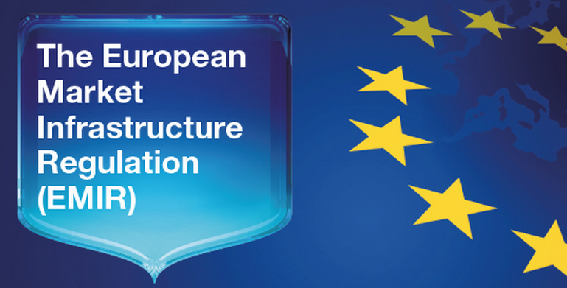
Figure 3: European Market Infrastructure Regulation (EMIR)
(Source: EIMF, 2023)
The implementation of the European Market Infrastructure Regulation (EMIR) aimed to enhance market transparency and mitigate risk by mandating the use of central clearing and reporting for derivatives transactions (Simona, 2015). The objective of EU authorities in streamlining the clearing process was to reduce the risk of counterparty failure and establish a more stable derivatives market. According to Acharya and Steffen (2013), significant advancements have been achieved in the global financial system with regard to increased transparency and responsibility, mostly attributed to the adoption and execution of MiFID II and MiFIR. The aforementioned legislation enhanced market supervision and investor protection by the reinforcement of reporting obligations pertaining to the trading of financial instruments. The need for transparency was emphasised in order to mitigate the likelihood of a repetition of the opaque and high-risk transactions that played a role in the occurrence of the financial crisis in 2008.
The focus on safeguarding consumer interests has been a prominent aspect of legislative endeavours after the implementation of the EU Mortgage Credit Directive (MCD) and the Packaged Retail and Insurance-based Investment Products Regulation (PRIIPs Regulation) (Erkens et al., 2012). The MCD standardised practises for the lending of mortgages and increased borrower information, with the goals of encouraging responsible lending and lowering the risk of mortgages that cannot be sustained. In the meanwhile, PRIIPs produced key information papers for retail investment products (Acharya and Steffen, 2013). These documents provided customers with information that was both clear and succinct on the possible risks and returns associated with the products.
Additionally, a fundamental shift in the institutional makeup of EU financial supervision occurred with the founding of the European Systemic Risk Board (ESRB) and the Single Supervisory Mechanism (SSM) (Erkens et al. 2012). In its capacity as an early warning system for possible crises, the European Systemic Risk Board (ESRB) was entrusted with the responsibility of detecting and reducing systemic risks throughout the EU. Concurrently, the SSM delegated responsibility for the supervision of important banks to the European Central Bank (ECB), with the intention of maintaining uniform and stringent scrutiny in order to avoid regulatory arbitrage (Acharya and Steffen, 2013).
In a nutshell, the EU authorities reacted to the 2008 financial crisis with a comprehensive strategy for reforming the whole system. They wanted to make the financial system more resistant to future meltdowns, so they implemented policies that focused on risk management, capital sufficiency, transparency, and consumer protection (Erkens et al. 2012). These changes not only attempted to avoid a repeat of the vulnerabilities that led to the crisis, but they also established the European Union (EU) as a frontrunner in the field of global financial regulation (Barth et al. 2012). The EU's devotion to promoting a stable and resilient financial environment is shown by its commitment to these measures, which will be implemented.

Key Reforms Enacted by Global Players:
International financial institutions were motivated to take action as a result of the aftermath of the 2008 financial crisis, which resulted in a wave of changes that intended to strengthen the overall financial environment (Mallard and Sun, 2022). This section goes further into the key initiatives undertaken by prominent actors such as the International Monetary Fund (IMF) and the World Bank. These initiatives represent the participants' concentrated efforts to develop a more robust and linked global financial system (Angeloni and Wolff, 2012). As a leading global organisation, the International Monetary Fund (IMF) has taken steps towards reforming its operations in accordance with the mandate it was given to foster monetary cooperation on a worldwide scale and maintain exchange rate stability (Barth et al. 2012). The International Monetary Fund (IMF) has prioritised the achievement of global financial stability and the prevention of future crises by considering it as the fundamental objective. The group intensified its surveillance efforts and undertook comprehensive examinations of the financial and economic conditions of the countries under its membership in order to reach its objective (Angeloni and Wolff, 2012). The result of these reviews can reveal policy deficiencies, that can be promptly identified and remedied, by reducing susceptibility.

Figure 4: Two lending facilities of the IMF
(Source: Self-developed)
The International Monetary Fund (IMF) has taken effective measures to enhance the global financial safety net. The International Monetary Fund (IMF) has implemented two lending facilities known as the Flexible Lending Line (FCL) and the Precautionary and Liquidity Line (PLL) in order to assist eligible member nations in managing times of extreme market volatility. The main aim of implementing these credit lines was to enhance trust and bolster stability within the global financial systems. It also includes mitigating the risk of cross-border transmission of a pandemic (Ercegovac et al., 2020). The World Bank, an essential agency for worldwide advancement, extended more assistance towards these endeavours. The main intention of the World Bank's efforts was the establishment of a robust monetary infrastructure in developing countries. The Global Findex Database can be entailed as a significant project due to its establishment via many collaborations (Angeloni and Wolff, 2012). These databases offered valuable insights into global financial inclusion and the availability of banking services, therefore it has helped in facilitating the formulation of more focused policy interventions by policymakers.
Furthermore, it can be noted that the Financial Sector Assessment Programme (FSAP) was strongly advocated by the World Bank. This programme included a cooperative effort between the International Monetary Fund (IMF) and the World Bank by aiming to undertake thorough evaluations of the financial systems of various countries (Derbali and Hallara, 2016). A comprehensive analysis has been initiated to assess the effectiveness of regulatory frameworks, risk management protocols, and systemic vulnerabilities. The main motive of the Financial System Assessment Programme (FSAP) is to enhance the stability and resilience of financial systems in both developed and developing countries by identifying deficiencies and providing specific suggestions for improvement (Ercegovac et al., 2020).
The international community has engaged in collaborative efforts which have been extended beyond the scope of officially formed organisations. As a framework for strengthening collaboration and coordination, the Financial Stability Board (FSB) is comprised of international organisations, as well as regulatory bodies and central banks (Derbali and Hallara, 2016). The Financial Stability Board (FSB) took on a crucial role in the process of establishing international standards and supporting the most effective practices in the area of financial regulation and supervision. Its efforts were centred on detecting systemic risks, improving transparency, and fixing regulatory deficiencies that may possibly cause more crises in the future (Ercegovac et al. 2020).
Therefore, the years after the financial crisis of 2008 were marked by a determined effort on the part of international financial institutions to strengthen the global financial system (Paulet and Mavoori, 2019). The increased supervision and the construction of financial safety nets by the International Monetary Fund (IMF), together with the emphasis on financial inclusion and sector evaluations by the World Bank, were all attempts to avert a repetition of the vulnerabilities that led to the financial crisis (Derbali and Hallara, 2016). The strategy of working together, as typified by the Financial Stability Board, placed an emphasis on coordinated efforts to create a more robust, linked, and stable worldwide financial ecosystem (James and Quaglia, 2021). These changes highlighted the resolve of global participants to reduce the risks posed to the economic system as a whole and to foster economic development that is sustainable on a global scale.

Critical Review of Reform Impact:
A comprehensive analysis of the changes that were implemented in the wake of the financial crisis that occurred in 2008 demonstrates that they had a mixed influence on the process of stabilising the financial system and individual banking institutions (Gutiérrez-López and Abad-González, 2020). It is necessary to conduct an all-encompassing analysis of the efficacy of the reforms because of the diverse character of the changes, which encompasses risk assessment, enhancements to transparency, and adjustments in banking practices.
Improved Risk Assessment:
The reforms brought in a variety of new processes that were designed to improve risk assessment and management within the financial sector as a whole.
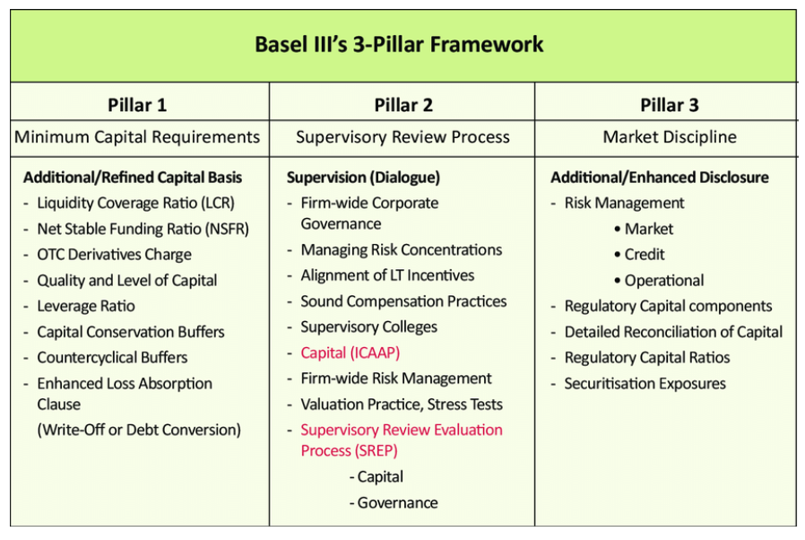
Figure 5: Basel III framework
(Source: Alexander, 2014)
Banks were forced to have bigger capital buffers to protect themselves from the effects of shocks as a result of stricter capital requirements, such as those defined in the Basel III framework (Matousek et al. 2015). Because of this, their resilience was improved, and they were better able to absorb losses, both of which contributed to a more stable financial environment. Another essential change, known as stress testing, included putting financial institutions in a variety of potentially dangerous situations, with the goal of identifying possible weak spots and ensuring that they were appropriately equipped (Bottineau et al. 2022). On the other hand, the efficacy of these risk assessment improvements has been called into question. Some people think that comparisons and projections are difficult to draw because of how complicated stress testing is and how many different kinds of financial organisations there are (Gutiérrez-López and Abad-González, 2020). In addition, there is the potential for unexpected effects, such as a reduction in lending due to a fear of taking risks, which is a cause for worry.
Enhanced Transparency:
According to Matousek et al. (2015), one of the primary goals of the regulatory changes that were enacted in the wake of the 2008 financial crisis was to increase transparency. Initiatives such as MiFID II and MiFIR were essential in bringing about these changes. In order to strengthen both the integrity of the market and the confidence of investors, these laws made it mandatory for all transactions involving financial instruments to be reported in their entirety (Ercegovac et al. 2022). However, the effect of these transparency initiatives has delivered conflicting outcomes, demonstrating the complicated interaction that exists between increasing openness and its larger repercussions.
The impact of these attempts to increase transparency has been dual, highlighting both the advantages and the problems for the ecology of the financial system (Kuznetsov, 2022). On the other side, the statutory reporting requirements have resulted in a landscape of investments that is more informed. Investors now have access to more information on the activities of the market, which enables them to make more informed decisions and provides the opportunity to spot abnormalities more quickly. Because of the increased transparency, unethical business practices that were previously allowed to operate under the radar have been significantly reduced, which has contributed to a more ethical and responsible financial marketplace (Navid, 2022).
On the other hand, the severe reporting requirements have resulted in large increases in compliance expenses incurred by financial institutions, notably banks (Zalewska, 2023). These charges have the potential to reduce market liquidity and impair the profitability of an enterprise. Because of the resources that were allocated to satisfying the reporting obligations, monies and efforts that might have been put towards the core operations of the firm were diverted. Additionally, the increased compliance cost might be a hardship for smaller participants in the market, reducing their capacity to successfully compete with bigger competitors in the industry. According to Gutiérrez-López and Abad-González's research from 2020, the associated cost constraints and limited market liquidity provide issues for institutions as they attempt to strike a balance between adhering to regulatory requirements and preserving a competitive advantage.
The push for more transparency in the global financial system has, in essence, resulted in the introduction of an evolving set of outcomes (Malakhova et al. 2020). Although increased transparency has unquestionably helped create a more informed investing environment and put a stop to unethical practises, the concurrent growth in compliance expenses has made things more difficult for financial institutions due to the additional complexity it has created. Finding the optimal balance between operational effectiveness and transparency continues to be a difficult task for both government regulators and private sector organisations (Acharya et al. 2022). To maintain a robust and healthy financial ecosystem, it will be necessary to perfect the implementation of transparency measures in order to maximise their intended advantages while minimising any unforeseen fallout. This will be necessary in order to keep pace with the ongoing changes in the financial landscape.
Changes in Banking Practices:
Significant changes in banking practice have been brought about as a direct result of the reforms, including a fresh emphasis on risk management and a reappraisal of business models. The focus of banks shifted from complicated, high-risk initiatives to more fundamental banking operations as part of a move towards a more conservative strategy (Matousek et al. 2015). Trading in derivatives, which was historically known for its opaque nature, has recently seen a transition towards centralised clearing and reporting, which has helped to promote stability. Nonetheless, unanticipated results developed as a result (Kokorin, 2021). The process known as "de-risking" occurred as a result of stricter restrictions. This resulted in banks withdrawing from riskier markets and customer segments, which might have an effect on financial inclusion and economic development (Goldstein and Véron, 2011). In addition, market liquidity in some asset classes was negatively impacted as a result of the decrease in the amount of proprietary trading and market-making activity (Tiwari et al. 2019).
Structural Adjustments and Industry Evolution:
Alterations to the sector's fundamental architecture were another effect of the reforms' implementation. In order to adjust to the new regulatory climate, several institutions chose to either scale down their activities or reorganise them, while others welcomed innovation as a means of doing so. The development of financial technology and regulatory technology, for example, has helped to solve compliance issues and ushered in more efficient banking procedures (Ladipo and Nestor, 2009). However, the rapid pace of technological development raises worries about the safety of data as well as the readiness of regulatory bodies.

HSBC Holdings plc and Reform Impact:
The multinational banking behemoth HSBC Holdings plc successfully negotiated the reform environment by committing to ethical business practises (Alford, 2010). The emphasis placed on diversity and inclusion, which is backed up by concrete measures and open reporting, is in line with the goals of the reform programme, which are to increase openness and reduce systemic risks. The deployment of risk assessment processes by HSBC, in accordance with the criteria of the regulatory authorities, prepares the institution to successfully weather adverse financial conditions (Pataccini, 2023) (HSBC, 2023). However, a detailed evaluation of the effect that the changes would have on HSBC's business model is required. Changes in the institution's lending practices and investment portfolios may have occurred as a result of the institution's efforts to comply with severe capital requirements and transparency rules (Ladipo and Nestor, 2009). The focus placed on responsible lending is in line with the aims of the reform effort, but it may have an effect on profitability.
In conclusion, the changes that were implemented in response to the financial crisis that occurred in 2008 have had a mixed effect on the financial system as a whole and on individual banking institutions (De Bruyckere et al. 2013). Unintended effects and issues have arisen despite the fact that risk assessment procedures and advancements in transparency have led to increased stability. Changes in banking practice and structural modifications reflect the dynamic development of the sector as a whole. Institutions such as HSBC Holdings plc are responding to both the demands of compliance and the imperatives of responsible business (Ladipo and Nestor, 2009) (HSBC, 2023). Due to the dynamic character of the current financial environment, continuous evaluation and modification are required in order to guarantee that the reforms continue to improve the overall system's stability while simultaneously supporting sustainable development (Agoraki et al. 2023).

Impact of Reforms on HSBC Holdings plc:
The post-2008 financial crisis reforms' influence on the business model of HSBC Holdings plc is a testimony to the complicated interaction that exists between regulatory modifications and the strategic development of an organisation (La Torre et al. 2021) (HSBC, 2023). An in-depth review of HSBC's business model reveals the extent to which it complies with these changes, as well as areas in which it does not, notably in risk management, capital allocation, and general business strategy.
Alignment with Post-Crisis Reforms:
HSBC's dedication to responsible business practises resonates with the transparency and risk management aims of post-crisis reforms, hence this bank is in line with the changes that were made after the financial crisis (Alford, 2010). The focus that the institution places on diversity and inclusion reflects the aims of the regulating body, helping to cultivate an organisational culture that is inclusive and in line with the overarching values of stability and justice (Brouwer et al. 2021). In addition, the fact that HSBC has shown that it can adhere to more stringent capital standards shows its compatibility with the reforms' capital adequacy goals. Indicative of the institution's proactive strategy to absorbing possible losses and increasing its resilience in the case of unfavourable scenarios is the institution's emphasis on the maintenance of a strong holdings capital buffer (Santillán-Salgado, 2011).
Risk Management and Compliance:
The connection of HSBC's risk management practises with post-crisis changes is readily apparent from these practises. The institution's involvement in stress testing, an important regulatory activity, demonstrates its attention to analysing and addressing any vulnerabilities by highlighting the institution's commitment to the process (La Torre et al. 2021). Not only does HSBC satisfy the standards of the regulatory agencies, but it also improves its ability to conduct an internal risk assessment by putting its operations through a variety of stressful situations. In addition, the fact that HSBC has implemented the risk assessment tools that the reforms have mandated has improved the company's capacity to recognise and respond to potential threats (Alford, 2010). The extensive risk assessment system that the institution has implemented, together with its dedication to ethical behaviour, places it in a favourable position within the newly restructured regulatory environment.
Capital Allocation and Strategic Adjustments:
The strategic changes that HSBC has made in how it allows its capital are an excellent example of a well-calibrated reaction to the current regulatory landscape. Not only does the institution's unshakable commitment to maintaining capital buffers and adhering to adequate common equity Tier 1 (CET1) capital ratios emphasise the institution's protection against bankruptcy, but it also emphasises the institution's responsible practises in resource management (La Torre et al., 2021). Nevertheless, strategic readjustments are required in order to achieve compliance with severe capital requirements. The amount to which HSBC is able to fulfil these stringent capital needs might have an effect on the lending methods and investment options that it chooses, despite the fact that HSBC's dedication to regulatory standards protects its financial stability. According to Santillán-Salgado (2011), striking a balance between ensuring compliance with regulatory changes and maintaining profitability provides a complicated problem.
Strategic considerations are required because of the intersection between regulatory requirements and the capacity to remain financially viable. The resiliency of HSBC may be improved by adjusting its strategy for allocating its capital in accordance with the changing environment (HSBC, 2023). Utilising sophisticated analytics and risk assessment tools may make it easier to make educated decisions, which in turn enables the institution to maximise its use of available capital while maintaining compliance standards (La Torre et al. 2021).
Furthermore, in order for HSBC to keep its revenue streams while still complying to the regulations, it has to come up with unique solutions. Investigating other sources of income, such as environmentally responsible investments or business alliances, might help reduce the possible negative influence on a company's profitability (HSBC, 2023). Not only does strategic diversification protect HSBC from the risks associated with reform-induced income swings, but it also enables the company to become a proactive player in an evolving financial paradigm.
HSBC's competence rests in the creation of a nuanced capital allocation plan that complies with regulatory obligations while simultaneously supporting sustainable development. This delicate balancing job is akin to a complex juggling act. HSBC is able to negotiate the hurdles given by rigorous capital requirements because the company integrates regulatory compliance with creative business models in a fluid manner (Bernier, 2022). This allows the company to ensure long-term survival and flexibility in a financial landscape that is always changing.
Business Strategies and Adaptation:
The answer that HSBC has provided to the changes comprises an expansion in the scope of the development of business strategies (Jackson, 2010). The emphasis that the reforms place on responsible lending and lowered systemic risks are reflected in the organization's decision to prioritise low-risk, core banking operations above high-risk endeavours. HSBC's operations are brought into alignment with the spirit of the reforms, and the bank is positioned as a responsible global participant as a result of this strategic shift (Chiu, 2023). Despite this, the path to compliance that HSBC is on is not devoid of obstacles. Stricter laws might unintentionally result in de-risking, which is when an institution withdraws from potentially riskier markets or portions of the market (Eubanks, 2010). As HSBC navigates the regulatory environment, one of the most important factors that it must take into account is the impact that de-risking will have on financial inclusion and the availability of banking services (HSBC, 2023).
The path that HSBC Holdings plc has taken after the end of the 2008 financial crisis sheds light on the complex interplay that exists between regulatory changes and institutional adaptability (Bernier, 2022). The institution has shown that it is dedicated to maintaining stability and sustainability by aligning itself with the reforms via the implementation of responsible business practices, upgrades to risk management, and strategic changes (Jackson, 2010). Compliance with capital requirements and comprehensive reporting illustrate HSBC's devotion to regulatory regulations, which allows the company to navigate the difficult balance between responsible lending and profitability. The institution's development within the context of the reformed regulatory environment illustrates both its resiliency and its proactive approach to tackling the challenges and possibilities presented by a changed financial ecosystem (Eubanks, 2010). As it continues to transform, HSBC illustrates how a global banking institution can manage complicated changes while remaining loyal to its fundamental principles and the commercial goals it seeks to achieve.

Structural Adjustments for HSBC Holdings plc:
A comprehensive strategy that optimises risk management, capital utilisation, and strategic positioning in response to regulatory changes is required when proposing specific structural adjustments to be made to HSBC Holdings plc (Jackson, 2010). Using the results of the compliance assessment and the business model analysis, the following suggestions have been crafted to improve HSBC's alignment with post-crisis reforms and to guarantee that the company will continue to be successful within the constantly shifting financial landscape (Lileikienė et al. 2021).
1. Enhanced Risk Management Framework:
By integrating risk management more deeply into its organisational DNA, HSBC can strengthen its commitment to responsible business practices (HSBC, 2023). The organisation need to give some thought to enhancing its stress testing procedures so that they cover a wider range of potential outcomes, which should include newly emerging risks such as cyber-attacks and climate-related occurrences (Hardie and Howarth, 2009). HSBC is able to proactively address possible difficulties and increase its resilience as a result of taking a more forward-looking approach to risk assessment (Gutiérrez-López and Abad-González, 2020). This allows the company to better adapt to an environment that is always changing.
2. Dynamic Capital Allocation:
Adjustments to the structure should include methods for using capital that maximise both regulatory compliance and profitability (La Torre et al. 2021). HSBC has to investigate methods to more dynamically deploy capital across its various business groups, taking into consideration risk-adjusted returns. The institution would be able to meet the demands of post-crisis reforms by adopting this strategy. At the same time, the institution would be able to meet the objective of producing sustainable income streams (Hardie and Howarth, 2009). In addition, HSBC might use sophisticated analytics to fine-tune the judgements it makes on capital allocation, therefore improving both its efficiency and its strategic alignment.
3. Fintech Integration and Innovation:
The development of FinTech and regtech gives an opportunity for HSBC to not only improve the quality of the client experience but also to expedite its compliance procedures (Cerutti and Schmieder, 2014). Investing in innovative technologies has the potential to promote transparency, decrease operational risks, and boost the effectiveness of reporting processes. HSBC can improve its competitiveness while maintaining compliance with the ever-changing regulatory landscape if it makes use of solutions from the financial technology (FinTech) industry (Hardie and Howarth, 2009).
4. Responsible Lending and Financial Inclusion:
Adjustments to the structure should be focused on broadening the scope of responsible lending practices at HSBC in order to guarantee access to financial services for a greater proportion of the population. While the institution must comply with rules, it must also proactively evaluate how the choices it makes on lending affect local people and economies (Cerutti and Schmieder, 2014). Through the promotion of financial inclusion, HSBC is able to align itself not only with the aims of the regulatory agencies but also with its commitment to ethical behaviour.
5. Strategic Partnerships and Diversification:
HSBC may further improve its resilience by investigating potential strategic alliances that are congruent with the responsible business goals it has set. Collaborations with climate-focused organisations, impact investing platforms, or sustainable infrastructure projects may diversify income sources while maintaining regulatory compliance (Kirkpatrick, 2009) (Ercegovac et al. 2020). By forming these relationships, HSBC would further demonstrate its dedication to making a good impact on a variety of socioeconomic and environmental issues.
6. Continuous Learning and Adaptation:
Modifications to the structure should be supported by a culture that emphasises lifelong education and adaption (Adrian et al. 2018). To ensure that its employees are aware of regulatory changes, emerging risks, and industry best practices, HSBC should engage in continual training and development for its team. With this approach, personnel would be given the tools they need to efficiently handle difficulties, and the environment would be cultivated to encourage creativity and flexibility (Cerutti and Schmieder, 2014) (Ho, 2016).
HSBC Holdings plc's structural modifications need to be directed by a forward-thinking strategy that blends compliance with responsible business practises and strategic agility (Goodhart and Schoenmaker, 2016). The dedication of the institution to responsible lending practices, risk management, and open reporting offers a strong platform on which to build the implementation of these suggestions (Kirkpatrick, 2009) (Arner et al. 2016). HSBC can navigate the ever-changing financial landscape while remaining steadfast in its commitment to stability, sustainability, and societal impact by improving risk assessment practises, optimising capital utilisation, embracing FinTech innovation, and fostering partnerships aligned with its values (Goodhart and Schoenmaker, 2016). HSBC's proactive approach to structural adjustments puts it as a forerunner in adapting to change while preserving its basic beliefs. As the regulatory landscape continues to develop, HSBC's proactive approach to structural adjustments positions it as a trailblazer.

Conclusion:
In conclusion, the aftermath of the financial crisis that occurred in 2008 was characterised by a major upheaval in the financial landscape, which was driven by important reforms. These changes, which were enacted by EU authorities as well as global participants, had the goal of fortifying the system against the weaknesses that had led to the crisis. Even if the effects of the reforms have been complex, it is indisputable that they have improved risk assessment, transparency, and responsible practices across the sector.
The path that HSBC Holdings plc has taken across this terrain shows the difficult balance that must be maintained between strategic adaptability and regulatory compliance. The institution's compliance with reforms, which it exhibits via public reporting, improvements in risk management, and diversification initiatives, proves that it is committed to maintaining stability and sustainability.
When one takes a look into the future, it becomes clear that the dynamic character of the business is exemplified by the continuous development of the financial system as well as the possibility of further regulatory modifications. It will be essential to the development of a robust and responsive financial ecosystem for regulatory bodies, financial institutions, and international organisations to continue working together. As the environment continues to change, the lessons that were learnt from the crisis that occurred in 2008 and the reforms that were implemented as a result will serve as guideposts in order to ensure a more stable, transparent, and inclusive global financial system.

References
Acharya, V.V. and Steffen, S., 2013. Analyzing systemic risk of the European banking sector. Handbook on systemic risk, pp.247-282.
Acharya, V.V., Gujral, I., Kulkarni, N. and Shin, H.S., 2022. Dividends and bank capital in the global financial crisis of 2007–2009. Journal of Financial Crises, 4(2), pp.1-39.
Adrian, T., Kiff, J. and Shin, H.S., 2018. Liquidity, leverage, and regulation 10 years after the global financial crisis. Annual Review of Financial Economics, 10, pp.1-24.
Agoraki, M.E.K., Kouretas, G.P. and De Simone, F.N., 2023. The performance of the euro area banking system: the pandemic in perspective. Review of Quantitative Finance and Accounting, pp.1-31.
Alexander, Kern. (2014). Stability and Sustainability in Banking Reform: Are Environmental Risks Missing in Basel III?
Alford, D., 2010. Supervisory colleges: The global financial crisis and improving international supervisory coordination. Emory Int'l L. Rev., 24, p.57.
Angeloni, C. and Wolff, G.B., 2012. Are banks affected by their holdings of government debt? (No. 2012/07). Bruegel working paper.
Arner, D.W., Barberis, J. and Buckey, R.P., 2016. FinTech, RegTech, and the reconceptualization of financial regulation. Nw. J. Int'l L. & Bus., 37, p.371.
Barth, J.R., Prabha, A. and Yun, G., 2012. The Eurozone financial crisis: Role of interdependencies between bank and sovereign risk. Journal of Financial Economic Policy, 4(1), pp.76-97.
Bernier, L., 2022. The 2008 economic crisis and the rebirth of public enterprises. The Economy of the Collective Interest: 75 years of scientific research, p.281.
Bottineau, I., Coffinet, J. and Le Meur, C., 2022. Large French banking groups are increasingly concentrating their international activities in the euro area. Bulletin de la Banque de France, (241).
Brouwer, T., Huttenhuis, J. and ter Hoeven, R., 2021. Empirical results for expected credit losses of G-SIBs during COVID-19. The proof of the pudding is in the eating. Maandblad voor Accountancy en Bedrijfseconomie, 95(11/12), pp.381-396.
Cerutti, E. and Schmieder, C., 2014. Ring fencing and consolidated banks’ stress tests. Journal of Financial Stability, 11, pp.1-12.
Chiu, I.H.Y., 2023. Prospects for international financial deglobalisation and its potential impact on international financial regulation. Law and Financial Markets Review, pp.1-19.
De Bruyckere, V., Gerhardt, M., Schepens, G. and Vander Vennet, R., 2013. Bank/sovereign risk spillovers in the European debt crisis. Journal of Banking & Finance, 37(12), pp.4793-4809.
Derbali, A. and Hallara, S., 2016. Systemic risk of European financial institutions: Estimation and ranking by the Marginal Expected Shortfall. Research in International Business and Finance, 37, pp.113-134.
EIMF, 2023. EMIR. Available at: https://eimf.eu/emir/ [Accessed on: 18.08.2023]
Ercegovac, R., Klinac, I. and Zdrilić, I., 2020. Bank specific determinants of EU banks profitability after 2007 financial crisis. Management: Journal of Contemporary Management Issues, 25(1), pp.89-102.
Ercegovac, R., Klinac, I. and Zdrilić, I., 2020. Bank specific determinants of EU banks profitability after 2007 financial crisis. Management: Journal of Contemporary Management Issues, 25(1), pp.89-102.
Ercegovac, R., Tolj, A. and Piplica, D., 2022. The pass-through effect of unconventional monetary policy to net interest income structure of European banks. Ekonomski vjesnik: Review of Contemporary Entrepreneurship, Business, and Economic Issues, 35(1), pp.45-54.
Erkens, D.H., Hung, M. and Matos, P., 2012. Corporate governance in the 2007–2008 financial crisis: Evidence from financial institutions worldwide. Journal of corporate finance, 18(2), pp.389-411.
Eubanks, W.W., 2010. The European Union's response to the 2007-2009 financial crisis (Vol. 1). Congressional Research Service.
European Parliament, 2011. Directorate-General for Internal Policies. Available at: https://www.europarl.europa.eu/RegData/etudes/etudes/join/2011/464423/IPOL-ECON_ET%282011%29464423_EN.pdf [Accessed on: 18.08.2023]
Frame, I., 2022. The ends and means of banking: the Royal Bank of Scotland after the 2008 crisis. Journal of Corporate Law Studies, 22(2), pp.931-970.
Giglio, F., 2021. Fintech: A literature review. European Research Studies Journal, 24(2B), pp.600-627.
Goldstein, M. and Véron, N., 2011. Too big to fail: the transatlantic debate. Peterson Institute for International Economics Working Paper, (11-2).
Goodhart, C. and Schoenmaker, D., 2016. The global investment banks are now all becoming American: does that matter for Europeans?. Journal of Financial Regulation, 2(2), pp.163-181.
Gutiérrez-López, C. and Abad-González, J., 2020. Sustainability in the banking sector: A predictive model for the European banking union in the aftermath of the financial crisis. Sustainability, 12(6), p.2566.
Gutiérrez-López, C. and Abad-González, J., 2020. Sustainability in the banking sector: A predictive model for the European banking union in the aftermath of the financial crisis. Sustainability, 12(6), p.2566.
Hardie, I. and Howarth, D., 2009. Die Krise but not La Crise? The financial crisis and the transformation of German and French banking systems. JCMS: Journal of Common Market Studies, 47(5), pp.1017-1039.
Ho, H., 2016. A case study of true and fair view override in financial reporting. Nang Yan Business Journal, 5(1), pp.13-19.
HSBC, 2023. Annual Report 2023. Available at: https://www.hsbc.com/investors/results-and-announcements/annual-report [Accessed on: 17.08.2023]
HSBC, 2023. Highlights. Available at: https://www.hsbc.com/ [Accessed on: 18.08.2023]
Jackson, J.K., 2010. Financial crisis: Impact on and response by the European Union. Diane Publishing.
James, S. and Quaglia, L., 2021. Brexit and the political economy of euro-denominated clearing. Review of International Political Economy, 28(3), pp.505-527.
James, S., Kassim, H. and Warren, T., 2022. From Big Bang to Brexit: The City of London and the discursive power of finance. Political Studies, 70(3), pp.719-738.
Johannes, R., Dedy, D. and Muksin, A., 2018. The Preparation of Banking Industry in Implementing IFRS 9 Financial Instruments (A Case Study of HSBC Holdings Plc Listed on London Stock Exchange of Year 2015–2017). International Journal of Economics and Financial Issues, 8(6), pp.124-136.
Kirkpatrick, G., 2009. The corporate governance lessons from the financial crisis. OECD Journal: Financial market trends, 2009(1), pp.61-87.
Kokorin, I., 2021. The rise of ‘group solution’in insolvency law and bank resolution. European Business Organization Law Review, 22, pp.781-811.
Kuznetsov, A.V., 2022. Imperatives for transformation of the international monetary system in the conditions of multipolarity. Finance: Theory and Practice, 26(2), pp.190-203.
La Torre, M., Leo, S. and Panetta, I.C., 2021. Banks and environmental, social and governance drivers: Follow the market or the authorities?. Corporate Social Responsibility and Environmental Management, 28(6), pp.1620-1634.
La Torre, M., Leo, S. and Panetta, I.C., 2021. Banks and environmental, social and governance drivers: Follow the market or the authorities?. Corporate Social Responsibility and Environmental Management, 28(6), pp.1620-1634.
Ladipo, D. and Nestor, S., 2009. Bank boards and the financial crisis. A corporate governance study of the 25 largest European banks.
Lileikienė, A., Obi, P. and Valackienė, A., 2021. An examination of the safety and profitability of EU and US banks since Basel III. Journal of Management, 37(2).
Malakhova, T.S., Kapustin, P.P., Morusov, S.A. and Udovik, E.E., 2020. European practice in ensuring sustainable development: Problems and contradictions. Int. J. Econ. Bus. Adm, 8, pp.14-23.
Mallard, G. and Sun, J., 2022. Viral Governance: How Unilateral US Sanctions Changed the Rules of Financial Capitalism. American Journal of Sociology, 128(1), pp.144-188.
Martínez, M.A. and Gil, J., 2022. Grassroots struggles challenging housing financialization in Spain. Housing Studies, pp.1-21.
Matousek, R., Rughoo, A., Sarantis, N. and Assaf, A.G., 2015. Bank performance and convergence during the financial crisis: Evidence from the ‘old’European Union and Eurozone. Journal of Banking & Finance, 52, pp.208-216.
Navid, K., 2022. How Many Single Rulebooks? The EU’s Patchwork Approach to Ensuring Regulatory Consistency in the Area of Investment Management. European Business Organization Law Review, 23(2), pp.347-390.
Pataccini, L., 2023. The (un) usual suspects? Exploring the links between illicit financial flows, Russian money laundering and dependent financialization in the Baltic states. Competition & Change, p.10245294231177352.
Paulet, E. and Mavoori, H., 2019. Globalization, regulation and profitability of banks: a comparative analysis of Europe, United States, India and China. The European Journal of Comparative Economics, 16(2), pp.127-170.
Santillán-Salgado, R.J., 2011. Banking concentration in the European Union during the last fifteen years. Panoeconomicus, 2, pp.245-266.
Simona, M.U.T.U., 2015. Exposure to Systemic Risk of the European Too-Big-to-Fail Banks During Crisis. Review of Economic and Business Studies, p.103.
Tiwari, A., Patro, A. and Mohil, S., 2019. Credit insurance under different policy regimes and associated risk of crisis. In The impacts of monetary policy in the 21st century: Perspectives from emerging economies (pp. 361-374). Emerald Publishing Limited.
Zalewska, A., 2023. Bankers' remuneration reforms and new challenges. Corporate Governance: An International Review, 31(1), pp.161-177.

