Pollen Assessment

Part 1
Figure 1:
This bar chart is of the number of pollen spore countered from the slide of pollen found at Whitland Bypass.

Figure 2: A bar chart displaying the number of pollen counted to each type of pollen, from the Whitland Bypass Slide.

The sample (slide) of pollen that I analysed was from the Whitland Bypass and was a sample from 70cm. As highlighted in figure 2 there was a considerable amount of tree pollen that had been detected from the sample especially in comparison to the amount of herb pollen found, which is next to nothing (only 1 pollen spore was found for herb); there is still a considerable amount of shrub pollen found in this sample even though it is still only a comparative one third to that of the tree pollen. The high percentile of pollen that comes from trees in this sample I analysed suggests that this sample would be from heavily wooded area, such as a forest. The wooded area is a predominantly Betula trees 33% of the pollen sample, however Alnus tress (26% of the pollen sample) are also incredibly popular in this area, further investigation from this area may even show that Alnus is more prominent than Betula however, from the sample given Betula has the highest pollen recorded from this sample as seen in figure 1; Figure 1 also shows that Corylus is the most predominant shrub at 17% of the pollen sample that the woodland area has. From this information, identifying that there are two distinguishable features of both a high proportion of Betula trees and a high percentage of Corylus shrub forensic investigators would be able to use this distinguishable information to locate and narrow down a specific area that would be linked to a crime in some way. Pollen spores can be collected from a victim, a possible perpetrator or even a possible weapon, collecting the pollen from these things and identifying the percentile of different pollen narrows down the perimeter of a possible crime scene using the a database that has the types of plant types in a certain area and from that information they can then find what areas have similar plant types and further on from that the percentage and density of the pollen in those areas, this cross analyses should then ultimately create a possible perimeter from which all an investigator would do is double check this idea by gathering another pollen sample from the suspected area and then comparing that with the found pollen from the victim/ perpetrator /weapon.
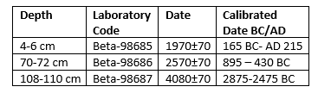
Figure 3, Radio Carbon Dates

The above figure is the radio carbon dates that relate to figure 4, the pollen diagram which I have divided into 3 zones, pollen zones on a diagram can be determined by a numerous array of ways from climate to stratigraphy, however in this instance the pollen zones are a measure of time as shown in figure 3. All 3 of these time zones are during the Holocene epoch, the first zone is the Neolithic, the second zone is the Bronze age and lastly the third zone is the Iron Age. The Holocene epoch roughly started 11,500 years ago at the end of the last glacial period after this, the pressures of glacial period had dissipated however the it became humans and animals that now shaped the taxonomic history of the pollen. (Moore, 1991: 8 and 181). Analysis of pollen deposits has lead to the creation of a determined timeline through the correlation of pollen fossils, it can be an indication of climate impact, human impact and animal impact on the environment and demonstrates how anthropogenic changes alter the pollen count (Roberts 1998:33).
Figure 4, zone 1 is the Neolithic 108-110cm, and from this figure we can see that it demonstrates that the pollens of herbs, trees and shrubs are increasing in a general sense, predominantly the trees especially the Alnus, the Corylus avellane type shrub also starts to peak in pollen percentile and similarly so does the Cyperaceae Herb. The reason for this increase is probably down to the increase in warmer temperatures as later on in the Neolithic we see a decrease in the Alnus trees and in herbs too, but shrubs take a huge increase to me this would indicate that there has been some sort of human interaction that has meant such as deforestation, a human anthropogenic taxonomic altercation, as this action would result in a higher percentage of shrubbery considering that shrubbery grows in place of trees typically (herbs often grow near some sort of wooded area which could offer an explanation for why there is also a decrease in herbs) (Berlgund, 1986: 457).
Figure 4’s Zone 2 is the Bronze age and starts around 70cm in the pollen analyses and roughly occurred on the end of the Neolithic 200 years ago to 800 years ago, this period of time on figure 4 (70cm) marks that again Alnus (tree) and Corylus (shrub) are back on the rise however this time so is Betula (Tree). It could be though that at this time that all trees would be on the slope downwards after all this is when humans need trees to burn to heat the bronze to make things, farming although started in the Neolithic was heading in a route of expansion and required deforestation, it may explain why on tree is on the decrease which is Quercus however it would not solve the reason as to why the other decreased other than that Quercus which had been the tree on the increase for a while was now being culled by human and animal interaction as a result both Alnus and Betula lost their competitor for dispersal and the decrease of Quercus resulted in the increase of other trees although that time period would be typical of a all round decrease of trees (Berlgund 1986: 455, 462 &463).
Lastly zone 3 is the most recent of the zones and is the Iron Age (4cm) is a period when both tree and shrub pollen fall across the board after they had been decreasing for a few hundred years but herbs at this point in time increased. This period of time was the roman period, the romans had invaded Britain and had a need to build their great temples and roads, they needed infrastructure, before their arrival Britain was still a heavily forested area, to get the infrastructure they required the Romans deforested the land for the great buildings they would make (Connolly, 1996: 313-317); this anthropogenic altercation explains why there would be less trees and shrubs, although it does not explain why there would be an increase in herbs. I can deduce three reasons for this change: the first being that due to the lack of competition from both tree and shrub pollen the herb pollen thrived (Berlgund 1986: 462), secondly that the romans and their wisdom and knowledge of medicine planted more herbs for medicinal purposes (Connolly 1996: 316) and lastly that it was both of these two combined, to create this increase in pollen which seems more likely than for it to simply be one reason on its own.

Figure 4:

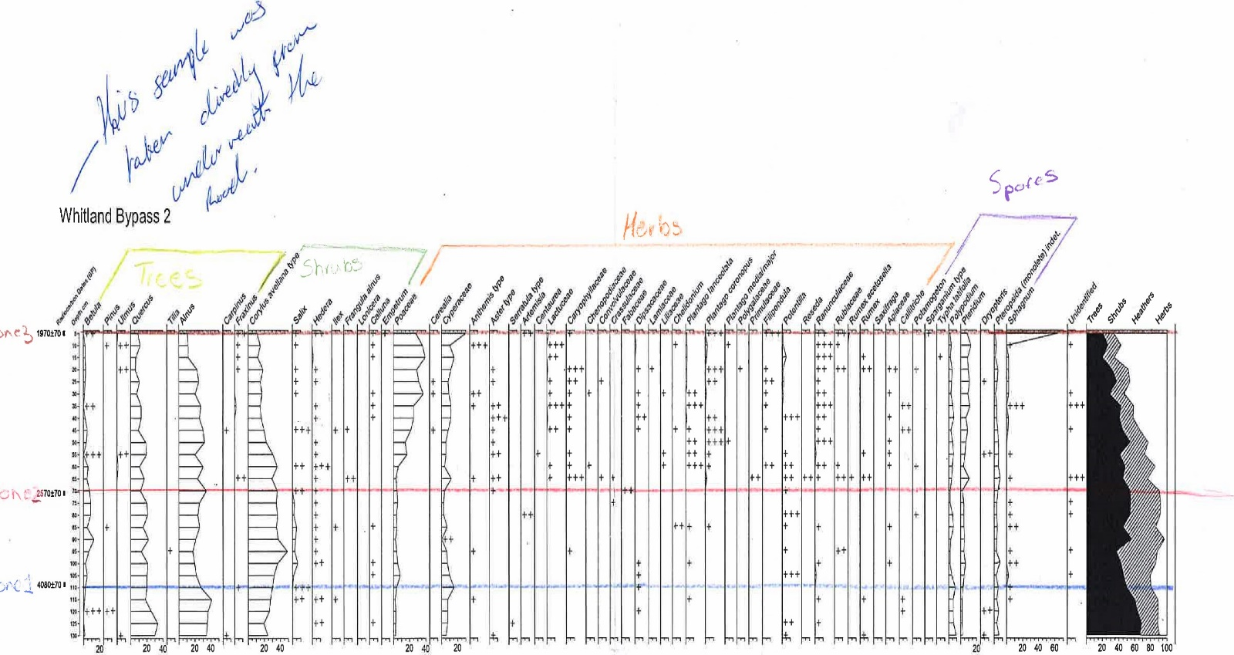

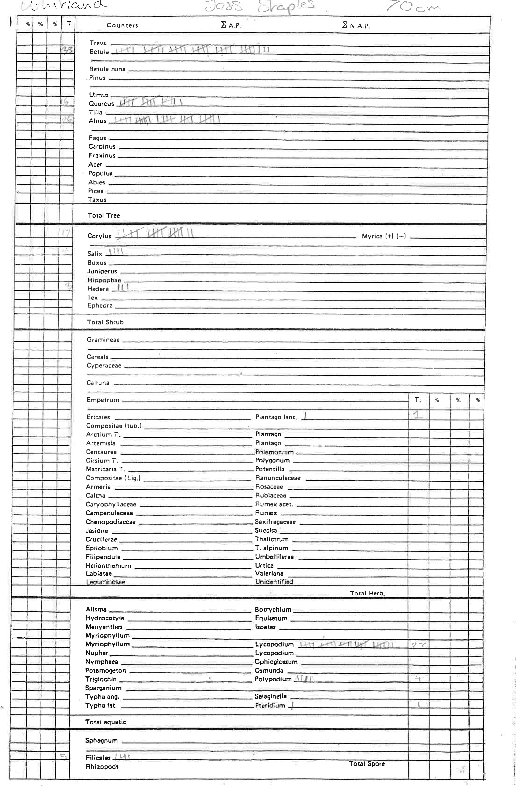
Bibliography:
B.E. Berglund (1986). Handbook of Holocen Palaeoecology and Palaeohydrology. Chichester, UK: John Wiley & Sons Ltd. 455-465.
J. Connolly, P. Wayne, 1996. Asymmetric Competition between Plant Species. Oecologia vol. 108, no. 2. pp. 310-318.
Ronald E. Martin (1999). Taphonomy, A Process Approach. Cambridge UK: Cambridge University Press. 227-234.
P.D. Moore, J.A. Webb and M.E. Collinson (1991). Pollen Analysis. 2nd ed. Oxford, UK: Blackwell Scientific Publications. 5, 7, 8, 168, 181.
Neil Roberts (1998). The Holocene, An Environmental History. 2nd ed. Oxford, UK: Blackwell Publishers Ltd. 28-36.

