Assessment 2
As part of this module we will be considering the relationship between ‘the circular economy’ and business.

For the assessment, you should firstly consider how the principles of the circular economy could underpin responsible business. You should then select a business or organisation as a case study and conduct some primary research to evidence why you feel the business already reflects the principles of the circular economy, what challenges it still faces and how those challenges could be achieved as a set of short, medium and long-term goals.

University of Wales Trinity Saint David
Pheobe Twigg
1810487

Introduction
The Circular Economy
“A circular economy is based on the principles of designing out waste and pollution, keeping products and materials in use, and regenerating natural systems” (MacArthur 2020). The circular economy is rethinking the future. Looking beyond the current take-make-waste model, it aims to focuses on positive society benefits and aims to redefine growth. Circular economy is the transition of sources to renewable energy sources, it builds economic, natural and social capital. This is based on three principles

The circular economy is important as a more circular economy not only creates opportunities for growth but also reduces waste, drive greater resource productivity, position the UK to better address emerging resource security/scarcity issues in the future and help reduce the environmental impacts of our production and consumption in both the UK and abroad (WRAP 2020).
Research stated that transitioning to the circular economy isn’t only adjusting to reduce the negative impacts of the linear economy, but it represents a systematic shift that builds ‘long-term resilience, generates business and economic opportunities and provides benefits environmentally and socially’ (MacArthur 2017).
The goal of a circular economy is to reduce the negative impact on the ecological systems. This system makes optimal use of raw materials and resources, continuously applying them in a way that generates the highest economic value along with the least environmental damage (Environmental Assessment Agency 2019).

Linear Economy
The linear economy is where most products and packaging are discarded after being used once. This leads to enormous levels of waste materials and pollution. Change is essential with the capacity of landfills reaching its limit and pollution of micro-plastics remotely increasing (Circule Solutions 2020). 80% of environmental impacts are determined by waste and pollution (MacArthur 2020).
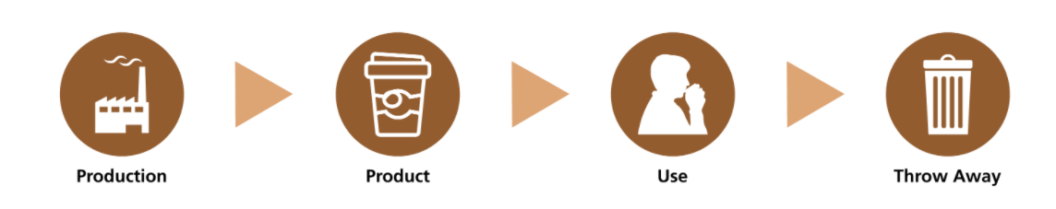

How the linear economy and circular economy are different
In a linear economy raw materials are mined and then processed into products that are thrown away after they’ve been used. Whereas a circular economy all raw materials cycles are closed. The circular economy requires more than just recycling it goes beyond that changing the way that value is created and preserved, in a more sustainable production along with which business models are used. A linear economy follows the traditional step-by-step plan ‘take-make-dispose’, whereas a circular economy follows the approach of the 3 R’s; reduce, reuse and recycle, as the resources used is minimised, the products reuse is maximised and raw materials are reused to a high standard (Environmental Assessment Agency 2019).
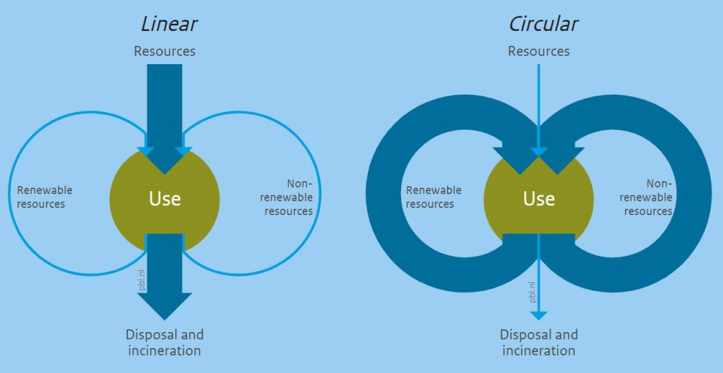
The circular economy is different to the linear economy as it is more profitable and causes less harm to the environment, with its main goal including sustainable economic growth, increased competitiveness and new jobs (Stiftung Entrepreneurship 2016). In contrast within a circular economy, sustainability is seen as the systems eco-effectiveness, not only the minimisation of the ecological impact but that the positivity of the ecological, economic and social impact is increased.

Problems of the linear economy and does the circular economy help this
The linear economy leads to business practices being assumed that there is a constant supply of natural resources. But this approach is seen to be coming under a large scale of pressure, due to a disadvantage of the linear economy is that the expense of production of the goods and materials is at the expense of the productivity of the ecosystem (Schmdit 2020). This suggests that when the products are discarded natural areas are covered with toxic substances which are often also emitted. The linear model jeopardises the supply of materials, this uncertainty is caused by the fluctuation of raw material prices, the scarcity in materials, the dependence and increase on different materials (Carlberg 2020). These can be solved in a circular economy. Research has stated that many organisations have notice that the linear system increases exposure to risks and higher resource prices (MacArthur 2017).
“The potential benefits of shifting to a circular economy extend beyond the economy and into the natural environment” (MacArthur 2017). The circular economy helps the effects of the linear economy as it provides substantial resource savings. Although the attention of the circular economy is increasing the raw materials extraction and prices are still increasing (MacArthur 2017).
Within the circular economy labour is valued more than raw materials and as a result this has led to employment opportunities growing. The circular economy aims to improve resources performance along with fighting against the volatility that climate change might bring to organisations. It provides strategic and operational benefits and creates a huge potential for value amongst economical, organisational, environmental and societal spheres (Clement 2020).
The circular economy provides a sharp distinction between the consumption and use of materials. Its core value is creating the potential for products, components and materials to be kept in use longer within the circular economy (MacArthur 2017).
The circular economy would benefit organisations on a significant scale if they were to adjust their operations in line with the circular economy principles. The benefits would vary from them gaining new profit opportunities, also the ability to gain reduced costs due to lower material requirements and the ability for stronger relationships with customers (MacArthur 2017).

Organisation’s circular economy credentials - AMAZON
Amazon overview
Amazon was founded by Jeff Bezos, who started the company from a book selling website however it generated a positive response, he then decided very soon that he had the potential of online portals, which then he established Amazon (Belson 2014). It is among the companies which first started offering products online.
The company was named after the largest river in the world. Amazon became a very popular site on the Web, making high marks on several Internet rankings. Amazon has a mission developed to set themselves separate from competitors, “Our mission is to continually raise the bar of the customer experience by using the internet and technology to help consumers find, discover and buy anything, and empower businesses and content creators to maximise their success” (Amazon 2020).
Amazon today is seen as more than just an everything store, it seen as a leader in consumer-facing AI and enterprise cloud service. Amazon sells books, music, movies, toys, electronics, housewares and many other goods. They also see themselves as a technology based company, simplifying online transactions for consumers (Amazon 2020).
In 2002 the Amazon launched their initial data on Internet traffic patterns Amazon Web Services (AWS). Amazon then later began to sell its own Kindle e-readers. In 2011 the company introduced a related low-cost tablet computer, the Kindle Fire (Amazon 2020). Amazon also introduced many of their own technology advances such as the Eco-dot, Alexa and many more. They then in 2017 expanded into an additional market of food, when they agreed to buy the supermarket chain, Whole Foods Market, Inc, which was valued at more than £13 billion (Hall 2019).

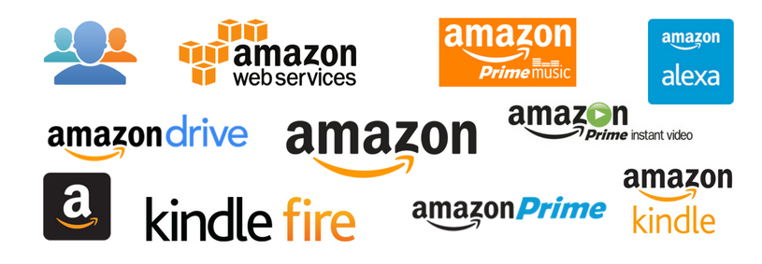
(Mohan 2018)

Amazon as a circular economy firm
Amazon are attempting to fit into the circular economy as Amazon’s vision of the circular economy is “keeping resources in use for as long as possible” and they stated that “We’re on a mission to ensure we’re using our size and scale to make a circular economy a reality” (Amazon 2020).
Amazon state in their sustainability strategy that they are minimising waste, increasing recycling and providing their customers with the option to reuse, repair and recycle their products that they’ve purchased, with the goal that less material will go into landfill and more back into the circular economy loop to keep materials in the economy. Sustainability must happen at scale, which drives sustainable innovation. Amazon are committed to reducing environmental footprint through initiatives of recycling through their operations and customers (Amazon 2020). Amazon have stated that they are committed to developing new recycling infrastructure along with the ability to invent packaging with materials that are recyclable, also supporting the recycling industry through investing in initiatives.
Amazon have stated on their website within their sustainability section that they have the commitment to support sustainable disposal and are inventing ways to support the disposal of packaging and products as part of “The Climate Pledge of becoming net-zero carbon by 2040” (Amazon 2020).
Amazon have announced that they have joined the Ellen MacArthur Foundation’s Network, as their commitment that is ongoing to reduce waste within their organisations and to share their stories of success across the industries. The Ellen MacArthur Foundation has a mission to accelerate the transition of the circular economy, it provides a framework of restorative and regenerative operations for the economy (Amazon 2020).

Amazon have provided insight into adapting to a circular economy they are providing more sustainability actions within their organisation, providing they are trying to recycle more of their products and packaging on a greater scale. They also offer standardised recycling instructions through “How2Recycle Labelling” along with The Recycling Partnership which they are supporting (Amazon 2020).

Amazon’s competitor IKEA are more committed to a circular economy as they are committed to ensuring that all their products will be 100% circular from using renewable or recycled materials to create their products and developing circular capabilities within their supply chain in contrast to Amazon who are concentrating on recycling. The circular economy goes beyond just recycling (MacArthur 2020). IKEA stated in their suitability strategy, “We work according to circular design principles, where products are designed to generate as little waste as possible from the very beginning. They are our way of ensuring that all products within the IKEA range fulfil our ambition to become fully circular.” (IKEA 2020).

Amazon circular model way forward
For Amazon to become circular within the economy they need to invent ways which all their products can be recycled and kept within the economy for long-term. They have unique opportunities to accelerate their transition into a circular economy through their collaboration and network. Amazon stated, “We look forward to working together as we raise the ambition and collective efforts of our network” (Amazon 2020). For Amazon to become more circular then need to become more sustainable on a greater level and follow the circular principles by working towards creating their products from renewable or recycled materials. With IKEA being in front of Amazon as a competitor that is working towards a circular economy, with them looking for ways that they can turn materials from old products into resources for new products (IKEA 2020). Amazon should consider the actions of their competitors and innovate their sustainability effort towards circular economy principles, as they are doing simple changes towards a circular economy in contrast to their competitors who are making higher changes. Amazon plan to enhance the use of renewable sources and continue to provide their customers with appropriate recycling opportunities to help them recycle and reuse products.

Challenges
Challenges faced by Amazon
Although Amazon have made efforts in becoming a circular economy it still has a long way to go and many challenges to overcome. Due to Amazon currently focusing on recycling, though trying to minimise waste and providing customers with options of reusing and recycling their products in order to send less material to the landfill and more back into the circular economy (Amazon 2020). Amazon Web Services through 100% renewable energy sources in the low impact challenge (Alumi 2017).
Meeting customer expectations is one of Amazon’s main challenges with customers becoming more aware of the importance of sustainability and it is seen that sustainability decisions are what consumers notice when they are decoding the underlying values behind a company (Purt 2014). This would be a medium impact challenge.
It’s very challenging for companies to live off renewable energy, due to the linear economy individuals are used to not recycling and using renewable and recyclable materials when creating their products. It is also difficult for Amazon to fully utilise the circular economy due to individuals’ minds being confined to non-renewable materials and sources (WRAP 2020). Amazon need to make more of an effort to reducing the impact that electronic waste is having on the economy and reduce the amount that is overfilling the landfill through providing recyclable products to customers as well as ways to recycle their products, though using more recyclable materials. It is a very difficult challenge for any organisation to reinvent their products for them to provide customers with all products from renewable sources in order to be within the circular economy. This would be a high impact challenge.
Another challenge Amazon are likely to face during the change to a circular economy is that of electronic and e-waste, as there are a range of electronic aspects which play a huge roll within our lives but are difficult to recycle. As research stated that when an electronic or electrical product reaches the end of life, they often can no longer be reused or repaired, therefore the recovery of these materials through recycling for use in new products could reduce the extraction and reduce the limit of rare materials and help the UK secure materials (Parliament 2020). This would be a high impact challenge.

Policies that support the circular economy
The Natural Capital Committee provides organisations with policies and protocols that give them guidance in becoming a circular economy. They provide advice to the government on how they should prioritise action to protect and improve natural capital (Natural Capital Committee 2020). Amazon’s effective proposal can suggest that the policy demands people to return the products they’ve used for recycling. If the Government was to enforce this, the firm should see 100% recycling and would provide Amazon with a greater insight of the importance of moving into a circular economy.
The European Commission Circular Economy Package is a policy that supports the circular economy, as effective policies such as this one can set up reverse logistics and innovative business models that can introduce and support circularity (World Business Council for Sustainable Development 2019). This will provide Amazon with some insight into what steps they need to take next in order to become circular but also to guide them along the way. The circular economy package provides support for organisations with “the revised legislative framework on the circular economy identifies clear steps for the reduction of waste and establishes an ambitious and credible long-term path for waste management and recycling” (GOV.UK 2020).
Another policy that could be effective for Amazon is the Green Deals policy which addresses the non-financial circular economy barriers. It has been seen to have added value to innovation within the fight to become a circular economy and with respect to agreements and cooperative discussions to achieve a circular economy (World Business Council for Sustainable Development 2019).

Amazon SWOT analysis

Solutions/ key objectives Amazon could pursue
Policymaking is one aspect that could be a solution to Amazon’s challenges as they can play an important role to help them overcome the barriers and to enable them to create the right conditions and set appropriate, direction for a transition to the circular economy (World Business Council for Sustainable Development 2019).
Amazon should operate according to the circular design principles which provides support of how products are designed ensuring they generate as little waste as possible from the very beginning. Another solution Amazon could obtain is the initiative to explore alternative fewer common materials and try and innovate solutions for how they could pro-long the products life. This would optimise source yields.
Amazon could offer their customers who purchase technological or electronic products with alternatives to just putting their products in waste, such as a recycling opportunity, this could be agreed through the development of a responsible purchasing policy being implemented, regarding how to recycle technological products.
Amazon could adopt a partnership with ‘Act and Sorb’ they are a company that turns industry waste into raw materials that are useful. Its an effective recycling process that increases the value of materials from waste (European Commission). This wold allow Amazon to create new products from their old products which get recycled effectively.

Conclusion
A circular economy is mainly focused on the ability to keep resources in use for as long as possible allowing the extraction of maximum value whilst they’re in use, then providing the ability to regenerate and reproduce products and materials at the end of their life, whilst the concept recognises the importance of the economy (WRAP 2020). The circular economy contradicts the current linear economy method of which take-make-waste which is waste products being disposed into landfills which lead to landfills reaching maximum capacity and an increase in environmental pollution. The linear method provides a negative effect for companies as well as the economy as it is seen as more expensive than the new circular economy method and the products have a reduced product lifespan, which is leading to it becoming under pressure (Entrepreneurship Campus 2019). There can be many benefits gained from the circular economy such as the ability to obtain products through raw materials which will give the ability for the product lifetime to be maximised to stay within the economy as the products are recycled and reused effectively.

References
Circule Solutions. (2020). Circular Packaging. Available: https://circulesolutions.com/circular-packaging/?gclid=EAIaIQobChMI2IjM37-F7gIVo-_tCh2YowHsEAMYAiAAEgIg_vD_BwE. Last accessed 5th January 2021.
Laville S. (November 2020). Amazon and Apple 'not playing their part' in tackling electronic waste. Available: https://www.theguardian.com/technology/2020/nov/26/amazon-and-apple-not-playing-their-part-in-tackling-electronic-waste. Last accessed 7th January 2021.
European Commission. (2020). Circular Solutions. Available: https://ec.europa.eu/environment/ecoap/scalingcircularbusiness/solutions_en. Last accessed 9th January 2021.
Amazon. (2020). Circular Economy. Available: https://sustainability.aboutamazon.com/environment/circular-economy. Last accessed 7th January 2021.
Alumi M. (December 2017). Amazon Works to Balance Growth with Sustainability. Available: https://digital.hbs.edu/platform-rctom/submission/amazon-works-to-balance-growth-with-sustainability/. Last accessed 9th January 2021.
Entrepreneurship Campus. (August 2019). The Difference Between Linear & Circular Economy. Available: https://www.entrepreneurship-campus.org/the-difference-between-linear-circular-economy/. Last accessed 9th January 2021.
World Business Council for Sustainable Development. (2019). Policy enablers to accelerate the circular economy. Available: https://circulareconomy.europa.eu/platform/sites/default/files/wbcsd_policy_enablers_to_accelerate_the_circular_economy.pdf. Last accessed 9th January 2021.
Natural Capital Committee. (2020). Natural Capital Committee. Available: http://www.naturalcapitalcommittee.org/. Last accessed 9th January 2021.
WRAP. (2020). WRAP and the circular economy. Available: https://www.wrap.org.uk/about-us/about/wrap-and-circular-economy#:~:text=What%20is%20a%20circular%20economy,end%20of%20each%20service%20life. Last accessed 9th January 2021.
GOV.UK. (2020). Circular Economy Package. Available: https://www.gov.uk/government/publications/circular-economy-package-policy-statement/circular-economy-package-policy-statement. Last accessed 9th January 2021.
Purt J. (2014). Consumer behaviour and sustainability - what you need to know. Available: https://www.theguardian.com/sustainable-business/2014/sep/10/consumer-behaviour-sustainability-business. Last accessed 9th January 2021.
IKEA. (2020). Why the future of furniture is circular Available: https://about.ikea.com/en/sustainability/a-world-without-waste/why-the-future-of-furniture-is-circular Last accessed 7th January 2021.
Amazon. (2020). Circular Economy. Available: https://sustainability.aboutamazon.co.uk/environment/circular-economy. Last accessed 7th January 2021.
Parliament. (November 2020). Recycling. Available: https://publications.parliament.uk/pa/cm5801/cmselect/cmenvaud/220/22008.htm. Last accessed 9th January 2021.
Howard M, Webster K. (October 2018). Circular business advantage: what organisations need to know. Available: https://medium.com/circulatenews/circular-business-advantage-what-organisations-need-to-know-c7ae1954cc46. Last accessed 7th January 2021.
WRAP. (2020). WRAP and the circular economy. Available: https://www.wrap.org.uk/about-us/about/wrap-and-circular-economy. Last accessed 6th January 2021.
Mohan M. (September 2018). Over 71 Amazon Products & Services You Probably Don’t Know. Available: https://www.matrics360.com/list-of-all-amazon-products-and-services/. Last accessed 7th January 2021.
Macarthur E. (2017). What is a circular economy? Available: https://www.ellenmacarthurfoundation.org/circular-economy/concept. Last accessed 6th January 2021.
Amazon. (2020). How we operate. Available: https://www.aboutamazon.co.uk/uk-investment/our-principles-for-how-we-operate. Last accessed 11th October 2020.
Schmidt C. (2020). The Circularity Gap Reporting Initiative: a global score for circularity. Available: https://www.circularity-gap.world/. Last accessed 6th January 2021.
Carlberg S. (2020). The circular economy — an opportunity for more sustainable IT products. Available: https://tcocertified.com/circular-economy/?utm_term=%2Bthe%20%2Bcircular%20%2Beconomy&utm_campaign=Circular+-+spring2020&utm_source=adwords&utm_medium=ppc&hsa_acc=6451387163&hsa_cam=9512205992&hsa_grp. Last accessed 6th January 2021.
Macarthur E. (2020). WHAT IS THE CIRCULAR ECONOMY? Available: https://www.ellenmacarthurfoundation.org/circular-economy/what-is-the-circular-economy. Last accessed 6th January 2021.
Environmental Assessment Agency. (2019). Opportunities for a circular economy. Available: https://themasites.pbl.nl/o/circular-economy/. Last accessed 6th January 2021.
Stiftung Entrepreneurship. (August 2019). The Difference Between Linear & Circular Economy. Available: https://www.entrepreneurship-campus.org/the-difference-between-linear-circular-economy/. Last accessed 6th January 2021.
Macarthur E. (January 2014). Effective business in a circular economy. Available: https://www.ellenmacarthurfoundation.org/news/effective-business-in-a-circular-economy. Last accessed 6th January 2021.
European Parliament. (2015). Circular economy: definition, importance and benefits. Available: https://www.europarl.europa.eu/news/en/headlines/economy/20151201STO05603/circular-economy-definition-importance-and-benefits. Last accessed 6th January 2021.
Clement F. (February 2020). Circular Economy: Definition, Principles, Benefits and Barriers. Available: https://youmatter.world/en/definition/definitions-circular-economy-meaning-definition-benefits-barriers/. Last accessed 6th January 2021.
Belson T. (July 2014). An Insight into Amazon. Available: https://www.kollimited.com/blog/126/an-insight-into-amazon.html. Last accessed 7th January 2021.
Hall M. (2019). Amazon.com. Available: https://www.britannica.com/topic/Amazoncom. Last accessed 7th January 2021.
McFadden C. (2nd November 2019). A Very Brief History of Amazon: The Everything Store. Available: https://interestingengineering.com/a-very-brief-history-of-amazon-the-everything-store. Last accessed 4th October 2020.

Appendences
A principle that is of importance with the circular economy is to decouple economic growth from the consumption of raw materials, this leads to the economy not having a shortage of raw materials to grow. This suggests a move towards the circular economy will promote economic growth (European Parliament 2015).
Renewable energy celebrate diversity, the ability to collaborate and adapt is essential as waste doesn’t exist in living systems.
A circular economy is the alternative to a traditional linear economy in which resources are used for as long as possible, extracting maximum levels of value from them whilst there in use for a maximum length of time and at the end of each service life recover and regenerate the products and materials at the end of each service life.
If the linear economy doesn’t change to a circular economy this could lead to the world reaching a point where it will lose capacity to sustain itself.
’Within a circular economy the perspective on sustainability is different than a linear economy, with a linear economy the focus is on eco-efficiency, to minimise the ecological impact for the same output.
The challenges of circular economy uses new ways of thinking in order to innovate solutions. This strives optimisation for the entire system (Macarthur 2017).
The circular economy provides the opportunity to design out waste and pollution, regenerate natural systems and keep products and materials in use, this then allows everything to be reinvented (MacArthur 2020).
Transitioning to the circular economy can be done effectively with the current advances such as digital technology as it has the power to support the transition by increasing virtualisation radically and feed-back driven intelligence.

An uncommon fact relating to Amazon’s logo is that it signifies that anything from A to Z can be purchased on this platform.
Amazon also operate their own shoe line along with apparel brands, along with consumer goods under their Amazon Basics level.
Amazon prime is one of the key services Amazon offer, as it’s a membership programme that provides customers with access to video streaming, e-books, music, free and effective shipping along with a variety of other Amazon specific services and deals (Mohan 2018).
Amazon have recently donated $100,000 to the Closed Loop Partners who provide supplies to men and women who are at the frontline of the pandemic within the sanitisation and recycling industry.
Amazon is a leader in the e-commerce industry, with over 350 million items for sale and 300 active customers, they are the first opportunity consumers use to find deals.
Amazon has a relentless commitment to the customer experience; their every strategic move and investment is guided by their goal of being the most ‘customer centric company’ (McFadden 2019).
Amazon must transition away from the take-make-dispose linear economy, towards organisational operations that allows their products be designed that they can be produced for their use to be extended, reuse and then recycled, in order for the materials to stay in the economy and to reduce landfill waste (Howard, Webster 2018).
Amazon stated that at their facilities around the world, “we are continuously expanding initiatives to maximize the positive impact of our surplus inventory”, they contribute product and food donations in order to reduce landfill waste and helping local communities engage towards a circular economy (Amazon 2020).
In contrast research has also stated that Amazon as a global giant should become more responsible for helping to collect, recycle and repair their electrical products which would lead the level of electronic waste been reduced, with 155,000 tonnes of electronic waste being thrown away each year in the UK, filling landfills (Laville 2020). Research has stated that Amazon have avoided playing their part in the circular economy, as they not being as sustainable as they could, by not collecting or recycling electronics in the way other organisations have (Laville 2020).

The circular economy allows benefits for companies as well as the economy as it allows companies to make cost savings, and it is reducing the waste and pollution to the environment. The goal of a circular economy is to reduce the negative impact on the ecological systems.

