
Academic skills assesment 3
REFLECTIVE REPORT

anamaria pop
Student id:2412053
UNIVERSITY OF WALES TRINITY SAINT DAVID
LECTURER: THOMAS ADEYEMI

Table of Contents
Note taking 2
Academic writing skills 4
Paraphrasing skills 5
Referencing list 7

Note taking
Taking notes does not mean writing down word by word everything that is taught in class or copying what you read. Notes include the main ideas of a topic (read or listened) using different methods or techniques, in a notebook or on a worksheet.
Also, will enable you to retain ideas, develop extraordinary study skills and better understand of what you are learning.
Above I have mentioned that there are different methos for taking notes, such as Cornell notes, tabular note taking, linear notes, mind map, diagrammatic.
Cornell notes method it was proposed by a professor at Cornell University, which is reflected in its name. The objective is to minimize the dedicated to studying notifications after class. To make use of this note you need to divide the page into three sections. At the bottom of the page, you have a full width section that is intended for the summary. The remaining part of the page you divide into two vertical sections. On the left is where you will write down keywords and questions. And the larger column is where you take notes during the course or lesson.
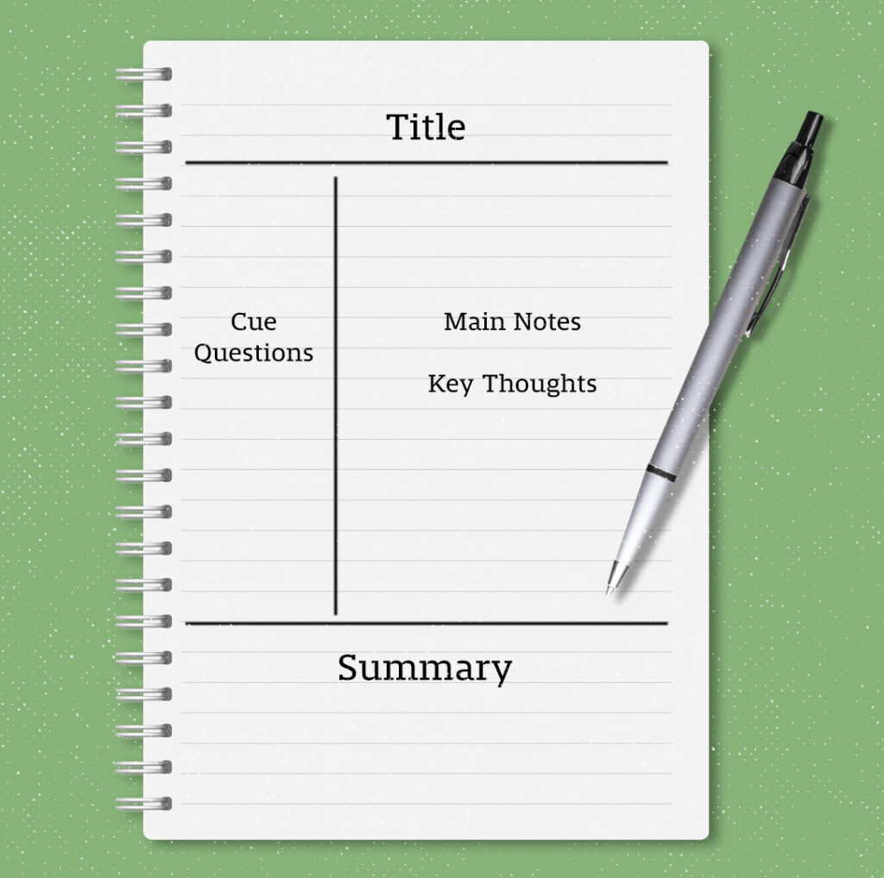 (Wilensky, 2022)

In my opinion, this method is very helpful because it makes you put your summary into you own words. This way, you learn quicker and with less effort. To find questions and keyword, you need to think about the information and relate it to what you already know, which also aids your learning.
Another note-taking method that you come across when studying learning strategies and methods is the mind mapping. But mind maps are extremely useful for giving you an overview of the topics discussed in a lesson or even a specific subject. It’s a great method to visually understand and link different concepts and ideas. However, a mind map lacks some of the finer details. That’s way I believe it is a more effective method for review purposes.
 (Gallardo, 2023)

The tabular note taking or tables, is an effective method for summarizing information you want to compare, like different opinions in a debate. Organizing points in a table allows you to assess them better, enhancing your possessions of a subject and beneficial in essay or exam preparation.
Tabular notes can be beneficial in social learning settings, such as tutorials or students support groups. Collaborating with classmates to create a table that contrasts different perspectives on a subject can be both engaging and informative.
As with other note-taking techniques, you can customize tabular notes to suit your preferences. Feel free to be inventive and experiment with various headings and categories.
Highlighting, in my opinion gives you a better understanding of the content. Choosing what to highlight or underline, makes you think critically and develop your own thoughts about the text. To use this method, have a quick look over the text and finally decide which parts you want to highlight to help you remember the important points and why they matter. (Anon., 2021)

Academic writing skills
Academic writing is a formal style of writing used in universities and academic publications. It is commonly used found in journal articles and academic books, and students are typically required to compose their essays, research papers and dissertations in this style.
While academic writing goes through the same writing process as other types of writing, it has its own unique rules about what to include, how to organize your work, and the overall style you should use.
The characteristics of academic skills are formal, evidenced, structured, precise, critical, balanced, objective.
Academic writing is all about sharing information without any favouritism. The main aim is to support arguments with solid evidence rather than relying on the author’s personal culture. Every claim made should be backed up with appropriate evidence.
To keep things neutral, it is crucial to accurately represent the work of other researchers as well as your own findings. This involves clearly explaining your research methods and being upfront about any limitations in your study.
Using a formal style in academic writing helps ensure that research is presented in a consistent way, making it easier to evaluate and compare different studies objectively.
Therefore, it is essential to use appropriate language. Avoid informal expressions, such as slang, clichés and casual phrases.
Using simple and exact words is important so that the reader understands exactly what you mean. This means you should be specific and avoid using vague words. Try not to use words like “perhaps” because they can make it seem like you are not sure about your arguments.
Academic writing relies on sources to back up its arguments. These sources can be other texts or media, photos or videos, that the writer examines or uses as proof. A lot of the sources you will find are written by other scholars because academic writing is a team effort that builds on earlier studies.
It is important to choose sources that are trustworthy and suitable for academic work. For instance, using Wikipedia is generally not a good idea. Instead of depending on random websites, you should look for reliable information in academic databases and your school library.
In academic writing, you always need to give credit to your sources. This means you should recognize when you quote or summarize someone else’s ideas, which includes adding in-text citations and a reference list.

Paraphrasing skills
Paraphrasing is your understanding of a text and rewrite with own words.
In academic writing, paraphrasing is important because it helps us use information and facts from studies done by other people. When we paraphrase, we take that we read and explain it in our words. This shows that we did our homework and makes our writing more trustworthy.
Plagiarism is a serious academic infraction that can occur when these ideas originate exactly from relevant studies or publications. According to our perspective, paraphrase allows us to include other people's thoughts in our own essays or academic papers without being suspected of plagiarism.
There are some key points to use when paraphrasing.
- Using synonyms words when needed to maintain the meaning of the context.
- Change the voice of the text from active to passive and the other way around.
- Modify adjectives, verbs, and nouns and alter word forms.
- Rearrange the words of sentence. Start in the middle or send the first words to the end. But make sure that the meaning is not changed.
- To simplify the text, you can merge sentences into one or split complex sentences into one or two shorter lists.

Referencing list
Gallardo, S. (2023). Mind Mapping Techniques for Students: How to Skyrocket Academic Success. [online] hbculifestyle.com. Available at: https://hbculifestyle.com/mind-mapping-techniques-for-students/.

Rielly, M. (2016). Note-taking. [online] www.plagiarism.admin.cam.ac.uk. Available at: https://www.plagiarism.admin.cam.ac.uk/resources-and-support/study-skills/note-taking.

user, A. (2021). Student’s guide to highlighting and note-taking. [online] Snippet’s Blog. Available at: https://blog.gosnippet.com/students-guide-highlighting-note-taking/.

Wilensky, J. (2022). Take Note: Popular Study Method has ‘Cornell’ Written All Over It. [online] Cornellians | Cornell University. Available at: https://alumni.cornell.edu/cornellians/cornell-notes/.

