

Module Tittle : Dissertation Proposal
Module Code: LCMB7020
Course: MBA general management
Dissertation Topic: Impact of advertising on the international students buying behavior of apple products

Supervisor: Rexon Nting
Student Name: Sanjay Avulareddy
Student Number: 2213727

Table of Contents
Introduction ......................................................................................................4
Justification of research……………………………………………………………4
Aims ..................................................................................................................5
Research objectives ........................................................................................5
Research questions .........................................................................................5
Literature Review .............................................................................................6
Conceptual review..........................................................................................6
Theoretical review ........................................................................................7
Empirical review.............................................................................................7
Research Methodology ...................................................................................8
Research Philosophy ......................................................................................9
Research approach .........................................................................................9
Research Strategy ..................................................................................9
Research choice .............................................................................................10
Data collection techniques ............................................................................ 10
Ethical consideration ......................................................................................10
Time prospect of the research ……………………………………………………11
Conclusion……………………………………………………………………………11
References ........................................................................................................12
Abstract
Companies and their target audience are connected through advertising, which provides a platform for the launch of new products or the recall of current ones. It is crucial in forming consumer perceptions since people frequently rely their opinions about a product on how it is portrayed in commercials. Information regarding accessible goods and services is the main goal of advertising, as seen from the perspective of the consumer (Warmke et al., 1977: 66).
Even though advertising has an unquestionable impact, it's important to recognize that a variety of factors also influence customer behavior. Consumer behavior is greatly influenced not only by advertising but also by product packaging, quality, endorsements, and general product esteem. Effective advertising, according to sellers, strives to create a recognizable brand name, slogan, or product image in addition to merely promoting a product (Warmke & al., 1977: 66). Businesses intentionally employ advertising to entice people to express interest and become customers. Jethwa Ney and Jain (2006) quote renowned Indian author Sabruto Senupta as highlighting the importance of this advertising role in brand positioning.

- Introduction
The impact of mass communication is felt on a global scale via a variety of platforms, including billboards, magazines, movies, music, films, and the internet. Given its wide distribution, advertising sticks out among these media as having a significant and long-lasting effect on viewers' brains (Katke, 2007). Advertising is an essential part of the promotional mix and one of the main components of the marketing mix, along with product, price, and place. It functions as the main means of communication between producers and customers. As a promotional tactic, advertising is essential to getting consumers to think about things and affect their decisions to buy. Public relations, sales promotion, and advertising are mass communication strategies used by marketers to interact with consumers. Television stands out as the most effective medium for advertising despite the use of other media because of its extensive reach (Latif & Abideen, 2011).
Advertising has a dynamic effect on consumer behavior; it shapes people's memory and influences their brand preferences. Consumer considerations, assessments, and ultimate purchase decisions are greatly influenced by brand memories, which are associations associated with a brand name (Romaniuk & Sharp, 2003). To carry out successful advertising, it is essential to do consumer behavior analysis. This involves determining the motivations behind behaviors under different conditions and recognizing the economic, social, and psychological elements that are at work.

- Justification of the research
Understanding the complex interactions between advertising and customer purchasing behavior is essential in the fast-paced world of modern business. Advertising is a crucial instrument for communication since it has a great impact on consumers' views and preferences, which in turn influences their purchase decisions. Consumer interaction methods have been redefined by the changing advertising landscape, which is characterized by ethical considerations and digital innovation. To better understand the nuances of this interaction, this study will examine the psychological, sociological, and cultural elements that influence how consumers react to advertisements. Through an in-depth exploration of these factors, the research aims to offer significant insights for companies and marketers, promoting the creation of more ethical and successful advertising strategies. This study aims to improve the synergy between companies and customers in the modern market by advancing academic understanding and practical applications through rigorous analysis.

- Research Aim:
The purpose of this study is to investigate how advertising affects customer purchasing decisions in the modern marketplace. To give a thorough understanding of how various ad kinds affect customers' perceptions, attitudes, and purchasing decisions, this study will examine the complex relationships between advertising techniques and consumer responses.
- Research Objectives:

- Examine the impact of different advertising channels on overseas students' opinions and preferences for Apple products (e.g., social media, traditional media, internet platforms).

- Examine how Apple's social media marketing tactics have affected overseas students, considering the influence of online reviews and user-generated content.

- Examine how advertising affects overseas students' purchasing decisions and how they view the brand image of Apple products.

- Examine how Apple advertising affected the post-purchase experiences and happiness of overseas students and investigate how well the advertised and real product experiences matched.
- Research Questions/Questions

- Which means of advertising—such as social media, conventional media, and online platforms—are most successful at reaching and swaying international students who might be contemplating purchasing Apple products?

- What impact do celebrity endorsements have on international students' perceptions and purchase decisions in Apple advertisements?

- To what extent do international students' post-purchase experiences and satisfaction levels correspond with the expectations that Apple's advertising sets out?

Literature review
6. Conceptual review
6.1 Advertising
In the broader marketing landscape, advertising holds a central role as a key component of the promotional mix, working synergistically with product, price, place, and promotion. As illuminated by Latif and Abideen (2011), advertising functions as a strategic tool, tactically elevating consumer awareness and exerting a substantial influence on the purchasing decisions of international students, particularly in the realm of Apple products. This resonates with Hussein et al.'s (2008) assertion that corporations, like Apple, must commit significant investments to promotional activities, with a particular emphasis on advertising, to establish their products as well-known brands. Emphasizing the intricate nature of advertising, as depicted by Arens (1996) and Dunn and Barban (1987), the process involves information, persuasion, and various communication, marketing, economic, social, and public relations aspects, employing paid and impersonal communication through diverse media channels to inform and influence specific audiences. Aligning with the insights of Zainul-Abideen (2012) and Morden (1991), the importance of advertising messaging is underscored in cultivating basic awareness and shaping perceptions, ultimately guiding the purchasing decisions of international students considering Apple products, as highlighted by Ayanwale et al. (2005) and Adelear et al. (2003). In essence, the impact of advertising on the buying behavior of international students reflects a multifaceted process that extends beyond mere product promotion, playing a pivotal role in brand development and consumer decision-making within the distinctive context of Apple products. (Ayan ale et al., 2005; Adelear et al., 2003).
6.2 Consumer buying behavior:
Consumer buying behavior, as outlined by Schiffman and Kanuk (2009), encapsulates the intricate mental, emotional, and physical processes individuals employ when choosing, acquiring, using, and discarding goods and services to fulfill their needs and desires. In the context of the impact of advertising on the international students' buying behavior of Apple products, economic factors, such as income, spending habits, product prices, and the availability of substitutes, play a pivotal role in shaping the decision-making process (Abraham, 1997; Kotler et al., 2001). Psychological variables, including perceptions, attitudes, and learning, further influence consumer behavior, emphasizing the importance of understanding how advertising stimuli contribute to shaping these mental processes among international students (Kotler et al., 2001). Additionally, the social and cultural aspects highlighted by Arnould and Thompson (2005) and Perault et al. (2005) are crucial considerations, suggesting that advertising must navigate the diverse cultural backgrounds of international students to effectively impact their purchasing decisions for Apple products. Thus, the multifaceted nature of consumer behavior underscores the need for a comprehensive exploration of how advertising strategies intersect with economic, psychological, social, and cultural factors to influence the buying behavior of international students in the realm of Apple products. (Arnould & Thompson, 2005; Perault, Jerome & McCarthy, 2005).
7. Theoretical review
7.1 Emotional Response:
In the context of the impact of advertising on the buying behavior of international students regarding Apple products, Moore's perspective (2004) underscores advertising's potency as a crucial instrument in integrated marketing communication. The primary objectives of advertising, as highlighted by Bymolt, Claasen, and Brus (1998), include establishing brand awareness, preference, and ultimately influencing product or service selection. Goldsmith and Lafferty's (2002) insights emphasize the significance of customers' perceptions of advertisements, stressing that these perceptions profoundly impact their views of the brand and, consequently, their intentions to make a purchase. Furthermore, the importance of brand recall, identified by Goldsmith and Lafferty (2002), adds a layer of complexity to the impact of advertising, suggesting that the ability of international students to recall Apple's advertisements is crucial in shaping their brand awareness and influencing their decision-making processes. The role of positive sentiments toward advertisements, contributing to enhanced ad memory, aligns with the competitive advantage that more memorable brands, such as Apple, may possess (Goldsmith & Lafferty, 2002). Additionally, Brassington and Petitt's (2001) findings on cue use as an effective method for brand advertisement memory underscore the intricate interplay between advertising strategies and the cognitive processes influencing the purchasing behavior of international students when considering Apple products.
7.2Environmental response
According to Adelaar et al. (2003), environmental reaction provides customers with experiential encounters that are used to market and sell goods and services. Companies create media experiences to position connected goods and services for promotion. According to Morris and Borne (1998), special marketing research investigates the impact of many environmental factors, including the ambiance of retail establishments and background music played while making purchases. According to Morris and Borne (1998), user experiences can be influenced by sensory modalities like sound, sight, and touch, which can affect how advertisements process information.
8.Empieical review
The varied research findings on consumer behavior in distinct cultural and regional contexts provide valuable insights into the impact of advertising, shedding light on its influence on purchasing decisions. Kumar's (2011) study on Nestle Limited in India reveals that consumer purchasing decisions are influenced by sales promotion, advertising, and the company's image, highlighting the multifaceted role of advertising in shaping consumer behavior. Taylor and Weiserbs' (1972) observation that advertising and consumption are mutually reinforcing in the United States further emphasizes the enduring impact of advertising on consumer choices. In India, Sharma, and Sharma (2009) establish a connection between a company's reputation, product quality, advertising, and brand, influencing sales. Ayanwale et al.'s (2005) findings in Kabul Province underscore the significant impact of advertising on customers' preferences. Moreover, the study by Adelaar et al. (2003) on Asian internet shoppers demonstrates that emotionally charged advertising can lead to impulsive behavior. Collectively, these studies underscore the pervasive influence of advertising on consumer behavior across diverse settings, providing a foundational understanding that can be applied to examining the impact of advertising on the international students' buying behavior of Apple products.
9. Research Methodology
Saunders et al. (2019) define research as a deliberate and purposeful undertaking that centers on the methodical collection, processing, and interpretation of data. The final objective is to provide clarification on a certain phenomenon or to address specific questions. This section uses the Research Onion Diagram Model as a guide to introduce various study approaches. This paradigm functions as a tiered method, taking researchers through several phases of the study process, from more focused and practical to more general conceptual concerns.
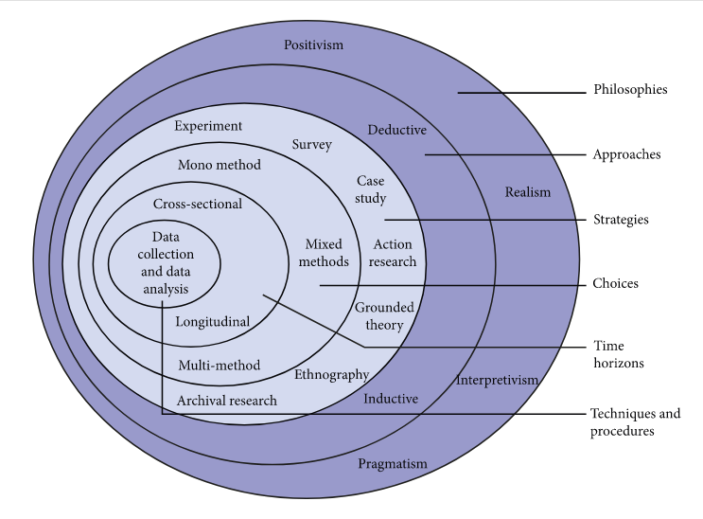
Source: Alturki R (2021)

Research Philosophy
The research takes a pragmatic approach, focusing on real-world problem-solving. The study integrates quantitative surveys, qualitative content analysis, and interviews in recognition of the intricate ways in which Apple product advertising affects the purchasing behavior of international students. This adaptable strategy is to give marketers information that are practical and dynamic, in line with the consumer market.
Research approach:
The integration of both qualitative and quantitative methodologies through a mixed methods approach is justified by the comprehensive nature of the research objectives. By combining qualitative methods, which allow for in-depth exploration of subjective experiences related to brand image and customer loyalty, with quantitative methods that provide statistical rigor, the study aims to offer a more holistic understanding of the complex interplay between these factors and purchasing behavior. The use of both deductive and inductive methodologies further strengthens the research design. The deductive approach aids in testing existing theories and assumptions about the causal relationship between brand image, customer loyalty, and purchasing behavior, ensuring a structured investigation. Meanwhile, the inductive approach allows for the discovery of new insights and patterns that may emerge during the exploration of the data.
Research Strategy
To overcome the drawbacks of depending on just one research strategy, the future study will combine qualitative and quantitative research methods (Patten ML and Newhart M, 2018). While secondary data will offer theoretical insights into branding strategies that improve customer satisfaction and affect purchasing decisions, primary data collection using questionnaires tries to identify the elements driving consumer buying behavior. To effectively accomplish its goals, the study intends to combine primary and secondary data sources.
Custom-made surveys will be made available online through a Google Forms link to gather primary data. A pilot study will be carried out in advance of the main study to evaluate the validity and reliability of the research instrument. It is noteworthy that interviews will not be a part of the data collection procedure. Using a careful pilot study to ensure the validity and reliability of the research instrument, this all-encompassing strategy aims to give a thorough understanding of the elements influencing consumer purchase behavior.
Research Choices and sampling
Participants for this study will be chosen using a variety of sampling techniques. Non-probability methods, such as convenience and deliberate sampling, will improve usability and guarantee that a variety of viewpoints are recorded. In the meanwhile, the study will be more representative overall if probability approaches such simple random and stratified sampling are used, as suggested by Bryman (2016). This would guarantee that the participants selected represent the larger population.
Data Collection Techniques:
The research on the impact of advertising on international students buying behavior of Apple products will employ diverse data collection methods. Surveys links will gather quantitative data on preferences and habits, providing a broad overview. Observational research will directly observe behavior in real-world settings. Social media analysis will offer real-time insights into sentiments and discussions.
Ethical consideration:
Throughout the research, ethical considerations, including obtaining informed consent, ensuring participant anonymity, and maintaining data confidentiality, will be paramount. Adherence to the ethical standards outlined by the American Psychological Association (APA, 2017) will be strictly followed. The study will be conducted with the highest ethical standards, ensuring participant privacy, obtaining informed consent, and adhering to ethical principles in social science research (American Psychological Association, 2017). Employing a combination of qualitative and quantitative methods, this robust research approach seeks to provide a comprehensive insight into the impact of social media on consumer buying behavior.

Time prospect of the research:
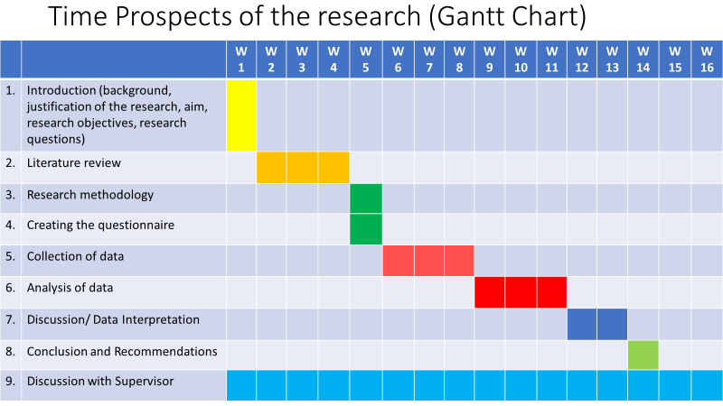

Conclusion
In conclusion, this study uses the Onion Model to examine how advertising affects international students' decisions to buy Apple products. The study employs a practical methodology that integrates quantitative surveys and qualitative content analysis to reveal the complex dynamics influencing consumer behavior. It is expected that the knowledge acquired would not only advance scholarly research but also offer practical suggestions for marketers attempting to negotiate the intricacies of the global student market. This study aims to shed light on efficient advertising tactics catered to the distinct preferences of this heterogeneous consumer group by exploring the subtle interactions between several parameters.

References
(Schwalbe, K. (2018). Information Technology Project Management, 8th ed.)
30, 38-49
Adelaar, T., Charig, S., Lanchnolorfer, K.M., Lee, B., & Morimoto, M. (2003) Effect of Media formats on emotion and impulse buying behavior. Journal of information Technology. 18, 247-266.
advertising effectiveness. Internet Research Journal of Electronic Networking Application
and Policy 12, 318-326.
Anyanwale, A.B., Alimi, T & Ayanbimpe, M.A. (2005). The influence of advertising on consumer
attention in Pakistan. KASBIT Business Journal.
behavior. A study of laptop purchases in Pakistan.
brand preference. Journal of social science 10,96-112
Brassington, F., & Petitt, S. (2011). Principles of Marketing. 3rd ed., Pearson Education
Dunn, S. W., & Barben, A. (1987). Advertising its Roles in Modern Marketing. Hindsdale Illinois,
Economic Review vol. LX11 (4) pp 642-655.
Goldsmith, R.E. & Lafferty, B.A. (2002). Consumer response to websites and their influence in
Harold Kerzner · 2017
Hussainy, S.K., Riaz, K, K., Kazi, A.K.m & Herami, G.M. (2008). Advertising Styles impact on
Journal of Marketing Management, 19, 25-44.
Latiff, A. & Abideen, Z.U. (2011). Effect of television advertising on children: A Pakistan
Nawazish, A.S., & Ahmed, A. (2005). Impact of Effective Advertising on consumer buying
perspective. European Journal of Economics, Finance and Administration Sciences.
Prentice Hall.
Project Management: A Systems Approach to Planning, ...books.google.com › books
Romanuik, J. & Sharp, B. (2003). Brand Salience and consumer defection in subscription markets.
Schiffman, L.G. & Kanuk, L.L. (2009). Consumer Behaviour, New Delhi, Prentice Hall of India.
Taylor, L.D. & Daniel, W. (1972). Advertisement and aggregate consumer function.. American
U.S.A. Dryden Press.

