

RESULT

ASSIGNMENT DETAILS AND FEEDBACK
SOUTH WEST WALES CENTRE FOR TEACHER EDUCATION
Sections marked with * should be completed by module lead
Student name: | Lauren Bell | Student P number: | 1700111
Programme: * | PGCE Primary
Module: * | The Enquiring Teacher | Module Level (6 or 7):* | 7
Module code: * | ECPP7001 | Contribution to Overall  Module Assessment (%): * | 100%
Module Lead:* | Catherine Morgan
Assignment Title:* | Write a critical and analytical essay that discusses your practitioner research ‘lesson study’ in relation to a chosen field. | Assignment No (x of x):* | 1/1
Start date:* | 09/01/18 | Submission deadline:* | 16/04/18
Return date of provisional marks & written feedback:*

Referencing: | In the main body of your submission you must give credit to authors on whose research your work is based. Append to your submission a reference list that indicates the books, articles, etc. that you have read or quoted in order to complete this assignment (e.g. for books: surname of author and initials, year of publication, title of book, edition, publisher: place of publication).
Submission: | All assignments must be submitted to Turnitin unless otherwise instructed by the Lecturer.  Note: the Turnitin version is the primary submission and acts as a receipt for the student. Late submission of the electronic version of the assignment will result in a late penalty. Penalties for late submission: Up to one week late, maximum grade D. Over one week late, Refer. Only the Extenuating Circumstances Panel may grant an extension. | Date: | 16/04/18

Module lead to tick to indicate if a hard copy version of the assignment must be submitted.* | YES
 | NO

Student Self Evaluation Form

This section repeats in brief the common assessment criteria detailed on previous pages. The extent to which these are demonstrated by you determines your mark. Using these criteria, tick the box that best indicates the level of achievement you feel you have achieved with regard to each of them.

Common Assessment Criteria Applied
Common Assessment Criteria Applied | REFER |  | D |  | C | B | A
 | OUTRIGHT FAIL | UNSATISFACTORY | SATISFACTORY |  | GOOD | VERY GOOD | EXCELLENT
1. Subject Knowledge and Understanding (which includes using research-informed literature and knowledge and understanding of the subject)
2. Intellectual Skills (Analysis)
3. Pedagogic and Professional Applications
(Practical Application and Deployment)
4. Key Transferable Skills
PLEASE COMMENT ON AREAS IN WHICH YOU FEEL THAT YOU HAVE PERFORMED WELL |  |  |  | PLEASE COMMENT ON AREAS you feel that you need TO DEVELOP

How can we improve pupil self-reflection through self-Assessment for Learning strategies?

Contents
Page
Aim, focus and purpose of the research | 1
Research context | 2
Short overview of relevant literature  Methodology  Research design  Methods  Sample  Limitations  Ethical considerations  Lesson studies and analysis  Lesson 1  Lesson 2  Lesson 3  Discussion and conclusions | 3  6  6  8  8  10  12  14

REFERENCES
APPENDICES
Appendix A: Extract from university tutor formative assessment report  Appendix B: Observation schedule  Appendix C: Scale of self-reflection  Appendix D: ARC model  Appendix E: Semi-structured focus group interview questions  Appendix F: Parental consent letter  Appendix G: Explanatory statement  Appendix H: Completed written assent sheet  Appendix I: Completed consent and assent confirmation form  Appendix J: RAG fans | A-1  B-1  C-1  D-1  E-1  F-1  G-1  H-1  I-1  J-1

List of tables
Table 1: Data produced by meta-analyses on the effect size of formative  assessment strategies | 3

Aim, focus and purpose of the research
On my recent teaching placement, I began to apply my knowledge and understanding of Assessment for Learning (AfL) by integrating into lessons a strategy involving reception pupils self-assessing how well they thought they achieved learning objectives using a RAG (red, amber and green) system. However, although both my school mentor and university tutor were impressed with me introducing a new strategy to the learning environment and making it accessible to pupils of such a young age, they discussed that a real test of my capabilities would be how I could improve pupils’ self-assessment to move them forward in their learning (see Appendix A).

Addressing this personal target, the aim of this small-scale research is:
- to enable Foundation Phase (FP) pupils to reflect on the quality of their learning at a deeper level and more accurately.
Alongside my fellow researchers, who also feel that AfL is an area within their teaching that they wish to further develop, I hope to achieve this aim by:
- building on existing school AfL strategies that each support pupils’ self-assessment using a RAG system and
- providing pupils with the tools required to improve their ability to reflect on their learning.

Research context
The research will be conducted across two primary schools in Wales, one of which was my placement school for this period of teaching experience and the other, that of my two research partners. My placement school can be characterised as a large, rural community school situated in West Wales, accommodating almost 430 pupils of the ages 3 to 11. Approximately 33% of the school’s pupils are eligible for free school meals (FSM), 34% identified as having additional learning needs (ALN) and 4% who speak English as an additional language (Estyn, 2012). The reception class that I was placed in is made up of 22 pupils (13 males and 9 females) and there are two teaching assistants based permanently in the classroom.

The other school is a smaller, rural school located in the South Wales region, with around 186 pupils between the ages 3 and 11 on roll. Approximately 34% of those pupils are eligible for FSM, 36% of them have ALN and all pupils speak English as their first language at home (Estyn, 2016). Partner 1 was placed in a mixed reception and year 1 class made up of 30 pupils, whereas Partner 2 taught in a mixed year 1 and 2 class, also containing 30 pupils.

In compliance with the data protection guidelines set out by the Data Protection Act (1998), all schools’, staff members’ and pupils’ identities will remain anonymous and will not be disclosed throughout this assignment. Therefore, in order of their reference, each school will be referred to as either “School A” or “School B” and pupils discussed, labelled “Pupil A” to “Pupil I”.

Short overview of relevant literature
According to Clarke (2014), formative assessment is the most powerful educational tool for raising pupils’ achievement and enabling them to become successful, lifelong learners. Recognising the rigorous and comprehensive research evidence supporting this, the work of Hattie (2008) has contributed significantly to the evidence about what should be considered effective and ineffective practice within the classroom. Synthesising over 800 meta-analyses from 50,000 studies, Hattie (2008) discovered that key aspects of formative assessment have the largest effect size, with assessment literacy, that is the term used to describe pupils’ ability to self-assess and improve their learning, proposed to have a substantial effect size of 1.44, as summarised in Table 1.

Table 1. Data produced by meta-analyses on the effect size of formative assessment strategies
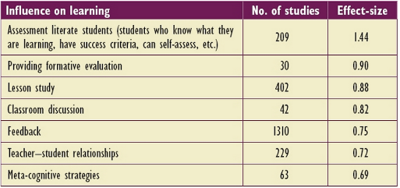
Source: Clarke (2014, p. 12)

With its elements strongly linked to AfL, formative assessment is a process involving both teachers and pupils, revolved around the continual review of progress and pupils thinking more actively about their learning (Berry, 2008). In this way, it is a type of assessment that is carried out to inform future teaching and learning, and therefore, requires teachers to create ongoing opportunities that encourage pupils to evaluate their learning through dialogue, including self-assessment, so that they can become more aware and evaluative of their own
progress (Black & Wiliam, 1998; Clarke, 2014). It appears, as Briggs et al. (2008) suggest, that “making learning accessible and explicit to children and allowing space for them to review their learning at different points during a lesson, not just at the end” (p. 26), should form the intention of those opportunities (Donaldson, 2015; Grigg, 2015).
With this in mind, several studies have emphasised the value of self-assessment, particularly its importance in enabling pupils to recognise their own learning needs and next steps by reflecting on their personal effort and performance (Black & Wiliam, 1998; Assessment Reform Group [ARG], 1999, 2002; Black & Harrison, 2001; Harrison & Harlen, 2006; James et al., 2007; Hattie, 2008; Wilson & Murdock, 2008; Hodgson & Pyle, 2010). For instance, focusing on self-assessment and evaluation as essential elements of AfL, James et al. (2007) reported that strategic and reflective thinking plays a vital role in fostering learning autonomy, suggesting that pupils’ achievement of learning goals is dependent upon the improvement of their metacognitive skills and not accepting the teacher as the primary source of knowledge (ARG, 1999, 2002; James & McCormick, 2007; Hodgson & Pyle, 2010).

Their large-scale project, Learning How to Learn (LHTL) (James et al., 2007), built on the King’s Medway Oxfordshire Formative Assessment Project (KMOFAP) (Black et al., 2002, 2003), with the researchers in the latter taking the findings from the critical research review, Inside the black box (Black & Wiliam, 1998), in order to establish how well those theoretical ideas could be applied to practice (Black & Wiliam, 2001; Black et al., 2002, 2003; James & McCormick, 2007; Hodgson & Pyle, 2010).

In particular, part of the KMOFAP focused on strategies supporting pupils’ self-assessment and evaluation, including traffic lighting, which involved pupils using the RAG system to visually signify their level of understanding in relation to the learning intentions (Black & Wiliam, 2001; Black et al., 2002, 2003). Emerging from the responses of the teachers involved in the research was that this style of self-assessment strategy provided them with immediate feedback regarding pupils’ perceived levels of success, and therefore, non-verbal indications of who required more assistance (Black & Wiliam, 2001). Further, whilst implementing the strategy, pupils were simultaneously developing skills of metacognition, evaluating their current understanding of the task at hand, as well as how they could improve their success (Black & Wiliam, 2001; Black et al., 2002, 2003).

Similar to these findings, Wilson & Murdock (2008) also offer valuable insight into the cognitive development of pupils, exploring the influence of different practical resources in aiding pupils’ reflective thinking. For instance, they mention that the use of sentence starters can help to stimulate reflective discussions and, importantly, ensure that feelings of success are accessible to every pupil, given the recommended nature of this resource (Wilson & Murdock, 2008; Grigg, 2015). What is more, in relation to pupils using self-assessment strategies during lessons, it seems that pupils could be better assisted to explain and justify their choices, if such resources were used to enhance those strategies (Harrison & Harlen, 2006; Wilson & Murdock, 2008; Grigg, 2015).

Despite, however, the interconnection of AfL, self-assessment and meta-cognition being supported by an extensive and growing research base, the evidence discussed has derived from studies conducted in secondary schools, with the samples used made up of secondary school head teachers, teachers and school project coordinators (Black et al., 2002, 2003; James et al., 2007). Indeed, although the LHTL project involved conducting pupil questionnaires, there is an absence of pupil voice within the data, and therefore, rich qualitative data relating to pupils’ engagement with self-AfL strategies and reflective thinking (James & McCormick, 2007).

In light of this, the aim and objectives of this study have been refined to inform this perceived gap in the literature. It is hoped that these will be achieved in order to fully address the research question, how can we improve pupil self-reflection through self-Assessment for Learning strategies?

Methodology
Research design
This research uses a lesson study approach and, therefore, entailed working collaboratively as researchers to plan, deliver, observe and evaluate lessons that were focused on a specific aspect of pupils’ learning (Dudley, 2014). In this way, with lesson study being a form of action research, it was necessary, as a group of three researchers, to identify, prior to conducting the research, a shared area of interest to investigate (Dudley, 2014, 2015). Resulting from discussion as a triad, it was decided that the research would look at further developing self-AfL strategies already existent in the separate FP placement classes, by attempting to enhance pupils’ self-reflection when engaged in self-assessment. It was this aspect of teaching and learning that the researchers each perceived as one to improve, so through identifying this collective target, the research question, and underpinning aim and objectives, were generated.

In order to achieve these intentions, a qualitative research method was believed to be the most appropriate to use, given that the research involved conducting in-depth inquiries into the behaviours and experiences of children within real-life contexts (Bhattacharya, 2017). Supporting this, Hatch (2002) suggests that qualitative researchers are concerned with employing a naturalistic approach to research, in the attempt to understand and explore subject matter from the perspective of participants. Contrary to quantitative researchers, whose interests lie in the formulation and testing of hypotheses or producing theories that explain participants’ behaviours (Hatch, 2002), qualitative researchers act as the primary instruments for collecting and analysing data, so therefore aim to get as close to the chosen participants as, ethically, possible (Sparkes & Smith, 2014).

Methods
Adhering to the lesson study structure, the research involved working collectively as researchers to plan and deliver a total of three lessons, with the members of the triad delivering one lesson each (Dudley, 2014). These lessons, although varied in terms of the actual content taught, were each centered around the area of interest, or in other words, what turned out to be three mathematics lessons, were each based on different mathematical concepts, however, the focus of the research was built into them as intended, not inhibiting the research in any way.

During each lesson, the researchers assumed either a participant role, in that they were the practitioner who was delivering the lesson, or a non-participant role, therefore, responsible for observing the lesson and taking notes. The non-participants’ notes were based on three case pupils, eligible to take part in the research, and recorded using an observation schedule adapted from a version by Peter Dudley (2014) and was, thereby, carefully designed to suit the purpose of this research (see Appendix B).

Informing their observation notes, adapted this time from the “Leuven Involvement Scale” (Laevers, 1994) and again produced by the researchers as a collective, was a scale used to measure pupils’ quality of self-reflection. Although quantitative in its nature, with five distinct levels, the scale, as Pascal & Bertram (1997) recognise, could assist in determining that quality of self-reflection, for the reason that, as an instrument for data collection that has been widely applied in qualitative research (Laevers & Heylen, 2003; Smithrim & Upitis, 2007; Malhotra & Chakrabarti, 2015; Woods, 2016), it provided a scaffold to better define and interpret the behaviours of the pupils observed (see Appendix C).

As for the participant role, after delivering their lesson, each participant recorded their observations using the “Assisted Reflective Conclusions” (ARC) model. With its layout familiar to the researchers, it allowed them to capture their reflections on the lesson delivered, particularly in relation to the planned research focus, and in doing so, identify potential next steps to transfer into the next lesson, or in the case of the third lesson in this lesson study cycle, future practice (see Appendix D). Indeed, as an essential process during the research, reflecting on their lessons required the researchers to deepen their thinking in order to pick out both the positive aspects and those to improve (Welsh Government, 2015). These were, therefore, completed as soon as possible after each lesson to inform post-lesson discussions.

Following each lesson, semi-structured focus group interviews were carried out, each with the relevant three case pupils and lasting around 10 minutes in duration. The purpose of the interviews was to ask the case pupils several questions relating to the self-assessment strategies used during the lessons, in the effort to further improve pupils’ quality of self-reflection. As Hatch (2002) supports, semi-structured interviews allow researchers to act as facilitators in supporting participants to collaboratively discuss their ideas around a given topic. This entailed asking the pupils open-ended questions that encouraged the sharing of different perspectives and those that were underpinned by supporting prompts, replacing the original questions when it was necessary to rephrase them (see Appendix E). Contrary to structured interviews, these interviews allowed us, as qualitative researchers, to elicit richer data, given that more flexibility was given to the participants (Hatch, 2002; Ennis & Chen, 2012). All three researchers were present during the focus group interviews and each interview was recorded using a dictaphone to assist the researchers in recollecting the information provided when interpreting and analysing the research findings.

Sample
The sample chosen for this research was made up of nine pupils, selected, as Sparkes & Smith (2014) support, using a purposeful sampling method. According to Lodico et al. (2010), determining a suitable sample within qualitative research requires researchers to select participants who, in relation to the research question, share a common characteristic and can provide the richest and most in-depth information about the phenomena being studied. This was particularly important for this study, as it focused on the behaviours and experiences of pupils within the primary school context and in relation to specific self-AfL strategies already familiar to them and used on a regular basis (Lodico et al., 2010; Bhattacharya, 2017). The sample was made up of four male pupils and five females, who each fell between the school ages, reception and year 2.

Limitations
As Bellenger et al. (2011) acknowledge, qualitative research is based on measuring and collecting data that is subjective, so the methodology involved in this type of research, including the intentions of the practitioner or practitioners conducting it, are also often deemed be subjective, raising questions about the validity and reliability of findings. Therefore, minimising subjectivity and ensuring the validity of findings, the observation schedule and scale of self-reflection were devised to support the non-participants’ observations, making the completed records less open to bias, and providing more rigidity and pre-determined structure during the data collection (Bellenger et al., 2011; Tavakoli, 2012). With the research being based on a shared interest of the researchers, there was a requirement to collectively gather and review the findings. In doing so effectively, it was ensured that some consistency was found between the researchers’ interpretations of the data, so that, as Letherby et al. (2013) support, the data could be considered, to a certain degree, legitimate and to represent truth.

Ethical considerations
Prior to the study, ethical clearance was gained from the University of Wales Trinity Saint David’s Ethics Committee following the submission of an ethical approval form. Acknowledging the importance of receiving ethical approval to carry out any research project, Wright and O’Flynn (2012) suggest that such permission depends on whether the purpose of the research, or the question being addressed, contributes to knowledge and understanding of a field, whether the methodology proposed is appropriate in meeting the aims of the study, and whether the researcher, or researchers, conducting the research recognises the risks associated with it, particularly in regards to the participants involved.

Addressing the latter initially consisted of issuing a letter of consent, accepted by the three schools involved, to inform the parents or guardians of the prospective participants of what the research entailed. It explained the general purpose of the study, that data collected would remain entirely confidential, that the identities of the school and pupils would remain anonymous in the work produced, and that their child, or children, had the right to withdraw at any time (see Appendix F). Their decision to either provide or not provide consent then dictated, as Craig (2009) supports, whether their child was asked to supply their own assent on the day of data collection.

In gaining assent, the participants whose parents or guardians had issued consent for them to take part in the research, had an explanatory statement read to them by the researcher delivering the lesson, outlining the researchers’ intentions, their role in the research, and that they were each allowed to withdraw from the research at any time without any form of consequence to follow (see Appendix G). At this point, pupils’ verbal assent was requested by asking them to simply raise their hand if they wanted to take part, and their written assent, by getting pupils to, on the sheet provided, circle the face next to their name that reflected their decision. The class teacher was then asked to provide a signature to confirm that this process had been done accurately and no false information had been noted (see Appendix H).

Full consent and assent had to be provided before researchers could choose three pupils from the relevant cohorts to be observed and be involved in the focus group interviews. Once the pupils were chosen at the beginning of each lesson, the class teacher was asked, on a second occasion, to confirm that the pupils selected were fully eligible to take part in the study and that all of the necessary procedures concerning both consent and assent, had been dealt with and completed appropriately, as evident from the confirmation form in Appendix I.

Despite, however, undergoing these procedures, the researchers were required to acknowledge that even if consent had been given for pupils to take part in the research and they had provided their own assent, every pupil still had the right to withdraw at any time without consequence. Respecting this, it was recognised by the researchers that closely monitoring pupils’ ongoing assent throughout the research was essential, in order to detect any form of body language or behaviours that indicated that they were uncomfortable or had the desire to withdraw. It was also acknowledged that pupils who had not had parental consent provided or given their own assent may have felt excluded, so every effort was made to ensure that they were included in the lessons’ focused tasks, without being pressured in any way to be involved with the research focus.

Acknowledging further risks, it was ensured that there was a member of school staff, either the class teacher or teaching assistants, present at all times during the research. In relation to the focus group interviews in particular, these were each conducted in easily accessible classrooms and in the presence of a staff member or members. The classrooms had large windows and the door in each remained open to ensure that the pupils and adults involved were clearly visible to all onlookers. In this way, the researchers abided by the schools’ relevant policies, as well as the university’s Code of Practice, to ensure that pupils’ safety and welfare was paramount throughout the entire duration of the research project.

Lesson studies and analysis
Lesson 1
The first lesson and focus group interview were led by Partner 1 at School A. In their class of reception and year 1 pupils, the main self-AfL strategy used is RAG fans, which simply encourage the pupils to display, visually, their perceived level of understanding in relation to learning objectives (see Appendix J). Prior to this study, Partner 1 commented that, during their placement, they tended to restrict the use of the RAG fans to the end of lessons, feeling that, for this reason, the pupils’ exposure to self-assessment is fairly limited and was controlled mainly by herself as the teacher when asking them to engage in using the fans during plenaries. Therefore, it was agreed collectively by the researchers that the first step in building on this current use of the RAG fans was to make more opportunities for the pupils to engage in self-assessment throughout lessons, and not just at the end.

As evident from the completed observation schedule in Appendix K, it was planned that the pupils would be given four opportunities throughout the lesson to use the RAG fans, including one at the start, following an explanation of the focused task, two during the completion of the task, and one at the end of the lesson. In this way, each of the stages required the pupils to self-assess their current understanding and progress in relation to the planned focused task (see plan in Appendix L).

At stage one, Pupil A, Pupil B and Pupil C were all perceived to have a very low level of self-reflection. Partner 1 began the lesson by explaining to the pupils the task of calculating one more and less of a number, before asking them, following the introduction and once sat at a working table, to show her how they would work out one more using the chicks and number lines provided. Using single digit figures, each pupil solved the problem set, demonstrating, as they did during the introduction, that they understood the concept of calculating one more, even though Pupil C required slightly more guidance.

When they were then asked to use the RAG fans to rate their current progress, the pupils exhibited a shared behaviour, not recognising the purpose of using the fans, and therefore, treating the resource more like a toy and something to entertain them. In particular, Pupil B initially presented Partner 1 with all three traffic light colours simultaneously, suggesting to the observers that the pupils lacked understanding of why and how the fans are used. Verifying pupils’ very low quality of self-reflection, it seemed that Pupil A choosing green and both Pupil B and C, amber, was mostly influenced by Partner 1, as the pupils were unable to justify, verbally, those choices.

As for stage two, having had a worksheet distributed to them, the pupils were left to solve their calculations more independently using the resources supplied. Similar to stage one, Pupil A appeared confident with working out one more of numbers, whereas Pupil B and Pupil C required increasing support, respectively. Then, progressing to calculate one less of numbers, the pupils all experienced a degree of difficulty, with Pupil A, specifically, continually reverting back to working out one more, even after Partner 1 had approached them to highlight the error. More so than in stage one, the pupils seemed easily distracted when faced with a more difficult element of the task, resorting to playing with the RAG fans and other resources.

When asked, this time, to use the fans to self-assess their progress, Pupil C was highly indecisive in selecting a colour, requiring Partner 1 to intervene and assist them in thinking about their understanding of the worksheet. With that support, Pupil C identified that some elements were easy, before Partner 1 proceeded to emphasise the meaning of the three colours on the fan and guide Pupil C to accept that selecting amber was most appropriate, given that they had made similar errors in the task to Pupil A. In light of this, it was thought by the observers that Pupil C showed, through assistance, improved aspects of self-reflection, whereas Pupil A, although also influenced by Partner 1 to modify their rating, remained categorised as having a very low level of self-reflection, as, similar to Pupil B, they continued to display a limited understanding of the fans. Screenshot

In the second half of the lesson, at stages three and four, Pupil A continued to display their competence in dealing with the concept of one more, even once challenged, along with the other pupils, to work with larger numbers. However, as before, Pupil A showed very little development in their self-reflection, by still appearing unable to explain to Partner 1 why they had chosen the green rating at both of the latter stages of the lesson. As for Pupil B and Pupil C, they made progress in the task through increased support from Partner 1, with both pupils demonstrating that they could exemplify their understanding of the task and correct any errors made. In this way, Pupil B showed slight development in their self-reflection, indicating to the observers that they acknowledged that their understanding of the task should dictate which traffic light colour they should choose when asked. Screenshot

Moving on to the focus group interview, all three pupils appeared to maintain their current quality of self-reflection, with Pupil A continuing to demonstrate that they did not understand the purpose of the fans, simply commenting, in response to the question, “Why did you choose this RAG rating colour?”:

I liked it (see Appendix M).

Pupil B and Pupil C, on the other hand, seemed to have slightly more understanding of their purpose, with Pupil B responding to the question, “What did you like best about the fans?”:

If we don’t know…answers, we said sad…or happy or alright (see Appendix M).

Despite this response though, as Partner 1 alluded to in their written reflection on the lesson and interview (see Appendix N), the self-assessment opportunities provided to the pupils throughout the lesson were controlled mostly by herself, with her input heavily dictating pupils’ choices of colour on the RAG fans and their attempts to self-reflect on those choices.
Therefore, ahead of the second lesson, it was discussed, as a collective, that there was a need for pupils to move away from being dependent on the teacher. To do so, it was concluded that peer discussion would be built into the self-assessment opportunities given, to observe pupils’ quality of self-reflection when required to share their thoughts with another pupil.

Lesson 2
This lesson and focus group interview were delivered by Partner 2, again at School A. In their mixed year 1 and year 2 class, the self-AfL strategy used is “Sizzle, Crackle, Pop”, which was introduced by Partner 2 when they were on their placement. This strategy, in the same way as the fans, represents a RAG system, with “sizzle” equating to green, “crackle” to amber and “pop” to red. Unlike the fans, however, this strategy requires pupils to verbally share their perceived understanding and progress relative to learning intentions. Partner 2 commented prior to the study that, as these pupils are slightly older, they have had more experience of engaging with self-assessment and evaluation, however, felt that the use of self-AfL strategies are still controlled largely by himself and the class teacher. This was why the second step, building on the existing use of this strategy, was to not only make more opportunities for the pupils to engage in self-assessment, as was done in the previous lesson, but to now support them to self-reflect more independently through the use of peer discussion.

At stages one and two, Pupil D, Pupil E and Pupil F each appeared to have a low level of self-reflection. After providing a brief overview of the lesson (see plan in Appendix O), Partner 2 began by assessing pupils’ prior knowledge of measuring, using a randomiser wheel to generate which pupils were to answer the questions asked. Having had their name chosen, Pupil D gave a desirable response to the question, “What do we use to measure?”, stating:

Cubes, rulers, blocks (see Appendix P).

Based on this introduction to the lesson, the pupils were then asked to rate their current understanding of measuring, using “Sizzle, Crackle, Pop”. At this point, it appeared that Pupil D, particularly, seemed to base their selection of RAG rating on their current progress by opting for ‘sizzle’, implying to the observers that the pupils had some understanding of how this self-AfL strategy is supposed to be used. However, none of the pupils offered a justification for their choices, verifying their low levels of self-reflection.

Partner 2 provided the next opportunity for self-assessment following his input on why and how rulers are used, involving some pupils being asked to determine the length of different classroom items using centimetres. At this stage, similar to stage one, Partner 2 encouraged pupils to consider the progress made in their learning so far when determining their rating. Pupil D, Pupil E and Pupil F maintained their selections of ‘sizzle’, ‘sizzle’ and ‘crackle’, respectively, however, provided, again, no explanation to support their choices.

By stage three, pupils had worked independently to measure, in centimetres, the parts of a bunny, on the worksheet provided. This was a task that the three pupils appeared to all complete with ease, working through it quickly and, in Pupil D’s case, offering their help to other pupils. With the pupils then asked to self-assess their understanding for a third time, pupils’ choices of rating remained the same. This time, however, Pupil F was approached by Partner 2 and asked their reason for choosing ‘crackle’, to which the pupil responded to by mentioning that they found the task easy. This demonstrated to the observers that, although some opinions were now being shared, pupils appeared to not be basing their self-assessment on their learning progress as encouraged to, given Pupil F’s choice to choose ‘crackle’ over ‘sizzle’. This left little option but to categorise the three pupils as still having a low quality of self-reflection.

Stage four, then, was when Partner 2 asked the pupils, following the completion of an additional measuring task, to discuss their self-assessment with a peer. Required to engage in deeper metacognition to explain why they had chosen the rating they had, some improvements were, indeed, seen in the pupils. For instance, Pupil E, justifying their choice of ‘crackle’ to a peer, stated:

I thought it was easy because the bunny was big so it was easy to measure (see Appendix P).

The observers felt that Pupil E had made slight improvement in their self-reflection, justifying their choice of rating by referring their opinion directly to the activity undertaken.
This type of response was what was hoped to be elicited and it seemed that the pupils were forced, almost, to exemplify why they had chosen their ratings, and in so doing, move away from choosing one over another purely out of preference.

Despite, however, Pupil E showing elements of a higher quality of self-reflection, Pupil D and Pupil F continued to lack complexity and depth in their responses, both offering simple opinions in relation to the tasks undertaken and no form of justification to back them up. Therefore, it was evident to the observers that both pupils were yet to exceed low levels of self-reflection, especially when compared to Pupil E.

Throughout the focus interview, all three pupils’ perceived levels of self-reflection remained the same, for the most part. Pupil D, however, began to demonstrate that they could engage in deeper thinking, responding to the question, “What did you like best about using sizzle, crackle, pop today and why?”:

I like sizzle, crackle, pop…if the teacher asks us what your work’s like, if it’s quite hard it’s pop, and then…I would just say “Miss, can I please stay on this level?” And if it was easy, I would say “Miss, can I have harder work?” And if I was on the middle, I would say, “Can you make it a bit harder but stay on this level?”

For the reason that Pupil D provided this type of response, the observers felt that they exhibited a better quality of self-reflection, evidencing an understanding of why they are encouraged to engage in self-assessment and, particularly, that each colour rating helps to signify how difficult they may be finding tasks or the content taught, during lessons.

Considering, however, the lesson as a whole, including the interview, although there appeared to be a significant difference in pupils’ quality of self-reflection compared to the first lesson, it seemed there was inconsistency when pupils were required to share their thoughts with a peer. Pupils’ responses, in relation to their progress and the learning that had taken place, either lacked density, in that pupils shared only a simple opinion to describe the degree of difficulty that they experienced during the task, or accuracy, in that their thoughts did not correlate to the rating that they had selected.

Therefore, in preparation for the final lesson, it was discussed, as a collective, that the next step in addressing the research intentions, could be to provide pupils with a resource to support them when thinking, independently, about their learning, including their next steps. That resource, offering pupils more of a structure to use in constructing their self-reflections, was a variety of sentence starters to suit each RAG rating (see Appendix Q). It was intended, through their use of this practical resource, that pupils’ responses would feature more depth and pupils could be exposed to extended vocabulary, relevant to thinking about their learning.

Lesson 3
With the final lesson and interview taking place at School B in a reception class, pupils here are familiar with using a visual RAG strategy involving them placing their individualised lollipop sticks in either a red, amber or green bucket when engaging in self-assessment. Before conducting this research, it was felt that, although the strategy was used on a daily basis by pupils, pupils were not exposed to regular self-assessment opportunities throughout lessons, much the same as the pupils in Partner 1’s class. In addition, pupils were not given the space to engage in self-reflection, neither alone or with the use of a peer, meaning that pupils’ feedback at the end of lessons was not often heard. This was why the final step, building on the current use of this strategy, was to not only make more opportunities for the pupils to engage in self-assessment and support them to self-reflect more independently through the use of peer discussion, as was done previously, but to now provide pupils with tools that enable them to reflect more deeply and accurately.
500
During the first half of this lesson,

Resources in appendices??
Anonymise appendices
See Appendix at beginning if poss
A quality or quality
Speech marks / apostrophes / questions consistent – italics etc
Metacognition
Polish appendices
Guide reader to relevant section of the appendices – Replace screenshots
Put overall ratings in as an appendix
Get Beth obs schedule from online

References
Assessment Reform Group (1999) Assessment for Learning: Beyond the Black Box. Cambridge University: Cambridge School of Education.
Assessment Reform Group (2002) ‘Assessment for Learning: 10 principles’, Assessment Reform Group [Online]. Available at: https://www.aaia.org.uk/content/uploads/2010/06/Assessment-for-Learning-10-principles.pdf (Accessed: 04 April 2018).
Bellenger, D.N., Bernhardt, K.L. & Goldstucker, J.L. (2011) Qualitative Research in Marketing. USA: Marketing Classics Press.
Berry, R. (2008) Assessment for Learning. Hong Kong: Hong Kong University Press.
Bhattacharya, K. (2017) Fundamentals of Qualitative Research: A Practical Guide. New York: Routledge.
Black, P. & Harrison, C. (2001) ‘Self- and peer-assessment and taking responsibility: The science student's role in formative assessment’, School Science Review, 83(302), pp. 43-49.
Black, P., Harrison, C., Lee, C., Marshall, B. & Wiliam, D. (2002) Working inside the black box: Assessment for learning in the classroom. London: King’s College London.
Black, P., Harrison, C., Lee, C., Marshall, B. & Wiliam, D. (2003) Assessment for Learning: Putting it into practice. Maidenhead: Open University Press.
Black, P. & Wiliam, D. (1998) Inside the black box: Raising standards through classroom assessment. London: King’s College London.
Briggs, M., Woodfield, A., Martin, C. & Swatton, P. (2008) Assessment for Learning and Teaching in Primary Schools. 2nd edn. London: SAGE Publications Ltd.
Clarke (2014) Outstanding Formative Assessment: Culture and Practice. London: Hodder Education.
Craig, D.V. (2009) Action Research Essentials. San Francisco: Jossey-Bass.
Donaldson, G. (2015) Successful Futures: Independent Review of Curriculum and
Assessment Arrangements in Wales, Crown Copyright. Available at:
http://gov.wales/topics/educationandskills/schoolshome/curriculum-for-walescurriculum-
for-life/why-we-are-changing/successful-futures/?lang=en. (Accessed: 04 April 2018).
Dudley, P. (2014) Lesson Study: A Handbook. Cambridge: LSUK.
Dudley, P. (eds.) (2015) Lesson Study: Professional learning for our time. London: Routledge.
Ennis, C.D. & Chen, S. (2012) ‘Interviews and focus groups’ in Armour, K.M. & MacDonald, D. (ed.) Research Methods in Physical Education and Youth Sport. London: Routledge, pp. 217-237.
Estyn (2012) A report on Fenton Primary School [Online]. Available at: https://www.estyn.gov.wales/sites/default/files/documents/Inspection%20report%20Fenton%20Primary%202012%20%28English%20only%29_0.pdf.pdf.pdf.pdf.pdf.pdf.pdf.pdf.pdf.pdf.pdf.pdf.pdf.pdf.pdf (Accessed: 31 March 2018).
Estyn (2016) A report on Llanhari Primary School [Online]. Available at:
https://www.estyn.gov.wales/sites/default/files/documents/Llanhari%20Primary%20School.pdf (Accessed: 31 March 2018).
Great Britain (1998) Data Protection Act. London: Stationery Office.
Grigg, R. (2015) Becoming an Outstanding Primary School Teacher. 2nd edn. London: Routledge.
Harrison, C. & Harlen, W. (2006) ‘Children’s self- and peer- assessment’ in Harlen, W. (eds.) ASE guide to primary science education. Hatfield: ASE, pp. 183-190.
Hatch, J.A. (2002) Doing Qualitative Research in Educational Settings. USA: State University of New York Press.
Hattie, J. (2008) Visible Learning. Abingdon: Routledge.
Hodgson, C. & Pyle, K. (2010) A Literature Review of Assessment for Learning in Science, Slough: National Foundation for Educational Research. Available at: https://www.nfer.ac.uk/publications/AAS01 (Accessed 05 April 2018).
James, M., Black, P., Carmichael, P., Drummond, M.J., Fox, A., MacBeath, J., McCormick, R., Pedder, D., Procter, R., Swaffield, S., Swann, J. & Wiliam, D. (2007) Improving Learning How to Learn: Classrooms, schools and networks. London: Routledge.
James, M. & McCormick, R. (2007) ‘Teachers Learning to Learn’, European Conference on Educational Research, 19-21 September 2007, University of Ghent [Online], pp. 1-22. Available at: http://www.leeds.ac.uk/educol/documents/176239.pdf (Accessed: 05 April 2018).
Laevers, F. (1994) The Leuven Involvement Scale for Young Children LIS-YC.:
Manual. Belgium: Centre for Experiential Education.
Laevers, F. & Heylen, L. (eds.) (2003) Involvement of Children and Teacher Style: Insights from an International Study on Experiential Education. Belgium: Leuven University Press.
Letherby, G., Scott, J. & Williams, M. (2013) Objectivity and Subjectivity in Social Research. London: SAGE Publications Ltd.
Lodico, M.G., Spaulding, D.T. & Voegtle, K.H. (2010) Methods in Educational Research: From Theory to Practice. 2nd edn. San Francisco: Jossey-Bass.
Malhotra, S. & Chakrabarti, S. (eds.) (2015) Developments in Psychiatry in India: Clinical, Research and Policy Perspectives. New Delhi: Springer.
Smithrim, K. & Upitis, R. (eds.) (2007) Listen to their Voices: Research and Practice in Early Childhood Music. Canada: Canadian Music Educators’ Association.
Sparkes, A.C. & Smith, B. (2014) Qualitative research methods in sport, exercise and health: from process to product. London: Routledge.
Tavakoli, H. (2010) A Dictionary of Research Methodology and Statistics in Applied Linguistics. Tehran, Iran: Rahnama Press.
Welsh Government (2015) Reflective practice [Online]. Available at: http://learning.gov.wales/docs/learningwales/publications/150611-reflective-practice-booklet-en.pdf (Accessed: 09 April 2018).
Wilson, J. & Murdock, K. (2008) Helping your pupils to think for themselves. London: Routledge.
Woods, A. (eds.) (2016) Examining Levels of Involvement in the Early Years: Engaging with children’s possibilities. London: Routledge.
Wright, J. & O’Flynn, G. (2012) ‘Conducting ethical research’ in Armour, K.M & MacDonald, D. (eds.) Research Methods in Physical Education and Youth Sport. London: Routledge, pp. 66-79.

Appendices
Appendix A: Extract from university tutor formative assessment report
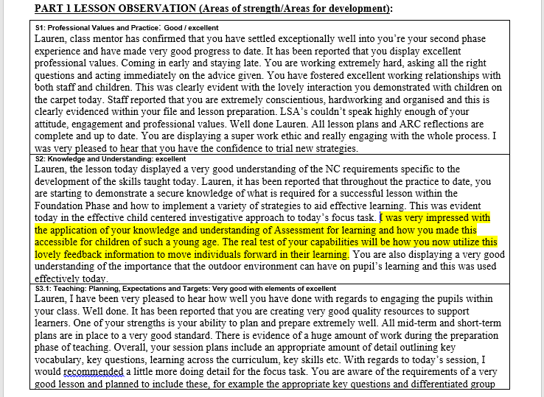

Appendix B: Observation schedule
Learning objective: |  |  | Lesson: |  | Observers:
Research focus: How can we improve pupil self-reflection through self-Assessment for Learning strategies?
Strategy used:
Pupil |  |  | Pupil |  | Pupil
Stage: 1 | Time: |  | Stage: 1 | Time: | Stage: 1 | Time:
Observation: |  |  | Observation: |  | Observation:
RAG rating: |  |  | RAG rating: |  | RAG rating:
Perceived level of self-reflection: |  |  | Perceived level of self-reflection: |  | Perceived level of self-reflection:
Stage: 2 | Time: |  | Stage: 2 | Time: | Stage: 2 | Time:
Observation: |  |  | Observation: |  | Observation:
RAG rating: |  |  | RAG rating: |  | RAG rating:
Perceived level of self-reflection: |  |  | Perceived level of self-reflection: Low |  | Perceived level of self-reflection: Low
Stage: 3 | Time: |  | Stage: 3 | Time: | Stage: 3 | Time:
Observation: |  |  | Observation: |  | Observation:
RAG rating: |  |  | RAG rating: |  | RAG rating:
Perceived level of self-reflection: |  |  | Perceived level of self-reflection: |  | Perceived level of self-reflection:
Stage: 4 | Time: |  | Stage: 4 | Time: | Stage: 4 | Time:
Observation: |  | Observation: |  |  | Observation:
RAG rating: |  | RAG rating: |  |  | RAG rating:
Perceived level of self-reflection: |  | Perceived level of self-reflection: |  |  | Perceived level of self-reflection:

Brief observer reflections (following lesson and focus group interview) | Brief observer reflections (following lesson and focus group interview) | Brief observer reflections (following lesson and focus group interview)

Next steps:
Appendix C: Scale of self-reflection

Level of self-reflection |  | Description of self-reflection levels
1 | Very low | Pupil provides very little or no honest feedback on their current progress and level of understanding. Lack of questioning or discussion with peers/practitioner. Provides limited contribution to identifying their next steps. Significant periods of disengagement with the self-assessment strategy used. Shows little or no alteration of their RAG rating due to very low quality of self-reflection, with little explanation or understanding. Requires consistent assistance throughout the lesson. Pupil is easily distracted and provides very little contribution to self-assessing their progress in an honest manner, perhaps copying that of others. Experiences difficulty with the lesson content but does not attempt to modify their RAG rating. They show little or no engagement with feedback provided by the practitioner. Lacks understanding of how they can progress. Comments or actions are repetitive and display very little development throughout the lesson.
2 | Low | Pupil provides some feedback on their current progress and level of understanding. They present some basic questions by questioning the unfamiliar, but are mostly prompted by the practitioner. Provides some contribution to identifying their next steps, but are mostly prompted by the practitioner. Shows some, yet infrequent, engagement with the self-assessment strategy used. Acknowledges need for alteration of their RAG rating when necessary, but this is mostly driven by the practitioner. Requires regular assistance throughout the lesson. Pupil provides some contribution to self-assessing their progress in an honest manner. Experiences difficulty with the lesson content but only attempts to modify their RAG rating when prompted. They show little engagement with feedback provided by the practitioner. Shows some understanding of how they can progress and can engage in very simple discussion with others when prompted. Comments or actions are not highly repetitive and show some development throughout the lesson.
3 | Moderate | Pupil provides some feedback on their current progress and level of understanding. They present some questions by questioning the unfamiliar, but are often prompted by the practitioner. Provides good contribution to identifying their next steps, showing some understanding of their own development and progress without being fully prompted by the practitioner. Shows some engagement with the self-assessment strategy used. Acknowledges need for alteration of their RAG rating when necessary, with some support from the practitioner. Requires some assistance throughout the lesson. Pupil provides good contribution to self-assessing their progress in an honest manner. Experiences some difficulty with the lesson content and recognises the need to modify their RAG rating when prompted. They show some engagement with feedback provided by the practitioner. Shows some understanding of how they can progress and can engage in simple discussion with others when necessary. Comments or actions are not highly repetitive and show some development throughout the lesson.
4 | High | Pupil provides a good amount of feedback on their current progress and level of understanding. They present some questions by questioning the unfamiliar, without being fully prompted by the practitioner. Provides good contribution to identifying their next steps, showing a good understanding of their own development and progress without being fully prompted by the practitioner. Shows good engagement with the self-assessment strategy used. Acknowledges need for alteration of their RAG rating when necessary, with little support from the practitioner. Requires little assistance throughout the lesson. Pupil provides a good, active contribution to self-assessing their progress in an honest manner. Experiences little difficulty with the lesson content and recognises the need to modify their RAG rating when necessary. They show good engagement with feedback provided by the practitioner. Shows a good understanding of how they can progress and can engage in discussion with others when necessary. Comments or actions are not repetitive and show clear development throughout the lesson.
5 | Very high | Pupil provides a good amount of in-depth and honest feedback on their current progress and level of understanding. They present questions by questioning the unfamiliar, without being prompted by the practitioner. Provides good contribution to identifying their next steps, showing a good understanding of their own development and progress without being prompted by the practitioner. Shows good engagement with the self-assessment strategy used. Acknowledges need for alteration of their RAG rating when necessary, without support from the practitioner. Requires little or no assistance throughout the lesson. Pupil provides a good, active contribution to self-assessing their progress in a very honest manner. Experiences little or no difficulty with the lesson content and recognises the need to modify their RAG rating when necessary. They show good engagement with feedback provided by the practitioner. Shows a good understanding of how they can progress and can engage in complex discussion with others when necessary. Comments or actions are not repetitive and show clear development throughout the lesson.

Appendix D: ARC model

Model Beirniadau Wedi Adfyfyrio Model BWA

Assisted Reflective Conclusions (ARC) Model
Dyddiad/Date:

Digwyddiad critigol (Ffocws)/Critical incident (focus):

Profiad/ Experience
Teimladau/
Feelings

“What are your feelings regarding the experience?”
Cofio a Deall/
Remember and Understand

“Can you list the aspects of the learning experience that went well?”

“What were the elements of the learning experience that were disappointing?”

Gwerthuso a dadansoddi/
Evaluate and analyse

“What will you keep the same to ensure effective teaching and learning in the future?”

“What was the cause of the most important disappointing element?”

Casgliadau a chamau gweithredu/
Conclusions and actions

“What are your possible solutions to the disappointing issues identified?”

“What will you do next?”

Y profiad newydd / Transformed experience

Appendix E: Semi-structured focus group interview questions
- What did you like or not like about the tools (Miss Evans/Miss Bell/Mr Saunders) used today to help you use (your fans / your lollipop sticks / sizzle, crackle, pop)?

- How do you think these tools helped you with your learning?

- Why did using these tools help you?

- Why did you choose this rating?

- What does the traffic light colour mean to you?

- What do you need to do to make your learning better?

- How did you find this out?

- How did the tools help you to know how to get better?

- How did (Miss Evans/Miss Bell/Mr Saunders) help you to know how to get better?

- What did you like best about using (your fans / your lollipop sticks / sizzle, crackle, pop) today?

- Why did you like this best?

Appendix F: Parental consent letter


Dear Parent/Guardian,

Your child’s school is a partner with Yr Athrofa at University of Wales Trinity Saint David in Carmarthen and Swansea. This school offers placements to students who are learning to be teachers.

The student-teacher in your child’s class has been given the task of planning, teaching and evaluating one lesson so that he/she can develop specific strategies to improve their own teaching. As part of this, student-teachers will be observing the children’s responses and asking some pupils their views on parts of the lesson. This is designed to inform students’ own practice and support children’s learning.

Any information collected would remain confidential, and both the school and the children would remain anonymous in work produced. The work undertaken would be in line with the University’s ethical guidelines. If, at any time, your child does not want to share ideas, they would not be required to do so.

If you are happy for your child to contribute to the project, please complete the parental consent form below and return directly to the school as soon as possible. If you are interested in the outcome of this project or if you have any questions, please contact the University Partnership Office - partnership@uwtsd.ac.uk.

Yours faithfully,


Catherine Morgan
Module lead – The Enquiring Teacher

_____________________________________________________________________________________________

As Parent/Guardian of…………………………………………………………………….. (pupil name), I do / do not give
consent (please delete) for my child to take part in this project.

Signed…………………………………………………………………………….(Parent/Guardian).

Date………………………………………………………

Appendix G: Explanatory statement
“Good morning/afternoon boys and girls.”

“Today I have brought along two friends for you all to meet, Miss Evans and Mr Saunders (use gestures to welcome fellow students). I am going to be teaching you today and while I am teaching you, Miss Evans and Mr Saunders are going to be watching the way you learn. They are interested to see how we use our lollipop sticks (hold up lollipop sticks) to think about how well we have learned. We will be using our lollipop sticks lots during today’s lesson as this will help Miss Evans and Mr Saunders to see how you are all getting on in the lesson.”

“I am going to be asking you lots of questions when you are using your lollipop sticks today to help you to get better at thinking about your learning.”

“So, would you like to help show my friends how we use our lollipop sticks?”

(Verbal assent) “Hands up for yes.”

“Thank you for your answers boys and girls. I would like you to look at this sheet now (written assent sheet). It has all your names on it and asks you to circle yes or no. Yes is the happy face and no is the sad face.”

(Written assent) “You need circle the happy face if you would like to help my friends today or circle the sad face if you would not like to.” (Use facial expressions and gestures to emphasise yes and no).

“Does everybody understand?”

*Work around pupils with sheet and pencil*

G = Change as applicable

Appendix H: Completed written assent sheet
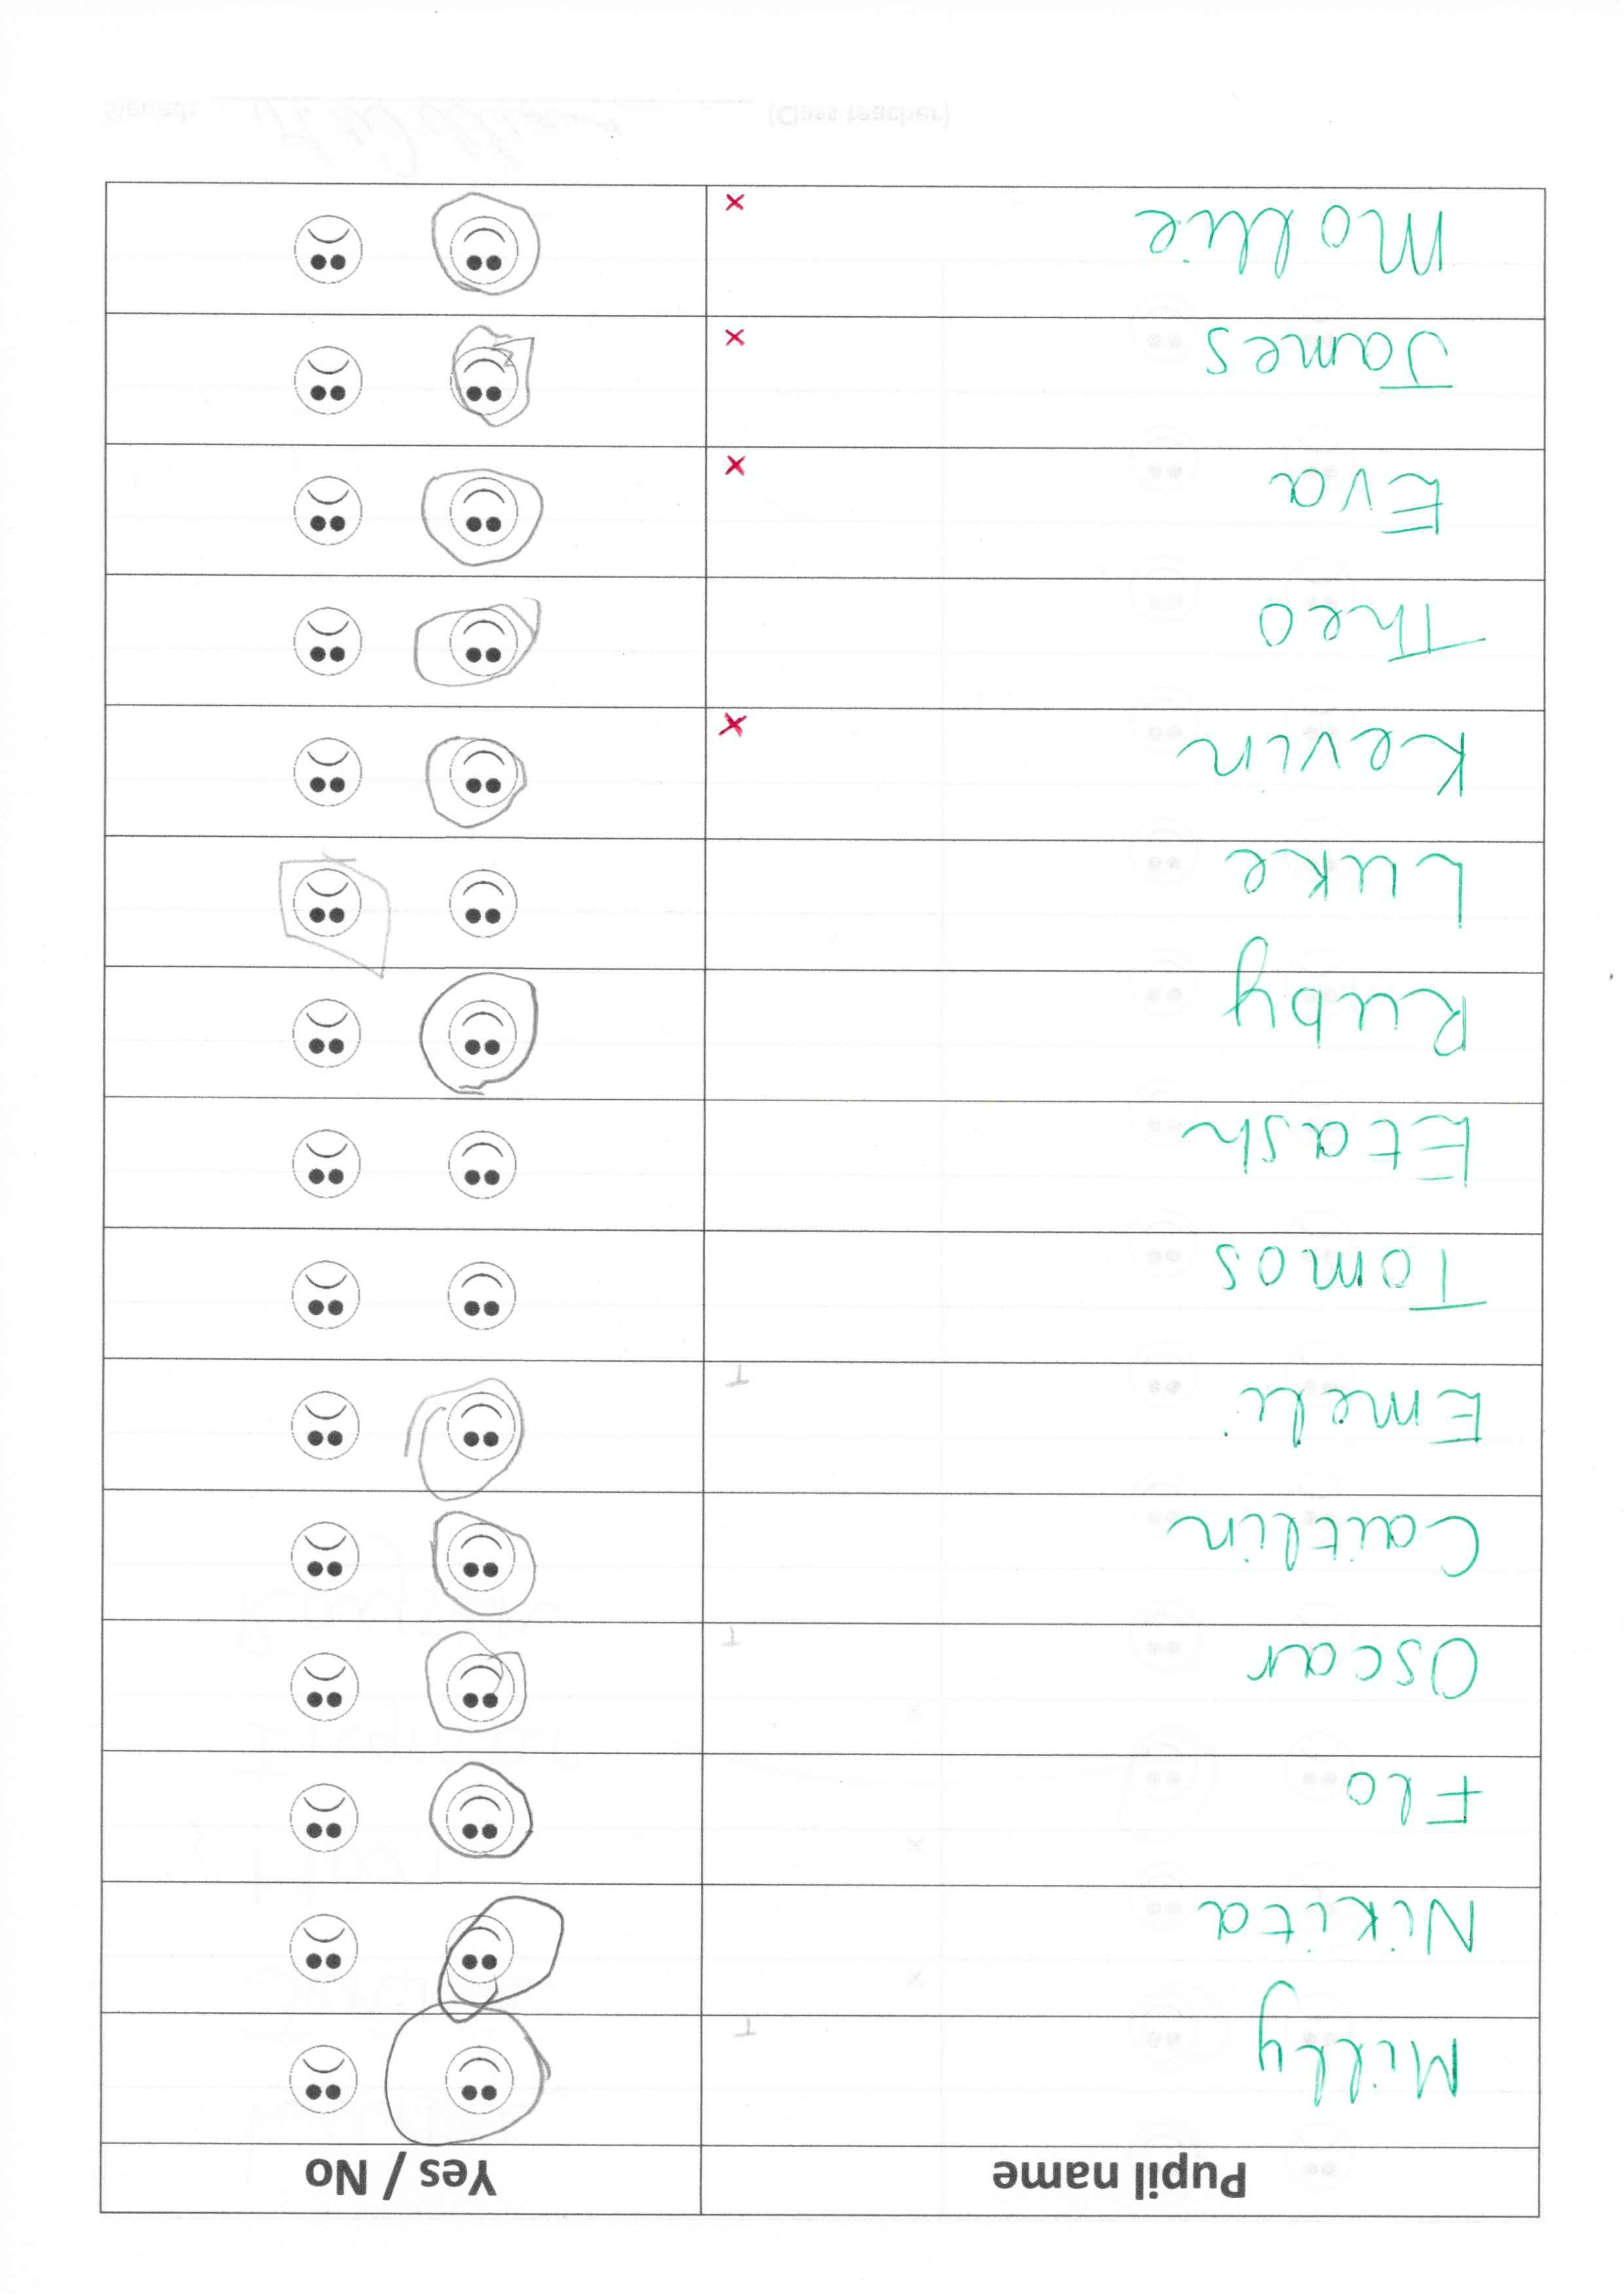
Name removed
Name removed
Name removed
Name removed
Name removed
Name removed
Name removed
Name removed
Name removed
Name removed
Name removed
Name removed
Name removed
Name removed
Name removed
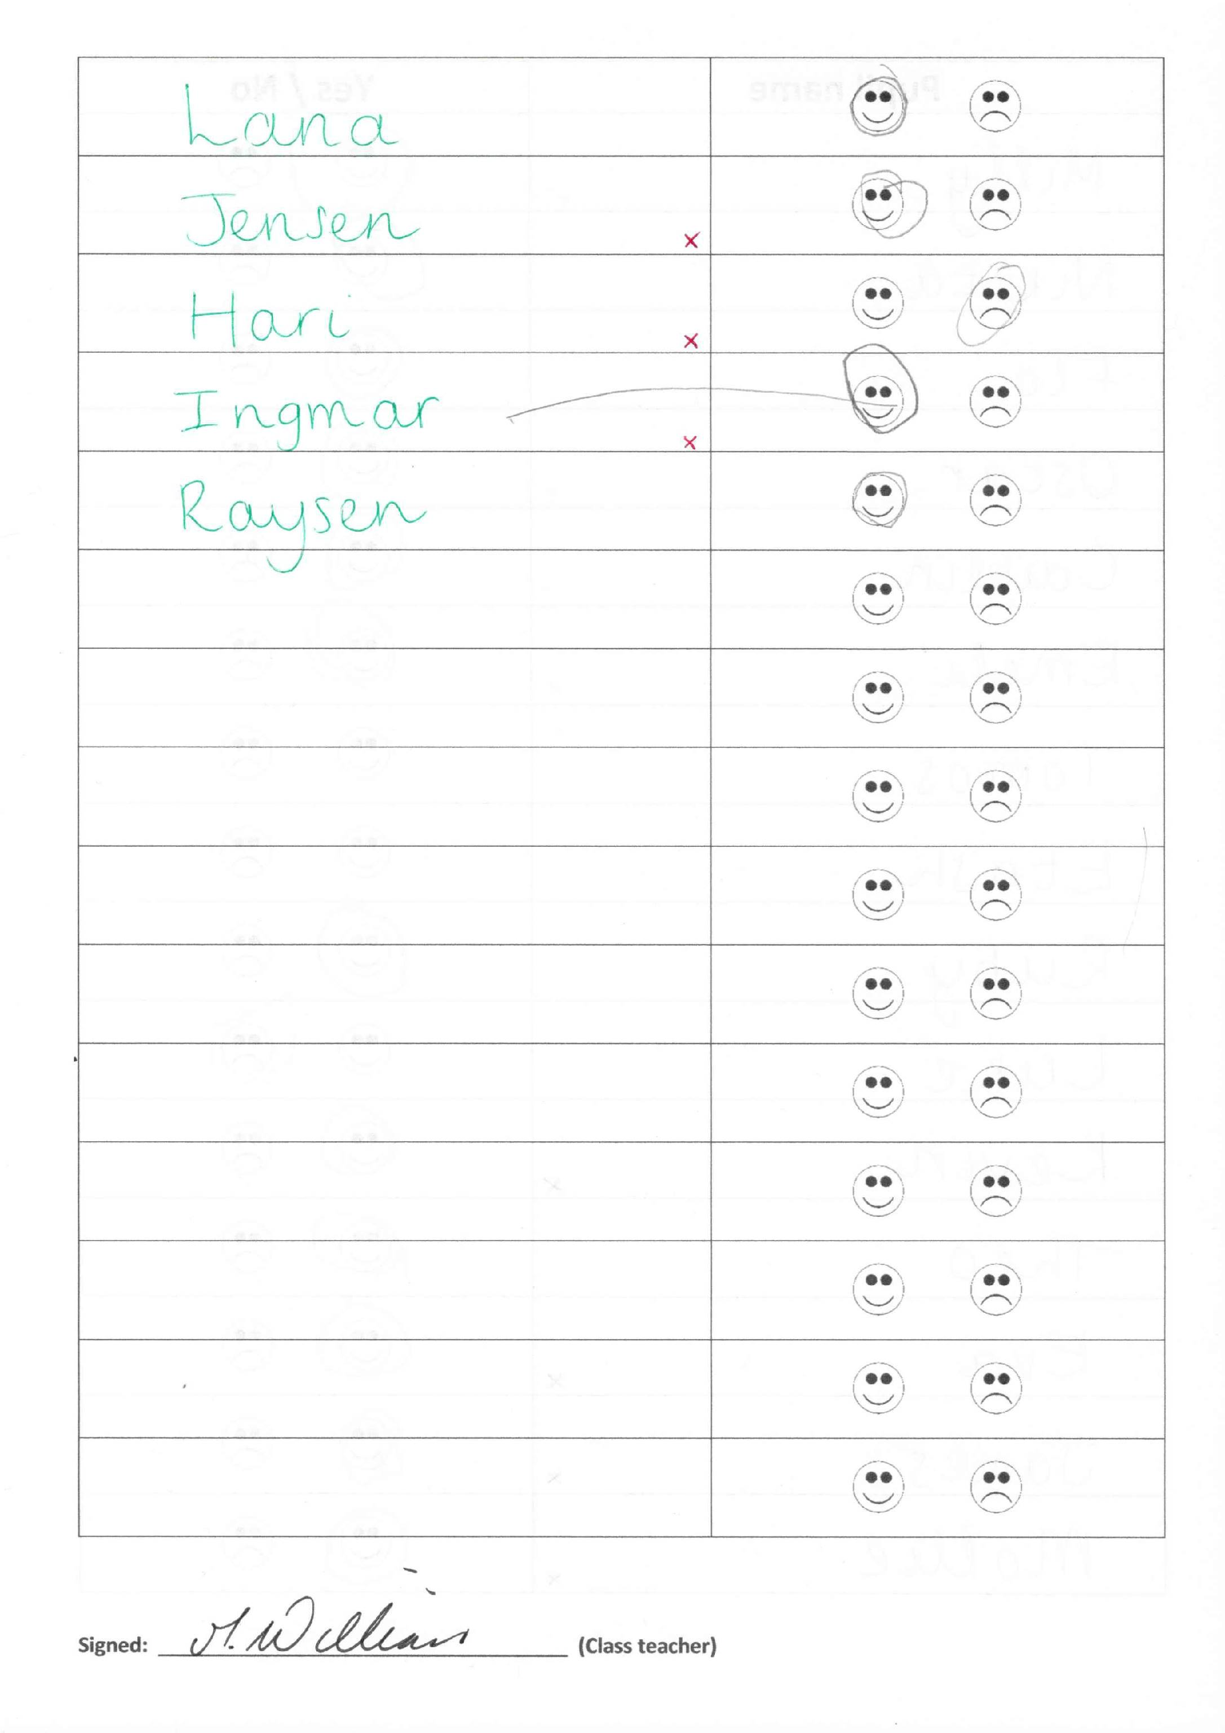

Name removed
Name removed
Name removed
Name removed
Name removed
Name removed

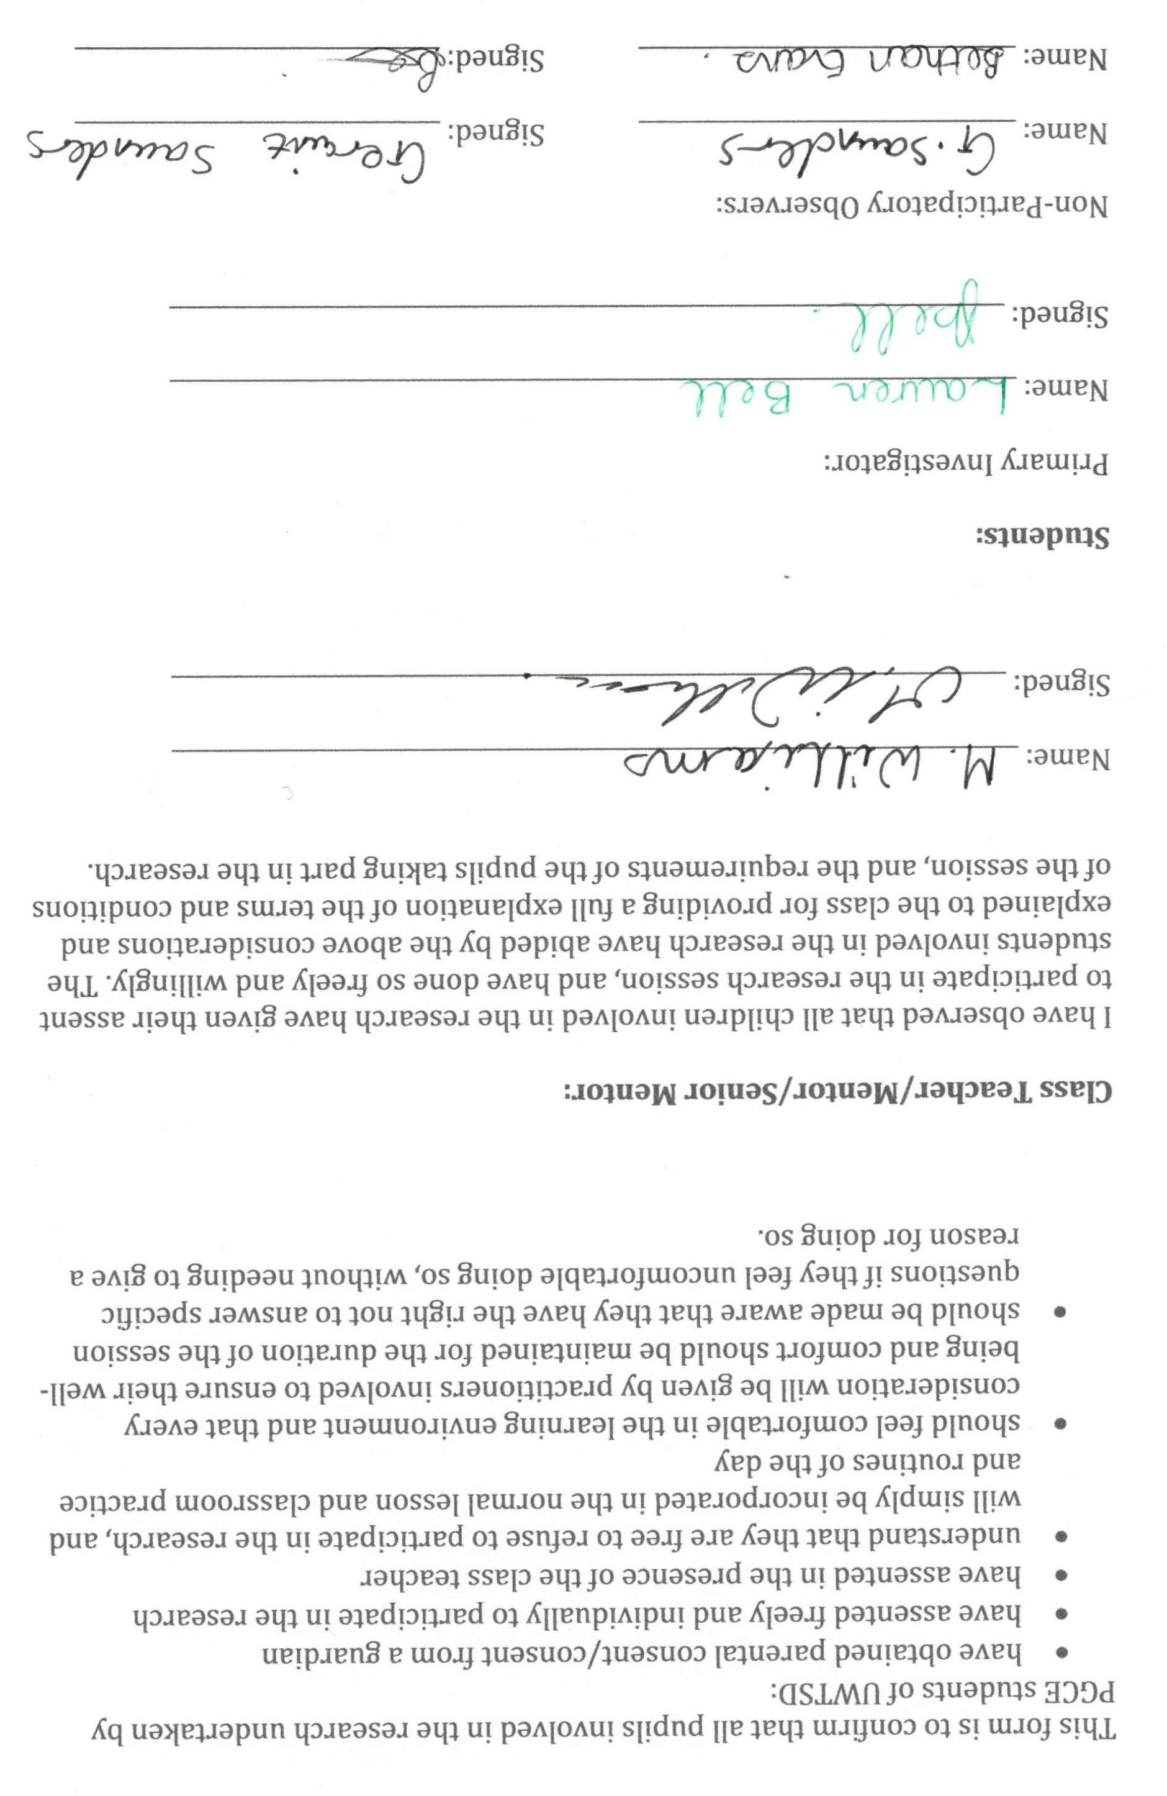
Appendix I: Completed consent and assent confirmation form
Name removed
Name removed
Appendix J: RAG fans
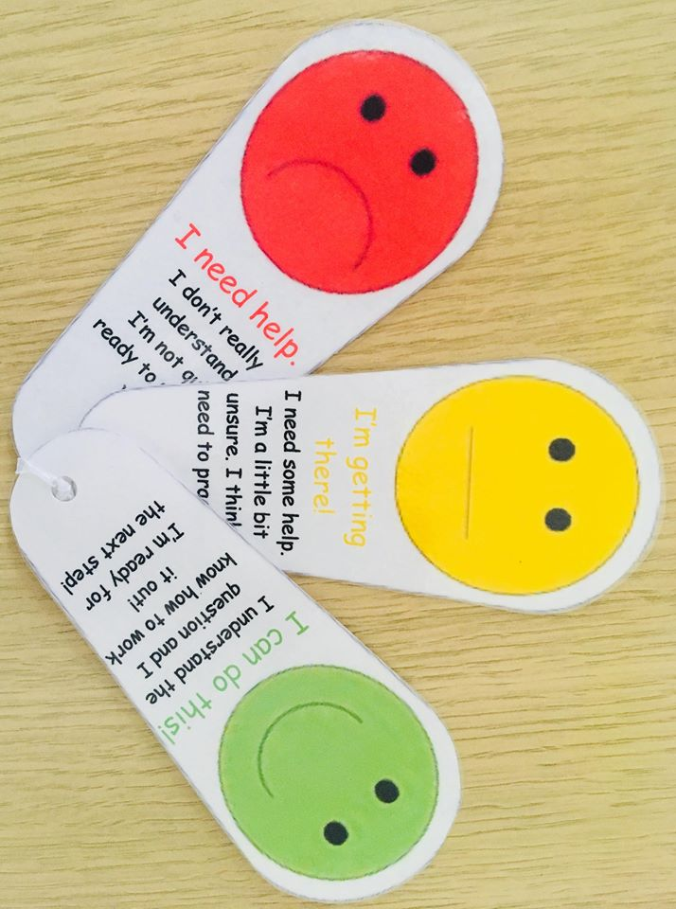

Appendix K:
Appendix L: Lesson 1 plan
Name of trainee: | Bethan Evans |  |  |  | Session ref: |  | n/a | Date: | 27/03/18 |  |  | Class: | Reception / Y1 |  |  | Foundation Phase Focus Plan  2d
Personal target(s) |  | n/a |  |  |  |  |  | Number of learners: |  | 30 | Age: |  | 4-6 yrs |  |  | Foundation Phase Focus Plan  2d
Learning objectives/intentions: |  |  | Calculate and recall ‘one more’ and ‘one less’ of a number | Success criteria |  | Reception: a) recall ‘one more’ and ‘one less’ of numbers within 5; b) calculate ‘one more’ and ‘one less’ of numbers within 10; c) use the number line to show addition and subtraction  HA/Year 1: a) recall ‘one more’ and ‘one less’ of numbers within 10; b) calculate ‘two more’ and ‘one less’ of numbers within 20; c) use the number line correctly to show addition and subtraction; d) identify the direction of addition/subtraction on the number line |  |  |  |  |  |  | Meeting learners’ needs: |  | Differentiated for Reception and Year 1 Curriculum Requirements
Introduction/plenary tasks |  |  |  |  | Main activities |  |  |  |  | Resources |  |  |  | Assessment for Learning (strategies and opportunities)
This session is building on from prior lessons on the topic of addition and subtraction. The task of this lesson is to see if the children can reflect on their learning efficiently.  Prior to the introductory task, we will be undertaking an assent session, whereby the children who have parental consent to participate in the lesson will either assent or refuse to partake in the lesson study. 3 children will be selected prior to the lesson to be part of the data, and participate in the interview at the end of the session.  Introduction  Is there anything special happening this week and next week?  I've heard you've all been working hard since I've been away! Miss Burke told me that you have been looking at adding one more and taking away/one less? Can some people come and show me and my friends how you work this out?  Use pupils at the front to demonstrate calculating one more and one less.  RAG rating about the task – predominantly based on their opinions. |  |  |  |  | Trainee focused task (purpose, outline of trainee’s role and children’s learning):  I will be completing a worksheet with the children based on counting ‘one more’ and ‘one less’. Will do a quick revision of the objective using the chicks and the number lines. RAG rate their understanding of this task.  The children will then be given a worksheet each and also a chick and timeline, one between two.  Differentiation: LA: Will be completing the task with numbers up to 5. Min. 2 examples each (2 for one more and 2 for one less) Extension: numbers up to 10; MA/HA: completing task with numbers up to 10, 3 examples of each. Extension: attempt one more/less with higher number up to 20; HA/Year 1: completing task with numbers up to 20. These children will also be looking at adding on more than one and taking less than one, e.g. 3 more, 2 less. Extension: if this were one more, what would two more be? How can we work this out?/two more/less of other two digit numbers (without number line).  Children will RAG rate after their worksheet task and the extension (if applicable). |  |  |  |  | Number Lines, Worksheets – Focus Task  RAG fans – Focus Task  Yellow counting chicks – Focus Task  Yellow Eggs, ‘Cracked’ number eggs – Enhanced Provision  PowerPoint - plenary  VOCABULARY  More  Less  Add  Take-away  Self-assess/RAG  I think...  It is... because...  I found this hard because...  I found this easy because...  Noodles and Rice |  |  |  | AfL:  This session is a lesson study for a research project focusing on how we can improve pupil self-reflection through the use of self-Assessment for Learning techniques. The main technique to be used will be RAG rating themselves.  The purpose of the session will be to use their RAG rating more frequently within a lesson. There will be a minimum of 4 uses of the RAG fans for self-assessment, 5 uses for pupils who progress on to the extension task.  How did you work that out? Do you think you could have worked it out a different way? (e.g. number line, putting one number in their head and counting on, etc.)  How do you feel about this activity? How would you rate yourself at the moment? Explain your rating.  Additional Questions:  If this were one more, what would two more be? How can we work this out?  Additional AFL:  Lollypop sticks – Questioning for plenary  Dwylo i fyny – Questioning for introduction
Additional adult tasks (purpose, outline of additional adults’ role and children’s learning):
The LSA/Class Teacher will be completing the same task as trainee.
For more information on additional adults, see attached page.

Mini-Plenary
Children will be stopped at specific points and asked to use their RAG fans to self-assess their work.

Plenary
Discuss learning – use name cards to ask children for ‘one more’ or ‘one less’ of a number.
Using PowerPoint to ask questions.

Class will RAG rate their main activity.

***

We will also be conducting an interview with 3 pre-selected children who have assented and have provided parental consent.
Independent learning opportunities:

Enhanced:
- Writing table: Easter worksheets (counting and colouring)
- Outside learning: one more/one less on the chalk number line. Using the dice to find the number and then finding ‘one more’ and ‘one less’ of that number. (Weather dependent)
- Maths area: matching up the two halves of the eggs. Using counters to add and take away one more/less.
Using the yellow egg, take a number and find one more than that number and then one less. Number lines also available to help.
Curriculum coverage (range and skills)
RECEPTION: Using Number Skills: Calculate using mental and written methods: mentally recall ‘one more’ of a number within 10; mentally recall ‘one less’ of a number within 10.
YEAR 1: Using Number Skills: Calculate using mental and written methods: mentally recall ‘one more’ of a number within 20; mentally recall ‘one less’ of a number within 20.
Literacy (LNF)(AFL)  RECEPTION: Oracy; Developing and Presenting Information and Ideas; Speaking: talk about things from their experience and share information  Oracy; Developing and Presenting Information and Ideas; Collaboration and Discussion: exchange ideas in one-to-one and small group discussions  YEAR 1: Oracy; Developing and Presenting Information and Ideas; Speaking: talk about things they have made or done, explaining the process.  Oracy; Developing and Presenting Information and Ideas; Collaboration and Discussion: contribute to conversations and respond to others, taking turns when prompted; take part in activities with others and talk about what they are doing |  | Numeracy (LNF)  RECEPTION: Using Number Skills; Use Number Facts and Relationships: count reliably up to 10 objects; read and write numbers to at least 10.  YEAR 1: Using Number Skills; Use Number Facts and Relationships: count reliably up to 20 objects; read and write numbers to at least 20.
DCF  Used as an aid to lesson. | Thinking  Reviewing the process/method: Show or describe some of what has been done; identify, in response to questions, what worked and what didn’t.  Evaluate own learning and thinking: show, in response to questions, some of what has been learned/found out. | ESDGC  Easter themed – understanding of symbols of Easter and how we celebrate it. Verbal - questions in introduction and plenary – recognising symbols. | YCC

