Report Title: Contemporary Developments in Employment Relations

Name: Stephen Watts

CIPD Membership Number: 48698902

Date: 1 May 2018

I declare that this assignment is my own work and that any information obtained from books and other sources have been appropriately referenced.

Signed......Stephen Watts......................... Date....1 May 2018.............

Contents
Introduction 3
1.1 Factors Affecting the Employment Relationship 3
1.2 Indeterminacy of the employment relationship. 5
1.3 Compare and contrast unitarist and pluralist approaches to employment relations 6
1.4 Other Factors which impact on employment relations 7
2.1 Types of Contracts 8
2.2 Sources of UK and EU Employment Relations Law-Making 9
2.3 Changes in Employment Law 10
2.4 Trade Unions 11
3.1 Differences in employee involvement, participation and partnership. 11
3.2 Union and Non-Unionised Representation 12
3.3 Employee Voice 13
4.1 Resolving Conflict 15
4.2 Trends in Recent Conflict 16
4.3 Recommendations 17
Bibliography 18

Introduction

In 2013 the Royal Mail announced that it was to be privatised which was to end 500 years of state control. It was seen as the most ambitious privatisation since that of the railways in 1994. In 2010 it was initially announced by the government of a proposed intention which at the time drew opposition from unions and consumer groups which included the threat of strike action by Communication Workers Union (CWU). (Economics Online, 2013) (The Economist, 2013)
The Communication Workers Union (CWU), which represents the majority of Royal Mail workers, argues that privatisation will lead to a deterioration in services and could harm working conditions for its members.
- Impact to Pensions
- Restructuring of process
- Changes to working week (5-day week)
- Pay Changes
A ballot of CWU members within the Post Office was conducted regarding the Privatisation proposal which saw the 112,000 workers who voted - a 74% turnout - 96% rejected the plan. (BBC News, 2013)

Factors Affecting the Employment Relationship

According to the CIPD 2018, Employee relations has replaced industrial relations as the term for defining the relationship between employers and employees. Today, employee relations are seen as focusing on both individual and collective relationships in the workplace, with an increasing emphasis on helping line managers establish trust-based relationships with employees. A positive climate of employee relations - with high levels of employee involvement, commitment and engagement - can improve business outcomes as well as contribute to employees' well-being.
Purcell & Ahlstrand (2007) describe two dimensions of employment relations:
- Individualism – A Philosophical stance that reflects the idea that each employee should be treated as an individual in the employment relationship.
- Collectivism – A Philosophical stance that recognises that some issues in the employment relationship are best dealt with on a collective basis – in a sense groups of workers have an independent voice and participate in decision making with leaders.
Within the structure of the Royal Mail there was a large collective presence through the leadership of the union CWU, which emphasised the use of collective bargaining to negotiate for its members. Collective Bargaining is the process wherein the unions (representatives of employees or workers), and the employer (or their representative) meet to discuss the issues related to wage, the number of working hours, work environment and the other terms of the employment. (Business Jargons, 2017)
There are 4 types of collective bargaining:
Fig 1 – Types of Collective Bargaining (Business Jargons, 2017)
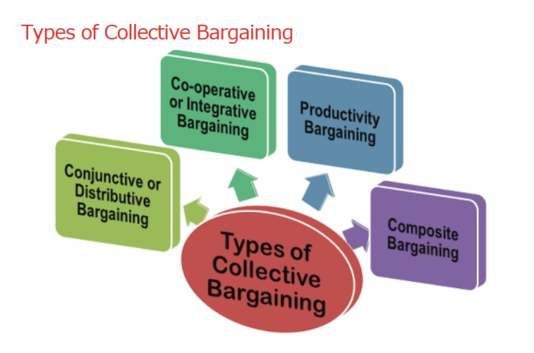
- Conjunctive or Distributive Bargaining – both the employee and the employer try to maximize their respective gains. It is based on the principle, “my gain is your loss, and your gain is my loss” i.e. one party wins over the other.
- Co-operative or Integrative Bargaining - Both the employee and the employer sit together and try to resolve the problems of their common interest and reach to an amicable solution. In the case of economic crisis, such as recession, which is beyond the control of either party, may enter into a mutual agreement with respect to the working terms. For example, the workers may agree for the low wages or the management may agree to adopt the modernized methods, so as to have an increased production.
- Productivity Bargaining - where the workers are given the incentives or the bonus for the increased productivity. The workers get encouraged and work very hard to reach beyond the standard level of productivity to gain the additional benefits.
- Composite Bargaining - In this type of collective bargaining, along with the demand for increased wages the workers also express their concern over the working conditions, recruitment and training policies, environmental issues, mergers and amalgamations with other firms, pricing policies, etc. with the intention to safeguard their interest and protect the dilution of their powers. Thus, the purpose of the Collective Bargaining is to reach a mutual agreement between the employee and the employer with respect to the employment terms and enjoy a long-term relationship with each other
A key aspect of the privatisation were the proposed changes to Pensions, with the closure of the final salary pension scheme. On 5 January 2017 Royal Mail began to put the first steps in place to end the Pension Scheme, however this was countered by the employee’s union CWU with the threat of industrial action. The company is exploring how to fund its pension scheme after 2018, when the current £1.7bn surplus is expected to run out.
Royal Mail said it cannot afford an increase to the annual £400m it currently contributes, having calculated that it needs to boost its payments to £1bn in order to keep running the fund. (The Telegraph, 2017)
Royal Mail stated "With our unions, we have been actively exploring possible changes to potentially enable us to keep the plan open on a defined benefit basis after March 2018 as part of our pension review process,” the company said. "Unfortunately, we have not been able to find an affordable way of doing this so far." (ibid)
According to the The Workplace Employment Relations Study (2011) following two decades of substantial decline, union presence was relatively stable among all but the smallest private sector workplaces over the period between 1998 and 2004. However, since 2004 there has been a significant decline in union memberships, mainly driven by the desire to by organisations to create better workplace culture and employee relations.
According to the CIPD (2017) Employee relations can be seen as a skill-set and lens through which to manage workplace relationships and practice, rather than as a management function or well-defined area of activity.
Despite well-publicised instances of industrial action, the employee relations embrace the relationship with individual employees as well as collective relations at work.
The ideas of 'employee voice' and the 'psychological contract' have been accepted by employers and reflected in their employee relations policies and aspirations.
Employee relations skills and competencies are still seen by employers as critical to achieving enhanced levels of employee involvement, commitment and engagement.
The strike action by Royal mail employees did not materialise as the CWU and Royal Mail executives agreed on a compromise following a period of collective bargaining.

1.2 Indeterminacy of the employment relationship.

Indeterminacy refers to a labour contract which does not state the capacity of effort to contribute by the workers with the exchange of rewards. (Colling & Terry, 2010)
Sisson (2008) described Indeterminacy as “Many of the benefits that employees receive from the exchange can be set. An example would be wages and conditions, helping to explain why they are so often the focus of attention.
As Brown and Walsh, (1994: 440) suggest, ‘The act of hiring … is not sufficient to ensure that the job gets done in an acceptable way … The employee has to be motivated – by encouragement, threats, loyalty, discipline, money, competition, pride, promotion, or whatever else is deemed effective to work with the required pace and care’.”
Rollinson & Dundon (2007) described 3 types of contract within Employee Relations:
- Formal Contract – Formally agreed terms of the employment relationship ie the legal concept is reflected in the contract of employment
- Informal Contract – Less formal expression of the employment relationship that reflects a degree of give and take between parties
- Psychological contract - an unvoiced set of expectations that the parties have of each other, together with the obligations that they feel towards each other.

1.3 Compare and contrast unitarist and pluralist approaches to employment relations

Farnham (1993) stated that there are two major frames of reference for ER, the unitarist and pluralist framework.
Unitarist approach consists in the belief that the management and workforce, or the groups of employees are working together for the good and the welfare of the company. (Difference Between, 2011)
Table 1 – Strength and Weaknesses of Unitarist Approach (Farnham, 1993)
Strength | Weaknesses
Bring employer and employee interests together to enhance employee commitment and loyalty | Lack of realisation that there are power inequalities between employers and employees resulting in conflict.
Emphasises the role of managers in attaining win-win situations for employees and organisations. If they can be convincing and influential leaders in the organisation, there will be no strong demand for trade unions. | Conflict treated negatively and not seen as a force that reflects inequalities and which can be used as opportunities to regain work harmony
Unitarist perspective assumes that all stakeholders are rational members, who will consider finding common interests. This belief provides a steady rationale for stressing common goals, so that a stable ER system can be achieved | Unitary perspective is very normative and lacks description of how common interests can be identified and shared across organisations
The unitarist perspective is essentially individualist in its ER approach
The Unitarist approach believes in the perception of the entire organization as one big family, where management and staff share common objectives, interests and purposes. (Difference Between, 2011)
Pluralist approach is the belief that the way to achieve good industrial relations is to acknowledge that the various groups of employees have different requirements and make different demands.
Table 2 – Strength and Weaknesses of Pluralist Approach (Farnham, 1993)
Strengths | Weaknesses
Pluralist theory emphasises that effective Industrial Relations interventions can resolve conflicts. | An inclination to dwell on rules and procedures and disregard the processes that also contribute to the resolution of conflicts.
Embraces a wider array of employee relations policies – e.g. trade unions can be effective allies in aligning individual and organisational interests compared to the unitarist approach to ER | Incapable of realising that the state also represents commercial interests and not just public interests.
Suitable for collective Industrial Relations systems, because it does not disregard the role of trade unions in managing employee-employer conflicts | May focus too much on worker interest, which can lead to the inefficiencies of collective bargaining processes.

Pluralists encourage that a particular system be followed in the interest of the organisation. It requires that power is nicely dispersed rather than concentrated in the hands of a few individuals. Pluralism gives ample opportunity for employees to voice out their opinions.
Within the Royal Mail the senior management level is there to maximise profits and want the best return from their employees. This would be described as a pluralist approach. A supporting factor of the royal mail would be the highly unionised culture pointing towards a more Pluralist approach.

1.4 Other Factors which impact on employment relations

A key factor within the employment relations was Competition. In 2006 the Royal Mail lost its 350-year monopoly on the UK postal market, going forward any licensed operator can deliver mail to residential and business customers in the liberalised market of which Royal Mail controls 99%. (UKEssays, 2013a)
This opened up the markets to private competitors. The proposed threat of strike by the CWU was over reduced pensions, pay and conditions, as rounds get longer and harder, and managers demand ever-greater efficiencies in a vain attempt to keep up with the competition.
The Royal Mail has to compete with booming non-unionised companies as ruthless as Amazon, Hermes or Yodel. (The Guardian, 2017a)

2.1 Types of Contracts

Type of Contract | Terms of contract/What Required of Employer | Advantages/Disadvantages
Full time and Part time | Provide a contract  State the statutory level of paid holiday  Hours of Work  Pay per hour/week/salary  Rules around sick pay  Provide a payslip  Provide maternity/paternity and adoptive pay | Structured, traditional, employee knows rights and entitlements which allows for forward planning.  Can sometimes be too rigid which leads to lack of flexibility.
Fixed Term | Lasts for a certain length of time  Are set in advance  Ends when a specific task is complete  Ends when a specific event takes place  Must receive the same treatment as full-time permanent staff | Clear guideline on duration allowing transparency for employee.  Lack of opportunities could lead to disinterest and commitment
Zero hour | On call when needed  Don’t have to give work  Employee does not have to work when asked  Entitled to statutory annual leave  Entitled to National Minimum Wage | Great Flexibility for both Employer and Employees  Very Unstructured allowing for zero planning

Table 3 – Types of Contracts (Gov.UK, 2018)
During the negotiations between the CWU and Royal Mail both parties reached an acceptable agreement on Pay and shorter working week, Pensions and Culture and operational changes. (Dawson, 2018) (Wilson, 2018)
With key changes to contracts namely:
- From October 2017, employees will receive a 5% increase in pay (including base pay, overtime and allowances). This rate of pay will also apply throughout 2018-19.
- From October 2018, a one hour reduction to the working week (currently 39 hours).
- From April 2019, employees will receive a 2% increase in pay (including base pay, overtime and allowances) and a further one hour reduction to the working week from October 2019.
- Eligible part-time employees will, in addition, receive increases in their hourly rate of pay equivalent to c.2.6% in October 2018 and October 2019 to reflect the impact of the shorter working week.
- Commitment to move towards 35 hour working week by 2022. (Dawson, 2018)
This was agreed by both parties to be a positive step towards creating a sustainable business while ensuring the employee is treated fairly and rewarded fairly for their contribution.

2.2 Sources of UK and EU Employment Relations Law-Making

UK Law-Making
“UK employment law originates in three places: in Parliament through the legislative process, in the courts through judicial decisions and in European Union institutions” (CIPD, 2016)
Acts of Parliament are sources of primary legislation in which the key principles of the law are set out. Important acts relating to employment law include the Employment Rights Act 1996, the Employment Act 2002, the Equality Act 2010, the Enterprise and Regulatory Reform Act 2013 and more recently the Trade Union Act 2016.
While the Acts are in their draft form and being considered by Members of Parliament, they are called Bills. Before the Bill can become an Act, it must receive Royal Assent, approval by the Queen. A date is set of when an Act will come in to force and at that date the Act becomes law which must be followed and enforced. (ibid)
In the UK the judiciary system is involved in secondary legislation, which are issued by ministers using powers that are passed to them and Acts of Parliament and are commonly known as legislations, such as Working Time Regulations 1998, the Transfer of Undertakings (Protection of Employment) Regulations 2006 and the Parental Leave (EU Directive) Regulations 2013.
EU Law-Making
“European law is derived from three principal sources: EU directives, treaties and regulations” (CIPD, 2018 a)
The UK joined the European Economic Community (EEC) in 1973, the Treaty of Rome committed member states to enforcing the principle of equal pay for equal work between men and women. The EEC evolved into what we now know as the European Union (EU), over time the scope of European employment law has expanded and now covers the following:
- health and safety
- transfers of undertakings (TUPE) - rights protecting workers when a business changes hands
- discrimination on grounds of sex, race, ethnicity, national origin, disability, age, sexual orientation and religion/belief
- working time
- data protection
- information and consultation
- part-time and fixed-term employees and agency workers
- family-friendly rights. (ibid)
The EU is made up of:
- European Council – sets the overall guidelines for the EU policies
- European Parliament – represents EU citizens and decides EU laws and budgets with Council Ministers.
- Court of Justice of the European Union – made up of 3 courts: - Court of Justice, General Court and Civil Service Tribunal. The purpose is to uphold the law.
- European Commission – represents the interests of the Community and has 27 members, one from each EU state.
- Council of the European Union – decides the laws and budget together with the European Parliament.

2.3 Changes in Employment Law

Changes within Employment Law which would have been relevant to Royal Mail:
The Trade Union Act 2016 (Gov.UK, 2016)
- clear and positive democratic mandate from union members: upholding the ability to strike.
- industrial action only ever goes ahead when there has been a ballot turnout of at least 50%
- in public services an additional threshold of 40% of support to take industrial action from all eligible members must be met for action to be legal.

Postal Services Act 2000
In 2000 the postal services act which governs the postal industry within the UK was introduced, the act provided for the Post Office to be converted to a PLC, set in place a new licensing system, gave the postal services commission (Post COMM) powers to protect the universal service, promote greater competition within the UK market and offer more protection to consumers with the introduction of Postwatch (Hooper et al, 2008).
Further to this then in 2006 the Royal Mail lost its 350-year monopoly on the UK postal market, where any licensed operator can deliver mail to residential and business customers in the liberalised market of which Royal Mail controls 99%. Creating Competition.

2.4 Trade Unions

“A trade union is an organisation made up of members (a membership-based organisation) and its membership must be made up mainly of workers” (nidirect, 2017)
The main aims of a TU are to protect and advance the interests of its members in the workplace. trade unions are independent of any employer. However, trade unions try to develop close working relationships with employers. This can sometimes take the form of a partnership agreement between the employer and the trade union which identifies their common interests and objectives.
Main role of TU is:
- negotiate agreements with employers on pay and conditions
- discuss major changes to the workplace such as large-scale redundancy
- discuss members' concerns with employers
- accompany members in disciplinary and grievance meetings
- provide members with legal and financial advice
- provide education facilities and certain consumer benefits such as discounted insurance (ibid)
During the Royal Mail dispute, the CWU played a key role in resolution with the employer, working together with the employees and employer to ensure a progressive outcome. They were recognised by the employer as influential in delivering the best results for all parties. (Dawson, 2018)

Differences in employee involvement, participation and partnership.

Type | Summary | Key Factors
Involvement | The soliciting of employee views, opinions, and ideas to harness the talents and cooperation of employees, but without the sharing of power in an eventual decision-making outcome. | Participation  Provides ideas  Shares Knowledge  Contributes to problem solving  Involved in generating solutions
Participation | The sharing of power between employees (or their representatives) and management, in the making of joint decisions. | Equal contribution of activities  Team accountability  Contribute ideas  Encourage group participation
Partnerships | A concept that is normally taken to imply cooperation (usually between management and trade unions) based on the satisfaction of mutual as well as separate interests. | Ownership and rights through active involvement  Has a democratic voice  Shares views often  Involved in all decision making  People first ethos

Table 4 – Differences of Employee Involvement, Participation and Partnership (Rollinson & Dundon, 2007)
In terms of the Royal Mail dispute participation took place in the form of collective bargaining through the CWU.

Union and Non-Unionised Representation

Union-Representation
In organisations that recognise union-centred representative voice, the existence of the trade union means that there is a voice mechanism, usually through collective bargaining or joint consultation. (Rollinson & Dundon, 2007)
Collective Bargaining – A process in which the representatives of recognised trade unions and employers negotiate, consult and communicate to agree the procedural and substantive terms and conditions of employment.
Joint Consultation – A voice process that can be direct or indirect and one in which management and employees (or their representatives) discuss and consider each other’s views prior to management making a final decision.
Relationships are built through the collective bargaining process usually meaning a willingness to compromise and could be a more effective voice method for employees where commitment or enthusiasm could be lacking. (ibid)
Non-Unionised Representation
Non-Union organisations are still able to use representatives and they will have similar rights to Union representatives when it comes to paid time off or training. (ACAS, 2018)
It is recognised that there are many organisations who do not recognise unions and many representatives are non-union. ACAS offers advice and support for both the organisation and representative. Many non-union representatives form a consultative forum with other non-union representatives within the same organisations and this can have consequences. (ibid)
Rollinson & Dundon (2007) described that there is a tendency to view representative voice in comparison with its unionised counterpart. This can sometimes escalate out of control, to the point that non-union voice schemes could be dismissed as ineffective. Some non-unionised employers e.g. John Lewis have developed deeper forms of voice than many union-centred channels.

Employee Voice

According to (Strauss, 2006) “Voice is meaningless if the message is ignored” highlighting the importance of 2-way communication with output, meaning a sense of listening and the person feeling valued. In its simplest form it is still a powerful reflection of doing the simple things well. It could also be described as “participation”; an involvement by individuals that allows some influence over the discussion topic. Strauss further states “it is actual influence not a feeling of influence that is important” which points to the emotions of individuals and the sense of contribution.
Another view on voice is described as employee involvement, defined as solicitating employee’s views, opinions and ideas to harness the talents and cooperation of employees, but without sharing of power in an eventful decision-making culture.
Participation is normally regarded as the more extensive form of voice as it shares the power of decision making. While involvement is seen as the weaker form of voice as it is used by management to identify ideas with a hope of bringing commitment from the team, but ultimately leaving the decision making to management. (Farnham & Pimlott, 1987)
There are a number of reasons why organisations move in different directions when trying to understand voice. A key part of that is how it is viewed by different stakeholders. Table 1 summarises differences in purpose and possible outcomes of voice viewed by different stakeholders.
Table 1 – Differences in the purpose and utility of employee voice (Dundon, et al., 2004)
Purpose of Voice | Perceived Utility from Voice | Mechanisms of employee voice | Range of Outcomes
Articulation of individual dissatisfaction | To resolve problems with management and prevent further breakdown in relations | Complaints; Grievance; Whistle blowing. | Leave or Loyalty
Collective Representation | A source To support Management | Union; collective bargaining; industrial action | Partnership - Derecognition
Contribution to management efficiency | To promote improvement in work organisation. | Upward problem solving; suggestion schemes; attitude surveys. | Identity and commitment; improved performance.
Demonstration of mutuality and partnership | To achieve long term viability for both organisation and employees | Partnership agreements | Influence over management decisions

According to (Marchington & Wilkinson, 2005) there can be wide differences in the purpose of employee voice, whether involvement or participation but it is necessary to have a form of evaluation. It is described that there are 4 dimensions to evaluating voice:
Depth – describes the extent of influence employees have in decision making. Shallow voice is when you have very little say in decision making.
Scope – broken down into 2 categories – Narrow allows management to have total reservation over decision making with only minor decisions being made available to employees; Wide minimal restriction with employees having an input in more senior decision making.
Level – describes the organisation level that voice occurs, high meaning HQ low meaning team level. The level that voice occurs is connected to both depth and scope as more detailed strategic decisions are most likely not to be considered at low level.
Form – the method used to facilitate voice. As described below as Direct/Indirect Voice
Figure 2 – The extent of Employee Voice (Marchington & Wilkinson, 2005)
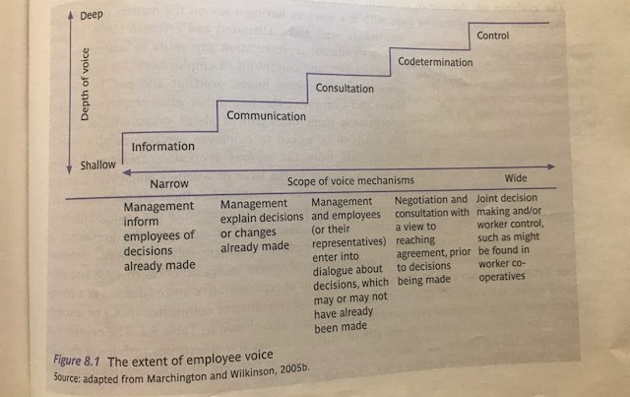
Stakeholders view voice in a different way, each will have desired outcome and will respond with varying levels of commitment depending on the output for them. Outcomes of employee voice can sometimes be viewed as improved performance and improved commitment; however, it is inconclusive. The success greatly depends on conditions to sustain and support voice long term. Involvement and Participation have been key factors of employee voice, however, through technology there is a growing trend that information and consultation are now seen as driving employee voice and empowering teams to be committed and loyal to the organisation.

.

4.1 Resolving Conflict

Conflict can be defined as disagreement between two or more parties as for example, individuals, groups, departments, organisations, countries - who perceive that they have incompatible concerns (Bloisi, 2006)
Conflicts present whenever an action by one party is perceived as preventing or interfering with the goals, needs, or actions of another. Conflict can be regarded as a reality of management and organisational behaviour which is related to power and politics.
Having policies and procedures in place to deal with conflict is essential and when issues cannot be resolved, early intervention is necessary to achieve an informal successful outcome. (ACAS, 2014)
Conflict normally falls within two categories:
- Conflict Between Individuals (colleague/colleague – colleague/manager)
- Conflict Between Groups (teams, large groups of employees and management)
Examples of causes of conflict include:
- poor management
- unfair treatment
- unclear job roles
- inadequate training
- poor communications
- poor work environment
- lack of equal opportunities
- bullying and harassment
(ACAS, 2014)
To resolve or minimise conflict ACAS (2014) recommends:
- train managers to handle difficult conversations with employees
- have clear discipline, grievance and dispute procedures for dealing with conflict
- consider outside help where necessary
- encourage open expression of opinions
- recognise the importance of feelings
- listen to what people have to say
- focus on interests not positions and personalities.
Organisational Misbehaviour is defined as “anything you do at work that you are not supposed to do”. It is also often identified as behaviour that is unacceptable to management and may significantly disrupt its functioning.
Organisational misbehaviour is voluntary and committed by choice. The intention to misbehave is defined as behaviour exhibited by an individual or group that is purposeful and can be harmful to a person, the work group, or the organisation. (Gregory & Yew, 2011)
This is normally the case for three reasons — either to benefit the individual, to benefit the organisation, or with the intention to damage and hurt a particular individual, organisation asset or social unit. (ibid)
The dispute with Royal Mail which threatened industrial action was a result of large scale conflict between management and employees for proposed changes to their pension and working conditions. The union CWU played a major role within this to get to a agreement which both parties were satisfied with, utilising key skills of listening and negotiating.

4.2 Trends in Recent Conflict

During the last 5 years we have seen a decline in collective conflict but individual conflict has risen. This in turn has seen a decline in official strike action with a rise in Employment Tribunals. Fig 3 and 4 show the rise and fall both since 1980.
Fig 3 – Industrial Action in Workplace 1980-2004 (Dix, et al., 2008)
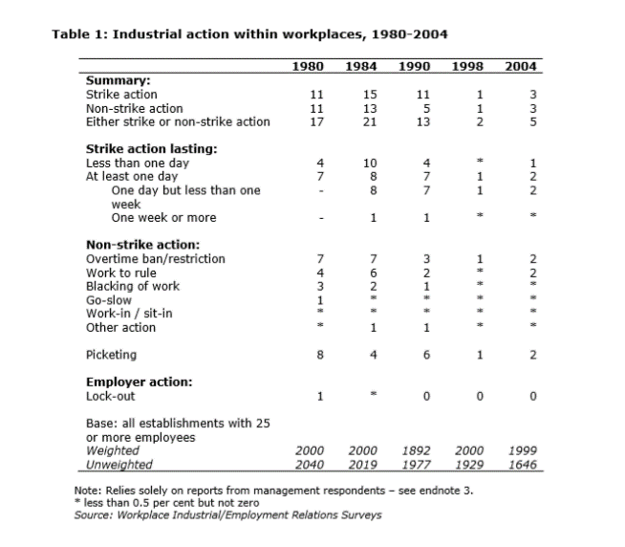
Fig 4 – Total Number of Employment Tribunals 1980-2004 (Dix, et al., 2008)
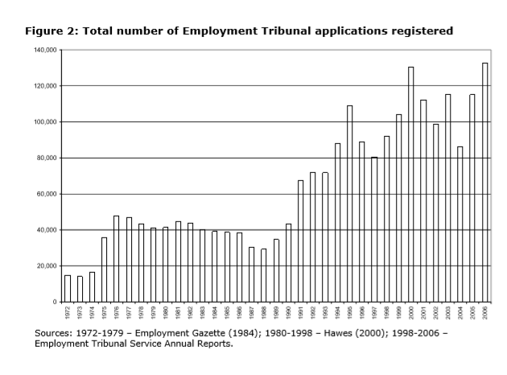

4.3 Recommendations

Being able to identify conflict early allows opportunity to face into the situation before it escalates. Furthermore, if you can differentiate between personal relations, instrumental conflict or conflicts of interest it can give good base to begin forming solutions. (ACAS, 2014)
At the early stages, it’s important that Listening, Communication, Negotiation between participants are in process. A more complex problem may require something more formal/specialised such as mediation this would normally be conducted by a third party. Some strategies when dealing with conflict are:
Compete or Fight – Classic win/lose where a stronger influencer win.
Collaboration – Likely to be a better result, compromise and discussion gets to the outcome.
Denial or Avoidance – Where everyone pretends it’s not a problem. Chances are, if its ignored it will re-appear only larger.
Smoothing over a problem – Harmony is maintained on the surface but there still may be conflict underneath. (ACAS, 2014)
Third Party Options outlined by ACAS:
- Mediation A voluntary form of conflict resolution which is a confidential way to resolve workplace disputes. An independent and impartial person will help two or more individuals reach a solution to a workplace dispute that is acceptable to all. Mediators ask questions to help uncover problems and options to resolve the differences. The aim is to restore the employment relationship where possible. Not all mediation is successful and about 20% do not agree on a solution, (ACAS, 2018 b).
- Arbitration When an impartial person can decide about a dispute. Can be used to decide unfair dismissal claims, is often used for collective disputes but can be used by individuals also voluntary on both sides. This can be used instead of a court of law, (ACAS, 2018 c).
- Conciliation ACAS (2018d) recommend that it is always best to resolve workplace disputes as early as possible using workplace policy and procedures. If a dispute cannot be resolved then contact ACAS, who must be notified of any employment tribunal claims, they will offer early conciliation which is open to everybody and eliminates the need for court. Early conciliation is cheaper, quicker and less stressful than an employment tribunal.

Bibliography
ACAS, 2014. Managing Conflict at Work. [Online]
Available at: https://moodle.uwtsd.ac.uk/pluginfile.php/81279/mod_resource/content/1/Managing-conflict-at-work-advisory-booklet%20ACAS%202014.pdf
[Accessed 19 May 2018].
ACAS, 2018 b. Mediation. [Online]
Available at: http://www.acas.org.uk/index.aspx?articleid=1680
[Accessed 21 May 2018].
ACAS, 2018 c. Arbitration. [Online]
Available at: http://www.acas.org.uk/index.aspx?articleid=1711
[Accessed 21 May 2018].
ACAS, 2018 d. Conciliation. [Online]
Available at: http://www.acas.org.uk/index.aspx?articleid=2343
[Accessed 21 May 2018].
ACAS, 2018. Non-Union Representation in the Workplace. [Online]
Available at: http://www.acas.org.uk/CHttpHandler.ashx?id=2308&p=0
[Accessed 20 May 2018].
BBC News, 2013. Royal Mail workers vote against privatisation. [Online]
Available at: http://www.bbc.co.uk/news/business-22973480
[Accessed 24 April 2018].
Bloisi, W., 2006. Management And Organisational Behaviour. 1st ed. London: Mcgraw-Hill.
Business Jargons, 2017. Types of Collective Bargaining. [Online]
Available at: https://businessjargons.com/types-of-collective-bargaining.html
[Accessed 1 May 2018].
CIPD, 2016. How UK employment law is made. [Online]
Available at: https://www.cipd.co.uk/knowledge/fundamentals/emp-law/about/uk-emp-law-made
[Accessed 19 May 2018].
CIPD, 2018 a. Employment law: EU and Brexit. [Online]
Available at: https://www.cipd.co.uk/knowledge/fundamentals/emp-law/about/eu-impact
[Accessed 19 May 2018].
CIPD, 2018. Employee relations: an introduction. [Online]
Available at: https://www.cipd.co.uk/knowledge/fundamentals/relations/employees/factsheet
[Accessed 16 May 2018].
Colling, T. & Terry, M., 2010. Industril Relations Theory and Practice. 3rd ed. London: Willey-Blackwell.
Dawson, C., 2018. Royal Mail and CWU reach agreement following dispute. [Online]
Available at: https://tamebay.com/2018/02/royal-mail-and-cwu-reach-agreement-following-dispute.html
[Accessed 19 May 2018].
Difference Between, 2011. Difference Between Unitarism and Pluralism. [Online]
Available at: https://www.differencebetween.com/difference-between-unitarism-and-vs-pluralism/
[Accessed 21 May 2018].
Dix, G., Forth, J. & Sisson, K., 2008. Conflict at Work: The pattern of disputes in Britain since 1980. [Online]
Available at: http://www.acas.org.uk/media/pdf/f/j/Acas_Research_Conflict_at_work_03_08-accessible-version-July-2011.pdf
[Accessed 20 May 2018].
Dundon, T., Wilkinson, A., Marchington, M. & Ackers, P., 2004. The Meanings and Purpose of employee voice. International Journal of Human Resource Management, 15(6), pp. 1150-1171.
Economics Online, 2013. Royal mail privatisation. [Online]
Available at: http://www.economicsonline.co.uk/Business_economics/Privatisation_of_Royal_Mail.html
[Accessed 1 May 2018].
Farnham, D., 1993. Employee Relations in Context. Great Britain: Short Run Press.
Farnham, D. & Pimlott, J., 1987. Understanding Industriel Relations. 1st ed. London: Casell.
Gov.UK, 2016. Trade Union Act becomes law. [Online]
Available at: https://www.gov.uk/government/news/trade-union-act-becomes-law
[Accessed 19 May 2018].
Gov.UK, 2018. Contract types and employer responsibilities. [Online]
Available at: https://www.gov.uk/contract-types-and-employer-responsibilities
[Accessed 19 May 2018].
Gregory, G. & Yew, L., 2011. Organisational misbehaviour: Should management intervene?. [Online]
Available at: http://www.theborneopost.com/2011/07/26/organisational-misbehaviour-should-management-intervene/
[Accessed 22 May 2018].
Kollewe, J., 2017. Royal Mail union warns of industrial action over pension scheme closure. [Online]
Available at: https://www.theguardian.com/business/2017/apr/13/royal-mail-union-industrial-action-pension-scheme
[Accessed 1 May 2018].
Marchington, M. & Wilkinson, A., 2005. Direct Participation. In: S. Bach, ed. Personnel Management A comprehensive guide to Theory and Practice. 4th ed. Blackwell: Oxford, p. 210.
nidirect, 2017. Introduction to trade unions. [Online]
Available at: https://www.nidirect.gov.uk/articles/introduction-trade-unions
[Accessed 19 May 2018].
Purcell, J. & Ahlstrand, B., 2007. Strategy and Style in Employee Relations. In: D. Rollinson & T. Dundon, eds. Understanding Employment Relations. Maidenhead: Mcgraw-Hill, p. 79.
Rollinson, D. & Dundon, T., 2007. Understanding Employment Relations. 1st ed. Maidenhead: McGraw-Hill.
Sisson, K., 2008. Industrial relations and the employment relationship. WARWICK PAPERS IN INDUSTRIAL RELATIONS, 88(1), p. 14.
Strauss, G., 2006. Worker Participation: some under-considered issues. Industriel Relations , 45(4), pp. 778-803.
The Economist, 2013. Why is the Royal Mail being Privatised?. [Online]
Available at: https://www.economist.com/the-economist-explains/2013/10/10/why-is-the-royal-mail-being-privatised
[Accessed 1 May 2018].
The Guardian, 2017a. Royal Mail’s employees are striking on behalf of all workers. [Online]
Available at: https://www.theguardian.com/commentisfree/2017/oct/05/royal-mail-strike-cwu-post-delivery-pay-conditions
[Accessed 21 May 2018].
The Telegraph, 2017. Royal Mail sounds the last post for its final salary pension scheme. [Online]
Available at: https://www.telegraph.co.uk/business/2017/01/05/royal-mail-sounds-last-post-final-salary-pension-scheme/
[Accessed 23 April 2018].
This is Money, 2015. Royal Mail fully privatised for first time in its 500 year history as government sells off remaining 14% stake. [Online]
Available at: http://www.thisismoney.co.uk/money/markets/article-3270365/Royal-Mail-fully-privatised-time-500-year-history-Government-divests-final-14-cent-stake.html
[Accessed 29 April 2018].
Uk Essays, 2013. The Characteristic Of Employment Relationship Consists Of Indeterminacy Business Essay. [Online]
Available at: https://www.ukessays.com/essays/business/the-characteristic-of-employment-relationship-consists-of-indeterminacy-business-essay.php
[Accessed 1 May 2018].
UKEssays, 2013a. Organisational Change And Development In Royal Mail. [Online]
Available at: https://www.ukessays.com/essays/management/managing-organisational-change-and-development-in-royal-mail-management-essay.php
[Accessed 21 May 2018].
Wilson, D., 2018. CWU claim victory in the Royal Mail dispute. [Online]
Available at: https://tamebay.com/2018/01/cwu-claim-victory-in-the-royal-mail-dispute.html
[Accessed 19 May 2018].
Workplace Employment Relations Study, 2011. The 2011 Workplace Employment Relations Study FIRST FINDINGS. [Online]
Available at: https://assets.publishing.service.gov.uk/government/uploads/system/uploads/attachment_data/file/336651/bis-14-1008-WERS-first-findings-report-fourth-edition-july-2014.pdf
[Accessed 19 May 2018].

