Module: BMSW 4003 _ BIRM Digital Skills and Research Methods
Student Name/Student Id: Mariana Roman/2118893

Table of Contents

Introduction 3
Research Design 3
Research Question 3
Methods 4
Ethical Considerations 6
Consent of participants 6
Confidentiality 7
Sampling 7
Accessibility to Correct Information 8
Transparency and Integrity 8
Results 8
Discussion 9
Benefits 10
MS Teams in more than Just a Chat 10
Before, During and After in Meetings 11
Conclusion 11
References 13

Introduction
Since MS Teams’ launch, Teams has now become that quickest development application in the history of Microsoft with around 250,000 universities making use of it. If students are studying in one of these universities, then they are possibly looking for fresh means to make use of the application on everyday basis as per to the research of (Yen and Nhi, 2021). MS Teams is a team collaboration hub in Office 365 and MS 365. MS Teams has various features to aid group of students to collaborate and communicate. At this particular core, Teams application is a chat-based workspace for collaboration that features individual and group messaging with persistent and threaded conversations. Students can raise one-on-one or group chat to a video or voice call. Similar to other services of messaging, Teams messages can incorporate GIFs and emojis too.

Research Design

Research Question
Which Collaboration Tools are used by UWTSD students and staff?

Methods
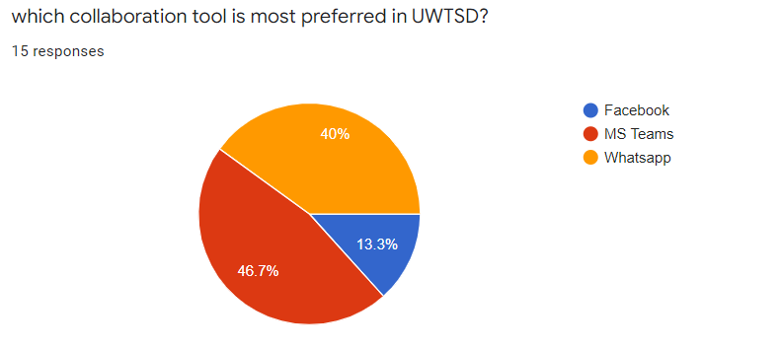
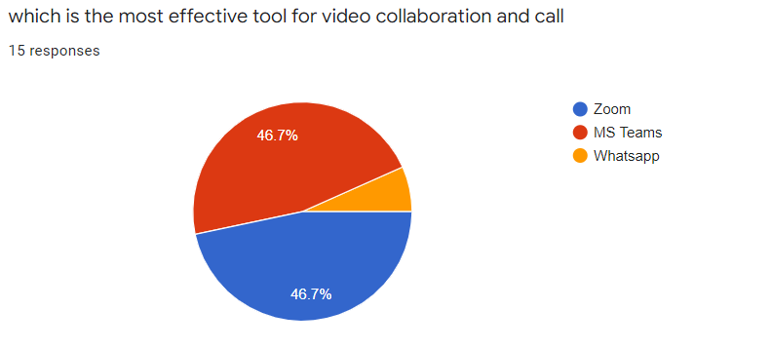
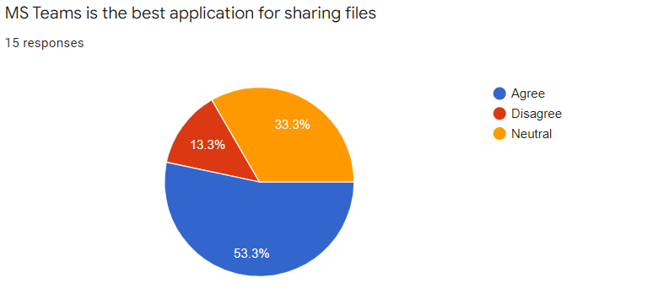

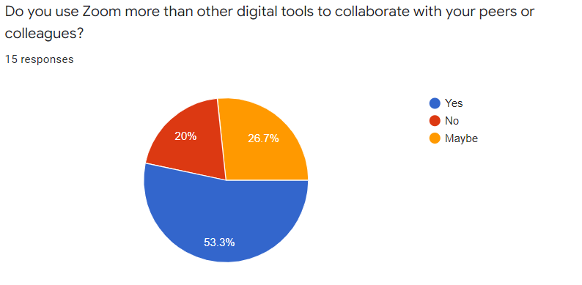

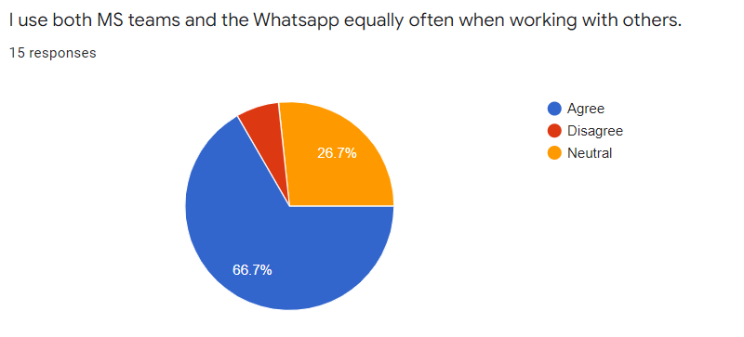
There were total 15 groups of participants who took part in the research survey. Different questions were asked to the participated related to Teams and different other collaboration applications. From question 1, it could be viewed that around 40% makes use of Whatsapp where as MS Teams comes second. Also, the participants preferred Zoom as the finest collaboration tool for video and audio calling. But these participants stated that when they work in the group they mostly prefer MS Teams or Whatsapp as according to them these are of the most efficient tools for working in a group. Furthermore, these participants stated that when they desire to share files, they make use of MS Teams as sharing files through MS Teams is quite simple and easy for them.
Along with surveys, interviews were also carried out in a group and also individually to acquire the thinking and responses of the participants. The participants stated that although Zoom is one of the fines tools for video and audio calling, but Zoom does not allow them to work on different other things such as security, chatting, sharing files etc and because of those students of UWTSD have to deal with significant issues. During 1-to-1 interviews, the participants stated that working in a group sometimes become complex for them as sharing files via Zoom is quite complex and takes a lot of time. Moreover, the participants said that they have faced serious issues regarding internet connections when they try to video call their colleagues on Zoom.

Ethical Considerations

Consent of participants
Nearly every research involves participants. To put up with ethical considerations, the researcher during research in UWTSD is required to inform students related to every activity which occurs during research and making informed consent from students before conducting research. The data that students are permitted to be cautious of is as following:
- Research purpose
- The forecasted research outcome
- The adverse research impact on participants
- Who is basically funding the project and how that particular funding will be exploited
The notion for taking this informed consent from students is that they surely will be cautious of what they are really doing (Wea and Kuki, 2021). If students are aware of purpose, they can choose whether they desire to take part in the project research. Moreover, participants are too entitled to ask for extra information if they find any uncertainties or become nervous during research. Once the researcher clears the doubts of every participant, they can ask UWTSD students to sign a form of consent.

Confidentiality
One of the vital ethical considerations during research in UWTSD is the informational confidentiality offered by students. The privacy meaning is that any data regarding to students or offered by students cannot be made accessed or accessible by anybody other than the researcher under no situations. The data of UWTSD is just exploited just to secure students from exterior threats.
Furthermore, confidentiality moreover guarantees that identifying information of the participants is not stated in the report or any other documents regarding UWTSD. The students are every time denoted to as nameless during research. Moreover, the research is needed to always keep in mind that the outcome or the data related to students is stated in such a manner that nobody could recognise it (Smolinski et al., 2021).

Sampling
Sampling is one of the foremost tasks that examiner should carry out before beginning the project in UWTSD. The examiner is required to portray why he chose a particular group of students for the purpose of research and why he has not involved several individuals. Every of this data must be evident and must be offered to students and funders if they have any type of objections related to the style of sampling.

Accessibility to Correct Information
When UWTSD students signed the consent form, they offer consent to give correct information for the purpose which means the researcher cannot exploit them as “guinea pigs” to collect data related to any topic that surely concerns them. (Purba, 2021) stated that lawfully, researchers cannot ask any questions other than the questions regarding the purpose of the research. The students have legal right to leave the research if they sense any disobedience of the convenience of information.

Transparency and Integrity
Final ethical consideration that could take place in research is transparency and honesty issue. Researchers are required to ensure that they sustain transparency and integrity in front of researchers. Researchers are forecasted to share every impending interest conflict that could impact their purpose of research.

Results
From the analysis and research, the results are mostly in favor of MS Teams because of numerous of benefits of MS Teams. The results clearly state that although in UWTSD, many students make use of Whatsapp but they are not satisfied by its services because they face distortion while calling and according to them the video quality of Whatsapp is not very clear in comparison to MS Teams. So, the results are simple, that the students of UWTSD are keen to make use of MS Teams rather than Whatsapp or any other collaboration tool because nearly everybody is using MS Teams and Whatsapp in their habitual lives and stated that when both are compared, MS Teams is way more effective and simple tool to use than Whatsapp.

Discussion
Using MS Teams in UWTSD can at certain times be intimidating. Be UWTSD are required to facilitate their students with the core skills they will require to flourish in their professional life for example communication and collaboration. If executed appropriately, UWTSD can exploit technology-facilitated learning to discuss the issues that UWTSD teachers deal with in higher education for example:
- Developing autonomy of students
- Allowing efficient team collaboration
- Developing digital skills within students for workplace preparation
MS Teams offers a finest digital space that brings apps, assignments, content and conversations together, facilitating UWTSD students to take whole control of their individual learning. Usable from any specific device, MS Teams simple to exploit and endorses collaboration amid UWTSD students and professors.
MS Teams could appear to merely be an online tool for video chat but a far more powerful and complex system is an offer here (Nawi and Hamidaton, 2022). From video sharing and video chat to collaborative editing and many more, this is ideal for UWTSD students and teachers. There is MS teams for the purpose of education which is free too. Well, there is a primary version that basically costs nothing and lodge s around 400,000 members, with around a storage of 2 GB for each. This surely makes it a viable choice for UWTSD leaders who desire a budget-friendly means to taking online learning.
To be evident, MS Teams does not assert to be a system of learning management, or desire to replace the current learning of UWTSD. Rather, it is constructed to aid perform along with university`s setup, improving how educators really teach and how UWTSD students can connect more from outside or inside the university. That could mean that online lesson based on video in which UWTSD students work in a collaborative manner on live document, but this moreover integrates with other tools of learning for remote learning whilst yet taking benefit of the numerous of online tools being exploited by students of UWTSD.
For UWTSD, Teams is a finest choice for internal collaboration and remote learning. Surely, whether you are a professor at UWTSD, or teaching first-class math, MS Teams is an efficient tool for making learning easy.

Benefits

MS Teams in more than Just a Chat
UWTSD students can make use of chat window in MS Teams to have rapid conversations with their class mates. But there is also a lot more than just this. If students are required to share a file, they simply just have to attach the file in chat. Then just make a video or voice call to their friends to talk about the file directly via the window. Or schedule a group meeting without needing to leave the chat. Integration of chat with other products of Microsoft such as Office and OneNote means no more extra switching amid applications during their conversation (Marčinković et al., 2021).

Before, During and After in Meetings
Getting each and everything ready for a meeting could be a complex issue. The plan is in sole email, accepted action in another. And where the things those students of UWTSD were supposed to examine before the call? Meetings in MS teams that experience so much simpler. As soon as UWTSD students make the meeting, they can begin chatting with other students related to agenda, share the files that they require them to examine, and sustain track of the notes of meeting and to dos. They can moreover examine who whose unrecognised individuals are that have been significantly invited (Buchal and Songsore, 2019). Afterwards, the call recording is instantly accessible in the similar tab, so if students by any means missed any meeting, they do not require hunting for the recording as this is the appropriate time with the agreed actions and meeting notes.

Enhanced Communication and Collaboration
All thanks to the correct integration with Office 365, students of UWTSD are not required to alter application when they are required to collaborate on a specific document. They can make the PPTs or word excels in teams, instantly share it with their colleagues within seconds.

Conclusion
It could be concluded that MS teams makes collaboration simpler by segmenting UWTSD in different collaboration, channels and teams so that their inbox is becomes a place of calm and their MS teams is their productivity place where they can carry out anything in a single place. For UWTSD searching for a cloud-based workspace for collaboration for their students, MS teams has now arrived as a foremost solution. MS Teams` rich mix of automation, collaboration and communication tools can bring together the students in even the most complex situations.

References
Buchal, R. and Songsore, E., 2019. Using Microsoft Teams to support collaborative knowledge building in the context of sustainability assessment. Proceedings of the Canadian Engineering Education Association (CEEA).
Marčinković, B., Aberšek, B. and Pesek, I., The Satisfaction of Primary School Teachers with the Introduction and Use of MS Teams in Distance Education. In 2021 44th International Convention on Information, Communication and Electronic Technology (MIPRO) (pp. 694-698). IEEE.
Nawi, A. and Hamidaton, U., 2022. Exploring Student’s Readiness and Behavioural Towards Virtual Learning via Microsoft Teams. Malaysian Journal of Social Sciences and Humanities (MJSSH), 7(2), pp.e001273-e001273.
Purba, L.S.L., 2021. Microsoft teams 365 and online learning: The student’s perception. Jurnal Pendidikan Kimia, 13(2), pp.130-136.
Smolinski, P.R., Szóstakowski, M. and Winiarski, J., 2021, December. Technology Acceptance of MS Teams Among University Teachers During COVID-19. In European, Mediterranean, and Middle Eastern Conference on Information Systems (pp. 346-361). Springer, Cham.
Wea, K.N. and Kuki, A.D., 2021, March. Students’ perceptions of using microsoft teams application in online learning during the covid-19 pandemic. In Journal of Physics: Conference Series (Vol. 1842, No. 1, p. 012016). IOP Publishing.
Yen, T.V.M. and Nhi, N.T.U., 2021. The practice of online English teaching and learning with microsoft teams: From students’ view. AsiaCALL Online Journal, 12(2), pp.51-57.

