  Component One: Student Journal (learning log) 750 words +/- 10%  Contribution to Overall Module Assessment: 25% | Student No: | 2243719
 | Module Title: | Hotel Placement - Hotel Administration & Front Office Operations
 | Module Code: | BMIH4004
 | Lecturer: | Ben Ka Po Chong
I am extremely proud of myself for going through placement and challenged myself to learn something new and expose myself to a new environment, having to learn about what it means to offer a genuine and pleasant hotel experience to guests.
Throughout my journal I will use Gibson’s reflective cycle, going through the six stages of exploring an experience: description, feelings, evaluation, analysis, conclusion, and action plan. (The University of Edinburgh, 2020)
I will start by describing my experience working at reception in Hotel Mercure North, Cardiff. As mentioned by J. Bardi – The front office is the nerve center of a hotel property. Communications and accounting are two of the most important functions of a front desk operation. (Bardi, 2011)
Initially, I felt a bit anxious, because of all the unknown that was expecting me, but at the same time, very confident, due to my experience in the hospitality environment. From the first day I was taught by my colleagues all the essentials of a receptionist. From how to use the systems, to perform check ins or check outs, providing information to a guest, where all the folders with different documents would stay, how to allocate keys for guests, how to register their car details for parking and how to keep in touch with the maintenance team or with the cleaning team.
Week by week I was getting better at knowing how to do these things and I was feeling very confident and happy that for a short period of time, I can be seen as a valuable team member.
One interesting experience was when a group of people came to check in and at that moment, I was alone in reception, as my colleague was showing to some other guests where one of the functions rooms is located. Even though I was still new to this, I remained calm and I welcomed them with a big smile and mentioned that I am in placement and at this point I would not be able to do their check in completely, but until my colleague would come back, I would be able to find their details on the system and allocate their keys and use the tablet to register their vehicles.
I was praised for my initiative, because I had a very good conversation with them and I used time efficiently, helped my colleague and when she arrived, she just finished the last bits of check in and payments and a large group was done in very little time.
The most important thing was that the guests did not have to wait too much. I used my skills efficiently and demonstrated initiative, problem solving skills, communication, and genuine honesty towards the customers. Hospitality-based experience signals that you know how to handle crucial customer interactions, a cornerstone of successful service-based companies. (Sturman et al., 2011)
Throughout my time in reception, I learned that it is very important to create a welcoming and efficient environment. This is the first point of action, the first place where people come when they enter a hotel and where they create their first impression. The clerks at the front desk play a very important role in presenting the hotel in its best light. They have continuous contact with the hotel’s guests throughout the working day. (Revfine, 2024)
Arrival is the guest’s first physical encounter with the hotel. He or she comes with preconceived ideas of what it will be like. Arrival is, therefore, one of the “moments of truth.” (Vallen and Vallen, 2014)
Concluding, I admit that I had a wonderful time whilst in the front office area. As I consider myself a people’s person, I was able to engage constantly with all the customers. I learned how to look for details that people might expect when they check in to a hotel, to make their experience smooth and tailored to their needs. But the most important, people will always prefer you to be professional yet human, always smile and if ever something goes wrong, just own it, and do your best to rectify that mistake.
For future, I admit that starting at reception is the best to learn about hospitality in a hotel. It is the centre point and almost everything is related to this area. Customer relationships may be measured by two factors. The first is the intimacy or the intensity of the interactions and the second factor is duration of the time spent with the customer. (Tesone, 2010)
For future I would spend more time understanding customer needs and what can I do to make their stay with us flawless. It is always about the little things that make big differences. Ultimately, develop my skills and knowledge in all areas, so I can become a successful manager.

References:
Access4Anele2Revf (2022). Front Office Department in Hotel: Everything You Need to Know. [online] Revfine.com. Available at: https://www.revfine.com/front-office-department-in-hotel/. [Accessed on 8 February 2024].
Bardi, J.A. (2011). Hotel front office management. Hoboken, N.J.: John Wiley & Sons. p.2.

Cottrell, S. (2019). The study skills handbook. 5th ed. Basingstoke: Palgrave.

Sturman, M.C., Corgel, J.B., Verma, R. and University, C. (2011). The Cornell School of Hotel Administration on Hospitality: cutting edge thinking and practice. Hoboken, N.J.: Wiley. p.23.

Tesone, D. (2010) Principles of management for the hospitality industry. London: Routledge. p.5.

Tewan, J. (2009) Hotel Front Office: Operations and Management, Oxford Higher Education Press p.14.

The University of Edinburgh (2020). Gibbs’ reflective cycle. [online] The University of Edinburgh. Available at: https://www.ed.ac.uk/reflection/reflectors-toolkit/reflecting-on-experience/gibbs-reflective-cycle. [Accessed on 8 February 2024].
University of Cambridge (2019). LibGuides: Reflective Practice Toolkit: Reflective writing. [online] Cam.ac.uk. Available at: https://libguides.cam.ac.uk/reflectivepracticetoolkit/reflectivewriting. [Accessed on 8 February 2024].
‌Vallen, G.K. & Vallen, Jerome J. (2014) Check-in check-out: managing hotel operations Ninth edition.; Pearson new international. p.230

Component Two
Contribution to Overall Module Assessment: 25%
Trip Advisor Review Response 150 words +/-10%
Dear Julian G,
Thank you for such a positive review and for taking the time to share your experience with us.
It is rewarding to know that you had such a pleasant experience with us. We are thrilled to hear that you appreciated our spacious bed and the pillows, as well as the value our rooms offer.
It is delightful to know that our staff made a marvellous impression and contributed in a positive manner to your experience whilst staying with us. This will encourage us to continue with our efforts to deliver a unique and memorable experience to all our guests.
We are also glad to hear that you appreciated our food presentation.
Regarding the options in the menu, we apologise for any inconvenience caused. Please rest assured we will take your feedback into consideration and offer more variety.

We all look forward to the pleasure of seeing you again in the future.

Emanuel Cogalniceanu
Mercure Cardiff North

Reference:
www.tripadvisor.co.uk. (n.d.). Peace in troubled times. - Review of Mercure Cardiff North Hotel, Cardiff - Tripadvisor. [online] Available at: https://www.tripadvisor.co.uk/ShowUserReviews-g186460-d192341-r937660486-Mercure_Cardiff_North_Hotel-Cardiff_South_Wales_Wales.html [Accessed 16 Feb. 2024].

Screen shot of referenced Trip Advisor review used:
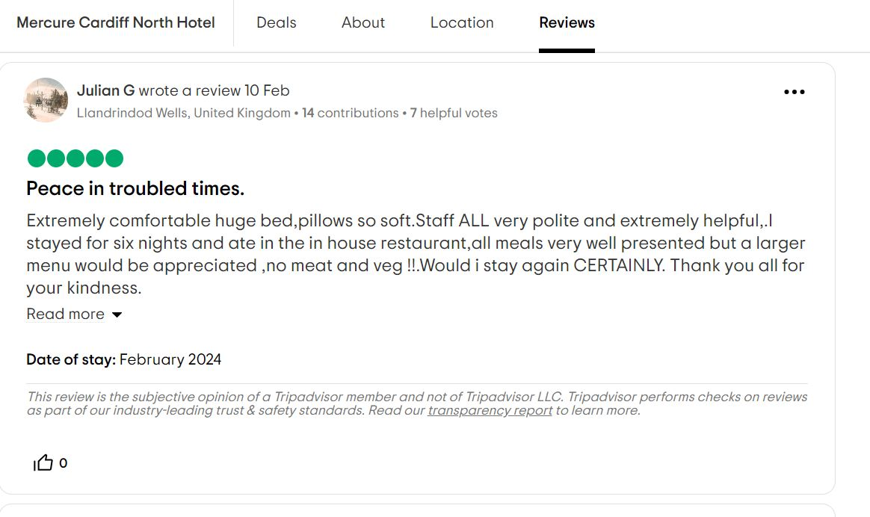
Letter of complaint response 500 words +/- 1-%
Dear Joanna,

Thank you for taking the time to bring these concerns to our attention and inform us about your experience. I greatly appreciate your comments about aspects of the room that need updating and your overall experience with us.
We sincerely apologise for the issues you encountered during your stay. We are saddened to hear that your experience was unpleasant. It is concerning to hear about the cleanliness of your room, as we pride ourselves on maintaining top-notch standards. Please be certain of the fact that we have meticulous cleaning protocols in place. This does not reflect our usual standards, and we take your feedback seriously.
We are deeply sorry to hear that the Wi-Fi service was poor and the connection was slow. We will contact our internet provider and make all the arrangements necessary to check the network and rest assured, we are addressing your feedback. We work constantly to make our guest experience brilliant and to ensure a comfortable stay for the time spent with us.
It is regrettable to learn that your experience with us was less than ideal, particularly that you have not managed to have a restful sleep, due to loud noises. We sincerely apologise for the issues you encountered during your stay and we will take your feedback into consideration for future improvements. If I may, did you call the front office to see if there was another room that we could give you to make your stay better?
We are saddened to hear that our service team did not meet your expectations. We will address this issue and work on improving our customer service and our guest experience. We understand the importance of impeccable service and will address this issue with our team to ensure better assertiveness and understanding of requests and inquiries.
We will address the issues you have mentioned in your letter with our team to ensure that such situations are not happening in the future.
We genuinely value your patronage and we sincerely hope that you would consider giving us another opportunity to display our exemplary level of service and guest experience. We aspire to offer a memorable and delightful experience to our customers. Your satisfaction remains our top priority and we are committed on rectifying all the concerns and issues you have encountered during your visit.
Thank you again for bringing these issues to our attention and I would be delighted to welcome you back and try to change your experience, to a genuinely positive one.
During your stay, breakfast and dinner will be on us, alongside a bottle of wine to your preference to compliment the dinner.
I hope that I can convince you to change your mind about another visit to our hotel. Please contact me directly on my email address, if you would be willing to give us a chance to turn your experience around.
It would be such a pleasure to personally welcome you back to our iconic location.

With much appreciation,
Emanuel Cogalniceanu

References:
Atanasoska, E. (2018). How To Respond to Negative Hotel Reviews [Examples]. [online] Hotel Reader. Available at: https://hotelreader.com/how-to-respond-to-negative-hotel-reviews/. [Accessed on 9 February 2024].

Brinza, C. (2023). How to Respond to Guest Reviews: A Hotelier’s In-Depth Guide. [online] TrustYou. Available at: https://www.trustyou.com/blog/guest-feedback-reviews/respond-to-guest-reviews-2. [Accessed on 9 February 2024].

Elphick, D. (2023). How to respond to negative hotel reviews. [online] Little Hotelier. Available at: https://www.littlehotelier.com/blog/running-your-property/best-ways-respond-to-negative-hotel-reviews/. [Accessed on 9 February 2024].
‌Landman, P. (2017). How to Respond to Negative Hotel Reviews | Online Reputation Management | Xotels Blog. [online] Xotels. Available at: https://www.xotels.com/en/marketing/how-to-respond-to-negative-hotel-guest-reviews. [Accessed on 9 February 2024].
www.mews.com. (n.d.). Bad hotel reviews | How to respond to negative reviews. [online] Available at: https://www.mews.com/en/blog/bad-hotel-reviews. [Accessed on 9 February 2024].

Component Three:
Contribution to Overall Module Assessment: 50% (1000 words +/- 10%)
Writing in essay format

Introduction:

The front office represents the heart of a hotel. It is the first meeting point between the customer and the place where they will stay for a determined period.
It also the main point of communication, all the information that goes between other departments, between business clients and guests, it is connected to the Front Office.
Answering guest inquiries about hotel services and other guests, marketing and sales department requests for information on guest room availability, and housekeeping department inquiries concerning guest reservations are but a few of the routine tasks performed almost constantly by a hotel front desk in its role as communications hub. (Bardi, 2011).
The front office plays a major role in ensuring that guests have a memorable stay, and their expectations are met or exceeded. It starts from the first impression and the first smile that the customer will see at reception until the very last moment, when the customer will check out and hopefully will be extremely satisfied to come again. Therefore, in order to work in this strategically important department you will be required to have a certain set of skills and to develop more skills whilst working and discovering new context or new demands.
Key Skill 1 – Customer Service Skills

Customer service skills is probably the most iconic set of terms in hospitality industry. Whether you already work in the field and your manager is going to emphasize that in your weekly brief, or you are applying for jobs and you are going to find that in job descriptions, or you will have it written in your CV, customer service skills are fundamental in hospitality.
Now applying these skills in the front office operation of a hotel it is also vital. It is crucial to know how to provide exemplary service to your guests and how to listen and satisfy their requests.
But what is “service”? “Service: The art of catering to the wants and needs of an individual and going so far as anticipating those wants and needs. Excellent service is friendly, helpful, prompt and anticipatory. It exudes warmth and caring and concern. Excellent service happens when the customer’s expectations are exceeded by the experience.” (Sturman et al., 2011).
A good example of customer service during my placement, would be when a customer requested an extra heater to her room, as she was having a cold and preferred the room warmer. I offered myself to take the heater and deliver it to the customer’s room and then also I offered her a cup of hot chocolate with marshmallows on top. Customer was absolutely surprised and delighted!
As a simple illustration, if people in an organisation believe that the marketplace rewards those organisations that provide good service and punishes those that don’t, then the importance of providing good customer service becomes a cultural belief. (Sturman et al., 2011).

Key Skill 2 – Communication Skills

Probably the nucleus within all skills required to work in the Front Office of a hotel would be communication skills.
First and most important you must be able to speak with the customers and provide them with the information they need to know about which one is their room, where is their room, timescales for breakfast and dinner, if required, function times and other bits of information.
Secondly, you have to communicate vital information with all the other departments. Communication skills will help you build rapport with your guests, manage complaints, deliver information to their queries and overall, they will help you create that memorable experience for them.
Communication involves active listening, verbal and written expression skills and the interpretation of non-verbal cues. (Tesone, 2010).
Seasoned reservation managers know that effective communication skills are more important than basic computer skills. Poorly trained reservation agents miss potential sales by failing to understand customer’s needs. (Vallen and Vallen, 2014).

Key Skill 3 – Organisational Skills

How you organise yourself and your tasks it is a significant skill in any field you would work. It is directly connected to your productivity, to your results, your time management and ultimately to your promotion.
You would require various well-polished skills to perform at your best capacity and be on top of all the queries and requests. Sometimes you might have to greet customers, answer the phone, and reply to an urgent message from a different department, solve queries on the computer, and resolve a guest’s issue.
Organisational skills require knowledge of scientific and relational aspects of service enterprises. (Tesone, 2010).
A good example of organisational skills during my placement was in a day when I arrived and asked what numbers we are expecting today to arrive and if there are any functions. My colleague briefed me and on top of the usual arrivals we had a football team checking in about the same time with a large function. We both agreed that preparation is important, so we assigned all the keys for the football players in advance, and placed them separately for when they arrive, I was given credentials on the laptop, so we can both check in, we arranged a separate area in the lobby for the people coming for the function, and we installed a second tablet for vehicle registration, to make the process more fluid. Everything went according to the plan and all the guests were checked in smoothly and delighted by the level of service we provided.

Key Skill 4 – Problem Solving Skills

Working in the front office of a hotel, you are always required to have a proactive attitude and a problem-solving approach. Sometimes you are dealing with guests, sometimes with business clients, managers, or other departments, and they all might have a query which might require for you to come with a solution to. For example, there might be a new software for reservations and it is quite complex, you did not manage to get a grip of all its functions and you are having issues checking in a large group of people.
The front office being such a vital department in a hotel and being directly responsible for the customer’s experience overall, the person working here needs to be able to understand clearly the query and then provide the optimal solution to the guest, sometimes even repeatedly if the guest has an issue that persists. (Roland, 2022).
Those who manage their own careers seek continuously challenging work because this type of work enables them to develop and apply such skills as problem-solving, broad-picture visioning, and long and short-range planning, as well as refine their interpersonal skills. (Sturman et al., 2011).

Reference List

‌ALEXANDER, E., 2023. ... ﬁnd the perfect person for the job. The Caterer, , pp. 22.

Bardi, J.A. (2011). Hotel Front Office Management, 5th Edition. Wiley Global Education. (p.2.)

Chechi, H. (2023). Communication skills for customer service and why they’re important. [online] Glion Website. Available at: https://www.glion.edu/magazine/communication-skills-customer-service/. [Accessed 16 Feb. 2024]

Hospitality Net. (n.d.). 11 In-Demand Hospitality Resume Skills | By Frank Giannotti. [online] Available at: https://www.hospitalitynet.org/opinion/4117976.html [Accessed 16 Feb. 2024].

O’fallon, M.J. and Rutherford, D.G. (2011). Hotel management and operations. Hoboken, N.J.: Wiley.

Premier Inn (2023). Force For Good. [online] Premier Inn. Available at: https://www.premierinn.com/gb/en/why/force-for-good.html. [Accessed 16 Feb. 2024]

Roland, I. (2022). What Soft Skills and Qualities Are Important for a Receptionist? [online] VoiceNation. Available at: https://voicenation.com/resources/important-receptionist-skills-and-qualities-voicenation/#:~:text=Problem%20solving%20skills&text=Usually%2C%20when%20someone%20contacts%20a [Accessed 16 Feb. 2024].

Sturman, M.C., Corgel, J.B. and Verma, R. (2011). The Cornell School of Hotel Administration on Hospitality. John Wiley & Sons. (pp. 10, 11, 25, 113)

Tesone, D.V. (2010). Principles of management for the hospitality industry. (pp. 13, 132).

Tewari, Jatashankar R (2009). Hotel Front Office: Operations and Management. New Delhi, India: Oxford University Press.

‌Vallen, G.K. and Vallen, J.J. (2014). Check-in check-out. Boston: Pearson. (p. 167)

