

Methods and Search Strategy Academic Poster

Student name: Shafeena Hussain Mushtaq
Student ID: 2314453

Module name: Independent Project
Module code: (BMHP6020)

Exploring Healthcare Access and Inequalities Among Older Adults (Aged 72–80) in the UK.
01 Introduction and Research Aim  This section provides an overview of the methodology used in this research and summarises the key processes involved in conducting a secondary, literature-based study. A methods chapter describes how the research will be conducted, including the data collection methods, how the data will be selected and analysed to achieve reliability and validity. The following poster outlines the most important steps of the methodology search strategy, data collection, validation, and analysis. This study seeks to critically analyse inequalities and healthcare access to older adults (72-80 years old) in the UK. The research aims to determine some structural, social, and systemic barriers that influence access to healthcare. It additionally tries to assess the existing healthcare policies and structures and come up with evidence-based solutions to enhance equity in healthcare delivery. | 02 Search Strategy  Search strategy in secondary research is a plan conducted to recognise the sources of publications and data that answer a research problem. It entails the identification of the right keywords, databases, and filters to screen the results (Chigbu et al., 2023). The search was also broadened to find some synonyms, such as the elderly population and health disparities. Boolean operators were used to enhance efficiency in search. The AND operator was used to bring together important concepts, and the OR operator was used to incorporate relevant words (Booth et al., 2022).
03 Searching for Information  The process of searching for information consisted of searching for and finding useful and valid sources. Firstly, such important databases as Google Scholar, NHS Digital, NICE guidelines and World Health Organisation (WHO) resources were employed. These sources were chosen because they are reliable and relevant to the study of healthcare. Simple keywords on the research topic were entered as the first step. It was then narrowed down to searches in terms of Boolean operators and filters like publication date (less than five years old), the UK regions, and peer-reviewed articles (Booth et al., 2022). | 04 Picture / Graph / Visual Aid / Statistics  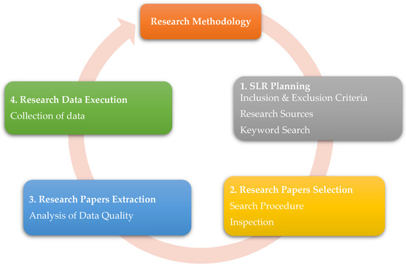  Figure 1. Research Methodology Process  Source: (Chigbu et al., 2023)
C
06 Inclusion Criteria  The inclusion criteria are the criteria that are applied to determine the sources that can be used in the research (Zetterstrom et al., 2022). The sources considered in this study were peer-reviewed journal articles, government reports, and policy documents that referred to healthcare access and inequalities. Articles that were published not more than five years ago were decided to be included in the selection to make sure that the information is up-to-date and pertinent (William, 2024). Also, the study of UK-based studies was aimed at ensuring consistency in the research purpose. | 07 Exclusion Criteria  The exclusion criteria are the criteria on which the sources that do not suit the research are excluded (Shaheen et al., 2023). Blogs, opinion articles, and websites that cannot be verified were also ruled out as not credible. The research excluded studies done outside the UK since they did not fit the research focus. Also, the articles which were not entirely accessible were eliminated, since insufficiently complete data might impact analysis quality.
08 Ethical Considerations
Here you can start with providing a definition of Ethics in Secondary Research. Below includes some examples of how you may have considered ethics in your research

References
Booth, A., Sutton, A. and Papaioannou, D. 2022. Systematic Approaches to a Successful Literature Review. 3rd ed. London: Sage Publications.
British Educational Research Association (BERA). (2024) Ethical Guidelines for Educational Research. 5th ed. London: BERA.
Chigbu, U.E., Atiku, S.O. and Du Plessis, C.C., 2023. The science of literature reviews: Searching, identifying, selecting, and synthesising. Publications, 11(1), p.2.
Economic and Social Research Council (ESRC). (2023) Framework for Research Ethics. Swindon: ESRC.
Shaheen, N., Shaheen, A., Ramadan, A., Hefnawy, M.T., Ramadan, A., Ibrahim, I.A., Hassanein, M.E., Ashour, M.E. and Flouty, O., 2023. Appraising systematic reviews: a comprehensive guide to ensuring validity and reliability. Frontiers in research metrics and analytics, 8, p.1268045.
William, F.K.A., 2024. Mastering validity and reliability in academic research: Meaning and significance. International Journal of Research Publications, 144(1), pp.287-292.
Zetterstrom, S. and Waernbaum, I., 2022. Selection bias and multiple inclusion criteria in observational studies. Epidemiologic Methods, 11(1), p.20220108.

