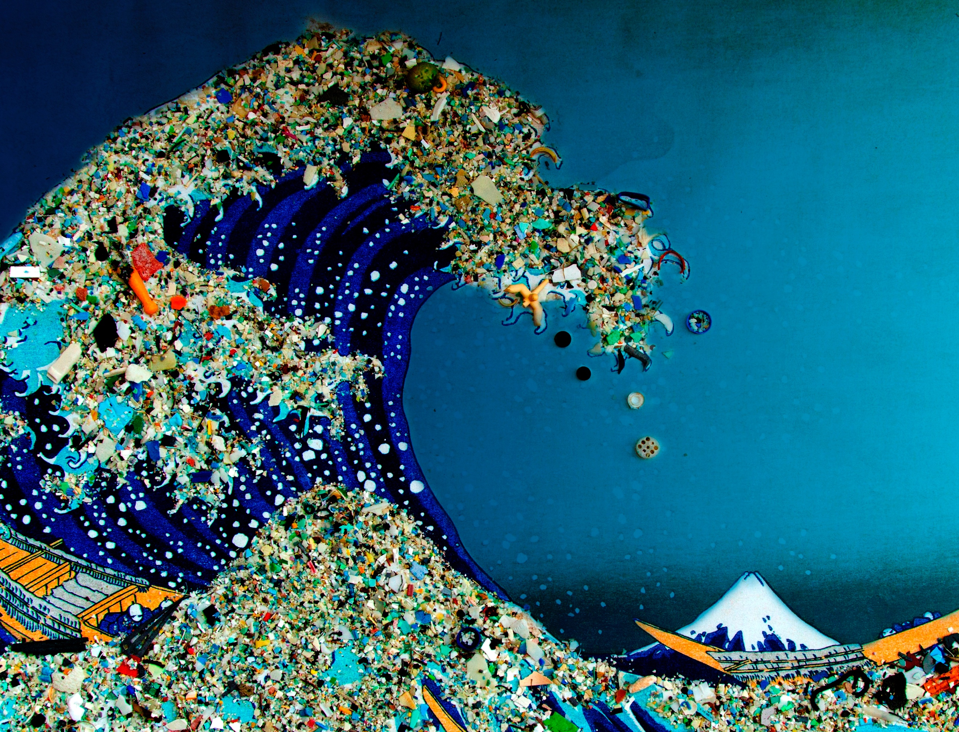
Marine Litter Pollution
Problems & Recommendations
Robert Kendall
Waste and Resource Management MSc Environmental Conservation and Management

Table of Contents
1. Introduction 3
2. Definition of plastic and its properties 5
3. Plastics in the ocean, sources and pathways 7
3.1 Macroplastics in the ocean, sources and pathways. 7
3.2 Microplastics and Nanoplastics in the ocean, sources and pathways 10
4. Significant areas of marine litter accumulation 13
5. The most significant problems posed by this litter 14
5.1 Physical impacts of macro and micro plastics. 16
5.1 (a) Entanglement 16
5.1 (b) Ingestion of plastics 17
5.1 (c) Transportation of Invasive Species 19
5.2 Chemical impacts of marine litter 19
5.3 Socioeconomic impacts of marine litter 19
6. Recommendations for solving marine litter 21
7. Conclusion 24
References 25
Appendix 28

Cover Image, (Water UCI, 2017)

Marine Litter Pollution: Problems & Recommendations

Robert Kendall
Student Number: P133451
Waste and Resource Management
MSc Environmental Conservation and Management

Introduction

Marine litter or marine debris is defined as anthropogenic solid waste that enters the marine environment of which originates from many different sea or land based sources and is now recognised as a major global concern affecting all oceans worldwide (European Commission, 2017; OSPAR Commission, 2018). Millions upon millions of tonnes of litter enter the oceans annually causing major environmental, biological, ecological, economic, health and aesthetic issues. The main causes of marine litter are poor solid waste management practices, poor standard infrastructure, wastewater/storm water treatment and collection as well as lack of public awareness on how consumption patterns considerably exacerbate the issue (Auta et al., 2017; Barboza and Gimenez, 2015; European Commission, 2017). Marine environments are highly dynamic and make up the physicochemical characteristics of adjoining estuarine, lagoon and freshwater environments. Therefore, amelioration and remediation of diffuse marine litter in costal environments are highly complex and more often than not an ineffective and uneconomical method of tackling the issue. (European Commission, 2017; Auta et al., 2017)

Marine litter comprises of a wide range of materials such as wood, glass, rubber, metals, paper and plastic (OSPAR Commission, 2018). Plastics are the largest and fastest growing municipal waste stream (from the 1950’s to 2002) making up to around 60 to 85% of all marine litter, and can reach up to 90-95% in some locations (Auta et al., 2017; Löhr et al., 2017; Wang et al., 2016), with global production significantly increasing and likely to continue to increase due to present consumption patterns and demographic trends (Auta et al., 2017; Löhr et al., 2017). It is estimated that <5% of all plastic waste gets recovered therefore, causing a significant amount to accumulate in our oceans (estimated 2-10% of all produced plastic) (Auta et al., 2017; Avio et al., 2017; Prevenios et al., 2017). However, it’s important to note that, determining the source pathway relationships of marine litter is highly complex and diverse, as a result the exact quantities may not yet be fully understood. (Löhr et al., 2017)

Plastics by definition are semi or fully synthetic produced polymers made up of chemically bonded monomers of organic molecules (Benno Meyer-Rochow et al., 2015). There are many different types of plastic polymers which can contain additives called Plasticisers to produce different characteristics. (Avio et al., 2017) The European plastic industry is the world’s second largest producer which directly employs around 1.45 million people contributing an estimated 26.3 billion euros towards public finance and welfare (Avio et al., 2017; UNEP, 2014). The most commonly produced polymers are; polyethylene (PE), polypropylene (PP), polystyrene (PS), polyvinylchloride (PVC), polyamide (PA), polyethylene terephthalate (PET), polyvinyl alcohol (PVA). (Avio et al., 2017; Benno Meyer-Rochow et al., 2015).

Plastics have become prevalent in today’s modern society due to its inexpensive, durable and lightweight properties and have become extensively used within the municipal, commercial, industrial and medicinal sectors. However, the single use functionality and low recovery value of plastics (e.g. single use plastic bags) coupled with poor waste management and disposal practices, are causing widespread environmental contamination (Wang et al., 2016). The first reports on plastic marine debris emerged during the 1970’s (Carpenter and Smith, 1972; Morris and Hamilton, 1974; Wong et al., 1974), but received little public attention at the time. Today however, with increasing production of plastics and the discovery of plastics in the world’s most remote islands and deep seas, the issue is now being widely recognised and gaining global political attention (Wang et al., 2016).

One of the major issues with plastic marine debris is the persistent nature of the contaminant and the rate of degradation due to its robust characteristics. This means that they don’t degrade quickly, if at all and form fragments and sediments referred to as macroplastics, microplastics (MP’s) and nanoplastics, where the contaminant can occur for decades, centuries and even a millennium in the marine environment, causing physical, chemical and economic impacts, affecting marine ecosystems and biota (UNEP, 2014; Wang et al., 2016). The first time the term MP’s was used in scientific literature as a descriptor of small plastic particles in the marine environment was by Thompson et al, 2004; “Lost at sea: where is all the plastic?” (Barboza and Gimenez, 2015; Thompson et al., 2004). MP’s are now usually categorised by size, macroplastics which are large plastic waste debris (>2.5cm in diameter), small macroplastics (<2.5cm in diameter), smaller microplastics and nanoplastics (<5mm in diameter) (Löhr et al., 2017; Li et al., 2016).

The inaugural United Nations Environment Assembly (UNEA) consultation in Nairobi on June 23rd 2014, raised concerns over how marine plastic debris is affecting marine biodiversity and ecosystems. Two UNEP supported reports for UNEA Nairobi published by the Plastic Disclosure Project (PDP) and Trucost, (Valuing Plastic and UNEP 2014 Year Book) made a conservative annual estimate of $13 billion in financial loss due to marine ecosystem degradation by plastic debris (UN., 2014). Within European Union, in 2008 the European Marine Strategy Framework Directive (MSFD, 2008/56/EC) requires member states to achieve good ecological status (GES) by 2020 and has included MP’s as an aspect to be monitored and measured, being the first legislative proposal globally where MP’s have been included (Gago et al., 2016). The UK government have been making steps toward tackling the issues with single use plastic where a £0.05p tax was placed on the consumer (09/20011-Wales, 04/2013-Northen Ireland, 10/2014-Scotland and 10/2015-England) for single use carrier bags, reducing their use by 85% (Welsh Government, 2018; Scottish Government, 2018; DAERA, 2018; HM Government, 2018).

Moreover, the UK government are now tackling the issue of primary source MP’s by creating a legislative ban on the sale and manufacture of any healthcare and beauty products containing plastic microbeads, which was proposed in September 2016 and came into force on the 9th January 2018 (Carrington, 2018). Furthermore, the UK government has set a non-legislative 25-year Environment Plan, to enhance our natural environment which placed plastic waste as a huge priority with the aim of, “eradicating all avoidable plastic waste by 2024” (HM Government, 2018).

Definition of plastic and its properties

Plastics hold a huge significance in today’s Modern society, the practicality and low cost of this material have bettered people’s lives, whether its preserving food and medicine, facilitating transportation to be more fuel efficient or connecting society together with its use in technology. In some way or another plastic has had a positive impact on people’s lives. However, the environmental impact of this material cannot be overlooked (UNEP, 2014).

To understand how plastic causes environmental issues, it is fundamental to understand what plastic consists of and how it behaves within the environment. Plastics by definition are semi or fully synthetic produced polymers made up of chemically carbon-based bonded monomers of organic molecules. There are many different types of plastic polymers which can contain additives called Plasticisers to produce different characteristics, these are usually added to polyvinyl chloride (PVC) and other non-biodegradable polymers. Moreover, Bisphenol A (BpA) are often used as a strengthening agent to epoxy-resins and polycarbonate plastics (Benno Meyer-Rochow et al., 2015). See Figure.1.

Plastics within the marine environment are highly persistent and reluctant materials that take a considerable amount of time to degrade. Ultimately plastics like other organic materials, do degrade but at a much slower rate. The factors that promote degradation or chemical breakdown (which changes material properties) of plastic polymers are caused by physical, chemical and biological conditions such as; ultraviolet (UV)-solar photodegradation, thermal reactions and thermo-oxidation, biodegradation by microbes and hydrolysis (Andrady, 2015; UNEP, 2016). The rates of degradation in the marine environment are highly dependent on a multitude of factors with the primary factors being, physical abrasion caused by wave action and (UV)-solar photodegradation, where the rate is augmented within shoreline areas located around equatorial regions. The rate of biodegradation is difficult to estimate but it’s believed to be extremely slow (UNEP, 2016; UNEP, 2014; Wang et al., 2016; Benno Meyer-Rochow et al., 2015).

Furthermore, plastics in the environment have the capability to absorb and concentrate persistent organic pollutants (POP’s) such as; polycyclic aromatic hydrocarbons (PAHs), poly- chlorinated biphenyls (PCBs) and dichlorodiphenyltrichloroethane (DDTs), as well as, metals (Wang et al., 2016).

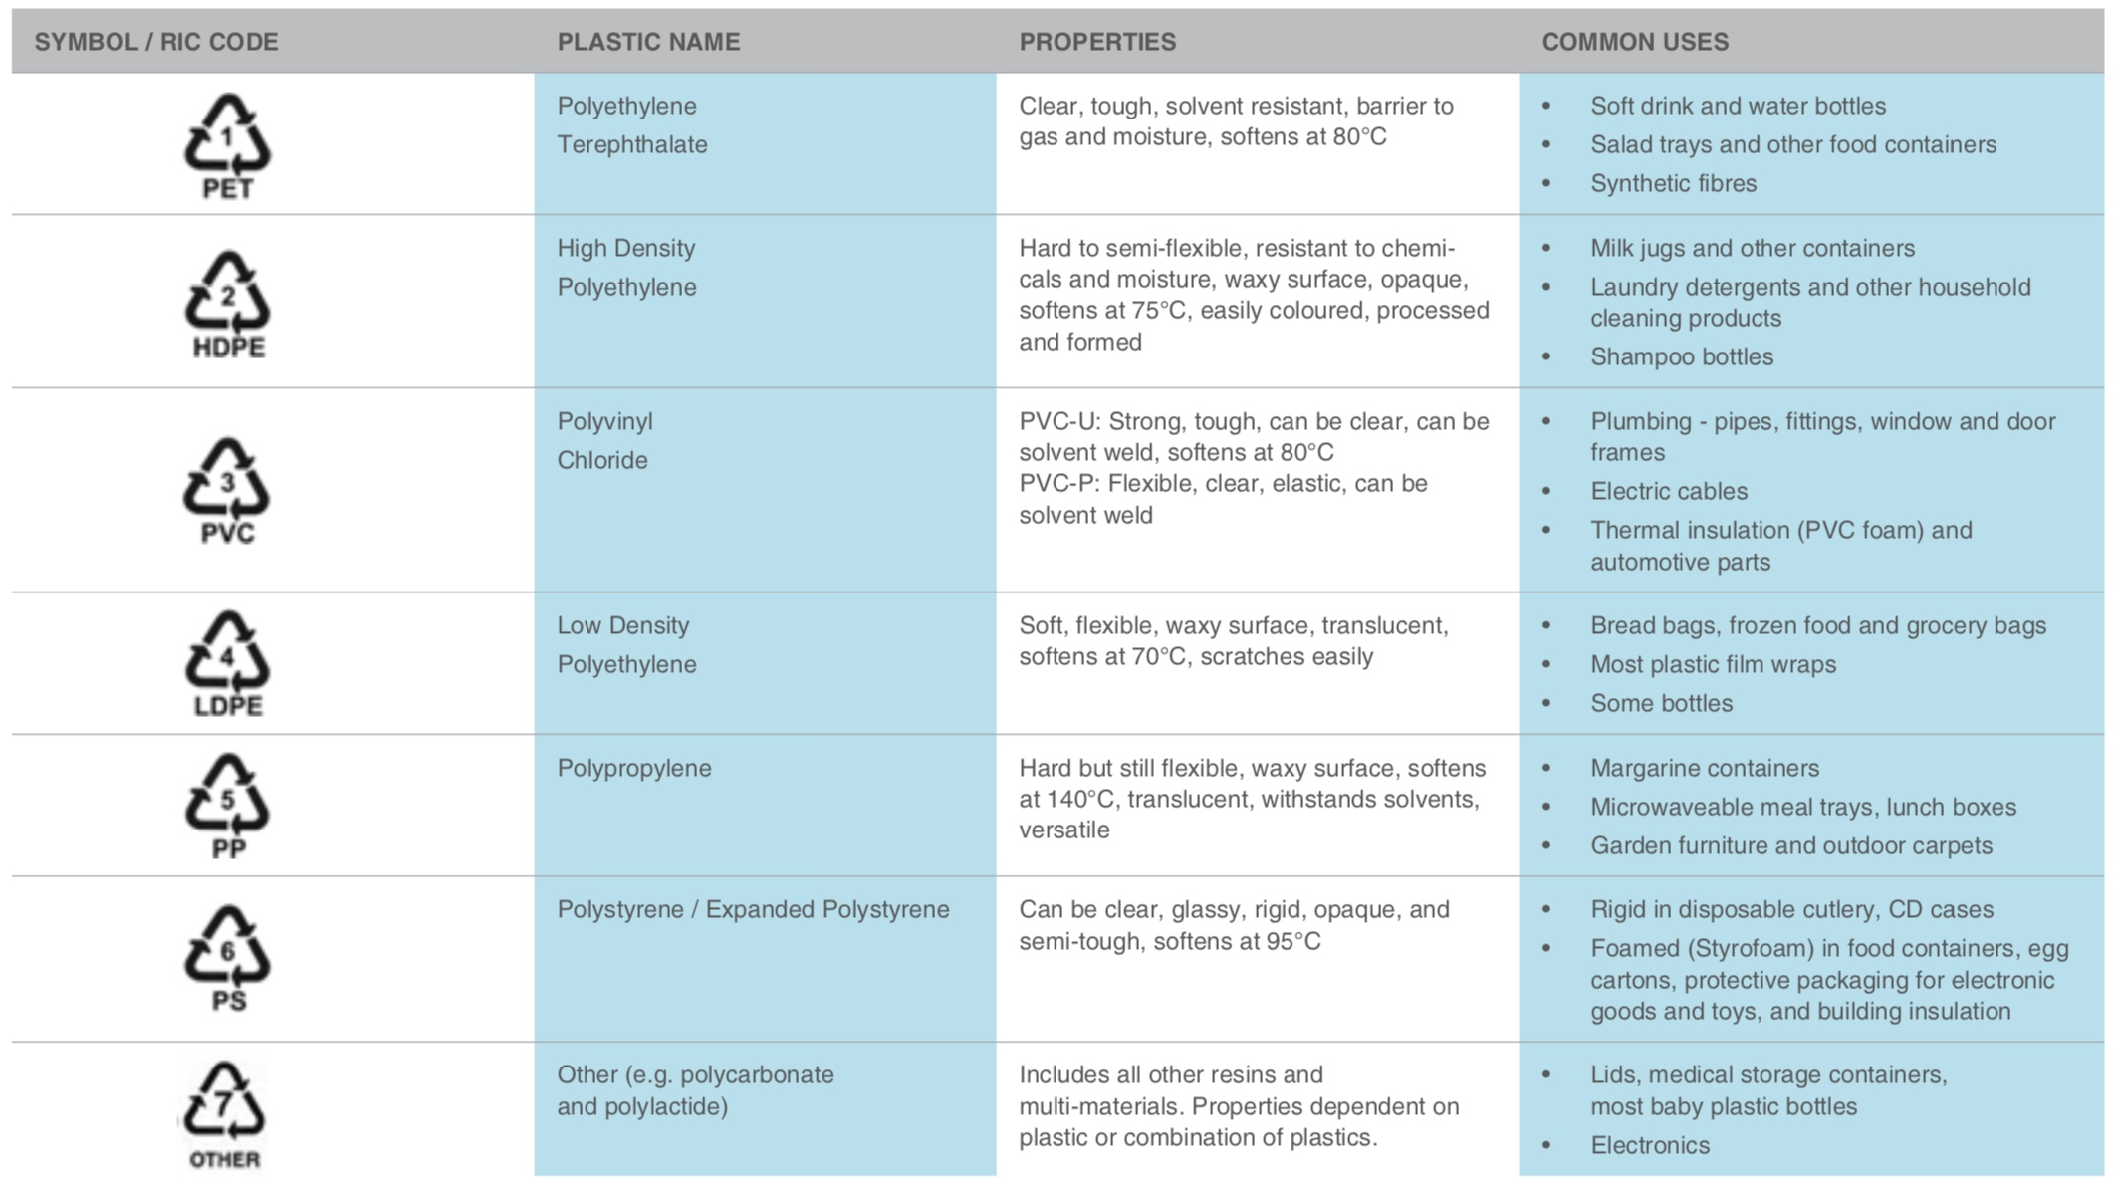
Figure.1. Types of plastic and its properties and common uses (UNEP, 2014).

Plastics that end up in the ocean can be categorized by size; macroplastics, microplastics and nanoplastics, with microplastics being also categorised by primary and secondary sources (Löhr et al., 2017). There is no official definition of nanoplastics. However, da Costa et al., 2016 suggested that the definition should be <1 micrometre (μm) (da Costa et al., 2016).

Macroplastics, >25mm Microplastics, <5mm Nanoplastics, <1 μm (smaller macroplastics, 25mm-5mm in diameter)

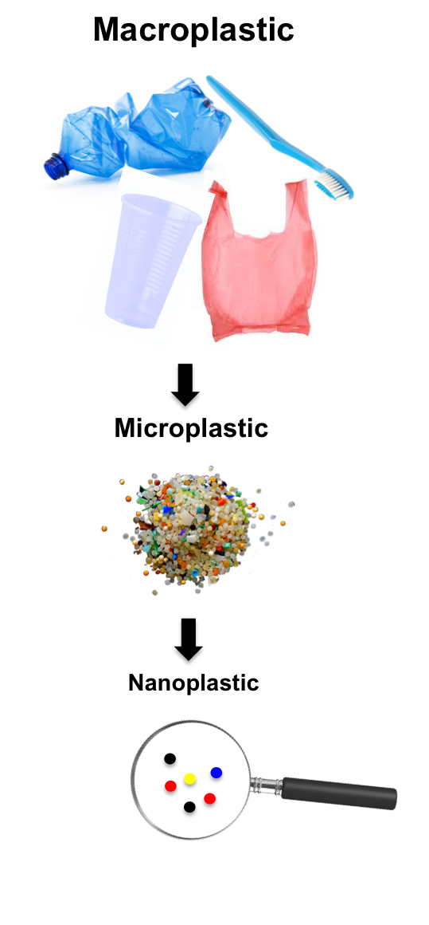

Figure.2. Macroplastics, Microplastics and Nanoplastics. Adapted from, Lehner, 2015; Löhr et al., 2017; Li et al., 2016; da Costa et al., 2016 (Note, there is no official definition of nanoplastic. The categorisation above is taken from da Costa et al., 2016)

Plastics in the ocean, sources and pathways

Plastics are the largest and fastest growing municipal waste stream (from the 1950’s to 2002) making up to around 60 to 85% of all marine litter, and can reach up to 90-95% in some locations (Auta et al., 2017; Löhr et al., 2017; Wang et al., 2016), with global production significantly increasing and likely to continue to increase due to present consumption patterns and demographic trends (Auta et al., 2017; Löhr et al., 2017). It is estimated that <5% of all plastic waste gets recovered therefore, causing a significant amount to accumulate in our oceans (estimated 2-10% of all produced plastic) (Auta et al., 2017; Avio et al., 2017; Prevenios et al., 2017). However, it’s important to note that, determining the source pathway relationships of marine litter is highly complex and diverse, as a result the exact quantities may not yet be fully understood (Löhr et al., 2017).

It is estimated that at least half of the world’s population lives within 60km from the ocean as 75% of all major cities are located in coastal areas with many others being located adjacent to rivers which are indirectly connected to the sea (UNEP, 2016). Therefore, it is reasonable to assume that these urbanised locations hold a significant role with regards to plastic waste ending up into the ocean. Moreover, it is important to note that there are strong regional differences as the quantities ending up in the ocean are subject to waste collection and management practices of wastewater and solid waste (UNEP, 2016; Li et al., 2016). Jambeck et al., 2015 claimed that, the majority of plastic marine debris originate from emerging economies. The article also reported that 83% of land based plastic waste comes from 20 out of the 192 investigated costal countries, with all but one (United States of America) being either; UMI Upper middle income, LMI lower middle income or LI low income countries. (World Bank definitions based on 2010 Gross National Income) (Jambeck et al., 2015). See appendix.1. However, these estimates are likely to change, as China (ranked 1st by Jambeck et al.) recently imposed a ban on importing 24 different kinds of solid waste called, yang laji or “foreign garbage”, (Laville, 2017).

Macroplastics in the ocean, sources and pathways.

Macroplastics are defined by larger debris of plastic (>25mm in diameter) and smaller macroplastics (25mm-5mm in diameter) that come from a plethora of land and maritime sources; fisheries, aquiculture, tourism, retailers, and construction which enter the ocean via pathways such as; rivers, storm water discharge and direct inputs. Macroplastics can vary in size and composition which usually consist of; plastic carrier bags, bottles and bottle tops, fragments of larger plastic products, packaging, fishing floats, buoys, balloons, abandoned fishing nets and traps (Axelsson and van Sebille, 2017; Löhr et al., 2017; UNEP 2016). See table.1. Land based sources of plastic debris contribute an estimated 80% of all marine plastic pollution, with the majority originating from densely populated and industrialised locations (Li et al., 2016). The pathway of plastic to the ocean see figure.3. is usually via watercourses, atmospheric processes and direct inputs of which are considerably exacerbated by extreme weather events (flooding and hurricanes).

Table.1. Prospective sources of land based macroplastics to the marine environment, descriptions of kind of waste, entry points and a qualitative importance estimate (taken from UNEP, 2016).
Sector | Description | Entry Points | Relative Importance
Retail | Household consumer goods and packaging | Watercourses, atmospheric processes and direct inputs | High
Food and Drink | Single use packaging | Watercourses, atmospheric processes and direct inputs | High
Households | Household consumer goods and packaging | Watercourses, atmospheric processes and direct inputs | High
Tourism Industry | Household consumer goods and packaging | Watercourses, atmospheric processes and direct inputs | High
Plastic Recyclers | Household consumer goods and packaging | Watercourses, atmospheric processes and direct inputs | Moderate
Construction | EPS, packaging | Watercourses, atmospheric processes and direct inputs | Low
Agriculture | Pots, pipes, films and sheets | Watercourses, atmospheric processes and direct inputs | Low
Terrestrial Transportation | End of life vehicle tyres | Watercourses and shoreline | Low

Macroplastics can also enter wastewater treatment systems via disposal through toilets, which usually includes materials like; sanitary products, nappies, cotton buds and contraceptives. Typically, these products are removed through primary sewage treatments. However, during heavy rainfall these systems can be overloaded causing these materials to enter untreated overflows and subsequently entering the environment. This is common in London, a 21st centaury metropolis with a 19th centaury wastewater infrastructure, where these materials are being regularly documented in marine litter surveys (UNEP, 2016).

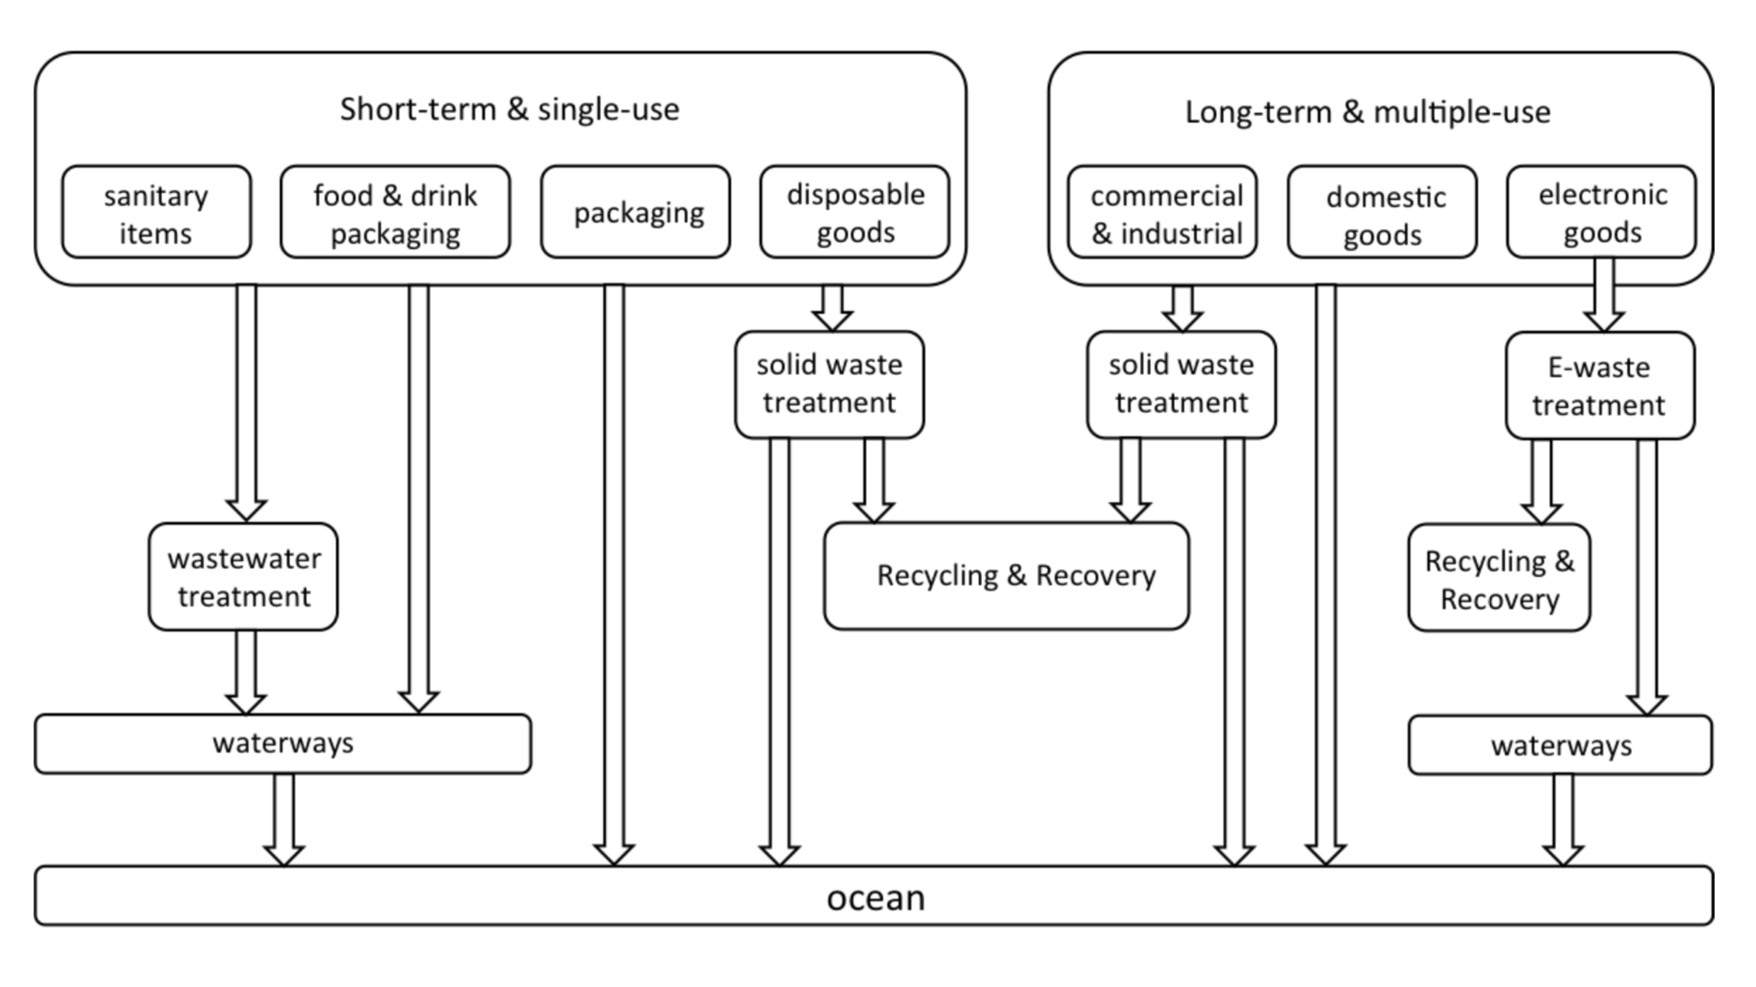
Figure.3. Source/Pathway of land-based macroplastics in the marine environment (UNEP, 2016).

Furthermore, macroplastics can directly or indirectly enter the ocean through sea-based sources. These sources usually are; fisheries, aquiculture, vessel based tourism and offshore shipping industry. It is believed that the fishing industry is the main contributor of sea-based macroplastics in the ocean and usually consist of; fishing equipment that is accidently lost, abandoned or illegally disposed at sea (UNEP, 2016). Figure.4. shows the source/pathway of sea-based macroplastics and table.2. lists the Prospective sources of land based macroplastics to the marine environment, descriptions of kind of waste, entry points and a qualitative importance estimate.

It is important to note that, sea-based sources can have indirect pathways with regional differences. For example, large tourist vessels usually contain good solid waste and wastewater treatment systems however, the disposal usually takes place at ports and as mentioned with land based pathways are subject to the quality of the infrastructure and can subsequently end up in the ocean. (UNEP, 2016; Jambeck et al., 2015).

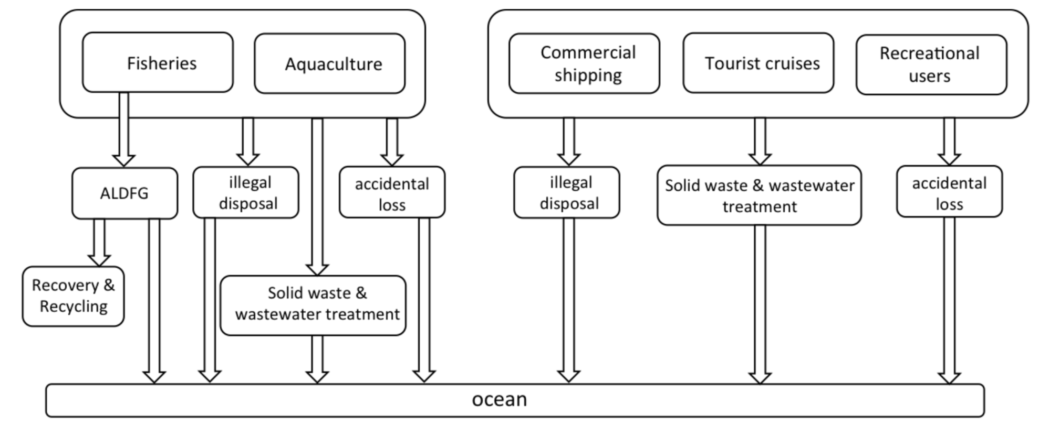
Figure.4. Source/Pathway of sea-based macroplastics in the marine environment (UNEP, 2016)

Table.2. Prospective sources of sea based macroplastics to the marine environment, descriptions of kind of waste, entry points and a qualitative importance estimate (taken from UNEP, 2016).
Sector | Description | Entry Points | Relative Importance
Fisheries | Fishing equipment, storage boxes, strapping bands and personal goods. | Coastal and marine | High
Aquiculture | Lines, nets, buoys, storage boxes and personal goods. | Coastal and marine | Moderate
Offshore Shipping | Packaging, cargo and personal goods. | Coastal and marine | Moderate
Vessel Based Tourism | Packaging and personal goods. | Coastal and marine | Moderate

Microplastics and Nanoplastics in the ocean, sources and pathways

Microplastics are defined by plastic marine debris that are <5mm in diameter and smaller nanoplastics are defined by plastic particles that are <1 μm (however, there is no official definition on the size of nanoplastics). Microplastics are also categorised by its primary and secondary sources (Löhr et al., 2017; Li et al., 2016; da Costa et al., 2016) (refer to figure.2. Primary source Microplastics cause a direct source of Microplastics to the environment, which originate from industrial/manufacturing uses, personal cosmetic care products (PCCP’s), plastic producers and more recently in medicine as a vector for administrating drugs (Auta et al., 2017; Löhr et al., 2017). Secondary Microplastics are harder to determine the point source as they consist of fragmented larger plastic products (macroplastics), fibres from synthetic clothing and fragments from vehicle tyres. These issues are especially problematic, in areas with poor wastewater treatment facilities (Löhr et al., 2017; Auta et al., 2017).

The main source of primary microplastics that enter the marine environment are from Plastic producers, industrial processes and domestic PCCP’s, which are used in air blasting practices and the use of microplastic particles called microbeads in PCCP’s (Li et al., 2016). Moreover, accidental loss from the manufacturing of plastic resin pellets (also referred to as nurdles or mermaids tears) that are only a few mm in diameter and are transported to be further processed into a finished product have been widely found in the marine environment (UNEP, 2016; Thompson, 2015).

However, even though modern wastewater treatment facilities have the ability to remove up to 99% of microplastics, they still pose a significant problem due to the sheer quantity of microplastics found in effluents (Li et al., 2016). Due to increasing research and lobbying from environmental groups, the UK government are now tackling the issue of primary source microplastics by creating a legislative ban on the sale and manufacture of any healthcare and beauty products containing plastic microbeads, which was proposed in September 2016 and came into force on the 9th January 2018 (Carrington, 2018).

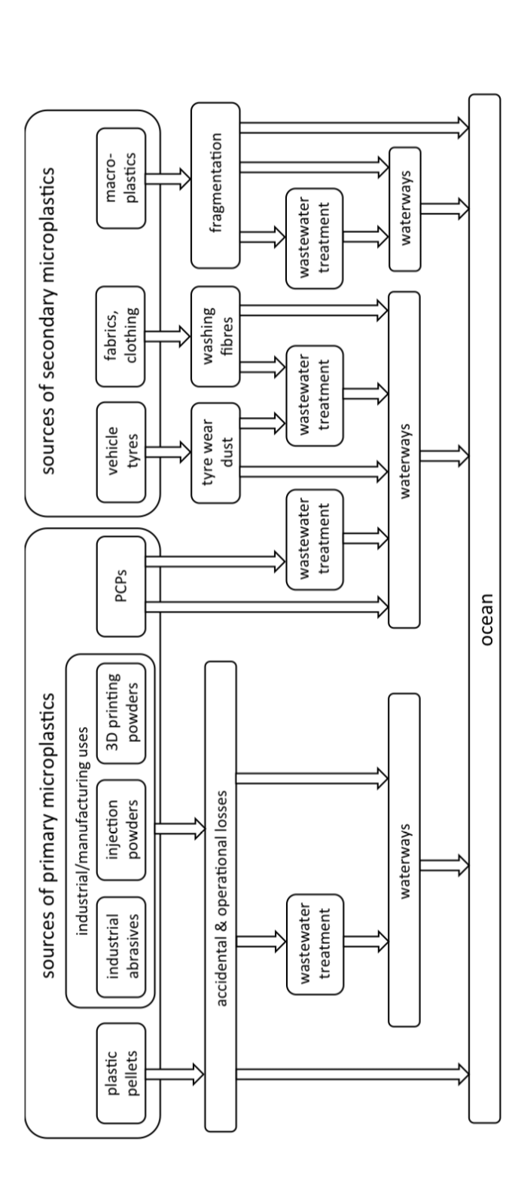

Figure.5. Primary and secondary microplastics, source/pathway to the marine environment (UNEP, 2016).

Secondary microplastics are defined as small plastic particles <5mm in diameter, that originate from larger plastic products. They originate from either, larger macroplastic debris that degrade and fragment over time to form smaller microplastics or fragments originating from synthetic fabrics and tyre dust (Auta et al., 2017).

Microplastics forming from macroplastics are due to factors such as; environmental conditions and the properties of the polymer (Auta et al., 2017; Avio et al., 2017). The factors that promote degradation or chemical breakdown (which changes material properties) of plastic polymers are caused by, physical, chemical and biological conditions such as; ultraviolet (UV)-solar photodegradation, thermal reactions and thermo-oxidation, biodegradation by microbes and hydrolysis (Andrady, 2015; UNEP, 2016). The rates of degradation in the marine environment are highly dependent on a multitude of factors with the primary factors being, physical abrasion caused by wave action and (UV)-solar photodegradation, where the rate is augmented within shoreline areas located around equatorial regions. Macroplastics that are exposed to these conditions, reduces the structural integrity of the polymer subsequently leading to fragmentation (Avio et al., 2017). The rate of biodegradation is difficult to estimate but it’s believed to be extremely slow, especially when these fragments enter the ocean as it reduces the degradative factors (Auta et al., 2017; Avio et al., 2017; UNEP, 2016; UNEP, 2014; Wang et al., 2016; Benno Meyer-Rochow et al., 2015).

As secondary microplastics originate from macroplastics (excluding fibres from synthetic fabrics and tyre dust) the main sources and pathways are considered similar. Refer to table 1 and 2 for a list of sources and pathways of macroplastics which is also highlighted as secondary microplastics in table 3.

Table.3. Land and sea based sources of microplastics to the marine environment, descriptions of primary/secondary sources, kind of waste, entry points and a qualitative importance estimate (taken from UNEP, 2016).
Sector | Primary Microplastics | Secondary Microplastics | Entry Points | Relative Importance
Tourism industry |  | Fragmented packaging, household consumer goods | Wastewater, rivers, coastal and atmospheric processes. | High
Food and drink |  | Fragmented single use packaging | Wastewater, rivers, coastal and atmospheric processes. | High
Plastic producers | Plastic resin pellets |  | Wastewater, rivers, coastal | Moderate
Retail |  | Fragmented packaging, household consumer goods | Wastewater, rivers, coastal | Moderate
Households | Personal cosmetic care products (PCCP’s) | Fragmented packaging, household consumer goods | Wastewater, rivers, coastal | Moderate
Terrestrial transportation |  | Tyre wear fragments | Wastewater, rivers | Moderate
Cleaning ships, hulls and buildings | Abrasive cleaners |  | Wastewater, rivers, coastal | Moderate
Manufacturing | Industrial abrasives, 3D printing and injection powders |  | Wastewater, rivers | Low
Plastic recyclers |  | Fragmented packaging, household consumer goods | Wastewater, rivers | Low
Construction |  | Fragmented EPS packaging | Wastewater, rivers, coastal | Low
Agriculture |  | Fragmented Pots, pipes, films and sheets | Rivers, Coastal, atmosphere | Low
Fisheries |  | Fragments and fibres from operational use of fishing gear, ropes | Coastal, marine | High
Aquaculture |  | Fragments and fibres from operational use of nets, ropes and (EPS) buoys | Coastal, marine | Moderate
Shipping | Accidental loss of plastic resin pellets |  | Coastal, marine | Moderate
Vessel based tourism | PCCP’s |  | Coastal, marine | Low

Wastewater holds a significant role in regard to the amount of microplastics that end up in the ocean. In developing countries, it is estimated that 90% of all wastewater effluent is discharged without any primary treatment. (UNEP, 2016) Coupled with the fact that these developing countries are usually the source of plastic production, subject poor waste management practices with inadequate infrastructure, are densely populated and import waste for reprocessing, highlights the complexity in managing the source of microplastics that end up in the ocean (Auta et al., 2017; Löhr et al., 2017; UNEP, 2016; Jambeck et al., 2015; Li et al., 2016).

Regardless of its source, microplastics are in the marine environment in high concentrations, where 245 tonnes of annual microplastics produced are believed to end up in the ocean and, subsequently cause degradation of marine ecosystems and marine biota (Auta et al., 2017). Some estimate that the US alone annually release 100 tonnes of microplastics into the ocean (Thompson, 2015).

Significant areas of marine litter accumulation

Plastics in the marine environment are carried and dispersed globally; at beaches and shorelines to seabed sediments and on surface waters located at the Antarctic to the Arctic and concentrate in remote locations (Auta et al., 2017). Although, it is reasonable to suggest that the highest concentrations of plastics are located within close proximity to its sources such as; urban areas and major shipping routes which had a significant increase in shoreline litter. However, the way plastic travels due to the ocean currents and the oceans mixed layer makes modelling highly complex (da Costa et al., 2016). Distribution is influenced by factors such as; density/buoyancy of plastic, location of the source/pathway and conveyance via ocean currents and waves (Auta et al., 2017).
A main feature of every major ocean globally is the formation of sub-tropical gyres. Gyres are a vortex of circular currents found within oceanic basins, sub-tropical gyres have slower currents therefore deposit materials such as plastic which causes mid ocean accumulation hotspots (UNEP, 2016). Circulation models have now confirmed that all five sub-tropical ocean gyres contain relatively high concentrations of plastic floating on the upper layer and the mixed layer depositing them in central convergence zones (da Costa et al., 2016). Refer to figure 6.
It is important to note, that it is difficult to ascertain whether, local hotspots (localised areas near urban areas and major shipping routes) are sources for the transportation of long distance plastic or, act as permeant accumulation zones (UNEP, 2016).

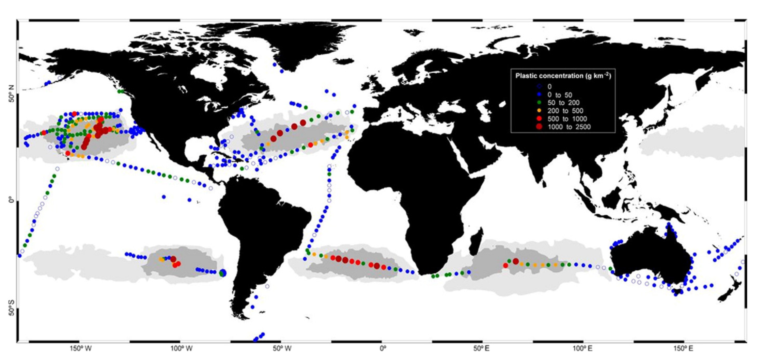
Figure.6. Surface water concentrations of plastic debris. Circles coloured show mass concentrations. Grey areas how accumulation sites (gyres) predicted by the global surface circulation model developed by Maximenko et al. Taken from (da Costa et al., 2016).

The most significant problems posed by this litter

Plastic marine litter causes a plethora of impacts from; aesthetic, socio-economic (through beach cleaning, potential impacts on human health or loss of tourism) to negative effects to marine ecology and marine ecosystems (physical impacts; entanglement, ingestion, smothering and invasive species transportation to chemical impacts; adsorption/desorption of POP’s and leachate from monomer and additives) (Li et al., 2016; Avio et al., 2017).
Refer to figure 7 and 8.

Plastics are directly responsible for 92% of all entanglement and ingestion incidents, with entanglement being the most prominent (55%) over ingestion (31%). However, entanglement incidences were the cause of more serious harm and were more frequently reported, as entanglement causes direct and visible harm (Li et al., 2016). Research into the physical effects of macroplastics through entanglement, ingestion by organisms and aesthetic issues have been widely documented, the chemical effects related to microplastics, however, are only now beginning to emerge (UNEP, 2014).

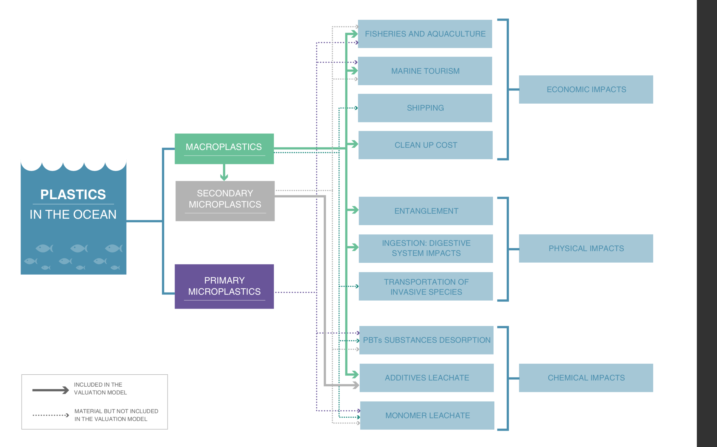
Figure.7. Impacts of macro and micro plastics (UNEP, 2014)

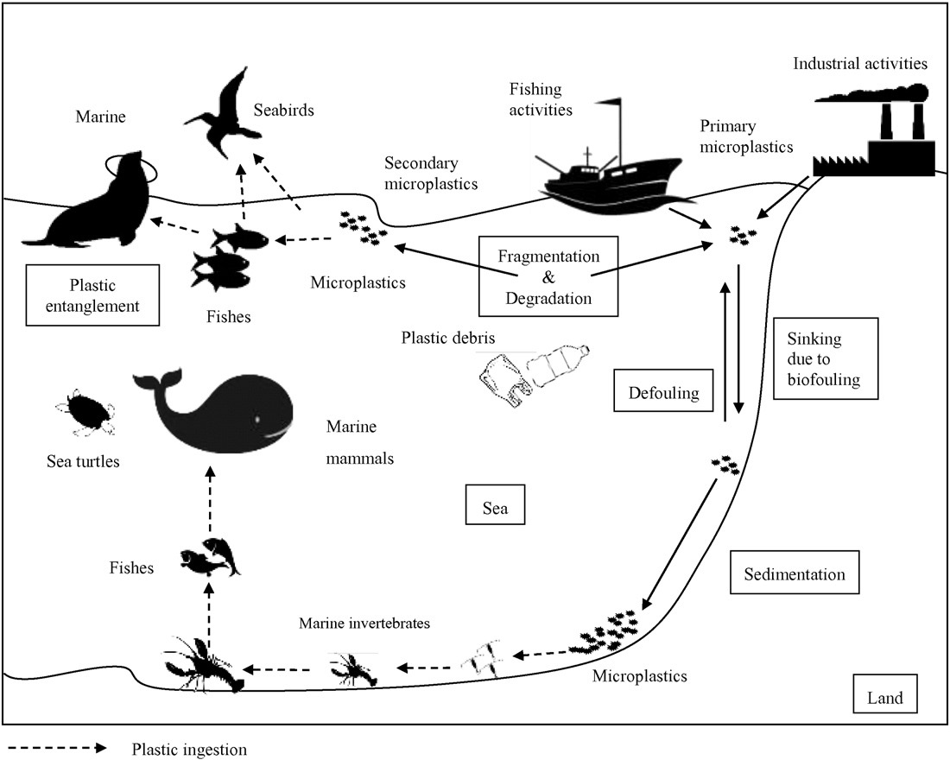
Figure.8. Source/Pathway of marine litter and biological receptors. (Li et al., 2016)

Physical impacts of macro and micro plastics.

5.1 (a) Entanglement

The most evident impact marine pollution has on marine organisms is, entanglement in discarded fishing gear and nets and plastic litter such as packing loops, which occurs all over the globe. Entanglement impede organisms to feed, avoid predators and become exhausted therefore causing them to starve or drown (Kühn et al., 2015). Marine organisms such as; sea turtles, crustaceans, mammals and seabirds are more susceptible to entanglement (Li et al., 2016). This is due to the behavioural traits of some species, for instance, sea turtles, who will use floating objects to evade predators or as foraging stations (Li et al., 2016).

There is a high percentage rate of entangled species that have been recorded among various marine organism groups. A survey conducted by Kühn et al., (2015) found that; 100% of marine turtles, 67% of seals, 31% whales and 25% of seabirds surveyed displayed signs of entanglement. This was a rise of 46% for all recorded bird + turtle + mammal species form a similar study by Laist (1997) (Kühn et al., 2015; Wang et al., 2016). This is probably due to more research conducted in this area and the growing amount of plastics produced and ending up in the marine environment. Moreover, there are many common species that receive little attention due to its perceived importance. Common fish species, invertebrates or low-key small species over a large entangled whale, for example (Kühn et al., 2015).

5.1 (b) Ingestion of plastics

Macro and microplastics cause physical impacts to marine organisms when ingested which has effected many species globally (Li et al., 2016). The effects of ingestion on marine organisms usually include; intestinal tract blockage, function of gastric enzyme secretion, feeding stimuli reduction, reduction in levels of steroid hormones, irregular ovulation and inability to reproduce (Li et al., 2016). Ingestion of plastic rarely result in instant mortality to marine organisms, however, non-lethal quantities or chronic effects result in long term problems. (Li et al., 2016) There are numerous reasons why marine organisms ingest plastic debris and the factors involved (intentional or accidental secondary ingestion) varies from species to species. (Kühn et al., 2015).

Intentional ingestion can be caused by a number of factors such as foraging, colour of plastics, age of organism. The most effected species from foraging are often omnivorous predators or filter feeders as they confuse plastic debris as prey (Kühn et al., 2015). For example, turtles mistake carrier bags for jellyfish and gull species foraging in bins and landfills (Li et al., 2016). Another factor that is believed to influence ingestion of plastic is colour, where organisms mistake plastic debris that are of a similar colour to its prey. For example, Alaskan parakeet auklets (Aethia psittacula) mainly ingested dark plastic particles where they naturally target light brown crustaceans which was correlated to mistaken food (Kühn et al., 2015). Furthermore, many studies have discovered that juvenile birds ingest higher amounts of plastic than adult birds (Li et al., 2016).

Secondary ingestion of plastic is usually caused by filter feeding organisms, such as; small crustaceans shellfish to fish and even large baleen whales. This is due to their feeding mechanism where they gather nutrition by filtering large volumes of water that contain plastic as well as their target food. Usually, non-food items can be expelled before entering the digestive system, however, this isn’t always the case (Kühn et al., 2015). Moreover, carnivorous species feeding on prey that contain plastic can cause secondary ingestion. For example, microplastics in blue fin tuna (Thunnus thynnus) are thought to be the result of blue fin tuna feeding on mesopelagic fish that contain microplastic (Li et al., 2016).

Furthermore, when macroplastics breakdown into microplastics the number of organisms that can ingest or absorbs plastic increases. It has been reported that organisms right down to the primary trophic level (phytoplankton and zooplankton) contain plastic. Which can be a pathway for plastics to enter the food chain and cause Biomagnication of POP’s to higher trophic species (Gago et al., 2016; Avio et al., 2017). Refer to figure.10.

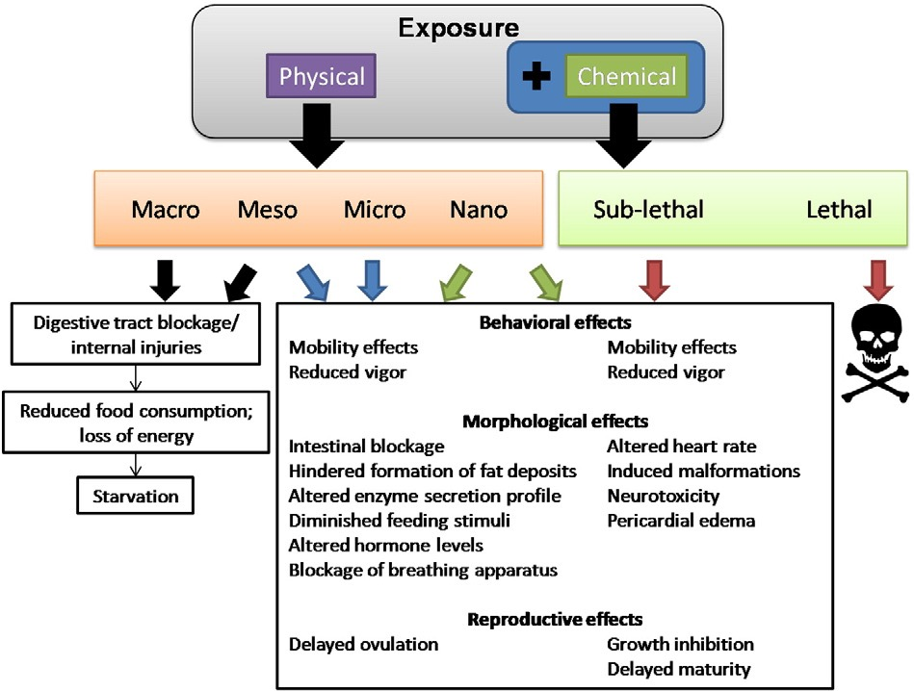
Figure.9. Physical and chemical effects to marine organisms by plastic ingestion. (da Costa et al., 2016).

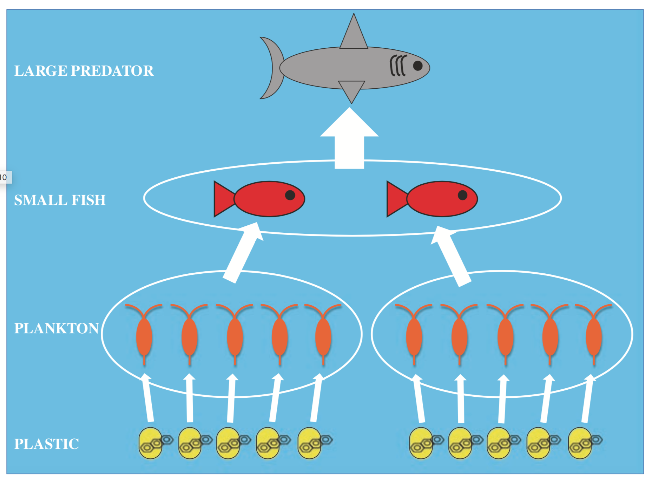
Figure 10. Biomagnication of chemicals up the food chain (Rochman, 2015).

5.1 (c) Transportation of Invasive Species

Plastic in the ocean can also contribute to the spread of invasive alien species via rafting on floating debris. These debris containing alien species can be carried long distances to other locations via ocean currents and wind, causing population growth in their new habitats and subsequently out competing native indigenous species (Kühn et al., 2015; Rech et al., 2016). There are many examples of marine biota using marine debris to travel medium and long distances. In Britain and Ireland there have been sightings of exotic molluscs and barnacles that arrived via trans-Atlantic rafting on anthropogenic marine debris. However, the actual contribution of marine debris to the spread of invasive alien species is relatively unknown. (Rech et al., 2016)

5.2 Chemical impacts of marine litter

As mentioned in section 5.1 (b) ingestion of plastic can cause physical effects, however, ingestion of plastics can also lead to chemical impacts. See figure.9. There have been numerous studies reporting that plastic marine litter can be a vector for transport and absorption of waterborne POP’s from primary to higher tropic levels (Rochman, 2015; Li et al., 2016; Auta et al., 2017). (Chemicals related to POP’s are also mentioned in section 2)

Plastics in the environment have the capability to absorb and concentrate POP’s such as; polycyclic aromatic hydrocarbons (PAHs), poly- chlorinated biphenyls (PCBs) and dichlorodiphenyltrichloroethane (DDTs) due to its hydrophobic composition (Wang et al., 2016; Li et al., 2016). This has resulted in marine organisms potentially bioaccumulating these POP’s through ingestion (Koelmans, 2015). Furthermore, plasticisers added during production can leach chemicals and cause sub-lethal effects to marine organisms (Rochman, 2015). Refer to figure.9 and 10

Moreover, contamination of human food by microplastic have been noticed. This not only consists of biotic food such as fish but have been discovered in abiotic foods such as sea salt. Therefore, microplastics can cause a pathway for human consumption of POP’s (Auta et al., 2017).

5.3 Socioeconomic impacts of marine litter

Anthropogenic marine litter can cause a multitude of socioeconomic issues, that can either increase the cost of activities connected with marine environment or reduce the economic benefits from the services it provides (Newman et al., 2015). See figure.11. for a list of socioeconomic impacts and effected sectors.

The economic impacts can be segregated into various categories;

- Economic costings due to loss of output or revenue (loss of revenue from fishing or loss of tourism income).
- Economic expenditure cost (price of clean-up operations, loss or damage to fishing gear and eventual medical costs from the effects of marine debris pollution)
- Welfare cost in economic terms (health impacts related to marine pollution and assessing the cost of loss of recreational and landscape aesthetics).

The complexity of measuring the full economic cost is very difficult due to the variety of factors involved (Newman et al., 2015). However, it is clear that marine litter burdens substantial economic impacts on a multitude of sectors that rely on the marine environment. This was reported by the UNEP, which reported a conservative annual estimate of $13 billion in financial loss due to marine ecosystem degradation by plastic debris (UN., 2014). Moreover, the polluters or producers rarely burden the cost therefore, the cost is placed on municipalities, small-scale agricultural businesses and fisheries, who operate on strict budgets (Newman et al., 2015).

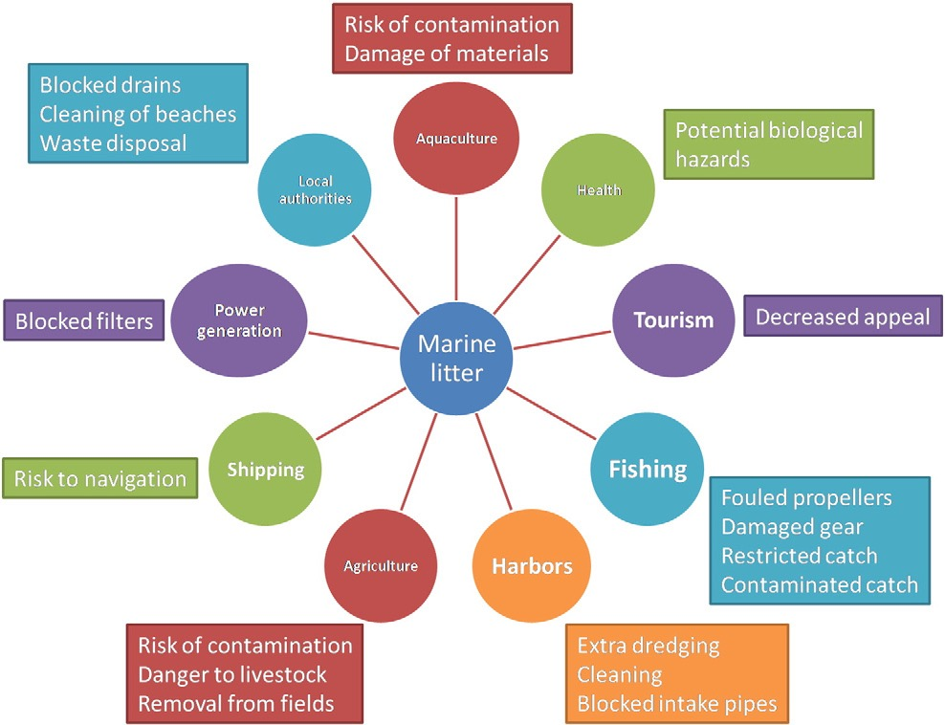
Figure.11. Socioeconomic impacts of marine litter (da Costa et al., 2016)

Recommendations for solving marine litter

The problems surrounding marine litter is multifaceted, therefore, the solutions towards solving the problem of marine litter will also need to be multifaceted. However, what is desperately needed is an urgent solution. The short-term solution will likely be better collection and waste management practices, but a more long-term solution is needed to tackle the issues surrounding marine litter (UNEP, 2016).

The long-term solution will mainly be to work towards a plastic circular economy. The basic principle of the circular economy is to move away from the conventional linier system (raw materials > production > use > non-recyclable waste) and move towards a more circular system that minimise waste by design in production. (UNEP, 2016; European Commission, 2018).

This can be better explained by the adoption of the 6 R’s;

- Reduce – raw material consumption
- Redesign – redesign products for secondary use or recycling
- Remove – unnecessary single use plastic products
- Re-use – alternative uses at end of life
- Recycle – avoid plastics being disposed
- Recover – energy from waste or re-synthesise fuel

(UNEP, 2016).

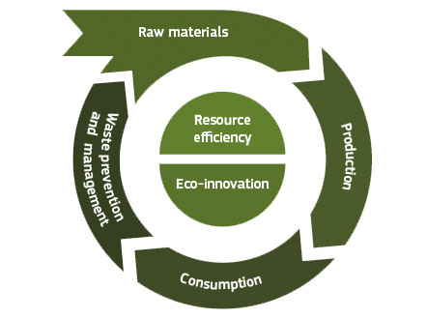

Figure. 12 conceptual model of the circular economy (European Commission, 2017).

The European Commission (EC) in December 2015 adopted a Circular Economy Action Plan (updated in January 2018) and acknowledges the need to move towards a low carbon and more circular economy. This includes a more circular plastics economy, and announced in 2017, that the commission; “will work towards all plastic packaging being recyclable by 2030”.

The new initiative aims to address plastics on three related issues;

- High dependence on virgin fossil feedstock
- Low rate of recycling and reuse of plastics
- Significant leakage of plastics into the environment

By gaining higher plastic recycling rates coupled with improved recyclates, will raise demand for secondary raw materials. Coupled with the effort to diversify feedstock will lead to greater independence for Europe in regard to, energy and resources. Moreover, will contribute towards, the climate and energy goals, jobs/growth agenda and reduce the negative environmental externalities by significantly reducing plastics entering the environment (European Commission, 2018). One of the key measures that need to be taken is to improve design for recyclability. Refer to figure 13.

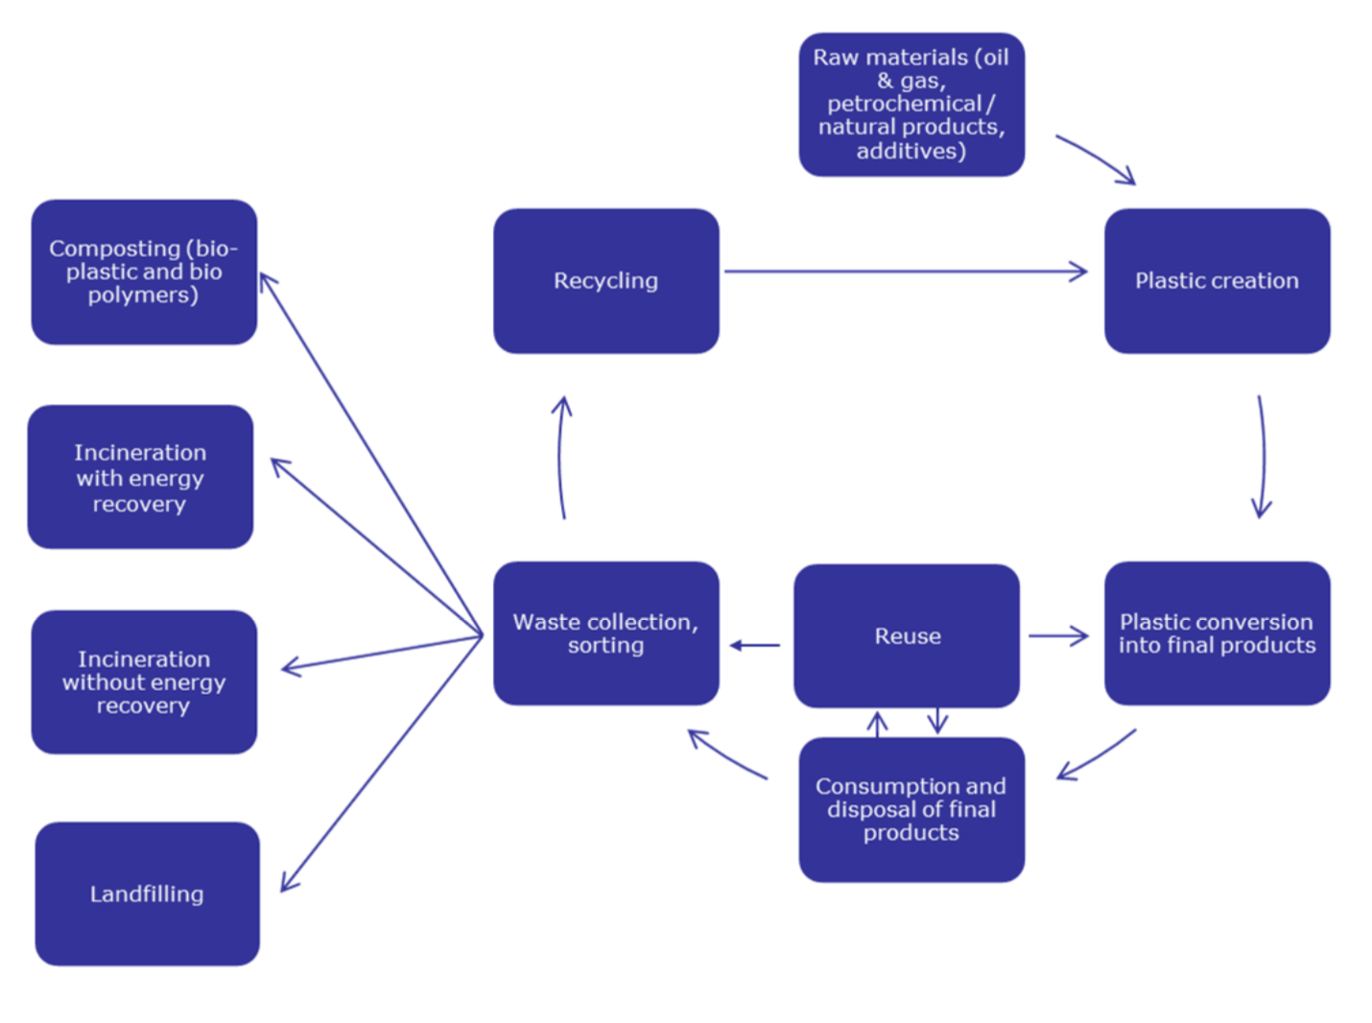
Figure.13. Circular plastic economy chain. (European Commission, 2018).

Case Study, Ecovative Design, Example of how innovation can improve single use products.

Ecoactive design is a company that uses fungal mycelium grown on raw agricultural waste that can’t be used to produce packaging material that can replace the use of polystyrene and other packaging. The benefit of using mycelium is that in its end life it can be composted and provide beneficial nutrients. The other benefits are that the process re-uses, before discarded agricultural waste and grows packaging in moulds which requires minimal processing therefore, reduces cost making the product economically viable. Ecoactive products are currently in market and has received continual growth since its inception in 2007. Ikea in 2016, announced that they plan to use Ecoactive products, as part of their commitment to be more sustainable (Ellen MacArthur foundation, 2018; Gosden, 2016).

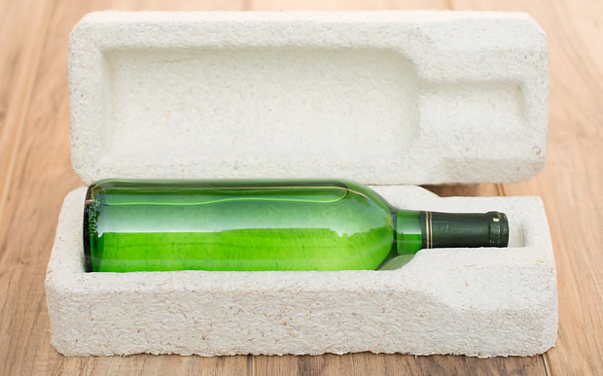

Figure.14. Example of packaging by Ecoactive (Gosden, 2016).

Bioremediation.

An emerging and promising approach to tackling plastics is the utilisation of microbes that possess the ability to breakdown plastic polymers amongst other Xenobiotic compounds, where they use these compounds as a carbon and energy source (Auta et al., 2017; Trivedi et al., 2016). Microbes hold the ability to adapt to all unfavourable environmental conditions including wastewater, where these microbes could be used in current water treatment facilities to remove plastic polymers and other Xenobiotic compounds. (Auta et al., 2017).

Conclusion

There is no doubt that plastic holds a significant role in a modern society and it is illogical to suggest that we can just simply stop using it. However, the impacts caused by plastics cannot be ignored. When plastic enters the ocean, it causes a plethora of issues; physical and chemical to marine biota and humans. The complexity of sources/pathways and behaviour (degradation/buoyancy) of marine litter in the ocean coupled with the complexity of oceanic currents, further adds to the complexity of the issue.

Therefore, strategies to solve the issue will need to be a, long-term, multi-pronged, collaborative effort involving; governments, governmental organisations, NGO’s, producers, manufactures, businesses, waste operators and citizen participation, through; legalisation, policies, incentives, education and infrastructure investment. Such as; uniformity of plastics and innovation to facilitate towards a circular economy, reduction of waste through waste management strategies, extended producer responsibility, citizen participation and engagement, consumer pressure on businesses and retailers as well as policies that promotes the move away from single use products.

Moreover, the developed nations need to be the global leaders in the management of waste and set a precedent for developing nations to follow. Working towards a more circular economy will reduce imports (production) and exports (waste) to these nations and subsequently reduce the associated environmental impacts.

References

Andrady A.L. (2015) Persistence of Plastic Litter in the Oceans. In: Bergmann M., Gutow L., Klages M. (eds) Marine Anthropogenic Litter. Springer, Cham, pp 57-72

Auta, H., Emenike, C. and Fauziah, S. (2017). Distribution and importance of microplastics in the marine environment: A review of the sources, fate, effects, and potential solutions. Environment International, 102, pp.165-176.

Avio, C., Gorbi, S. and Regoli, F. (2017). Plastics and microplastics in the oceans: From emerging pollutants to emerged threat. Marine Environmental Research, 128, pp.2-11.

Axelsson, C. and van Sebille, E. (2017). Prevention through policy: Urban macroplastic leakages to the marine environment during extreme rainfall events. Marine Pollution Bulletin, 124(1), pp.211-227.

Barboza, L. and Gimenez, B. (2015). Microplastics in the marine environment: Current trends and future perspectives. Marine Pollution Bulletin, 97(1-2), pp.5-12.

Benno Meyer-Rochow, V., Valérie Gross, J., Steffany, F., Zeuss, D. and Erren, T. (2015). Commentary: Plastic ocean and the cancer connection: 7 questions and answers. Environmental Research, 142, pp.575-578.

Carrington, D. (2018). Plastic microbeads ban enters force in UK. The Guardian. [online] Available at: https://www.theguardian.com/environment/2018/jan/09/plastic-microbeads-ban-enters-force-in-uk [Accessed 12 Jan. 2018].

DAERA. (2018). Northern Ireland carrier bag levy annual statistics 2015/16 released. [online] Available at: https://www.daera-ni.gov.uk/news/northern-ireland-carrier-bag-levy-annual-statistics-201516-released [Accessed 12 Jan. 2018].

da Costa, J., Santos, P., Duarte, A. and Rocha-Santos, T. (2016). (Nano)plastics in the environment – Sources, fates and effects. Science of The Total Environment, 566-567, pp.15-26.

Ellen MacArthur foundation. (2018). Growing alternatives to petroleum-based packaging. [online] Available at: https://www.ellenmacarthurfoundation.org/case-studies/growing-alternatives-to-petroleum-based-packaging [Accessed 24 Jan. 2018].

European Commission. (2017). Marine litter - GES - Environment - European Commission. [online] Available at: http://ec.europa.eu/environment/marine/good-environmental-status/descriptor-10/index_en.htm [Accessed 2 January. 2018].

European Commission. (2017). The Circular Economy tools and instruments - Environment - European Commission. [online] Available at: http://ec.europa.eu/environment/green-growth/tools-instruments/index_en.htm [Accessed 16 Jan. 2018].

European Commission. (2018). Communication from The Commission to The European Parliament, The Council, The European Economic and Social Committee and The Committee of The Regions. A European Strategy for Plastics in a Circular Economy. COM/2018/028 final

Gago, J., Galgani, F., Maes, T. and Thompson, R. (2016). Microplastics in Seawater: Recommendations from the Marine Strategy Framework Directive Implementation Process. Frontiers in Marine Science, 3.

Gosden, E. (2016). Ikea plans mushroom-based packaging as eco-friendly replacement for polystyrene. The Telegraph. [online] Available at: http://www.telegraph.co.uk/news/earth/businessandecology/recycling/12172439/Ikea-plans-mushroom-based-packaging-as-eco-friendly-replacement-for-polystyrene.html [Accessed 24 Jan. 2018].

HM Government. (2018) A Green Future: Our 25 Year Plan to Improve the Environment. London: HM Government, pp.128.

Jambeck, J., Geyer, R., Wilcox, C., Siegler, T., Perryman, M., Andrady, A., Narayan, R. and Law, K. (2015). Plastic waste inputs from land into the ocean. Science, 347(6223), pp.768-771.

Koelmans A.A. (2015) Modeling the Role of Microplastics in Bioaccumulation of Organic Chemicals to Marine Aquatic Organisms. A Critical Review. In: Bergmann M., Gutow L., Klages M. (eds) Marine Anthropogenic Litter. Springer, Cham, pp.309-324.

Kühn S., Bravo Rebolledo E.L., van Franeker J.A. (2015) Deleterious Effects of Litter on Marine Life. In: Bergmann M., Gutow L., Klages M. (eds) Marine Anthropogenic Litter. Springer, Cham, pp.75-116.

Laville, S. (2017). Chinese ban on plastic waste imports could see UK pollution rise. The Guardian. [online] Available at: https://www.theguardian.com/environment/2017/dec/07/chinese-ban-on-plastic-waste-imports-could-see-uk-pollution-rise [Accessed 17 Jan. 2018].

Lehner, R. (2015). Macro-, Meso-, Micro-, but What About Nanoplastic? - Planet Experts. [online] Planet Experts. Available at: http://www.planetexperts.com/macro-meso-micro-but-what-about-nanoplastic/ [Accessed 17 Jan. 2018].

Li, W., TSE, H. and FOK, L. (2016). Plastic waste in the marine environment: A review of sources, occurrence and effects. Science of The Total Environment, 566-567, pp.333-349.

Löhr, A., Savelli, H., Beunen, R., Kalz, M., Ragas, A. and Van Belleghem, F. (2017). Solutions for global marine litter pollution. Current Opinion in Environmental Sustainability, 28, pp.90-99.

Newman S., Watkins E., Farmer A., Brink P.., Schweitzer JP. (2015) The Economics of Marine Litter. In: Bergmann M., Gutow L., Klages M. (eds) Marine Anthropogenic Litter. Springer, Cham, pp.367-394.

OSPAR Commission. (2018). Marine Litter | OSPAR Commission. [online] Available at: https://www.ospar.org/work-areas/eiha/marine-litter [Accessed 2 Jan. 2018].

Prevenios, M., Zeri, C., Tsangaris, C., Liubartseva, S., Fakiris, E. and Papatheodorou, G. (2017). Beach litter dynamics on Mediterranean coasts: Distinguishing sources and pathways. Marine Pollution Bulletin.

Rech, S., Borrell, Y. and García-Vazquez, E. (2016). Marine litter as a vector for non-native species: What we need to know. Marine Pollution Bulletin, 113(1-2), pp.40-43.

Rochman C.M. (2015) The Complex Mixture, Fate and Toxicity of Chemicals Associated with Plastic Debris in the Marine Environment. In: Bergmann M., Gutow L., Klages M. (eds) Marine Anthropogenic Litter. Springer, Cham, pp.117-140.

Scottish Government. (2018). Carrier bag charge - mygov.scot. [online] Available at: https://www.mygov.scot/carrier-bag-charge/ [Accessed 12 Jan. 2018].

Thompson R.C. (2015) Microplastics in the Marine Environment: Sources, Consequences and Solutions. In: Bergmann M., Gutow L., Klages M. (eds) Marine Anthropogenic Litter. Springer, Cham, pp.185-200

Thompson, R., Olsen, Y., Mitchell, R., Davis, A., Rowland, S., John, A., McGonigle, D. and Russell, A. (2004). Lost at Sea: Where Is All the Plastic?. Science, 304(5672), pp.838-838.

Trivedi, P., Hasan, A., Akhtar, S., Siddiqui, M., Sayeed, U., Kalim, M. and Khan, A. (2016). Role of microbes in degradation of synthetic plastics and manufacture of bioplastics. Journal of Chemical and Pharmaceutical Research, 8(3), pp.211-216.

UN. (2014). UN News - Plastic waste causes $13 billion in annual damage to marine ecosystems, says UN agency. [online] Available at: http://www.un.org/apps/news/story.asp?NewsID=48113#.WlOBIbZ0chs [Accessed 8 Jan. 2018].

UNEP (2014). Valuing Plastic. The Business Case for Measuring, Managing and Disclosing Plastic Use in the Consumer Goods Industry. Nirobi: UNEP, pp.1-116.

UNEP (2016) Marine plastic debris and microplastics – Global lessons and research to inspire action and guide policy change. United Nations Environment Programme, Nairobi, pp.1-179.

Wang, J., Tan, Z., Peng, J., Qiu, Q. and Li, M. (2016). The behaviors of microplastics in the marine environment. Marine Environmental Research, 113, pp.7-17.

Water UCI (2017). Plastic Ocean Art Exhibit. [image] Available at: http://water.uci.edu/event/plastic-ocean-art-exhibit-3/ [Accessed 22 Jan. 2018].

Welsh Government. (2018). Carrier bag charge Wales|Retailers. [online] Available at: http://www.carrierbagchargewales.gov.uk/retailers/?lang=en [Accessed 12 Jan. 2018].

Appendix

Appendix 1. Waste estimates for 2010 for the top 20 countries ranked by mass of mismanaged plastic waste (in units of millions of metric tons per year) (Jambeck et al., 2015)



