  IBC Challenges  business communication between Mexico and the United Kingdom | Jie Gong  International Business Communication (BMBM6021

Executive Summary
The global rise in international trade and economic globalization has spurred increased business activities among individuals from diverse cultural backgrounds. Consequently, cross-cultural business negotiations have become a focal point in international business operations. Business negotiation, involving two parties in economic and trade cooperation, aims to establish transactional agreements or resolve disputes. Effective communication is recognized as a crucial element for multinational corporations to operate successfully at various levels. This editorial explores the business cultures of Mexico and the United Kingdom, emphasizing the significance of cross-cultural business communication in the context of global business relations. It identifies key situations requiring effective communication in international business and delves into the reasons for communication failures, emphasizing the impact of cultural differences and language barriers. The editorial concludes by presenting strategies to overcome communication failures, including language and cultural considerations, the adaptation theory in negotiations, and the importance of establishing genuine relationships and mutual respect in cross-cultural business cooperation. Overall, successful international business communication necessitates a comprehensive understanding of language, culture, time, teams, and enterprises to build trust, understanding, and effective cooperative relationships, thereby overcoming potential communication barriers and improving the success rate of business negotiations.

Content Page

Executive Summary 1
1.0 – Introduction 3
2.0 – Main Findings 4
1. The situation of IBC 4
2.Different situations that require effective communication in international business 5
3.Communication failure 6
● Reasons for the communication failure 6
● What is the effect of a failed communication is？ 11
4. Strategies to overcome these failures 12
● On Language and Culture 12
● Adaptation theory 13
● In business communication 14
3.0 – Conclusions 15
4.0 – Recommendations 16
References 17

- – Introduction

With the increase of international trade and economic globalization has led to an increase in business activities between individuals from diverse cultural backgrounds. As a result, cross-cultural business negotiations have gained significant attention. Business negotiation involves two parties engaged in economic and trade cooperation to reach a transactional agreement or resolve a dispute. Effective communication is crucial for multinational corporations to exchange knowledge, develop relationships, negotiate deals, and build partnerships (Szkudlarek et al., 2020; Barner-Rasmussen et al., 2014; Griffith et al., 2002). It can benefit the company's development and create more business opportunities. This editorial discusses and analyses the business cultures of Mexico and the United Kingdom, highlighting the importance of cross-cultural business communication in the context of global business relations. It also identifies areas that require attention when dealing with multinational companies, as well as reasons for business communication failures and their solutions.

2.0 – Main Findings
- The situation of IBC
Due to the rise in international trade and economic globalisation, business negotiations between individuals from diverse cultural backgrounds are becoming more common. As a result, intercultural business negotiations are now a crucial aspect of most international business operations(Szkudlarek, B. et al. 2020) ---communication plays a crucial role in exchanging knowledge, developing and maintaining relationships, negotiating transactions, and building and maintaining partnerships.Effective communication is widely acknowledged as a crucial element for multinational corporations (MNCs) to operate successfully at interpersonal, team, and organizational levels (Barner-Rasmussen et al., 2014; Bstieler and Hemmert, 2008; De Vries et al., 2010; Griffith et al., 2002; Matveev and Nelson, 2004; Piekkari and Zander, 2005; Zander, 2005). Business negotiation is a consultative activity between two parties in economic and trade co-operation for the purpose of reaching a certain transaction or resolving a certain dispute. Effective and successful business negotiation will benefit the company's growth and bring more business opportunities. Although related fields such as language (e.g. Tenzer et al., 2017; Tietze and Piekkari, 2020) or knowledge transfer (Gaur et al., 2019; Yildiz, 2020) have established systematic bodies of knowledge, little attention has been paid to the significance of interpersonal communication, which is fundamental to any business activity. This editorial considers the current state of affairs in this area and highlights the areas that require attention when conducting business with companies in other countries.

2.Different situations that require effective communication in international business
- Cross-cultural communication: In international business, it is crucial to communicate effectively with people from diverse cultural backgrounds. Cultural differences, such as attitudes towards time, etiquette, and expression, must be taken into account to ensure successful cross-cultural communication.
- Cross-language communication: In international business, you may need to communicate with people whose mother tongue is different, so you need to ensure the accuracy and clarity of the language, and at the same time, you can make use of translation tools or hire a translator to help communication.
- Cross-geographical communication: In international business, it may be necessary to communicate remotely, such as by telephone, video conferencing, etc., so it is necessary to pay attention to the time difference, signal stability and other factors to ensure that the communication is carried out smoothly.
- Cross-team communication: In international business, it may be necessary to communicate with people from different teams, such as sales team, marketing team, production team, etc. Therefore, it is necessary to ensure the timeliness and accuracy of the information, as well as to have good collaboration ability to ensure the smooth progress of cooperation between teams.
- Cross-company communication: In international business, it may be necessary to communicate with other companies, such as cooperation, competition and other aspects of communication, so it is necessary to pay attention to the corporate image and brand image to ensure the professionalism and effectiveness of communication.

3.Communication failure
- Reasons for the communication failure
Communication failures that may occur in international exchanges are due to language barriers, cultural differences, and signal interference. Language barriers may lead to the inability of both parties to understand each other's meaning, cultural differences may lead to misunderstanding or conflict, and signal interference may lead to unclear transmission of information. The following are analyzed from several aspects
- Culture and language
Culture has a significant impact on language and communication. Each language offers tools to establish and dissolve relationships, but various cultures utilise these tools differently. When communicating with colleagues in a global business environment, it is important to consider the social and cultural aspects of language. This can help us better understand situations where someone may appear to be negligent or deliberately disrespectful, when in fact they are simply following their own cultural norms. For instance, communicating indirectly may help maintain good relationships, but it can be challenging for a cross-cultural audience. Conversely, being too direct can hinder relationship-building by disregarding cultural norms.（Elizabeth Keating，et al. 2016）
Another Example: Cultural differences in vocabulary
Vocabulary is the main basic unit of language. Lexical meanings can be divided into "conceptual meanings" and "implicit meanings". The former is more circumscribed and is usually the meaning given in the dictionary. The connotative meaning of a word refers to its extended and associative meanings. It is an important carrier of different cultures and can be a significant barrier to intercultural communication. The same vocabulary may have different meanings in different cultures. Therefore, it is crucial to understand the socio-cultural meaning of vocabulary in business activities.
Example 1: General Motors sells cars in Mexico under the name NAVO, but this name is not suitable for a car as it means 'it doesn't go' in Spanish. As a result, the company failed miserably in the Mexican car market.（Hu W，2008）
According to the above and cases, we need to pay attention to the differences in language culture in business communication with a Mexican company. Otherwise it may lead to bad results

2.The ences in culture and business customs
The UK and Mexico are very different in terms of culture and business practices and we will refer to the cultural dimensions of Hofstede and Trompenaars for comparison.
Since Hofstede's (1980) work, cultural dimensions have become a major reference point for implementing cultural and comparative communication models (Merkin et al., 2014). As shown in the figure（1）, according to Hofstede's cultural dimensions, the UK has a higher level of uncertainty avoidance. This means that the British are more inclined to follow rules and regulations and prefer clear plans and arrangements. In contrast, Mexico scores lower on this dimension, as Mexicans tend to be more comfortable with uncertainty and prioritize flexibility and improvisation.
The United Kingdom and Mexico differ in their approach to rights distance. The UK values equal distribution of rights and places less emphasis on authority and hierarchy, instead prioritising individual performance and achievement. In contrast, Mexico places greater importance on social status and class, and respects authority and hierarchy.
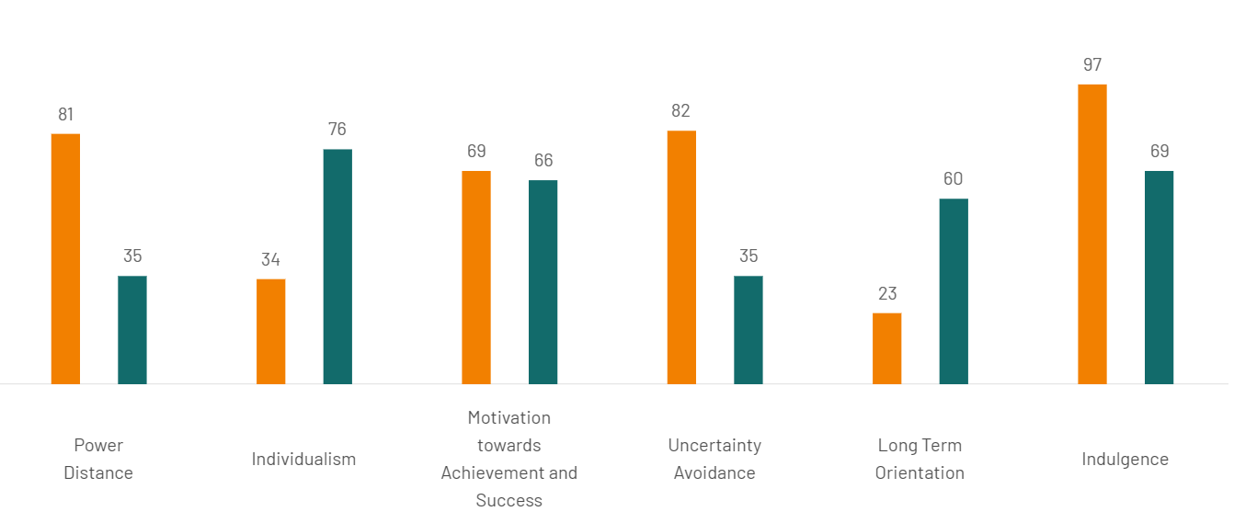
Figure（1）
Country comparison tool (no date) Hofstede Insights. Available at: https://www.hofstede-insights.com/country-comparison-tool?countries=mexico%2Cunited%2Bkingdom (Accessed: 3 January 2024).

According to Trompenaars' (1993) cultural dimension, the UK is more individualistic and independent, prioritising individual freedom, self-actualisation, and personal achievement. In contrast, Mexico is more collectivist and teamwork-oriented, prioritising group interests and collective responsibility.
Regarding attitudes towards time, the UK prioritises timely and efficient completion of work, emphasising time management and punctuality for appointments. In contrast, Mexico is more flexible and relaxed in this regard, placing less importance on punctuality and being more willing to adapt to changing circumstances（Hofestede，G，1996）.
Upon comparing the cultural dimension models of the two scholars, it is evident that there are significant differences between the UK and Mexico in terms of individualism and collectivism, power distance, and uncertainty avoidance. When conducting business between the two countries, it is crucial to comprehend and respect the cultural differences that may impact communication styles, decision-making, and relationship building in business environments.

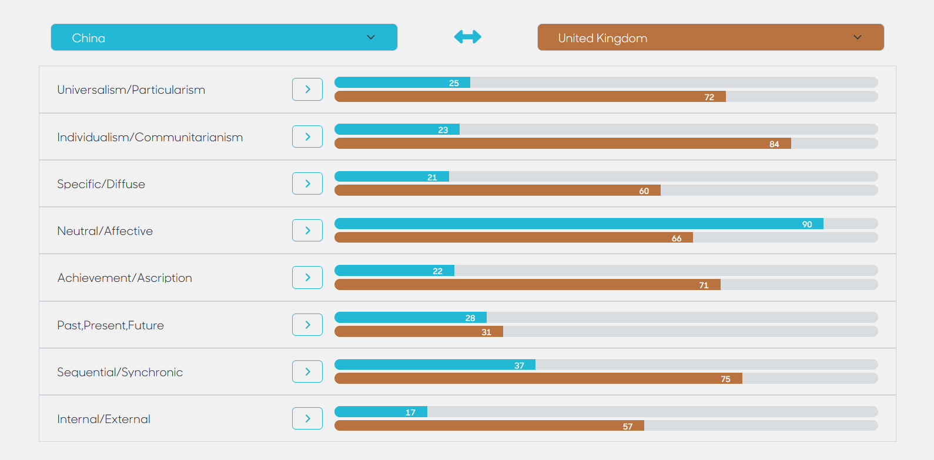
Figure（2）
Compare countries (2023) Trompenaars Hampden-Turner. Available at: https://www.thtconsulting.com/culture-factory/culture-explore/compare-countries/ (Accessed: 03 January 2024).

3.Different communication styles —— high and low context
Hall's concept of high and low context distinguishes Mexico as a high context culture and the United Kingdom as a low context culture. As a result, there are differences between Mexican and British business cultures.
In Mexican business situations, non-verbal communication is more warm and intimate than in other cultures. Physical contact such as hugging, kissing, and patting is common and is seen as a way of expressing friendliness and closeness. This is because Mexican business culture places emphasis on personal relationships and emotional connections, not just business transactions. In British business culture, people tend to maintain a certain distance and politeness, with less physical contact. On the other hand, in Mexican business situations, non-verbal communication is more direct and expressive. Mexicans tend to express their opinions and emotions directly, and they may use gestures, facial expressions, and voice changes to emphasize their points. In British business culture, there is a greater emphasis on remaining calm and restrained. People tend to use more discreet and indirect ways to express their opinions. Additionally, the Mexican business culture is relatively more flexible in its concept of time. Mexicans may prioritize relationships and socializing, and business meetings may start late or have longer conversations. In contrast, British business culture places a greater emphasis on punctuality and efficiency, with meetings typically adhering to a predetermined timetable. （OLIVIA HERNANDEZ-POZAS,et al. 2020)While there are some differences between Mexican and British business cultures in terms of non-verbal communication styles, directness, and perception of time, it is important to note that both cultures have their own unique strengths and challenges. It is crucial to comprehend and acknowledge these differences when conducting business in Mexico. Neglecting to do so may result in unsuccessful international business communications with Mexico, particularly if the differences in negotiation styles are not acknowledged and conflicts arise during the negotiation process.

- What is the effect of a failed communication is
In business, communication breakdowns can have a negative impact on relationships. Firstly, ineffective communication can damage trust between parties, as it may cause doubt in the partner's integrity and ability. Secondly, misunderstandings and conflicts can arise, which can affect the cooperation process and even lead to the termination of the relationship. In addition, a lack of communication can result in inefficiencies and increased costs, as more time and resources are required to rectify the issues caused by miscommunication. Generally, communication breakdowns can significantly impact business relationships and hinder cooperation. For instance, as seen in the example of the Mexican automobile market mentioned above, it can lead to unsatisfactory sales （a lack of optimism in the market）.

4. Strategies to overcome these failures
According to the above mentioned business communication failures, we can solve them through the following strategies
- On Language and Culture
Cross-cultural business communication often faces challenges related to language translation and misunderstandings. Mexicans may face difficulties expressing their opinions and ideas clearly in meetings or understanding our requirements and expectations due to their lack of fluency in English. To improve language communication effectiveness, we can take the following measures:
1.Before engaging in business communication, both parties can receive language and cultural training to better understand each other's backgrounds and facilitate mutual understanding of opinions and ideas.
2.During the meeting, it is important to use clear and concise language, avoiding excessive jargon and complex sentence structures, to ensure effective communication and understanding of each other's perspectives.
3.In business communication, both sides must be patient and understanding, and at the same time strive to overcome the language and cultural barriers. At the same time, given the high context of Mexico, we can choose to appropriately add some body language in the negotiation process, which is in line with the adaptation theory I am going to discuss next. In order to achieve successful cooperation, we can properly adapt to the business culture and habits of the other side
4.Because of the Mexican pay more attention to feelings, we can carry out basic greetings and exchanges with the staff of the other company before the negotiation, which is used to pull into the feelings of both sides
- Adaptation theory
Another approach to analysing language in business negotiation is through the theory of conformity, proposed by Verschueren. Conformity emphasises that language use involves making choices to meet communication needs. Cross-cultural business negotiation is a form of communication that achieves its purpose through language use. Therefore, studying it from the perspective of conformity theory is both reasonable and effective. During cross-cultural business negotiations, cultural differences between negotiators, such as varying religious beliefs, values, and modes of thinking, can often result in language and cultural negative transfer. This can lead to negotiation errors. To ensure clear and objective communication, it is important to use value-neutral language and avoid biased, emotional, figurative, or ornamental language. Furthermore, it is recommended to use a passive tone and impersonal construction, avoiding the use of first-person perspectives unless absolutely necessary.To achieve successful cross-cultural business negotiations, it is crucial for both parties to adapt to the communicative context. It is important to use subject-specific vocabulary when it conveys the meaning more precisely than a similar non-technical term. This includes language use, physical environment, social environment, and psychological environment. The success or failure of such negotiations depends on this adaptation. When negotiating, it is important to consider all four components of the communicative context in order to achieve success.
- In business communication,
it is important for both parties to respect each other's culture and traditions to avoid cultural conflicts and misunderstandings.
When cooperating in business between the UK and Mexico, it is crucial to establish a foundation of genuine relationships and mutual respect. This is because Mexico's business culture places great emphasis on personal relationships and emotional connections, not just business transactions. In Mexico, building trust and friendly relationships is emphasised, with a focus on learning about each other's families, lives and backgrounds. This kind of interpersonal relationship can help establish trust and mutual respect between partners, promoting the smooth progress of cooperation. Establishing a foundation of real human relationships and respect is also crucial for cross-cultural cooperation. Cultural differences can lead to misunderstandings and conflicts due to variations in language, values, and communication styles. To reduce these barriers, it is important to establish authentic human relationships and mutual respect. This can increase mutual understanding and trust, promoting effective communication and cooperation between partners and improving the success rate of cooperation. Establishing authentic relationships and mutual respect is crucial for promoting cross-cultural collaboration in business between the UK and Mexico. This can foster trust, enhance mutual understanding, and mitigate cultural barriers, thereby facilitating seamless cooperation.

3.0 – Conclusions
In general, a successful international business communication requires full consideration of language, culture, time, team, enterprise and other factors to build trust, understanding and effective cooperation relationship. By understanding cultural differences, respecting each other, and coping flexibly in communication, we can effectively overcome potential communication barriers and improve the success rate of business negotiation.

4.0 – Recommendations

1. Language and Cultural Training:
Preparation: Before engaging in business communication, both parties should undergo comprehensive language and cultural training to understand each other's backgrounds better.

2. Clear and Concise Communication:*
Avoid Jargon: Use clear and concise language during meetings, avoiding excessive jargon and complex sentence structures and enhance effectiveness by ensuring that communication is easily understandable, facilitating a shared understanding of perspectives.

3. Patience and Adaptation:
Cultural Adaptation: Acknowledge the high-context nature of Mexican culture and adapt communication styles accordingly.
Body Language: Integrate appropriate body language, aligning with the adaptation theory, to convey messages effectively and build rapport.

4. Recognition of Emotional Focus:
Basic Greetings and Exchanges: Recognize the importance of feelings in Mexican culture by initiating basic greetings and exchanges before negotiations.
-Emotional Connection: Building a personal connection helps create a positive atmosphere and establishes an emotional link between parties.

6. Respect for Culture and Traditions:
-Foundation of Genuine Relationships: Emphasize the establishment of genuine relationships and mutual respect when cooperating between the UK and Mexico.
-Cultural Emphasis: Recognize the importance of group connections in Mexico's business culture, going beyond mere transactions.

Implementing these recommendations will contribute to fostering a positive cross-cultural business environment, reducing communication barriers, and enhancing the success of international business collaborations, particularly between the UK and Mexico.

References

Barner-Rasmussen, W. et al. (2014) ‘Cultural and language skills as resources for boundary spanning within the MNC’, Journal of International Business Studies, 45(7), pp. 886–905. doi:10.1057/jibs.2014.7.
Bstieler, L. and Hemmert, M. (2008) ‘Developing trust in vertical product development partnerships: A comparison of South Korea and Austria’, Journal of World Business, 43(1), pp. 35–46. doi:10.1016/j.jwb.2007.10.001.
Compare countries (2023) Trompenaars Hampden-Turner. Available at: https://www.thtconsulting.com/culture-factory/culture-explore/compare-countries/ (Accessed: 03 January 2024).
Country comparison tool (no date) Hofstede Insights. Available at: https://www.hofstede-insights.com/country-comparison-tool?countries=mexico%2Cunited%2Bkingdom (Accessed: 3 January 2024).
de Vries, R.E., Bakker-Pieper, A. and Oostenveld, W. (2009) ‘Leadership = communication? the relations of leaders’ communication styles with leadership styles, knowledge sharing and leadership outcomes’, Journal of Business and Psychology, 25(3), pp. 367–380. doi:10.1007/s10869-009-9140-2.
Gaur, A.S., Ma, H. and Ge, B. (2019) ‘MNC strategy, knowledge transfer context and knowledge flow in mnes’, SSRN Electronic Journal [Preprint]. doi:10.2139/ssrn.3368627.
Griffith, D.A. (2002) ‘The role of communication competencies in International Business Relationship Development’, Journal of World Business, 37(4), pp. 256–265. doi:10.1016/s1090-9516(02)00092-5.
Griffith, D.A., Hu, M.Y. and Ryans, J.K. (2000) ‘Process standardization across intra- and inter-cultural relationships’, Journal of International Business Studies, 31(2), pp. 303–324. doi:10.1057/palgrave.jibs.8490908.
Hofstede, G. (1996) ‘Riding the waves of commerce: A test of trompenaars’ “model” of national culture differences’, International Journal of Intercultural Relations, 20(2), pp. 189–198. doi:10.1016/0147-1767(96)00003-x.
Hu, W. (2008) ‘The understanding of cross-cultural conflict in international business is based on the analysis of failed business cases’, Modernization of shopping malls, 1(1), pp. 68–69. doi:https://www.doc88.com/p-0746148637131.html?r=1.
Keating, E.L. and Jarvenpaa, S.L. (2016) Words matter: Communicating effectively in the new global office. Oakland, CA: University of California Press.
Matveev, A.V. and Nelson, P.E. (2004) ‘Cross Cultural Communication Competence and multicultural team performance’, International Journal of Cross Cultural Management, 4(2), pp. 253–270. doi:10.1177/1470595804044752.
Merkin, R., Taras, V. and Steel, P. (2014) ‘State of the art themes in cross-cultural communication research: A systematic and Meta-Analytic Review’, International Journal of Intercultural Relations, 38, pp. 1–23. doi:10.1016/j.ijintrel.2013.10.004.
PIEKKARI, R. and ZANDER, L. (2005) ‘Preface : Language and communication in international management’, International Studies of Management &amp; Organization, 35(1), pp. 3–9. doi:10.1080/00208825.2005.11043726.
Tenzer, H., Terjesen, S. and Harzing, A.-W. (2017a) ‘Language in international business: A review and agenda for future research’, Management International Review, 57(6), pp. 815–854. doi:10.1007/s11575-017-0319-x.
Tenzer, H., Terjesen, S. and Harzing, A.-W. (2017b) ‘Language in international business: A review and agenda for future research’, Management International Review, 57(6), pp. 815–854. doi:10.1007/s11575-017-0319-x.
Tietze, S. and Piekkari, R. (2020a) ‘Languages and cross-cultural management’, The SAGE Handbook of Contemporary Cross-Cultural Management, pp. 180–195. doi:10.4135/9781529714340.n15.
Tietze, S. and Piekkari, R. (2020b) ‘Languages and cross-cultural management’, The SAGE Handbook of Contemporary Cross-Cultural Management, pp. 180–195. doi:10.4135/9781529714340.n15.
Yildiz, H.E. (2020) ‘Cross-cultural issues in knowledge management: A multi-discourse review’, The SAGE Handbook of Contemporary Cross-Cultural Management, pp. 196–211. doi:10.4135/9781529714340.n16.
ZANDER, L. (2005) ‘Communication and Country Clusters : A Study of language and leadership preferences’, International Studies of Management &amp; Organization, 35(1), pp. 83–103. doi:10.1080/00208825.2005.11043727.
‘Mexican nonverbal communication’: (2020) The Seven Keys to Communicating in Mexico, pp. 149–174. doi:10.2307/j.ctvswx8wb.12.
‘Review article : Geert Hofstede: Culture’s consequences: International differences in work related values’ (1983) Organization Studies, 4(4), pp. 390–391. doi:10.1177/017084068300400409.
‘Riding the waves of culture: Understanding cultural diversity in business’ (1993) Long Range Planning, 26(5), p. 153. doi:10.1016/0024-6301(93)90118-y.

