

Critical Literature Review for Doctoral Research

PART 1&2

By Jiyu Zhang
(Student ID: 2321392)

Module Name: Critical Literature Review for Doctoral Research (LCDB7009)
Module Lead: Steve Griffiths

June 2024

Contents
Part 1 3
Introduction: 3
1.1 What is a literature review? 4
1.2 Purpose of literature review 4
1.3 Types of literature review 5
1.4 Identify the research gap. 7
1.5 Attempt to eliminate bias 9
Limitation 9
Conclusions 10
Part 2 10
Introduction 10
2.1 Definition of M&A 11
2.2 Types of M&A 11
2.3 M&A Motives 12
2.4 Real Estate M&As in China 13
2.4.1 Background 13
2.4.2 The structure of the industry 13
2.4.3 The Role of Government in Real Estate in China 15
2.4.4 Crisis in Real Estate 16
2.5 Stakeholder theory 17
2.6 Theoretical recommendations on policies 21
Limitation 21
Conclusion 22
References 22

Figure List

Figure 1 Steps in conducting a critical literature review 5
Figure 2 Schematic of the main differences between the types of literature review (Brennan, et al., 2020) 7
Figure 3 Seven Types of Research Gaps 9
Figure 4 Stakeholders in China’s Real Estate Industry 15
Figure 5 Value chain of Real Estate 19
Figure 6 Stakeholders and Their Responsibilities 21
Figure 7 Stakeholders around the Real Estate M&As 22

Part 1

Introduction:
This part mainly expounds the relevant contents of literature review. In this part, I wrote what is literature review, the purpose of writing literature review and the benefits that literature review can bring to research. It also analyses the steps of writing literature review, the types of literature analysis and their advantages and disadvantages. This paper analyses the method of finding research gap and how to avoid bias in research.

1.1 What is a literature review?
Literature review is an important tool for researchers to quickly understand the development history and current situation of an academic field (Denney & Tewksbury, 2013). It provides a comprehensive summary of a specific theory, topic or method in a discipline (Paul & Criado, 2020) and provides evidence in the research topic to strengthen persuasiveness (Rowley & Slack, 2004) . Literature review also searches, sorts out and evaluates the available literature in the selected research subject field (Lim, et al., 2022) , and gives a comprehensive overview of the findings of previous research. By summarizing and summarizing, we can show the focused content in the current academic research and the gap between different research directions (Denney & Tewksbury, 2013) . Available literature includes articles from academic and professional journals, published books, and network resources, etc (Rowley & Slack, 2004).

1.2 Purpose of literature review
The purpose of literature review can be summarized into three points. Identify research gaps, establish theoretical frameworks, and promote academic exchange.
Identify research gaps. A literature review can summarize previous research, explain the results of previous studies, collect and organize the ongoing research of relevant research subjects, combine existing knowledge and conclusions for a coherent summary, critically examine past research contributions and successes, and clarify the limitations of previous research viewpoints or discover alternative viewpoints. In critiquing previous research, weaknesses or deficiencies in previous literature may be highlighted (Lune & Berg, 2017) , and identifying key issues or research priorities can help researchers determine the direction of further research in the field (Rowe, 2014).
Establish a theoretical framework. Literature review is very helpful in evaluating past theories or research results, and in checking the validity or accuracy of theories (Tranfield, et al., 2003). Modern disciplines are built on the continuous progress of basic research (Snyder, 2019) , and all research may require reference to existing knowledge in other fields (Rowley & Slack, 2004). This is also the foundation of academic research, and literature reviews can help construct new theoretical frameworks for research.
Promote academic exchange. Introducing a literature review in a paper can demonstrate the researcher's understanding of the field, enhance the credibility and persuasiveness of the paper (Lune & Berg, 2017). A comprehensive literature review not only serves current research projects, but also provides a solid foundation for researchers to conduct subsequent research in the certain field and facilitates internal communication and discussion within the academic community, promoting the development of related research fields (Lim, et al., 2022).

Figure 1 Steps in conducting a critical literature review
1 Defining the scope. Summarized the research topics, problems and key points, select the research objects and methods to be used, delimit the research scope, and determine the time range, geographical range and subject field.
2. Collect relevant literature. Using academic database to search for keywords and consult journals and books: refer to authoritative journals and books in related. Tracking other documents cited from found documents.
3 Evaluating the sources. Evaluate the quality of the literature according to the research purpose, methods, sample size and the reliability of the results. Classified the literature by theme, research methods and theoretical framework. Then make a summary table for each document.
4. Analysing and synthesize information. Organize information and express them clearly and coherently. Analyse the literature in different periods and compare the research methods, sample selection and data analysis methods of different researchers.
5. Critical assessment. Comment on the methods, conclusions and main arguments of the selected literature, avoid personal prejudice or subjective assumptions.

1.3 Types of literature review
Normally, there are variety types of literature review using in academic research. Based on the different subjects, researchers choose the proper one to find the gap, or organizing the former giants’ idea to find useful findings. Narrative literature reviews, critically appraised topic (CAT), scoping review, rapid review, and systematic review are the most common types of writing literature reviews (Grant & Booth, 2009).
Rozas & Klein (2010) believes that narrative literary criticism lays the foundation for understanding the beginning, current, and future direction of a specific research institution. They can focus on theoretical, methodological, or outcome related issues related to specific themes. Narrative reviews can provide a detailed description and in-depth exploration of a specific topic, giving readers a comprehensive understanding of research in that field. Sorting and evaluation of existing literature, narrative reviews can provide direction and suggestions for subsequent research, promoting the in-depth development of academic research (Cooper & Hedges, 1994; Davies, 2000).
Critically Applied Topic (CAT) is a brief evidence-based assessment, not a comprehensive review or synthesis of all available knowledge on the topic. It focuses on in-depth analysis and evaluation of a specific problem in real-life situations.
Scoping Review is a method that searches, filters, organizes, and summarizes the current research status of a specific topic or field. The main purpose is to provide a comprehensive and rapid overview of existing research in a certain research field or topic, clarify the conceptual boundaries of a certain topic or field, explore the breadth or scope of research, summarize and map evidence, and provide information for future research
Rapid review usually refers to an efficient and simplified literature review or evaluation process aimed at providing a quick overview and evaluation of specific topics or issues in a short period of time. This type of review may be used in academic research, policymaking, and project decision-making.
Systematic Review is a comprehensive and systematic collection, evaluation, and analysis of all relevant data from multiple studies related to a certain field, to draw comprehensive conclusions. Meta-analysis reviews often use statistical methods to merge and analyse the results of multiple independent studies. These two methods are usually used in combination.
Figure 2 using speed, methodological detail, risk of bias, and comprehensiveness to evaluate five types of literature review.
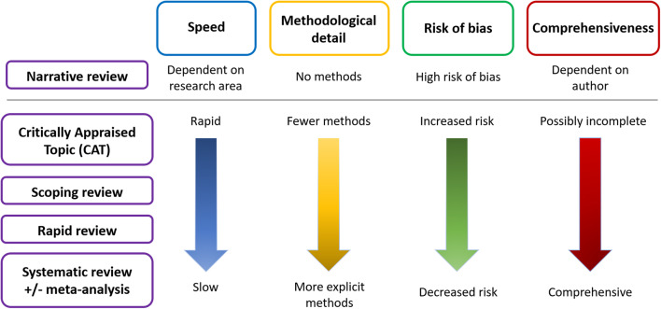
Figure 2 Schematic of the main differences between the types of literature review (Brennan, et al., 2020)
As shown in Fig. 2, there are positive and negative features of each literature review types. For example, systematic review, it uses multiple methods to build a structured and comprehensive result in certain detail, with high objectivity of evidence and credibility. However, the systematic review takes a long time and is at a disadvantage in the latest research (Hiebl, 2023). Critically Applied Topic (CAT) evaluates relevant research in a concise and clear manner, but the evaluation and conclusions of CAT may be influenced by the subjectivity of researchers, resulting in higher risks.
Narrative review is usually written by the author based on their own understanding and judgment and may have some subjective preferences. Compared to Systematic Literature Reviews, narrative reviews often lack strict literature screening and evaluation criteria and are typically selected by authors based on author’s understanding and judgment, which may affect the comprehensiveness and reliability of the review results.

1.4 Identify the research gap.
Research gaps refer to the part that has not been discovered in a certain research field or has not been deeply studied. It could be different in research groups or samples, research methods, data collection and analysis processes, or other unused research variables or conditions. Research gaps are very important, which requires researchers to be very familiar with the research field and read a lot of literature to ensure that their research methods are up to date. Generally, reading a large number of books and articles (including academic articles and ordinary articles) is one of the main ways to find the answer. Researchers may find the missing parts in this field in the literature. However, research gaps are obtained by collecting documents, it will not appear directly in the documents. More importantly, researchers need to sort out and criticize the existing knowledge, use their own knowledge and tools to analyse the future development direction in this field, and make a comprehensive comparison to determine whether this is the case. Not all research gaps are worthy of further exploration. Research gap plays an important role in the development of research field. It can help researchers to understand the importance and relevance of research by comparing the gap between the existing knowledge and the present. With the gap, researchers can improve the credibility of future research and the possibility of solving key problems.
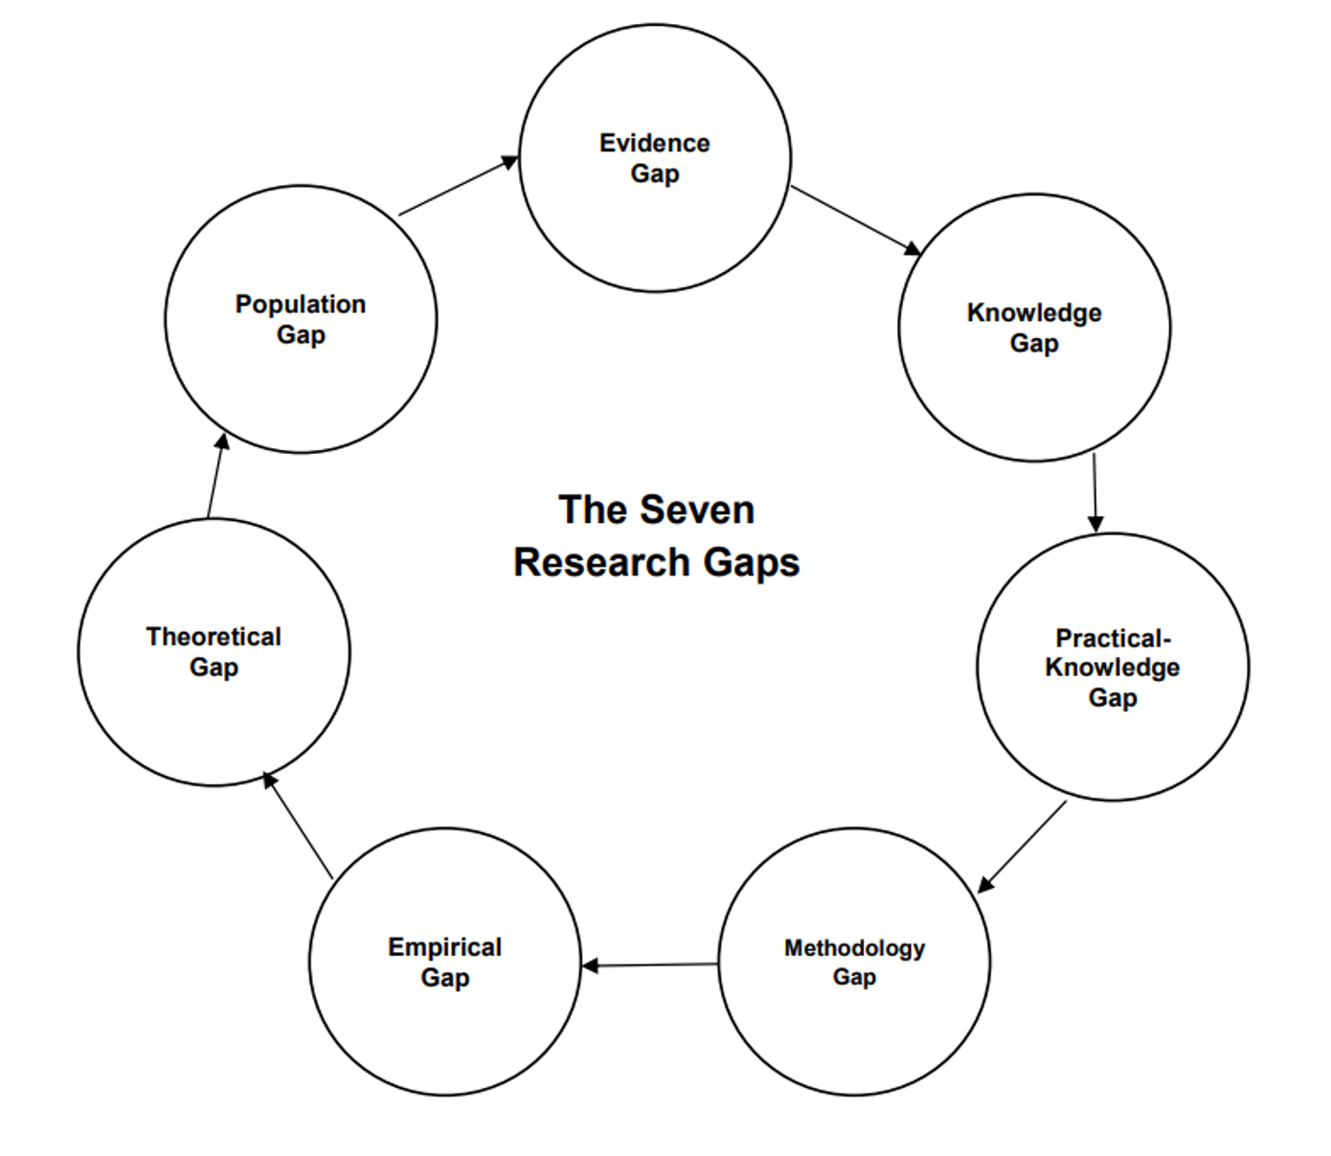
Figure 3 Seven Types of Research Gaps
Miles (2017) summarized the research of Robinson (2011), Müller-Bloch (2014), Jacobs (2011), and result seven common research gaps, Evidence Gap; Knowledge Gap; Practical-Knowledge Conflict Gap; Methodological Gap; Empirical Gap; and Theoretical Gap; Population Gap in the research. This does not mean that these gaps will all appear in a study, they only provide researchers with directions to search for gaps, as researchers often encounter difficulties in the identifying process. Furthermore, finding research gaps would be facing some problems.
Firstly, excessive information: Researchers need to screen and organize a large amount of academic literature, which requires a lot of time and effort. It is difficult to accurately identify research gaps due to information overload. Secondly, the complexity of research fields. Some research fields may involve interdisciplinary intersection, requiring researchers to have broad knowledge background. If researchers have insufficient knowledge reserves, it may be difficult to identify potential research gaps. However, due to limitations in resources such as time and funding, researchers may not be able to conduct. Thirdly, researcher’s preferences. Researchers need to strive to overcome the influence of personal factors such as knowledge background and research interests to objectively evaluate the current situation in the research field.

1.5 Attempt to eliminate bias
Firstly, it is necessary to clarify the inclusion and exclusion criteria for literature, and ensure that these criteria are objective, reproducible, and transparent, focusing on the core issues. This helps to reduce subjectivity in selecting literature. Secondly, give more weight to high-quality research, maintain an objective and cautious attitude to avoid excessive inference or interpretation of data, strive to present research with different perspectives, cite research that contradicts your own views, and demonstrate the comprehensiveness and diversity of the research. Finally, invite peers or mentors to review your literature review after completion, to improve the quality and credibility of the literature review.
Limitation
Time lag: The literature review is mainly based on published research results, so it may not reflect the latest research. There will be a lag from data collection to paper publication. It is a time-consuming process, with limited processing power, resulting in a low number of papers analysed (Claus & Møller, 2019). Language and cultural biases: Reviewers may be more inclined to cite literature from familiar language and cultural backgrounds, thus ignoring important research in other languages or cultures. Selective citation: The quality and depth of a review largely depend on the reviewer's knowledge background, research interests, and skill level. The reviewer may choose to cite literature based on their own views or preferences.
There are some limitations when I am writing this section. Due to time constraints, I am unable to screen and process many literatures. When collecting literature, it also reflects my preferences in the research question. The limitation of my abilities and understanding of the research field also affect in selecting literature. Even though I try to maintain my objectivity, but there may still be biases that I am not aware.

Conclusions
In this section, I explained what a literature review is, the purpose of writing a literature review, and the benefits to the research. Next, I analysed the steps of writing a literature review and compared five methods of literature analysis. Then, I analysed the methods for studying gap and the potential issues that may arise during the process. Finally, I discussed the possible biases in literature analysis, provided suggestions for eliminating biases, and identified my own limitations in this part.

Part 2
An analysis of mergers and acquisitions (M&A) in the real estate sector in China. Focus on stakeholder engagement.

Introduction
M&A is a common kind of organizational change in business activities, which will appear at all stages of industry development. The real estate industry in China is currently in an active period of M&A, and the relevant policies and research are constantly updated. This part starts with the types and motives of M&A, then introduces the current situation of China real estate industry and the government's attitude towards M&A, analyses the basic composition of the real estate industry with stakeholder theory, analyses the impact of M&A on stakeholders and puts forward the limitations of the current standards for measuring the success of M&A. It should be helpful to add neglected stakeholder opinions into the process of policy formulation and research.

2.1 Definition of M&A
Merger and acquisition(M&A) play a significant role in business (Anderson, 2024). M&A is a compound word of merger and acquisition. Merger refers to the merger of two or more enterprises into one company, which can be carried out in many ways, such as holding, leasing and business transfer (Bahadir, et al., 2008). Acquisition refers to the purchase of shares or assets of another company in cash or other ways, to obtain the ownership and control of the company (Bahadir, et al., 2008). Its essence lies in the transfer of enterprise ownership (Singh, 1971). Shortly, M&A between enterprises can be understood as obtaining the ownership of other legal entities through economic means on the premise of observing the principles of friendliness and voluntariness (Feldman & Hernandez, 2022).

2.2 Types of M&A
Based on different target of business, M&A can be classified as various types, as Takeover, Merger, and Acquisitions (Ahern & Weston, 2007). While the basic types of it could be based on industry, Horizontal, Vertical, and Mixed. There can thus be significant differences in the dynamics and outcomes between M&A (Søderberg, 2003; Faulkner, et al., 2012).
Horizontal M&As refer to M&As between enterprises that produce similar products or have similar production processes, essentially a merger between competitors (Häkkinen, et al., 2004). The advantage is to quickly expand production scale, achieve professional division of labour and cooperation, unify technical standards, and sell products and purchase raw materials uniformly. The basic feature of horizontal M&As is the horizontal integration of enterprises, which has the most direct impact on industry development. In recent years, due to the global wave of industry restructuring and the support of Chinese national policies for horizontal M&As, the development of industry horizontal M&As has been very rapid, and its proportion in China's M&A activities has always been around 50%.
Vertical M&As are M&As that occur between the upstream and downstream of the same industry. The vertical merger and acquisition of enterprises is not a direct competitive relationship, but a relationship between suppliers and demanders. Therefore, the basic characteristic of vertical M&As is the vertical integration of enterprises within the overall market scope (Rozen-Bakher, 2018).
Conglomerate M&As are M&As that occur between companies in different industries. In theory, the basic purpose is to diversify risks and seek economies of scope. It is an important way of diversified business operations, providing a powerful, convenient, and low-risk way for enterprises to enter other industries (Cao, et al., 2022).
Mergers and acquisitions can take many forms, involve different motivations or dynamics, and have different impacts on the parties involved. However, all mergers and acquisitions have a common goal, which is to generate value from the transaction in some form.

2.3 M&A Motives
Although researchers have established various theoretical frameworks to reveal the motives of M&A, it is difficult to separate them from financial factors, strategic development and management performance (Faulkner, et al., 2012). In the financial aspect, M&A can produce synergistic effects, including complementary resources (Capron, 1999), reducing costs and acquiring key technologies, patents or intellectual property rights, which require the integration of both parties to enhance the overall efficiency and competitiveness of enterprises (Haspeslagh & Jemison, 1991). Through continuous merger, the acquired companies can gain more market share, better cope with market competition, improve market access standards, reduce existing competitors and restrict potential competitors from entering the market (Trautwein, 1990). Mergers and acquisitions can also make profits by buying undervalued target companies (Barney, 1986). Some companies may not perform well as a whole, but the value after the split may be higher (Kaplan & Strömberg, 2009).
In terms of strategic development, mergers and acquisitions of companies with overcapacity are regarded as one of the main ways in long-term strategic management to reduce the industry average, reduce industry risks, expand products and markets, and improve the company's influence (Bower, 2001). However, the long-term performance that strategic management attaches importance to may not necessarily achieve the expected goals (Zollo & Meier, 2008).
Compared with the previous motives, the shareholders of the acquisition company can get benefits from mergers and acquisitions, which is often regarded as the main factor in management performance (Junni & Teerikangas, 2019). However, mergers and acquisitions will not be selected simply to increase the interests of shareholders. The enterprise will learn from the recent acquisition experience what is beneficial to him and strengthen the optimal acquisition strategy. Once the company continues to make profits, M&A will spread in the same industry by means of communication, which will lead to the growth (or decline) cycle of M&A activities and trigger M&A waves (Ryan, 2012).

2.4 Real Estate M&As in China

2.4.1 Background
The Chinese government has reformed the land management and housing systems since 1978, reclaiming land ownership to the state (Qu, et al., 1995). In the 1990s, housing was provided free of charge as employee benefits to employees of state-owned enterprises (Han, 1998). In the late 1990s, the welfare housing policy was abolished, and real estate entered the market as a commodity and was allowed to be traded (Cai, et al., 2020). During the same period, China's real estate market entered a stage of rapid development (Liu & Xiong, 2018). In 2002, funds were allowed to be established when selling or leasing land to deposit funds (Qun, et al., 2015). After 2003, housing prices in first tier cities in China such as Beijing, Shanghai, and Shenzhen have already been in an upward phase (Fang, et al., 2016). After 2008, China's real estate market entered a period of regional imbalance but overall prosperity due to large-scale conferences and competitions, such as the 2008 Beijing Olympics and the 2016 Hangzhou G20 Summit, where housing prices rose much faster than other regions (Gupta & Kaur, 2023) . This also drove the rapid development of the real estate industry and the expansion of real estate enterprises. The number of Chinese real estate enterprises increased from 24378 in 1998 to 105434 in 2021 (Ni Pengfei, et al., 2023). After 2019, the market changed, and the prices of China's housing market continued to decline. It is reasonable to consider the impact of COVID-19 on the people. They reduce unnecessary economic expenses (Wang, et al., 2023), such as exchanging properties. In 2023, indicators such as real estate investment and sales continued to decline compared to 2022. The downward trend in the real estate industry continues to suppress consumer willingness to purchase homes and puts the entire industry at high risk. Faced with this situation, the Chinese government is also making continuous efforts to ensure the sustained and stable development of this livelihood industry.

2.4.2 The structure of the industry
As shown in the figure, the upstream, midstream, and downstream of the real estate industry involve multiple industries and stakeholders. Financial institutions and governments are independent outside the industry, providing policy support and financial guarantees for the development of the real estate industry (Coiacetto, 2009).
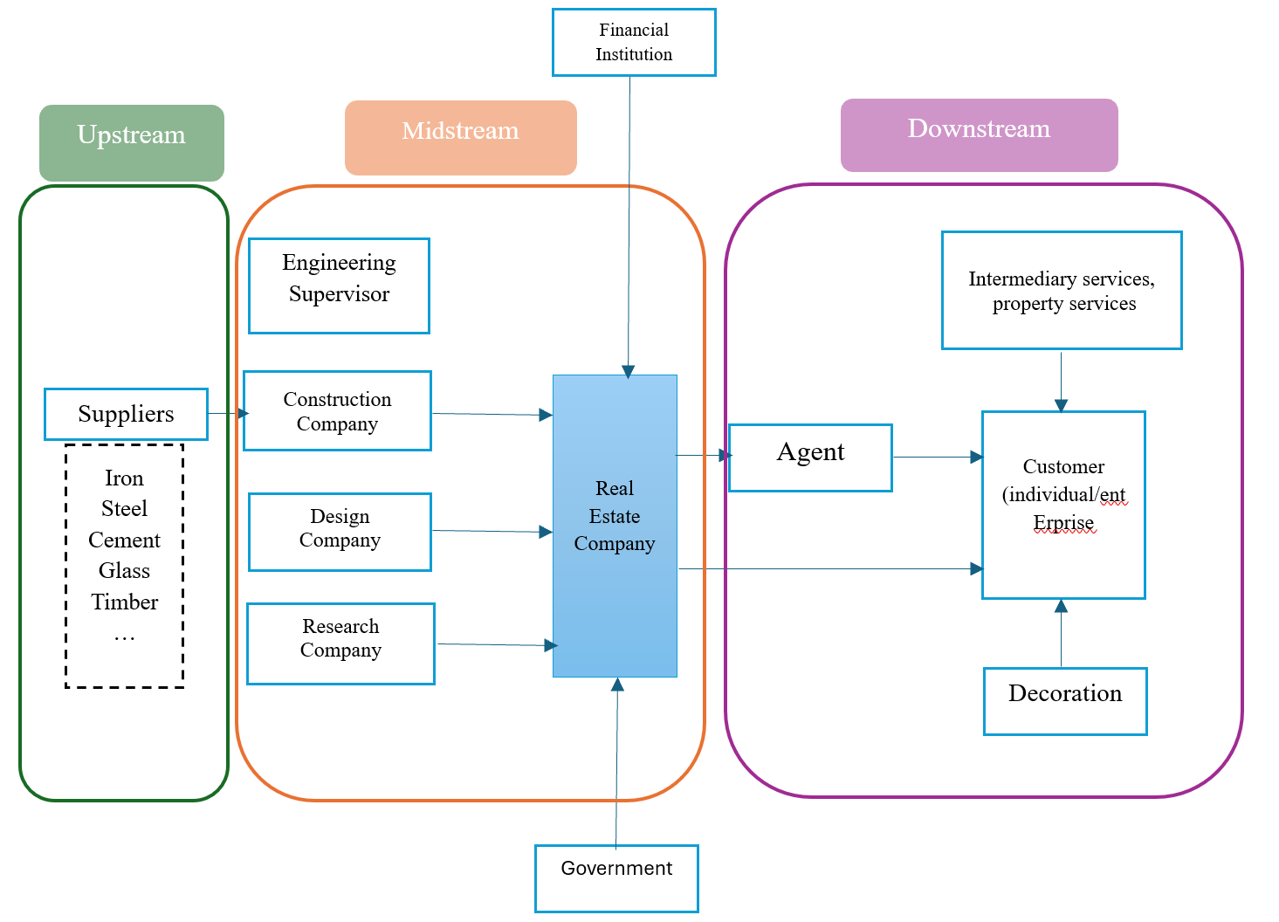
Figure 4 Stakeholders in China’s Real Estate Industry
The upstream industry mainly focuses on raw material supply, including construction material production and supply of engineering machinery manufacturing. After the merger, the real estate enterprise may have a larger scale and stronger development capabilities, so the demand for upstream raw materials such as steel bars, cement, wood, and other building materials may increase (Han, et al., 2021). This increase in demand is a positive signal for upstream enterprises, which can drive their production and sales growth. This means a more stable partnership and a more reliable source of orders for upstream suppliers. After the merger, it may have stronger bargaining power when negotiating with upstream enterprises, which may have a certain impact on the profit margin of upstream enterprises.
The midstream industry includes real estate developers and construction companies. Mergers and acquisitions help real estate companies integrate high-quality resources, including land, capital, technology, and management experience (Chen, et al., 2022). Through the synergistic effects brought about by mergers and acquisitions, including management synergy, operational synergy, and financial synergy, enterprises can quickly expand their scale, achieve resource sharing and complementarity, and improve resource utilization efficiency. Simultaneously obtaining market share and customer resources from the acquired company, further enhancing market competitiveness
Downstream include consumers, real estate agents, and related service industries (Liu, 2018). After mergers and acquisitions, real estate companies often have larger scales, more resources, and market influence, which can drive the market expansion of downstream industries such as home decoration and property management.

2.4.3 The Role of Government in Real Estate in China
The Chinese government has always maintained a leading position in important industries (Fung, et al., 2006). Mergers and acquisitions belong to the financial industry, with high risks; The real estate industry is one of the pillar industries of the economy, and its mergers and acquisitions can be seen as a combination of these two industries, which requires caution. During the period of rapid development in the real estate industry, the government paid more attention to measures such as controlling the reasonable development range and stabilizing housing prices and did not interfere too much with mergers and acquisitions of real estate enterprises. But after 2020, the decline in residents' willingness to buy houses and the continuous decline in housing prices both indicate that the real estate industry has turned towards a period of decline (Wang, et al., 2023). In order to cope with the unfavourable development prospects of the industry, (PBC & China Banking and Insurance Regulatory Commission, 2021; 2022) jointly propose support for real estate enterprise mergers and acquisitions at relevant meetings starting from 2021, and require commercial banks and other financial institutions to support the financing needs of mergers and acquisitions, striving not to hinder the completion of mergers and acquisitions due to financial issues. (Ministry of Housing and Urban-Rural Development, 2024)emphasis of the coordination mechanism for urban real estate financing requires commercial banks and financial institutions to treat real estate enterprises of different ownership equally and meet the reasonable financing needs of real estate development enterprises. Local council provide certain tax incentives for real estate M&As, strengthen market supervision of real estate M&As, prevent monopolistic behaviours and unfair competition in the market, and maintain a fair competition order in the market.
This indicates that the role of the Chinese government in mergers and acquisitions in the real estate industry depends on the development of the industry, with the core purpose of promoting stable development of the industry and economy, reducing or even avoiding risks.

2.4.4 Crisis in Real Estate
The word real estate crisis in 20th Century
Since the 20th century, there have been three large-scale real estate crises around the world, namely, the real estate foam in Japan in the 1970s and 1980s, the real estate foam in Hong Kong in 1997, and the subprime mortgage crisis in the United States in 2008. The real estate foam is worth the fact that the excessively high land and real estate prices are seriously divorced from the actual economic level. It usually ends with triggering an economic crisis, at a very heavy cost. The real estate foam in Japan and Hong Kong both originated from the rapid economic development and ended in the economic recession and crisis they faced. The subprime crisis in the United States was caused by the US government's relaxation of restrictions on lending to financial institutions, allowing those who should not have received loans to effortlessly obtain them and to purchase a variety of unnecessary items, including houses, under the temptation of encouraging consumption. Finally, due to the large number of people unable to repay loans on time, systemic risks emerged in the financial system, leading to a global economic crisis. (PBC & China Banking and Insurance Regulatory Commission, 2022)
China’s real estate risk
The Chinese real estate industry might be under the risk, with similarities to the risks mentioned above. For example, a period of high housing prices and people's enthusiasm for investment combine to cause the original housing prices to skyrocket. The rise in housing prices confirms that buying a house is a profitable investment, and the cycle of buying a house, rising housing prices, and buying a house. This is very likely to trigger a real estate foam. But after COVID-19, people's income decreased, their willingness to invest decreased, and the real estate industry entered a decline range as a result. The real estate industry, as a heavy asset industry, faces funding problems and an increase in mergers and acquisitions within the industry when the construction sales process is not smooth. The previous subprime mortgage crisis in the United States was jointly planted by the financial and real estate industries, which may also be the reason why the government remains highly concerned about mergers and acquisitions of real estate companies. At present, there is no real crisis in mergers and acquisitions between Chinese real estate enterprises.

2.5 Stakeholder theory
2.5.1Theoretical background
Freeman (1984) proposed a shareholder theory that differs from the focus on maximizing shareholder interests. He believed that a company is not established and operates independently, but needs to engage in transactions with other organizations, which means it will establish mutually beneficial relationships with other stakeholders that rely on resources. Crane (1998) further clarified the scope of stakeholders, including all groups within and outside the organization that can influence or be influenced by the organization. Gibson (2017)divides stakeholders into stakeholders (providing or receiving benefits), risk-taking (bearing or providing risks), and value chain stakeholders. The relationship between these stakeholders and the enterprise can be positive or negative, but the substantive purpose of these relationships is still for their respective interests.
2.5.2 Stakeholders in Real Estate Industry
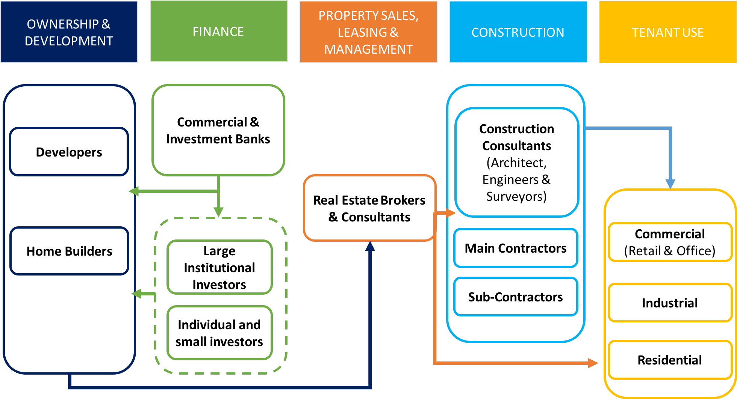
Figure 5 Value chain of Real Estate
From the value chain diagram, there are five types of stakeholders related to real estate, namely owners, finance, sales, construction and tenant use。 They can all benefit from the real estate industry. Owners can directly profit from company operations, the financial industry benefits from real estate companies through investment and loans, real estate companies profit from themselves, the construction industry profits by undertaking new houses and other projects, and tenants profit from renting and living. Among these stakeholders, their status is unequal.
In the figure, we can see that the key stakeholders among stakeholders are owners, consultants, construction workers, and contractors. Compared to tenants, they have a closer interest relationship with real estate companies. But even if they are all key stakeholders, their status is still not equal. The owner has the highest status and can provide sources of benefits to other three parties, as well as bear a higher proportion of risks in the real estate industry.
Compared to the other three categories, workers are the most vulnerable key stakeholders. Their work comes from a joint venture between real estate and construction companies, and the jobs they receive vary depending on whether they have professional skills. Skilled workers have better risk tolerance than ordinary employees. Consultants and contractors are in the middle position, as they have their own professional skills and may actively profit while relying on the real estate industry to maximize their income. When real estate risks occur, all stakeholders will be affected to varying degrees. Although risks may vary depending on the industry location, the lower the income, the poorer the risk resistance of the group with fewer choices, such as construction workers.
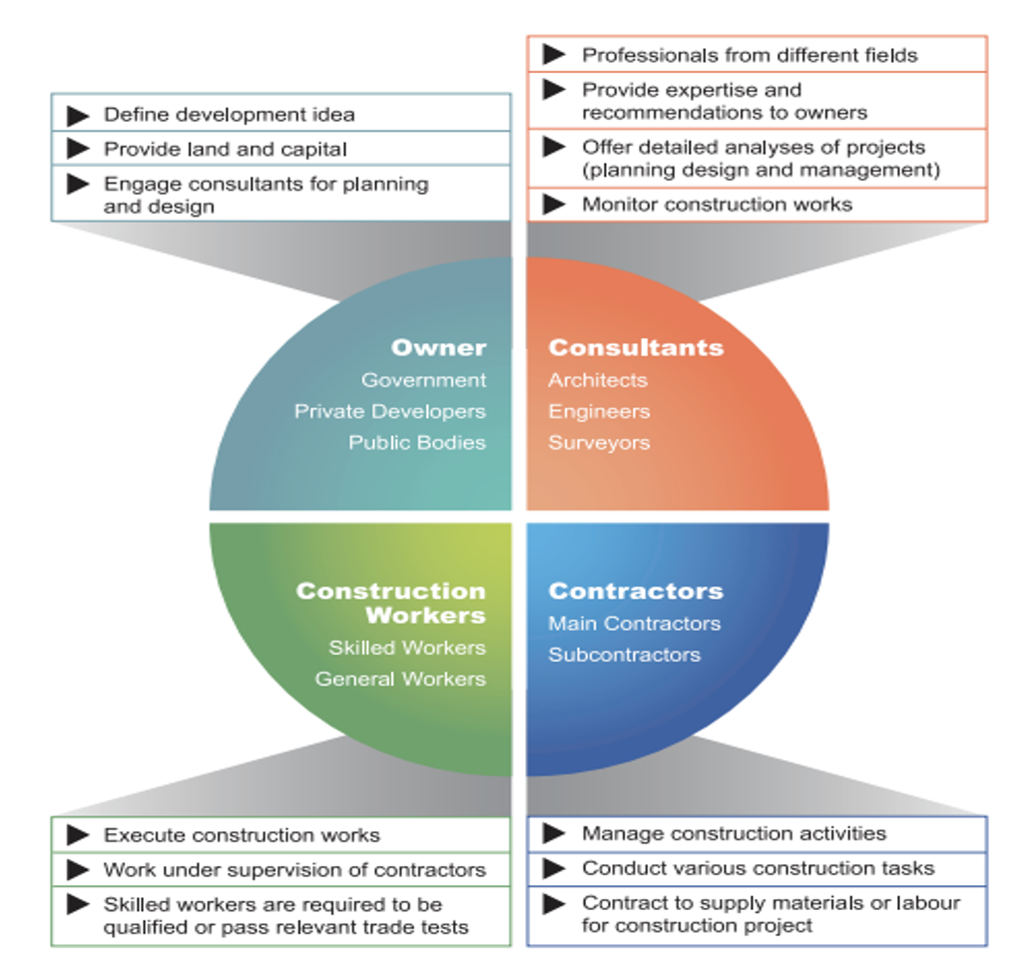
Figure 6 Stakeholders and Their Responsibilities
M&A is a kind of organizational change, will have a certain impact on the real estate value chain. Stakeholders should have been affected (mostly negative). Marginal stakeholders are groups that receive little attention, are not valued, and are silenced within an organization (Chowdhury, et al., 2024). In real M&As, the midstream represented by real estate enterprises has received more attention and research. People are concerned about real estate prices, the performance of real estate companies, or changes in real estate policies, but in this industry, the upstream and downstream parts at both ends are often overlooked and marginalized, especially the employees (including real estate companies) and consumers within these industries. Their opinions have no impact on the process of mergers and acquisitions, and they can only passively bear the impact of mergers and acquisitions. After mergers and acquisitions, the number of companies will decrease, and there is a high probability that internal employees will face risks such as unemployment and job transfers; The material suppliers and distributors of the acquired company may be replaced, and externally, the acquired company may enhance its competitiveness, expand the market, and obtain higher market position and revenue; It is also possible that after completing the merger, the expected goals were not achieved, resulting in a significant loss of the merger amount.
The previous stakeholders are all in the real estate industry, and there should be some external stakeholders affected by M&As. When analysing the impact of stakeholders, we need to considering them, such as creditors, government, financial institution. Figure XX is the stakeholders who will be acquired by real estate enterprises both inside and outside the industry.
Real Estate M&As
Figure 7 Stakeholders around the Real Estate M&As
Shareholders: Merger and acquisition news usually has an impact on the stock market, as market uncertainty may lead to abnormal fluctuations in stock prices. It may also lead to a change in the company's control, thereby affecting the interests of shareholders.
Real estate company employees and construction workers: Mergers and acquisitions may lead to company restructuring or business adjustments, which may result in changes to labour contracts, including workplace, job content, salary benefits, etc., affecting employee job stability, and even some employees facing unemployment risks. The corporate culture after mergers and acquisitions may be different from the original, and employees need time to adapt to the new work environment and team culture, which may bring some anxiety and pressure.
Suppliers and partners: After the merger and acquisition, existing contract terms may be re-evaluated and other suppliers or replacement of more favourable cooperation conditions for the acquiring company may be sought
Consumers: The impact is mainly concentrated in downstream real estate service businesses. For example, after a merger, the new company may adjust its products and services, leading to a change in brand image, thereby affecting consumer and customer brand loyalty (Umashankar, et al., 2022; Karaduman & Kaya, 2016). A very small number of consumers will give up choosing to purchase or lease properties due to the merger of real estate companies. Therefore, consumers have a very low weighting in real estate mergers and acquisitions and are marginalized stakeholders.
Creditors: According to the provisions of the Company Law, creditors should be notified when the company is merged, and they are allowed to ask the company to pay off debts or provide corresponding guarantees. Therefore, after the merger, creditors may need to renegotiate the debt settlement plan with the company or accept new guarantee measures. Mergers and acquisitions may cause creditors to re-evaluate the credit risk of the new entity.

2.6 Theoretical recommendations on policies
In the research of M&A, researchers discuss in depth the development direction of finance, management and enterprise strategy. The government's policy support is basically carried out from the macro perspective of promoting economic development and reducing industry risks. Some stakeholders will benefit from it. However, individual stakeholders should be considered by researchers and the government in research and policy making. Researchers should pay due attention to the neglected parts of stakeholders and look for the possible impact (especially negative impact) of real estate mergers and acquisitions on them, or their ability to influence the results of mergers and acquisitions. When formulating policies, the government should mention protecting the basic interests of ordinary stakeholders, especially marginal stakeholders. The development of industry and economy is closely related to them.

Limitation
Stakeholders have different responsibilities in M&A. Shareholders, owners, banks and governments bear more responsibilities and risks, so there is a reason to pay more attention to them in the study. Marginal stakeholders bear less risk, and it is reasonable to be marginalized in the research. But now, most of the results of M&A are measured by the financial performance of the company after M&A. By comparing the financial data and financial indicators before and after M&A, the success of M&A can be judged. This conceals a large number of personal marginal stakeholders, whose wishes are difficult to quantify and then analyze. However, qualitative research requires higher sample selection and is more difficult to implement, and personal wishes will change because of the changes in their situation, so it is difficult to obtain credible evidence representing the whole group.

Conclusion
In this part, I analyze the types and purposes of M&A in China real estate industry and the support policies of China government for horizontal M&A of real estate enterprises. Based on the stakeholder theory, this paper analyzes the benefits and possible risks that stakeholders in different stages of the industry can obtain in M&A, and points out that the existing research mainly focuses on key stakeholders and the current situation that can be measured by financial indicators. This paper puts forward the possible benefits of expanding stakeholders, and also shows the limitations of studying marginal stakeholders, such as the decline of credibility. I hope this part of the research can make some progress for all stakeholders as a measure of real estate mergers and acquisitions.

References
Ahern, K. R. & Weston, J. F., 2007. M&As: The good, the bad, and the ugly. Journal of Applied Finance, 17(1), pp. 5-20.
Anderson, L., 2024. Building Commitment: The Importance of Employee Resiliency in Mergers and Acquisitions. (Master's thesis, The College of St. Scholastica).
Bahadir, S. C., Bharadwaj, S. G. & Srivastava, R., 2008. Financial Value of Brands in Mergers and Acquisitions: Is Value in the Eye of the Beholder?. Journal of Marketing, pp. 72(6), 49–64.
Barney, J., 1986. Strategic factor markets: Expectations, luck and business strategy. Management Science, 32(10), p. 1231–1241.
Baumeister, R. F. & Leary, M. R., 1997. Writing narrative literature reviews.. Review of general psychology, 1(3), pp. 311-320.
Bower, J. L., 2001. Not all M&As are alike—and that matters. Harvard Business Review, 79(3), pp. 93-101.
Brennan, M. L. et al., 2020. Critically appraised topics (CATs) in veterinary medicine: applying evidence in clinical practice. Frontiers in Veterinary Science, Volume 7, p. 314.
Cai, Z., Liu, Q. & Cao, S., 2020. Real estate supports rapid development of China's urbanization. Land use policy, pp. 95, 104582.
Cao, C., Ray, G., Subramani, M. & Gupta, A., 2022. Enterprise systems and the likelihood of horizontal, vertical, and conglomerate mergers and acquisitions. MIS Quarterly, 46(2).
Capron, L., 1999. The long-term performance of horizontal acquisitions. Strategic Management Journal, 20(11), p. 987–1018.
Chen, H. et al., 2022. Dynamics and Driving Mechanism of Real Estate in China’s Small Cities: A Case Study of Gansu Province. Buildings, 12(10), p. 1512.
Chowdhury, R., Sarasvathy, S. & Freeman, R., 2024. Toward a theory of marginalized stakeholder-centric entrepreneurship. Business Ethics Quarterly, pp. 34(1), 1-34.
Chowdhury, R., Sarasvathy, S. & Freeman, R. E., 2024. Toward a Theory of Marginalized Stakeholder-Centric Entrepreneurship.. Business Ethics Quarterly, 34(1), pp. 1-34.
Claus, B. & Møller, C., 2019. Smart literature review: a practical topic modelling approach to exploratory literature review. Journal of Big Data, 6(1), pp. 1-18.
Coiacetto, E., 2009. Industry structure in real estate development: Is city building competitive?. Urban Policy and Research, 27(2), pp. 117-135.
Cooper, H. & Hedges, L., 1994. The handbook of research synthesis. 1st ed. New York: Russell Sage Foundation.
Crane, A., 1998. Marketing, morality, and the natural environment. (Doctoral dissertation, University of Nottingham).
Davies, P., 2000. The relevance of systematic reviews to educational policy and practice. Oxford Review of Education, 26(3/4), p. 365–378.
Denney, A. & Tewksbury, R., 2013. How to write a literature review. Journal of criminal justice education, 24(2), pp. 218-234.
Fang, H., Gu, Q., Xiong, W. & Zhou, L., 2016. Demystifying the Chinese housing boom. NBER macroeconomics annual, pp. 30(1), 105-16.
Faulkner, D., Teerikangas, S. & Joseph, R., 2012. Handbook of mergers and acquisitions.. Oxford: Oxford University Press.
Faulkner, D., Teerikangas, S. & Joseph, R. J., 2012. The handbook of mergers and acquisitions. Oxford: Oxford University Press.
Feldman, E. R. & Hernandez, E., 2022. Synergy in mergers and acquisitions: Typology, life cycles, and value. Academy of Management Review, pp. 47(4), 549-578.
Freeman, R., 1984. Strategic Management: A Stakeholder Approach. Cambridge: Cambridge University Press.
Fung, H. G., Huang, A. G., LIU, Q. W. & Shen, M. X., 2006. The development of the real estate industry in China. Chinese economy, pp. 39(1), 84-102.
Gibson, K., 2017. Regarding marginal stakeholders. In Stakeholder Management. s.l.:Emerald Publishing Limited.
Grant, M. J. & Booth, A., 2009. A typology of reviews: An analysis of 14 review types and associated methodologies. Health Information & Libraries Journal, 26(2), pp. 91-108.
Gupta, R. & Kaur, G., 2023. Relationship between Shadow Banking and Real Estate Bubble in China. In BUSINESSES: RESILIENCE AND SUSTAINABILITY: Evidence from Emerging Market Developing Economies, pp. 89-103.
Häkkinen, L., Norrman, A., Hilmola, O. P. & Ojala, L., 2004. Logistics integration in horizontal mergers and acquisitions. The International Journal of Logistics Management, 15(1), pp. 27-42.
Han, S., 1998. Real estate development in China: a regional perspective. Journal of Real Estate Literature, pp. 6(2), 121-133.
Han, Y., Zhang, H. & Zhao, Y., 2021. Structural evolution of real estate industry in China: 2002-2017. Structural Change and Economic Dynamics, Volume 57, pp. 45-56.
Haspeslagh, P. C. & Jemison, D. B., 1991. Managing acquisitions. New York: Free PresS.
Hiebl, M. R., 2023. Sample selection in systematic literature reviews of management research. Organizational research methods, 26(2), pp. 229-261.
Jacobs, R., 2011. "Developing a Research Problem and Purpose Statement", in The Handbook of Scholarly Writing and Publishing. T. S. Rocco and T. Hatcher (eds.) ed. San Francisco: Jossey-Bass.
Junni, P. & Teerikangas, S., 2019. Mergers and Acquisitions. Oxford Research Encyclopedia of Business and Management.
Kaplan, S. N. & Strömberg, P., 2009. Leveraged buyouts and private equity. Journal of Economic Perspectives, 23(1), pp. 121-146.
Karaduman, I. & Kaya, E., 2016. Branded Real Estate Agencies: The impact of the brand on consumer behavior in real estate market. International Journal of Research Science and Management, 3(4), pp. 5-14.
Knopf, J. W., 2006. Doing a literature review. PS: Political Science & Politics, 39(1), pp. 127-132.
Lim, W., Kumar, S. & Ali, F., 2022. Advancing knowledge through literature reviews:‘what’,‘why’, and ‘how to contribute’. The Service Industries Journal, 42(7-8), pp. 481-513.
Liu, C. & Xiong, W., 2018. China's real estate market. In: 1, ed. The Handbook of China's Financial System. Princeton: Princeton University Press, pp. 183-207.
Liu, G. L. K. S. A. M. I. a. Z. Y., 2018. Strategic business model typologies evident in the Chinese real-estate industry. International Journal of Strategic Property Management, 22(6), pp. 501-515.
Low, J. T., 2011. A literature review: What exactly should we preserve? How scholars address this question and where is the gap. 1 ed. Ithaca: arXiv preprint arXiv:1112.1681.
Lune, H. & Berg, B. L., 2017. Qualitative research methods for the social sciences. 9th ed. s.l.:Pearson.
Miles, D. A., 2017. A taxonomy of research gaps: Identifying and defining the seven research gaps. In Doctoral student workshop: finding research gaps-research methods and strategies, Dallas(Texas), pp. 1-15.
Ministry of Housing and Urban-Rural Development, P., 2024. Deploy real estate related work in 2024. Beijing, s.n.
Müller-Bloch, C. & Kranz, J., 2014. A Framework for Rigorously Identifying Research Gaps in Qualitative Literature Reviews. The Thirty Sixth International Conference on Information Systems, Volume Fort Worth 2015, p. 1–19.
Ni Pengfei, P., Ni, Z. & Xu, H., 2023. Research on the new model and construction of China’s real estate development. China Real Estate Finance, pp. (06):52-59.
Nocke, V. & Whinston, M. D., 2022. Concentration thresholds for horizontal mergers. American Economic Review, pp. 112(6), 1915-1948.
Paul, J. & Criado, A. R., 2020. The art of writing literature review: What do we know and what do we need to know?. International business review, 29(4), p. 101717.
PBC & China Banking and Insurance Regulatory Commission, 2021. Notice on Providing M&A Financial Services for Risk Disposal Projects of Key Real Estate Enterprises, Beijing: s.n.
PBC & China Banking and Insurance Regulatory Commission, 2022. Notice on Doing Current Financial Support for the Stable and Healthy Development of the Real Estate Market, Beijing: s.n.
Piesse, J., Lee, C., Lin, L. & Kuo, H., 2022. Piesse, J., Lee, C. F., Lin, L., & Kuo, H. C. (2022). Merger and acquisition: Definitions, motives, and market responses. In Encyclopedia of finance. s.l.:Springer.
Qu, F., Heerink, N. & Wang, W., 1995. Land Administration Reform in China. Land Use Policy, pp. 12(3)193-203.
Qun, W., Yongle, L. & Siqi, Y., 2015. The incentives of China's urban land finance. Land Use Policy, pp. 42, 432-442..
Robinson, K., Saldanha, I. & McKoy, N. A., 2011. Development of A Framework for to Identify Research Gaps Systematic Reviews. Journal of Epidemiology, 64(1), pp. 1325-1330.
Rowe, F., 2014. What literature review is not: diversity, boundaries and recommendations. European Journal of Information Systems, 23(3), pp. 241-255.
Rowley, J. & Slack, F., 2004. Conducting a literature review. Management research news, 27(6), pp. 31-39.
Rowley, J. & Slack, F., 2004. Conducting a Literature Review. Management Research News, 27(6), pp. 31-39.
Rozas, L. W. & Klein, W. C., 2010. The value and purpose of the traditional qualitative literature review. Journal of evidence-based social work, 7(5), pp. 387-399.
Rozen-Bakher, Z., 2018. Comparison of merger and acquisition (M&A) success in horizontal, vertical and conglomerate M&As: industry sector vs. services sector. The Service Industries Journal, 38(7-8), pp. 192-518.
Ryan, B., 2012. Shareholder value: A driver of merger and acquisition activity. In D. Faulkner, S. Teerikangas, & R. Joseph (Eds.). In: Handbook of mergers and acquisitions. Oxford: Oxford University Press, p. 320–338.
Singh, A., 1971. Take-overs: Their Relevance to the Stock Market and the Theory of the Firm. Cambridge: Cambridge University Press.
Snyder, H., 2019. Literature review as a research methodology: An overview and guidelines. Journal of business research, Volume 104, pp. 333-339.
Søderberg, A. M., 2003. Merging across borders: People, cultures and politics. s.l.:Copenhagen Business School Press DK..
Summers, j., 2011. Guidelines for Conducting Research and Publishing in Marketing: From Conceptualization Through the Review Process. Journal of the Academy of Marketing Science, 29(4), pp. 405-415.
Tranfield, D., Denyer, D. & Smart, P., 2003. Towards a methodology for developing evidence‐informed management knowledge by means of systematic review. British journal of management, 14(3), pp. 207-222.
Trautwein, F., 1990. Merger motives and merger prescriptions.. Strategic management journal, pp. 11(4), 283-295.
Umashankar, N., Bahadir, S. C. & Bharadwaj, S., 2022. Despite efficiencies, mergers and acquisitions reduce firm value by hurting customer satisfaction. Journal of Marketing, pp. 86(2), 66-86.
Wang, L. et al., 2023. Synergistic evolution of resilience and efficiency in the real estate industry: Evidence from 35 large and medium-sized cities in China. Applied Economics Letters, pp. 30(19), 2702-2710.
Zollo, M. & Meier, D., 2008. What Is M&A Performance?. Academy of Management Perspectives, Volume 22, pp. 55-77.

