

Marketing Fundamentals
LCBB4004

Name:
ID:

Table of Contents
Introduction 2
STP marketing Framework 2
Blog 1: Market Segmentation 2
Blog 2: Market Targeting 3
Blog 3: Product Positioning 4
7P’s marketing model 5
Blog 4: Product 5
Blog 5: Price 6
Blog 6: Place 6
Blog 7: Promotion 7
Blog 8: People 7
Blog 9: Process 8
Blog 10: Physical evidence 8
Conclusion 9
References 10

Introduction
The following assessment will evaluate the various aspects of Tesco while majorly focusing on its marketing strategies to reach its products and services to wider populations. All these aspects of Tesco will be outlined in the services of ten blogs based on the STP marketing framework and 7Ps marketing mix.

STP marketing Framework

Blog 1: Market Segmentation
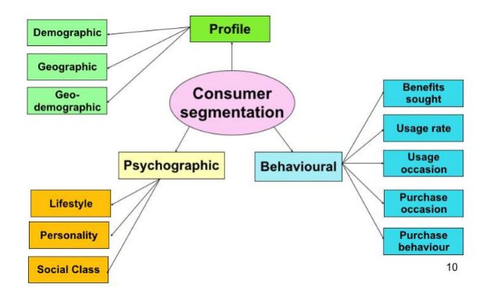
Figure 1: Market Segmentation of Tesco
(Source: Tesco plc, 2021)
Tesco being one of the leading multinational retail sectors of the UK operates in four main segments that are Fresh Food, Grocery, Household & Healthcare and Financial Services. The company uses this process to make the most of its marketing budget. According to Tuten (2019), Tesco uses multi-segment placement extensively to target as many segments with various items at the same time. The geography category of Tesco has been divided into two parts known as Regions and Density. Similarly, the demographic category of Tesco has been further expanded with seven divisions that include age, gender, income, occupation, education, social status and family size. According to Weinstein (2020), the psychographic category of Tesco has been further split into two divisions that are lifestyle and personality. Lastly, the behavioural category of Tesco has four divisions in total, which mainly includes occasions, benefits sought, the user status and attitude. This segmentation criterion of Tesco has helped the company in increasing market share to around 28.4%, which makes them the third-largest retailer in the world is measured gross revenue (Tesco plc, 2021). On the other hand, Sarkar (2021) has observed that currently, Tesco offers both online and offline services to their customers. The online sales services of Tesco have played a vital role for the company to maintain the flow of revenue in the crisis of Covid-19.

Blog 2: Market Targeting
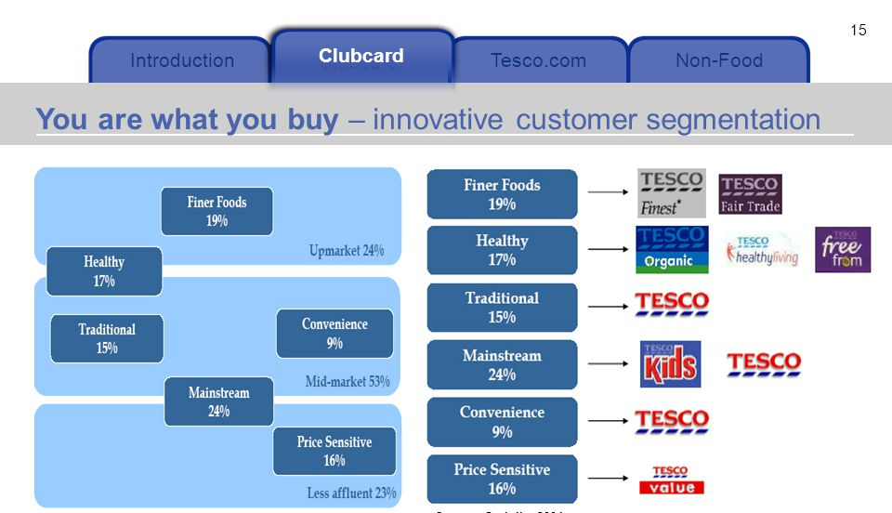
Figure 2: Market Targeting of Tesco
(Source: Guo and Wang, 2019)
According to Tirawatnapong and Fernando (2018), the market targeting of Tesco depends on cost-conscious individuals who are interested in bargains, sales and value variety. The prime targets of Tesco are the consumers from middle-income as well as have small children. In context to this, Guo and Wang (2019) observed that Tesco continues to target other categories such as those who are more concerned with quality. This particular aspect of the company has helped them cater to their customers who have been looking for something affordable and of good quality. Further, Tesco ensures to make the best usage of television, newspaper and other media outlets to connect with wider consumers from around the world. Ngamcharoenmongkol (2018) outlined that Tesco give their major emphasis on meeting the traditional, contend and conformer aspects of their targeted segments. Market research for instance has played a crucial role for Tesco in tracking the current trends of the customers as well as their major competitors in the targeted marketplace. Tesco ensures to be accurate in targeting their ideal consumers with the help of a good portrait image of the brand in the public. Further, the major aspect of the company is to offer its customers a wide range of products at an affordable price.

Blog 3: Product Positioning
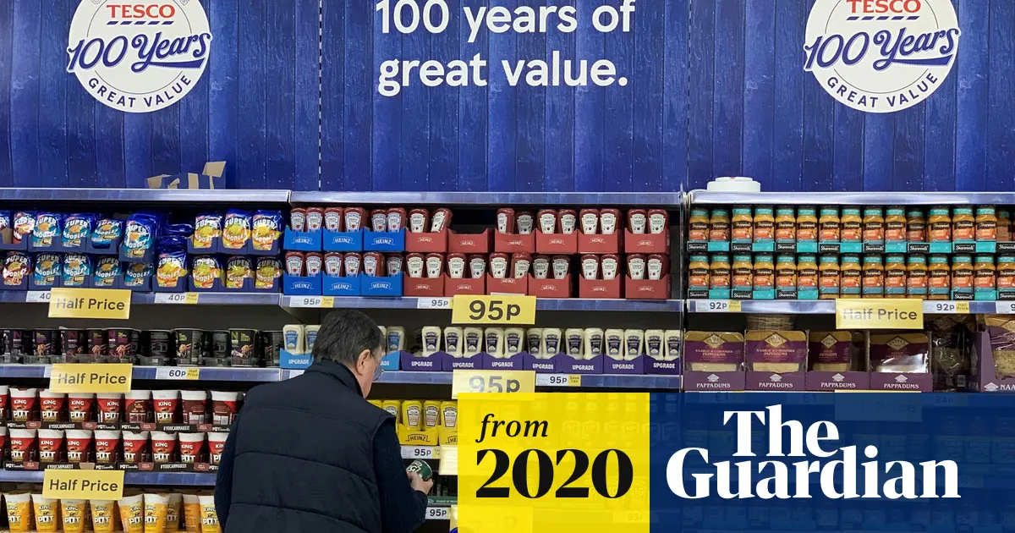
Figure 3: Product Positioning
(Source: Guardian, 2022)
According to Tirawatnapong and Fernando (2018), Tesco uses experimental positioning to target their customers for their health and beauty range of products. Further, it can be noted that Tesco has positioned itself as a low price retailer through advertisements taglines such as “cheapest price every day”. This has played a crucial role for Tesco in grabbing the attention of the targeted customers around the world. Along with this, Aiello et al. (2020) observed that Tesco also has loyalty programs that retargeted their customers after a certain period. This particular strategy has been used by Tesco to position itself as customer-centric and rebate them as they keep shopping with the company. In addition, it can slow be noted that Tesco has been much more than a supermarket chain selling millions of its products. For instance, Tesco has a huge conglomerate, spanning various verticals. This gives the company a higher competitive advantage in its targeted marketplace. Aiello et al. (2020) outlined that Tesco places the most popular products in the middle of the long aisles. This ensures that the customers can trek along the aisle passing all the other products for purchases.

7P’s marketing model
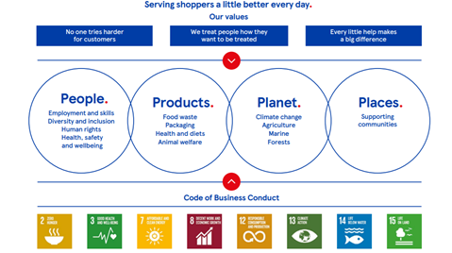
Figure 4: 7P’s of Tesco
(Source: Tesco, 2021)

Blog 4: Product
Tesco sells multiple products are food items, cloths, stationery items, cosmetics, electronics, financial services and many more. Further, Kim et al. (2019) outlined that the expanding product range of Tesco has helped them in meeting every need of their customers in the targeted marketplace. Apart from this, Tesco is also capable of manufacturing their products such as Tesco Lotus, Tesco Value, Everyday Value and F&F Clothing under their brand. Tesco ensures that it sells products from all the top brands while making them affordable to their customer's demands in the market. For instance, the sales of Tesco products in 2020 have increased by 48%, which has spiked their overall sales value by 8%. According to Brannen et al. (2020), the Extra Cheras carry 18000-20000 SKU across the store of Tesco holds about 70% of their food products where only about 30% of it is non-food products. Tesco is a full-line discount store that aims to offer a broad variety of products, limited services and low prices. The products of Tesco offer their customers an opportunity to choose from both national and international brands under one roof with a price under their budget. Furthermore, Tesco also offers facilities such as free parking, customer service, baby room and many more to grab the attention of wider customers as well as to gain greater customer loyalty.

Blog 5: Price
Tesco follows a cost leadership strategy, which plays a crucial role in them maintaining low prices for all its products and services without any compromise on the overall quality. Domański and Łabenda (2020) observed that Tesco enjoys economies of scale and works consistently with their suppliers to make an efficient supply chain for a reduction in their prices. Despite this, Tesco faces tough competition from the companies such as Aldi and Lidl within the UK’s market. Along with this, it also majorly affected the pricing strategy of Tesco. In order to compete with these firms, Tesco uses cost-plus pricing that helps them add standard mark-up for the cost of their products. Apart from this, Guo and Wang (2019) observed that Tesco often uses cost-based pricing that helps them set prices based on the cost of activities such as producing, delivering, and selling the products at a fair rate for a positive return to their overall efforts and risk.

Blog 6: Place
Tesco uses both online and offline channels for the distribution of their products and services to the customers across their targeted marketplace. Tesco has over 7000 offline stores around in both national and international borders for meeting the needs and demands of their customers. Felgate and Fearne (2017) outlined that the offline stores of Tesco are of six types such as Tesco Express, Tesco Extra, Tesco Metro and many more. On the other hand, the online business of the company is known as Tesco Direct where it uses different channels available from reaching out to wider customers. According to Ma et al. (2020), Tesco has many restaurants and cafes within their stores such as Pak Hailam Kopitiam, KFC and many more. This particular aspect of Tesco within their stores has helped them increase the shopping experience of their customers. Similarly, the free parking space offered by Tesco to their customers with greater security and safety of their belongings.

Blog 7: Promotion
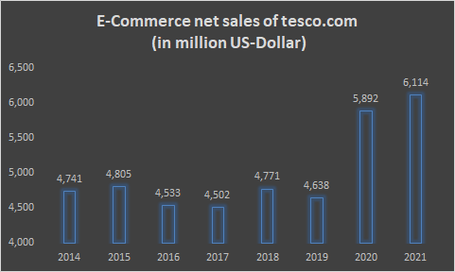
Figure 5: Online sales of Tesco
(Source: Lehn, 2020)
According to Rosnizam et al. (2020), Tesco has a strong brand image that has helped its promotional activities. In order to accelerate their promotional activities, Tesco uses mediums such as television, newspapers and other media outlets to reach their message to wider customers. Further, it can be noted that Tesco is one of the largest spenders on traditional advertising among other UK grocery retail industries. Lehn (2020) observed that Tesco spent over 80.8 million in 2019, which was a lot higher than the amount they spent on advertising in 2018. Apart from this, Tesco often provides options such as a buy one get one free offer for some of their products to grab the attention of their customers towards their products and services. Loyalty cards for instance have played a crucial role for Tesco in retaining the loyalty of their customers. Clubcard owners of Tesco get points each time they shop while allowing them to redeem for getting more discounts. Along with this, it also allows its customers to get personalised discounts. In context to the figure below, it can be noted that the sales of Tesco in 2021 under the E-commerce platform have significantly risen while adding greater profitability to their overall sales.

Blog 8: People
Nearly 420,000 people work in Tesco, which has helped the company is offering a greater number of customer assistance, especially for those who play a crucial role in securing the overall success of the company. The workforce at Tesco is competent as the company spends a huge amount and time on employee tanning as well as on development. Guo, Lin, and Zhen Wang (2019) opined that Tesco also ensured to enhance their reward scheme for their employees, which has played a vital role for the company in retaining their skilled employees. Despite this, many market analysts have argued that Tesco often fails to motivate its young workers. The sales assistants of Tesco are greatly responsible for the greater success of the company. Furthermore, Tesco also uses programs such as the Colleague Privilege card, Save as You Earn and Buy You Earn to gain the loyalty of their employees. The competitive and highly skilled attitude of the customers has contributed greatly to the major success of the company (Tesco plc, 2021). Tesco often held press conferences to announce its plans. This has allowed Tesco to maintain a transparent relationship with their customers while keeping them updated on all their discounts, offers and possible changes within their business operations.

Blog 9: Process
The major target of Tesco in the addressing process in Tesco is to keep their customers happy by ensuring to speed up their billing services and easy requirements of the products in the store in both online and offline mode (Lehn, 2020). In order to achieve this, Tesco ensures to employ competent staff while ensuring to pay closer attention to the grievance of their customers as well as addressing their issues. According to Yusof (2019), the process is accounted for by the set of activities that are performed for achieving their success goals. In the offline store of Tesco, the customers get to pick up their product and move to customer assistants for making the payment. Further, it can be noted that the marketing process of Tesco includes five steps that identifies their mission, situation analysis, setting targets, marketing strategy development and planning as well as evaluations.

Blog 10: Physical evidence
The physical evidence of Tesco proves the authentication of their products and services offered to their targeted customers. The factors such as logos, colour, labels and equipment are used by the company as proof to their consumers. The logo of Tesco for instance is excellent enough to catch the attention of the consumers (Guo et al., 2019). On the other hand, the offline stores of Tesco are easy to navigate all the necessary products in a systematically organised manner. In comparison to other retail stores such as Sainsbury, Tesco avoids elaborating their stores. This has been effective for Tesco n avoiding customers' confusion related to the products selling on the crowded shelf. Tesco gives them emphasises money spent on furbishing their stores for greater customer attraction and retention in future (Rosnizam et al., 2020). Along with this, the company also uses sensors or technological tools to make their customer navigate the desired products under the categorised segment of the store.

Conclusion
The above discussion also outlines that Tesco is one of the leading multinational retailers in the UK. On the other hand, the prime aspect of the company is to offer their customers quality products at affordable prices. This particular aspect of the company has helped them gain a greater competitive advantage over other retailers.

References
Aiello, L.M., Quercia, D., Schifanella, R. and Del Prete, L. (2020). Tesco Grocery 1.0, a large-scale dataset of grocery purchases in London. Scientific data, 7(1), pp.1-11.
Brannen, M.Y., Mughan, T. and Moore, F. (2020). The creative use of insider ethnography as a means for organizational self investigation: The “Essence of Tesco” project. In The Routledge companion to anthropology and business (pp. 132-154). Routledge.
Domański, R. and Łabenda, M. (2020). Omnichannel of private label grocery products in Tesco and Carrefour retail chains on the Polish market. Ekonomski Vjesnik, 33(1), pp.191-202.
Felgate, M. and Fearne, A. (2017). Analyzing the impact of supermarket promotions: a case study using tesco clubcard data in the UK. In The Sustainable Global Marketplace (pp. 471-475). Springer, Cham.
Guardian (2021) Tesco to stop sale of plastic-wrapped multipacks in stores, the Guardian. Available at: https://www.theguardian.com/business/2020/jan/24/tesco-to-stop-sale-of-plastic-wrapped-multipacks-in-stores (Accessed: 22 April 2022).
Guo, L. and Wang, Z. (2019). Ratio analysis of J Sainsbury plc financial performance between 2015 and 2018 in comparison with Tesco and Morrisons. American Journal of Industrial and Business Management, 9(2), pp.325-341.
Hashim, M., Nazam, M., Abrar, M., Hussain, Z., Nazim, M. and Shabbir, R. (2021). Unlocking the sustainable production indicators: a novel tesco based fuzzy AHP approach. Cogent Business & Management, 8(1), p.1870807.
Kim, W., Hallsworth, A. and Kim, H. (2019). On being local and being successful in Korea: Tesco and E‐mart. Area, 51(3), pp.461-469.
Lehn, D.V. (2020). Digitalization as “an Agent of Social Change” in a Supermarket Chain: Applying Blumer's Theory of Industrialization in Contemporary Society. Symbolic Interaction, 43(4), pp.637-656.
Ma, Y., Ding, J. and Hong, W. (2020). Delivering customer value based on service process: The example of Tesco. com. International Business Research, 3(2), p.131.
Ngamcharoenmongkol, P. (2018). Central Food Retail: Business Expansion and Brand Architecture Strategy. Asian Case Research Journal, 22(01), pp.199-218.
Rosnizam, M.R.A.B., Kee, D.M.H., Akhir, M.E.H.B.M., Shahqira, M., Yusoff, M.A.H.B.M., Budiman, R.S. and Alajmi, A.M. (2020). Market opportunities and challenges: A case study of Tesco. Journal of the Community Development in Asia (JCDA), 3(2), pp.18-27.
Sarkar, M. (2021) TESCO – British Retailer that redefined Grocery Shopping, The Strategy Story. Available at: https://thestrategystory.com/2021/06/10/tesco-business-model/ (Accessed: 22 April 2022).
Tesco plc (2021). Available at: https://www.tescoplc.com/investors/reports-results-and-presentations/annual-report-2021/ (Accessed: 22 April 2022).
Tirawatnapong, R. and Fernando, M. (2018). Factors influencing Bangkok people purchase intention towards Tesco Lotus house brand products. International Research E-Journal on Business and Economics, 4(2), pp.15-29.
Tuten, T.L. (2019). Principles of Marketing for a Digital Age. SAGE, UK.
Weinstein, A. (2020). Creating superior customer value in the now economy. Journal of creating value, 6(1), pp.20-33.
Yusof, A. (2019). Tesco Plc likely to exit Asia business, focus on home country, EU. New Straits Times, 4(2), pp.1-1.

