REHAN JOSEPH
(2404834)
Networks and Cyber Security Essentials
ACCA4024
Assignment 1
13 May 2025


Contents
Table of Figures 3
Introduction 4
1. Identification of Threats 4
1.1 External Threats 4
1.2 Internal Threats: A Closer Look 7
2. Security Policies 8
3. Mitigation Measures 9
3.1 Phishing Attack Mitigation 10
3.2 Unauthorized Access Prevention 10
3.3 DDoS Threat Reduction 10
3.4 Insider Risk Management 11
3.5 Shadow IT Containment 11
4.1 Monitoring Strategy 11
Incident Response Plan[18] 12
5. Training and Awareness Program 14
5.1 Program Objectives 14
5.2 Training Components[20] 14
5.3 Incentives and Engagement 15
5.4 Effectiveness Metrics 15
Conclusion 15

Table of Figures
Figure 1: Bar Chart 5
Figure 2: Visualization of key cybersecurity threats ranked by severity, including employee negligence and insider threats. 7
Figure 3: Core components of FSL's cybersecurity framework, highlighting tools for threat mitigation and risk management. 9
Figure 4: Monitoring Strategy 12
Figure 5: Incident response lifecycle illustrating key phases from detection to recovery and lessons learned. 14
Figure 6: Measuring Success 15

Cybersecurity Enhancement Report for FinSecure Ltd (FSL)
Prepared by: Rehan Josep, IT Security Manager
Date: May 13, 2025

Introduction
FinSecure Ltd (FSL) has recently experienced a surge in cybersecurity incidents, including phishing campaigns targeting client accounts and unauthorized access attempts. These threats highlight the critical need for a robust security framework to safeguard sensitive financial data, maintain client trust, and ensure regulatory compliance. This report outlines a strategic approach to counter internal and external risks through precise threat identification, tailored security policies, effective mitigation measures, proactive monitoring, and a dynamic staff training program. By implementing these measures, FSL will strengthen its defenses, minimize risk, and cultivate a security-conscious culture.

1. Identification of Threats

1.1 External Threats
FSL operates in the financial services sector, a prime target for cybercriminals due to the high value of its data. The following external threats have been identified:
•Phishing Attacks: Recent incidents indicate sophisticated email-based attacks tricking employees into revealing credentials or downloading malware.
Phishing attacks represent a significant threat in the realm of cybersecurity, characterized using deceptive tactics to acquire sensitive information from users. These attacks often involve social engineering techniques, where attackers impersonate legitimate entities to trick individuals into revealing personal or financial credentials. The evolution of phishing has led to various modalities, necessitating a thorough understanding of the methods employed by attackers and the motivations behind these [1].

Recent literature highlights the increasing sophistication of phishing attacks, which have expanded to target not only individuals but also organizations. The prevalence of these attacks underscores the need for effective detection and prevention strategies. Various studies have categorized phishing attacks into distinct types, providing a framework for understanding the different approaches attackers may utilize[2]. Furthermore, the impact of phishing extends to emerging domains such as the Internet of Things (IoT), where the vulnerabilities associated with connected devices can be exploited
•Ransomware: Malicious software that encrypts data and demands payment, potentially disrupting operations and incurring significant costs.
The rise of ransomware attacks has become a pressing issue in cybersecurity, with various studies highlighting the increasing prevalence and sophistication of these threats. Cybercriminals exploit vulnerabilities in systems to penetrate target computers, encrypt data, and demand ransom for access, which can result in severe disruptions to business operations[3].
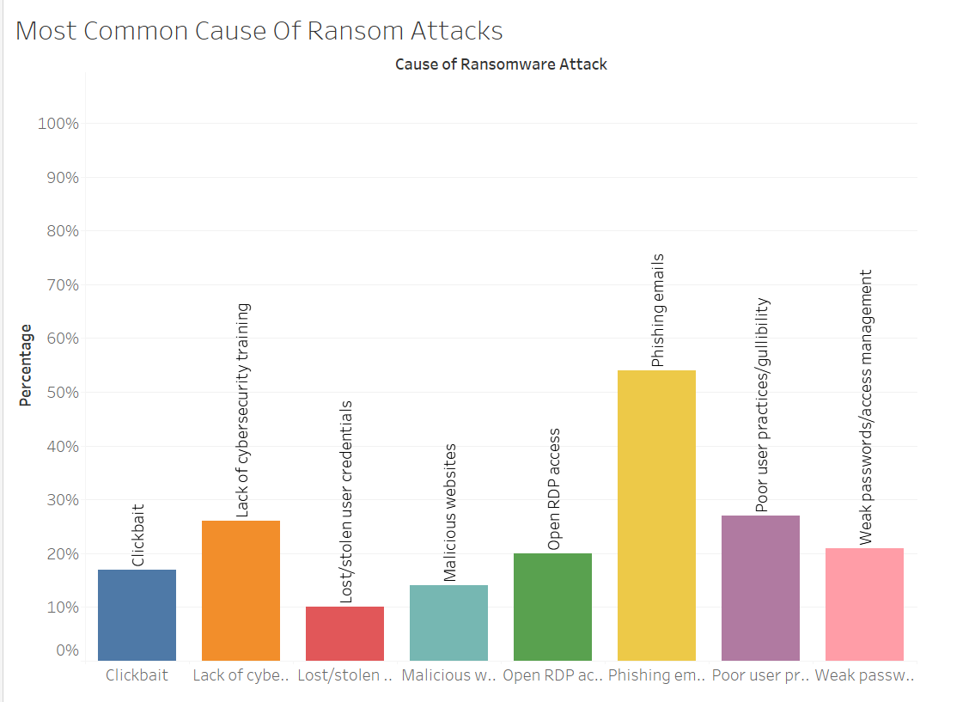
The economic impact of ransomware is notable, with organizations facing millions of dollars in costs due to ransom payments and recovery efforts. The financial burden is exacerbated by the evolving nature of ransomware, which includes tactics such as double extortion, where attackers not only encrypt data but also exfiltrate it, threatening to release it publicly unless a ransom is paid[4]This evolution complicates the landscape for organizations, making it essential for them to understand the risks and implement robust cybersecurity measures to mitigate potential attacks[5].
Figure 1: Bar Chart

The bar chart shows the main causes of ransomware attacks from a 2020 survey[1]. Phishing emails lead with 54%, followed by poor user practices at 27%, lack of cybersecurity training at 26%, and weak passwords at 21%.
In light of these findings, it’s clear that strengthening user awareness and cybersecurity education is not just a priority—it’s a necessity. By tackling phishing and user-related vulnerabilities head-on, organizations can turn the tide against ransomware and build a more resilient digital future.

• A Distributed Denial of Service (DDoS) attack is a malicious attempt to overwhelm a target’s network, server, or online infrastructure with a flood of illegitimate traffic, rendering it inaccessible to legitimate users. Unlike a single-source Denial of Service (DoS) attack, DDoS leverages a distributed network of compromised devices—often forming a botnet (e.g., hijacked computers, IoT devices, or servers)—to amplify the assault[2]. Attackers typically exploit vulnerabilities in protocols like HTTP, TCP, or UDP, sending massive volumes of requests that exhaust bandwidth, CPU, or memory resources[3].
For FinSecure Ltd (FSL), this threat is particularly acute due to its reliance on online client services, such as real-time account access, payment processing, and customer support portals. A successful DDoS attack could disrupt these critical operations, undermining client trust and incurring financial losses.
Types of DDoS Attacks Relevant to FSL
- Volumetric Attacks:
  - Description: Flood the network with excessive traffic (e.g., UDP floods, ICMP floods) to saturate bandwidth[4].
  - Impact on FSL: Could clog the internet pipe connecting FSL’s servers to clients, preventing access to online banking or trading platforms. For example, a 100 Gbps flood could overwhelm a typical enterprise connection.
- Protocol Attacks:
  - Description: Exploit weaknesses in network protocols (e.g., SYN floods) to exhaust server resources like connection tables[3].
  - Impact on FSL: Might disable FSL’s web servers by tying up resources, halting transaction processing during peak hours.
- Application Layer Attacks:
  - Description: Target specific applications (e.g., HTTP floods) with seemingly legitimate requests that overload backend systems like databases.
  - Impact on FSL: Could cripple the client portal by overwhelming the login page or API endpoints, disrupting user authentication.
Why DDoS is a Critical Risk for FSL
FSL’s business model hinges on uninterrupted online availability. Clients expect 24/7 access to financial services, and any downtime—especially during high-traffic periods like tax season or market volatility—could lead to:
- Revenue Loss: A 1-hour outage might cost thousands in unprocessed transactions, with indirect losses from missed market opportunities.
- Reputation Damage: Clients may perceive downtime as a sign of unreliability, driving them to competitors.

1.2 Internal Threats: A Closer Look
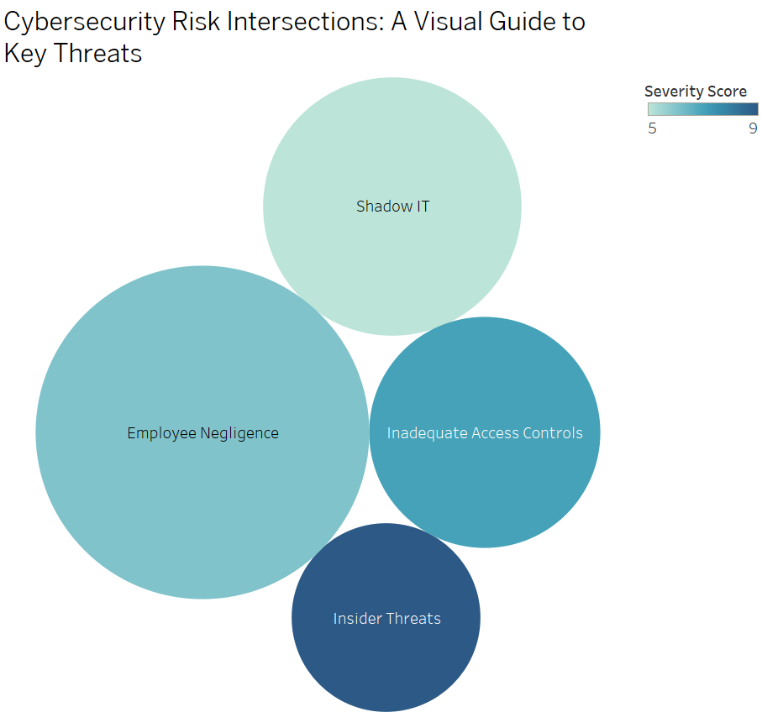
Internal vulnerabilities at FinSecure Ltd (FSL) heighten external risks, posing significant challenges to network security. These threats stem from within the organization and require targeted mitigation to protect sensitive financial data.
Figure 2: Visualization of key cybersecurity threats ranked by severity, including employee negligence and insider threats.

- Employee Mistakes: Unintentional errors, like clicking on phishing emails or using weak passwords (e.g., "Password123"), can lead to security breaches. Remote workers, especially those distracted or lacking training, increase this risk by accidentally exposing client data or allowing attackers into FSL’s systems.
- Insider Risks: Employees who are unhappy or influenced by outsiders may intentionally share sensitive information, such as client account details, or disrupt operations. A single employee with access to critical systems could cause significant damage quickly[5].
- Unauthorized Tools: Remote workers using personal tools, like unapproved file-sharing apps or outdated devices, bypass FSL’s security measures. This creates gaps where malware or data leaks can occur without detection.
- Weak Access Management: Employees with more system access than needed, such as an HR staff member with admin privileges, pose a risk. If their accounts are compromised, attackers could gain control over entire systems, amplifying the damage[6].
These internal threats, though often overlooked, can cripple FSL’s operations and erode client trust. Addressing them demands a blend of policy enforcement, technical safeguards, and cultural change.

2. Security Policies
FSL’s security policies align with industry best practices (e.g., NIST Cybersecurity Framework, ISO 27001) and address identified threats. Below are key policies:
2.1 Acceptable Use Policy (AUP)[7]
- Objective: Define permissible use of company devices, networks, and data.
- Details: Prohibits personal use of corporate systems, mandates strong passwords (minimum 12 characters, alphanumeric), and requires multi-factor authentication (MFA) for all access points.
2.2 Remote Work Policy
- Objective: Secure remote access amid increased work-from-home trends.
- Details: Mandates VPN usage with end-to-end encryption, bans unapproved devices, and requires regular security updates on personal devices used for work[8].
2.3 Data Protection Policy
- Objective: Safeguard sensitive client and financial data.
- Details: Enforces encryption for data at rest and in transit, restricts data access based on role, and requires annual audits of data handling practices.
2.4 Incident Reporting Policy
- Objective: Ensure timely reporting and response to security incidents[8].
- Details: Requires employees to report suspicious activity within 1 hour via a dedicated hotline or portal, with anonymity options for whistleblowers.
2.5 Third-Party Risk Management Policy
- Objective: Mitigate risks from external vendors.
- Details: Mandates vendor security assessments, contractual cybersecurity clauses, and continuous monitoring of vendor compliance.

3. Mitigation Measures
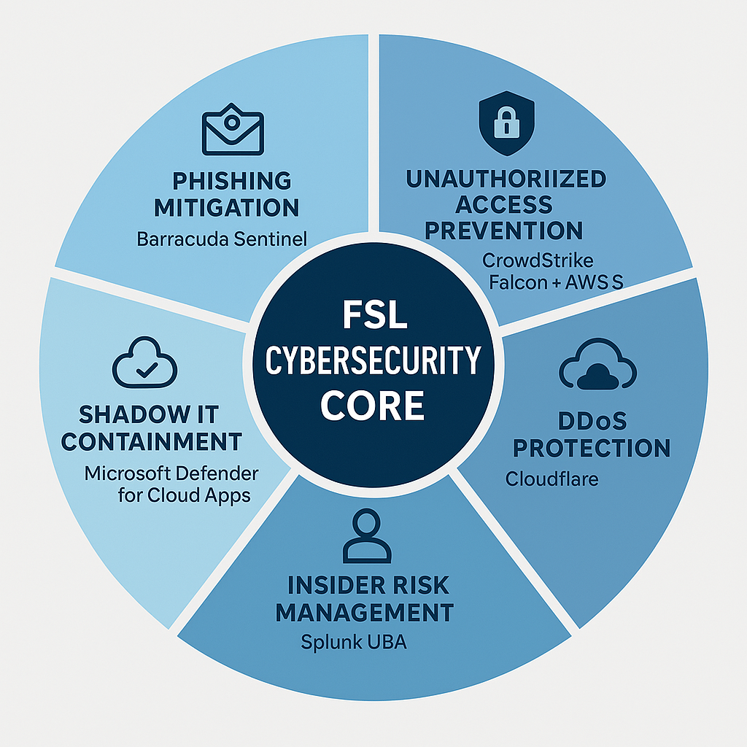
Recent security incidents at FinSecure Ltd (FSL), including phishing attacks and unauthorized access attempts, demand targeted actions to neutralize identified threats. This section presents practical measures to mitigate external risks (e.g., phishing campaigns) and internal vulnerabilities (e.g., employee oversights). Each measure details implementation steps and includes brief descriptions of required tools, ensuring robust protection of company systems, data, and operations as mandated by the board.
Figure 3: Core components of FSL's cybersecurity framework, highlighting tools for threat mitigation and risk management.

3.1 Phishing Attack Mitigation
- Measure: Deployment of an intelligent email filtering system.
- Tool Description: Barracuda Sentinel—a security program that scans emails to block scams and harmful messages[9].
- Implementation: Installation of Barracuda Sentinel occurs across email infrastructure for comprehensive screening. Configuration targets fraudulent senders (e.g., “FSL Support” from unverified domains) and malicious links. Integration with monthly staff simulations replicates phishing attempts—such as “Urgent: Account Verification Required”—to improve detection skills. Execution prevents external actors from compromising sensitive client and financial information.

3.2 Unauthorized Access Prevention
- Measure: Implementation of endpoint security and routine data backups.
- Tool Description: CrowdStrike Falcon—a software tool that watches devices for suspicious activity and stops attacks[10].
- Additional Tool: AWS S3—a secure online storage service for saving and protecting files[11].
- Implementation: Deployment of CrowdStrike Falcon extends to all company devices for ongoing monitoring. Setup identifies unusual actions, such as repeated login failures, and triggers alerts[12]. Daily encrypted backups of critical data—including client records—utilize AWS S3 with strict access controls. Quarterly recovery tests confirm restoration capabilities, ensuring resilience against breaches or ransomware. This maintains data security and availability.

3.3 DDoS Threat Reduction
- Measure: Utilization of a cloud-based protection service for Distributed Denial-of-Service (DDoS) attacks[13].
- Tool Description: Cloudflare—a service that shields websites from overload attacks by filtering traffic.
- Implementation: Engagement with Cloudflare establishes traffic management for FSL’s online platforms. Configuration sets connection limits to block excessive requests. Annual testing simulates attack conditions, verifying uptime for customer portals and banking services. Implementation ensures service continuity during attempts to disrupt network resources.

3.4 Insider Risk Management
- Measure: Application of behaviour monitoring and restricted access protocols[14].
- Tool Description: Splunk UBA—a system that tracks user actions to spot unusual or risky behaviour[15].
- Implementation: Installation of Splunk UBA monitors employee system interactions, flagging anomalies like late-night file access. Enforcement of role-based access limits permissions to job-specific needs—finance personnel access financial data, not human resources records. Monthly reviews maintain compliance and adjust privileges accordingly. This reduces potential internal data exposures or disruptions[15].

3.5 Shadow IT Containment
- Measure: Adoption of a cloud access security broker (CASB) to regulate application usage.
- Tool Description: Microsoft Defender for Cloud Apps—a tool that checks and controls what software employees use[16].
- Implementation: Activation of Microsoft Defender for Cloud Apps oversees software across the organization. Configuration blocks unapproved applications, such as unauthorized file-sharing tools. Maintenance of an approved software list—updated quarterly—specifies acceptable tools like FSL’s email system. Execution prevents data leaks through non-compliant channels[16].
These measures directly counter FSL’s phishing and unauthorized access incidents with clear, effective solutions. Implementation leverages reliable tools—described briefly for clarity—establishing a strong defence framework. Integration with monitoring, response, and training efforts ensures comprehensive security for company operations.

4.1 Monitoring Strategy
FinSecure Ltd (FSL) will establish a streamlined Security Operations Center (SOC) to serve as the central hub for protecting our systems. By leveraging our existing IT team and partnering with external specialists, we’ll ensure effective and efficient operations. The strategy includes the following components:
- Tools: We will deploy a Security Information and Event Management (SIEM) system, such as Splunk or IBM QRadar, to monitor network activity. The SIEM will collect and analyze logs—records of all system events—to detect threats in real time, such as unauthorized login attempts or suspicious network traffic[17].
- Frequency: Monitoring will operate 24/7, with the SIEM generating automatic alerts for any unusual activity, such as repeated failed login attempts or unexpected data transfers during off-hours.
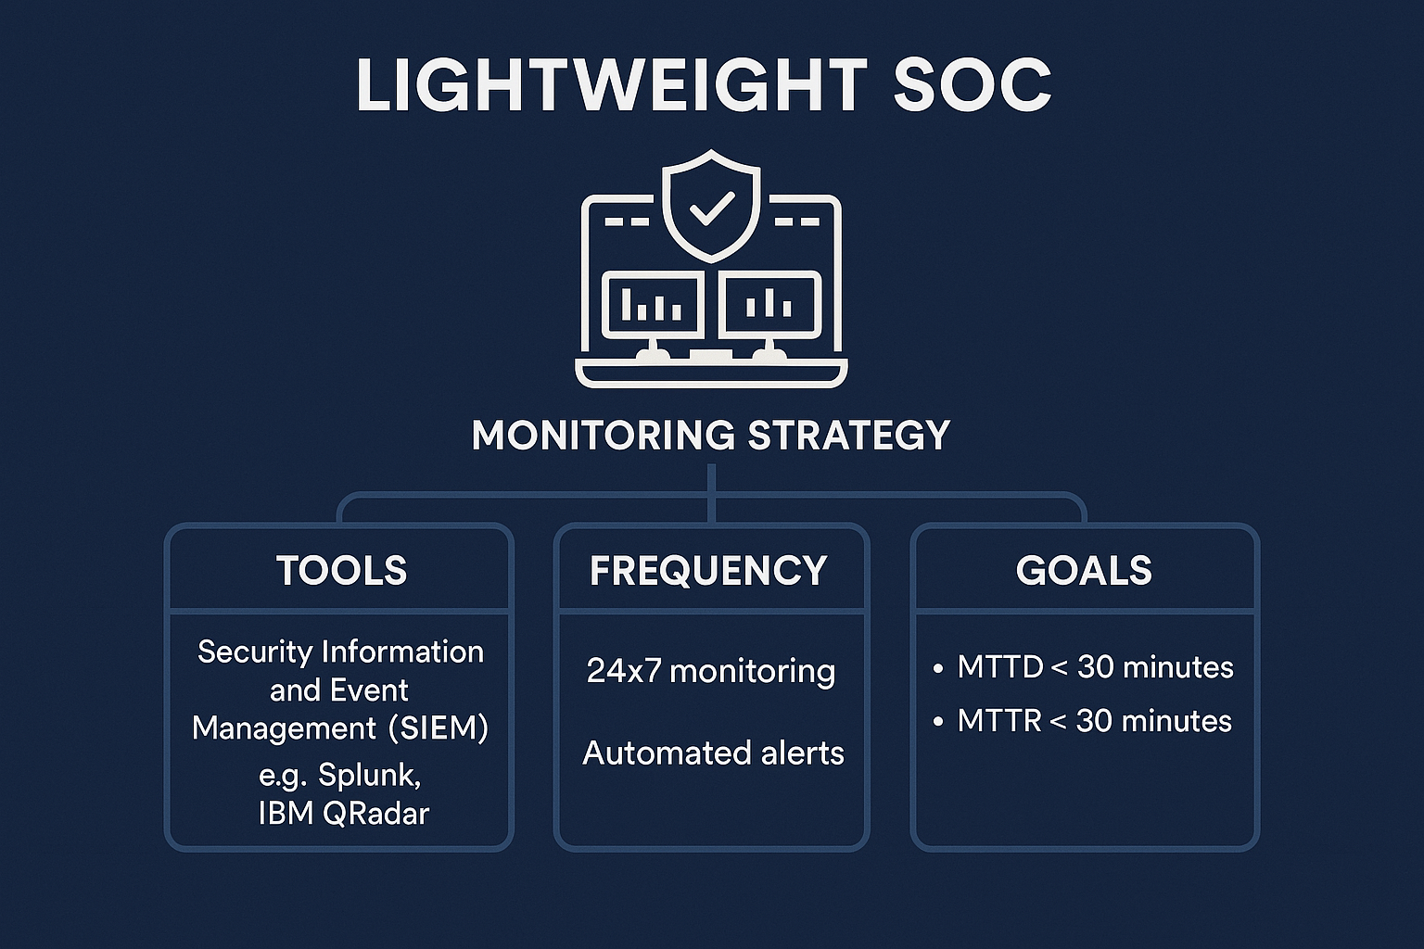
- Goals: Our objective is to identify and address threats swiftly. We aim to detect critical incidents (mean time to detect, or MTTD) within 30 minutes, aligning with industry best practices to limit exposure. Similarly, we will respond to incidents (mean time to respond, or MTTR) within 30 minutes to contain and resolve issues before they escalate.
Figure 4: Monitoring Strategy

Incident Response Plan[18]
The organization has established a comprehensive six-step incident response plan to address cybersecurity incidents, such as malware infections or unauthorized intrusions, in a systematic and efficient manner. This plan ensures preparedness, rapid response, and continuous improvement to safeguard systems and data.
1. Preparation
The organization proactively prepares for potential incidents by assigning key roles, including an Incident Commander to lead the response and an IT Lead to manage technical operations. A detailed, regularly updated contact list containing phone numbers and email addresses of all relevant personnel is maintained. Incident response tools and plans are tested periodically to ensure readiness, enabling a coordinated and effective response when an incident occurs.
2. Identification
Upon detection of suspicious activity, the organization swiftly verifies the incident. The Security Information and Event Management (SIEM) system generates alerts for potential threats, and employees are trained to report anomalies, such as phishing emails. The incident response team confirms the incident within 15 minutes, analyzing indicators to determine the nature and scope of the threat.
3. Containment
Once an incident is confirmed, the incident response team contains the issue to prevent further impact. Affected systems, such as a compromised server, are isolated from the network through segmentation, limiting the threat's ability to spread. Containment measures are implemented within one hour to minimize damage and maintain operational integrity.
4. Eradication
The organization eliminates the root cause of the incident, whether it is malware, exploited vulnerabilities, or other threats. Forensic tools are utilized to thoroughly investigate and remove all traces of the incident. This cleanup process is completed within 24 hours, ensuring no residual threats remain in the environment.
5. Recovery
After eradication, the organization restores affected systems to normal operation. Clean system copies are retrieved from secure backups, verified for integrity, and deployed to ensure they are free from compromise. Systems are fully restored within 48 hours, enabling the organization to resume operations with confidence in their security.
6. Lessons Learned
Within seven days of resolving an incident, the incident response team conducts a comprehensive debrief to evaluate the response. The team documents successes, identifies areas for improvement, and updates the incident response plan and security controls accordingly. This iterative process strengthens the organization’s defenses against future incidents.
4.3 Diagram: Incident Response Flowchart
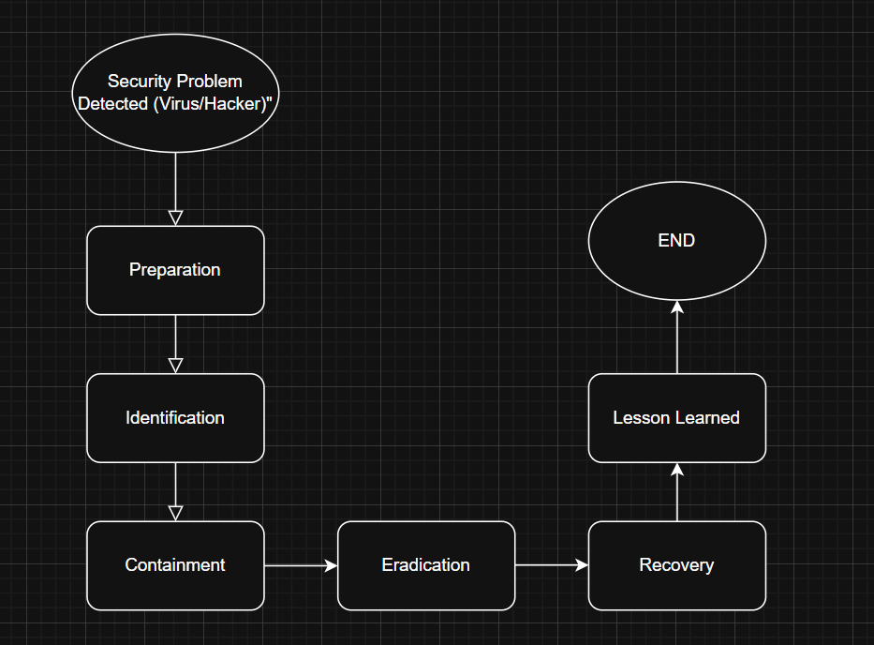
Figure 5: Incident response lifecycle illustrating key phases from detection to recovery and lessons learned.

5. Training and Awareness Program

5.1 Program Objectives
- Equip staff to recognize and respond to threats[19].
- Foster a proactive security culture aligned with FSL policies.

5.2 Training Components[20]
- Onboarding Module: 2-hour session for new hires covering policies, phishing recognition, and password hygiene.
- Quarterly Workshops: 1-hour interactive sessions with gamified phishing simulations (e.g., KnowBe4 platform) and real-world case studies.
- Monthly Micro-Learning: 5-minute videos or quizzes delivered via email on topics like MFA usage or VPN best practices.
- Annual Refresher: Full-day event with external experts simulating a breach, testing response skills.

5.3 Incentives and Engagement
- Reward System: Offer points for completing training, redeemable for gift cards or recognition in company newsletters[21].
- Security Champions: Appoint departmental volunteers to promote awareness and report compliance gaps[21].

5.4 Effectiveness Metrics
- Measure phishing click rates (target <5% within 6 months), policy violation incidents (reduce by 50% in year 1), and staff feedback via surveys.
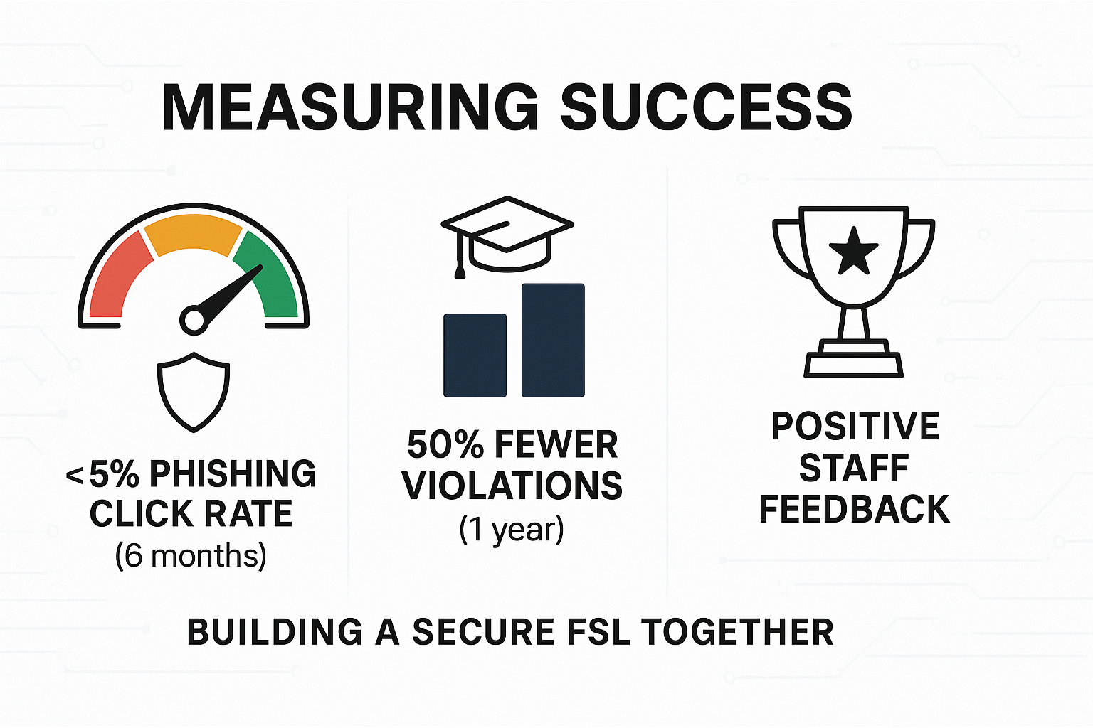
Figure 6: Measuring Success

Conclusion
This report provides FinSecure Ltd with a strategic roadmap to counter its cybersecurity challenges. By identifying critical threats, enforcing robust policies, implementing targeted mitigation measures, establishing a vigilant monitoring and response framework, and investing in staff training, FSL can transform its security posture. These efforts will not only mitigate risks but also enhance operational resilience and client confidence in an increasingly hostile digital landscape. Immediate next steps include board approval of the proposed budget and timeline, with implementation targeted to commence by Q2 2025.

References
[1] "Cyber Threat Intelligence." https://www.bridewell.com/cyber-threat-intelligence (accessed Mar 25).
[2] M. Alomari, et al., "A Comprehensive Review of Distributed Denial-of-Service (DDoS) Attacks: Techniques and Mitigation Strategies," 2024. doi: 10.1109/WiDS-PSU61003.2024.00051.
[3] "How do DoS attacks exploit vulnerabilities in network protocols? – Cyberly," Accessed: Apr 11, 2025, [Online]. Available: https://www.cyberly.org/en/how-do-dos-attacks-exploit-vulnerabilities-in-network-protocols/index.html
[4] T. Mahjabin, et al., "A survey of distributed denial-of-service attack, prevention, and mitigation techniques," International journal of distributed sensor networks, vol. 13, no. 12, pp.155014771774146, 2017. doi: 10.1177/1550147717741463.
[5] "Understanding Internal and External Vulnerability Scans", CYRISMA Cyber Risk Management Platform, https://www.cyrisma.com/understanding-internal-and-external-vulnerability-scans/ (accessed May 13, 2025).
[6] K. Timonera, "External vs. Internal Vulnerability Scans: What’s the Difference?" Datamation, -12-05 2023. Accessed: May 13, 2025, [Online]. Available: https://www.datamation.com/security/external-vs-internal-vulnerability-scans-whats-the-difference/
[7] Martins A, "What Is an Acceptable Use Policy (AUP)?" Accessed: May 12, 2025, [Online]. Available: https://www.business.com/articles/acceptable-use-policy/
[8] Souza B. "The Critical Role of Policies, Standards, and Procedures in Cybersecurity Governance." https://www.execcybered.com/blog/the-critical-role-of-policies-standards-and-procedures-in-cybersecurity-governance (accessed May 12).
[9] D. Strom, "9 cloud and on-premises email security suites compared," CSO (Online), 2021.
[10] G. Kurtz, "QUID PRO ... WHOA," Forbes, vol. 203, no. 1, pp.24, 2020.
[11] "Introduction to AWS Simple Storage Service (AWS S3)." https://www.geeksforgeeks.org/introduction-to-aws-simple-storage-service-aws-s3/ (accessed May 6).
[12] R. Shtonda, et al., "PRACTICAL APPROACHES TO CYBER PROTECTION OF MOBILE DEVICES WITH THE HELP OF A SOLUTION ENDPOINT DETECTION AND RESPONSE," Kìberbezpeka.osvìta, nauka, tehnìka, vol. 1, no. 21, pp.17–31, 2023. doi: 10.28925/2663-4023.2023.21.1731.
[13] A. Sharma, et al., "Analysis and Implementation of DDOS Attacks and Prevention," 2023. doi: 10.1109/ICAICCIT60255.2023.10465773.
[14] B. Hayes, K. Kotwica and R. Lefler, "INSIDER THREATS," Financial Executive, vol. 27, no. 5, pp.34, 2011.
[15] "SPLUNK SECURITY SOLUTIONS ENHANCE SECURITY," Computer Security Update, vol. 16, no. 10, 2015.
[16] Nemnom C, "What Is Microsoft Defender For Cloud Apps? All You Should Know - CHARBEL NEMNOM - MVP | MCT | CCSP | CISM - Cloud & CyberSecurity," -10-10 2022. Accessed: May 12, 2025, [Online]. Available: https://charbelnemnom.com/microsoft-defender-for-cloud-apps/
[17] D. Daggett, "Analyzing Risks of Virtual Private Network Connections," United States. 2024.
[18] A. Fernandes, et al., "A Strategy for Implementing an Incident Response Plan," 2021. doi: 10.34190/EWS.21.080.
[19] K. Labs. "Top 11 Essential Security Awareness Training Topics in 2025 - Keepnet." https://keepnetlabs.com/blog/top-11-essential-security-awareness-training-topics-of-2025 (accessed May 5).
[20] A. Anwar, "8 Essential Topics To Cover In Your Cyber Security Training," Accessed: May 5, 2025, [Online]. Available: https://www.cyberpilot.io/cyberpilot-blog/8-essential-topics-to-cover-in-your-cyber-security-training
[21] K. Labs. "How to Increase Employee Interest in Security Awareness Training? - Keepnet." https://keepnetlabs.com/blog/how-to-increase-employee-interest-in-security-awareness-training (accessed May 5).

