WORKPLACE CULTURE AND ITS IMPACT ON ORGANISATIONAL EFFICIENCY.

Mohammad Wasimuzzaman
Student ID: 1708859
Lecturer: Dr Eric Osei
Module code: BMSK5005

Executive Summary
In this report, it has highlight about the company Vila Spice and Grill, Birmingham. It has also highlighted about the external environmental factors which are effecting this organization with the help of PESTLE analysis. It has also highlighted about the internal factors of the organization which is affecting their performance through SWOT and McKensy’s 7 framework analysis. It has also highlighting about the ethical stance of the organization. Apart from that; it has also discussion about the comparison of the organizational culture with its competitors. Lastly, a recommendation has been provided for increasing the workplace culture of this organization in the future.

Table of Contents
1. Introduction 4
2. Findings 4
2.1. Analysis of external environmental factors of the organization 4
2.2. Analysis of the internal factors of organization 6
3. Analysis 10
3.1. Analysis of the ethical stance of the company 10
3.2. A Comparison of the company’s culture with its competitors 11
4. Recommendation 12
5. Conclusion 13
Reference List 14
Appendices 16
Appendix 1: Sale tax rate of UK in the year 2019 16
Appendix 2: Inflation rate of the UK 17

1. Introduction
Workplace culture is the kind of environment which is established by the company for its employees. It plays an important role in discovering the work satisfaction as well as progression and relationships of the employees within the organization. In the present, study, the discussion has been done based on the identification of external environmental elements which are impacting Vila Spice and Grill, Birmingham (VSG) company performance through PESTLE analysis. Further discussion has been completed on the basis of SWOT analysis as well as McKensy’s 7 framework for understanding the internal factors of the mentioned enterprise. Apart from that, ethical stance, as well as comparison of this brand culture with its competitors, has also been finished in this study.

2. Findings

2.1. Analysis of external environmental factors of the organization
PESTLE Analysis
Factors | Description | Impact
Political | - Corporate tax is 19% in the year 2019 (gov.uk, 2019)  - In the year 2019, the sales tax rate is 20% (tradingeconomics, 2019) (Refer to Appendix 1) | Negative
Economical | - The inflation rate has reduced by 1.7% (tradingeconomics, 2019) (Refer to appendix 2)  - GDP rate has been increased by 1.3% (tradingeconomics, 2019) | Positive
Social | - Different cultural people available  - Presence of people with various food habits.  - Literacy rate in the UK is 99% (macrotrends,2019) | Positive
Technological | - £ 5.5 bn has been invested in the technology by the UK government  - Online food ordering apps and websites  - Smooth payment system through digital banking | Positive
Legal | - Equality Act of 2010 (legislation.gov.uk, 2019)  - Health and safety at work act of 1974 (hse.gov.uk)  - Employment Rights Act of 1996 (legislation.gov.uk, 2019)  - Food Safety Act of 1990 (legislation.gov.uk, 2019) | Positive
Environmental | - Environmental protection act of 1990 (legislation.gov.uk, 2019)  - Recycling Law of the UK (recyclingbins.co.uk, 2017) | Positive
Table 1: Pestle Analysis based on the UK hospitality industry
(Source: Arif and Hossin, 2016)
Analysis
In the statement of Kara (2018), PESTLE analysis has become one of the popular models for the researchers. It has been adopted as the comprehensive process utilizes for the market as well as industry assessment. It is consist of environmental as well as political, legal, social, economic and technological factors which can encourage organizational failure as well as success. It is the type of approach for analyzing the external factor. In this context, the political factor consists of tax regulations as well as government stability and so on. The economic factor is consists of GDP rate, inflation rate and GNP rate. On the other hand, social factor is consists of culture as well as the values of the people and social influences. The technological factor is related to the development of technology in relation to the marketing and industry. Legal factor sates the laws and regulations followed in the industry and environmental about the protection of the environment.
The political factors such as sales tax rate as well as the corporate tax rate have influenced the profit and loss of the company VSG negatively. In this context, they have to give 19% corporate tax rate as well as a 20% sales tax to the government of the UK (tradingeconomics, 2019). This high rate can affect the financial status of this organization in a negative way. The financial growth of this brand can also get impacted by these factors also. The GDP rate has increased in the year 2019 which can have a positive impact on financial growth. On the other hand, the inflation rate has also decreased which can also have a positive effect on this company. The influence of social factor can also have a positive impact on the growth of the profitability of this company. This organization is technologically advanced as they provide fast delivery of the food items after order is placed. They follow all the legal aspects by maintaining the rules as well as regulations of the government policy. They also follow the recycling law by not using plastic bags for food packaging as well as delivery (vilaspice.co.uk, 2019).

2.2. Analysis of the internal factors of organization
SWOT Analysis
Strengths  - A strong presence of Indian and Bangladeshi foods  - Offers a great amount of delicious food (vilaspice.co.uk)  - Accepts all types of cards for payment purpose  - Uses fresh and finest ingredients | Weaknesses  - Lack of beverage offerings like alcohol  - Lack of local dishes availability  - Food delivery is chargeable above 4-mile radius (vilaspice.co.uk)
Opportunities  - They can start preparing local foods  - Can prefer all type of cultural people  - Opportunity to have different types of beverages available | Threats  - Strong competitors like Ledbury, five Fields and The French table  - Government policy as well as tax  - Huge number of competition in the market
Table 2: SWOT Analysis of the VSG organization
(Source: Jha-Thakur and Fischer, 2016)
Analysis
As opined by Jha-Thakur and Fischer (2016), SWOT analysis is mainly used for analyzing the prospects of the business internal environment. In the SWOT, the internal factors can be considered as strengths as well as weaknesses. In this context, the external factors can be considered as threats as well as opportunities. However, the strengths of the brand VSG can be included as they are famous for preparing Indian as well as Bangladeshi grilled foods. On the other hand, they accept all kinds of credit as well as debits. They are restaurants are fully air-conditioned.

Figure 1: SWOT Analysis of VSG
(Source: Jha-Thakur and Fischer, 2016)
However, in this perspective, the weaknesses of this enterprise can be identified as they do not offer alcohol to the customers who prefer it. They also charged a minimum amount for delivering the food above 4-mile radius distance. They are not offering the dishes for the local people. On the other hand, they have opportunities to add local items in their menu in order to target their local customers. They should also alcohol along with coffee as well as desserts. They have a direct threat from the five fields as well as Ledbury and French tables’ restaurants. The huge amount of tax has also a negative impact on the financial growth of this firm.
McKinsey’s 7 frameworks
As per the view of Cox et al. (2019), the model of 7S provides resource-based observation of the strategic assets present to the company especially with the help of seven key factors like strategy as well as systems, structure, staff, style, shared values and skills. This model has been designed for explaining major factors within the company which has been contributed to gaining its strategic objectives.
Strategy
This concept is the plan of the organization for creating as well as maintaining a competitive advantage within a specified industry. In this context, the main strategy of the enterprise VSG is to prepare dishes for the local people in order to make them strongly present in the competitive advantage. The adding of the local dishes can help them to gain the attention of the local people towards their restaurant apart from Indian customers (Cox et al. 2019).
Style
This step of this model represents the techniques followed by the managers of a particular brand in order to manage the organization successfully. However, in any other words, it can be considered as the style management of the leaders of the enterprise. In this context, the brand like VSG follows the leadership style in order to fulfil its planned objectives of making them successful.

Figure 2: Different steps of structure of McKinsey’s 7
(Source: Cox et al. 2019)
Structure
This part of the model states about the division as well as units of the business is organized along with stating about the particulars job roles of each member (Irani and Sharif, 2018). In this context, this company follows the hierarchical structure in order to divide their employees as per their job roles as well as categories.
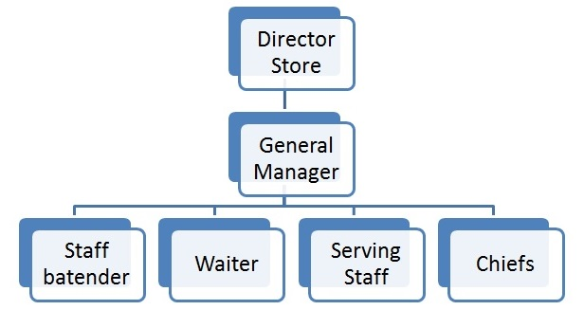
Figure: organizational hierarchy
System
It is the procedures as well as processes of the organization which tells about the regular activities of the business as well as regarding the decision which has been taken place. In this perspective, the decision about job roles as well as the responsibilities of every member of the restaurants by the management level of this brand. The manager of this firm takes the decision for doing their business in order to achieve their targeted goals (Cox et al. 2019).
Staff
It is the kind of factor which is concerned about the hiring of the talented as well as experienced employees for the company for keeping the sustainability of the company. However, in this context, by following this model the human resources department of this brand can understand regarding the number of employees is needed to hire. They also recruit the employees as per the requirements of them.
Skills
It is the type of capabilities which is required for the employees in order to help the particular company to achieve their goals. This also includes competences as well as the capabilities of taking responsibilities of their job. In this context, this brand hires their staff members as per the knowledge as well as skills, experience and abilities of them for achieving their organizational goals.
Shared values
It is the fundamental factor of this model as it is the standards as well as norms which helps employees behaviours as well as actions of the enterprise. Hence, it can be considered as the foundation of the company. However, in this context, by following this stage of the model, this brand can be able to understand the attitudes of their employees towards their work. It can also help them to the contribution of the workers for achieving their organizational goals gradually (Rhodes, 2016).

3. Analysis

3.1. Analysis of the ethical stance of the company
In the mentioned of Bachmann et al. (2015), when within the enterprise, organizational trust failure happens then the responsible person for causing this issues can be included as individual employees within the company. In this context, trust plays a significant role in facilitating exchange in social, however, most of the global events have determined trust within the institutions as well as organization.
The organization VSG increases the trust within their customers by providing clear information about the food ingredients they used for preparing dishes. Thrust is the most important of the business which is needed to be maintained by all the companies in order to remain in a competitive advantage. In this context, high organizational ethical practices by this organization have helped them to increase their productivity by lowering the cost of their business transactions. Apart from that, they are able to create their loyalty towards their customers as well as they have also increased their trustfulness of their suppliers. They are also able to keep the successful team of workers as well as social capital. On the other hand, as stated by Rhodes (2016), it is also necessary to value as well as respect the cultures as well as believes of the different people.
The most important ethical concept followed by this organization is that they respect the various cultures as well as the tastes of their customers in order to retain their customers. They provide a friendly environment for their customers in order to make them comfortable which is the most important ethical factor. They respect the privacy of their customers by providing time to select their personal choice food items. They also helped the customers to select foods from the menu card who are not able to make a choice successfully. The employees of this organization respect as well as value the cultures as well as beliefs of the individual’s employees by maintaining the ethical consideration of the company. The individual team members value the decisions of each other and also take suggestions from others, in case, they are not able to solve the problems of them (thefrenchtable.co.uk, 2019).

3.2. A Comparison of the company’s culture with its competitors
The organization French table is famous for preparing French dishes as well as for a comfortable environment. Along with that they also offer local dishes to their customers in order to retain them. They have maintained their professionalism in the context of their customers (thefrenchtable.co.uk, 2019). They also offer alcohol as beverages along with coffee as well as desserts to their customers. In this context, the VSG Company does not offer alcohol to their customers who preferred this beverage which can have a negative impact as they can lose their customers to the rival brand. On the other hand, they do not prepare local dishes rather only concentrated on the Asian as well as Bangladeshi foods for their customers. Thus, they have a low presence of local customers on their restaurants which can impact their financial growth as well as profitability. Charles Handy Model of Organization Culture divide the culture in an organization as four types like power, role, task, and person (Rhodes, 2016). According to the power culture, power in an are among the some people in the organisation who have the influence to the very activities of the organization. There are the some who enjoy special privilege than other and they also delegate’s responsibilities to other. In role culture potion held in organization by the person are based of roles and responsibilities and these responsibilities and roles are set by the organizational structure and there is a tall organizational structure to indicate all activities and roles within the organization (Pakdil and Leonard, 2015) . Task culture is based on achieving success for a specific project or time line. Where power is moved on the basis of work and project as well as the team member. Peron culture. When employee feels that they are more important than their organization and tis is called person culture. Individual are more self-centered than the organization they are busy with self-success rather than organizational success.

In this perception, the French table brand offers gift vouchers as well as monetary gift cards to their customers for ordering foods (thefrenchtable.co.uk, 2019). It is the most preferred restaurants for all types of customers. They also respect the requirements as well as preferences of their customers whether they are local or global customers. However, on the other hand, VSG Company also gives more preferences to Bangladesh as well as Indian customers rather than local customers. The French table values as well as respect the different culture customers in order to retain as well as satisfy them. The employees of this organization have great coordination among each other which help them to maintain their competitive advantage in the market.
On the other hand, their staff members respect the opinions as well as decisions of other individual team members by acknowledging their decisions respectfully. They also have the availability of selecting foods from their 3-course meals as well as 5-course meals. However, the VSG does not offer these preferences to their customers which can have a huge negative impact on their productivity. Both the organizations value their employees and in order to retain them, they provide rewards to their employees as a mot6ivation. The motivation of the employees is the most important factor for making any organization successful.

4. Recommendation
In order to increase the organizational culture of the workplace of this company, then VSG the three steps of Kurt Lewin’s model which can be included as unfreezing as well as refreezing and movement. However, by following this model, they can able to successfully implement the changes in their workplace culture. It is also important to maintain food security by them in order to increase the productivity of the company. As per the observation of Irani and Sharif (2018), food security is the most important factor which includes as well as impings upon and also incorporates a number of environmental operations in the context of the supply of the food as well as demand, services, regulations and health.
On the other hand, according to Pakdil and Leonard (2015), the culture of the organization can affect the performance as it impacts the behaviours of the individuals. In this context, it is the essential element in the lean process of successful as cultures discover whether a method or an idea is adopted or rejected. On the other hand, it is the system of beliefs which is shared by the members of the company which can be involved as traditions as well as adaptable process, stories and working to achieve successful goals.
However, in order to enhance the workplace culture of this company, it also necessary for them to motivate their employees by acknowledging their performance with the help of rewards as well as incentives. The motivation of the workers can help to retain their talent as well as experienced staff in order to increase the efficiency of their business successfully (Christians et al. 2015). On the other hand, highly motivated employees can help them to satisfy their customers with their effective services. The managers of this organization should also provide timely feedback to their employees for helping them to rectify their mistakes successfully.

5. Conclusion
In the entire study, it can be concluded that the maintenance of business ethics is the essential key factors for making any company successful as well as developed. In this context, organizational cultures play an important role in the success of the enterprise. The company VSG maintains its business ethics in order to retain their customers as well as their skilled employees effectively as well as efficiently. The PESTLE and SWOT analysis have helped to understand the internal as well as external factors which are impacting the performance of the mentioned brand in the context of both positive as well as negative way.

Reference List
Arif, T.M.H. and Hossin, M.Z., (2016). A comparative analysis of internal and external environments between Hotel Hyatt, UK and Hotel The Cox Today, Cox’s Bazar, Bangladesh. IOSR Journal of Humanities and Social Science, 21(6), pp.13-22.
Bachmann, R., Gillespie, N. and Priem, R., (2015). Repairing trust in organizations and institutions: Toward a conceptual framework. Organization Studies, 36(9), pp.1123-1142.
Christians, C.G., Richardson, K.B., Fackler, M., Kreshel, P. and Woods, R.H., (2015). Media Ethics: Cases and Moral Reasoning, CourseSmart eTextbook 1(1), pp.1-6. UK: Routledge.
Cox, A.M., Pinfield, S. and Rutter, S., (2019). Extending McKinsey’s 7S model to understand strategic alignment in academic libraries. Library Management, 40(5), pp.313-326.
gov.uk, (2019). Rates and allowances: Corporation Tax. Available at:https://www.gov.uk/government/publications/rates-and-allowances-corporation-tax/rates-and-allowances-corporation-tax [Accessed on 2nd October 2019]
hse.gov.uk, (2019). Health and Safety at Work etc Act 1974. Available at:http://www.hse.gov.uk/legislation/hswa.htm [Accessed on 2nd October 2019]
Irani, Z. and Sharif, A.M., (2018). Food security across the enterprise: a puzzle, problem or mess for a circular economy?. Journal of Enterprise Information Management, 31(1), pp.2-9.
Jha-Thakur, U. and Fischer, T.B., (2016). 25 years of the UK EIA System: Strengths, weaknesses, opportunities and threats. Environmental Impact Assessment Review, 61(1), pp.19-26.
Kara, E., (2018). A Contemporary Approach For Strategic Management in Tourism Sector: PESTEL Analysis on The City Muğla, Turkey. İşletme Araştırmaları Dergisi, 10(2), pp.598-608.
legislation.gov.uk, (2019). Employment Rights Act 1996. Available at:http://www.legislation.gov.uk/ukpga/1996/18/contents [Accessed on 2nd October 2019]
legislation.gov.uk, (2019). Environmental Protection Act 1990. Available at:http://www.legislation.gov.uk/ukpga/1990/43/contents [Accessed on 2nd October 2019]
legislation.gov.uk, (2019). Equality Act 2010. Available at:http://www.legislation.gov.uk/ukpga/2010/15/contents [Accessed on 2nd October 2019]
legislation.gov.uk, (2019). Food Safety Act 1990. Available at:http://www.legislation.gov.uk/ukpga/1990/16/contents [Accessed on 2nd October 2019]
macrotrends, (2019). U.K. Literacy Rate 1990-2019. Available at:https://www.macrotrends.net/countries/GBR/united-kingdom/literacy-rate [Accessed on 2nd October 2019]
Pakdil, F. and Leonard, K.M., (2015). The effect of organizational culture on implementing and sustaining lean processes. Journal of Manufacturing Technology Management, 26(5), pp.725-743.
recyclingbins.co.uk, (2017). UK Recycling Law. Available at:https://www.recyclingbins.co.uk/blog/uk-recycling-law/ [Accessed on 2nd October 2019]
Rhodes, C., (2016). Democratic business ethics: Volkswagen’s emissions scandal and the disruption of corporate sovereignty. Organization Studies, 37(10), pp.1501-1518.
thefrenchtable.co.uk, (2019). About Us. Available at: https://www.thefrenchtable.co.uk/ [Accessed on 3rd October 2019]
tradingeconomics, (2019). United Kingdom GDP Annual Growth Rate. Available at:https://tradingeconomics.com/united-kingdom/gdp-growth-annual [Accessed on 2nd October 2019]
tradingeconomics, (2019). United Kingdom Inflation Rate. Available at:https://tradingeconomics.com/united-kingdom/inflation-cpi [Accessed on 2nd October 2019]
tradingeconomics, (2019). United Kingdom Sales Tax Rate – VAT. Available at:https://tradingeconomics.com/united-kingdom/sales-tax-rate [Accessed on 2nd October 2019]
vilaspice.co.uk, (2019). Vila Spice & Grill. Available at: http://www.vilaspice.co.uk/ [Accessed on 3rd October 2019]

Appendices

Appendix 1: Sale tax rate of UK in the year 2019
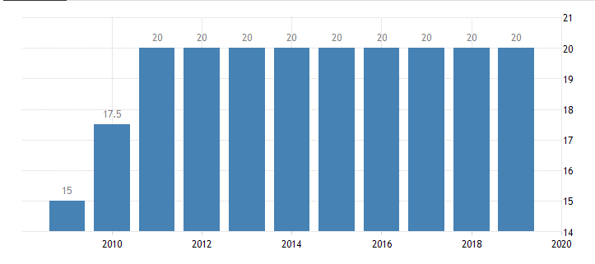
(Source: https://tradingeconomics.com/united-kingdom/sales-tax-rate)

Appendix 2: Inflation rate of the UK
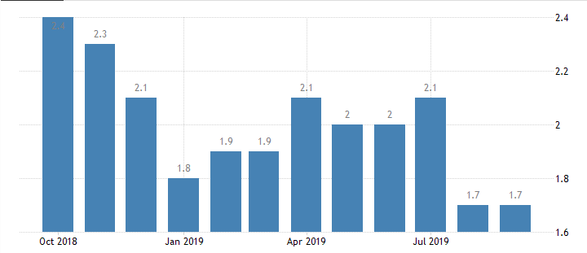
(Source: https://tradingeconomics.com/united-kingdom/inflation-cpi)

