

Usability Comparison of a Set of Websites & Implementation of a Usability-Compliant Website

By Callum William Bain

Supervisor: James Williams
Second Marker: Stephen Hole

Project submitted as part of the requirements for the award of BSc (Hons) Computing (Applied Computing)

26th April 2023

DECLARATION
I, Callum William Bain, declare that I am the sole author of this Project; that all references cited have been consulted; that I have conducted all work of which this is a record, and that the finished work lies within the prescribed word limits.
This work has not previously been accepted as part of any other degree submission.

FORM OF CONSENT
I, Callum William Bain, hereby consent that my Project, submitted in candidature for the B.Sc. (Hons) Computing (Applied Computing) degree, if successful, may be made available for inter-library loan or photocopying (subject to the law of copyright), and that the title and abstract may be made available to outside organisations.

Table of Contents
Table of Contents
Table of Contents 2
Table of Figures 4
Abstract 6
1. Introduction 7
2. Literature Review 8
2.1. Definition of Usability 8
2.2. Criteria 9
2.3. Case Studies 10
2.4. Website Best Practices & Concepts 11
2.5. Usability Evaluation Tools 13
2.6. Justification of Website Set for Testing 17
2.7. Website Design & Implementation Considerations 18
2.8. Conclusion 20
3. Methodology 22
3.1. Research 22
3.2. Development 24
3.3. Project Planning 26
4. Design & Implementation 28
4.1. Design 28
4.1.1. Website Set Testing 28
4.1.2. Pre-Documentation 39
4.2 Implementation 41
4.2.1. Website Implementation 41
4.2.2. Implemented Website Testing 45
4.2.3. Usability Tools Testing 46
4.3. Comparison to the Set 51
5. Evaluation 52
5.1. Conclusions 52
5.2. Aims & Objectives 52
5.3. Future Alterations 53
6. Conclusion & Recommendations 54
6.1. Further Research 55
7. Reflection 56
References 57

Table of Figures
Figure 1 - axe Audit Overview 13
Figure 2- axe Testing Modes 14
Figure 3- WAVE Audit Overview 15
Figure 4- Accessibility Checker Audit Overview 16
Figure 5- Accessibility Checker Audit Critical Issues 16
Figure 6- Ecommerce Site Error Disparities [21] 17
Figure 7- Full Gantt Chart & Timeline 26
Figure 8- Gantt Chart Pt.1 (Aim & Obj.) 26
Figure 9- Gantt Chart Pt.2 (Timeline) 27
Figure 10- Gantt Chart Pt.3 (Timeline cont.) 27
Figure 11- Amazon Home Page Accessibility Checker Testing 29
Figure 12- Amazon Deals Page Accessibility Checker Testing 30
Figure 13- Amazon About Page Accessibility Checker Testing 30
Figure 14- Amazon Home Page axe Testing 31
Figure 15- Amazon Deals Page axe Testing 32
Figure 16- Amazon About Page axe Testing 32
Figure 17- Amazon Home Page WAVE Testing 33
Figure 18- Amazon Deals Page WAVE Testing 33
Figure 19- Amazon About Page WAVE Testing 33
Figure 20- eBay Home Page Accessibility Checker Testing 34
Figure 21- eBay Deals Page Accessibility Checker Testing 34
Figure 22- eBay Help Page Accessibility Checker Testing 35
Figure 23- eBay Home Page axe Testing 35
Figure 24- eBay Deals Page axe Testing 36
Figure 25- eBay Help Page axe Testing 36
Figure 26- eBay Home Page WAVE Testing 37
Figure 27- eBay Deals Page WAVE Testing 37
Figure 28- eBay Help Page WAVE Testing 37
Figure 29- Website Homepage (Wireframe) 39
Figure 30- Website Categories (Wireframe) 39
Figure 31- Website 'Daily Deals' (Wireframe) 40
Figure 32- Website Contact (Wireframe) 40
Figure 33- Header/Navigation HTML Code 42
Figure 34- Header/Navigation CSS Code 42
Figure 35- Header/Navigation Without Fix 42
Figure 36- Header/Navigation With Fix 43
Figure 37- Product Card Column Fix 43
Figure 38- Image Alternative Text HTML 43
Figure 39- Image Alternative Text via WAVE 44
Figure 40- Header Button Hover CSS 44
Figure 41- Failed Website Responsiveness 45
Figure 42- Final Website Home Page axe Testing 46
Figure 43- Final Website Categories Page axe Testing 47
Figure 44- Final Website Deals Page axe Testing 47
Figure 45- Final Website Contact Page axe Testing 48
Figure 46- Missing Search Bar Label 49
Figure 47- Incorrect Colour Contrasting 49
Figure 48- Final Website Home Page WAVE Testing 50
Figure 49- Final Website Categories Page WAVE Testing 50
Figure 50- Final Website Deals Page WAVE Testing 50
Figure 51- Final Website Contact/News Page WAVE Testing 50
Figure 52- WAVE Comparison of Amazon, eBay, & the Final Website 51
Figure 53- axe Comparison of Amazon, eBay, & the Final Website 51
Figure 54- Project Aim & Objectives 52

Abstract
Website usability & accessibility is an important topic, not just in web design, but which also affects the greater perception of websites in general. With many website home pages having no compliancy with major guidelines such as the WCAG, and therefore are more open to lawsuits from its users who require accessibility & usability on a daily basis, it is important to make websites as usable & accessible as possible, in order to allow those users to correctly navigate and use these sites, and to ensure uniformity throughout a website’s pages.
The aim of this project is to investigate the most-visited pages of a set of e-commerce sites, and test them using widely-available 3rd party online usability & accessibility tools, in order to gauge what errors occur on these pages, and how they can be improved upon and modified to ultimately make web pages usable & accessible to those who require it.
In order to demonstrate the findings of the tools, a test website will be created, using HTML, CSS & JavaScript, which mimics the style, form, and appearance of the website set, using the findings of the 3rd party tools, with the end goal of improving upon the design of the set in order to make them compliant, and highlight what changes can be implemented in order to make websites more accessible & usable.
The project concludes with the testing of the implemented e-commerce website, following the findings of the tools when compared to the results of the initial set, and identifies some errors within the set which can modified, and elements to be implemented, to increase website usability compliance.

1. Introduction
Usability testing is the practice of testing the utility of a website or web service within a group of representative users through setting and completing tasks, & matching relevant data against pre-defined criteria, [1]. Website usability has been studied extensively, and is an area which has seen many changes due to the advancement of technologies and the release of standards such as those outlined by the World Wide Web Consortium (W3C), most recently WCAG 2.1, [2].
Despite being an evolving field, some common patterns remain; Nielsen notes that many findings from a 1994 study have carried over from population, including the impatience of users, the need for more personable sites, faster download/upload times, and adequate search facilities, [3].
Website usability has a close link with accessibility, and both concepts have some overlap. Whereas usability is the designing & testing of sites to be as efficient & effective as possible, accessibility addresses the requirement for sites to accommodate for those with physical disabilities, with an emphasis on the need to be able to perceive, navigate, understand & interact with websites. To this end, it is required to incorporate those with disabilities in the process of usability testing, in order to ensure sites and those involved with the project understand the use of sites by those with disabilities, [4].
There are advantages to conducting usability testing on websites, the most distinct being the identification of issues which may arise when designing & creating a website or web service which requires intense human interaction, as well as being able to recognise improvements to design, and being able to analyse site performance, [5].

2. Literature Review

2.1. Definition of Usability
The International Organisation for Standardization (ISO) defines usability as the ‘extent to which a system, product or service can be used by specified users to achieve goals with effectiveness, efficiency and satisfaction’, as well as having use as a qualifier in reference to ‘the design knowledge, competencies, activities and design attributes that to contribute to usability’, [6]. Shackel aims for a deeper definition, positing that usability ‘is not only conceived of as ease of use but also equally involves efficacy’, summarising as ‘the capability to be used by humans easily and effectively’, although he does highlight a problem with the generalisation of the definition, proposing another measured on operational criteria, [7].
Lawrence & Tavakol propose that most people are aware of what poor usability is, rather than knowing usability as a whole. They state that good usability is when individuals ‘use something almost or completely without noticing’ they are using an interface to complete a task, and when users do take notice of the interface, ‘it might be the pleasure of using’ it. Conversely, poor usability is when a user experiences frustration, or when ‘the method/interface seems to be a barrier’, impeding progress rather than enabling it, [8].

2.2. Criteria
The proper assessment & evaluation of the usability testing of a website must be split into several criteria. These criteria should be universal between all types of website, especially those of the same set, such as e-commerce of business. Nielsen highlights the importance of dividing the term usability into five attributes, namely learnability, efficiency, memorability, errors, and user satisfaction, [9].
Due to the complexity of usability testing, there is the possibility of multiple different criteria to test websites against. In an evaluation report of the Website usability evaluation tool Webuse, Chiew & Salim identify several aspects found within four existing website usability evaluation tools, including user satisfaction, emotional effect, efficiency, user control, readability, and uniformity of the user interface. Additionally, they highlight common criteria of website usability, including omitting the need of left-right scrolling, accessibility & compatibility with different browsers, minimizing distracting elements such as automatically-scrolling text, a consistent navigational system, typical responses in regard to UI widgets such as radio buttons, and overall consistent website design, [10].
Pearson, Pearson & Green assess the importance of five key criteria for assessing web criteria; navigation, download speed, personalization, ease-of-use, and accessibility. They found that respondents considered ease-of-use the most important criteria, and personalization as having the least importance. Additionally, male and female respondents viewed the criteria differently, [11]. In a comparison of usability evaluation methods, Hasan, Morris & Probets identified a total of 243 usability issues through user-testing & heuristic evaluation methods, with most ‘major’ severity problems being identified with heuristic approaches. Further, all problems were divided into several categories; the most problems were found in website navigation, followed by content and design issues, [12]. Fernandez, Insfran & Abrahāo found that the most widely-used method of usability testing is user-testing, and most other studies applied evaluations during implementation phases resulting in increased cost, [13].

2.3. Case Studies
Due to the evolving state of websites, similar studies have been executed and observed in the past. Researching these case studies will help in structuring the final project and its research, and to have sets of data to compare the independent research against.
In a study carried out on the accessibility of collegiate websites with the use of Web Accessibility Test (TAW) and the browser extension accessibility engine (axe), Ismail & Kuppusamy found that a total of 2646 observed problems with 44 websites and a number of warnings of 15,995, revealing a need to overhaul how some websites are design, implemented & used. After conducting their research, Ismail & Kuppusamy provide suggestions to improve a website’s usability, including using alt-text on all images where appropriate, providing captioning and transcripts for any audio-based multimedia, using intuitive text when creating hyperlinks, using a consistent structure & headings on all pages, summarizing graphs and figures, & providing alternate plug-ins for browsers which do not support or cannot access certain features of the website, [14].

2.4. Website Best Practices & Concepts
When building websites there are several key elements & concepts which must be followed in order to create a responsive and effective site:
User-friendliness is a large part of creating websites; the target audience and observers must be considered when creating a website. For example, navigation of the various pages of the site should be easy to understand and use, such as implementing a navigation bat with clearly-labelled buttons to the various pages of the website. While all pages should be consistent, there are several elements which help create a responsive website, such as the navigation bar, a site-wide search bar, and form entry such as log-in pages.
With a growing global market share of 60%, [15], mobile responsiveness is key in order to create a website which is viewable & usable on mobile devices. A responsive website can help to keep the target audience engaged with the site, and extends the userbase to those who are usually mobile more than they are sitting at a desktop device. Furthermore, tablet devices should also be considered in order to create a widely-accessible website which can be interacted with from any device anywhere.
The speed of a website, and the first impression it gives the audience, is a vital indicator of whether the user will engage with the website for longer than they intend. A slow-loading website will most likely push the user away from using the site, typically with a 3-5 second load rate. Therefore, keeping websites optimized by cutting down unnecessary code & choosing appropriate image types can help keep user retention on a website.
Visually-appealing aesthetics play a very important role in creating websites. Visuals should be considered not only from an aesthetic standpoint, but also from a functionality point, as poorly-designed sites can confusing layouts will only hinder a website’s retention and progress. All aspects should be considered when designing the visuals of a site, including user-friendliness, ease of use, and website optimization, which will help to create a responsive, usable website, [16].

As there are many ways to implement websites in terms of usability and accessibility, there are multiple guidelines in place which help to understand the needs of disadvantaged users of websites.
In September 2022, the World Wide Web Consortium (W3C) introduced the Web Content Accessibility Guidelines (WCAG) 2.2, an international standard which details how to make web content more accessible to people with disabilities. It includes guidelines for a multitude of issues, such as
Perceivable components which include text alternatives such as braille, large print & simpler language, adaptability without losing content such as through website responsiveness, and distinguishability such as colour contrast & visual representation;
Operable components such as keyboard accessibility including key shortcuts, navigation including correct page titles, appropriate headings, & focusing, and different methods of input such as through pointers or target sizes;
Understandable components such as readability through language with consideration of reading levels & correct abbreviations, predictability of a site’s navigation such as correctly-labelled hyperlinks, and input assistance such as error suggestion & prevention, and accessible authentication, [17].

2.5. Usability Evaluation Tools
There are numerous tools which can be used to help determine the usability & accessibility of a website. These tools have pre-defined criteria which can help create data to be investigated and evaluated in order to improve upon a website’s foundation, or to create a better, more user-friendly and accessible website from scratch. Therefore, there are many considerations to take into account when selecting the best tool for website evaluation.
Using one or a combination of tools can help in order to gauge the issues with a website, which can then be used as data when comparing the website set. Three tools have been considered for the intent of testing the set of websites;
Axe DevTools: Free, open-source browser-based extension toolkit which allows for efficient, effective accessibility testing of websites across various devices. The tool allows for a quick scan of a part or the whole of a website, which highlights the issues with a page through the four categories of Minor, Moderate, Serious & Critical. There are also different in-depth Intelligent Guided Tests to select from, which can be used to highlight issues with specific website elements such as tables, website structure, keyboard usage & forms, [18].
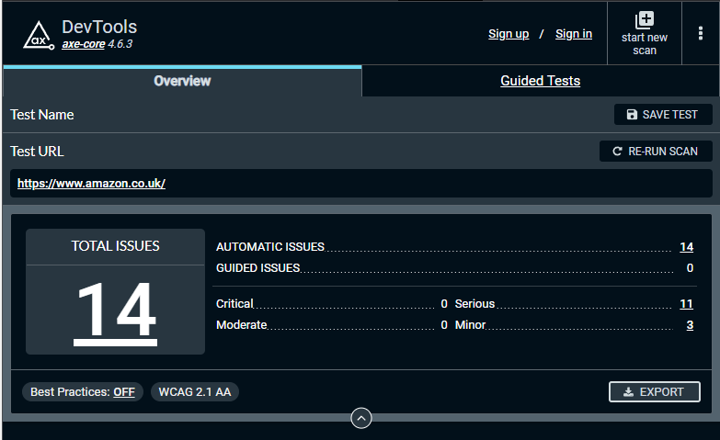
Figure 1 - axe Audit Overview
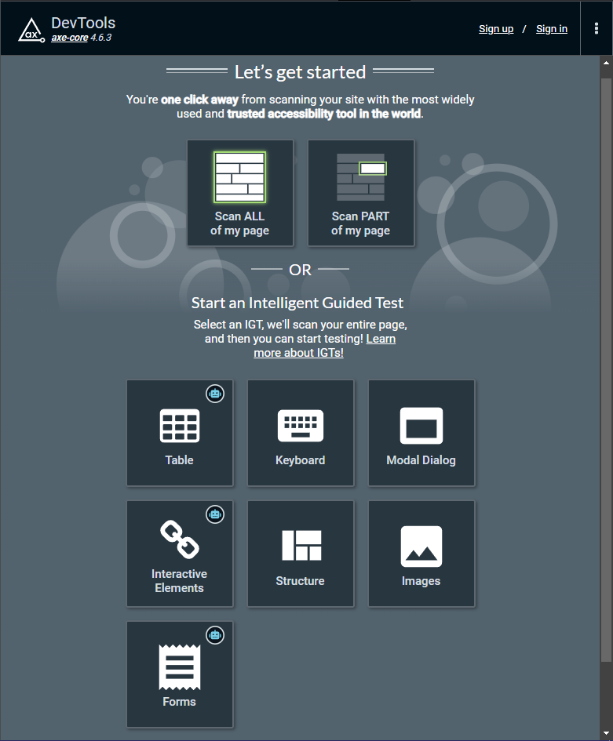
Figure 2- axe Testing Modes

WebAIM WAVE: A suite of evaluation tools which allows users to identify issues to help create web content which is more accessible to individuals with disabilities. It can be used to identify accessibility issues & assists with WCAG compliancy. It can be used to provide a summary of detected issues, including code & contrast errors, alerts & the amount of structural elements. It also provides a detailed summary of issues, a list of the order in which a screen reader narrates the website, and the structure of the website’s code, [19].
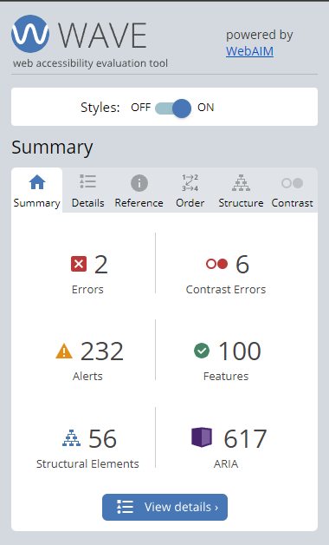
Figure 3- WAVE Audit Overview
Intent Based Accessibility Checker: A free web-based checker, compliant with the WCAG, which identifies web accessibility issues and provides information on how to fix them or improve the website. After providing the website URL and the country of the domain, the tool provides an audit to be used to fix the website’s issues, highlighting compliancy, the score of a website displayed as a percentage, and an overview of the issues detected and the elements of the site which successfully pass checks. It also displays the critical issues found after the audit and provides a detailed explanation on how to resolve them, [20].
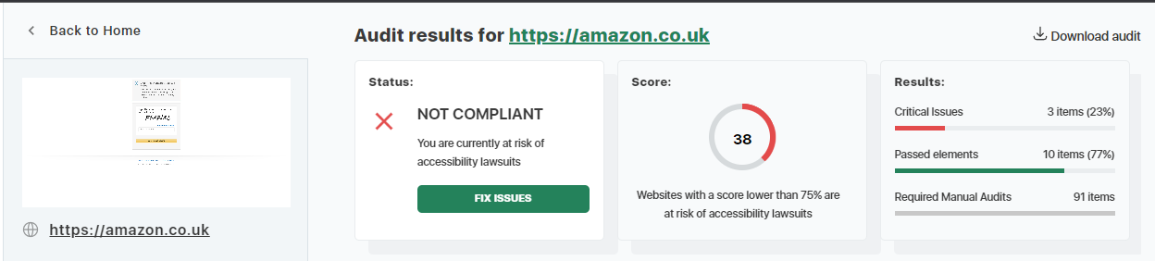
Figure 4- Accessibility Checker Audit Overview
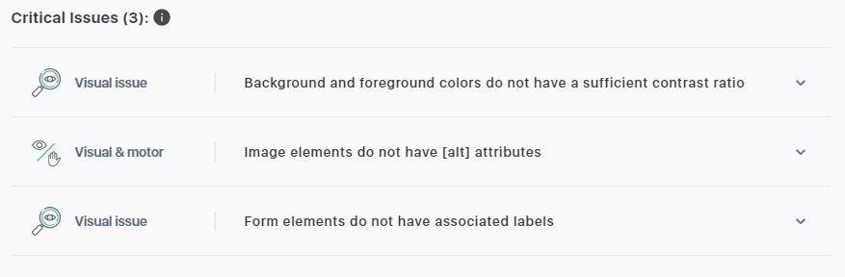
Figure 5- Accessibility Checker Audit Critical Issues
These tools have been selected to test the website set as they are all compliant with the WCAG up to version 2.1, and are freely available to install and use on any device. After the tools have been used on the website set, their results will be recorded and used during the creation & implementation of the final website.

2.6. Justification of Website Set for Testing
E-commerce websites are one of the most common types of website online, allowing users to purchase and order items without the need to leave their digital device. While most ecommerce sites focus on specific companies or products, there are many popular sites which offer a range of different types of products for purchase from many sellers, including Amazon & eBay. Due to their popularity & dominance among other types, it is important to have an ecommerce site which is intuitive to use, and is as accessible as possible in order to acquire the widest range of users. Due to this, e-commerce sites are an important avenue to consider for set testing, as their prevalence results in many differing levels of usability compliance.
An advantage to e-commerce sites is the practicality features to those with physical disabilities who would otherwise not be able to physically shop for themselves, allowing them to order online to their place of residence without requiring extra input from them. This is also true for those with mental disabilities, such as autism or high social anxiety, who may find shopping in person to be a difficult or otherwise overwhelming task.
Despite this ease of use, there are many issues with e-commerce websites which could be addressed in order to increase their accessibility to those with disabilities. A 2022 report by WebAIM focusing on the accessibility of the top one million home pages discovered numerous flaws with many of the websites: across the tested pages, over fifty million accessibility errors were detected, averaging 50.8 errors per page. The report also details the increased complexity of home pages over a twelve month period with 7.7% increase of elements. Focusing on ecommerce platforms, of the four tested there was a large disparity between errors found within them, such as Magento home pages having over four times as many errors than home pages created through Squarespace, [21].
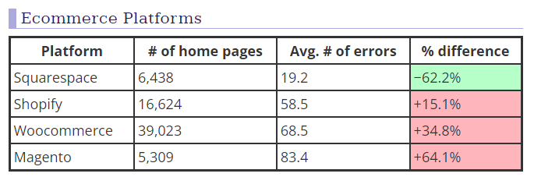
Figure 6- Ecommerce Site Error Disparities [21]

2.7. Website Design & Implementation Considerations
There are multiple components to consider when creating an online website, including the technologies required to achieve the intended features, and creating the base of the website and how it appears to users.
Hypertext Markup Language (HTML) is the standard for all website pages displayed online, and therefore allows for any device or internet browser to understand and display the site to its user automatically. As of HTML5, this browser compatibility also extends to legacy systems such as Internet Explorer, which supports most features which are commonplace within current applications. Due to being the base for all website pages across all devices, the basic layout & design of the website will be written in HTML code.
HTML5 is the latest version of HTML version, used on all web pages, designed to support various multimedia features including various tags, such as form elements & geolocation. It also follows W3C standards to ensure some backwards compatibility with, and consistency across, legacy browsers. The key feature of HTML5 is its user friendliness, and includes built-in audio & video compatibility for playing media such as videos in web pages, better streamlined form features, and uses session/local storage to store data within the browser, useful for e-commerce sites with cart functions, [22].
A Cascading Stylesheet (CSS) is a language which describes how HTML elements are displayed on a screen, such as the style and type of font, numerous colours, appearance of lists and buttons, etc.. They can be reused across a website in order to keep a consistent style and layout across every page at the same time, [23]. CSS can be used to aid accessibility within HTML, however if used improperly or incorrectly, can result in a website with lowered usability & accessibility. For example, improper implementation of CSS header elements can result in screen readers being unable to correctly navigate a page, or can fail visually if a header tag is not correctly styled as a header.
While CSS can be used to style a page into any design, it is important to consider which elements are affected by incorrect CSS styling which can result in elements of the web page not behaving as they should, [24]. The individual properties of CSS are supported by different browsers, and care should be taken in enabling elements/properties which are compatible with the most browsers and versions, [25].

JavaScript (js) is a scripting/programming language which allows the user to implement a variety of complex features on a webpage, including real-time content updates such as clocks or carousels, interactive maps, animated images, and multimedia widgets such as videos & music interactivity. It is implemented alongside CSS and HTML to improve a user’s experience of a website and its pages, [26]. Proper implementation of JavaScript practices allows for faster page loading & increased performance, improve the readability of code for other developers, and making the process of debugging and code maintenance easier and straightforward. It also helps to prevent errors such as misspellings, and increased security.
There are different methods of ensuring consistency with JS scripts. For example many coding style guides exist from different sources, such as the community-based Idiomatic, and companies such as Google, & AirBnB. Coding styles are useful for collaborative projects with multiple developers due to consistency & clarity regardless of any code written by any other developer. Descriptive names can also help code easy to describe and understand for others who work with the code, & using consistency such as through naming conventions, i.e. using camelCase or PascalCase, especially due to JavaScript being a case-sensitive language. Additionally, commenting code is a good method of making code readable to others, as well as more understandability when accessing the website/code through legacy systems, [27].
User Experience (UX) is the most important consideration of website design, as a website acts as an online representation of a brand, being easily accessible and visible to the target audience, and browsers happening across the site for the first time. Having a good, effectively-designed website with an emphasis on the user instils a good, positive image for the business. There are important aspects to creating good UX; having a clear ‘flow’ or layout to a website makes it easier for users to read and navigate with consideration to the purpose of the website, providing the user with the information they will be looking for in a clearly & quickly accessible area. Reducing non-essential or unimportant information also aids the user on what they can interact with and to make clear what the objective of the site is. Consistent design and function, as with boxes, headings, or text, as well as consideration to mobile responsiveness and device compatibility, will help keep user retention and increase brand identity, [28].

2.8. Conclusion
Defining usability as a concept is an important step to creating a functional product which can be used by all types of people, with a focus on the efficiency & satisfaction of completing goals while using the product, while also having a part focus on ease of use. While good usability can be difficult to accurately define, and is vulnerable to generalization, users are more commonly recognized with poor usability, as users will take more notice of systems with poor usability over those which are more efficient; being able to create a product which satisfies the user when fulfilling their task first and foremost is a key aspect to design.
In assessing usability, there are several criteria which must be met in order to conclude that the product is usable by users and the target audience, and which must be universal across all types and forms of website of the same set. User satisfaction, efficiency, and readability are all aspects which must be included within a website, but the inclusion of common criteria including browser compatibility, minimization of unnecessary elements, typical responses from UI elements, and consistent navigation must also be considered in website designs.
Web design best practices can encompass a variety of elements, although can be broken down into the most common key requirements and criteria. User-friendliness, especially towards the target audience and casual observers, can make a website much more usable and accessible when implemented well. Common features including page consistency & navigational elements can help users easily navigate a website without needing to search through an entire site to find what they need. Mobile responsiveness is also a key factor due to the increasing market share of tablet and smartphone devices. Speed and aesthetics can also be used to keep user retention, and functionality with regards to these aspects should also be considered.
Usability and accessibility are closely-tied concepts, and having a non-accessible website will causes issues with use in terms of usability. Due to both concepts being connected, there are existing guidelines which detail how to help understand the needs of disadvantaged users, such as W3C’s WCAG 2.2 revision, including issues such as perceivable, operable & understandable concepts.

There are many tools which can be used to test the usability of websites, and which provide pre-defined testing criteria, highlighting any issues a website has and how they can be rectified. Using these tools on the website set will be beneficial in order to compare data against in order to create & implement the final website.
Due to the prevalence of e-commerce websites there are many examples which can be tested with tools in order to gather data to implement the final website. The popularity of sites such as Amazon & eBay, allowing users to order items online regardless of ability, especially users with physical & mental disabilities who could not otherwise shop for themselves, makes them in important avenue for a usability testing set, as well as the many issues prevalent with certain sites.
There are many components which go into creating a website, and proper implementation and consideration can create an intuitive & usable website. Elements such as HTML, CSS & JS are important to apply & structure correctly in order to have a better understanding of the code from the perspective of an outsider.

3. Methodology

3.1. Research
The positivism philosophy is a method which adheres to factual knowledge gained through observation, which is limited to data collection & the objective interpretation of data. Research of this type requires the distancing of personal values, and the data collected is observable and quantifiable. In turn, this data is later interpreted as statistical analyses, [29]. Due to the collection of quantitative data through the use of different score-based usability testing tools, as well as the comparison between the final implemented website against the previously-established quantitative data from the aforementioned tools from the tool-tested website set. Additionally, studies which are built upon positivism focus on identifying associations & casual relationships through quantitative approaches, based on findings preferably from a large sample size, through the replication of findings, [30]. In aid of gathering data to better actualize a usability score between sites, historical data and statistics relating to the usability of the website set or similar will be considered when necessary, especially where some websites may lack relevant data.
There are many advantages to using this philosophy: First, due to the collected data being based on observable evidence and statistics, the results found by using the method are easily replicable by others, saving time & resources for future quantifiable studies based on a same or similar criteria. Additionally, the findings of the research are reliable enough to be able to support any scientific assumptions made during the course of the research. Correlational can also be found within the data gathered and other studies using the positivist methodology. The key advantage of this approach is the validity of the research results observed when using the method, [31].
As the positivism approach relies solely on statistical data, there are limitations to using the method. A particular disadvantage to the positivism approach is the difficulty of generalization of the findings, and the lack of interpretation compared to other approaches which, in the scope of the project, could result in an overall fulfilling finalized product, [32]. A further issue of positivist research, as well as the use of usability testing tools, is that the research is usually a point-in-time circumstance; that is, positivist research usually measure data at a specific point in time. In the scope of this project, all website pages will be taken at different period of time over a small timeframe, and therefore will be differently designed in a point of time beyond the project, as well as only being based on an overall score rather than specific guidelines which could to fix the problems present in the website set, [33].
This project is considered a mixture of software development & experiment, as the objective of the project is both the creation of a finalized product, i.e. the implementation of the final website, and the comparison of the final website against the previously website test criteria as established via usability testing tools.
In order to evaluate the data of the website set, three predetermined tools will be used. These tools are the Intent Accessibility Checker, axe DevTools browser extension, & the WebAim Web Accessibility Evaluation Tool WAVE browser extension. These tools are being used as they provide an overview of the issues relating to each website, including a score assigned by comparing guidelines. The evaluation criteria will be drawn from the results acquired from using the usability/accessibility tools on the website set, as well as historical data from previous studies if appropriate.

3.2. Development
There are many different approaches which can be considered and used in the process of creating the finalized website. In particular, two development methods have been chosen in the implementation of the website:
The Waterfall method of sequential development process which flows as a waterfall through each phase of the project, such as design, implementation, & testing, with each phase concluding before moving on to the next step. Crucially, waterfall models depend on the quality of the work created on the front end of the project, including the documentation of each step such as the user interface, & the outcome of its features, [34]. The Waterfall model is made of six phases: Identification of Requirements, Analysis of required software & hardware needed for project completion, the Design process of the project in the form of a flowchart, Coding of the software, Testing the executed code for mistakes or discrepancies which are amended by returning to the Design phase, and the Acceptance of the finalized software if it meets all user requirements, [35].
There are some benefits to the Waterfall model, such as the agreement of the requirements taking place in the first phase, before any work on the project takes place, resulting in clear planning & scheduling, accurate estimates for cost & resources following a laid out project schedule, and easy to measure progress on the project as the model is followed. However, there are disadvantages to this method as well, including a rigid & linear project plan which lacks flexibility, a costly redevelopment if the end user is dissatisfied with the product, and difficulty with customer articulation at the beginning of the project, [36].
Prototyping is the process of designing and developing a working model as an early idea for the finalized design & implementation. The Prototyping method features four phases: Identifying the user’s basic requirements, Development of a working initial prototype, Implementation & use of the prototype system, and the Revision & enhancement of the initial prototype system. With this method, the initial product is revised and remodelled until it resembles the finalized product which matches user requirements. The model acts as a representation of written specifications, and anticipates evaluation of the design in its operating environment, [37].

The primary advantage of prototyping is the visualization of the prototype: There is less of a chance of error through the use of initial designs and wireframe diagrams/drafts, and quick diagrams can be created which cater to all of the user requirements. Being able to communicate the visualizations with the user during the testing phase also allows for more interaction between user and prototype. Improved quality of the final product, and reduced costs through testing and development, are also benefits to the approach, [38]. These benefits are applicable to this project, as the progress of the project through the initial stages to the final product is easily documented, and the user requirements of the system can be compared to the current state of the project.
Despite its advantages, there are some drawbacks of using the method. For example, the prototyping, reviewing & repeating process can be a time-consuming procedure due to testing multiple iterations of a product, any bad design decision having an impact on the final product, & and sense of misunderstanding of the final product compared to an earlier prototype build if any popular features or additions were removed in the final build, [39].
Due to uncertainty on which methodology would be best for the project, due to the requirements of testing a set of websites and the implementation of a final website, a mixed approach of these two methods will be utilized during the project’s development.
The software used in this project will primarily be Notepad++, due to its ease of use and highlighting of errors and missteps within the code. It is also universally used on all platforms, making the code available for use and review by any other user. The final website will be made of a combination of different languages and document types, namely Hypertext Markup Language (HTML) for the website’s composition, a Cascading Stylesheet (CSS) document for the appearance and layout of the website, and JavaScript (JS) for any interactive element on the site’s pages, including image carousels.

3.3. Project Planning
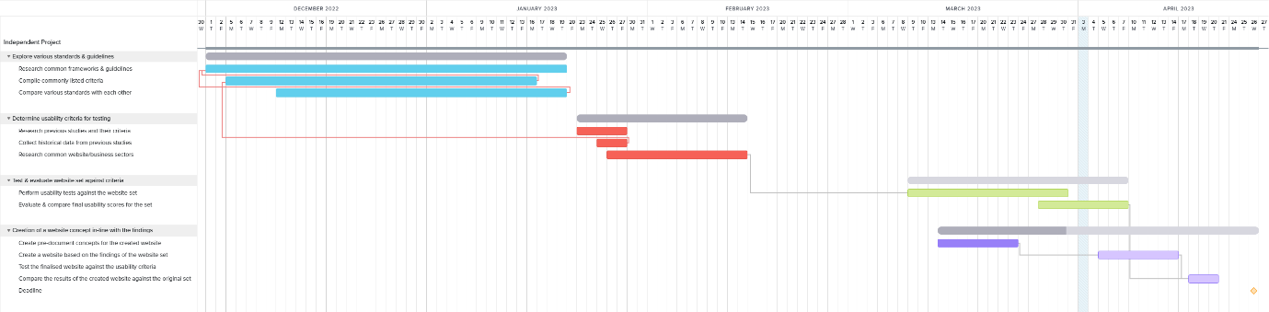
In order to create a timeframe of when the project will be complete, and when each aim & objective will be completed in creating the final product, a Gannt chart was created to provide a timeline. Due to the nature of the implementation and development of the final product, including testing, the dates shown are subject to change, and act as preliminary & predictive dates. Below is the full chart, as well as cropped segments for a clearer view.
Figure 7- Full Gantt Chart & Timeline

H
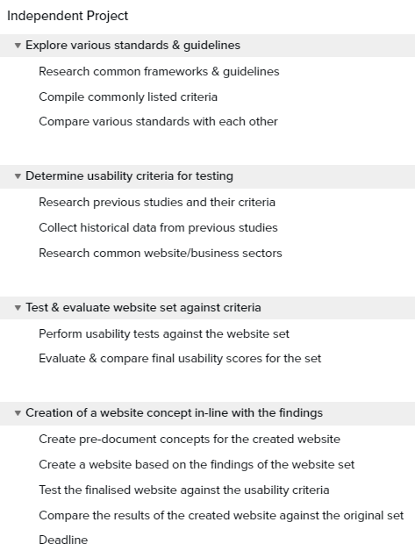
Figure 8- Gantt Chart Pt.1 (Aim & Obj.)

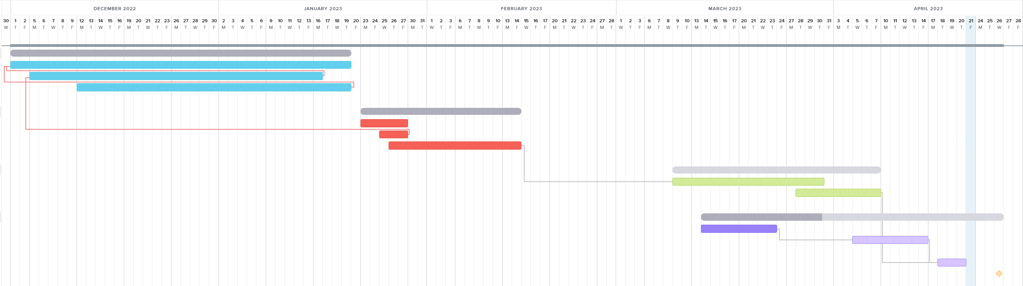
Figure 9- Gantt Chart Pt.2 (Timeline)

G
G
G
G
G
G
G
G
G
G
Figure 10- Gantt Chart Pt.3 (Timeline cont.)

4. Design & Implementation

4.1. Design
The final product of the project is the creation & implementation of an e-commerce site similar in appearance & operation to other popular sites. The website will contain at least four pages: a Home page, an overview of product categories, a ‘daily deals’ section which highlights several offers available to the user, and a contact page which allows the user to communicate with the website & its owners via email or other methods.
The website requirements will be sourced from two sets of data & information; the results found from the various usability testing tools used on the set, including which aspects of design & implementation are not in accordance to suitable usability rules, as well as the WCAG 2.1 list of guidelines, supplied by the W3C. As the usability testing tools used in the course of testing the website set are derived from the WCAG, any criteria not noted by the testing tools will be highlighted separately. Additionally, other aspects of design will be included within the final product not found within the WCAG, or within the testing toolset, including optimization for multiple devices, the clarity of the website, & ease of learnability and simplicity within the site.

4.1.1. Website Set Testing
The sets of data used to source the requirements of the website implementation will be acquired by testing the initial website set in order to observe which guidelines they are not complying to, and how these can be rectified or modified in order to create a more user-friendly & accessible website.
The first action to take is to assign a usability score to the website set; this is achieved by using the established tools on each of the sites in the set, then observing & noting the scores assigned to them. Using these scores is crucial in order to create a site which has better usability score in comparison to the original websites of the set separately. In order to divide an average score, and to ensure some aspects are not excluded from the final list of issues, multiple tools will be used separately on each website. Over the course of testing the final website, the same tools will be used, and a score will be created from the averages of each tool.

The first website of the set tested was amazon.co.uk, focusing on its home page, with additional testing undertaken on the ‘About’ & ‘Daily Deals’ pages. From the results given by the Accessibility Checker tools after testing the pages individually, a common list of issues were found: the most common critical issue noted are visual issues, including incorrect ordering of headings, the disabling of zoom functionality across all tested pages, indiscernible or in correct link names, and incorrect labelling on some images and form elements. Some other critical issues were also detected during testing, such as visual & motor including non-unique key values, and cognitive issues such as inaccessible button names. Other critical issues included visual issues which may interfere with screen readers due to mismanaged sequential ordering or incorrect numerical listing. Overall, the tested pages gave an average score of 55 out of 100 of guideline compliance.
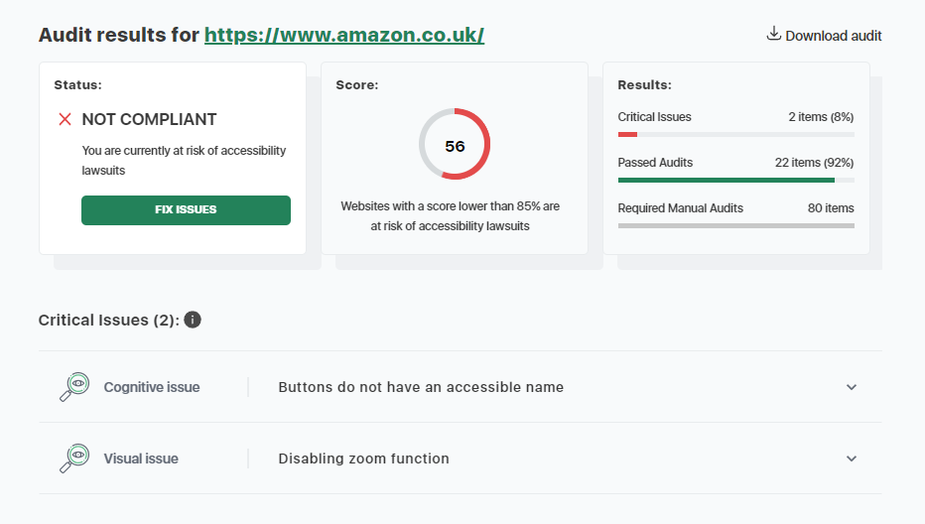
Figure 11- Amazon Home Page Accessibility Checker Testing
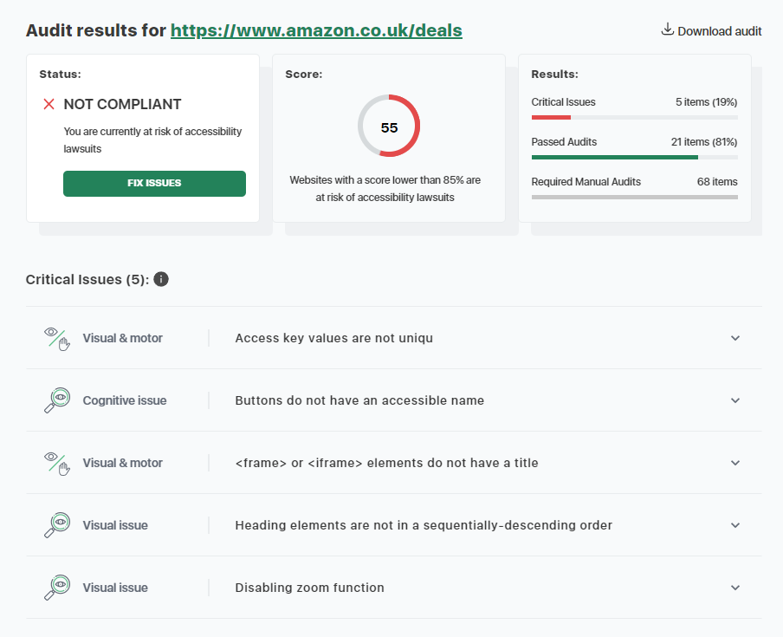
Figure 12- Amazon Deals Page Accessibility Checker Testing
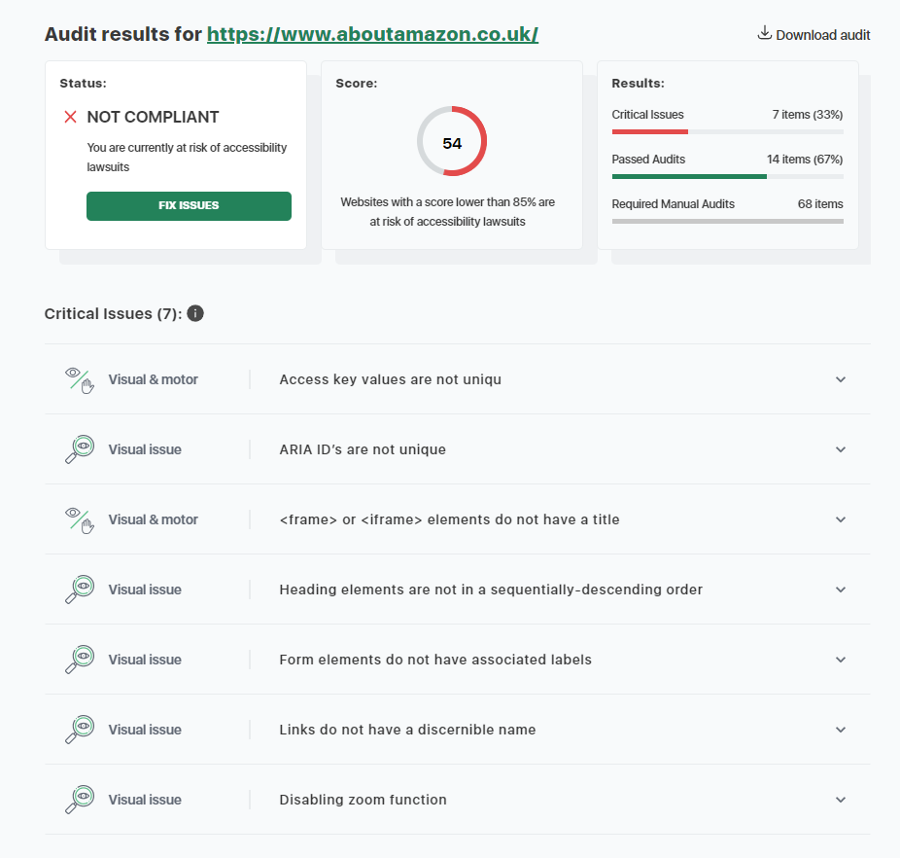
Figure 13- Amazon About Page Accessibility Checker Testing

The axe tool provided an overview & list of the issues found within the pages, and a series of errors, ranging from minor to critical were found. The most critical errors were found within the ‘About’ page, while the home page had the least issues. Some issues were common throughout the pages tested, including numerous faults with unique ID attributes, and faults within lists. Discernible text, and colour contrast were also issues found across the site.
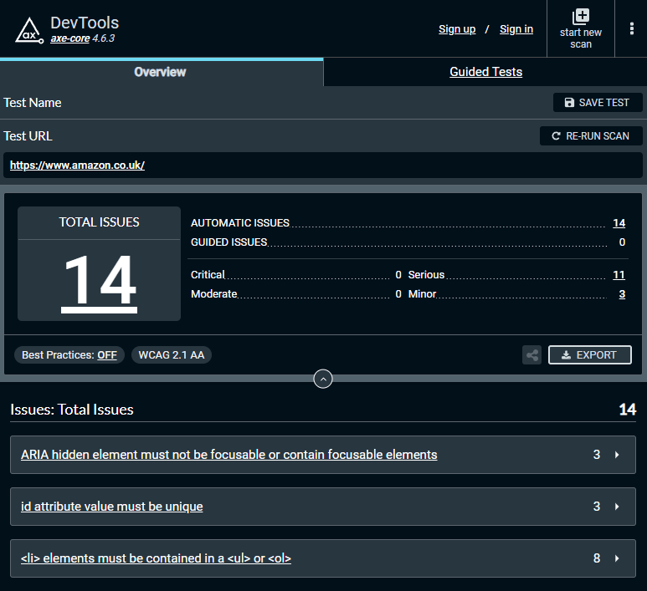
Figure 14- Amazon Home Page axe Testing
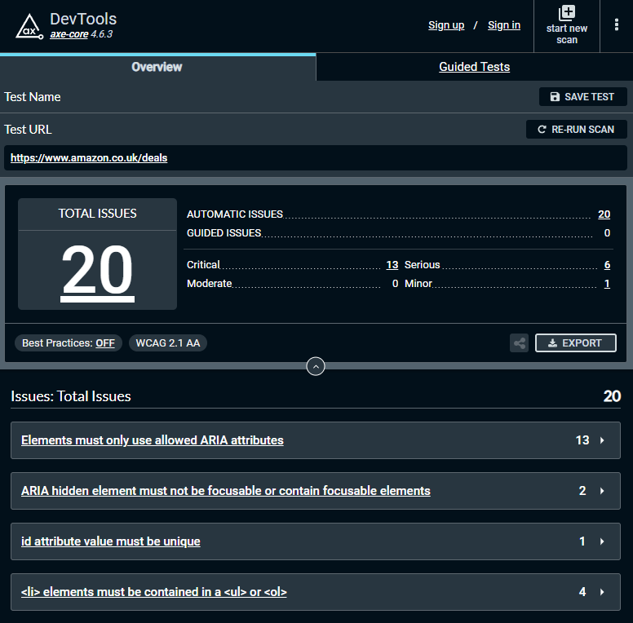
Figure 15- Amazon Deals Page axe Testing
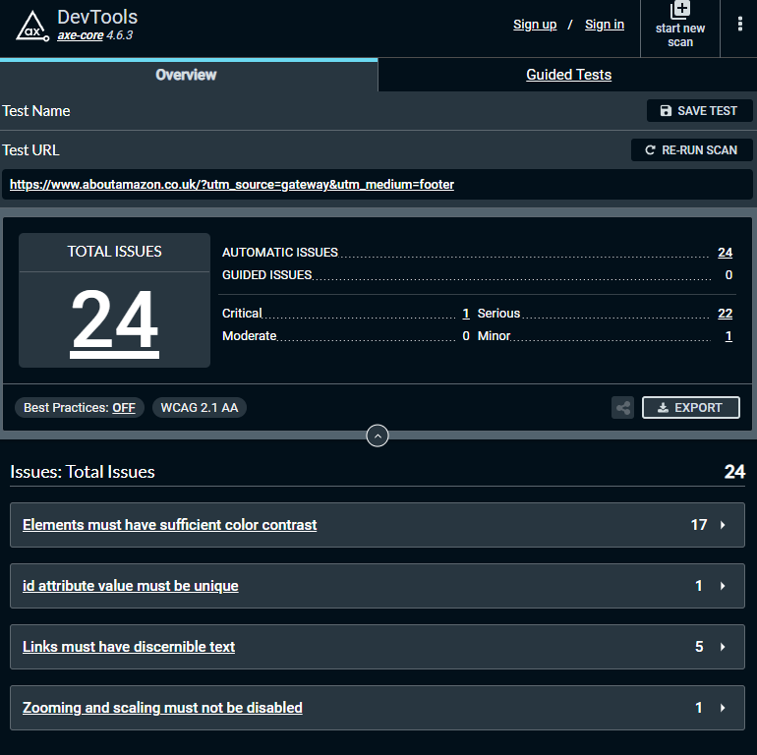
Figure 16- Amazon About Page axe Testing

Using the WAVE tool highlighted numerous errors throughout the site, including missing alternative text, empty buttons & links, and numerous colour contrasting issues. Some minor issues were also alerted to, such as redundant text, alternative text too long to act as a description, redundant links, incorrect table layouts, & very small text.
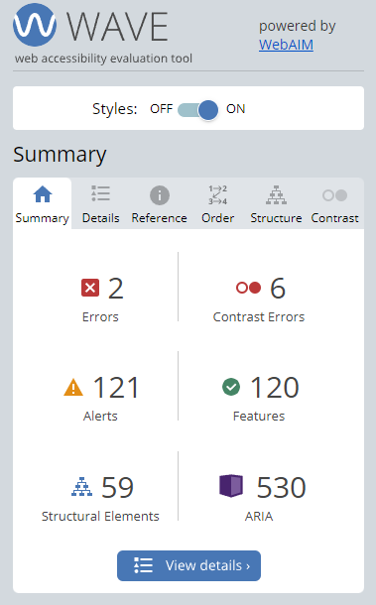  Figure 17- Amazon Home Page WAVE Testing | 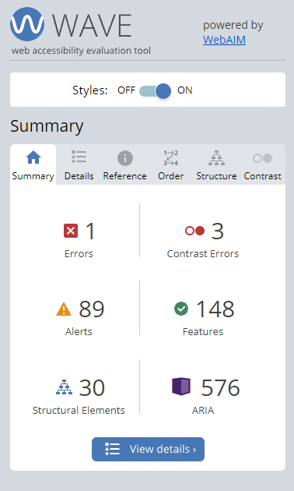  Figure 18- Amazon Deals Page WAVE Testing | 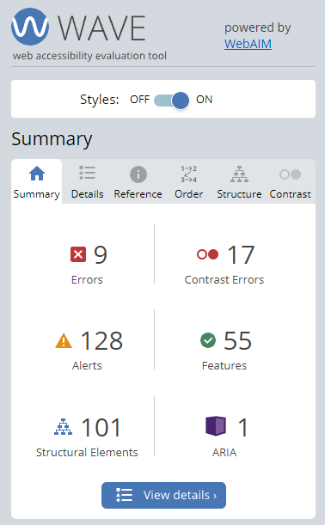  Figure 19- Amazon About Page WAVE Testing

The second website of the set tested is the ebay.co.uk website and its associated pages. Using the Accessibility Checker tool, the pages scored higher in testing, however issues still persisted, with some issues being in common with both websites and their pages, such as the lack of unique key IDs, a lack of titles within <frame> elements, missing alt-text for image elements, and a lack of associated labels within form elements. During testing, the individual pages scored higher, scoring 77% compliance across all pages.
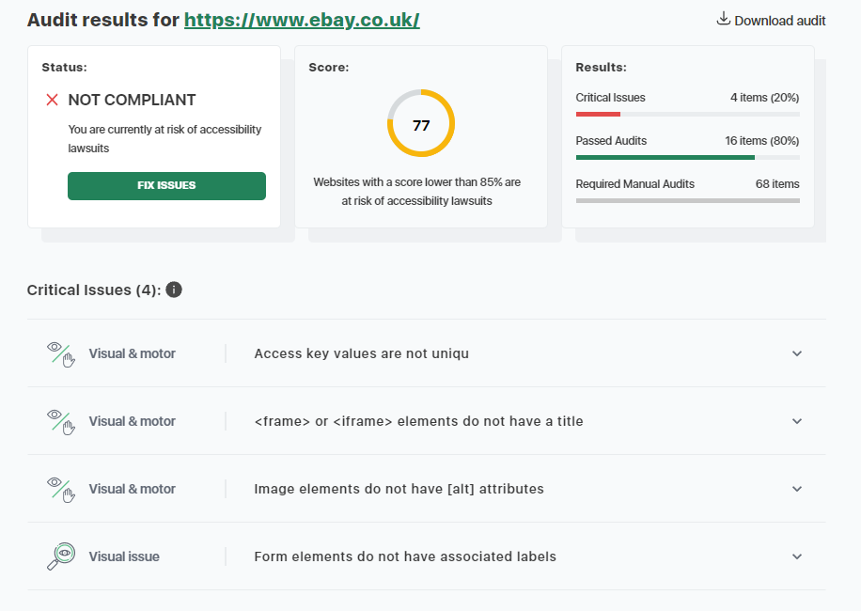
Figure 20- eBay Home Page Accessibility Checker Testing
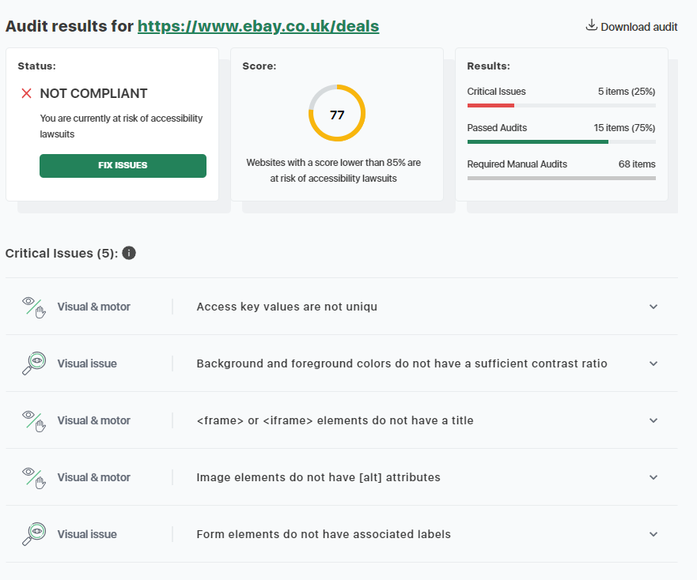
Figure 21- eBay Deals Page Accessibility Checker Testing
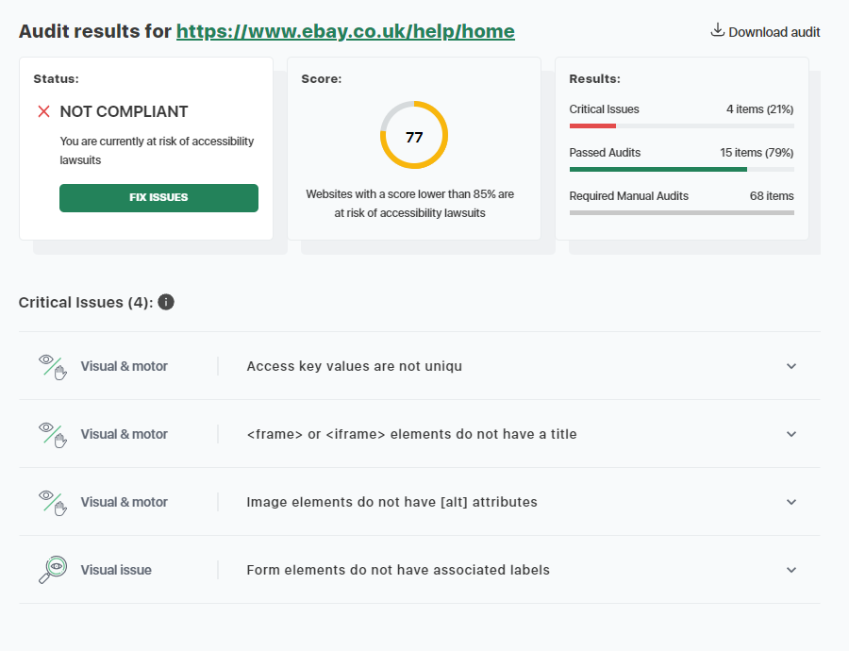
Figure 22- eBay Help Page Accessibility Checker Testing
After testing the pages with the axe tools, many critical issues were found, particularly with the ‘Daily Deals’ page, although other pages had their own issues as well. Namely, the issues found across the site were a lack of discernible text for links and buttons, non-unique id attributes, and a range of issues with ARIA elements, including valid & accessible naming, and issues with hidden ARIA elements.
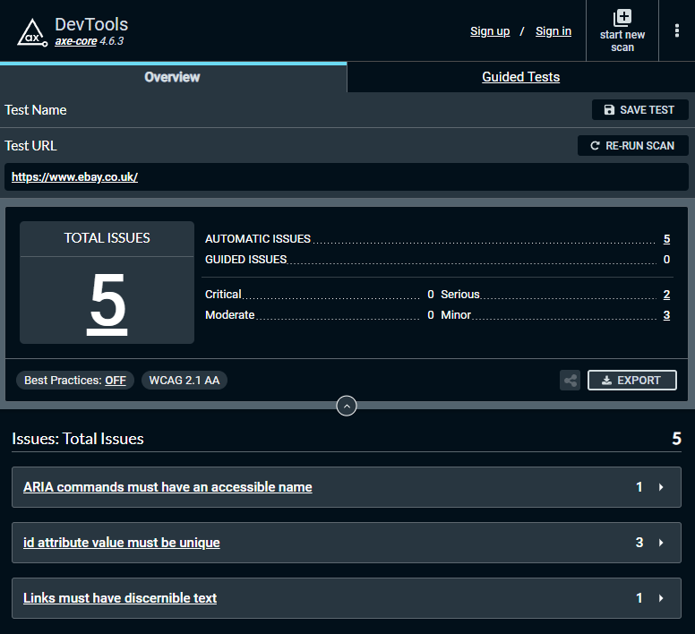
Figure 23- eBay Home Page axe Testing
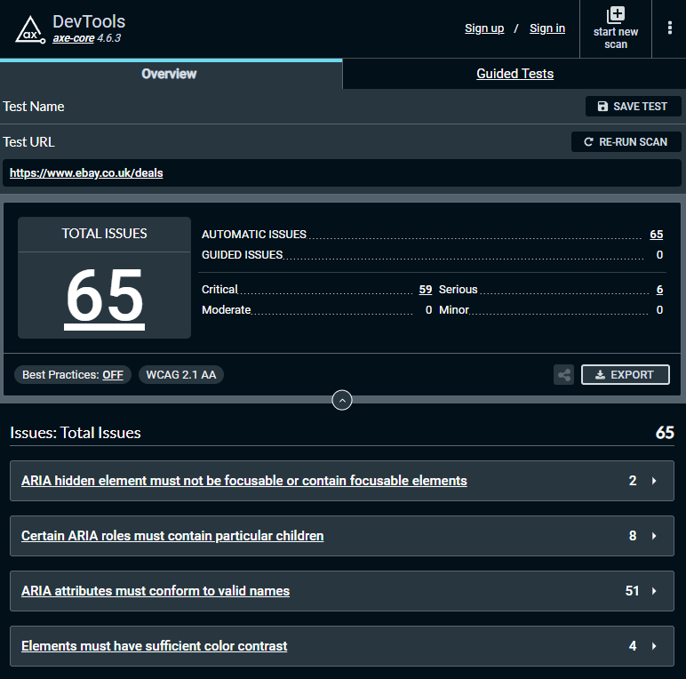
Figure 24- eBay Deals Page axe Testing
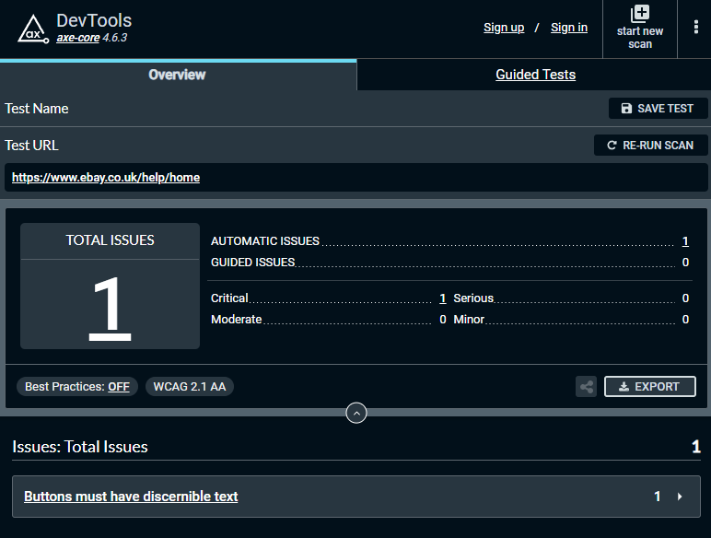
Figure 25- eBay Help Page axe Testing

The WAVE tool discovered some errors, mostly concerning alerted, but minor, issues. As with the axe testing, most issues were found within the ‘Daily Deals’ page. The critical errors found were missing form labels, missing alt-text for images, and broken ARIA menus. The alerted issues included redundant links, alt-text & titles, incorrect table layouts, small text, and device-dependant event handlers.
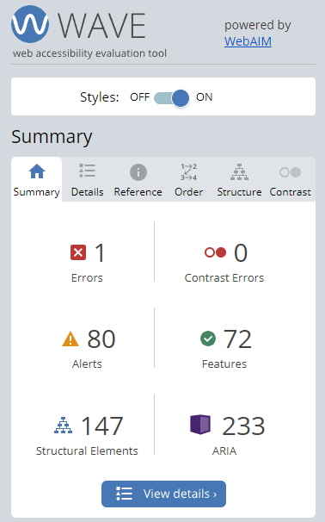  Figure 26- eBay Home Page WAVE Testing | 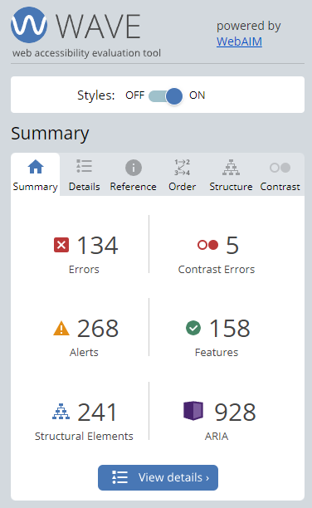  Figure 27- eBay Deals Page WAVE Testing | 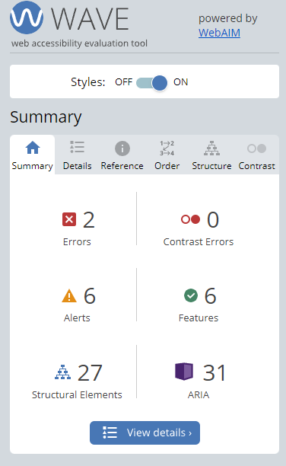  Figure 28- eBay Help Page WAVE Testing

In conclusion, the requirements for the final website will have a focus on fixing visual errors such as incorrect colour contrasting & a lack of correct labelling on links & images will be taken into consideration, and cognitive issues & issues with code will be fixed. A complimentary colour scheme will be used to minimise on colour contrast issues.
Many of the issues found by testing the individual pages using usability/accessibility tools fell within the coding of the website, including incorrect labels or missing alt-text for images, and should be addressed in order to create a more accessible website. Furthermore, the site should employ a logical structure in order to ensure compatibility with screen readers, and allow for zooming in without effecting responsiveness.

4.1.2. Pre-Documentation
To help with the implementation of the website, predocument wireframes have been produced. Wireframe diagrams are a method of designing a website at a structural level, and are used to lay out the overall design of the individual pages early in the production process, to establish a basic structure and design of the site before any content is added. Such diagrams provide useful advantages towards the website implementation process, such as providing a template for the overall design for the website and its pages in accordance to user & designer requirements, & being easier to review and modify than working prototypes, [40]. These wireframes are made as preliminary material, the final product will not be 1:1 with these models, as they simple act as a rough layout.
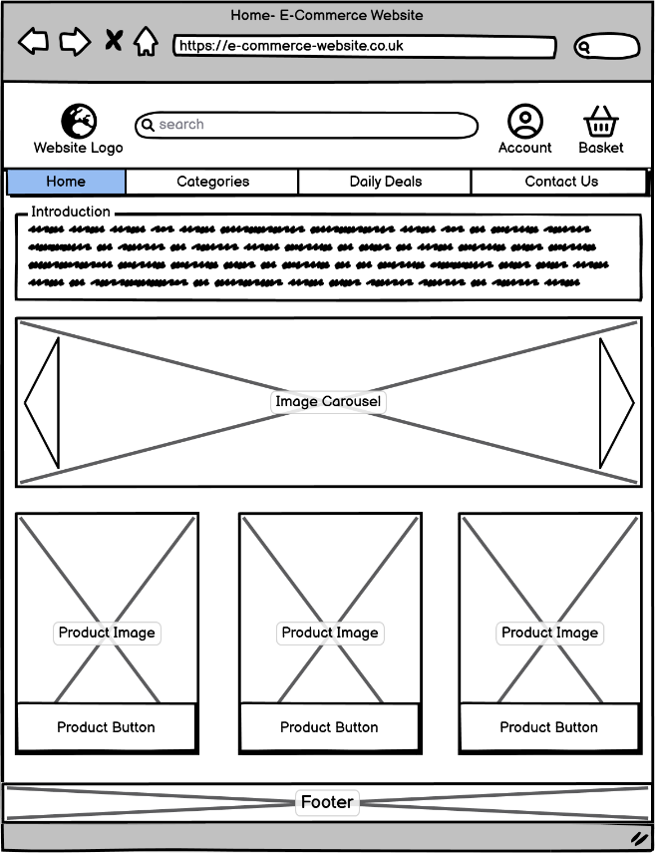  Figure 29- Website Homepage (Wireframe) | 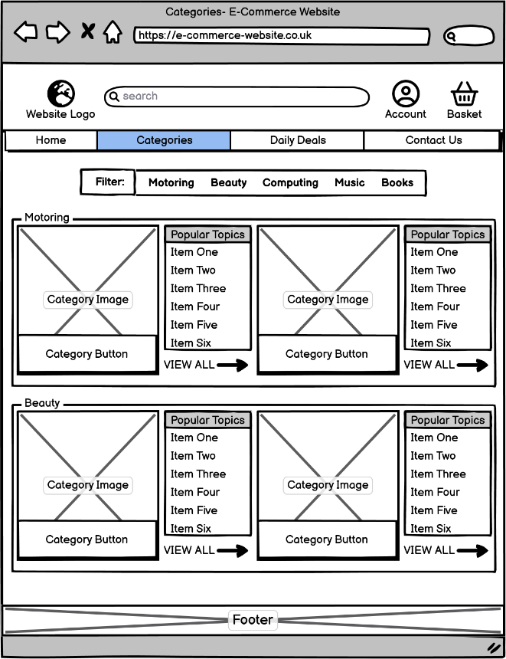  Figure 30- Website Categories (Wireframe)

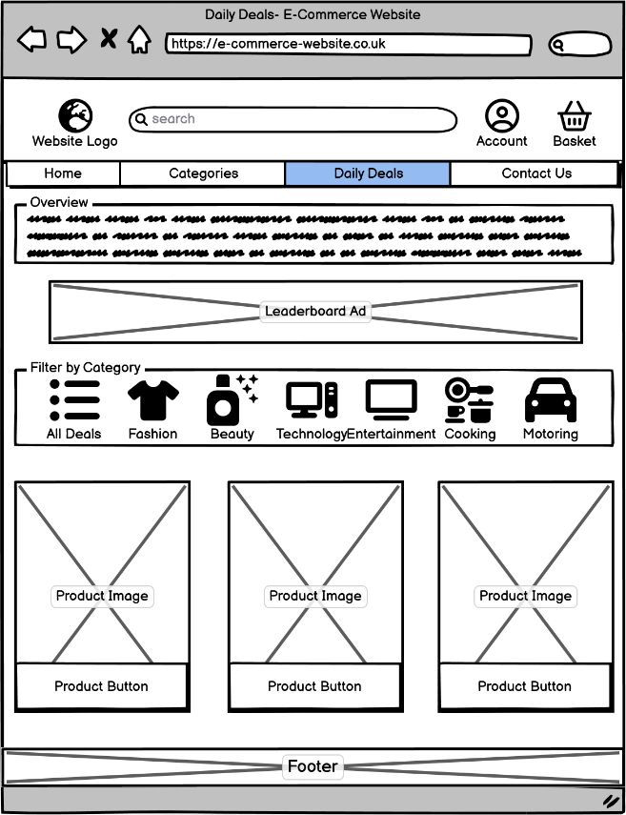  Figure 31- Website 'Daily Deals' (Wireframe) | 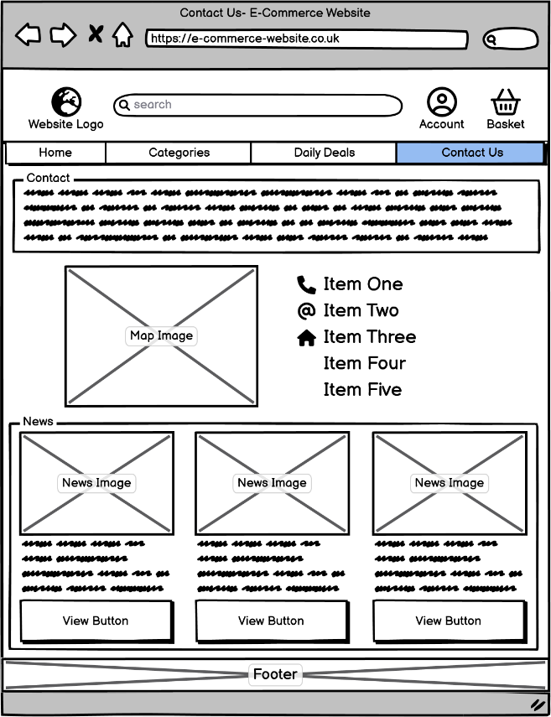  Figure 32- Website Contact (Wireframe)
These designs were created using the Balsamiq software, and will function as a form of template for the finished website design, helping towards the implementation. Due to being wireframes designs, the overall appearance of the finalized website will vary, however all pages will follow the basic layout of these wireframes, such as featuring a navigation bar, identifiable buttons, contextual blocks of text, & alternative text for images. These elements will be designed and implemented in accordance to the WCAG 2.2.

4.2 Implementation

4.2.1. Website Implementation
Due to being a development project, the implementation held a prominent role, in accordance with the final aim & associated objectives, due to the required creation of a functional website with a focus on usability & accessibility. Simply, without extensive implementation, there would be no user interface or usability elements to test against the website set. Therefore, the implementation of the final website was extensive, and was not totally straightforward, as many issues were encountered during the process.
The main (IDE) used to create the website was Notepad++, due to its ease of use & compatibility with many different coding languages, and the ability to use in conjunction with a web browser in order to update the website pages in real-time. The downside to using the IDE was the lack of communication & error-handling; this would leave some testing to lead to no fruition, and extended the duration of implementing and testing. In order to display and test the website, the Google Chrome & Microsoft Edge web browsers were used.
The website was created using a sequentially method. The header & navigational bars at the top were created first, followed by the footer. Afterwards, all the content & body of the different pages could then be created individually. This allowed for smoother testing, however due to a labelling issue within the header, the issue would persist across all pages, and would be detected in testing.
Throughout development, there were some issues with the creation of the website which needed to be addressed; the most common problem with the creation of the website is the implementation of the top header/navigation bar, particularly when implementing a search bar, its associated ‘Go’ button, and keeping the account & basket buttons in line with the rest of the header. The issue was resolved during testing, and the fault was found within the CSS stylesheet; incorrect pixel definition, and a lack of a ‘float’ element within the CSS had not enabled the header to display properly. This was mitigated by resolving the issue & implementing proper pixel sizes, as well as introducing the ability for the search bar within the header to ‘float’ to the left.
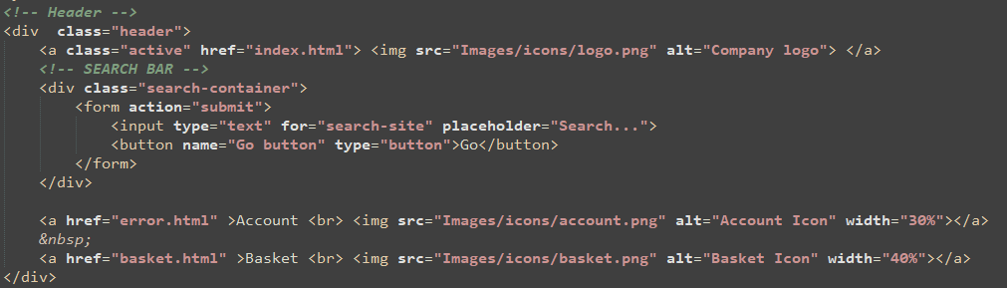
Figure 33- Header/Navigation HTML Code
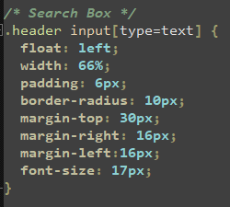
Figure 34- Header/Navigation CSS Code

Figure 35- Header/Navigation Without Fix
Figure 36- Header/Navigation With Fix
Another issue found within development was the product cards on the Home & categories page displaying incorrectly. This included incorrect formatting within the CSS file which would modify both pages with the same code, creating an issue with one page while the other displayed properly. This was fixed by creating separate ‘card’ properties in the CSS file, which would define the two pages differently, and thus would allow them to have different properties.
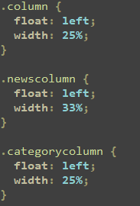
Figure 37- Product Card Column Fix
Some elements have been added to the site in order to increase usability and accessibility. For example, every image was given an alternative text which succinctly describes them, and the colour scheme was designed to allow for clear colour contrasting, including highlighting buttons when hovered over, and formatting text to ensure clear readability.
Figure 38- Image Alternative Text HTML
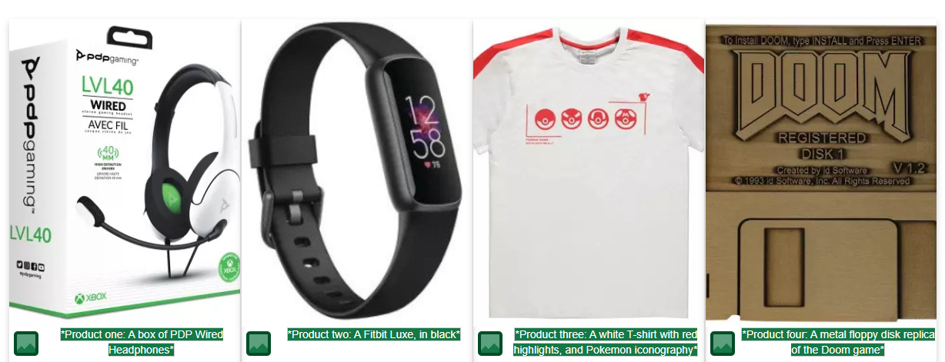
Figure 39- Image Alternative Text via WAVE
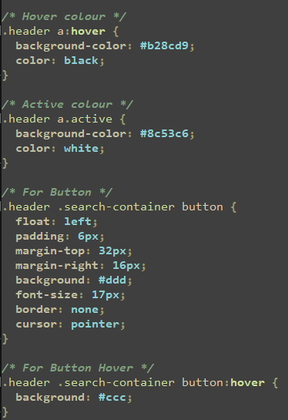
Figure 40- Header Button Hover CSS

4.2.2. Implemented Website Testing
In order to ensure that the website meets the requirements, and is functional, extensive testing was undertaken. This includes manual tests, as well as using the usability tools discussed.
Testing was broken down into four categories:
- Functionality, including system simulation & usage.
- Usability, such as testing alternative text on images, & ensuring compliancy with the WCAG. This category will be fulfilled using the usability & accessibility tools on the final website.
- Interface, including working navigational bars, button highlights, etc. This includes colour contrasting as tested using the usability tools, as well as working links to other pages & sites.
- And Compatibility, such as through different types of web browser, and responsiveness in a mobile/tablet environment, [41].
As well as the testing of the website itself, the tools previously used on the website set will also be used on the website, in order to display data in a similar fashion for ease of analysis & comment.
Due to the simplicity of the code, as well as the up-to-date versions of HTML, CSS & JS used, the final website is compatible with tested web browsers, including Chrome, Edge & Firefox. However, testing has shown that the website can be more responsive towards mobile phone & tablet devices, and further testing & modification of code make the website more accessible & usable for those on mobile devices.
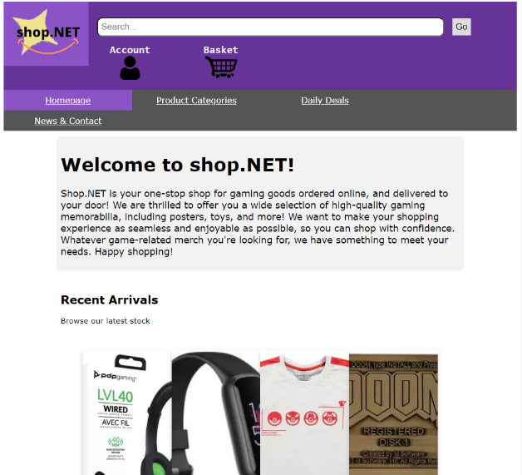
Figure 41- Failed Website Responsiveness

4.2.3. Usability Tools Testing
Using the usability/accessibility tools on the final website has produced data which can be actively compared to the website set. This will allow a better visualisation of the data in order to better compare the results of testing the set against testing the final website.
Using axe on all pages of the website revealed that there were not too many issues with the pages of the website. The Categories & Contact/News pages detected no issues or errors, however a couple of serious issues were detected, such as indescribable link text on the main index/home page, and a lack of correct colour contrasting on the ‘Deals’ page. While this would be a fault, the text was designed specifically to illicit this response; editing the code to separate colours would have mitigated the issue.
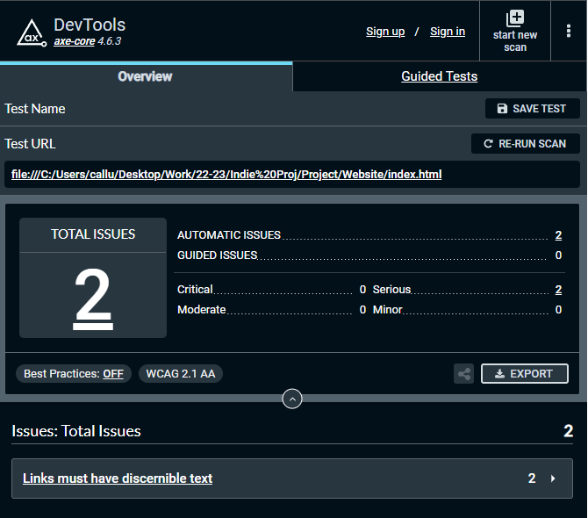
Figure 42- Final Website Home Page axe Testing
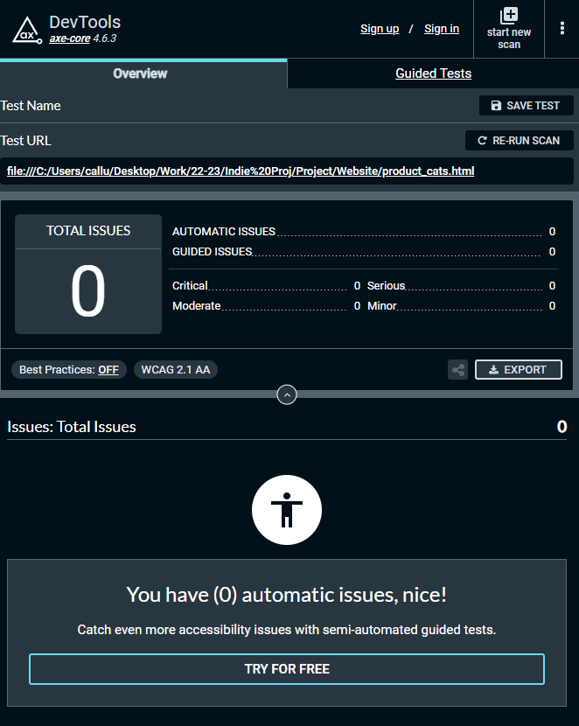
Figure 43- Final Website Categories Page axe Testing
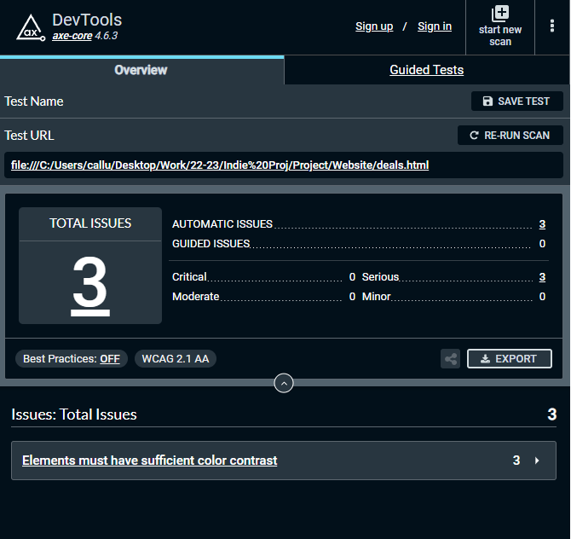
Figure 44- Final Website Deals Page axe Testing

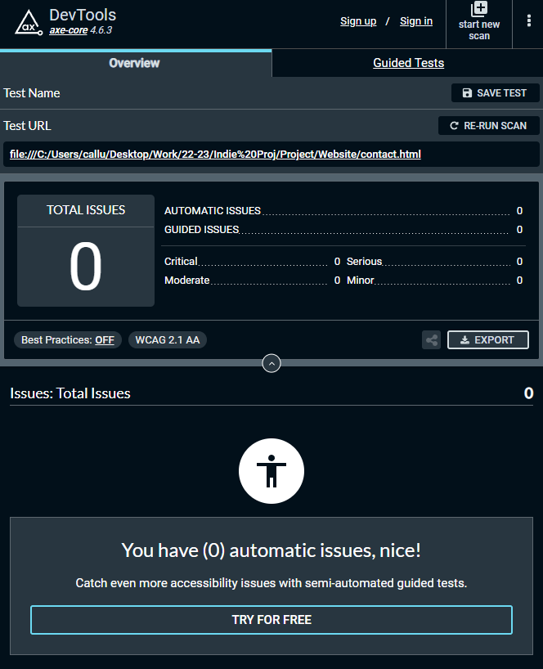
Figure 45- Final Website Contact Page axe Testing

Through WAVE testing, some issues in particular were highlighted during the course of testing the final site. As mentioned previously, an issue with a missing label on the search bar within the header/navbar was present across all pages, due to being based on the same template. Across the whole site, there was little issues detected with each page, however some errors and alerts did persist. For example, as with the axe tool, colour contrast issues were detected on the ‘Deals’ page, due to some line-through text styled to be red.
Figure 46- Missing Search Bar Label
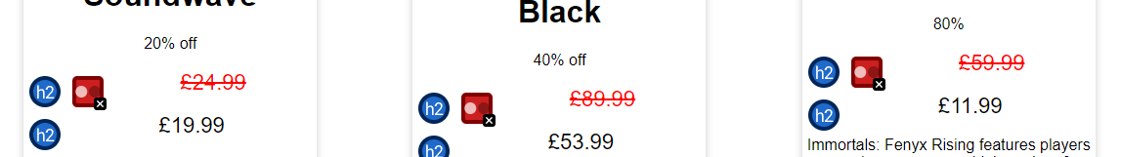
Figure 47- Incorrect Colour Contrasting
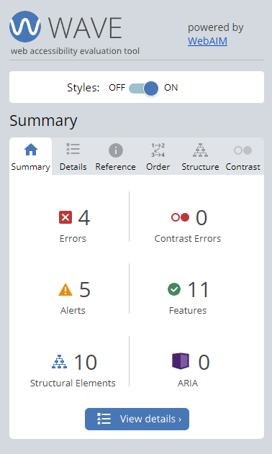  Figure 48- Final Website Home Page WAVE Testing | 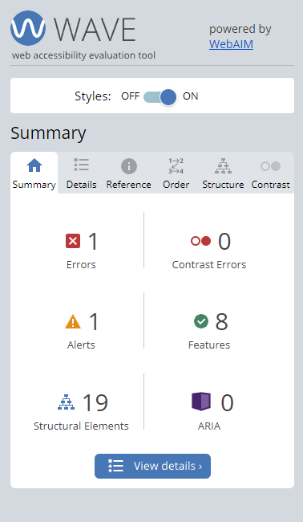  Figure 49- Final Website Categories Page WAVE Testing | 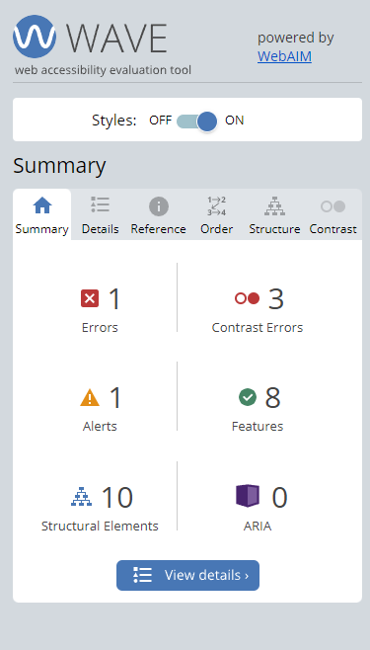  Figure 50- Final Website Deals Page WAVE Testing
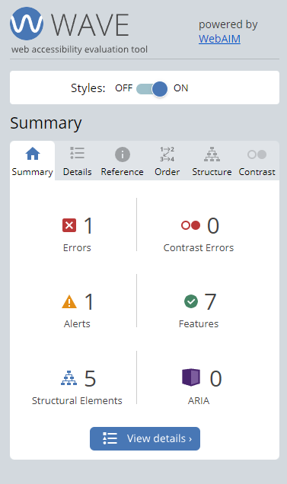
Figure 51- Final Website Contact/News Page WAVE Testing

4.3. Comparison to the Set
In order to gauge the success of the project, the findings of usability testing tools will be compared to those found within the set. Overall, there were little issues detected which the final website had in common with those found within the set. The set had more critical & serious errors within their pages than the final website, and the final website was designed to adjust the issues found against the set.
One aspect found within the website set compared to the final website is the presence of extensive ARIA elements within the pages, which help in part to increase the accessibility of the pages. The website set was also featured more structural elements than the final product, such as multiple lists, proper search implementation, and proper inline framing.
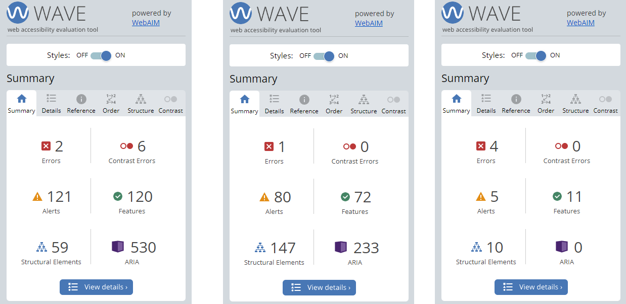
Figure 52- WAVE Comparison of Amazon, eBay, & the Final Website
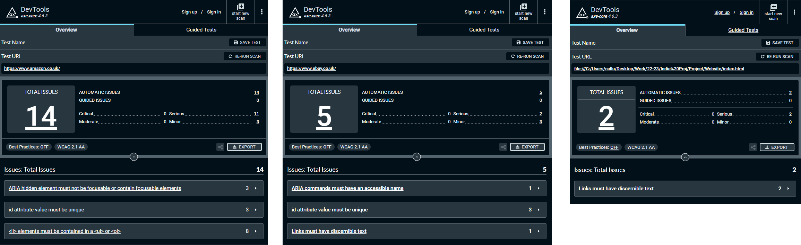
Figure 53- axe Comparison of Amazon, eBay, & the Final Website

5. Evaluation

5.1. Conclusions
From the implementation of the website, and testing using the usability & accessibility tools, there are many different methods & implementations which can be used to create a fully responsive, usable & accessible website. Although professional e-commerce websites such as Amazon & eBay feature elements which make them accessible, there are still alterations which can be made to make them truly usable.
Overall, the results are in line with what was expected of the website, its design, and its implementation. The testing results of the final website shows that the professional e-commerce sites, while designed in a way which is accessible and usable, still have some aspects which could be included or modified so as to make them more compliant with various guidelines, especially the WCAG. Additionally, it is important to review the websites’ code & inclusions regularly in order to ensure that they are fully accessible.

5.2. Aims & Objectives
Over the course of the project, all of the established aims & objectives were met. Through the literature review, the first two objectives were met, due to the identification of the various standards & guidelines used within the testing of the website set and final product, and the third objective was met through the testing of the website set, and the discussion of the findings of the multiple tools. The fourth and final objective was achieved through the development & implementation of the final website, as well as its testing using usability tools, & the comparison with the initial findings of the website set. Through the fulfilment of the project objectives the greater project aim was also achieved, with the finalised website designed & created.
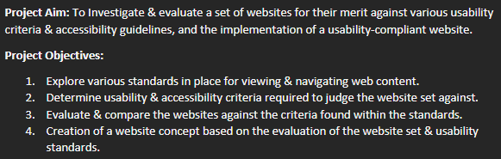
Figure 54- Project Aim & Objectives

5.3. Future Alterations
Due to the time constraints of the project, there would be many different decisions made within designing & implementation if the project was to be repeated.
As the final website was created using pure HTML, CSS & JavaScript, further technologies could have been implemented in order to create a more true-to-form e-commerce website. For exampling, using JQuery, a type of JavaScript library, would have greatly simplified the process of adding JavaScript, and would have helped with more advanced implementation of JavaScript-rich features such as dynamically updating content, animate images, & multimedia such as videos & sounds, in order to make the website much more like those it is based upon. Additionally, implementing Hypertext Processor (PHP) code could have further added interactive & dynamic functionality, in relation to including interaction with databases in order to give the products distinct values, which could have lead to the implementation true basket/shopping cart functionality.
Additionally, more focus could have been on the implementation Accessible Rich Internet Applications (ARIA) roles & attributes: including these elements, such as set attributes, roles, & properties, would have made the website more accessible to those users with disabilities, and would have helped better evaluate the website against the professional sites which did include them, as well as defining clear sections of the website pages in order to acquire better usability results, [41].
For testing the website set, a larger variety of websites could have been used and tested in order introduce a larger pool of issues would could have been addressed in the final website. Other usability tools, such as dedicated contrast checkers, or more accessibility-orientated tools, would have also allowed for more extensive testing of the website set and the final product.

6. Conclusion & Recommendations
The first step of the process in undertaking the project was the definition of the key aim and objectives that would help define & guide the development of the project. These objectives were met over the course of the project, during pivotal moments; The first and second were achieved through discussion during the literature review of usability/accessibility guidelines, and establishing the groundwork for the requirements of the final product, and the requirements of the project overall. The third objective was met through testing the initial website set with the usability Tools axe, WAVE & Accessibility Checker, and these tools also helped during the final objective of creating the final website, then testing it against the findings of the tools on the website set.
The design of the website was laid out with a series of drafts & wireframe diagrams of the initial four pages of the site. While the pages adhered to these wireframes, they did deviate somewhat, featuring images & buttons were they were not located on the wireframes, and the image carousel on the index/home page was placed towards the bottom of the page below the items on display, rather than above the items; this alteration was made to better aid the readability of the site, and to ensure that the first item visitors to the website saw were the introduction, and the products. Following the completion of the implementation of the website, it was tested using two of the three tools used on the initial website set. This was done to ensure consistency, and to ease the data analysis.
As discussed, time constraints had an effect on the implementation process, and improvements can be made to the final website in order to become completely WCAG compliant. Given a more robust schedule, and proper time keeping and management, a fully compliant wand working website could be achieved. Additional development, including implementing ARIA within the code, could have also lead to a more compliant website, as detect through testing using WAVE. A larger website set, and more testing tools, would have also aided in creating more-defined requirements for the final website. Despite deviation from the Gantt chart, the final product was created, and could be tested in a timely manner in order to analyse the data with the website set’s findings.

6.1. Further Research
Further research is possible on the topic, due to a constant shift & development in web standards & guidelines. As these guidelines continue to grow, and the fields of usability & accessibility are further investigated, there will always be some form of further research required in web design & development. There is precedent for usability & accessibility testing for websites beyond simple e-commerce, such as university or corporate websites, and in relation to testing, a more broader spectrum of disabilities and people can be used in order to achieve greater revisions of guidelines.

7. Reflection
Over the course of the project, there had been many opportunities to gauge the skills of planning, website design, implementation & evaluation. It has also enabled a worldview in which websites, regardless of their size, scale or popularity, always have room for improvement in the regions of usability & accessibility. The use of various languages such as HTML, CSS & JS also advanced the development of this skill, with more consideration towards how the languages can be used effectively in tandem with on another to create a meaningful, accessible & usable website.
A primary skill developed throughout the project was critical thinking, which was developed through tasks such as composing a literature review with careful consideration to the contents in order to succinctly summarise the requirements of the final product. Visual design was also refined through the design process, including the drafts & wireframe diagrams, and through the creation of the final website. The use of tools to analyse findings was also a contributing factor, as consideration was required in which aspects of websites was to be improved, with a ‘form over function’ mentality throughout the design & implementation process.
On the technical details of the project, time management played a key factor in how & when the project was undertaken, such as how to make websites more effective, or through the use of webpage templates with full functionality, without sacrificing usability & accessibility. While the project had not fully followed the preliminary Gantt chart, the creation of the chart helped develop the scope of the project as a whole.
Some more focus could have been shifted towards implementation, and better in-depth research could have been undertaken in order to better implement the final website, in particular in relation to overall responsiveness.
Overall, the process and completion of the project has contributed to many different skills, and has helped in key aspects such as website designing & implementation, time management, and the overall user experience.

References

[1] | Interaction Design Foundation, “What is Usability Testing? | IxDF,” [Online]. Available: https://www.interaction-design.org/literature/topics/usability-testing. [Accessed 25 November 2022].
[2] | World Wide Web Consortium, “Web Content Accessibility Guidelines (WCAG) 2.1,” 5 June 2018. [Online]. Available: https://www.w3.org/TR/WCAG21/. [Accessed 20 October 2022].
[3] | J. Nielsen, “Changes in Web Usability Since 1994,” 30 November 1997. [Online]. Available: https://www.nngroup.com/articles/changes-in-web-usability-since-1994/. [Accessed 25 November 2022].
[4] | World Wide Web Consotrium, “Accessiblity, Usability, and Inclusion | Web Accessiblity Initiative | W3C,” 6 May 2016. [Online]. Available: https://www.w3.org/WAI/fundamentals/accessibility-usability-inclusion/. [Accessed 26 November 2022].
[5] | usability.gov, “Usability Testing | Usability.gov,” [Online]. Available: https://www.usability.gov/how-to-and-tools/methods/usability-testing.html. [Accessed 25 November 2022].
[6] | International Organization for Standardization, “Ergonomics of human-system interaction — Part 11: Usability: Definitions and concepts,” 2018.
[7] | B. Shackel, “Usability – Context, framework, definition, design and evaluation,” Interacting with Computers, vol. 21, no. 5-6, p. 339–346, 2009.
[8] | D. Lawrence and S. Tavakol, “Website Usability,” in Balanced Website Design, London, Springer London, 2007, pp. 37-38.
[9] | J. Nielsen, Usability Engineering, San Diego: Academic Press, 1993.
[10] | T. K. Chiew and S. S. Salim, “WEBUSE: WEBSITE USABILITY EVALUATION TOOL,” Malaysian Journal of Computer Science, vol. 16, no. 1, pp. 47-57, 2003.
[11] | J. M. Pearson, A. Pearson and D. Green, “Determining the importance of key criteria in web usability,” Management Research News, vol. 10, no. 11, pp. 816-828, 2007.
[12] | L. Hasan, A. Morris and S. Probets, “A comparison of usability evaluation methods for evaluating e-commerce websites,” Behaviour & Information Technology, vol. 31, no. 7, pp. 707-737, 2012.
[13] | A. Fernandez, E. Insfran and S. Abrahão, “Usability evaluation methods for the web: A systematic mapping study,” Information and Software Technology, vol. 53, no. 8, pp. 789-817, 2011.
[14] | A. Ismail and K. S. Kuppusamy, “Web accessibility investigation and identification of major issues of higher education websites with statistical measures: A case study of college websites,” Journal of King Saud University - Computer and Information Sciences, vol. 34, no. 3, pp. 901-911, 2022.
[15] | StatCounter, “Desktop vs Mobile vs Tablet Market Share Worldwide | Statcounter Global Stats,” [Online]. Available: https://gs.statcounter.com/platform-market-share/desktop-mobile-tablet. [Accessed 14 January 2023].
[16] | Bloomtools, “Key Elements Of Effective Web Design | Bloomtools,” 10 December 2020. [Online]. Available: https://www.bloomtools.com/blog/7-key-elements-of-effective-web-design. [Accessed 14 January 2023].
[17] | Wolr dWide Web Consotrium, “Web Conten Accessiblity Guidlines (WCAG) 2.2,” 6 September 2022. [Online]. Available: https://www.w3.org/TR/WCAG22/. [Accessed 14 January 2023].
[18] | Deque Systems, Inc., “axe: Accessiblity Testing Tools and Software,” [Online]. Available: https://www.deque.com/axe/. [Accessed 14 January 2023].
[19] | WebAIM, “WAVE Wev Accessiblity Evaluation Tools,” [Online]. Available: https://wave.webaim.org/. [Accessed 14 February 2023].
[20] | Intent Based LTD, “Accessiblity Checker - ADA & WCAG Compliance (Free Scan),” [Online]. Available: https://www.accessibilitychecker.org. [Accessed 14 February 2023].
[21] | WebAIM, “The WebAIM Million,” WebAIM, Logan, 2022.
[22] | K. Tej, “How to test Browser Compatability for HTML5 | BrowserStack,” BrowserStack, 7 April 2022. [Online]. Available: https://www.browserstack.com/guide/html5-browser-compatibility-test. [Accessed 24 Feburary 2023].
[23] | W3Schools, “CSS Introduction,” [Online]. Available: https://www.w3schools.com/css/css_intro.asp. [Accessed 30 Feburary 2023].
[24] | Mozilla Corporation, “CSS and JavaScript accessiblity best practices - Learn web development | MDN,” 26 February 2023. [Online]. Available: https://developer.mozilla.org/en-US/docs/Learn/Accessibility/CSS_and_JavaScript. [Accessed 2 March 2023].
[25] | W3Schools, “CSS Reference Browser Support,” [Online]. Available: https://www.w3schools.com/cssref/css3_browsersupport.php. [Accessed 2 March 2023].
[26] | Mozilla Corporation, “JavaScript - Dynamic client-side scripting - Learn web development | MDN,” [Online]. Available: https://developer.mozilla.org/en-US/docs/Learn/JavaScript. [Accessed 6 March 2023].
[27] | A. Monus, “JavaScript best paracitices - Raygun Blog,” 22 November 2022. [Online]. Available: https://raygun.com/blog/javascript-best-practices/. [Accessed 13 March 2023].
[28] | The Marketing Squad, “4 Website Design Considerations | The Marketing Squad,” [Online]. Available: https://themarketingsquad.com/4-website-design-considerations/. [Accessed 14 March 2023].
[29] | J. Dudovskiy, “Positivism - Research Methodology,” [Online]. Available: https://research-methodology.net/research-philosophy/positivism/. [Accessed 10 April 2023].
[30] | Y. S. Park, L. Konge and A. R. Artino, “The Positivism Paradigm of Research,” Academic Medicine, vol. 95, no. 5, pp. 690-694, 2020.
[31] | L. Pham, “Qualitative approach to research a review of advantages and disadvantages,” University of Adelaide, Adelaide, 2018.
[32] | D. I. Purnamasari, “Mixed Approach Pros And Cons of Positivism and Alternativism: Towards The Perfection of Science Development,” International Journal of Management Services, vol. 7, no. 4, pp. 188-194, 2016.
[33] | M. Rahman, “The Advantages and Disadvantages of Using Qualitative and Quantitative Approaches and Methods in Language "Testing and Assessment" Research: A Literature Review,” Journal of Education and Learning, vol. 6, no. 1, p. 102, 2017.
[34] | Adobe Communications Team, “Waterfall Methodology: Project Management | Adobe Workfront,” Adobe Inc., 18 March 2022. [Online]. Available: https://business.adobe.com/blog/basics/waterfall. [Accessed 6 April 2023].
[35] | M. McCormick, “Waterfall vs. Agile Methodology,” MPCS, Inc, 2012.
[36] | ProjectManager.com, Inc., “Waterfall Methodology: The Ultimate Guide to the Waterfall Model,” [Online]. Available: https://www.projectmanager.com/guides/waterfall-methodology. [Accessed 10 April 2023].
[37] | J. D. Naumann and A. M. Jenkins, “Prototyping: The New Paradigm for Systems Development,” MIS Quarterly, vol. 6, no. 3, pp. 29-44, 1982.
[38] | S. O. Onuh and Y. Y. Yusuf, “Rapid prototyping technology: applications and benefits for rapid product development,” Journal of Intelligent Manufacturing, vol. 10, pp. 301-311, 1999.
[39] | W. T, “All Advantages and Disadvantages of Prototype Model,” 23 March 2203. [Online]. Available: https://biplus.com.vn/advantages-and-disadvantages-of-prototype-model/. [Accessed 13 April 2023].
[40] | Experience UX, “What is wireframing?,” [Online]. Available: https://www.experienceux.co.uk/faqs/what-is-wireframing/. [Accessed 6 April 2023].
[41] | R. Vogels, “A 6-Step Guide to Web Application Testing [Agencies Approved],” [Online]. Available: https://usersnap.com/blog/web-application-testing/. [Accessed 26 April 2023].
[42] | Mozilla Foundation, “ARIA - Accessiblity | MDN,” 23 April 2023. [Online]. Available: https://developer.mozilla.org/en-US/docs/Web/Accessibility/ARIA. [Accessed 26 April 2023].

