AI Statement
I confirm that I have not used any AI tools in the research and creation of this assignment. I confirm that I have not presented any AI generated materials as my own work. I confirm I have copies of my drafts, notes, and other resources I used, which I may be asked to provide in evidence.

Jobs Growth Wales/ACT Placement

Tegan Cartlidge

Table of Contents
Page No. | Content
4-8 | Reflective Commentary
9-10 | Reference List
11 | Additional Evidence: Pictures of engagement
12 | Additional Evidence: Examples of Work Completed
13-15 | Additional Evidence: Organisation mission or value statements
16-35 | Appendix

Reflective Commentary
The placement I undertook at ACT/Jobs Growth Wales (JGW+) was as classroom teacher, focused on increasing engagement of a cohort of pupils identified as struggling with mental health and wellbeing in ways which have compromised their remaining in mainstream education. I was certain that this would be an environment where developing counselling skills could be of great value. The role required a pastoral focused approach centred on building rapport, relationships and enthusiasm for growth among young people who have often felt disillusioned and marginalised.
This role operated in coordination with the centre manager and the wellbeing-lead to help students experience a safe pastoral base between their vocational courses and apprenticeships. The young people were between 16-19 and daily attendance ranged from 3 to 16 students. I focused on developing engaging lessons around discussion-based topics. My counselling skills supported me in developing a strong rapport with the students and they grew in confidence to share information about their lives, opinions, and concerns in ways more conducive to building lasting and/or professional relationships.
My feelings prior to placement were confronting as I considered the responsibility of teaching a class of pupils and holding their engagement without a formal teaching qualification. I felt a sense of incongruence (Rogers, 2020/1951), concerned about the differentiated provision afforded to young people outside of mainstream setting, feeling concern that I would be part of a short-changing system, not allocating skilled teachers to those most in need of them.
I leant on my counselling training to consider how to bracket and boundary any feeling that I should not be in the role. I focused on the opportunity for horizontalism (Joyce & Sills, 2018) afforded by not being a teacher attached to the mainstream system which was not working for these young people. I spoke with my personal counsellor and formed a determination to focus upon empathy, unconditional positive regard and congruence (Rogers, 1957) to develop an environment of growth in the classroom, rather than feeling I should be disclosing myself as an imposter.
Young people showed curiosity in my different route into the classroom and engaged strongly with the principles I was modelling. They saw and showed me value in different voices contributing to education. I began to understand their frustration at the more prescriptive and less emotionally aware (as I interpreted it) approaches of many teachers and I began to reflect these feelings and hold them myself. Hearing the students speak openly about their experiences in education, I felt concern about the systemic issues related to power dynamics (Foucault, 2019/1978) experienced by young people as damaging to their wellbeing.
During this placement I felt strong compassion for young people and the challenges they faced. When told young people were stealing snacks, I was upset and made food more available in our classroom. When young people shared their worries or experiences, I held space and experienced strong empathic reactions which contributed to a therapeutic relationship (Hough, 2021) held between us.
The ‘way of being’ (Rogers, 1980) I worked to model for the young people was highly successful and in line with their own valuing system. Congruence was interpreted by young people as being real and authentic. This was more challenging when many voiced open dissatisfactions with the school operations. Times where I openly encouraged enthusiasm for parts of school processes were called out as inauthentic by young people and this at times challenged the relationship.
Empathy demonstrated in motivational interviewing skills (Cooper, 2024), taking care to show young people I was listening and engaged with their experiencing was hugely effective. Young people sought me out in their own time to share space with me and be open about their feelings and show curiosity about my own life and experiences. Both I and they contributed to this emerging relational depth (Mearns & Cooper, 2017) built upon respect, safety and open communication.
At times, this challenged me to set boundaries (McLeod, 2013) around my own time and consistently I struggled to feel like I should ringfence time for myself. I recognise boundaries as important in the development of the therapeutic frame (Gray, 2013) and this was a learning point for me.
A challenge in the placement setting was navigating prejudice. Unfortunately, not all interactions followed the respectful and empathetic model and there was discrimination that made its way into the room. I struggled to keep arguments civil as anti-traveller rhetoric was used against the Irish Travellers in the class. I was able to build relationships with them away from everyone else, but they did not benefit from the wider emotional safety that everyone else did and they never integrated with their classmates. Misogynistic and homophobic views espoused by many also needed to be challenged to champion equality as the BACP ethics (BACP, 2020) include. I found my counselling theory beneficial as I could discuss gender performativity (Butler, 2006/1990) and the discourses of prejudice (Foucault, 2019/1978) with more confidence than before.
Following my placement, I consider that bringing counselling skills and specifically the core conditions of person-centred therapy (Cooper, 2024; Rogers, 1957) to the pastoral relationships with the young people in placement was impactful. Working without the pedagogical responsibilities to cover curriculum or assess and measure attainment I was able to focus on the listening and motivational interviewing skills (Cooper, 2024) which made up my skills practice. I was able to work on providing features of the therapeutic relationship such as the forming of alliance (Finlay, 2022), empathic attunement (Freire & Di Malta, 2024), horizontalism (Joyce & Sills, 2018), parts work (Schwartz, 2023) and use the ‘here and now’ (Yalom, 2010), to contribute to attempting to meet young people at relational depth (Mearns & Cooper, 2017). The young people noted and showed appreciation for the “realness” of the interactions and demonstrated their desire that more teaching staff approached communicating with them in that way.
Taking this individual therapy skillset to a dynamic group environment with changing classes each day and a responsibility to challenge prejudice and maintain equality and safety in the room was challenging. Our counselling skills have not incorporated group settings and so I feel I have much growth to do before I can effectively hold the therapeutic frame in such a dynamic setting.
More work on my part to understand the intersectionality of the students, their specific backgrounds, their ways of seeing the world, their cultural specificity, while reflexively understanding my own (Wright, 2018), might allow me to feel more congruent in challenging moments of aggression or prejudice. Continuing my theory work to consider discourse analysis (Willig, 2024) or specific approaches to group facilitation might be helpful here.

References
BACP. (2020). Counselling skills competence framework. https://www.bacp.co.uk/media/8890/bacp-counselling-skills-competence-framework-may20.pdf
Butler, J. (2006). Gender trouble: Feminism and the subversion of identity. Routledge. (Original work published 1990).
Cooper, M (Ed.). (2024). The tribes of the person-centred nation: An introduction to the world of person-centred therapies (3rd Ed.). PCCS Books.
Finlay, L. (2022). The therapeutic use of self in counselling and psychotherapy. Sage.
Foucault, M. (2019). Power: Essential works 1954-84 (Hurley, R, Trans.). Penguin UK. (Original work published 1978).
Friere, E., S., & Di Malta, G. (2024). Empathy. In G. D. Malta, M. Cooper, M O’Hara, Y. Gololob & S. Stephen (Eds.), The handbook of person-centred psychotherapy and counselling (3rd Ed.). Bloomsbury.
Gray, A. (2013). An introduction to the therapeutic frame. Routledge.
Hough, M. (2021). Counselling skills and theory (5th Ed.). Hodder Education
Joyce, P., & Sills, C. (2018). Skills in gestalt counselling and psychotherapy (4th Ed.). Sage.
Rogers, C. R. (1957). The necessary and sufficient conditions of therapeutic personality change. Journal of Consulting Psychology, 21(2), 95-103. https://doi.org/10.1037/h0045357
Rogers, C. R. (1980). A way of being. Mariner Books.
Rogers, C. R. (2020). Client-centred therapy: 70th Anniversary edition. Robinson. (Original work published 1951).
Schwartz, R., C. (2023). No bad parts: Healing trauma and restoring wholeness. Penguin Random House.
McLeod, J. (2013). An introduction to counselling (5th Ed.). McGraw Hill.
Mearns, D., & Cooper, M. (2017). Working at relational depth in counselling and psychotherapy (2nd Ed.). Sage.
Willig, C. (2024). Discourse analysis. In J. Smith (Ed.), Qualitative psychology: A practical guide to research methods (pp. 143-168). Sage.
Wright, J. (2018). Reflective writing in counselling and psychotherapy (2nd Ed.). Sage.
Yalom, I., D. (2010). The gift of therapy: An open letter to a new generation of therapists and their patients. Piatkus.

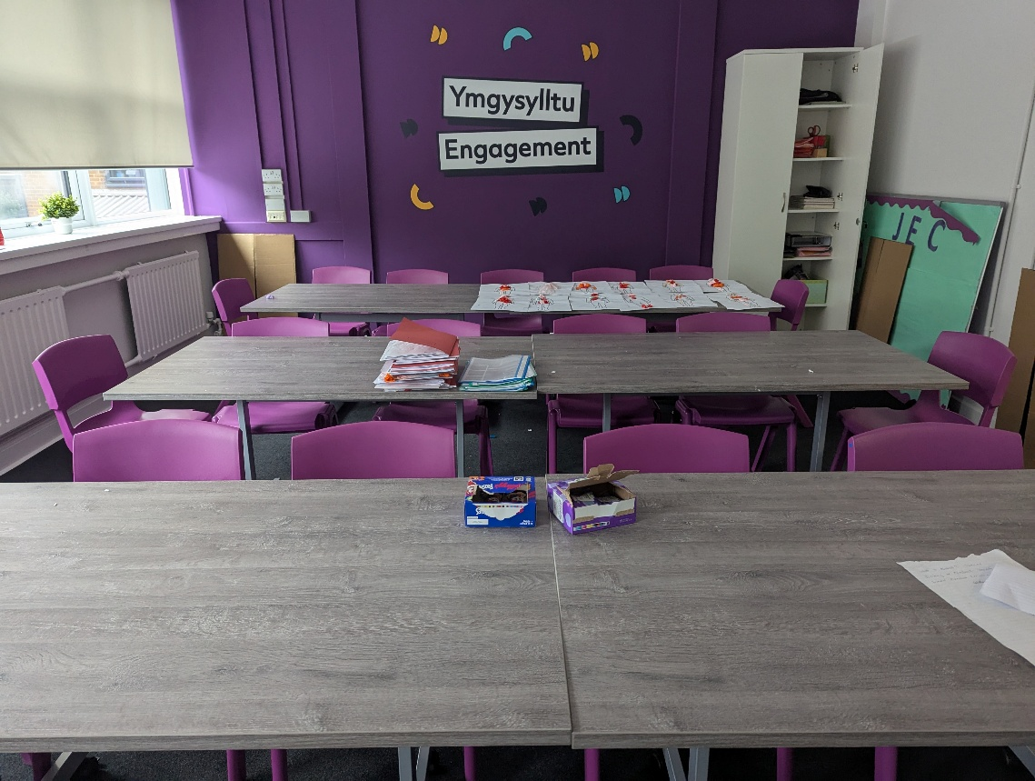
Additional Evidence: Pictures of engagement

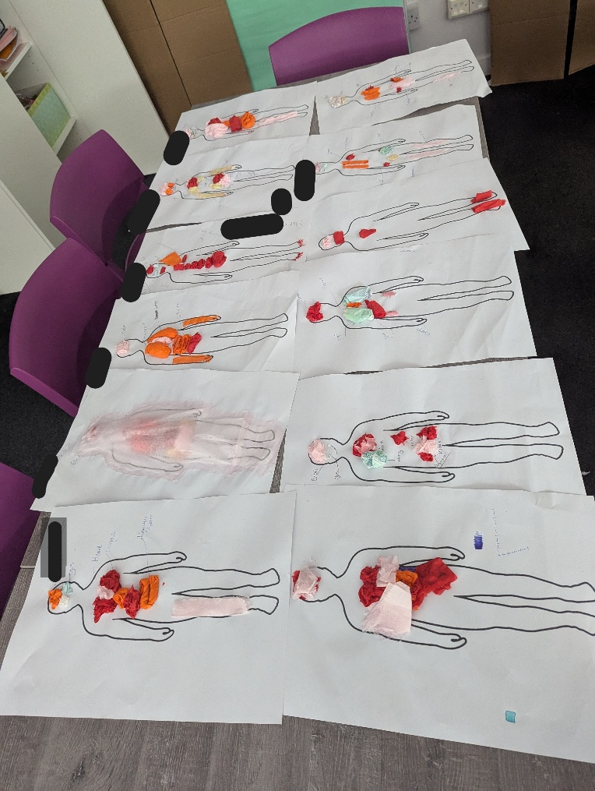

The therapeutic environment of the classroom is best evidenced by the completed work of the young people. These are young people who have historically disengaged from activities in the classroom and have a history of behaviours that mediate their fear of ‘getting it wrong’. By providing psychological safety with the core conditions, on days without added outside distress, like this day pictured, they all completed a creative anatomy map.
This work formed part of an overarching body of work relating to harmony with, and care for, self and the body.

Additional Evidence: Examples of Work Completed
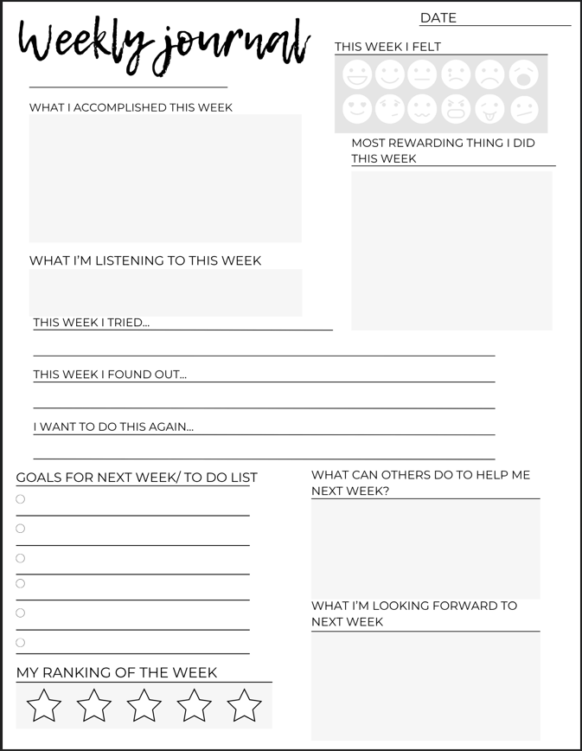

This is an example of one of the sheets I created using Canva for the ‘Student Handbook Packs’ mentioned in my reflexive log (see Appendix G). These were filled out by students every week to get them used to reflecting on their week through journalling. The basis of this was to ensure there would be a structured space every week held for contemplation and goal setting for the week ahead.

Additional Evidence: Organisation mission or value statements
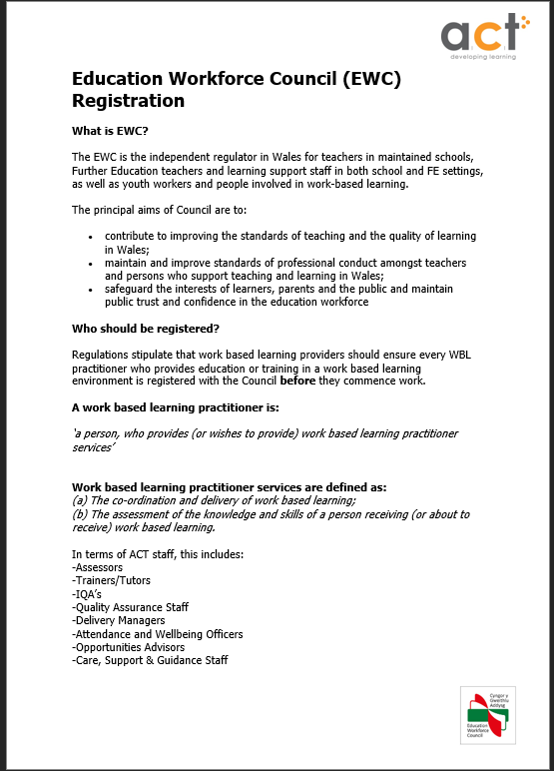

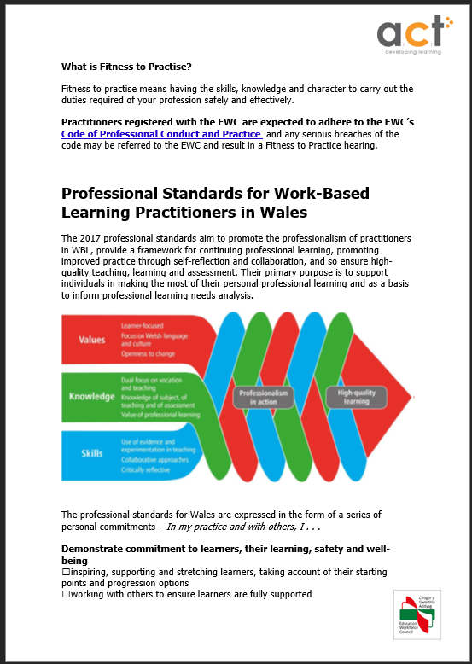

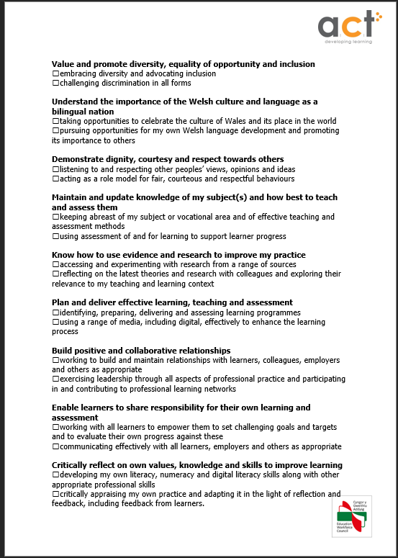

Policies and procedures around what it means to be suitable to help young people learn and grow with integrity. There are many points at which this document and the BACP Counselling Skills Competency Framework line up and demonstrate why this placement aligns with counselling ethics. The emphasis on improving your practice by seeking up to date awareness and knowledge and demonstrating dignity and respect aligns with the BACP model of working, however, in practice these could be difficult due to the added pressures of reporting and performance indicators.

Appendix
Appendix A- Request Email to JGW+/ACT
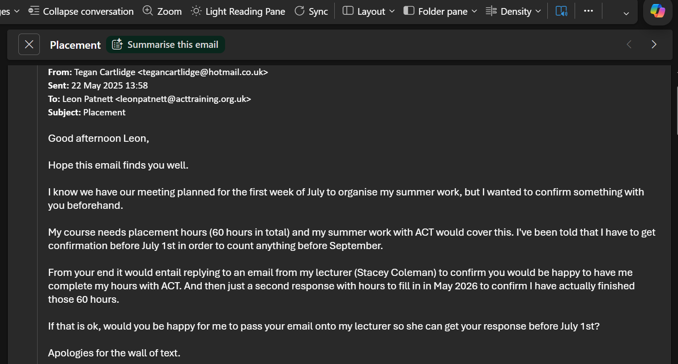
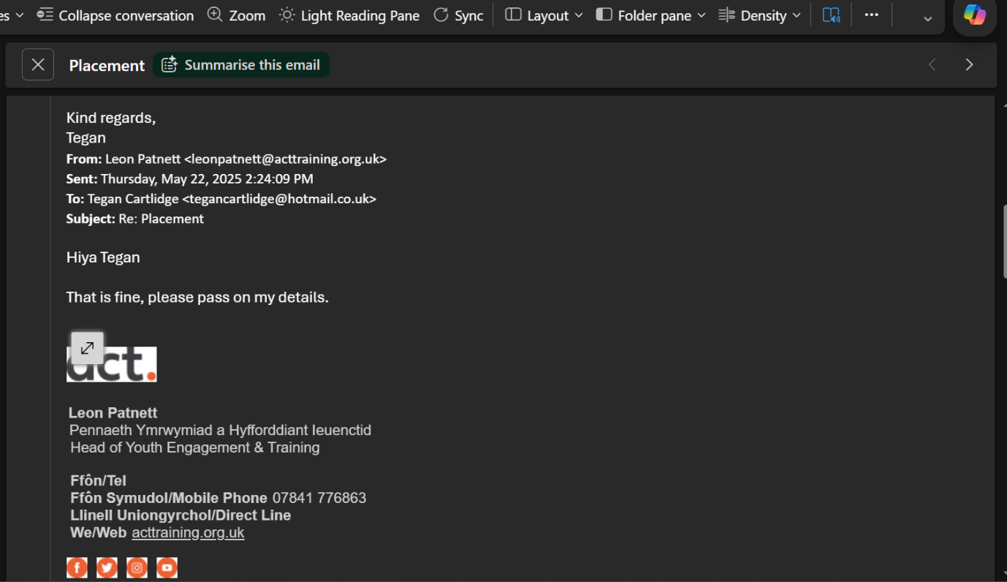

Appendix B- Letter of Offer of Role
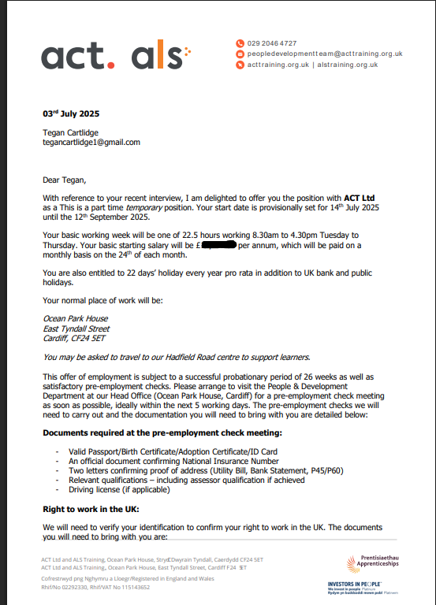

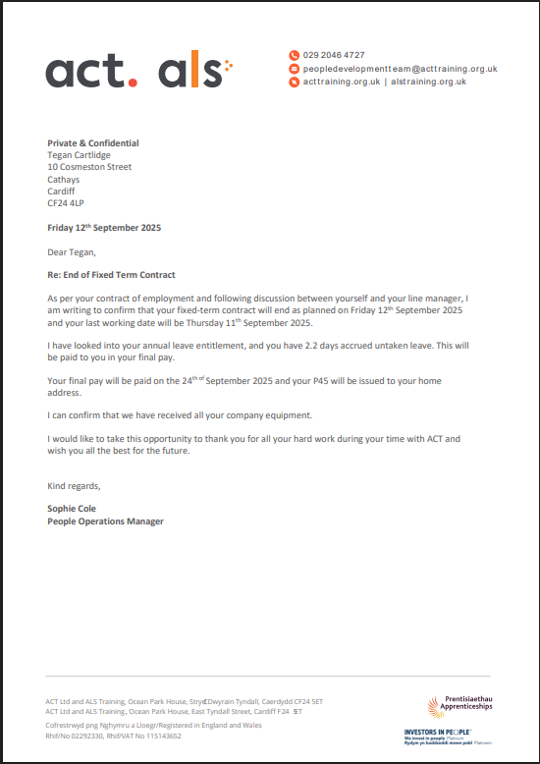
Appendix C- Notice of End of Role

Appendix D- Placement Information Form
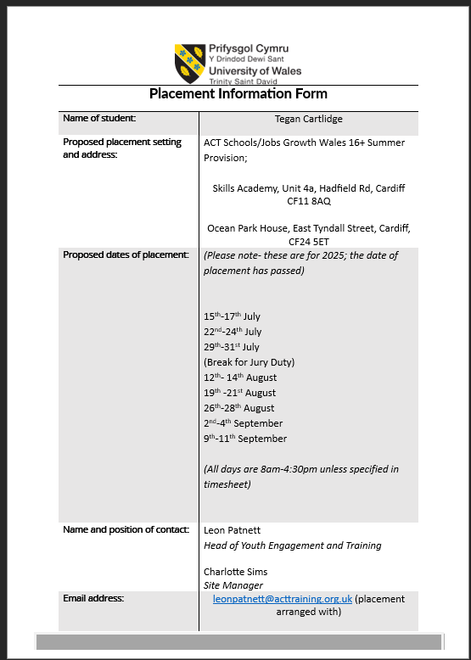

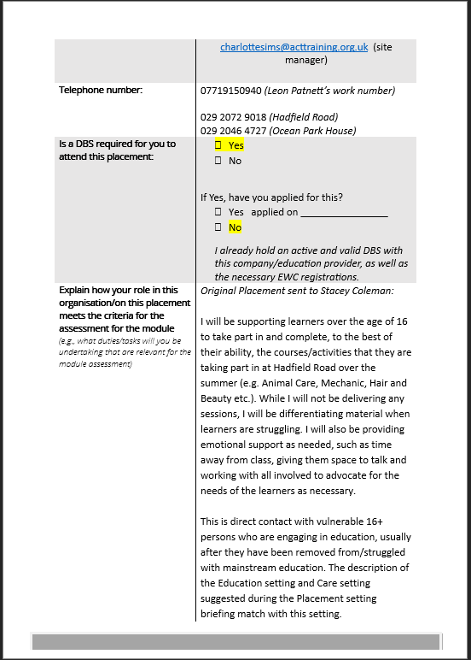

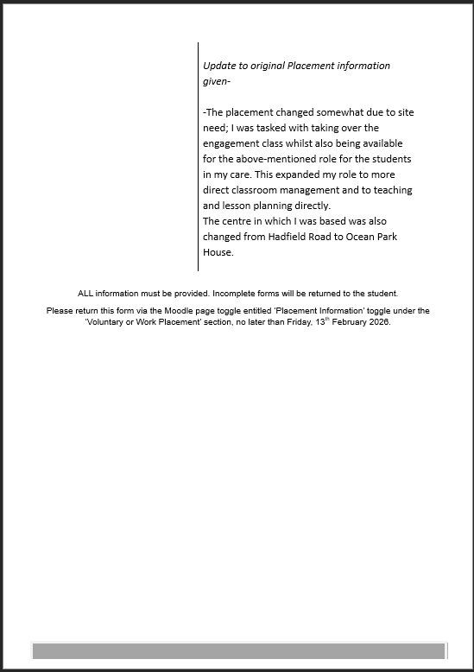

Appendix E-UWTSD Email Confirming Placement
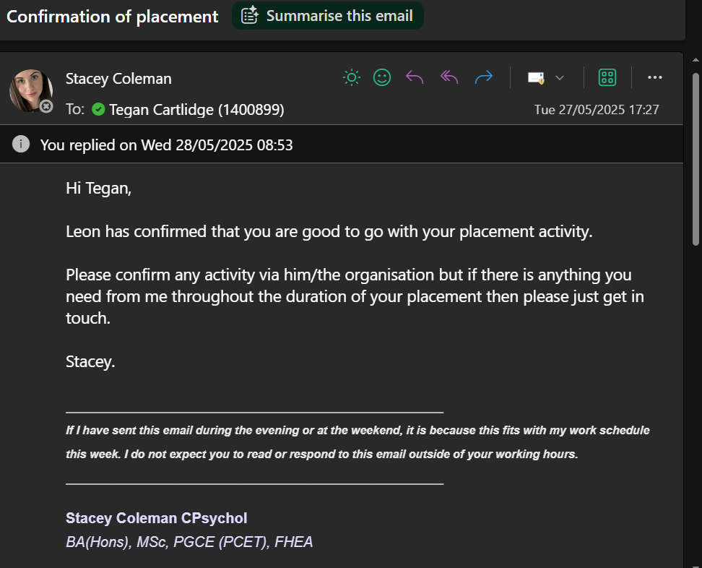

Appendix F- Time Sheet

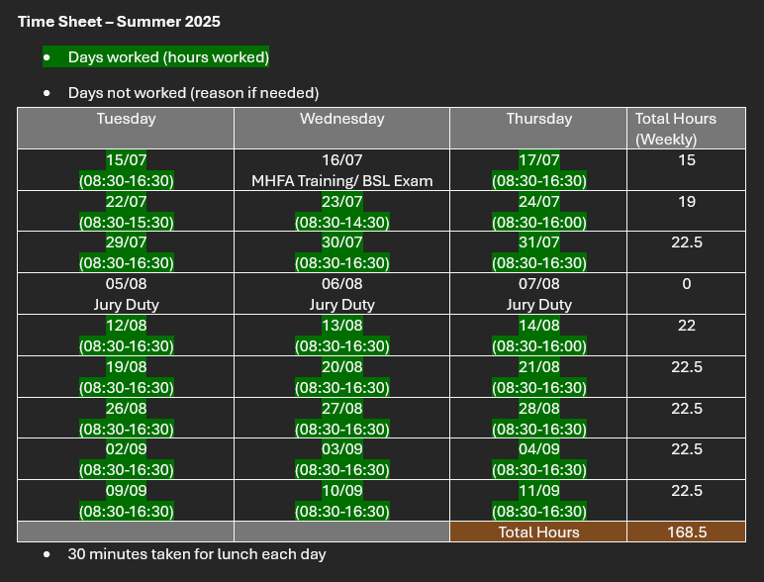

Appendix G- Reflexive Log


