Name : Mihaela Geanina Oneamoise
Student ID: 2232227
Module : Computer Systems Fundamentals
Programme: CertHE in Digital Skills B.Eng in Electrical Engineering
Assessment title : Computer System component specification
Lecturer : Stalin Jacob

Task1
1.Black case | £29.99 | We need a case in the first | 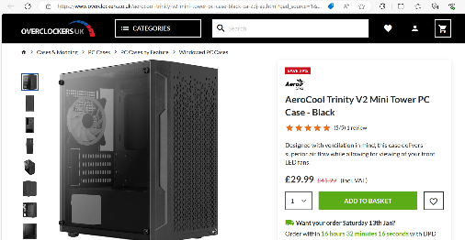
2.CPU- AMD RYZEN 5 PRO 3400G CPU BENT PINS | £42.99 | I think just for check emails and watch YouTube it is a good CPU | 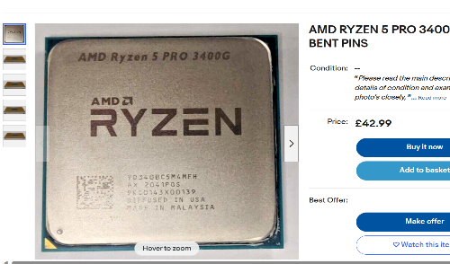
3.Motherboard- MSI MAG B650M Mortar WIFI (Socket AM5) DDR5 Micro-ATX Motherboard- | £190 | It is a good price and again just for those things is more than enough | 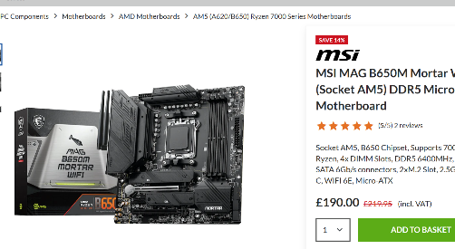
4.RAM- Crucial 16GB (2X8GB) DDR5 PC5-38400C40 4800MHZ Dual Channel Kit RAM | £59.99 | It’s nothing special,  I choose 16GB because are enough space | 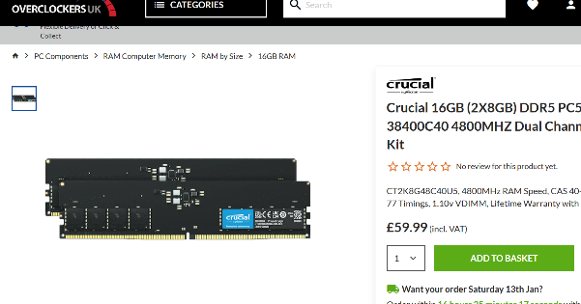
5. SSD-Crucial BX500 1TB SSD 2.5" SATA 6Gbps Solid State Drive | £61.99 | 1TB it’s seeming like not too much, but again just for emails, YouTube and join some classes are more than enough | 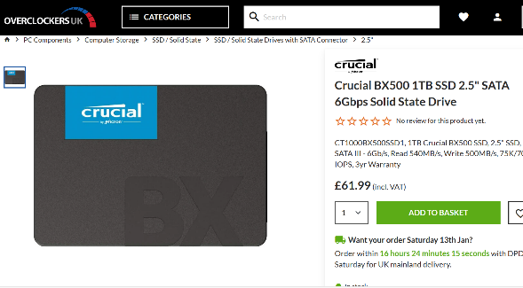
6. GPU- Gigabyte GeForce RTX 3060 Wind Force OC LHR 12GB GDDR6 PCI-Express Graphics Card- | £289 | I choose an integrated graphics cards only need to run basic tasks | 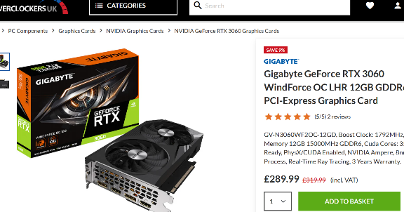
7. PSU-Super Flower Golden Green HX 650W "80 Plus Gold" Power Supply – Black | £79.99 | I need it because is a critical piece of any desktop, it is cheap and cover the basics of power supplies | 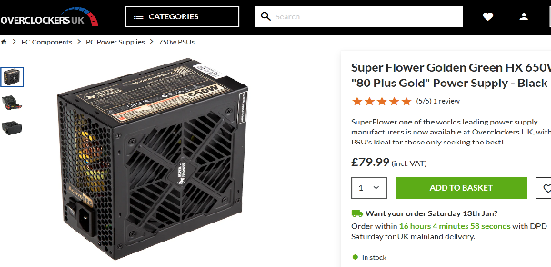
8. Windows 10 Home CD Key | £10.99 | They need a window for make possible to complete all types of everyday tasks | 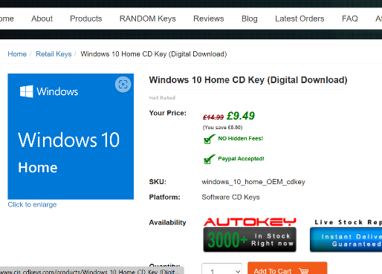
9. McAfee® Total Protection | £24.99 | I choose an antivirus to protect the person from hackers and viruses
10. Monitor-ASUS 24" TUF VG249Q1A FHD 165Hz 1ms Free Sync/G-Sync | £168.95 | They need a monitor as well and I choose 24” -not too big but also not too small | 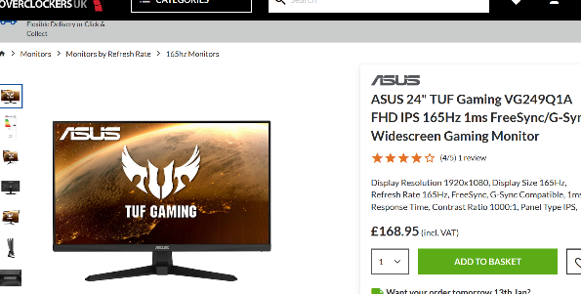
11.Mouse- Glorious Model O USB RGB Odin Gaming Mouse - Glossy Black (GO-GBLACK | £40 | I bought a mouse | 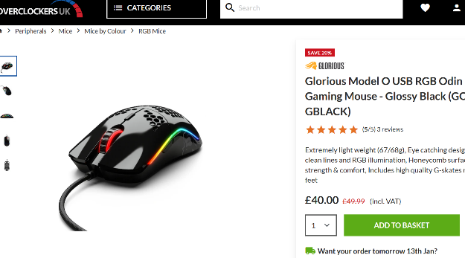
12.keyboard- Ducky One 2 Phantom Black Mechanical Gaming Keyboard Cherry MX Brown Switch - UK Layout | £100 | We need a keyboard as well | 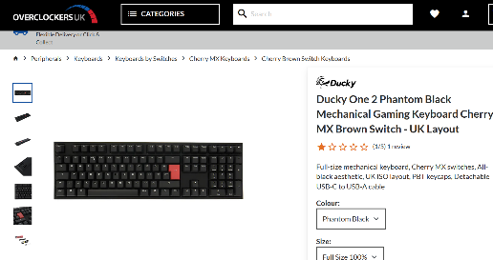
13. Network connectivity Wi-Fi 2.4ghz from home | £30 Monthly | I think they have a network at home for their phones, so they will use that network for computer as well.

Task 2

Processor 12th Gen Intel(R) Core(TM) i3-1215U 1.20 GHz
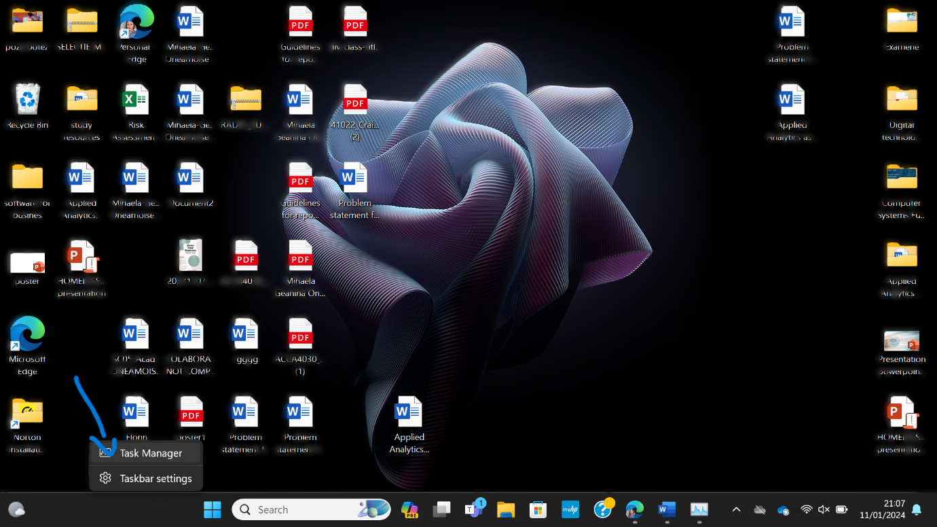
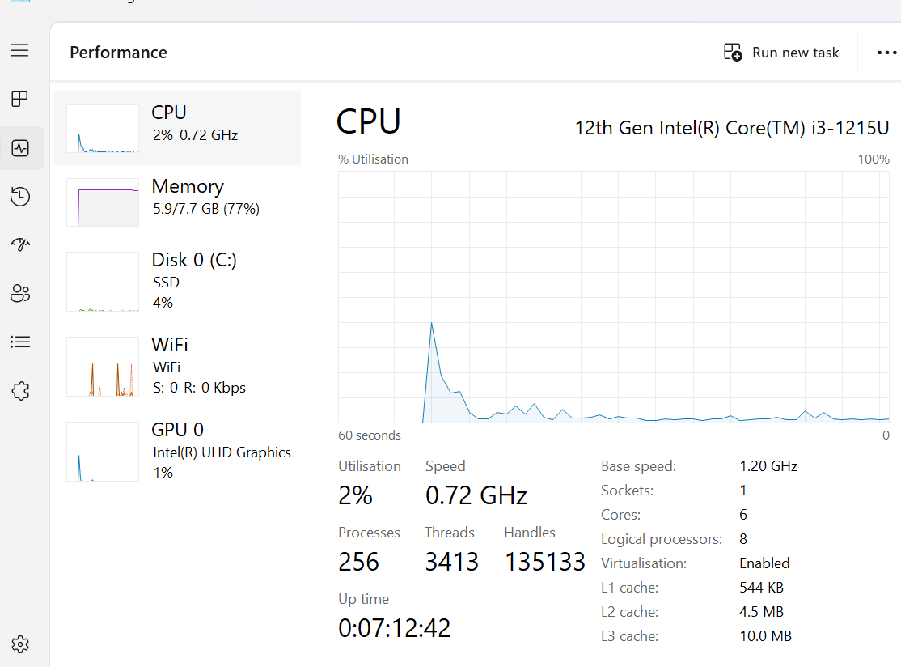

RAM 8.00 GB (7.68 GB usable)
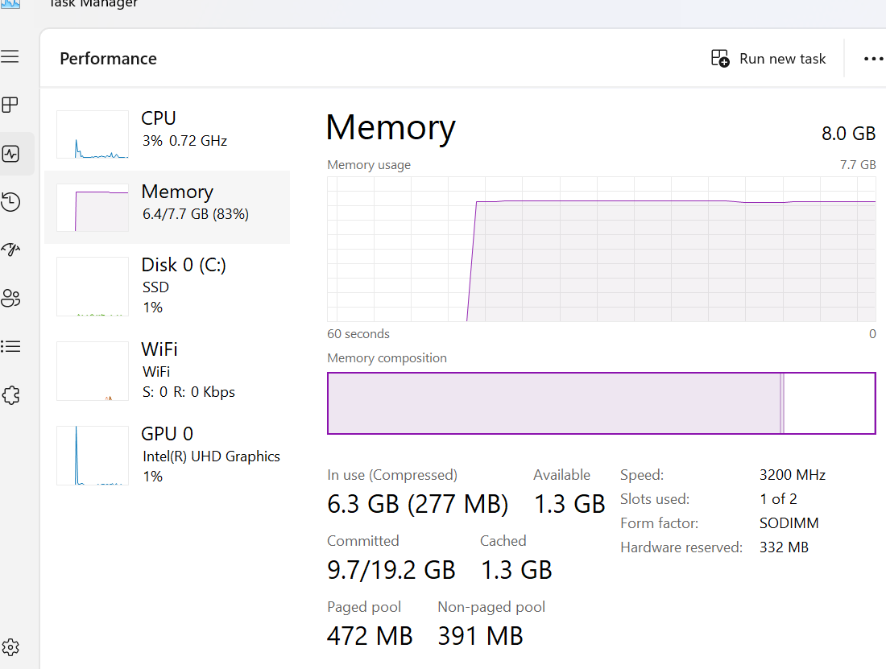

Storage capacity and types

Types:
Primary storage: RAM, ROM
Secondary storage : hard disc drives , USB flash drives, SD cards , CD-DVD disks
Cloud and virtual storage : remote servers or network to store and access data over the internet.
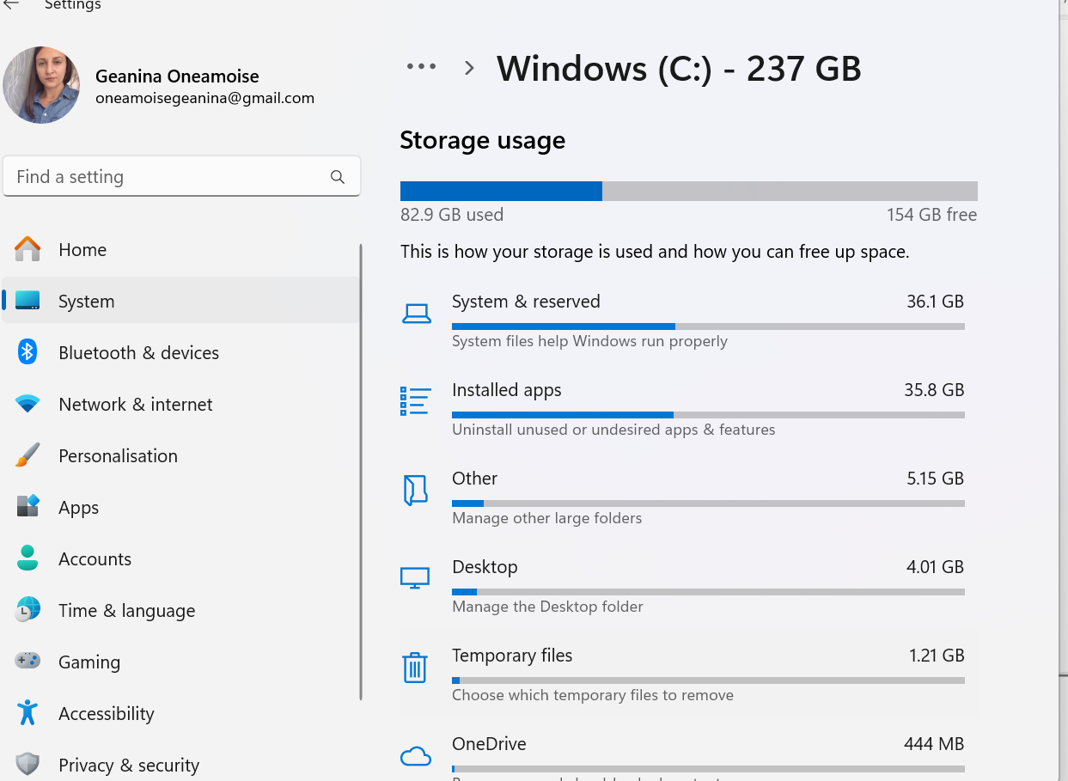

I/O devices are :
- Keyboard: An input device that lets you enter text, numbers, and commands by pressing keys.
- Mouse: An input device that lets you move a cursor on the screen and perform actions by clicking buttons.
- Monitor: An output device that displays images and text on a screen.
- Printer: An output device that prints documents, photos, and other files on paper.
- Speakers: An output device that produces sound and audio from the computer.

OS : 64-bit operating system, x64-based processor

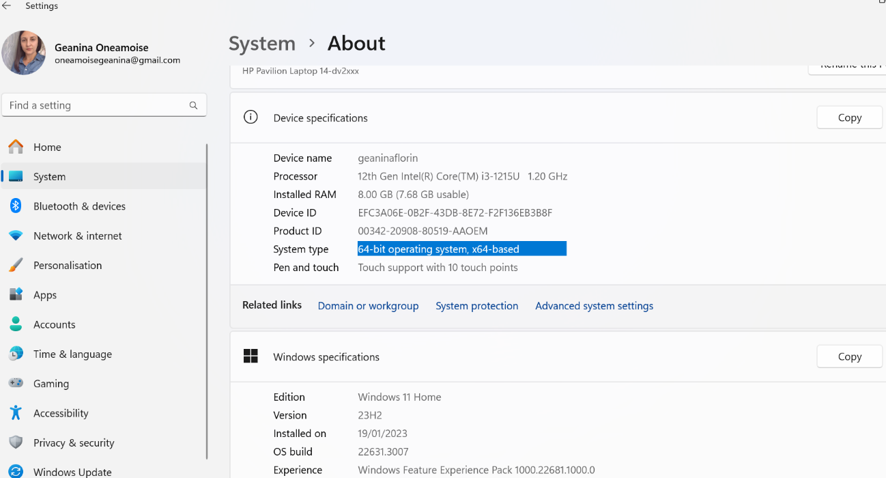

Installed Applications
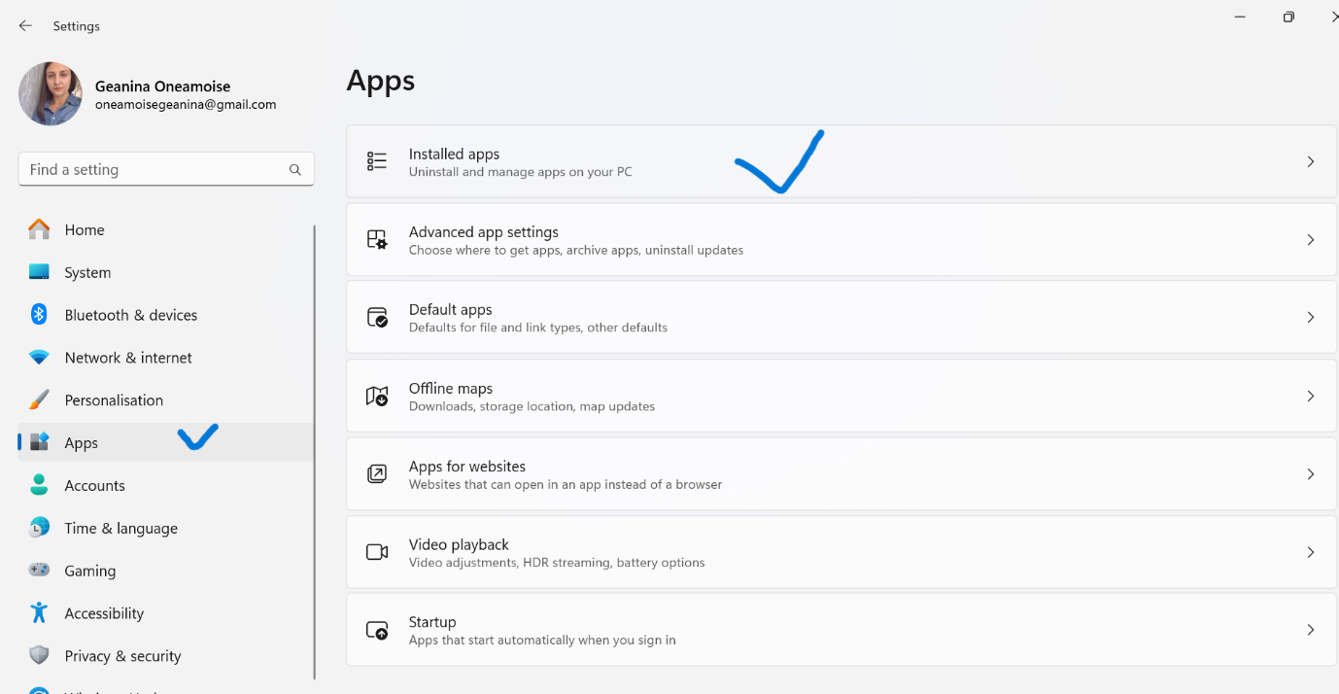
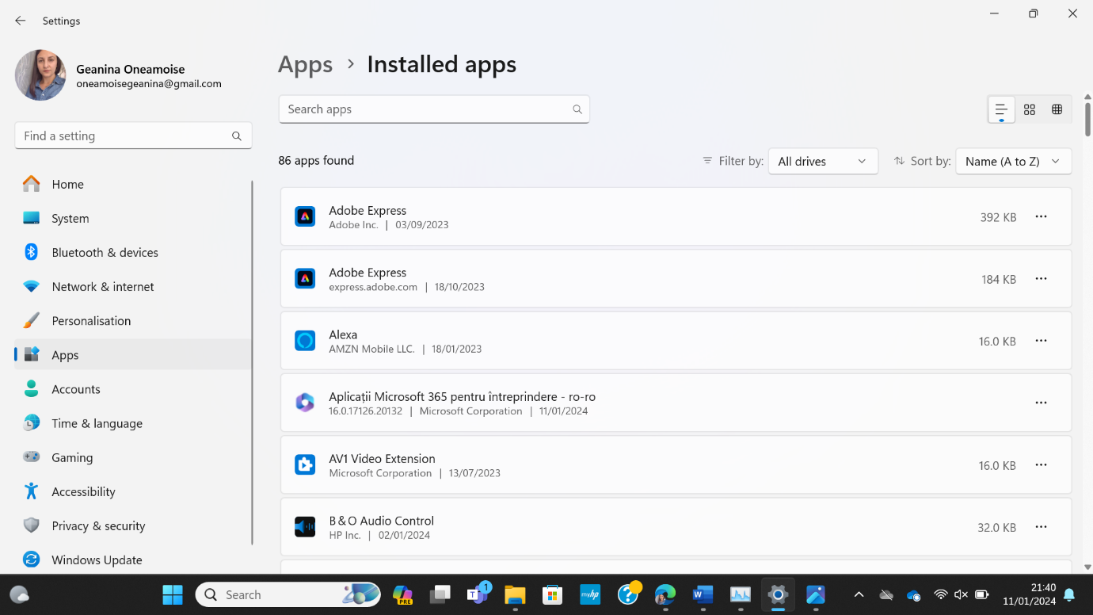
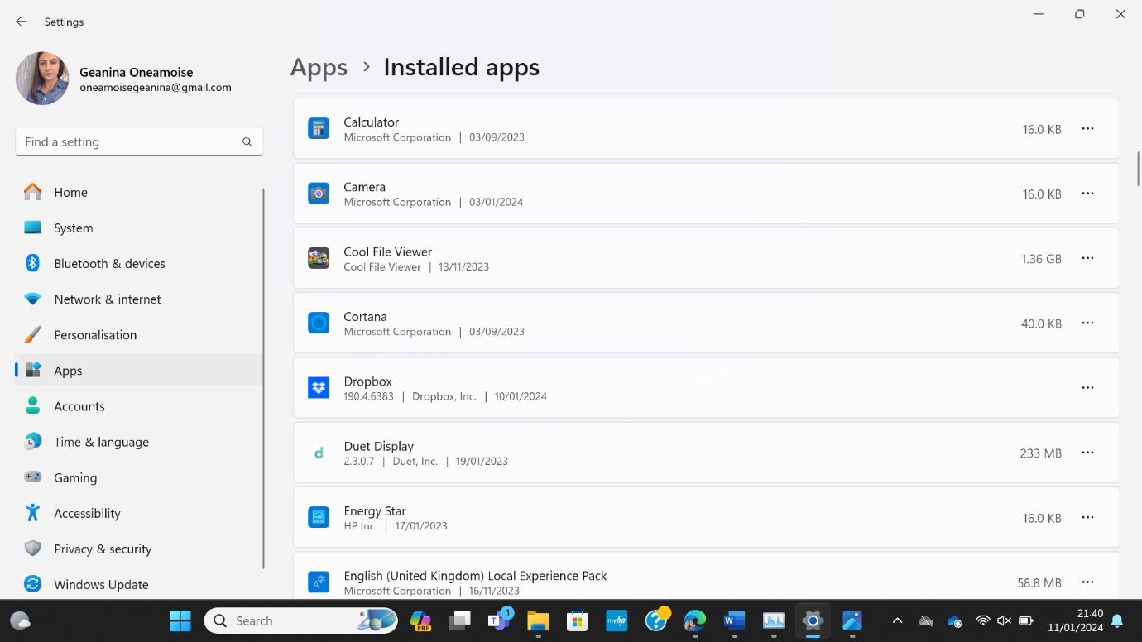

Internet connectivity
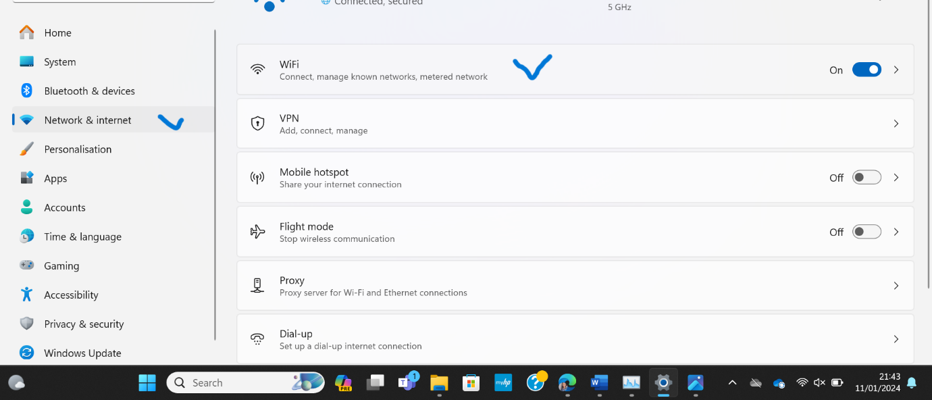

CPU speed

12th Gen Intel(R) Core(TM) i3-1215U

Base speed: 1.20 GHz
Sockets: 1
Cores: 6
Logical processors: 8
Virtualisation: Enabled
L1 cache: 544 KB
L2 cache: 4.5 MB
L3 cache: 10.0 MB

Utilisation 7%
Speed 0.80 GHz
Up time 0:15:38:21
Processes 273
Threads 3615
Handles 157966

Hard disk transfer speed-10MB/s

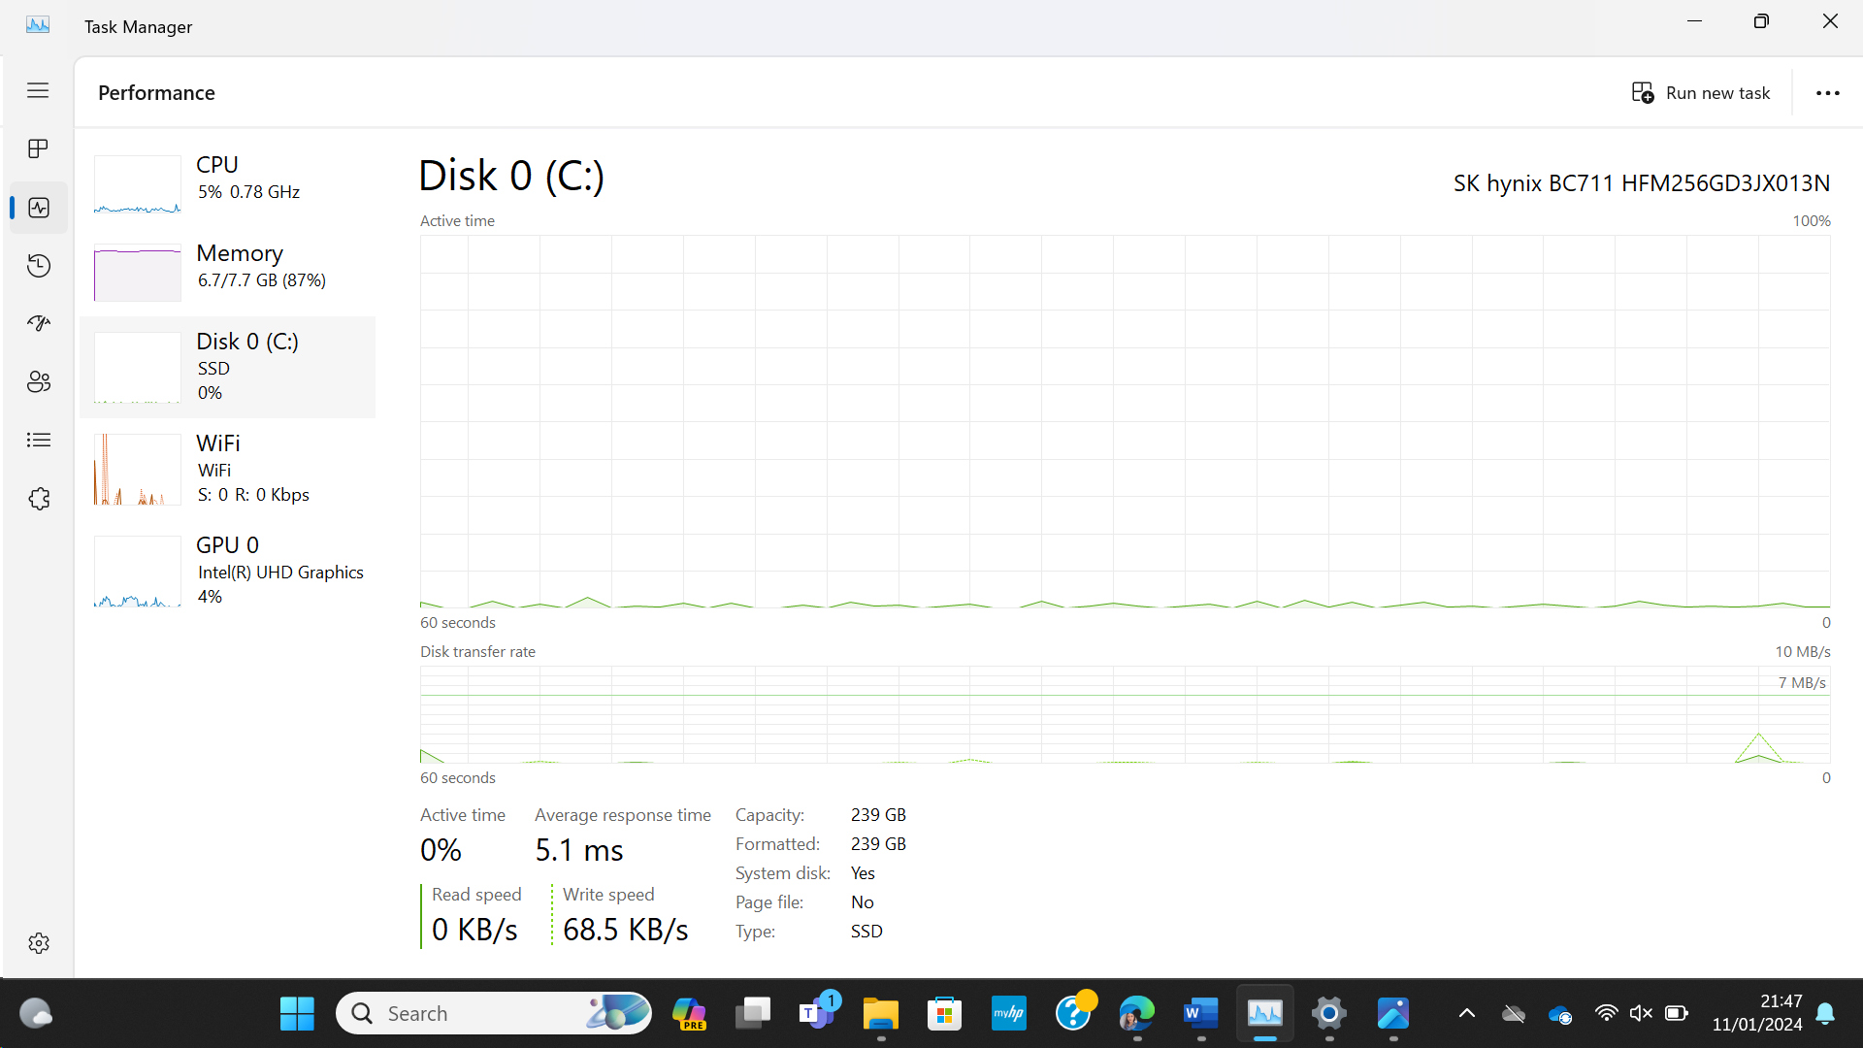

Graphic Performance

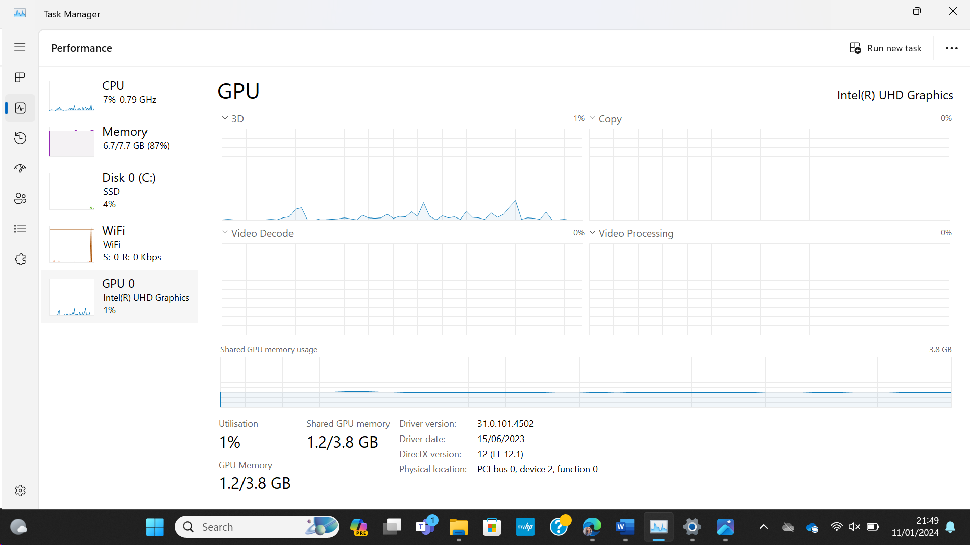

Network/Internet speeds

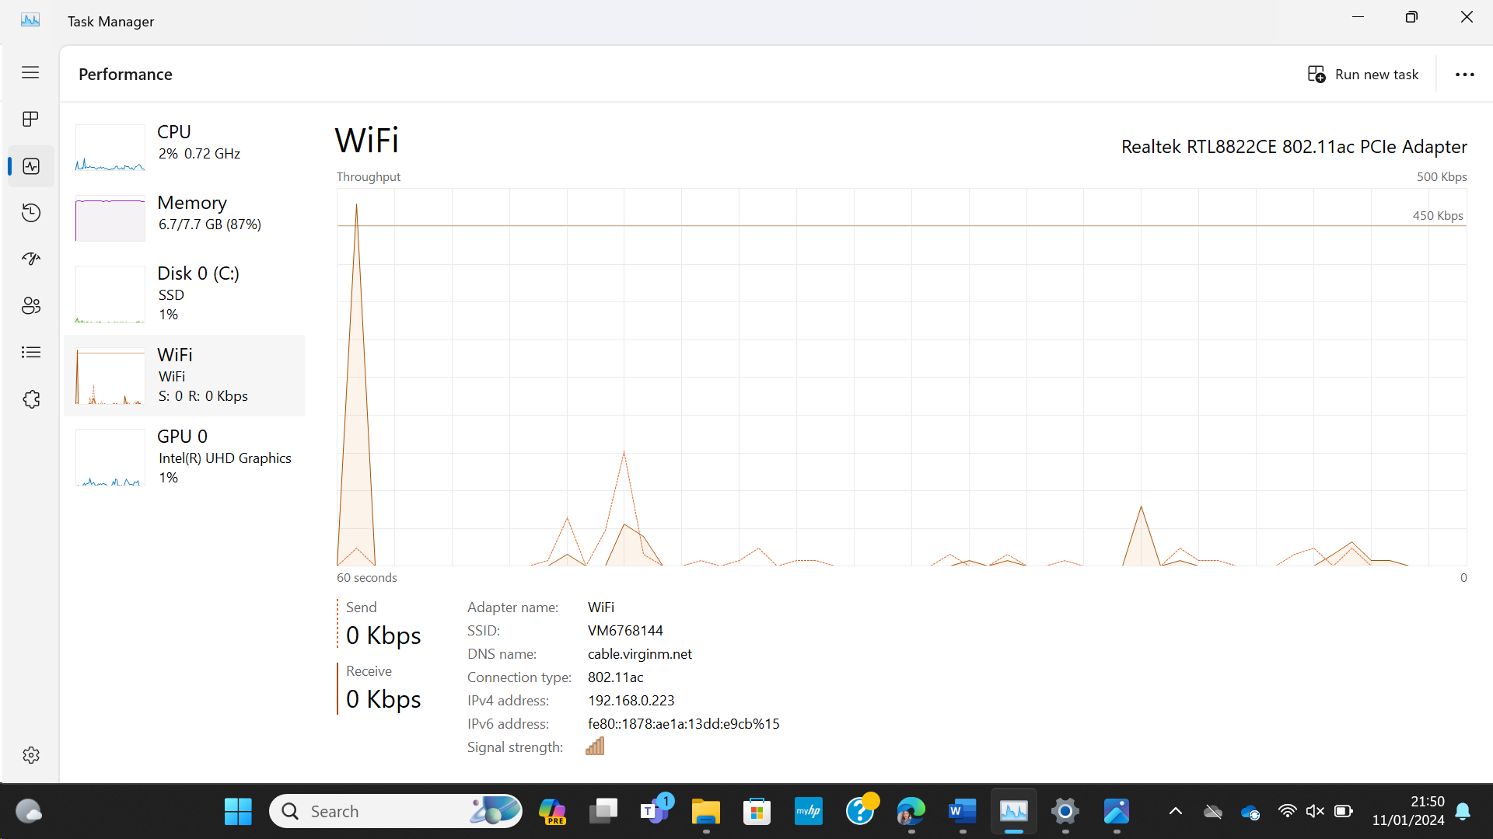

REFERENCES

[1] Available: 13 Different Types of Storage Devices/Drives in Computer Systems (Guide) (tech21century.com)
[2] Available: How to build a PC: a step-by-step guide to get the job done | TechRadar
[3] Available :Amazon: Daily Deals (youtube.com)
[4] Available: Cube PC Deals | Cube - The PC Specialists at Box.co.uk

