Marks and Spencer Report

1710013
Monika Serafin

University of Wales Trinity St David

Submission date: 20th July 2018

Word count: 2,159

EXECUTIVE SUMMARY

Marks and Spencer is a well known and respected brand. In recent years the organisation has taken a publicly known and continued loss of profit. From being the world’s second largest retailer, to teetering on the edge of losing its FTSE 100 status. The purpose of this assignment is to research the Marks and Spencer’s brand, understand its beginnings, development and status. Using internet-based research methods, SWOT analysis and PESTLE the report aims to identify the issues the business has that cause its profitability loss during the past decade and suggest options that could be used to boost the companies brand presence in the marketplace.

CONTENTS PAGE

Title 1.
Contents page 2.
Terms of reference 3.
Procedure 4.
Findings 5.
Conclusion 9.
Options 10.
Appendices 11.
Acknowledgements 14.
References / Bibliography 15.

TERMS OF REFERENCE

This report was requested by Archie Norman, the Chairman of Marks and Spencer. The report was requested by Mr. Norman on 18th June 2018. The purpose of this report is to identify the recent decline of Marks and Spencer’s profits, and to suggest measures to increase profitability. This report was researched and compiled by Monika Serafin, of the University of Wales, Trinity St David. Briefly, the problems identified are a distinct and continuous loss of profit following its 1998 peak, a loss of public respect, a new generation of bargain hunting shoppers and the strong competition of other high-street retailers.
The date of submission is 20th July 2018.

PROCEEDURE

The information used to research this report was sourced primarily from documents, journals and statistical data relating to Marks and Spencer found using the internet. A full bibliography of these sources can be found within the reference section of this report.

FINDINGS

Firstly some history of the company.
Michael Marks was a Polish Jew who moved to Britain in the late 1800’s. In 1884 Mr. Marks met with Jowitt Dewhirst, a nationally well-known businessman whose son went on to establish the Dewhirst brand. Dewhirst lent Marks £5 to open a ‘penny bazaar’ in Leeds. Thomas Spencer was Dewhirsts bookkeeper, and in 1894 Marks invited Spencer to join his venture. The successful pair had stalls 11 and 12 in the Birkenhead open market, and in the space of a few years had opened fifteen other stalls across North West England. In the early 20’th century Marks and Spencer ran a policy of only selling British made good – some source from Isaac Dewhirst. They kept this policy until the 1990’s. Marks and Spencer soon became a British brand synonymous with quality and high standards and was linked with high regard and prestige. In 1960, Marks and Spencer opened a store in Kabul – Afghanistan, marking their global strength and dominance. In 1973 Marks and Spencer opened stores across Canada, however these stores weren’t popular and in 1999 all of the Canadian stores had closed. In 1975 M&S opened stores across Western Europe, but these too all closed by 2001, except those in Paris where the brand remained strong. M&S profits peaked in the years 1997/1998 with a yearly profit of over £1 Billion. Since then profits steeply fell to a yearly profit of £145 million in 2001. M&S began online shopping in 1999, and began closing shops across the North of the U.K. In 2010 the Retail Knowledge Bank conducted an audit and found that the M&S women’s wear brand was at a ten year low. Following this, the Chief executive Marc Bolland made plans to strengthen the brand image and set high targeting sales of £800 million to £1 Billion, discontinued some of the well know women’s clothing lines and revamped the website and strap line; “Only at Marks and Spencer’s”. In 2017 Marks and Spencer made a Net income of £115.7 million and employed 84939 staff. Marks and Spencer’s currently remains on the FTSE 100 Index but has become dangerously close to loosing that prestige. Due to their continued fall since their 1998 high; where they were the first British retail company to make pre-tax profits of over £1 Billion, shareholders are now beginning to withdraw as share prices have fallen drastically by over a fifth since 2017 reports Alex Ralph for The Times in May 2018. Marks and Spencer announced that a further 100 stores may need to close within the next four years.

During analysis of Marks and Spencer’s performance a possible link between the leadership of Sir Richard Greenbury, who was Chairman and Chief Executive of Marks and Spencer’s from 1988 to 1999, the retailers peak in 1998, and subsequent gradual fall following Sir Richards leaving Marks and Spencer’s. It would appear that Greenbury was the driving force for the increasing profitability of Marks and Spencer and that perhaps the appointment of Luc Vandevelde as Chairman and CEO in 2000 could be attributed. But market pressures are more likely responsible than leadership, although, it has been reported by the media that a power-struggle ensued following Greenburys exit as new CEO’s battled and jostled for position. However, there were various factors surrounding the decline of the retailing giant which need to be understood.

There are many strengths to the retailer; its link with quality and high standards resounds, and remains a trusted brand throughout the U.K. However this opinion is failing due to various reports in the media of its decline and the obvious closing of outlets throughout the country. Marks and Spencer have a large range of products from a vast food range, to clothing to bank accounts, loans and mortgages, pet insurance to home furnishings, flowers and a substantial online presence with online shopping and next day delivery options. Being a market leader, they can afford to employ the best retail and marketing minds, strategists and business leaders with influence in their field, however, despite this advantage profits remain slumped.

Weakness seems to shroud Marks and Spencer. It is at risk of losing its prestigious FSTE 100 status, shareholders are investing elsewhere due to the share price fall, more attractive investment options, and more publicly the close of high-street outlets across the country signal frailty. Strong competition from a range of high-street and online retailers and banks make success difficult for the company. The respect and high regard the public once had from its loyal customers has been replaced by a generation of shoppers looking for bargains rather than quality, and the quality that M&S once stood for can be purchased cheaper elsewhere.

There are few opportunities available to Marks and Spencer. They have entered and explored a range of products as mentioned above. Expanding the brand throughout rapidly expanding economies such as China could become profitable. It is possible that a merger or partnership with a large brand could save the profitability of the company, but by doing so may damage the reputation as publicly this could further signal weakness.

Various threats surround the business, such as the strong competition of online retailers such as Amazon and Ocado the online retailer. Ocado’s rapidly expanding online delivery service shares soured following a partnership with one of Americas most successful retailers Kroger; writes Alex Ralph in The Times May 2018. Amazon remains successful as its outlay is relatively cheap with no high-street properties and ever embracing new technology, such as proposals to deliver some items via drone! Stakeholder abandonment, coupled with a reported pension fund deficit could reduce and finances required to fulfil any plans for reconstruction and development.

Environmentally, Marks and Spencer is performing well, proving the retailer acknowledges the environmental impact that such large businesses have. They have reduced their carrier bag usage by 80% since 2008. 100% of their wood, paper and card packaging comes from renewable resources. They can boast to be the worlds first Carbon Neutral retailer – However this may come at a financial loss as they offset emissions via financial resources.

Socially too, they currently employ almost 85,000 employees and claim to have supported over 17,000 disadvantaged people with their work experience programmes. The morality of Marks and Spencer appears sound.

Marks and Spencer embrace technological advances and has an exceptional website with easy to use links. However, the once loyal generation are literally a dying breed, and the compatability to reach its senior citizen shoppers who remember Marks and Spencer as a leading retailer via online websites could be a futile move.

CONCLUSION

Marks and Spencer has communicated a ‘Plan A’ to its customers via their website, promising enhancement in the areas of ‘wellbeing’, ‘community’ and ‘planet’, working upon its morality and responsibility which is important to its customers, but its loyal shoppers who recall the days of splendour of Marks and Spencer are being replaced by a new generation of shoppers who seek bargains over quality.
Years of austerity being bounded around in the UK’s media has created a generation of bargain hunters not quality seekers and M&S needs to embrace this. However, to do so, by perhaps introducing a similar idea as the ‘Tesco Value range’ into Marks and Spencer could have negative implications.
Building upon its morality of the environment and to increase its public awareness of social issues, Marks and Spencer could increase respect in the population by using profits to address the pension deficit that is reported it currently possess for its employees. In the grand scale of things this gesture could be viewed as its CEO’s and Chief executives considering its employees and its morality over profits.
Expanding into rapidly developing world economies, such as China and India could be beneficial and create well needed income.
A merger or partnership could be a double-edged axe, while strengthening its global position, it could weaken its brand name.
An updating of its brand that attracts the new generation needs consideration, while maintaining the standards and values by which M&S built itself from, a complex process perhaps but one imperative to the continued success of the business.
Market research, involving the public and its loyal customers is required, also including researching its shareholders and supplier’s opinions, involving these vital links and exploring their opinions will create a range of valid points needed to redevelop M&S and provide transparency and an air of honesty. Despite the retail businesses greatest minds being employed by M&S, profits still appear slumped and using the perspective of its customers will shed new light on what its shoppers view and expect of the M&S brand.

OPTIONS

With greatest respect, the Chairman and the board may wish to resolve the organisations problems using the information presented in the findings/conclusions sections.

APPENDICIES

London Stock Exchange statistics: as of 18th July 2018

MKS MARKS AND SPENCER GROUP PLC ORD 25P
price (GBX) | 311.10 | Var % (+/-) | -0.61% ( -1.90)
High | 314.00 | Low | 311.10
Volume | 7,833,866 | Last close | 311.10 on 18-Jul-2018
Bid | 312.00 | Offer | 312.20
Trading status | Market Close | Special conditions | NONE
As at 18-Jul-2018 20:58:23 - All data delayed by at least 15 minutes.
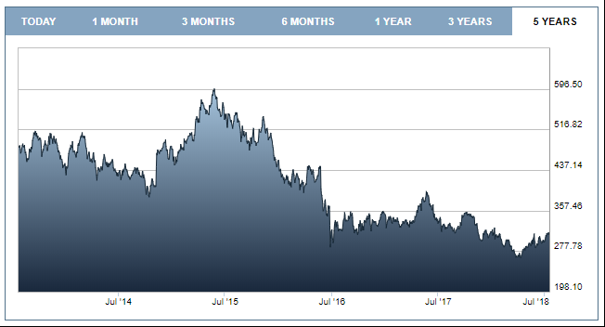

Marks and Spencer Turnover and Profits
Table 1996 - 2017
Year ended | Turnover (£ M) | Profit before tax (£ M) | Net profit (£ M) | Basic eps (p)
01-Apr-17 | 10,622.00 | 613.8 | 115.7 | 7.2
02-Apr-16 | 10,555.40 | 488.8 | 404.4 | 24.9
28-Mar-15 | 10,311.40 | 600 | 481.7 | 29.7
29-Mar-14 | 10,309.70 | 580.4 | 506 | 32.5
30-Mar-13 | 10,026.80 | 564.3 | 458 | 29.2
31-Mar-12 | 9,934.30 | 658 | 489.6 | 32.5
02-Apr-11 | 9,740.30 | 780.6 | 598.6 | 38.8
03-Apr-10 | 9,536.60 | 702.7 | 523 | 33.5
28-Mar-09 | 9,062.10 | 706.2 | 506.8 | 32.3
29-Mar-08 | 9,022.00 | 1,129.10 | 821 | 49.2
31-Mar-07 | 8,588.10 | 936.7 | 659.9 | 39.1
01-Apr-06 | 7,797.70 | 745.7 | 520.6 | 36.4
02-Apr-05 | 7,490.50 | 505.1 | 355 | 29.1
03-Apr-04 | 8,301.50 | 781.6 | 452.3 | 24.2
29-Mar-03 | 8,019.10 | 677.5 | 480.5 | 20.7
30-Mar-02 | 8,135.40 | 335.9 | 153 | 5.4
31-Mar-01 | 8,075.70 | 145.5 | 2.8 | 0
01-Apr-00 | 8,195.50 | 417.5 | 258.7 | 9
31-Mar-99 | 8,224.00 | 546.1 | 372.1 | 13
31-Mar-98 | 8,243.30 | 1,155.00 | 815.9 | 28.6
31-Mar-97 | 7,841.90 | 1,129.10 | 746.6 | 26.7
31-Mar-96 | 7,233.70 | 965.8 | 652.6 | 455.8

Statistics on Richard Greenbury's tenure as Chief Executive (1988-1998 completed financial years)[edit]
- Number of UK stores: 1985 (before appointment) - 283; 1998 - 300
- Sales: 1985 - £3,213,000,000; 1998 - £8,343,300,000
- Pre-tax profits: 1985 - £303,400,000, 1998 - £1,168,000,000

Share Price
311.10pGBp -1.90
17:01 at 18/07/2018

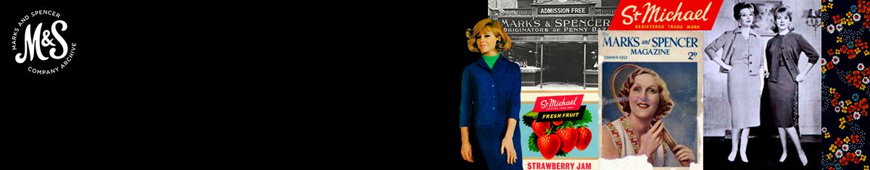

Did you know?

80% We’ve reduced our carrier bag usage by 80 percent saving 4 billion carrier bags since 2008
27m items of clothing have been Shwopped since we launched in 2008
1st We are the world’s first and only carbon neutral major retailer
17,000 disadvantaged people have benefited from our work experience programmes
100% of our wood and paper comes from more sustainable sources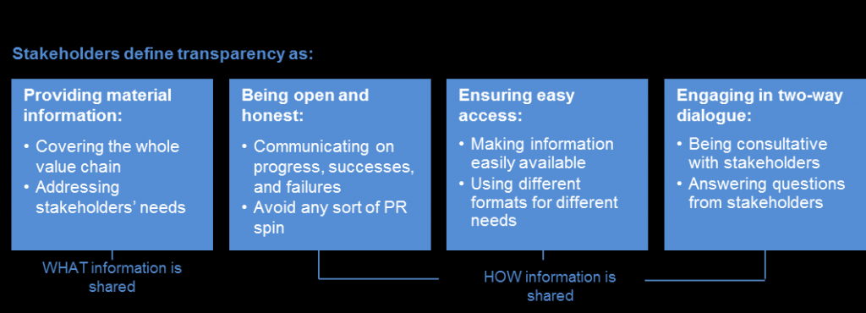
ACKNOWLEDGEMENTS

Thanks must be shown to the tutors who have supported me throughout my education, without which my confidence and ability to create a piece of work to this standard would have not been possible.

Further appreciation is given to my family, for their patience while I study and research.

REFERENCE LIST / BIBLIOGRAPHY

- https://www.thetimes.co.uk/article/high-street-must-change-or-shut-up-shop-3zzgk65p6

- https://www.thetimes.co.uk/edition/business/marks-spencer-at-risk-of-symbolic-relegation-from-ftse100-08b5tqkx9

- https://corporate.marksandspencer.com/?intid=gft_company

- https://corporate.marksandspencer.com/annual-report-2018/mands_financialstatements_2018.pdf

- https://www.marksandspencer.com/c/style-and-living/the-mands-archive

- https://en.wikipedia.org/wiki/Marks_&_Spencer

- https://www.londonstockexchange.com/exchange/prices-and-markets/stocks/summary/company-summary/GB0031274896GBGBXSET1.html

- http://www.dewhirst.com/about-us/our-history/

- https://www.telegraph.co.uk/money/?xml=/money/2008/07/02/bcnmshist102.xml

- https://en.wikipedia.org/wiki/Richard_Greenbury#Marks_and_Spencer

- https://corporate.marksandspencer.com/documents/plan-a-our-approach/globescan-mands-transparency-study-highlights-report-may2015.pdf

