Business Skills for the Workplace
SOCIAL MEDIA AND MARKETING

Name: Guy Massamba
ID:232805
Module Name: Digital Skills
Module Code: LCLM4002
Assignment: Report
Lecture Name: Hoang Dang Nguyen
Word count: 1344
Submission date: 28th April 2024 by; 14:00

Table of Contents

1.Introduction 3
2.Paragraph 1: Overview of Social Media - Its Use and Development in Recent Years 4
3.Paragraph 2: Marketing - Traditional vs. Modern Methods 5
4.Paragraph 3: Utilizing Social Media for Marketing and New Customer Acquisition 5
5.Paragraph 4: Advantages of Using Social Media for Customer Outreach 6
6.Paragraph 5: Disadvantages of Using Social Media for Customer Outreach 6
7.Conclusion 6
References 7

1. Introduction
Marketing is a tool use by corporations or companies to sell their products and services to a specify market and organisations, to businesses and consumers (Alexandra.2024).
In the age of a brand's website as its primary point of digital interaction as part of a virtually digitising world, social and digital platforms have become the core of marketing and customer engagement. This study explores a revolution that marketing experienced because of digital media platforms, imagining an environment very distinct from the way firms used to communicate in the past. We will address the issue of the social media era, representing how it started from simple communication tools to smart marketing tools that give the maximum possible outreach to its end users. The talk will include both benefits and pitfalls associated with the employment of social media for marketing purposes so as to provide the audience with the view that is not one-sided in regard to the effectiveness and challenges of the method. Through studying the ways in which these platforms assist consumers as well as help companies grow brands, this report is going to provide critical points on the prevailing social media strategies for businesses that are aiming to improve the effectiveness of their marketing and customer engagement (De Vries,2012).

2.Paragraph 1: Overview of Social Media - Its Use and Development in Recent Years
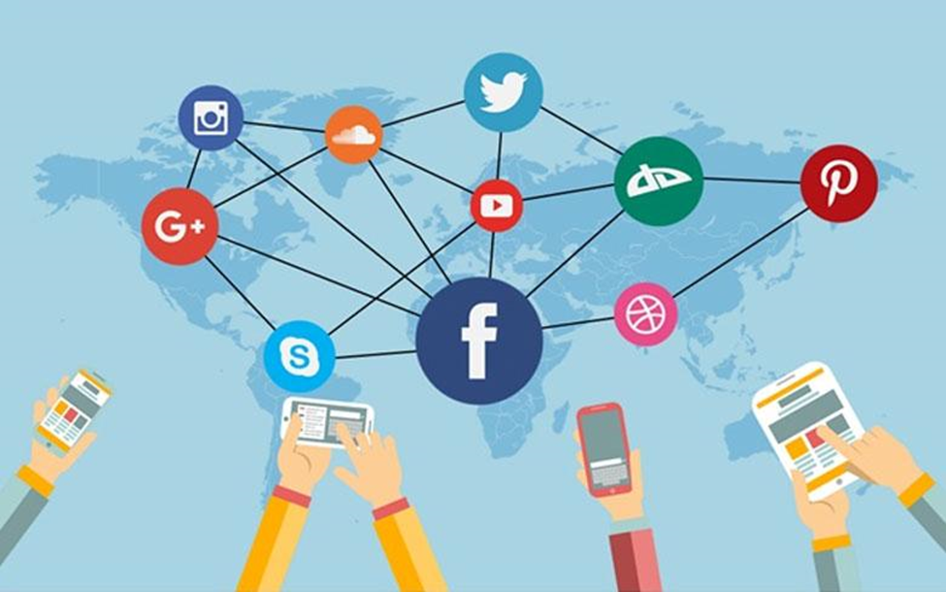
Social media writes the history of media transfer when it appears that classic media channels evolve in digital ecosystems in which users can additionally generate, extract and exchange content. In this way, communication has evolved into both real-time interaction and the spreading of information into resource-saving and cost-effective manner. In the last ten years, Instagram, Tiktok, and LinkedIn are among the platforms that have gone to the moon. The widespread adoption and user participation on the platforms has been phenomenal. Such surge is mainly ascribed to the platforms' never-ending efforts aimed at creating new features that could be used both by individual artists' images and businesses for the purpose of branding (Funk,2008).
Similar to these platforms, organisations have significantly employed them for just about the same reasons in order to maximise visibility and connectivity to the customers. Social network can let companies run shoppable ads and provide for online communication with consumers and enriching brand awareness via great content. The two-way communication naturally achieved by these platforms brings immediate feedback to the table and the much needed engagement of the customers, making them the foundation of effective branding and marketing. Conveying that, social media is no longer just a part of digital marketing but a basis of it though, it is full of opportunities to communicate with the target audience and increase their clients (Kaplan,2010).

3.Paragraph 2: Marketing - Traditional vs. Modern Methods
Marketing is the key tactic of an organisation, which is given the instruments and tasks of promotion and distribution. The instruments and tools include market research and advertising it. Marketing, traditionally, had depended on print press, TV commercials, and radio spots as a go-to media. The traditional methods were only to be used as a medium to communicate with consumers, both ways were not possible and personalization did not exist (Mangold. 2009).
Digital technology is one that has really changed the way marketers think and work with a lot of options such as SEO, content marketing, and social media marketing allowing an advertiser to reach their target consumer in a very dynamic manner. By addressing specific groups individually and serving personalised content, the efficiency and effectiveness of marketing increases greatly, while the opinion of customers is instant and useful, as the only metrics for success should be taken into account (Qualman,2012).

4.Paragraph 3: Utilizing Social Media for Marketing and New Customer Acquisition
The way social media platforms are shaping marketing by means of targeted ads, partnerships with celebrities, and viral campaigns which can be shared across many platforms is a new reality. Companies understand that every person in the world is different, they design marketing campaigns and advertisements that are tailor-made to reach specific demographics based on data. For instance Spotify established their playlists as a big part of their success through their personalised playlists with the help of social media. Nike uses Instagram story to drive traffic to their products which is helped by a direct link to those products (Romero,2010).

Altogether the use of analytics and other digital tools are helping to make social media marketing very effective. Social online platforms such as Facebook and Google offer enterprise based data analysis services that help in monitoring key metrics of marketing activities like engagement rates, click-though, and conversion rates, thus supporting the optimization of the marketing strategies and determining the consumer preferences and behaviours on social platforms (Smith,2012).

5.Paragraph 4: Advantages of Using Social Media for Customer Outreach
Social Media expands the outreach of marketing which is now scalable as these platforms include one such advertising advantage such as Facebook and Instagram. Research has shown that face-to-face interaction tends to create a stronger customer bond, which was also depicted in the Dove's "Real Beauty" ad that featured customer-generated content. Data-based strategies build unique and personalised experiences which lead to customer satisfaction. Thus, data-based strategies foster customer’s lifelong loyalty.

6.Paragraph 5: Disadvantages of Using Social Media for Customer Outreach
Social media brings along dangers such as PR scandals and competitors; yet detailed analytics is complicating the ROI measurement process. Digital overkill and privacy infringement are sweeping further, resulting in cautious data management implementation to maintain confidence and satisfaction (Kaplan, 2010).

7.Conclusion
This report has focused on a significant progression of social media and its clearly transformational influence on the way of marketing is carried out. Social media, now with widespread use, has gone beyond being a simple tool for communication and is the tool of choice for customer outreach with two fundamental benefits of affordability and interaction. They set the stage for almost instantaneous interactions with the customers as well as feedback coming in and that helps businesses to re-calibrate their marketing efforts and develop their brands using customer centricity.
While social media has its own drawbacks like negative publicity and competition, the integration of these tools is important for any business to grow successfully considering their advantages. Incorporation of effective strategies and ethical practices, by use of analytics, creative content and relationship with audience assistance the organisation to be in the digital world be successful for long.

References
Alexandra T 2024.Marketing in business: Strategies and Types Explained: investopedia.com.
De Vries, L., Gensler, S. and Leeflang, P.S., 2012. Popularity of brand posts on brand fan pages: An investigation of the effects of social media marketing. Journal of interactive marketing, 26(2), pp.83-91.
Funk, T., 2008. Web 2.0 and beyond: Understanding the new online business models, trends, and technologies. Bloomsbury Publishing USA.
Kaplan, A.M. and Haenlein, M., 2010. Users of the world, unite! The challenges and opportunities of Social Media. Business horizons, 53(1), pp.59-68.

Mangold, W.G. and Faulds, D.J., 2009. Social media: The new hybrid element of the promotion mix. Business horizons, 52(4), pp.357-365.

Qualman, E., 2012. Socialnomics: How social media transforms the way we live and do business. John Wiley & Sons.

Romero, C.L. and Constantinides, E., 2010. Segmenting The Web 2.0 Market: Behavioural And Usage Patterns Of Social Web Consumers. Journal of business case studies, 6(7), pp.55-66.

Smith, A.N., Fischer, E. and Yongjian, C., 2012. How does brand-related user-generated content differ across YouTube, Facebook, and Twitter? .Journal of interactive marketing, 26(2), pp.102-113.

