A critical evaluation and the identification of next teaching and learning steps focusing on a case study of an individual learner or a group of learners, based on an observed critical incident.
Introduction:
A critical evaluation will be conducted within this assignment, focusing on a critical incident observed within a school environment which Mohammed (2016, p.25) defines as a ‘situation which impacts a person or group of people’. Implying that a critical incident can be defined as an unplanned event that has/is happening creates a reaction that Brookfield (1990, p. 84) described as being ‘vividly remembered’. The incidents can be seen in everyday life, therefore, suggests can be both positive and negative. Tripp (1993) emphasises the importance of teachers and others within the education profession being able to reflect on these incidents effectively. Griffiths (2000) acknowledges Tripps’ Critical Incident Methodology, stating that being able to critically reflect effectively is a useful tool for those within the teaching profession to have. Therefore, individuals within the education profession are developing on their own experiences and development, to ensure they are reflecting on both personal and professional skills. This can suggest that if an incident occurred within the classroom, an approach or plan could be put in place, as the teacher has been actively reflecting on their teaching strategies/classroom management to support individuals (Joshi, 2018, p.82).
In terms of the assignment, it will demonstrate the use of key theories, policies and research which are relevant and reliable to the critical incident within the school environment and the development of the children and young people. Throughout, it will consider and acknowledge the Four Purposes within the Curriculum for Wales (Welsh Government, 2021) while evaluating approaches and strategies supporting equality, diversity including challenging beliefs and assumptions. Donaldson (2015) stated that the four purposes are the vision and aspiration for every child and young person. The reasoning behind the four purposes if for it is to promote the individual – this can be identified as the child (Welsh Government, 2020). This can suggest that the children are to be at the centre of the curriculum, as the four purposes is based on supporting individual to development into the world we live in today (Donaldson, 2015).
The four purposes are to support the individuals to become –
- Ambitious, capable learners, ready to learn throughout their lives
- Enterprising, creative contributors, ready to play a full part in life and work
- Ethical, informed citizens of Wales and the world
- Healthy, confident individuals, ready to lead fulfilling lives as valued members of society. (Donaldson, 2015).

The role of critical reflection
Cottrell (2013, p. 188) defines critical reflection as ‘more than just thinking’ which Lishman (2015) acknowledges, stating it is when an individual focuses their attention back to a previous experience/incident. This can suggest that critical reflection is when strategies, attitudes and effectiveness of a previous experience/incident have been considered and used to challenge the individual (Reynolds, 2013). As a teacher, knowing the individual/child is important in all aspects, allowing them to understand what works for the child when learning; are they auditory, kinaesthetic, reading/writing learners? (Brown, Roediger and Mcdaniel, 2014), Is the seating plan suited to all of the children? It can suggest that these questions may seem small to some but could make a great impact, positively, on the childs’ learning and school experience. Teachers and others within the school must become critically reflective practitioners for critical reflection to work (Hattie, 2012). This can suggest why Hattie (2012) argues that pupils cannot reflect critically on their own work and progress if teachers/members of the school are not doing it themselves. This can suggest that teachers must evaluate how effective the lesson went not only for their own development but also for the pupils. Many reflective models can be used to allow these questions to be answered and reflected effectively within a school and classroom environment such as Schon, Kolb and Gibbs. Brookfield (1990) defines a reflective model as a continuous cycle of self-observation. Zwozdiak-Myers (2012) identifies that self-reflection is also necessary to encourage individuals in becoming critical practitioners and therefore, within Education, teachers should consider this as an ongoing skill.
Within the Professional Standards for Teaching and Leadership, under one of the five sections; pedagogy, and subheading of ‘Reflection on Learning’ it is highlighted that being ‘on track’ it states, ‘in planning, the student-teacher demonstrates awareness of the importance of encouraging learners’ reflection around behaviours and outlooks for learning’ (University of Wales Trinity Saint David, 2022, p.7). Brookfield, Mandzuk and Clifton (1998, p.116) stated that when colleagues/staff members work together, critical conversations will be had. Therefore, can suggest if done correctly, it will create positive environment for all within the school environment (Badia, Becerril and Gómez, 2021, p.123). This could be one of many reasons as to why Bruster and Peterson (2013, p.170) stressed the importance of ensuring student teachers become reflective practitioners. It was identified that when teachers do reflect effectively, students acknowledge them as ‘good teachers’ (Johns, 2000). Therefore, from a student teachers point of view, if appropriate guidance and feedback is given, through the teacher being critically reflective, then this will have a positive effect on the student teachers own reflection (Zwozdiak-Myers, 2012). Grigg (2010) does state that when critical reflection is done effectively, it is usually individuals who are always ready to improve on their teaching, whether it is through consulting with other teachers or through further reading and research.
From a wider aspect of critical reflection, the Curriculum for Wales (Welsh Government, 2021) is a relevant change occurring in schools across Wales. Professor Graham Donaldson reviewed and made recommendations to the old curriculum (Daugherty and Elfed-Owens, 2010, p. 233) suggesting that the world we live in is forever changing. As the first curriculum for Wales was introduced in 1988, many argued that it did not allow children to develop to their full potential in todays’ world (Knight and Crick, 2021). Bethane (2018, p.1) statements can suggest they agree, stating that the education system was ‘outdated’ and ‘not fit for purpose’. With further reading, it had been identified that the book written was published in 2018, suggesting the Curriculum for Wales had not yet been implemented into schools yet. Therefore, with many statements such as Bethane (2018) and Knight and Crick (2021) it highlights how the Curriculum for Wales will benefit individuals with their learning and development.
A critical reflection on the Curriculum in Wales had been made through Professor Donaldsons’ (Donaldson, 2015) recommendations, as the outcome created a curriculum which focuses more on the individual and their personal development which they will participate in. It will allow children to take responsibility of their own learning, rather than a certain level all children must be reaching in terms of their age (Welsh Government, 2021). This suggests children are the centre of the learning it encourages individuals to develop at their own level (Dauncey, 2021).
Observation School and Class Context –
The literature review will comply with the British Educational Research Association guidelines (BERA, 2018) which states that ‘confidential and anonymous treatment of participants’ data is considered the norm for the conduct of the research’ (BERA, 2018, p.21). To ensure ethical considerations are acknowledged and followed accordingly, the school or the name of the child/children shall not be named. The BERA (2018) guidelines stated those involved in the research as ‘participants’, which within this particular review they are identified as the children. This is to ensure that the research conducted is ethically correct.
The school is located in a small village within the county of Rhondda Cynon Taf, supporting children between the ages of 3-19, identifying as an ‘all-age school’ (Estyn, 2022, p.3). Within the schools’ primary department, the most recent Estyn report stated that over a hundred pupils were attending (Estyn, 2017). However, on arriving at the school, an introduction and discussion occurred with the headteacher, mentioning that the school overall is at seven hundred pupils and at full capacity with two hundred pupils within the primary department. The most recent Estyn (2017) report shows that the school is within a socioeconomically affluent area, with 8% of pupils eligible for Free School Meals (FSM) from the most recent report. This is significantly lower than the average in the year of 2017, which has been calculated at an average of 18% (Welsh Government, 2017).
Within the classroom, there were twenty children aged six to seven within year two, identifying as Progression Step 2 within the new curriculum (Welsh Government, 2020) with one teacher and one teaching assistant. The teacher had mentioned there are some pupils who attend ELSA sessions (Emotional Literacy Support Assistants) who provide emotional and social support to those needed (Supporting Service Children in Education Wales, 2022). This information is relevant due to the critical incident which occurred including one of the pupils attending ELSA. BERA (2011) has stated that the methods used for research should be appropriate for their purpose. Therefore, this assignment the methods used were observations and field notes.
The theme within the class was ‘Fy Nghorff Arbenning’, as explained in Appendix 1 where children will be having the opportunity to discuss what is a part of the body, what the body needs to keep healthy. Throughout the classroom, there were many resources being used and displayed demonstrating an awareness of the Curriculum for Wales including the four purposes (Welsh Government, 2021).
The classroom had a ‘lloches lles’ where children were able to have time to themselves. The area was made to feel safe, with cushions, mirrors, and books for children to use and relax. This corner of the classroom is supported by ‘respecting others and myself’, encouraging individuals to become ethical, informed citizens of Wales and the world (Welsh Government, 2015, p.30). Child A, following the BERA (2018) guidelines used this area at the beginning of the day before the morning session and therefore felt appropriate to include expressing previously it gave an opportunity to deal with their own emotions in a ‘comfy’ environment.
As mentioned previously, Child A is supported through ELSA and therefore, using areas of the classroom such as the ‘lloches lles’ is very much needed, giving them an opportunity to self-regulate in their own individual way. This particular child found a calming way of reading the same book when in this corner of ‘Ruby Finds a Worry’ which had been identified by the teacher. The book focuses on Ruby having a worry and how she can overcome this worry to feel like herself again. This can suggest the individual seeks comfort in the book as it is aimed for children to talk about their hidden worries.
The Critical Incident –
The critical incident observed is shown in Appendix 1 and relates to ‘Child A’. At the beginning of the session, the teacher began to settle the class on the mat ready to begin their session, Child A had shown to be disengaged and unsettled, such as not sitting on the mat quietly.
The teacher modelled what each area of the classroom was going to be doing today, each station was set up with a range of activities to motivate individuals about the new theme ‘Fy Nghorff Arbenning’. All stations demonstrated effective use of the Four Purposes by Professor Graham Donaldson (Welsh Government, 2021). The activities were linked to the ‘Health and Wellbeing’ Area of Learning and Experience (AoLE) as it was focusing on the understanding of our body parts. A statement of what matters suggests ‘developing physical and well-being has lifelong benefits’ (Welsh Government, 2022, N/A). This suggests that by the class learning about body parts and healthy eating within their new theme, they are understanding the benefits of a healthy diet and also what are the body parts.
The critical incident occurred within the station of ‘drawing, cutting and gluing’ a picture of a friend or family member where they were developing to become enterprising, creative contributors (Welsh Government, 2021). Donaldson (2015) states that creativity should be prominent in education supporting Professor Dai Smith’s 12 recommendations that schools are to be a ‘creative society’ (Welsh Government, 2015, p.1). This can suggest that allowing pupils to become creative, encourages new innovative skills and knowledge such as building on their confidence. By using creativity within the curriculum, pupils become engaged and motivated to learn (Ahmad and Shaheen, 2011).
Child A used this station to begin the lesson, showing little to no interest. They rushed their drawing to move on to the next station, colouring the whole picture in one colour. The critical incident occurred from this point, where Child A moved onto another station but was close enough to oversee the ‘drawing’ station. Another child, identifying as Child B, had taken their time ‘drawing a person’, with positive reinforcement from myself, Child A had quickly noticed this. Child A then had come back to the drawing station, ripped up their old drawing and recreated it again. This time to a high personal level, carefully coloured, 2 eyes, a nose, mouth and ears etc. A statement within the enterprising, creative contributors which links to this activity is to ‘connect and apply their knowledge and skills to create ideas and products’ (Donaldson, 2015, p.31). Individuals, including Child A used their own knowledge with end results showing that they have understood what they have learnt and shown it in a creative way of drawing ‘their own person’.
Literature Review
The aim of this section is to critically evaluate the existing and current literature based on two areas of the study which is linked to the critical incident. The critical incident emphasises on the area of ‘assessment for learning’ and the impact of ‘group work within primary education’.
Working in groups within primary education
As a part of the Curriculum for Wales (Welsh Government, 2020, p.1), collaboration is included within one of the four purposes as ‘enterprising and creative contributors’, emphasising within the report of ‘Successful Futures’ by Professor Graham Donaldson (Welsh Government, 2015). Hattie (2016) acknowledges and states that collaborative learning is effective and beneficial for learners which creates a safe environment for children to explore their ideas and test them (Donaldson, 2015). Slee and Shute (2015) study identified that half of a primary school class believed that when working in small groups or as pairs, they achieve more than if they were working independently.
Vygotsky’s ‘Zone of Proximal development’ can support the previous point (Mooney, 2013). The sociocultural theory identifies that learning is an essential social process which should be supported by parents/guardians, caregivers, peers and society (Vygotsky, 1978). Mooney (2013, p.101) explains that the name of assistance used to support the child can be recognised as ‘scaffolding’. Vygotsky (1978) defined his theory as the distance between the most difficult task a child can do alone compared to the most difficult task a child can do with help.
It is important to highlight that Vygotsky believed that the ‘scaffolding’ does not have to be only from a teacher/adult but also from other children (Mooney, 2012). This could suggest he is emphasising on the importance of the child’s peers who have already learned the desired skill, allowing them to learn from each other. Within the critical incident, Vygotsky’s theory was observed, following from Appendix 1, Child A quickly finished their work to move on to the next area of painting. It can suggest Child A possibly did not quite understand the task of drawing as they did not take their time in completing it. Therefore, through observing with Vygotksy’s theory in mind, having a ‘scaffold’ such as Child B, who had an example of their work and had been positively reinforced, Child A had then come back to complete as they had a better understanding of what to do following Child B (Vygotsky, 1978). Soto-Icaza, Aboitiz and Billeke (2015, p.1) explain that interaction between children while working, not only develops their social skills but also their cognitive, suggesting that the two skills work together to support the child in their development (Mooney, 2013)
As Child A came back to the area, it can be seen as ‘imitating’ in what Child B had done. Mooney (2013) explained that children learn from each other every day and Vygotsky strongly believed this develops on individuals’ new concepts and skills. Obaki (2017, p. 1) explains that when there are too many activities and learning areas prepared, it can impact the childs’ cognitive and social behaviour. However, Barth, et al (2004, p.115) believes that it is important to allow individuals to explore the classroom where they are able to create their own social interactions which will influence learning engagement and motivation. The classroom itself was set out to allow children the freedom of choosing which area they wish to work in. Olds (2001) has explained it can be viewed as a positive as when children feel comfortable they tend to explore their surroundings to help support their learning. Through freedom within the classroom, children and young people’s wellbeing has improved (Department of Education, 2022). This supports Olds (2001) point that children feel comfortable and secure within their classroom environment. It suggests that the findings from Department for Education (2022) can suggest due to the recent Covid-19 Pandemic, freedom within the classroom and school is vital for individuals to improve their wellbeing, due to the lack of ‘freedom’, for example in ‘lockdowns’ (Organisation for Economic Cooperation and Development, 2020).

Assessment for learning
Hattie (2012) describes Assessment for Learning as ‘more visible’ to support individuals on how they can develop to reach their own individual development level. From Appendix 1, the activity can be seen as formative assessment which William, Lee, Harrison and Black (2004, p. 105) describes as ‘guided student learning’. Appendix 1 suggests that small groups within the class were planned to shape and guide learning activities by the teacher.
The Curriculum for Wales involves the children when assessing, giving opportunities to voice their opinion to ensure they are challenged and supported as individuals and are progressing at their own level (Welsh Government, 2015). It is important to acknowledge that children have different learning styles and learn at different paces. To support this, Romanelli, Bird and Ryan (2009, p.1) identified that pupils who understand their own preferences and techniques when learning has an overall positive effect on their education.
Within the critical incident (Appendix 1), Child A is seen to move around the classroom and unable to concentrate on the one activity. The class can be seen as ‘rotation learning’ where individuals move around each table which have different activities to complete throughout the day. Kim, et al (2020, p.2) identified that around 83% of children were engaged in new friendships when working within smaller groups. However, Cilleseen and Marks (2017) believes children should work in a whole classroom approach, by learning through the teacher. It can suggest that Cilleseen and Marks (2017) believes that the teacher is identifying as a focal point, where they are the centre point of learning. While Slee and Shute (2015) argues previously children achieve more when working in smalls groups. If the classroom was set up in how Cilleseen and Marks (2017) believed it should, there would be a small chance that Child A and Child B would had communicated with one another, as observed on the playground that are not within the same ‘friendship group’.
Many have argued that questioning the pupils is a method which helps understand what children understand already and what they possibly need support in. Hall (2016) explained that the gap in between what a child understands and what they need support in is known as the learning targets. It was identified that questioning is one of the main methods of formative assessment allowing children to develop their thinking skills (Education, 2008). Donaldson (2015) expressed that when formative assessment is done correctly, learners can do ‘what could take up to a year, can be done in six months’ (Donaldson, 2015, p.68). This suggests is an effective way to double the speed of learning. Child A can be seen as to questioning themselves when observing that Child B had completed their work. Possible questions could had been asked is ‘what do I have to do?’, ‘how can I complete this?’ while also asking Child B how they had created theirs (Hattie, 2012).
Appendix 1 shows although the positive reinforcement was not aimed at Child A, it still had an impact on them by observing. Skinner’s theory of positive reinforcement (Ferguson and O’Donohue, 2001) allowed Child A to understand that when Child B had completed their work, they were seen as being ‘rewarded’ through being praised. Lucero and Chen (2020) explains that those who are reinforced positively, self-confidence develops. This can suggest that although the child was unsure what they had to do within the activity, through positive reinforcement and observation, they were able to complete their work to the best of their ability, identified as Article 29 within the UNCRC (Unicef, 2020, p.1) where ‘education must develop every child’s personality, talents and abilities to the full’. Donaldson (2015) can suggest that Child A is identifying as an ambitious, capable learner through communicating with others such as Child B to help them develop and complete their task and by the end trying their hardest (Welsh Government, 2015).
Reflection –
Using the reflective model by Gibbs (1988) I will be discussing the critical incident through the six stages of; description, feelings, evaluation, analysis, conclusion and action plan while considering my own next steps.
Description: During my time within the school, I had the opportunity to observe a morning session in year two. Three critical incidents were observed throughout the school, however, I believed that the incident that occurred within year two demonstrated as the most interesting one to evaluate and discuss. Appendix 1 discusses the critical incident which has been discussed with the assignment.
Feelings: All observations had positive outcomes allowing me to learn from the teachers within the classes which will support my professional practice now and in the future. All teachers used different strategies which reassured me that not everyone teaches the same, in the same way that not all children learn the same (Solvik and Glenna, 2022). Although I had been in the class for the morning, I did not feel as though my presence disturbed the observation in a negative way. I had communicated and discussed with the children what they had been doing but I did not feel as though the ‘Hawthorne effect’ had occurred (Oswald, Sherratt and Smith, 2014, p.53).
Evaluation: As discussed previously, the incident focused on an individual who through positive reinforcement, scaffolding and observing others, completed their work to a high level. This demonstrated the use of Vygotsky (1978) and B.F Skinner (Ferguson and O’Donohue, 2001) theories being used to support Child A. The first time the individual completed their task, it was quickly finished, identifying that they were not engaged.
Analysis: Acknowledging that this was only one session in a day, which is not a considerable amount of time when in a school and classroom environment. After further reading, I have developed my understanding of theories being used within the classroom and the impact they have on children.
Conclusion: Overall, it demonstrated that Child A learns best within a smaller group, using visual aids to support and also positive reinforcement – such as encouragement and praise. The class had clearly been designed and structured to support individuals such as Child A allowing to move around the class/activities freely (Olds, 2001). It demonstrated that the teacher is very aware of the individuals and their needs as the children have been involved in the set out of the classroom and the strategies that have been used are there to support them as individuals to reach their full potential – article 6 within the UNCRC (Unicef, 2020).
Action plan: By observing and researching this critical incident, it has encouraged me to think about the professional next steps to take in my learning and education to become a teacher in the near future. Strategies such as rotation learning which the teacher had used to support children and their learning encouraged collaborative work. It allowed children with mixed abilities and personalities to work together encouraging one of the four purposes; ethical, informed citizens (Donaldson, 2015). Reflecting on my time within the classroom, the teacher clearly knew the pupils as individuals, as they understood what learning strategies, which were identified within the ‘Assessment for Learning’ section would support their learning. I will ensure to take on for future teaching, to understand the children as individuals. This will be to ensure that when planning and creating lessons, individuals needs are also being considered to ensure all can participate. For example, the teacher knew that working in a ‘carousel’ around the classroom would benefit individuals who like to keep busy, including Child A. By Child A observing and imitating the actions of Child B, it was discussed that Skinner’s of ‘positive reinforcement’ had been used effectively. For my own professional learning and reflection on the critical incident, I would like to incorporate the use of Assessment for Learning such as ‘working with partner’ or ‘in small groups’ to encourage the use of ‘positive reinforcement’ with the individuals (Mooney, 2013). For example, praising those who are working well instead of ‘targeting’ those who are being disruptive, which would also cause attention.

Conclusion –
Throughout this assignment, it has acknowledged relevant theories such as Gibbs, Vygotsky and Skinner to the critical incident, which has been supported by a variety of literature research such as the UNCRC (Unicef, 2020) and the Curriculum for Wales (Welsh Government, 2015). The critical incident has given me opportunities to understand the importance of the role of reflection including to support future learners effectively and help to continue to develop on my own my role as a teacher in the near future. Using observation within the critical incident has encouraged me to not be afraid of changing the structure of the classroom or how lessons are to be taught, as Solvik and Glenna (2022) emphasised that not all teachers teach the same, in the same way as not all children learn in the same way.
The Curriculum for Wales (Welsh Government, 2020) is changing education with the outcome being to support individuals and their own learning and development. Therefore, teachers are vital for those individuals to learn, and when reflecting on their practice and own development, it encourages individuals to be guided into becoming all of the Four Purposes, known as ‘Ambitious and capable learners, enterprising creative contributors, ethically informed citizens and healthy and confident individuals’ (Donaldson, 2015, p.29).

Appendices –
Observation/Field Notes
Appendix 1
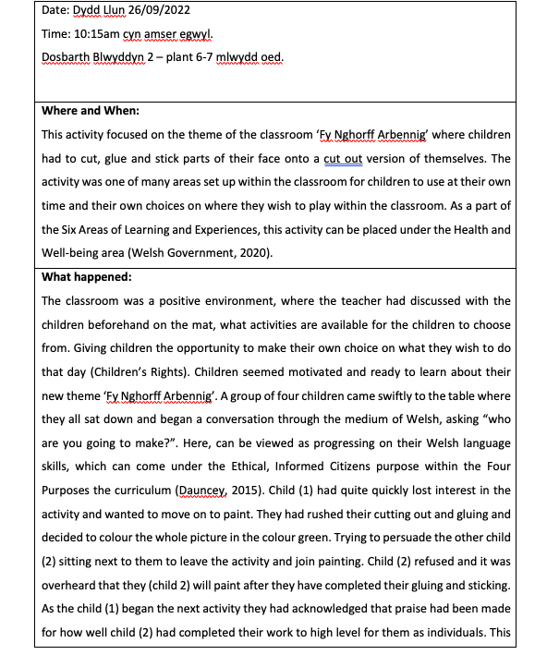
Record 1

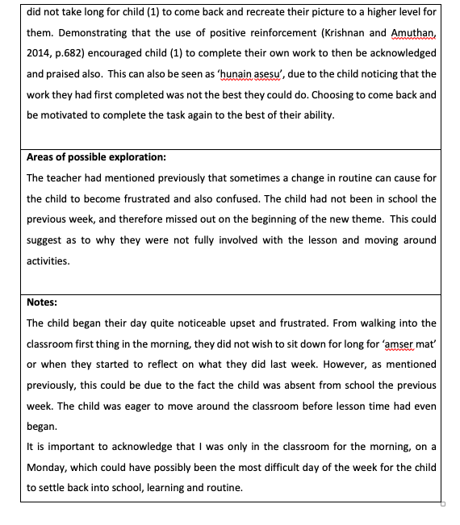

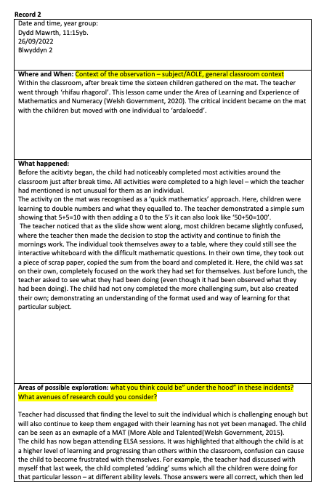

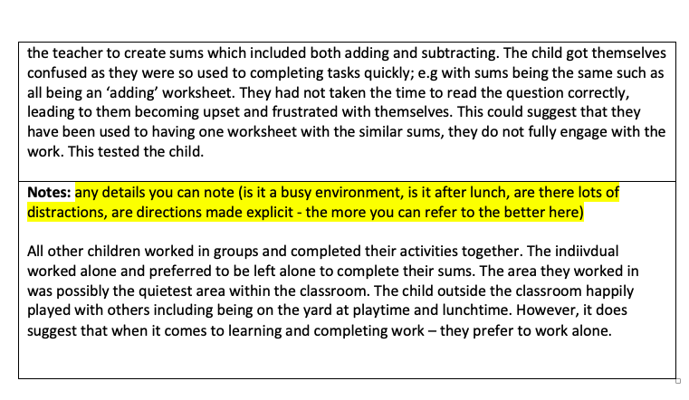

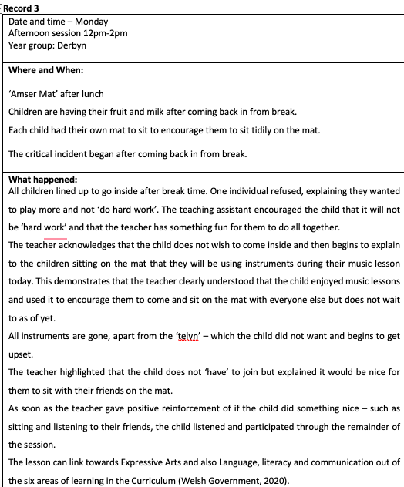

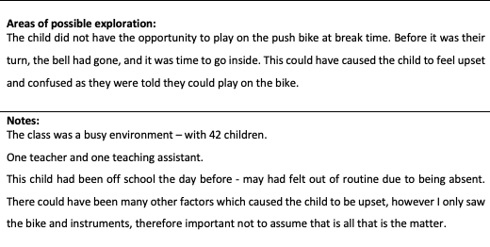

Reference list -
Ahamad, M., and Shaheen, S. (2011) ‘Encouraging Creativity an Innovation In Education’, Indian Journal of Applied Research, 3(2), pp. 114-117. DOI: 10.15373/2249555X/FEB2013/39
Badia, A., Bercerril, L. and Gómez, M. (2021) ‘Four types of teachers’ voices on critical incidents in teaching’, Teacher Development, 25(2), pp. 120-135. DOI: 10.1080/13664530.2021.1882549
Barth, J.M., Dunlap, S.T. et al. (2004) ‘Classroom environment influences on aggression, peer relations, and academic focus’, Journal of School Psychology, 42(2), PP. 115-133. DOI: doi.org/10.1016/j.jsp.2003.11.004.
British Educational Research Association. (2018) Ethical Guidelines for Educational Research. London: BERA.
Brookfield, S.D. (1990) The Skillful teacher. San Francisco: Jossey Bass.
Brookfield, S., Mandzuk, D. and Clifton, R. (1998) ‘Becoming a critically reflective teacher’, Interchange, pp. 115-118. Available at: https://librarysearch.uwtsd.ac.uk/discovery/fulldisplay?docid=cdi_proquest_miscellaneous_839126481&context=PC&vid=44WHELF_UWTSD:44WHELF_UWTSD_VU1&lang=en&search_scope=Search_ELEC&adaptor=Primo%20Central&tab=Everything&query=any,contains,Brookfield,%20S.D.,%202017.%20Becoming%20a%20critically%20reflective%20teacher.%20John%20Wiley%20%26%20Sons.&offset=0.
Brown, P.C., Roediger, H.L. and Mcdaniel, M.A. (2014) Make It Stick: The Science of Successful Learning. Massachusetts: The Belknap Press of Harvard University Press.
Bruster, B.G. and Peterson, B.R. (2013) ‘Using critical incidents in teaching to promote reflective practice’, Reflective Practice, 14(1), pp. 170-182. DOI: 10.1080/14623943.2012.732945.

Cillessen, A. H., and Marks, P. E. (2017). ‘Methodological choices in peer nomination research’ in New Dir. Child Adolescence Development. Pp. 21–44. DOI: 10.1002/ cad.20206
Cottrell, S. (2013) Critical Thinking Skills: Effective analysis, argument and reflection. 3rd Ed. London: Palgrave.
Dauncey, M. (2021) Donaldson Review: The ‘purposes’ and content of a Curriculum for Wales. Available at: https://research.senedd.wales/research-articles/donaldson-review-the-purposes-and-content-of-a-curriculum-for-wales/ (Accessed: 10th of October 2022).
Daugherty, R. and Elfed-Owens, P. (2003) ‘A National Curriculum for Wales: A Case Study of Education Policy-Making in the Era of Administrative Devolution’, British Journal of Educational Studies, 51(3), pp. 233-253. DOI: 10.1111/1467-8527.t01-2-00237.

Department for Education. (2022) State of the nation 2021: children and young people’s wellbeing. Available at: https://assets.publishing.service.gov.uk/government/uploads/system/uploads/attachment_data/file/1053302/State_of_the_Nation_CYP_Wellbeing_2022.pdf (Accessed: 24th of October 2022).

Donaldson, G. (2015) Successful Futures – Independent Review of Curriculum and Assessment Arrangements in Wales. Available at: https://gov.wales/sites/default/files/publications/2018-03/succesful-futures-a-summary-of-professor-graham-donaldsons-report.pdf (Accessed: 10th of October 2022).

Estyn. (2017) An Estyn Inspection. Available at: https://www.estyn.gov.wales/system/files/2020-08/Ysgol%2520Llanhari%2520en.pdf (Accessed: 23rd of October 2022).

Estyn. (2022) All-Age schools in Wales – A report on the challenges and successes of establishing all-age schools. Available at: https://www.estyn.gov.wales/document-page/20884/contents/document-details/introduction (Accessed: 21st of October 2022).
Ferguson, K.E. and O’Donohue, W.T (2001) The psychology of B.F Skinner. California: Sage.

Fisher, R. and Williams, M., 2012. Unlocking Creativity: A teacher's guide to creativity across the curriculum. Routledge.

Gibbs, G. (1998). Learning by Doing: A Guide to Teaching and Learning. London: Further Educational Unit.
Gibbs, G.(2010) Using assessment to support student learning. Available at: https://eprints.leedsbeckett.ac.uk/id/eprint/2835/1/100317_36641_Formative_Assessment3Blue_WEB.pdf (Accessed: 26th of January 2023).
Hattie, J., (2012). Visible Learning For Teachers: Maximising The Impact On Learning. New York: Routledge.
Johns, C. (2000). Becoming a reflective practitioner. Oxford: Blackwell Science
Jones, P., Judge, B., McCreery, E. and Eales-Reynolds, L. (2013) Critical thinking skills for education students. 2nd Ed. London: Sage Publications.
Joshi, K.R. (2016) ‘Critical Incidents for Teachers’ Professional Development’, Journal of NELTA Surkhet, 5(1), pp. 82-88. DOI:
10.3126/jns.v5i0.19493.
Kim, S., et al. (2020) ‘Experiences in Early Elementary Classrooms’, Frontiers in Psychology, 11(1), PP. 1-14. DOI: 10.3389/fpsyg.2020.587170.
Knight, C. and Crick, T. (2021) ‘Inclusive Eduction in Wales: Interpreting Discourses of Values and Practice Using Critical Policy’, ECNU Review of Education, 5(2). PP. 258-283. DOI: https://doi.org/10.1177/20965311211039858
Lishman, J. (2015) Handbook for Practice Learning in Social Work, and Social Care. 3rd Ed. London: Jessica Kingsley Publishers.
Lucero, K.S. and Chen, P. (2020) ‘What Do Reinforcement and Confidence Have to do with it? A systematic pathway analysis of knowledge, competence, confidence and intention to change’, Journal of European CME, 9(1). PP. 1-6. DOI: 10.1080/21614083.2020.1834759

Mazzone, L., Ducci, F., Scoto, M,C., Passaniti, E., D’Arrigo, V.G and Vitiello, B. (2007) ‘The role of anxiety symptoms in school performance in a community sample of children and adolescents’, BioMed Central Public Health, 7(1), DOI: 10.1186/1471-2458-7-347.

Miller, J.M., Ford, S.F. and Yang, A. (2020) ‘Elevation through reflection: closing the circle to improve librarianship’ Journal of the Medical Library Association, Pp. 353-363. DOI: 10.5195/jmla.2020.938

Mohammed, R. (2016) ‘Critical incident analysis: reflections of a teacher educator’, Research in Teacher Education, 6(1), pp. 25-29. DOI: 10.15123/PUB.5093.
Mooney, C. (2013) Theories of Childhood: An introduction to Dewey, Montessori, Erikson, Piaget and Vygotsky. 2nd Ed. St Paul: Redleaf Press.
Olds, A.R. (2001) Childcare: Design guide. New York: McGraw-Hill.
Organisation for Education Cooperation and Development. (2020) Youth and COVID-19: Response, recovery and resilience. Available at: https://www.oecd.org/coronavirus/policy-responses/youth-and-covid-19-response-recovery-and-resilience-c40e61c6/ (Accessed: 24th of October 2022).
Oswald, D., Sherratt, F. and Smith, S. (2014) ‘Handling the Hawthorne effect: The challenges surroundings a participant observer’, Review of Social Studies, 1(1), Pp. 53- 73. Available at: https://www.research.ed.ac.uk/en/publications/handling-the-hawthorne-effect-the-challenges-surrounding-a-partic (Accessed: 25th of October 2022).
Power, S., Rhys, M., Taylor, C. and Waldron, S. (2018) ‘How child-centred education favours some learners more than others’, Review of Education, 7(3), pp. 570-592. DOI: https://doi.org/10.1002/rev3.3137.

Romanelli, F., Bird, E. and Ryan, M. (2009) ‘Learning Styles: A Review of Theory, Application, and Best Practices’, American Journal of pharmaceutical Education, 73(1), PP. 1-5. DOI: 10.5688/aj730109.

Slee, P.T. and Shute, R.H. (2015) Child development: Theories and Critical perspectives. 2nd Ed. Oxfordshire: Routledge.

Solvi, R.M. and Glenna, A,E.H. (2022) ‘Teachers’ potential to promote students’ deeper learning in whole-class teaching: An observation study in Norwegian classrooms’, Journal of Educational Change, 23(1), Pp. 343-369. DOI: 10.1007/s10833-021-09420-8.

Soto-Icaza, P., Aboitiz, F. and Billeke, P. (2015) ‘Development of social skills in children: neutral and behavioural evidence for the elaboration of cognitive models’, Frontiers in Neuroscience, 9(333), pp. 1-16. DOI: 10.3389/fnins.2015.00333.

Steinmayr, R. and Spinath, B. (2008) ‘The importance of motivation as a predictor of school achievement’, Learning and Individuals Differences, 19(1), pp. 80-90 DOI: 10.1016/j.lindif.2008.05.004

The University of Edinburgh. (2020) Gibbs’ Reflective Cycle. Available at: https://www.ed.ac.uk/reflection/reflectors-toolkit/reflecting-on-experience/gibbs-reflective-cycle (Accessed: 23rd of October 2022).

Tripp, D. (2012) Critical incidents in teaching: developing professional judgement. Oxfordshire: Routledge.
Unicef. (2020) A Summary of the UN Convention on the Rights of the Child. Available at: https://www.unicef.org.uk/wp-content/uploads/2019/10/UNCRC_summary-1_1.pdf (Accessed: 11th of October 2022).
University of Wales Trinity Saint David. (2022) Professional Standards for Teaching and Leadership. Internal Yr Athrofa report. Unpublished.
Vygotsky, L., (1978). Mind In Society. Cambridge: Harvard University Press.
Welsh Government. (2015) Creative learning through the art an action plan for Wales. Available at: https://gov.wales/sites/default/files/publications/2018-02/creative-learning-through-the-arts-an-action-plan-for-wales-2015-2020.pdf (Accessed: 23rd of October 2022).
Welsh Government. (2017) Pupils eligible for free school meals by the local authority, region and year. Available at: https://statswales.gov.wales/Catalogue/Education-and-Skills/Schools-and-Teachers/Schools-Census/Pupil-Level-Annual-School-Census/Provision-of-Meals-and-Milk/pupilseligibleforfreeschoolmeals-by-localauthorityregion-year (Accessed: 22nd of October 2022).
Welsh Government. (2019) Cross-curricular skills framework. Available at: https://hwb.gov.wales/curriculum-for-wales/cross-curricular-skills-frameworks (Accessed: 23rd of October 2022).
Welsh Government. (2020) Supporting learner progression: assessment guidance. Available at: https://hwb.gov.wales/curriculum-for-wales/assessment-arrangements/supporting-learner-progression-assessment-guidance (Accessed: 23rd of October 2022).
Welsh Government (2021) Introduction to Curriculum for Wales guidance. Available at: https://hwb.gov.wales/curriculum-for-wales/introduction/ (Accessed: 5th of October 2022).
Wiliam, D., Lee, C., Harrison, C. and Black, P. J. (2004). Teachers developing assessment for learning: impact on student achievement. Assessment in Education: Principles Policy and Practice, 11(1), 49-65. DOI: 10.1080/0969594042000208994.

WJEC. (2019) Positive environment. Available at: http://resource.download.wjec.co.uk.s3.amazonaws.com/vtc/2018-19/hsc18-19_3-2/_multi-lang/unit02/02-feature-of-a-positive-environment-that-takes-account-of-childrens-needs.html (Accessed 23rd of October 2022).
Zwozdiak-Myers, P. (2012) The Teacher’s Reflective Practice Handbook. London: Routledge.

