University of Wales Trinity Saint David

School of Engineering



Leading an Engineering Team Tasked to Develop an Aftermarket Programable ECU

Workshop and Practice (ACHA4011)
BEng Motorsport Engineering

Franklin Spencer Tim Attwood
2004876
November 2021
Table of Contents
1 Introduction 2
2 Team Structure 3
2.1 The Development Team Structure 3
2.2 Team Integration 5
2.3 Professional Working Standard 6
3 Product Development 7
3.1 Problem Solving Methods 7
3.2 Quality Control 8
4 Discussion 9
5 Conclusion 11
6 Reference List 12

Introduction
This technical report covers being an engineering team leader developing a new product, in this case an aftermarket programable ECU, throughout this report it shows the team structures needed, problem solving methods and discuses legal, environmental and sustainability issues. An aftermarket programable engine control unit (ECU) is used to take full control of the electronics that run an internal combustion engine and allows the user to choose exactly how the engine is run. It is important to note that with the move of electric vehicles these control units that control an engine do not necessary disappear but exist in a slightly different form. In an electric vehicle there is a motor controller also known as an electric speed controller (ESC) which is responsible for the control of the electric motor used to propel the vehicle.

Team Structure
To develop an ECU to run an internal combustion engine, a team of engineers from a range of different engineering back grounds are going to be required ensuring that all aspects of the ECU are covered.

The Development Team Structure
Since an ECU is a complex device which electrically controls something mechanical, it is clear to see that electrical and mechanical engineers are needed. It is important to remember what a team is:
A team is defined by a small number of individuals with complementary skills holding themselves mutually accountable for a commitment to quality, customer service, and productivity.
(Natale, Libertella, Rothschild, 1995)
When looking at a team in this way it is easy to see that when one has a well-matched team just how powerful it can be. This is the team structure tree that has been created showing the different types of people needed.
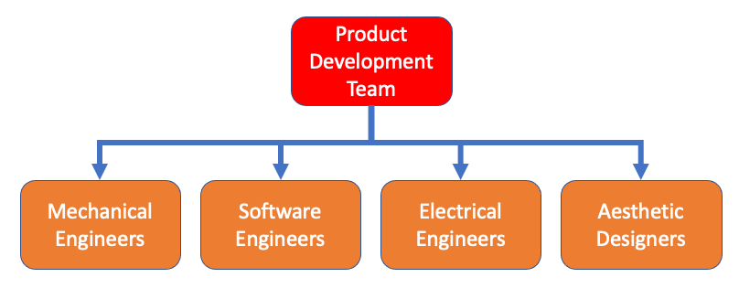
Mechanical Engineers – Since the ecu is controlling an engine which is a mechanical device it would require mechanical engineers who know how engines operate and what requirements it needs to run correctly.

Electrical Engineers – An ECU is essentially a computer utilising a central processing unit (CPU) to perform thousands of calculations a second and this CPU needs to interact with other subcomponents within the ECU such as digital storage chips and analogue to digital converters. The selection/manufacturing of these different components requires the knowledge of such items. In addition, all these components need to be electrically connected within the ECU, then the ECU needs to be able to connect to all the different sensors and actuators on an engine.

Software Engineers – The microchips in the ECU need to be programmed in order to perform the calculations required, this requires the ability to write accommodating code to the processors. Furthermore, in order to communicate with the ECU, it requires software to be designed to run on a personal computer which allows the user to change the values of certain parameters to be able to configure and tune the different maps that run the engine.

Aesthetic Designers – The product is going to need an enclosure which as basic as it may be needs to be designed and where this could be done by the mechanical engineers in order to make the product aesthetically pleasing, it would be more appropriate to have designers to design the enclosure to make the ECU look as striking as it performs.

Team Integration
The product development team would not be the only team involved with the product because there needs to be advertising and budgeting which means the product development team needs to communicate with other teams as shown below.

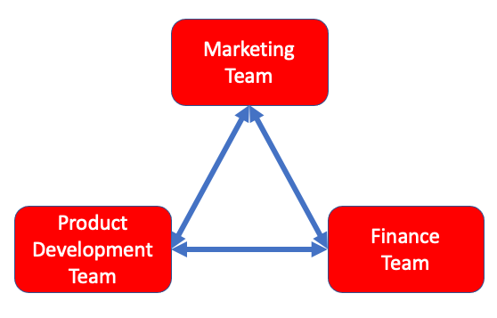
Marketing Team – In order for the product to sell successfully it relies on the marketing team to advertise the product and to get feedback from the target audience for changes to be made to the ECU. This requires the marketing and development team to liaise with each other so improvements can be raised with the engineers.
Finance Team – Budgets are going to be one of the most important aspects to a new product and it is down to the finance team to organize the budgets to all the different teams, meaning the product development team would have a limited amount of money to develop the product. It is up to the product development team to split the budget up to the different sub teams, for example, the mechanical engineers getting 30%, software engineering 25%, electrical engineers 25% and the aesthetics designers 20%. Of course, the finance team would liaise with market team to set budgets to spend on advertising, pricing etc.

Professional Working Standard
Codes of conduct are critical to engineers due to liability and public risk; therefore, it is important to have engineers who are accredited with an organisation like the Institute of Mechanical Engineers (IMechE).
The IMechE (2021) promotes high standards of ethical conduct among members to:
- Protect the members of the public
- Protect IMechE members
- Uphold the reputation of the institution and the wider engineering profession
If you are a Chartered Engineer with the IMechE then it means your skills have been assessed and shows you are a competent engineer. This means as an employer you are partly protected because the codes of conduct are set by the IMechE. The codes of conduct are as follow:
- All members shall act with care and competence
- All members shall act with integrity and in a reliable and trustworthy manner
- All members shall engage responsibly with the environment
- All members shall contribute positively to the culture and public perception of the profession and the Institution
(IMechE, 2021, p. 1)
Another very similar organization is the U.S.A. based National Society of Professional Engineers (NSPE) who’s codes of conduct are similar:
Engineers, in the fulfilment of their professional duties, shall:
- Hold paramount the safety, health, and welfare of the public.
- Perform services only in areas of their competence.
- Issue public statements only in an objective and truthful manner.
- Act for each employer or client as faithful agents or trustees.
- Avoid deceptive acts.
- Conduct themselves honourably, responsibly, ethically, and lawfully to enhance the honour, reputation, and usefulness of the profession.
(NSPE, 2019, p. 3)

Product Development
Problem solving is a key skill to an engineer and when it comes to product development it is critical to find the best solution when faced with an issue.

Problem Solving Methods
Since there a several methods to approach problem solving it is important to select the best one. The main technique for problem solving is the rational approach and most other methods of problem-solving stem from this technique shown below:

The rational approach is a multi-step process that works well for a wide range of problems. Many other problem-solving techniques mirror or build off its seven steps, so it may be helpful to begin with the rational approach before moving on to other techniques. Here are the seven steps of the rational approach:
- Define the problem.
- Identify possible causes.
- Brainstorm options to solve the problem.
- Select an option.
- Create an implementation plan.
- Execute the plan and monitor the results.
- Evaluate the solution.
Indeed Editorial Team (2021)
Andrew Pressman (2019, p. 7) tackles problem solving by using a method called design thinking, this is not an algorithm and there is no correct answer, rather there are multiple different solutions, some being more suitable than others. The method for design thinking is listed below which is very similar to the rational problem-solving method shown earlier.
- Information gathering
- Problem analysis and definition
- Idea generation
- Synthesis through modelling
- Critical evaluation
(Pressman, 2019, p. 5-6)

This extract is from a book for simulation and computational problem solving so it is coming from a very technical base subject like engineering therefore should help when working out which method to use.
- Recognising the Problem
- Defining the Problem
- Solving the Problem
  - Establish System Boundary
  - Formalisation
  - Solve the Model
  - Sensitivity Analysis
  - Verification and Validation
(Tang and Leu and Abbass, 2019, p. 4-8)

Quality Control
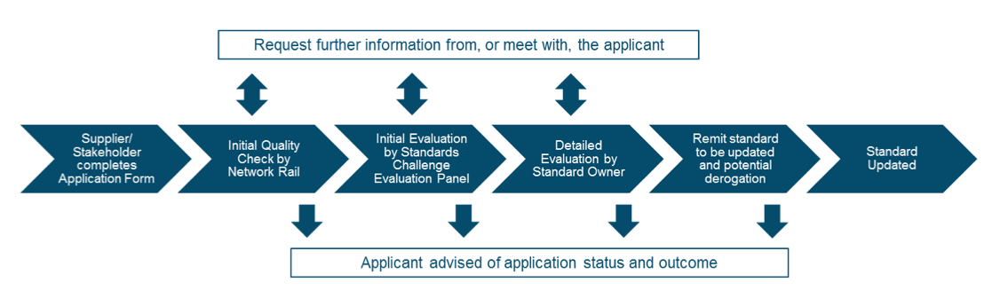
To ensure product development is kept to a high standard, the team would implement quality control measures. A prime example of quality control is Network Rail, when undergoing standards upgrades/changes because public safety is so important for rail transportation it is vital that these standards are the best they can practically be. Before new changes are implemented, they have a very comprehensive quality control method for new standards shown below.
(Network Rail, 2018, p. 7)
Network Rail uses a very similar quality control method when it comes to practical repairs on the tracks, their method is to send in 3 other teams to check over the work to ensure everything is up to standards and nothing is missed.

Discussion
The manufacturing of any product will have an impact on the environment due to the energy and materials used. However, the manufacturing of an ECU would be at a lower production rate due to the current demand for ECUs, this means the resources needed would be very low in comparison to laptop manufacturing currently in high demand. Also, the materials used in ECUs are generally able to be sourced from recycled materials such as aluminium and copper.

Manufacturing an ECU to run an internal combustion engine in today’s world may well seem like a bad idea with the move to electric vehicles, especially in the UK where the UK government’s (Department for Transport, 2020) 1st step is to phase-out the sale of new petrol and diesel cars and vans by 2030. The 2nd step is to have all new cars and vans to be fully zero emission at the tailpipe from 2035. Although on the surface this only effects new vehicles the UK government is wanting to phase out fossil fuels altogether. We can see this due to the change in standard petrol (rated at 95 RON) which most drivers use, the UK government (Department for Transport, 2021) announced that standard (95 octane) petrol in Britain will become E10. The UK government says this is because E10 petrol contains up to 10% renewable ethanol, which helps to reduce carbon dioxide (CO₂) emissions associated with petrol vehicles and tackle climate change. Petrol in the UK currently contains up to 5% renewable ethanol (known as E5). This phase out of fossil fuels would take a long time and optimising current engines to use less fuel and produce less pollution would certainly be a step forward. This is where an aftermarket ECU can become very useful due to the ability to run the engine in a certain way, this includes achieving better fuel consumption and better emissions. In addition, it makes it possible to run an engine happily on green fuels such as E85 with up to 85% renewable ethanol. Although this is more applicable to older cars where the emission laws are less stringent because of the limited technology manufactures had many years ago, there are still a lot of older cars being used on the road. A study by Tristan Shale-Hester (2021) reveals the average age of a UK car is now 8.4 years - the highest figure since records began, with almost 10 million vehicles from 2008 and earlier still on the road. This may be due to people wanting to produce less waste with the move of climate change.

Health and safety are at the upmost importance and the testing of engines the product development team would be doing would be carried out in workshops. Personal protective equipment (P.P.E.) is mandatory for workshops in the UK and in this case doing engine testing on a dynamometer the UK government (Health and Safety Executive, 2015) requires one to use the following:
Eye protection – safety glasses
Hearing protection – ear defenders
Feet protection – steel toed shoes
Body protection – protective clothing

Conclusion
Undergoing this product development using the team structure and integration with other teams suggested would cover the development of the ECU and be suitable for a smaller business. Based on the research for problem solving the proposed route for this product development would be:
- Problem analysis and definition
- Brainstorm options to solves the problem
- Analysis of the different options
- Solution selection
- Create an implementation plan
- Execute the plan and monitor the results
- Critical evaluation
The quality control measures for ECU development would utilise 2 different outside panels to carry out quality checks on the product, similar to the way Network Rail do their quality checks. This ensures nothing is missed. Taking into consideration the discussions on environmental and sustainably issues it is important to implement features that ensure the suitability and manufacturing of the ECU are in line with current regulations. Through the testing and development of the ECU in workshops it would be mandatory to wear the appropriate safety gear discussed.

Considering my own development, I see myself going down the route of further education due the interest I have in this area of engineering and would like to end up working hands on in manufacturing and development in the automotive/motorsport world. To achieve this, I believe I need to prove my knowledge and practical skills in the motorsport environment.

Reference List
Department for Transport (2021) E10 petrol explained
Available at: https://www.gov.uk/guidance/e10-petrol-explained
(Accessed: 27/11/2021)

Department for Transport (2020) Government takes historic step towards net-zero with end of sale of new petrol and diesel cars by 2030
Available at: https://www.gov.uk/government/news/government-takes-historic-step-towards-net-zero-with-end-of-sale-of-new-petrol-and-diesel-cars-by-2030
(Accessed: 27/11/2021)

Health and Safety Executive (2015) Personal Protective Equipment at Work
Available at: https://www.hse.gov.uk/pubns/priced/l25.pdf
(Accessed: 28/11/2021)

Indeed Editorial Team (2021) 12 Approaches to Problem Solving for Every Situation
Available at: https://www.indeed.com/career-advice/career-development/approaches-to-problem-solving
(Accessed: 23/11/2021)

Institute of Mechanical Engineers – IMechE (2021) Code of Conduct Explained
Available at: https://www.imeche.org/about-us/imeche-governance/governance-and-finance-reviews/code-of-conduct-explained
(Accessed: 25/11/2021)

Institute of Mechanical Engineers – IMechE (2021) Code of Conduct Regulations Page Number: 1
Available at: https://www.imeche.org/docs/default-source/1-oscar/About-us/governance/code-of-conduct-regulations.pdf?sfvrsn=2
(Accessed: 25/11/2021)

Samuel M. Natale, Anthony F. Libertella, Brian Rothschild (1995) Team Performance Management
Volume 1 Issue 2
Available at: https://www.proquest.com/docview/217097709?accountid=130472
(Accessed: 17/11/2021)

National Society of Professional Engineers – NSPE (2019) NSPE Ethics Reference Guide
Available at: https://www.nspe.org/sites/default/files/resources/pdfs/Ethics/EthicsReferenceGuide.pdf
(Accessed: 25/11/2021)

Network Rail (2019) Catalogue of Network Rail Standards
[Flow chart]
Available at: https://www.networkrail.co.uk/wp-content/uploads/2018/12/NR_CAT_STP_001-Issue-110.pdf
(Accessed: 27/11/2021)

Andrew Pressman (2019) Design Thinking: A Guide to Creative Problem Solving for Everyone
London: Routledge

Tristan Shale-Hester (2021) Average age of UK cars reaches record high
Available at: https://www.autoexpress.co.uk/news/59950/average-age-uk-cars-reaches-record-high
(Accessed: 27/11/2021)

Jiangjun Tang, George Lew and Hussein a. Abbass (2020) Simulation and Computational Red Teaming for Problem Solving
New Jersey: John Wiley & Sons

