Kallum Doyle (2237962)
2237962@student.uwtsd.ac.uk
7th March 2025 @ 1500 HRS
2500 Words
Research, build, and deploy, a Virtualised network
Network Operating Systems and Services

Contents
Table of Figures 3
Task 1 4
Hypervisors 4
Types of Hypervisors 4
Features & Hardware Requirements 4
Advantages of Hypervisors 4
Different Use Cases 5
IP Addressing 6
Data Transmission and Role of IP Addressing 6
Routers, Switches and Subnetting 6
IP Addressing 6
Routing 8
Routing Protocols 8
Real World Applications 8
Network Services 9
Virtual Personal Network (VPN) 9
Certificate Authorities 9
DHCP 9
Active Directory Domain Services 9
Task 2 10
Hypervisor Choice 10
Download and Setup 11
Downloading and Setup 11
Network Deployment 16
IP Addressing Configuration 20
Debian Client 20
Debian Server 21
Windows Client 22
Windows Server 23
Test and Troubleshooting 25
Successful Connectivity within Same Networks 25
Unsuccessful Connectivity Within Different Networks 30
Reflection 32
Troubleshooting 32
Personal Reflection 32
References 33

Table of Figures
Figure 1 3
Figure 2 5
Figure 3 7

Task 1

Hypervisors

Types of Hypervisors
Type 1 hypervisors are run directly on a computer’s physical hardware and require no host operating system, which allows for direct access and control over the host’s hardware resources. Common types of this hypervisor include VMware ESXI & Microsoft Hyper-V.
Type 2 hypervisors in contrast run on an existing operating system. Resources for the virtual machine are assigned through the host’s operating system. Examples of two popular hypervisors of this type include Oracle VirtualBox and VMWare Workstation. [1-2]
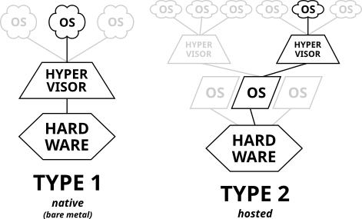
Figure 1
A comparison of Type 1 and Type 2 hypervisors.
Source: [3]

Features & Hardware Requirements
Hypervisors offer features such as resource distribution, partitioning and isolation. Hypervisors have strictly allocated resources partitioned to it via the host operating system. Each virtual machine is isolated from the host operating system alongside other virtual machines ran on the operating system. [2]
Hardware requirements vary dependant on the guest operating system. For example, VMs running Windows 11, it is recommended the host computer to have a minimum of 64GB of disk space, 4GB of RAM and two or more virtual processors. [4]

Advantages of Hypervisors
There are several advantages hypervisors provide for hosting operating systems. By isolating virtual machines from the host operating system, the scalability of a potential attack is reduced significantly as it is difficult to compromise the host machine. An attack can only occur on one virtual machine at a time.
In the event of an attack, virtual machines can be rolled back to a certain point in time dependant on the backup interval of the virtual machine. This means data can be preserved in the event of an attack and the machine can be disinfected with ease. [2]
Hypervisors support a variety of guest operating systems of different versions, dependant on the hypervisor software. For example, VirtualBox supports many Windows editions from 7-10, alongside a range of Linux flavours such as Ubuntu, Fedora or Debian. [5]

Different Use Cases
Type 1 hypervisors are found most in cloud computing and commercial environments. This type of hypervisor is best utilized for resource-intensive applications. Whereas type 2 hypervisors are commonly found in desktop and development environments where the resource requirement is lower. [6]

IP Addressing

Data Transmission and Role of IP Addressing
Computers can transmit data to each other when on the same network, when they are being connected through a medium. They can resolve information about each other by sending a broadcast to each computer on the network, one broadcast for resolving MAC addresses and another for IP addresses. Once a computer knows the MAC and IP address of a computer, it can freely send, and receive data from that computer, given it also knows its IP and MAC address. [7, Ch. 1, pp 4-49]

Routers, Switches and Subnetting
Switches enable the sharing of resources between network devices such as computers and services, whereas routers enable multiple switches to connect to form a larger network with the capacity to span multiple locations. Both devices are essential to small business networks for efficient and reliable communication. [9]

IP Addressing
IPV4 address typically consists of 32 bits of information, which is divided into four sections / bytes. IP addresses contain a network and node address. The network portion depends upon the three classes of the IP addresses. Class A IP addresses assign the first section as the network address, and the remaining are used for denoting the host. This results in the largest number of host addresses. Class C addresses assign the first three sections as the network address, and the last section for host addresses, resulting in the smallest number of host addresses.
The class can be identified based on the range of the first number:
- For class A, the number range is 1-126.
- For class B, the number range is 128-191.
- For Class C, the number range is 192-223.
[7, Ch.2, pp 68-101]
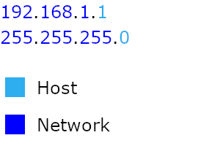
Figure 2
A visual representation of a Class C network address with its corresponding subnet mask.
Knowing the subnet mask of the address allows for understanding the network and host portion. For class A, the default subnet mask would be 255.0.0.0, and for class C it would be 255.255.255.0. [8, Ch.3, pp 115-116]
Additionally, each class has a private IP address range designated for networks with no internet access requirements. For example, an IP address of 12.165.23.4 is a public class A IP address, whereas a private IP address for the same class would be 10.1.1.1. [7, Ch.2, pp 68-101]
IPV6 addresses are like IPV4 addresses but contain 128 bits instead of 32 bits and utilize hex digits. Typically, the first 64 bits is the network prefix, and the remaining 64 bits denote the host addresses. An example of an IP address would be 4de9:ab61:9bfe:aeb0:ad97:1850:6bc1:3f49. IPV6 is useful due to its ability to support a significantly higher number of electronic devices in comparison to IPV4. [8]

Routing
Transmitting packets across networks with the upmost efficiency is known as routing. Network communications largely depend on the router's efficiency for overall communication efficiency. There are multiple ways a router can determine the most efficient way to transmit data, known as routing protocols. [9]

Routing Protocols
Two groups of routing protocols exist known as static and dynamic protocols. Both have their advantages and disadvantages. Dynamic routing does not require much manual configuration, as the network changes and the difficulty of configuration remains constant, whereas static routing requires manual intervention and can become more complex with increasing network size.
Static routing is ideal for smaller networks where routing destinations are constant. They remain light on resources and provide better security as routes are not broadcasted over the network. Dynamic routing is best for large networks that are expected to change in size frequently. Dynamic routing is not so good for security and resource usage, but it reduces manual configuration requirements. [9]

Real World Applications
Open Shortest Path First (OSPF) Protocol is a commonly used protocol due to its ability to support large and small networks with great efficiency. It uses the short path first algorithm to calculate the shortest path from the current network point to the following network point. [10]
OSPF is utilized by a multitude of entities to manage their networks:
- Organizations use OSPF due to its ability to scale effectively, while quickly and automatically adapting to changes to the network topology.
- ISP providers also utilize OSPF to manage network infrastructure automatically and efficiently with minimal downtime and data loss.
- Data centres use OSPF due to it automatically rerouting packets where a failed router is encountered. [12]
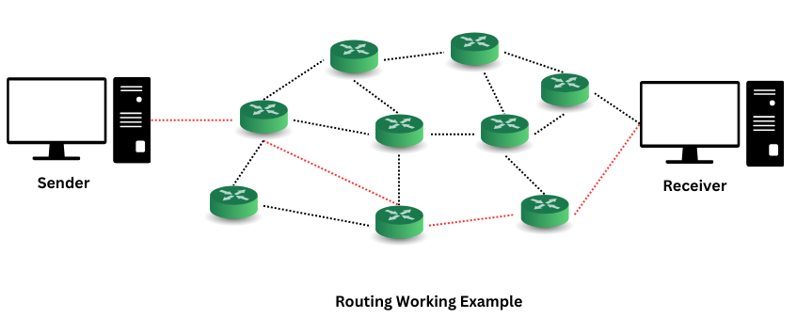
Figure 3
A DEMONSTRATION OF THE ROLE OF ROUTERS IN TRANSMITTING DATA FROM ONE COMPUTER TO ANOTHER USING OPFS.
SOURCE: [11]

Network Services

Virtual Personal Network (VPN)
VPNs enable secure data transmission over public networks, allowing employees to access company resources remotely. They are utilized in various network sizes, from home offices to large organizational networks. By utilizing VPNs for client connectivity, employees can work from anywhere with internet access, all while ensuring that sensitive data remains protected. [13]

Certificate Authorities
Digital certificates are a pair of cryptographic keys digitally signed by a certificate authority, which is viewed as a trusted entity. A certificate authority’s job is to verify the identity of the person or company before designing and releasing the digital certificate to the client. Digital certificates can be found in extranet VPNs to secure a secure tunnel to the organization. This system allows for network scalability and improved reliability of data transmission. [13]

DHCP
DHCP allows devices on a network to obtain an IP address without manual configuration. As a client-server protocol, it significantly reduces the workload for network administrators. DHCP works by enabling devices to broadcast a request for an IP address from a DHCP server on the network. IP addresses can be recycled over time automatically, allowing different devices to use them at different periods. [14]

Active Directory Domain Services
Active Directory Domain Services (AD DS) is a directory service designed for ease of use by network users and administrators, that provides methods for storing and creating data regarding network objects. This enables easier access and utilization of network information. AD DS manages user account information, such as names and passwords, as well as network resources, enabling access restriction and management. [15]

Task 2

Hypervisor Choice
The type 2 hypervisor will be the choice of hypervisor used within this report, derived based on the research conducted above. While an offer of cloud service is available for hosting the network, utilizing a personal computer offers greater convenience in comparison as the network can be accessed without internet access. Additionally, no dedicated personal computer was available for usage as a hypervisor. This contributed to the decision of using a general-purpose computer with the network configured on it.
The primary benefit of this decision is the cost aspect. There is no additional cost to running the network, as all of it is done on an existing operating system. If there are hardware resources available for partitioning amongst the guest operating systems, the resource cost is minimal.

Download and Setup

Downloading and Setup

VirtualBox
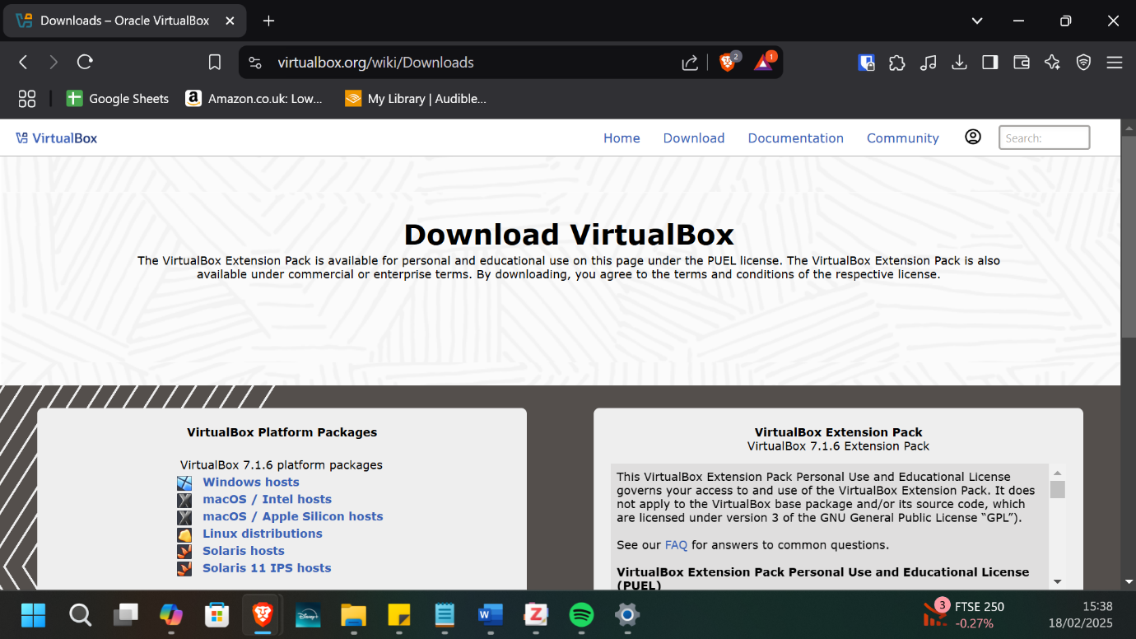
VirtualBox is a type 2 hypervisor software that was chosen as the choice of hypervisor software for hosting the network.

Windows Server
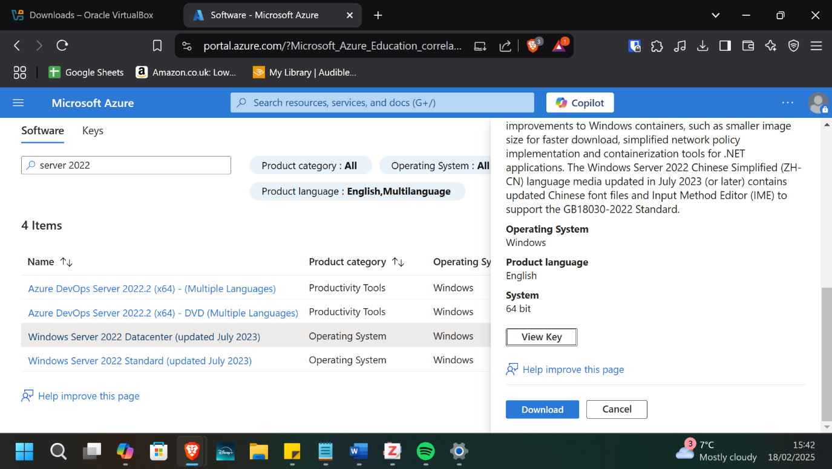
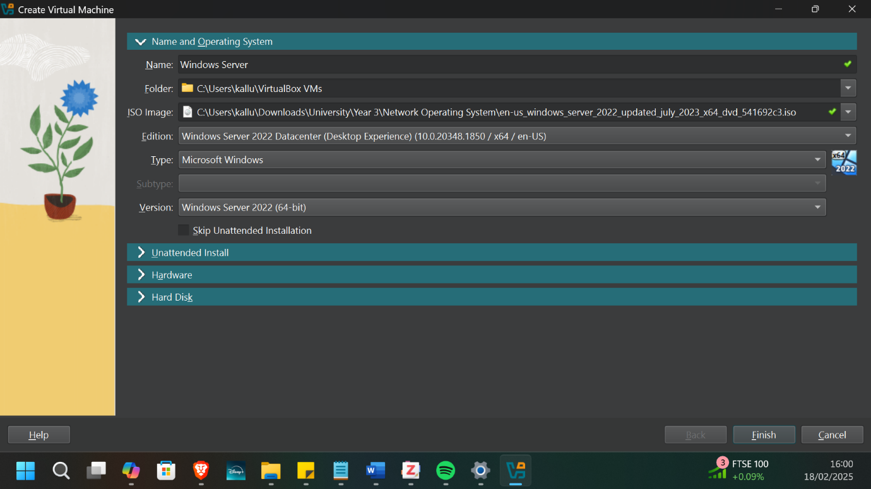

Windows Server 2022 Datacenter was the version of windows server chosen for the guest operating system of the windows server component of the network. In particular, the desktop experience version was chosen.

Windows Client
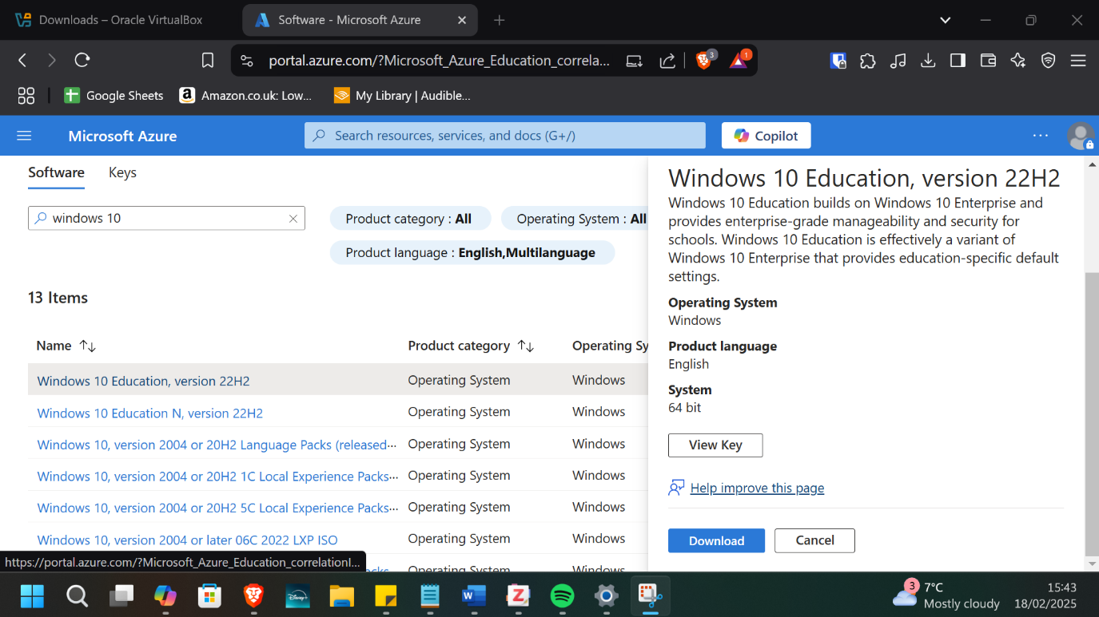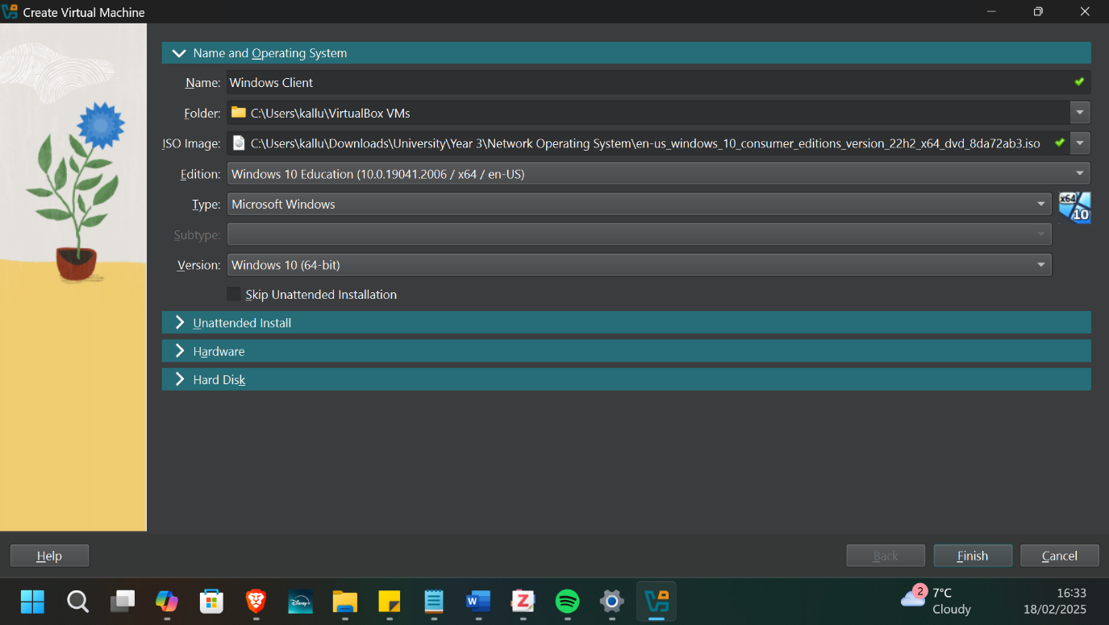
The standard version of Windows 10 education was chosen as the guest operating system for the windows client component of the network.

Debian Server and Client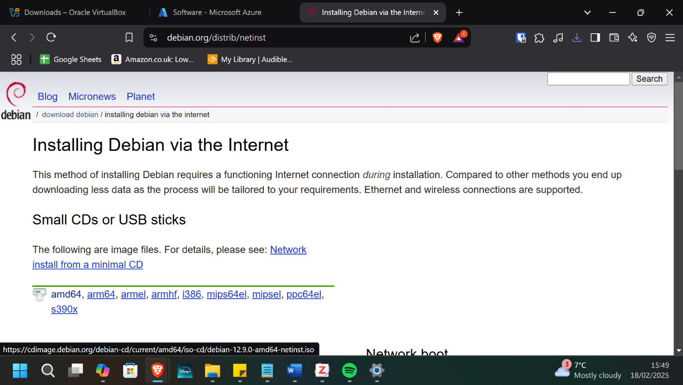
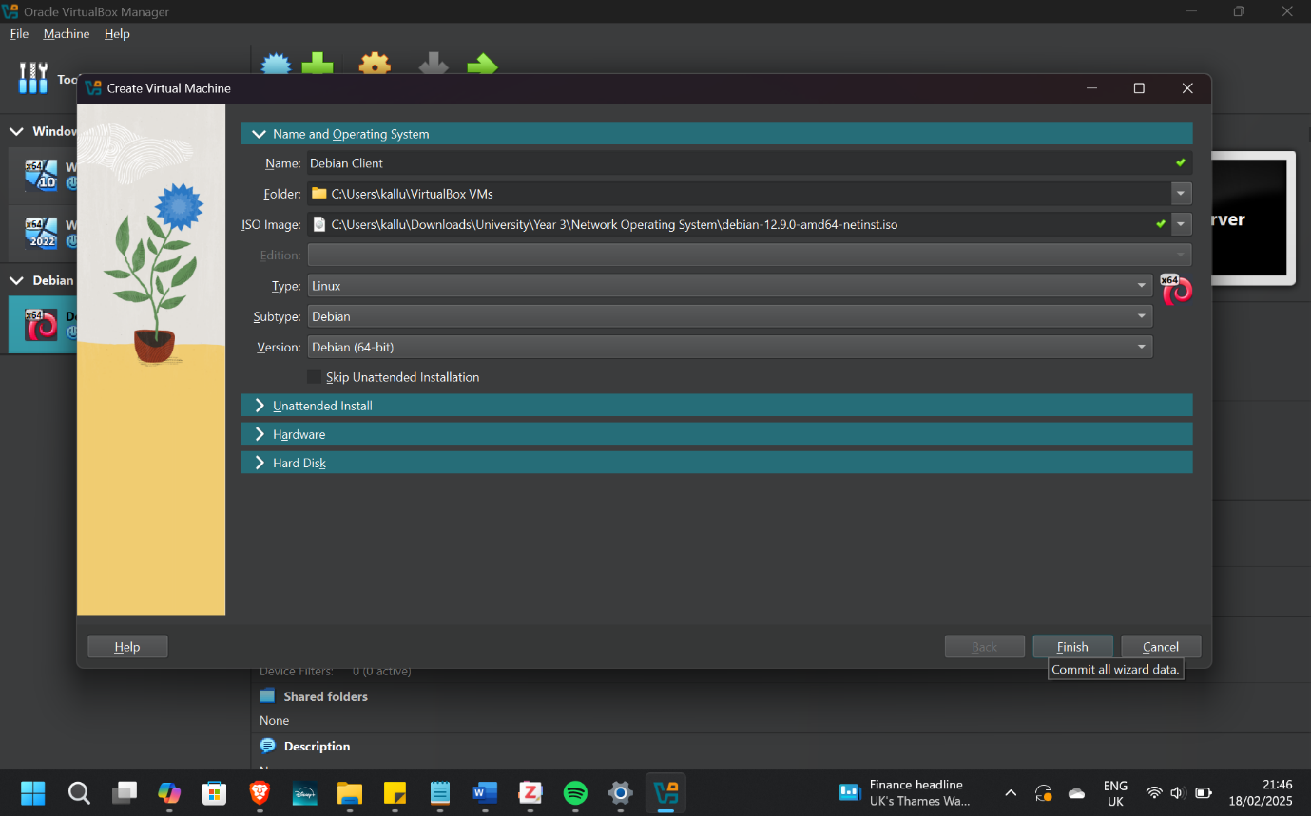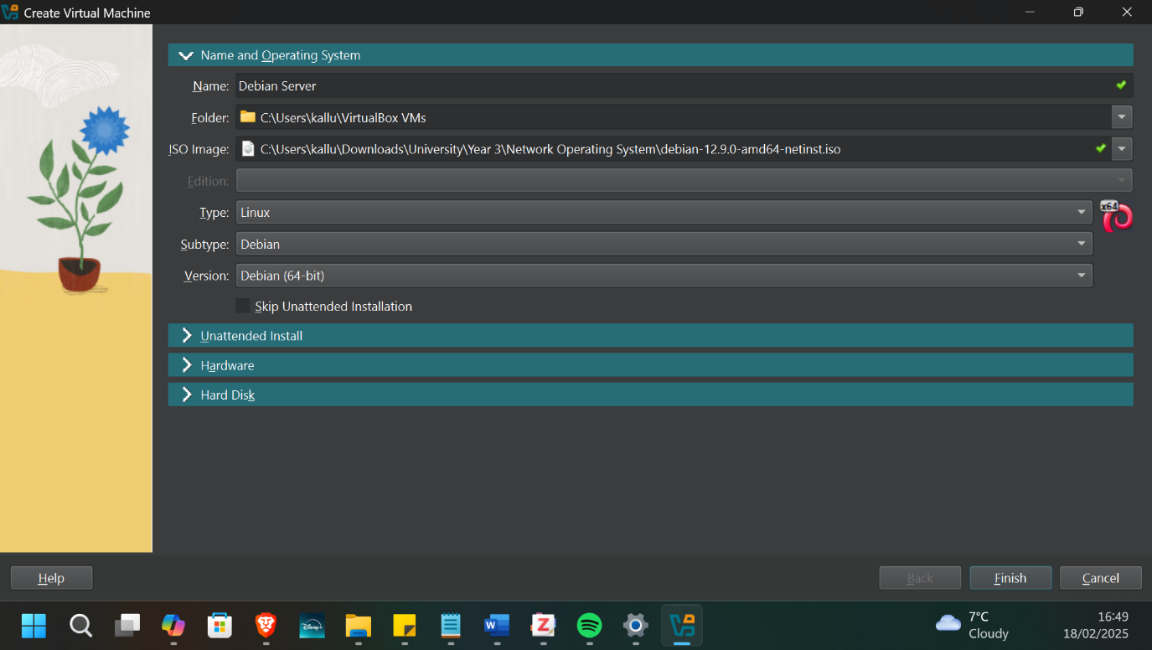A single debian ISO was downloaded and used to configure the linux client and server components of the network.

Network Deployment

Windows Client
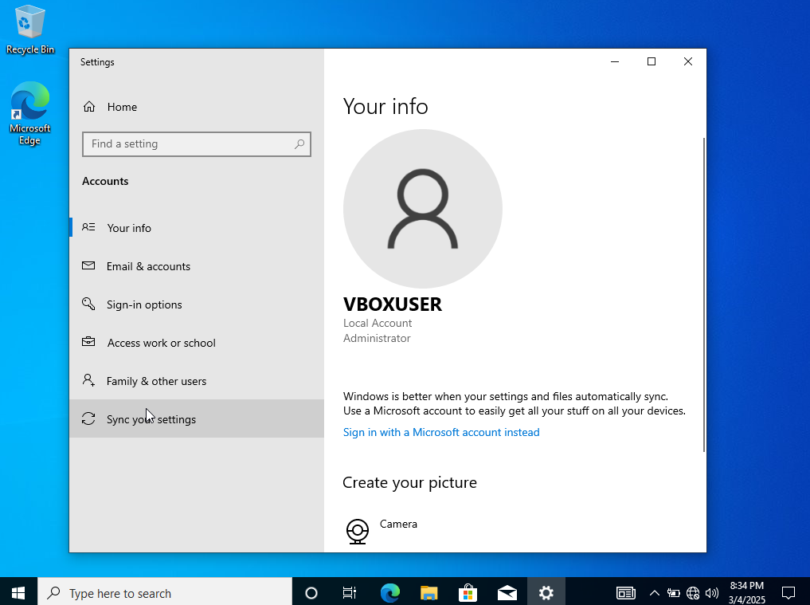
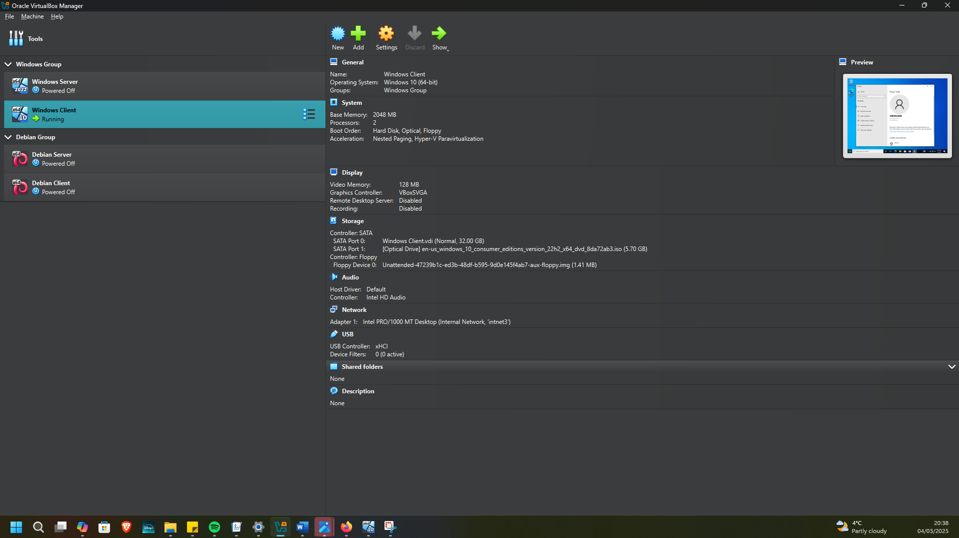
The windows client was deployed on an internal network that consisted of the windows server and windows client.

Windows Server
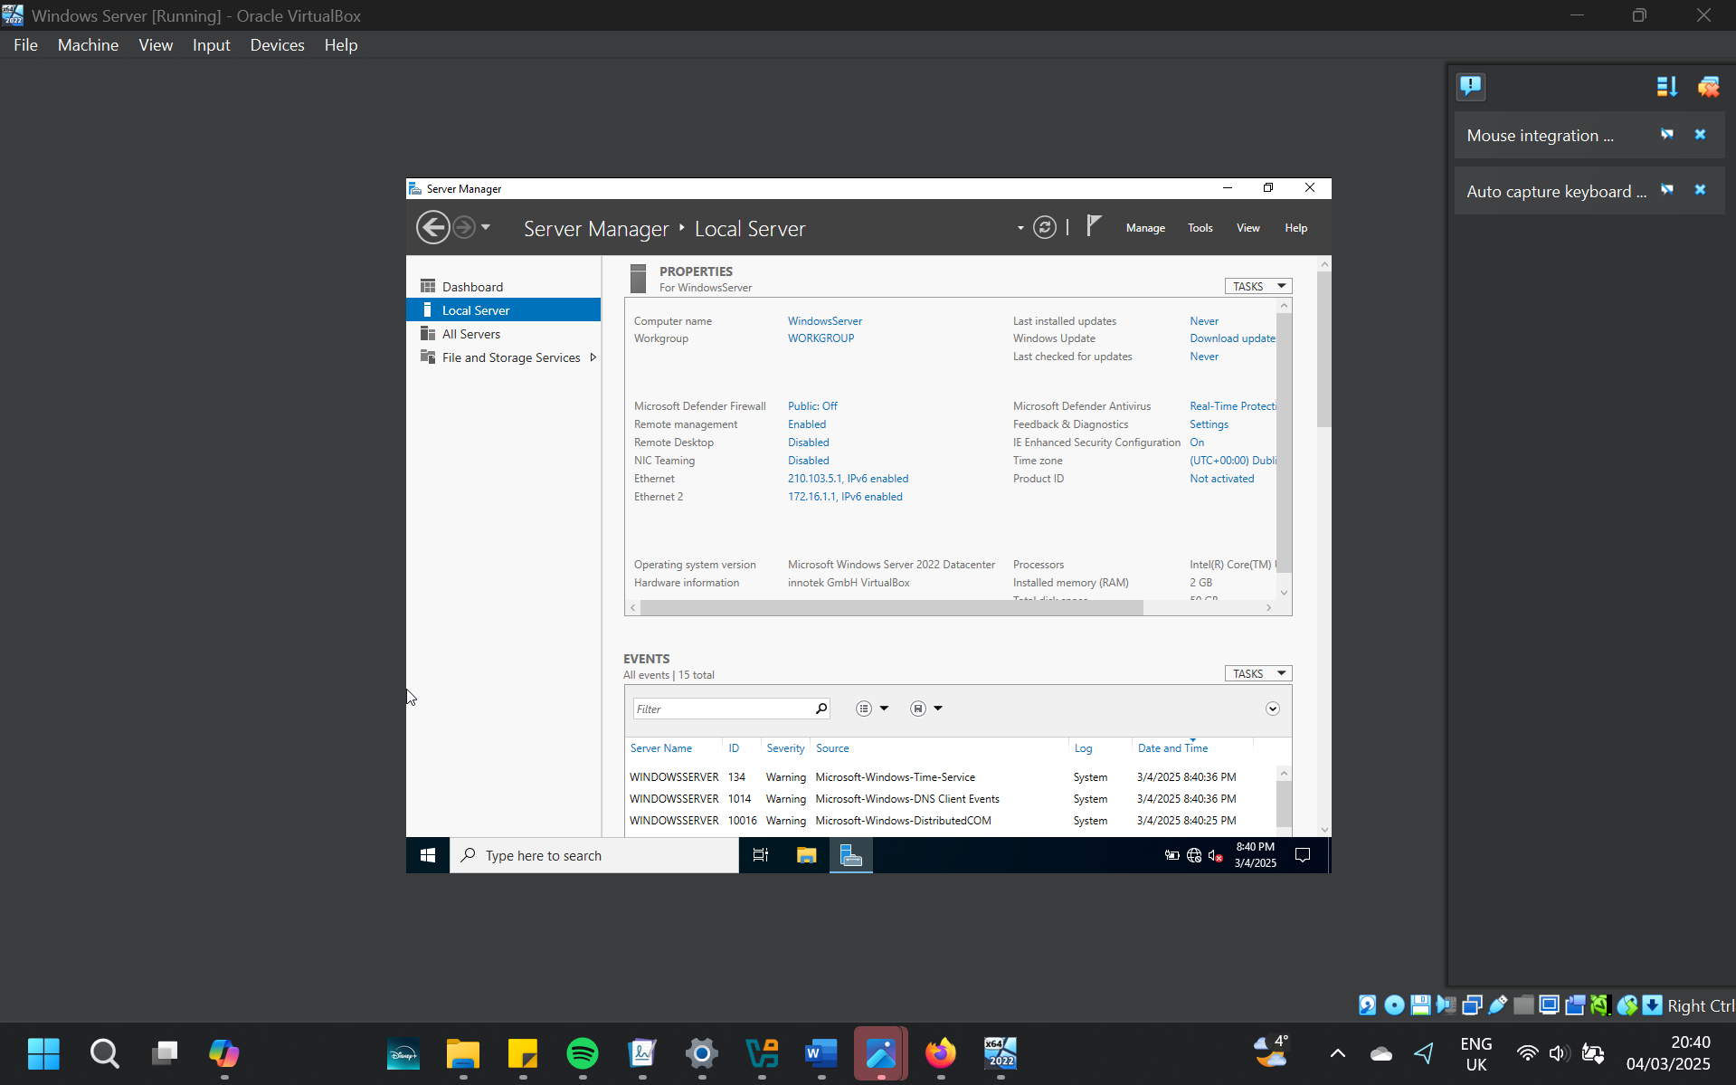
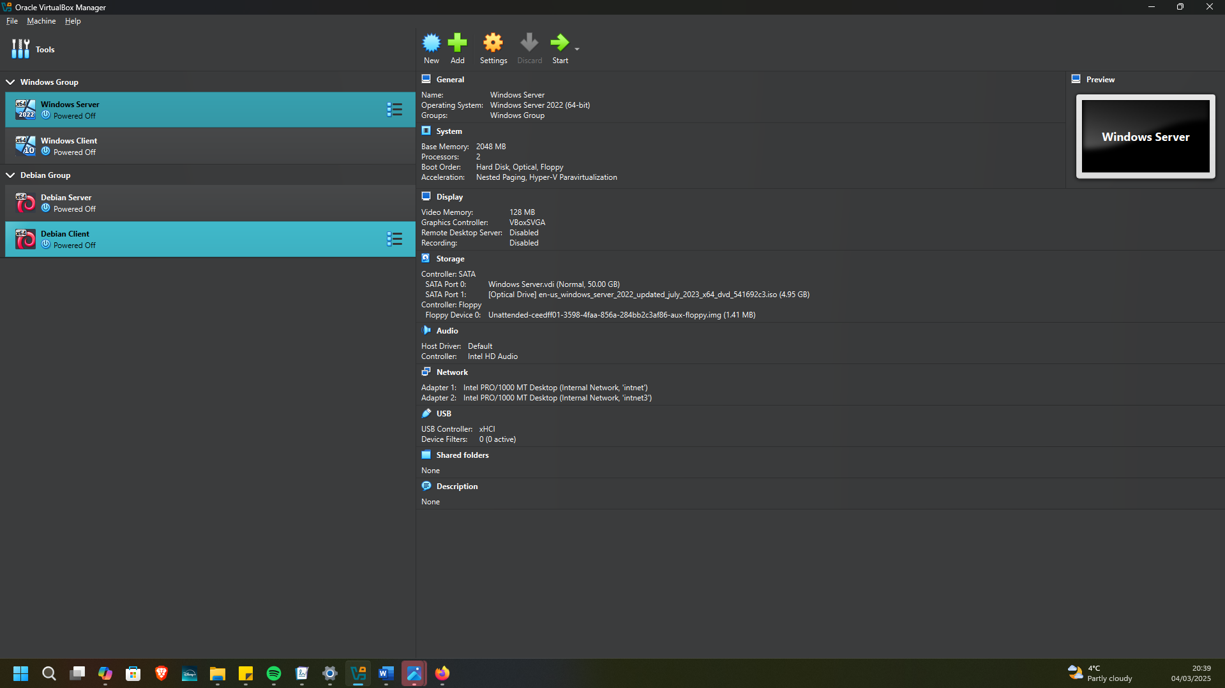
The windows server was deployed with two internal network adapters. One was inclusive of the windows server and windows client, and the other linked the Debian server and windows server together.

Debian Server
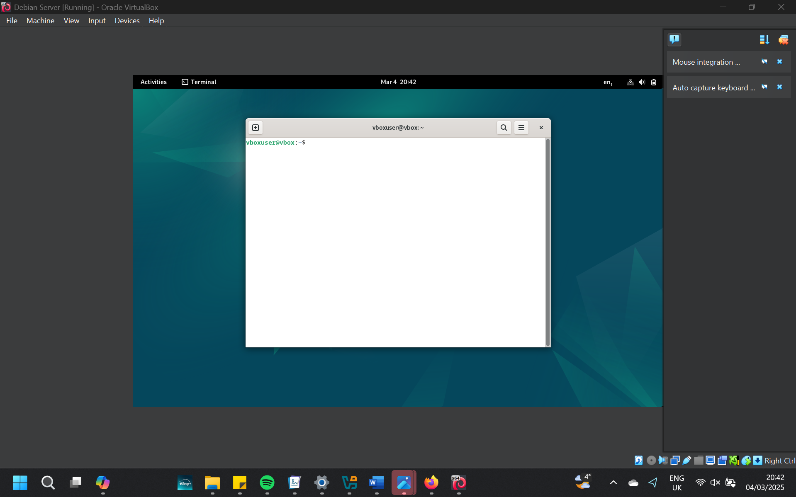
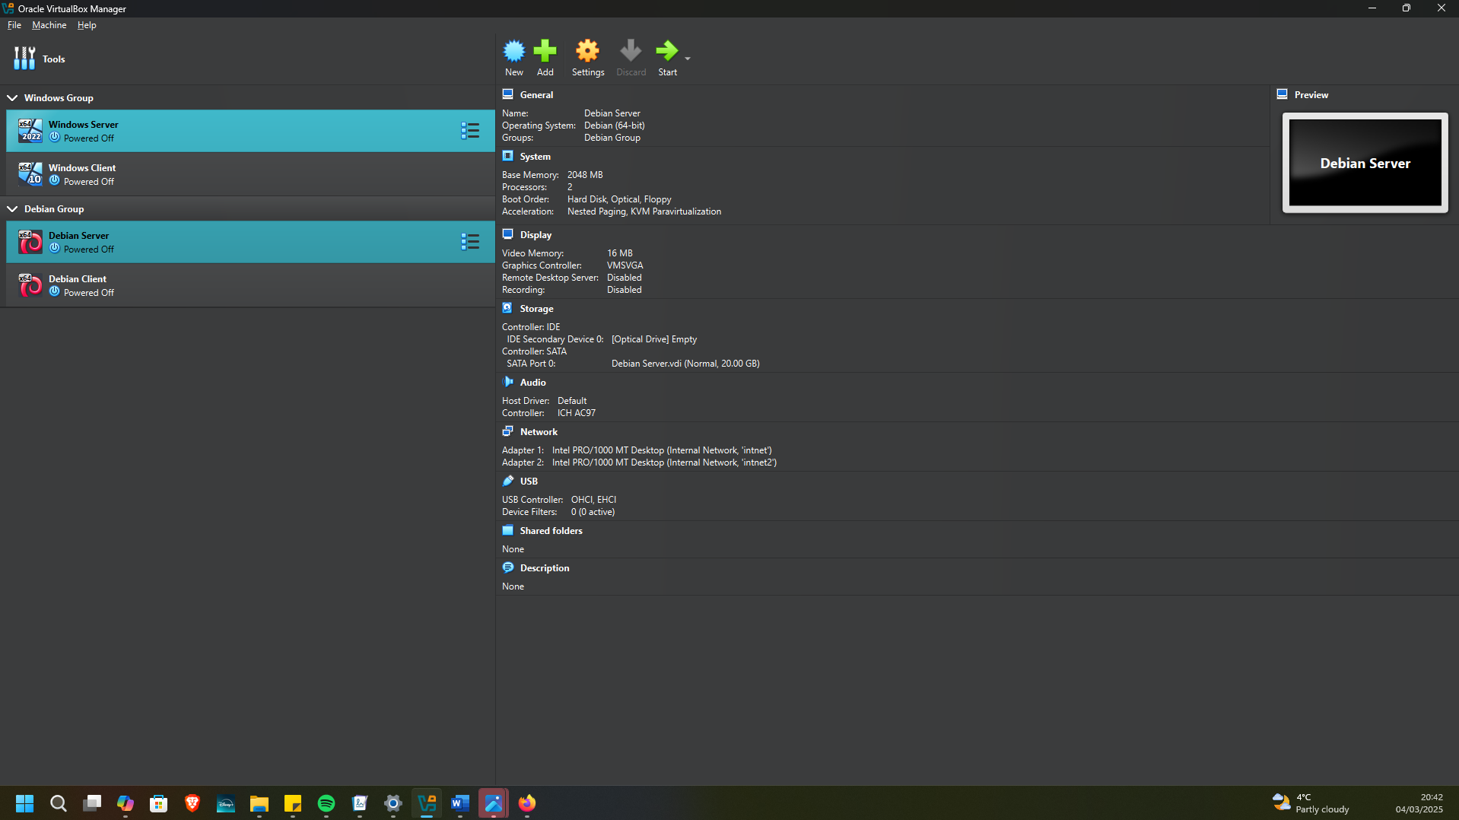
The Debian server also had an internal network adapter for communication with the windows server, while having another internal network adapter for communication with the Debian client.

Debian Client
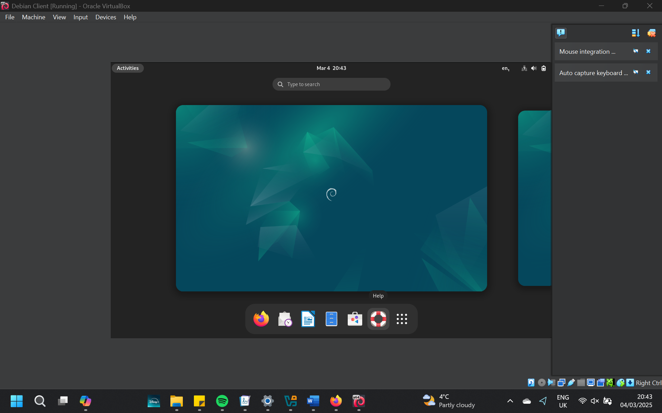
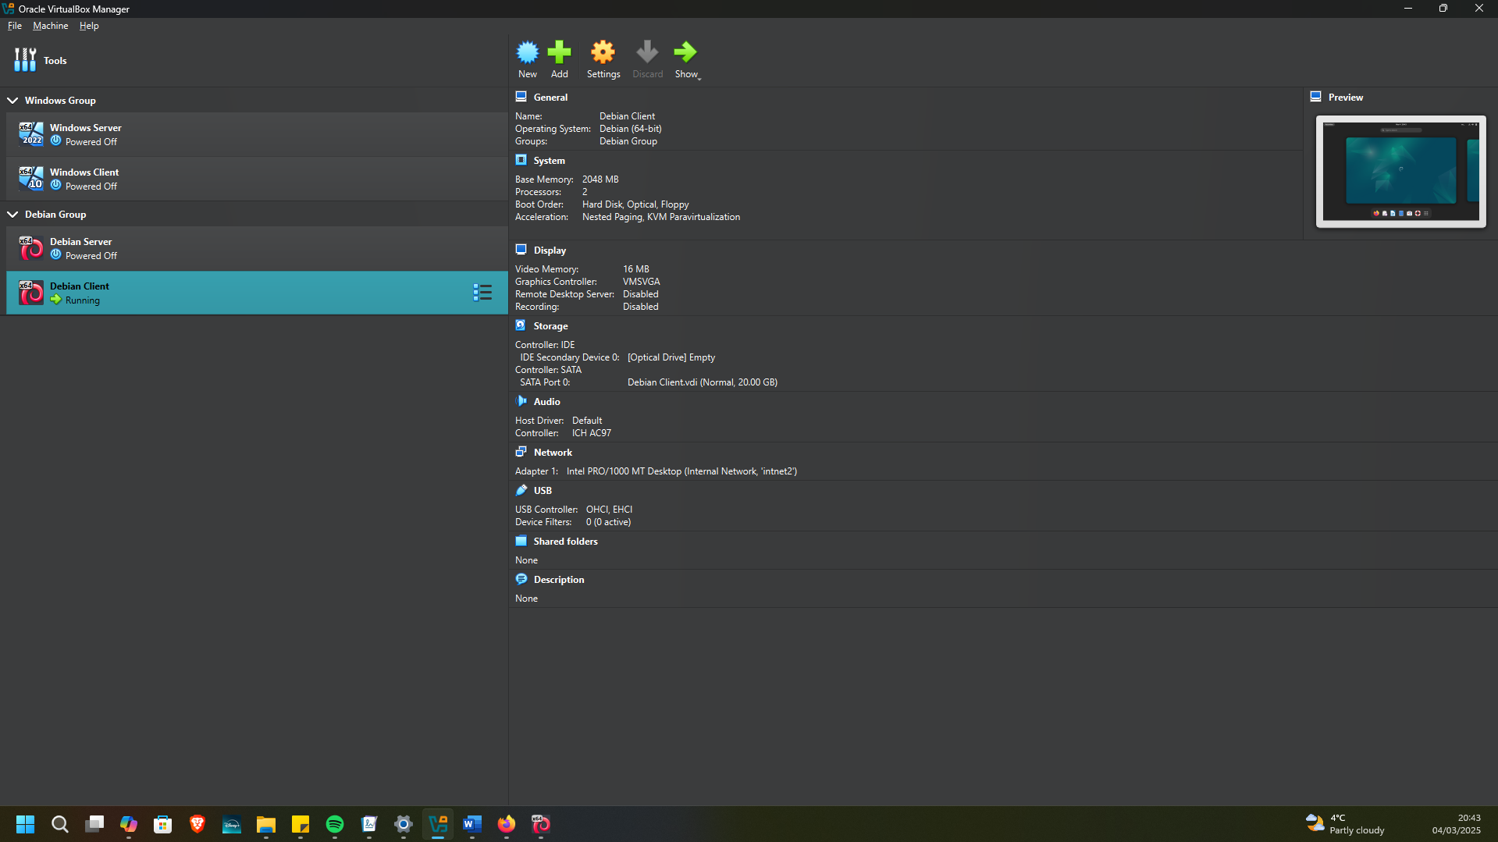
Finally, the Debian client had an internal network adapter for communicating with the Debian server.

IP Addressing Configuration

Debian Client
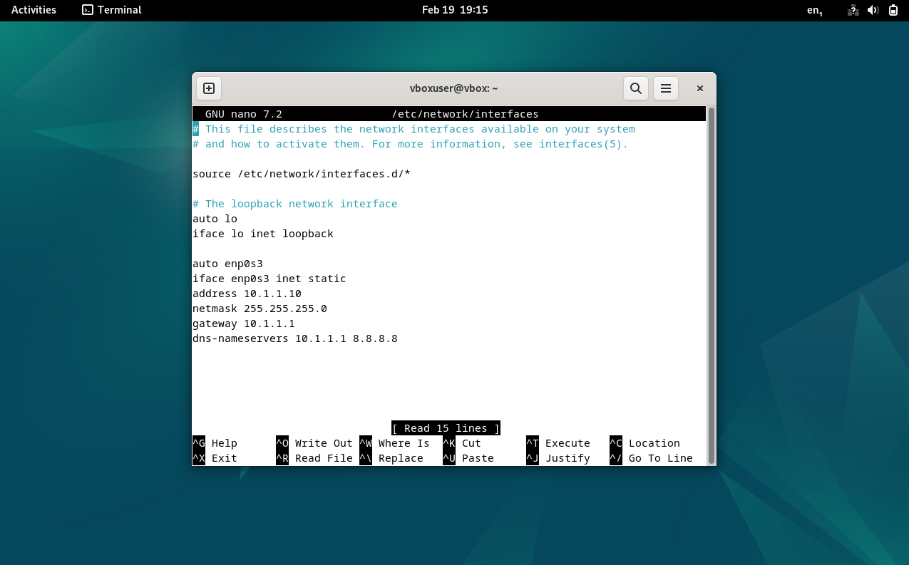
The Debian client was set up on the 10.1.1.0/24 network, using the Debian server as the default gateway, using an IP address of 10.1.1.10.

Debian Server
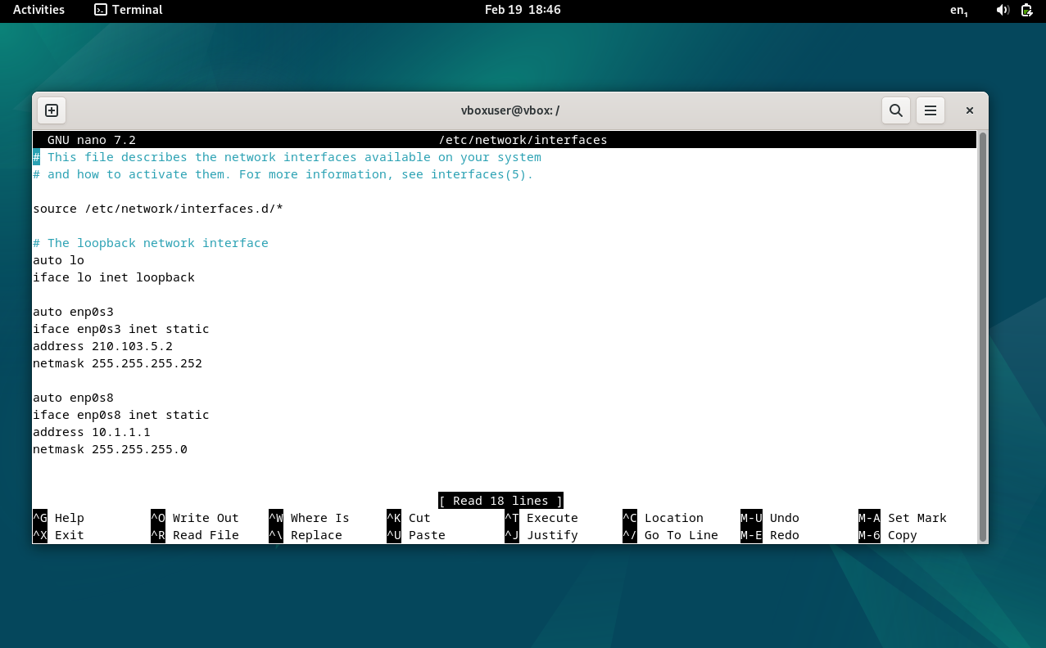
The Debian server was set up on the 10.1.1.0/24 network for communication with the Debian client, with an IP address of 10.1.1.1. Additionally, it was set up on the 210.103.5.0/30 network with an IP address of 210.103.5.2 for communication with the windows server.

Windows Client
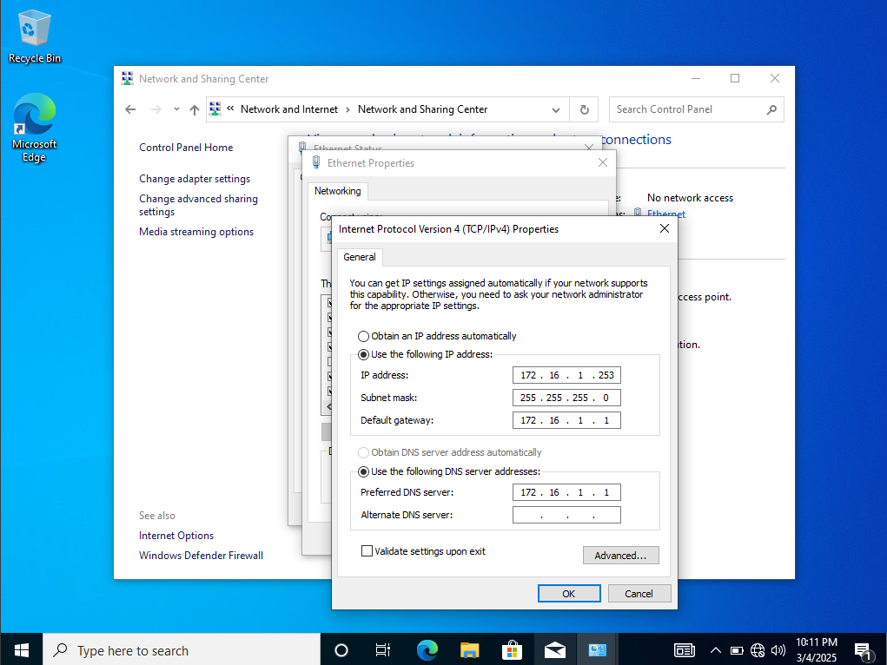
The windows client was set up on the 172.16.1.0/24 network for communication with the windows server, using the windows server as the default gateway. The windows client IP address was 172.16.1.253.

Windows Server
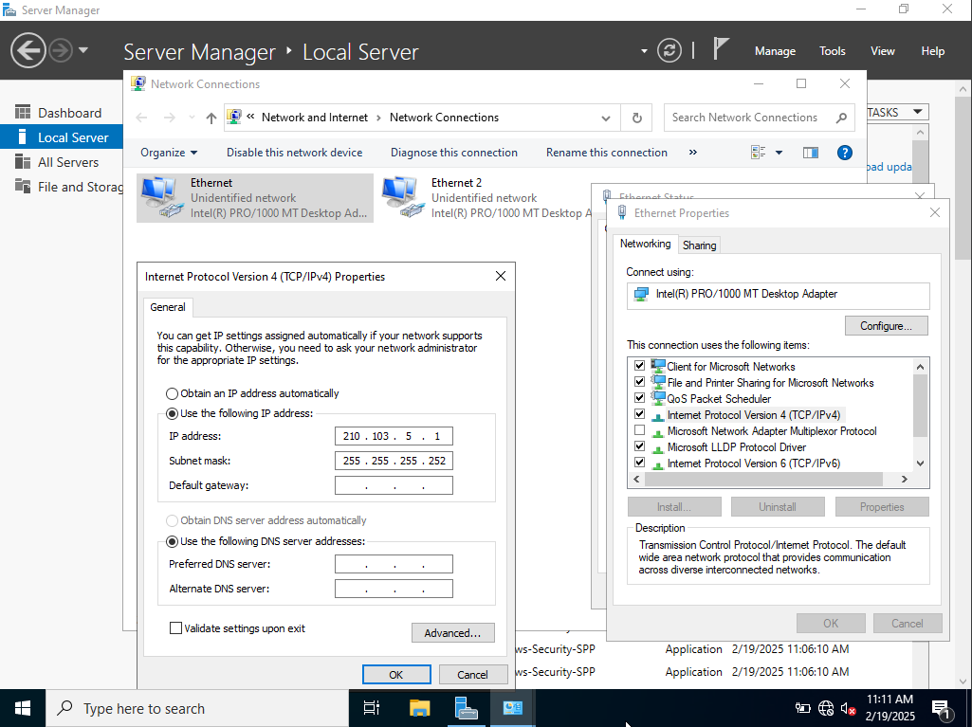
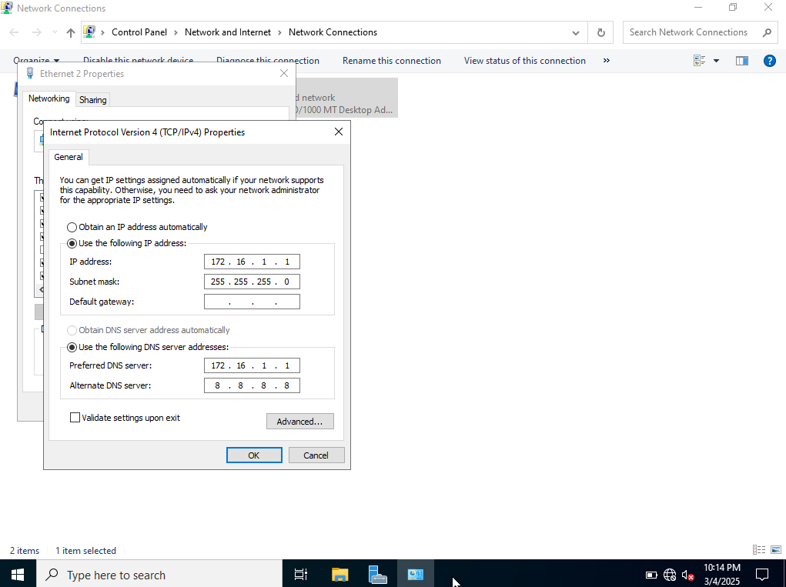
The windows server was set up on the 172.16.1.0/24 network for communication with the windows client, with IP address 172.16.1.1. It was also set up on the 210.103.5.0/30 network for communication with the Linux server, with IP address 210.103.5.1.

Test and Troubleshooting

Successful Connectivity within Same Networks
The network was set up, with:
- The Debian client successfully pinging the Debian server and vice versa.
- The Debian server successfully pinging the windows server and vice versa.
- The windows server successfully pinging the windows client and vice versa.
Proof of the connectivity is demonstrated below by usage of the ping command.

Debian Client to Debian Server
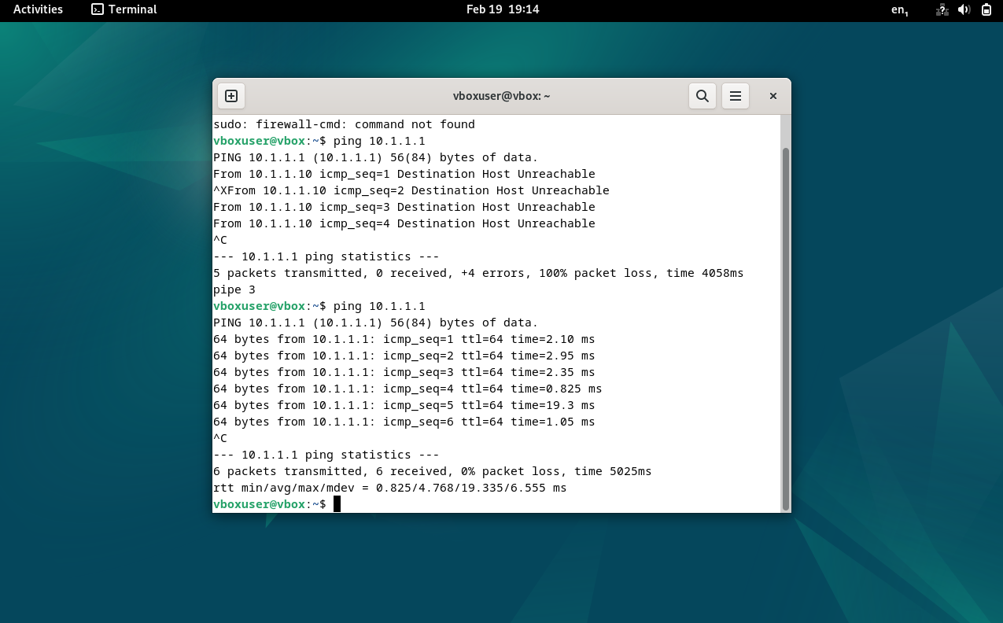

Debian Server to Debian Client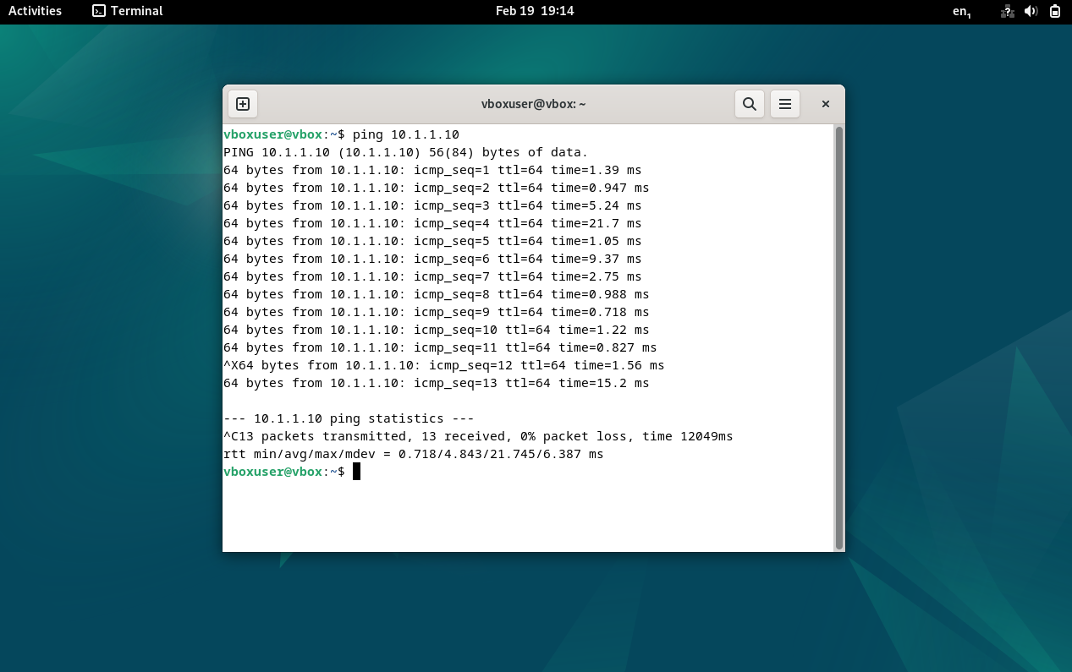

Debian Server to Windows Server
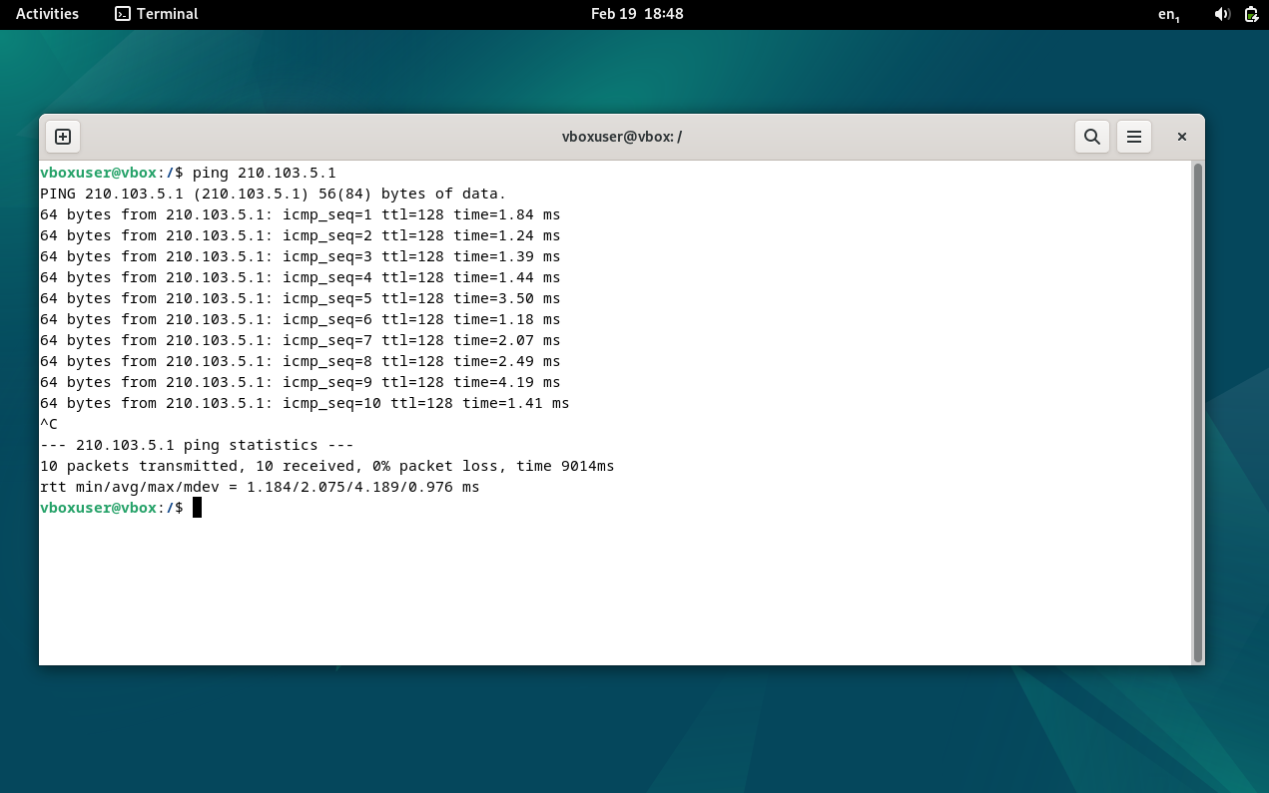

Windows Server to Debian Server
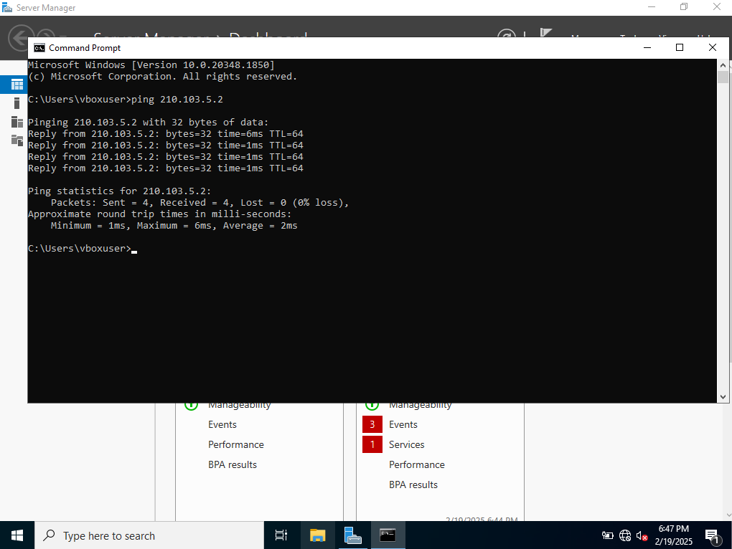

Windows Client to Windows Server
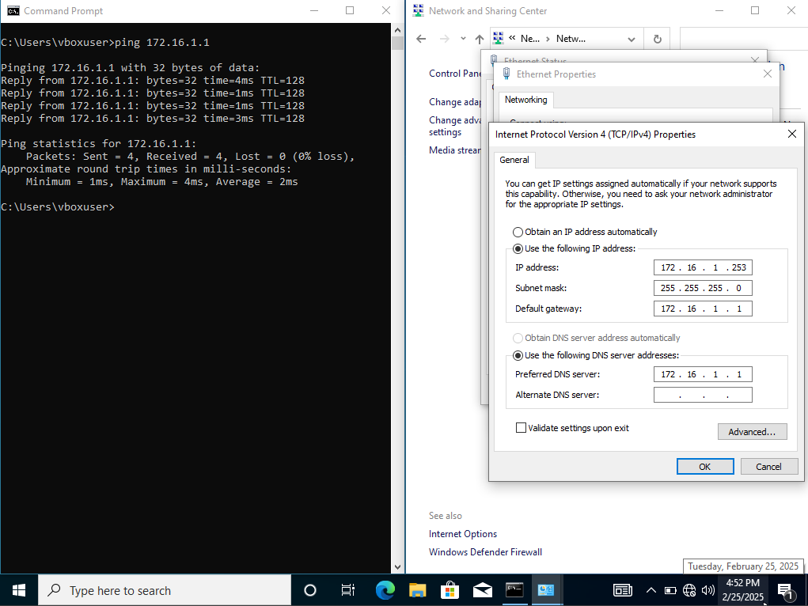

Windows Server to Windows Client
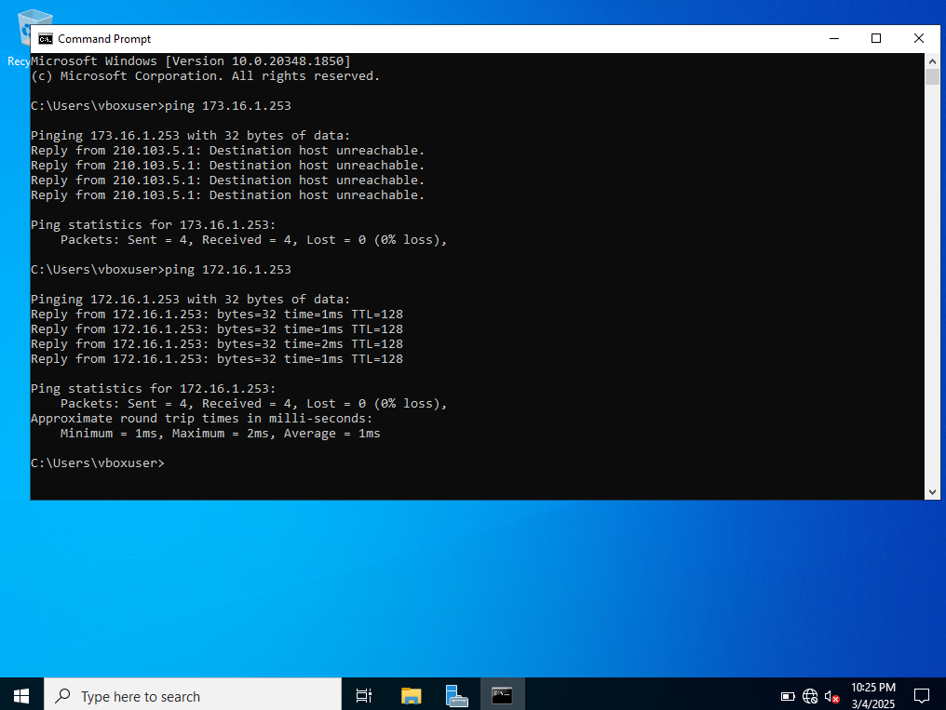

Unsuccessful Connectivity Within Different Networks
The below sections demonstrate the unsuccessful pinging between separate networks.

Debian Client to Windows Client
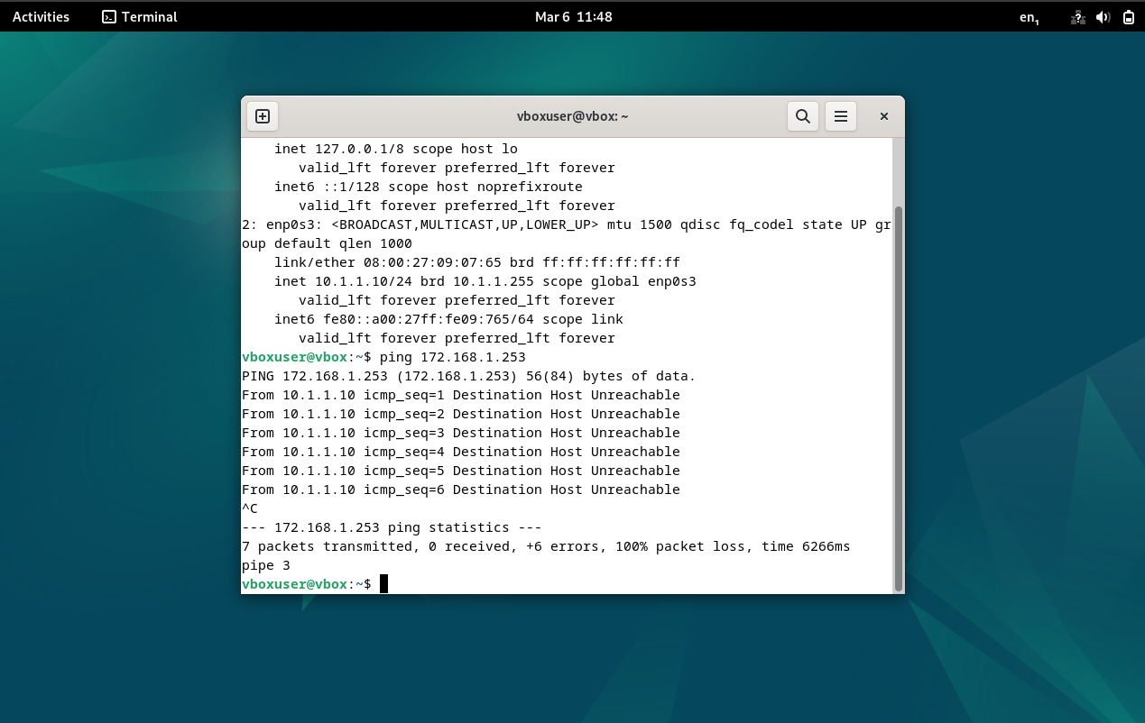

Debian Server to Windows client
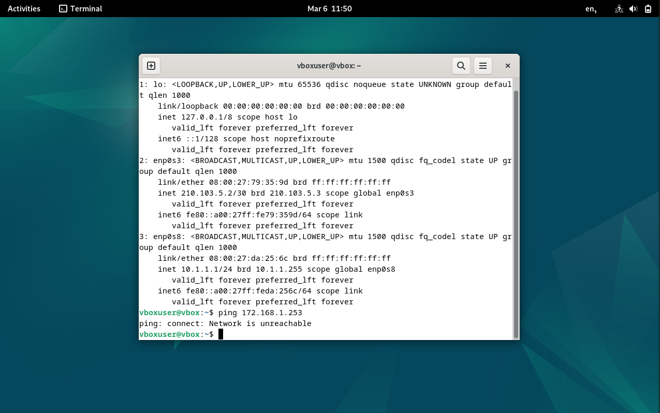

Windows Server to Debian Client
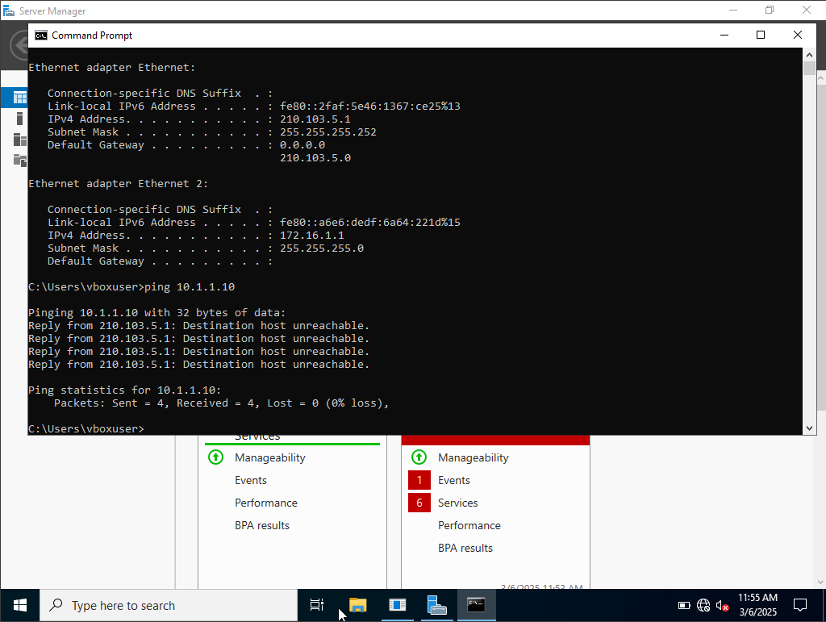

Reflection

Troubleshooting
When attempting to set up the Debian network, the server initialized without prompting for any package configuration. This was because the skip unattended install option was not checked while initializing the virtual machines (software keys were obtained via the universities Azure services for students). [17]
This meant that the server packages were not installed when setting up the computer. To resolve this, the tasksel command was ran and the web server and SSH server packages were installed. [16]
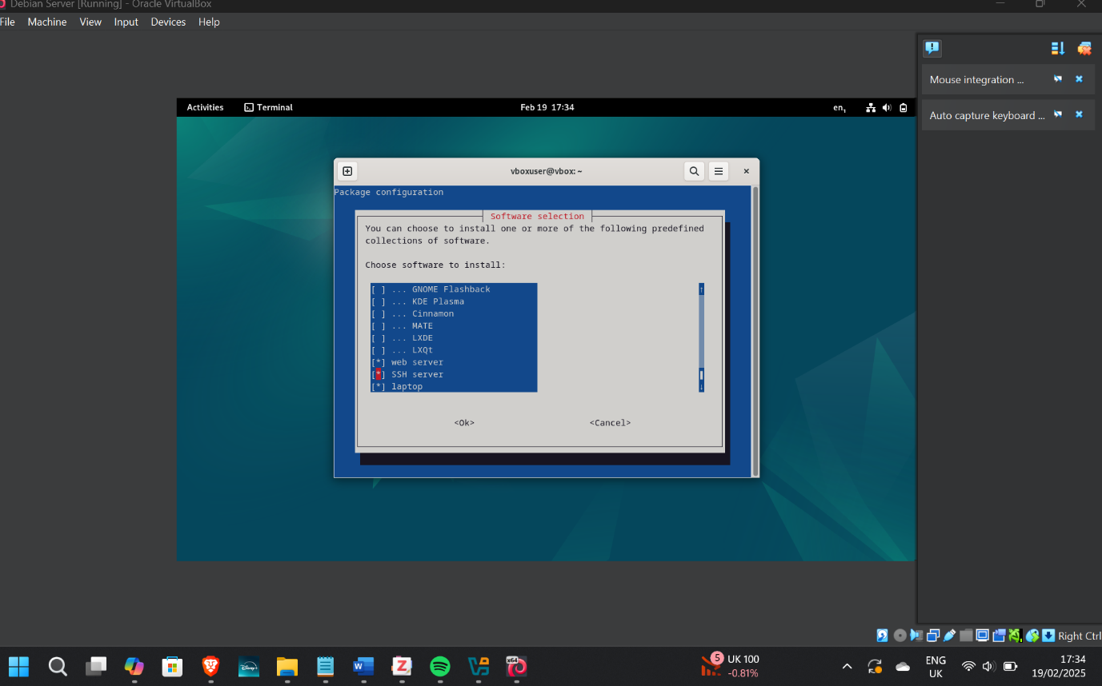

Personal Reflection
The research conducted within this report provided valuable insight into the fundamentals of networking technology, alongside the hosting of a basic network.

References
[1]
A. Blenk, A. Basta, M. Reisslein, and W. Kellerer, “Survey on Network Virtualization Hypervisors for Software Defined Networking,” IEEE Communications surveys and tutorials, vol. 18, no. 1, pp. 655–685, 2016, doi: 10.1109/COMST.2015.2489183.
[2]
Z. Aalam, V. Kumar, and S. Gour, “A review paper on hypervisor and virtual machine security,” Journal of physics. Conference series, vol. 1950, no. 1, pp. 12027-, 2021, doi: 10.1088/1742-6596/1950/1/012027.
[3]
Scsami, CC0, via Wikimedia Commons. Available: https://commons.wikimedia.org/wiki/File:Hyperviseur.svg
[4]
mestew et al, ‘Windows 11 requirements’. [Online]. Available: https://learn.microsoft.com/en-us/windows/whats-new/windows-11-requirements
[5]
‘Guest_OSes – Oracle VirtualBox’. Available: https://www.virtualbox.org/wiki/Guest_OSes
[6]
‘Type 1 vs Type 2 Hypervisors - Difference Between Hypervisor Types - AWS’, Amazon Web Services, Inc. Available: https://aws.amazon.com/compare/the-difference-between-type-1-and-type-2-hypervisors/
[7]
T. Lammle, CCNA Cisco Certified Network Associate Study Guide, 6th ed. Hoboken: Wiley, 2007.
(https://www-vlebooks-com.ezproxy.uwtsd.ac.uk/Product/Index/4137?page=0&startBookmarkId=-1)
[8]
‘An Introduction to Computer Networks — An Introduction to Computer Networks, desktop edition 2.0.11’. Available: https://intronetworks.cs.luc.edu/current2/html/
[9]
‘What is a Switch vs a Router?’, Cisco. [Online]. Available: https://www.cisco.com/c/en_uk/solutions/small-business/resource-center/networking/network-switch-vs-router.html

[9]
associated with work Cisco Networking Academy Program, Routing and switching essentials v6. Companion guide. Indianapolis, Indiana: Cisco Press, 2017.
https://librarysearch.uwtsd.ac.uk/discovery/fulldisplay?docid=alma99100193459702421&context=L&vid=44WHELF_UWTSD:44WHELF_UWTSD_VU1&lang=en&search_scope=MyInst_and_CI&adaptor=Local%20Search%20Engine&tab=Everything&query=any,contains,Routing&pfilter=rtype,exact,books&offset=0
[10]
L. Huawei Technologies Co., Data Communications and Network Technologies, 1st Edition 2023. Singapore: Springer Nature, 2023. doi: 10.1007/978-981-19-3029-4.
[11]
‘What is Routing?’, GeeksforGeeks. [Online]. Available: https://www.geeksforgeeks.org/what-is-routing/
[12]
‘Open Shortest Path First: Definition & Routing Protocol’, StudySmarter UK. Accessed: Available: https://www.studysmarter.co.uk/explanations/computer-science/computer-network/open-shortest-path-first/
[13]
J. M. Stewart and D. Kinsey, Network security, firewalls, and VPNs., Third edition. Burlington, Massachusetts: Jones & Bartlett Learning, 2021.
[14]
M. E. Dooley and T. Rooney, IP address management, Second edition. Hoboken, New Jersey: Wiley, 2021. doi: 10.1002/9781119692263.
[15]
iainfoulds, et al., ‘Active Directory Domain Services Overview’. [Online]. Available: https://learn.microsoft.com/en-us/windows-server/identity/ad-ds/get-started/virtual-dc/active-directory-domain-services-overview
[16]
‘WebServers - Debian Wiki’. [Online]. Available: https://wiki.debian.org/WebServers
[17] ‘Microsoft Azure’. [Online]. Available: https://portal.azure.com

