Component 1 Report: Effective Teamworking for Team Success
Module: BMSW4002
Student: Masuma Begum- 1915403
Lecturer: Dale Clarke
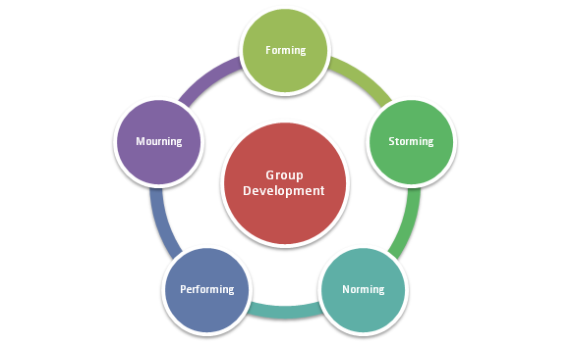

Summary

The purpose of this report is to identify which team model can be used for effective team development. The report discusses the Tuckman’s team development model. Furthermore, the report contains citation from important literature to prove the importance of following a specific team development strategy in order to accomplish an effective team, and in addition the consequence of an ineffective team.

Contents page

Summary 2
Contents page 3
Introduction: 4
Overview of Team working: 5
Models of team development: 6
Team Roles 8
The impact of ineffective teamwork 9
Conclusion 10
References: 11

Introduction:

The purpose of this report is to identify Effective Teamworking for Team Success. This report studies How students can develop an effective team and the impact of effective teamworking can have for the team success, in addition this report explores barriers to effective teamwork, and the types of roles that are needed to create a cohesive and effective team. This report discusses the two teamwork Models, the Tuckman’s model of teamwork development, the Belbin's Team Roles and Effective Team working, moreover this report identifies how these models can be put in place to create effective team working for the team’s success. Team is managerially defined as any group of people who must significantly relate with each other in order to accomplish shared objectives (Robbins, S.P. and DeCenzo, D.A.2005) In other words, a team is a group of people working together to achieve mutual goals. Being in a team does not equate to a total suppression of personal agendas, but it does require a commitment to the vision and involves each individual working toward accomplishing the team’s objective (Greenberg, J., et al. 1996)

Overview of Team working:

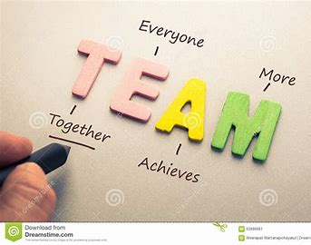

A team is a group of more than 1 individual working together to achieve a goal, this can be at any organisation, for example 3 students working together on a presentation at a university, or you can also define a team as a group of colleagues working together on a project at work. It is crucial for all team members are aware of the objective they are working towards, otherwise the group will fail to achieve their objective. A team is a group of individuals, all working together for a common purpose.
The individuals comprising a team ideally should have common goals, common objectives and more or less think on the same lines. Individuals who are not compatible with each other can never form a team. They should have similar if not the same interests, thought processes, attitude, perception and likings. (Juneja, 2015).
working as a team comes with many challenges, as team members may have different opinions which could lead to conflict, to be able to work as a team to produce effective teamwork, it is important all team members contribute and communicate with each other effectively.
R. Meredith Belbin has written in his book "Teams of able people would not necessarily produce favourable results since the balance might be wrong. on the other hand, a team needed able people in order to succeed. the composition of the team- a subject almost needed able people in order to succeed. The types of behaviour in which people engage are infinite. But the range of useful behaviours, which make an effective contribution to team performance, is finite. These behaviours could be grouped into a set number of related clusters to which the term ‘Team Role’ is applied." (Belbin, 2012) in simple words a team needs to work together, interact and get along with each other to be able to achieve their goal.

Models of team development

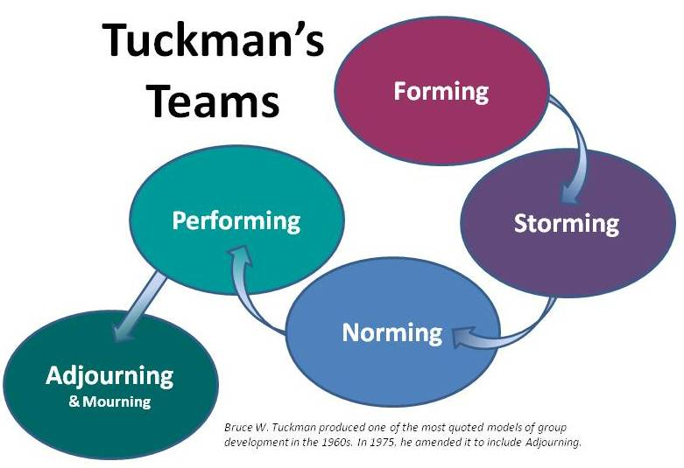

The Tuckman’s model for students to develop an effective team is the most effective model in comparison to any other models. The Tuckman’s model consists of 5 stages, which are FORMING, STORMING, NORMING, PERFORMING, ADJOURNING. The Tuckman’s model is a great way to get any teams to start working effectively.
Here is a breakdown of the Tuckman’s model, and how it can help students to work as a effective team.

1) Forming
The forming stage outlines the point at which everyone has first gotten together. At this point, people are still figuring out the norms of the group and aren’t likely to openly present their new ideas. The great part about this stage is that everyone is on their best behaviour; but as a project manager, you’ve got the big responsibility of guiding everyone in the right direction. You ought to be especially mindful of this during he forming stage so you can kick off your team development on the right foot! (Girdler, 2021)

- During the first stage students may be anxious, as they haven’t fully understood what the team have been formed for- its purpose. Others are simply excited about working in a new team and the challenges ahead. During the forming stage students can get to know each other and discuss about anything they’re not sure of. The forming stage provides the student an opportunity to form a good team.

2) Storming
In the storming stage, people are starting to show their working styles. This might mean that you’ve got conflict popping up, hidden agendas coming to light, and team members challenging the person of authority. As the project manager, it’s your job to call out the ‘elephant in the room.’ And if you want to successfully get your team through this stage, you can’t be afraid to do so! (Girdler, 2021)
- At students’ behaviour towards each other can be assessed, if any students are disagreeing on a topic the conflict will be visible, and the tutor can intervene and resolve the issue.

3) Norming
This stage is exactly what it sounds like: people have gotten past the hiccups and are becoming aware of their own activities. The clouds have parted, so to speak, and people are tackling their own tasks and responsibilities effectively. This means that team members are starting to take ownership of their responsibilities, giving the project manager an easier time with their job of managing. Norming reveals the positives of everyone working together. (Girdler, 2021)
- At the norming stage all the students would have resolved any conflicts amongst themselves, and all the students in the team are all aware of the tasks which of have been assigned to them, and they are ready to proceed with the team task.

4) Performing
Now, we get to the most beautiful part of the team development stages – the performing stage. This stage is great because at this point, everyone is synced. Team members stop thinking of themselves as individuals and start thinking of each other as a collective group, meaning that the team starts acting as one unit and individuals help each other out with things. This is an amazing stage to be in; and if you know how to effectively get through the previous stages, you’ll be able to get here! (Girdler, 2021)
- With all the team members on the right track they have now successfully moved on to the performing stage, they are all ready to get straight on with their task and are all working and communicating amongst themselves.

The last stage in the model is called adjourning, which has to do with closing things off and departing on a positive note. There are many emotions and some complications that can come with this, and that’s why I want you to understand it in detail. There are also some ways you can be creative with it, cultivating an environment where departing the project doesn’t happen hastily. (Girdler, 2021)
If the students successfully complete the stages in order, and reach the adjourning stage, they have accomplished their task as an effective team. When students have completed this stage they have completed the task they were assigned.

Another team model which is very effective is The GRPI Model of Team Effectiveness
The GRPI model was first introduced by Richard Beckhard in 1972 to aid with understanding teams. Following this, doctors Irwin Rubin, Mark Plovnick and Ronald Fry then developed and popularised one of the oldest team effectiveness models in 1977, and it has stuck around for good reason. GRPI is an acronym that comprises the four pillars of the model — goals, roles, processes and interpersonal relationships.
Let’s break it down:
- Goals: There must be clear objectives and intentions regarding individual and team goals, combined with robust and open communication about priorities and expectations.
- Roles: The entire team must have a defined team leader and clear roles and responsibilities. For example, each team should have a project lead as well as individuals who are assigned to roles that match their expertise.
- Processes: Teams need established decision-making and problem-solving procedures, along with clear team processes.
- Interpersonal relationships: Team performance is based on frequent, honest communication, engagement and flexibility between team members.

Team Roles

In any organisation to create a cohesive and effective team it is important to have a procedure in place where the team members are following a certain model, for example following the Tuckman’s model is an excellent way to achieve an effective team. Furthermore, every team member should feel included and communication amongst the team should be precise and clear. “Communication represents the starting point in any activity, so efforts should be made for the communication to take place under optimum conditions, to avoid interference that may arise, and the teams working communication is to be effective and to facilitate achievement goals”. (Gavrilă-Paven, 2017).
Making a great team requires a completely new set of soft skills that don’t come easily. Members have to voice their opinions, deal with aggressive personalities, and work through differences. Above all, members must take personal responsibility for delivering results. So how do you know if your team is working together at a championship level? Smart leaders know that for their teams to work well, they must accurately identify employees’ skill sets and assign them tasks that are well suited to their abilities. When putting together teams, they choose people they sense will work together well. The combined efforts of their team members produce superior results and build a sense of solidarity within their organizations. (Rose, 2021)
In any organisation big or small, in order to achieve effective team work, the team roles should be considered, it is crucial to identify each team members ability and assign them the task they are best at. For example, Team Leadership Is Critical, Teams need a leader to provide direction and move the assigned project forward.
Be Aware of Team Blockers
Inevitably, a team will have a member that may impede group cooperation and may not be committed to the importance of teamwork. Here are a few behaviours that you may see from a blocker:
- Takes up too much space in the conversation
- Is negative about every idea
- Never participates
- Pushes ideas
- Becomes distracted during teamwork
- Attempts to stop progress
If you have a team member that is blocking the progress of the group, it’s important to talk to them about their behaviour. Focus on what you can do to bring them along, rather than push them out of the group (S Meier, 2020)

The impact of ineffective teamwork

The impact of ineffective or poor teamwork can be exhausting for any organisation, especially if one or more team members are not engaging, or not committed to the team. the best solution is to have a conversation with the team and resolve the conflict, so that a bigger problem doesn't arise later. The consequence of an ineffective teamwork can lead to overall financial loss, in addition to that it may even affect another individual’s wellbeing

“Lack of teamwork is at the heart of many workplace issues, according to a review by the Royal College of Surgeons (RCS) that has implications across many different sectors.
The RCS found that, where rare complications occurred in surgical practice, poor teamwork between surgeons was often a leading factor. Its analysis of 100 surgical reviews from the past decade identified poor teamwork as an issue leading to problems in surgery in more than three-quarters (76 per cent) of cases” (Basker, 2019),
Maggie Basker has highlighted in this citation that having an ineffective teamwork amongst surgeons in a surgical practice has led to complications in surgeries, in her research she has mentioned, Professor Timothy Rockall, chair of the RCS Invited Review Mechanism, said that teamwork was an issue because consultants were not meeting regularly to reflect on practice, or tensions between group members had formed due to organisational restructuring.
“It’s vital that surgical teams improve the quality and frequency of discussions about surgical performance, so that problems can be resolved before they affect the safety of patients,” Rockall said.
The review also identified the absence of agreed working practices, such as those governing the handover of patients when on call. Although practices may exist, the RCS found they were not always explored.
More than half (57 per cent) of reviews identified that surgical teams needed to improve multidisciplinary teamworking. The RCS called on surgical teams, NHS leaders and private hospitals to embed strong teamworking skills across all their services. (Basker, 2019), Maggie Basker has proved in her research the importance of having an effective working team, and the consequence of an ineffective team.

“To be effective, teams in the workplace must develop standards and skills, then implement ongoing training and coaching to ensure they are put into practice.
To be successful, teamwork must exist at all levels of the organization, including the very top. The advantages of teamwork on the lower levels of an organization also produce benefits on the top levels. Working as a team should be viewed as a management philosophy that greatly benefits everyone in the organization and your customers”. (Schuck, 2002)

Conclusion

in conclusion to have a team to work effectively to achieve a goal within a deadline it is crucial to introduce a certain policy in any organisation to follow a team developing model, whether it’s a place of work or education for team members to achieve a goal they must go through the norming phase from Tuckman’s team developing model. "The forming stage outlines the point at which everyone has first gotten together. At this point, people are still figuring out the norms of the group and aren’t likely to openly present their new ideas. The great part about this stage is that everyone is on their best behaviour; but as a project manager, you’ve got the big responsibility of guiding everyone in the right direction. You ought to be especially mindful of this during he forming stage so you can kick off your team development on the right foot!" (Girdler, 2021)

overall to establish an effective team, all team members need to be fully equipped with the knowledge needed for their goal, and in addition to that the progress of the team has an impact on every aspect of any organisation. In conclusion to this report we can agree that what Belbin was mentioned in his book is crucial and on point. "Teams of able people would not necessarily produce favourable results since the balance might be wrong. on the other hand, a team needed able people in order to succeed. the composition of the team- a subject almost needed able people in order to succeed. The types of behaviour in which people engage are infinite. But the range of useful behaviours, which make an effective contribution to team performance, is finite. These behaviours could be grouped into a set number of related clusters to which the term ‘Team Role’ is applied." (Belbin, 2012) in simple words a team needs to work together, interact and get along with each other to be able to achieve their goal.

References:

Aritzet, A., Sawiles, S. and Senior, B., 2007. (PDF) Belbin's Team Role Model: Development, Validity and Applications for Team Building. [online] ResearchGate. Available at: <https://www.researchgate.net/publication/4771221_Belbin's_Team_Role_Model_Development_Validity_and_Applications_for_Team_Building> [Accessed 12 October 2021].

Basker, M., 2019. Poor teamwork can have serious consequences. [online] People Management. Available at: <https://www.peoplemanagement.co.uk/experts/research/poor-teamwork-serious-consequences> [Accessed 16 October 2021].
Basker, M., 2019. Poor teamwork can have serious consequences. [online] People Management. Available at: <https://www.peoplemanagement.co.uk/experts/research/poor-teamwork-serious-consequences> [Accessed 16 October 2021].

BELBIN, R. M. M.
Team Roles at Work
"The types of behaviour in which people engage are infinite. But the range of useful behaviours, which make an effective contribution to team performance, is finite. These behaviours could be grouped into a set number of related clusters to which the term ‘Team Role’ is applied."
Belbin, R., 2012. Team Roles at Work. Hoboken: Taylor & Francis.
BELBIN, R. M. M.
Team Roles at Work
"The types of behaviour in which people engage are infinite. But the range of useful behaviours, which make an effective contribution to team performance, is finite. These behaviours could be grouped into a set number of related clusters to which the term ‘Team Role’ is applied."
Belbin, R., 2012. Team Roles at Work. Hoboken: Taylor & Francis.

Robbins, S.P. and DeCenzo, D.A. (2005) Fundamentals of Management Essential Concepts and Applications. 5th Edition, Pearson Education, Inc., Upper Saddle River, New Jersey, 292-295.

Rose, D., 2021. Effective Teamwork: 8 Simple Characteristics of a Great Team. [online] Skillpath.com. Available at: <https://skillpath.com/blog/effective-teamwork> [Accessed 15 October 2021].

Gavrilă-Paven, I., 2017. Effective Team Communication Role in Project Implementation Success. [ebook] Available at: <https://eprints.ugd.edu.mk/18192/1/Proceedings-book-2017.pdf#page=63> [Accessed 15 October 2021].
Girdler, A., 2021. Team Development Stages – Tuckman Model Explained | CornerStone Dynamics. [online] Cornerstonedynamics.com. Available at: <https://www.cornerstonedynamics.com/team-development-stages-tuckman-model-explained/> [Accessed 15 October 2021].

Girdler, A., 2021. Team Development Stages – Tuckman Model Explained | Cornerstone Dynamics. [online] Cornerstonedynamics.com. Available at: <https://www.cornerstonedynamics.com/team-development-stages-tuckman-model-explained/> [Accessed 15 October 2021].

Girdler, A., 2021. Team Development Stages – Tuckman Model Explained | CornerStone Dynamics. [online] Cornerstonedynamics.com. Available at: <https://www.cornerstonedynamics.com/team-development-stages-tuckman-model-explained/> [Accessed 15 October 2021].
Girdler, A., 2021. Team Development Stages – Tuckman Model Explained | CornerStone Dynamics. [online] Cornerstonedynamics.com. Available at: <https://www.cornerstonedynamics.com/team-development-stages-tuckman-model-explained/> [Accessed 15 October 2021].
Girdler, A., 2021. Team Development Stages – Tuckman Model Explained | CornerStone Dynamics. [online] Cornerstonedynamics.com. Available at: <https://www.cornerstonedynamics.com/team-development-stages-tuckman-model-explained/> [Accessed 15 October 2021].
Girdler, A., 2021. Team Development Stages – Tuckman Model Explained | CornerStone Dynamics. [online] Cornerstonedynamics.com. Available at: <https://www.cornerstonedynamics.com/team-development-stages-tuckman-model-explained/> [Accessed 16 October 2021].

Greenberg, J., et al. (1996) Behaviour in Organization. Canadian Edition, Prentice Canada Inc., Scarborough, 294 p.
S Meier, D., 2020. Roles & Responsibilities of Effective Teamwork. [online] Work - Chron.com. Available at: <https://work.chron.com/roles-responsibilities-effective-teamwork-27655.html> [Accessed 15 October 2021].

Schuck, P., 2002. Ineffective work teams - Smart Business Magazine. [online] Smart Business Magazine. Available at: <http://www.sbnonline.com/article/ineffective-work-teams-how-teamwork-impacts-customer-service-quality> [Accessed 16 October 2021].
juneja, p., 2015. Understanding Team - What is a Team ?. [online] Managementstudyguide.com. Available at: <https://www.managementstudyguide.com/understanding-team.htm> [Accessed 12 October 2021].

