

Master of Business Administration
Module name: Human Capital Management

Module code: LCMB7023

Assessment component 1:
The influence of national and international labour markets on HRM and IHRM strategies

Lecturer: Hoang Dang Nguyen

Word count: 2647

Table of Contents
Introduction 3
1. Impact of technological advancements on labour markets, HRM, and IHRM strategies 3
1.1 The changes in the labour market 3
1.2 Implications for HRM and IHRM strategies 4
2. The key demographic and geopolitical factors 5
2.1 Influencing the employment market: Using PESTLE analysis 5
2.2 Challenges for HR professionals 7
3. Addressing persistent skills gaps and talent shortages in critical sectors 8
3.1 The technology sector 8
3.2 Hospitality sector 8
3.3 Healthcare Sector 9
4. Reflective report on current capabilities 10
4.1 Abilities in technology 10
4.2 Communication capacity 11
4.3 Teamwork ability 11
4.4 Leadership 12
4.5 Self-directed learning 13
Conclusion 13
References 14

Introduction
A major evolution has occurred in the Labour market through digital transformation and Human Resource Management (HRM) is currently sharpening the practices to meet the technical requirements. Within the international Human Resource Management (IHRM) the leaders need to focus on both domestic and global markets of labour to recruit the appropriate candidates for their companies. Geopolitical and demographic factors are able to change the practices and create obstacles for HR professionals that need to be addressed efficiently. By overcoming the challenges different industries can improve their ability to operate in the market while ensuring consumer satisfaction.

1. Impact of technological advancements on labour markets, HRM, and IHRM strategies

1.1 The changes in the labour market
The current landscape of employment is evolving day by day due to the growing development of technical solutions. AI, automation, and online platforms are changing jobs and the skills of workers as per the shifting nature of the work processes. With the help of machine learning and its predictive labelled data, more tasks once carried out by people are being done by AI and automation, making them more efficient (Binns, 2018). AI development, cybersecurity, digital marketing, and platform management are new positions which indicate a shift to knowledge-based economies. Changes in labour markets due to technological development include the transformation of jobs, skills, work organisation, and employer-employee relationships, leading to the adjustment of labour policy to ensure an inclusive and fair adaptation of the workforce. The global market of AI is currently $186.44 billion, as the demand for AI-related tools is growing exponentially in various fields (Statista, 2024). There has been a high level of automation in areas like manufacturing, customer service and logistics, which decreases the repetitive labour requirements and enhances the technical expertise required in data analysis. Online platforms are transforming the nature of employment and developing alternative types of job roles. The increased remote and freelance opportunities have been brought on by the emergence of the platform economy, including Uber, Upwork, and food delivery applications (El Hajal and Rowson, 2021). However, the change also disrupts the conventional labour patterns, where workers tend to experience minimal job security, benefits and definite employment rights.
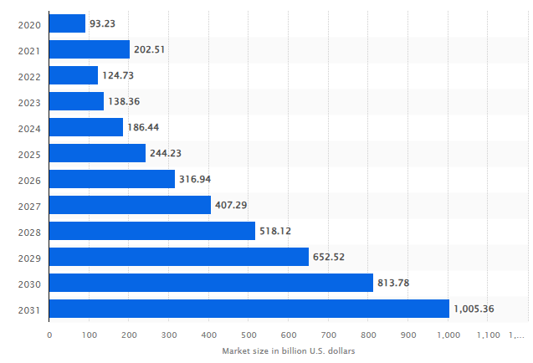
Figure 1: The global market size of AI
(Source: Statista, 2024)

1.2 Implications for HRM and IHRM strategies
HRM and IHRM are greatly affected by the technological development of AI, automation, and digital platforms. In order to fit the contemporary roles of HRM, new skills and methods are required that can align with the data driven and strategically inclined positions. Talent acquisition can be supported by AI-powered HR Analytics as it effectively assesses performance and engage with the workers (Natarajan et al., 2024). With the help of new technologies, the HR department can automatically routine practices while focusing on planning the work force and over all organisational development.
In the case of IHRM, digital technologies help organisations to handle global talent in a more efficient manner. Digital workforce providers have also broadened the global concentration of talent, simplifying the process of recruiting employees worldwide or outsourcing operations internationally (Bhatti, Faqirah and Ullah, 2025). This necessitates the HR leaders to re-architect global workforce solutions, acquire cross-cultural virtual working capabilities, and overcome issues of time zones, communication, and varied expectations of labour. The growth of temporary and remote employment also requires new policies to classify workers, performance management, and the well-being of employees in various countries.
The fast changes of skills imposed by AI and automation highlight the importance of the continuous learning and reskilling approach. HRM should invest in online training, career growth opportunities and change management to equip employees with advancements in technology (Prasad et al., 2024). Moreover, there are ethical implications such as privacy of the information, bias in algorithms and the treatment of temporary workers fairly. HRM and IHRM approaches should hence consider prioritising inclusive digital transformation, global talent agility and human-centred leadership so as to be able to assure sustainable workforce adjustment in a technologically driven period.

2. The key demographic and geopolitical factors

2.1 Influencing the employment market: Using PESTLE analysis
Political effect
The government policies affect the employment patterns by labour laws, immigration, taxation and minimum wages as the stability in politics encourages investment and creation of employment. On the other hand, geopolitical tensions, trade restrictions and change in regulations may destabilize the global labour mobility and adversely influence the organisational planning of the multinational labour force (Chen and Wang, 2024).
Economic factors
Due to poor economic times and high inflation, layoffs and freezing in recruitment would be common, whereas more jobs would be created through positive financial situation. The emergence of the economy and cost-cutting policies has changed the conventional employment relations and made flexible work arrangements more widespread (Heery, 2025).

Social influence
The recruitment and retention practices are affected by an ageing workforce, growing diversity and changing workforce demands with regard to work-life balance and meaningful work. Remote and hybrid work models have altered the work culture and relationships between employees and their employers.
Technological advancement
The development of AI, automation, and online platforms is changing the nature of industries, generating the necessity of new digital skills and decreasing the need in regular labour. AI’s size in the HR market is exponentially growing and at present is at $8.16 billion (Precedence Research, 2024). The use of technology has also made talent more globally accessible and remote working possible.
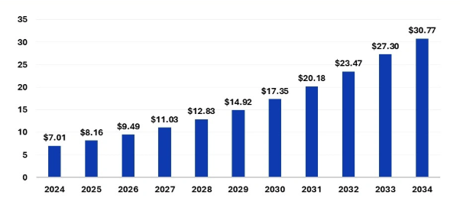
Figure 2: AI in the HR market size
(Source: Precedence Research, 2024)
Legal aspect
The legal considerations of employment, health and safety and data protection evidently influence the HRM decisions (Ebert, Wildhaber and Adams-Prassl, 2021). Regulations regarding the employee rights, equality and contractual practices must be adhered to by organisations, impacting the HR strategies and organisational policies.
Environmental factors
The renewable energy and responsible business practices are creating new employment opportunities in sustainable businesses. The HRM are embracing green practices, which generate the need to acquire green skills and green jobs.

2.2 Challenges for HR professionals
Workforce Transformation and Skills Gap
The swift technology development in AI, automation, and digital platforms is transforming the role of jobs and rendering most of the traditional skills irrelevant. The HR professionals have to solve the increasing skills gap through strategic reskilling and upskilling of employees to suit the changing organisational demands. The change to remote, digital-based workforces also necessitates the redesigning of training, performance management and talent development systems by the HR (Pasagi and Arifin, 2024). On the economic front, unstable market applications and the pressure on costs necessitate the HR to juggle talent expenditures with economic effectiveness. The challenge of ensuring the agility of the workforce and at the same time actively involving and engaging the employees in their work is a highly important issue.
Adherence to Compliance, Diversity and Ethical Practices in Employment
Increased regulatory complexity, such as labour laws, data protection, equality laws, international employment regulations and others, make it harder and harder to conform, particularly when organisations are based in more than one country. Diversity, inclusion and equity can lead to fair employment practices by the HRM as the management navigate through different ethical issues and try to maintain employee wellbeing throughout the recruitment and onboarding process (Armstrong, 2020). The problem is aggravated by managing culturally diverse remote teams and ethical treatment of temporary and contract workers.

3. Addressing persistent skills gaps and talent shortages in critical sectors

3.1 The technology sector
Digital skills supply is habitually less than demand, and this has resulted in a talent war among employers. The HRM can bridge the skill gaps by making investments in continuous learning programs to upskill the employees regarding advanced technical solutions. The management of an IT company should upscale their training programs by collaborating with vocational training firms, offering growth and development opportunities to every employee (Gadre and Deoskar, 2024). Other forms of retention, including flexible work models, work cultures that are innovation-focused, and well-defined career paths, also make the workforce in the tech industry sustainable.

3.2 Hospitality sector
Chronic staffing shortages in the hospitality industry are factors that are fuelled by high turnover, challenging working environments, seasonal changes, and lack of career advancement. After the pandemic, there is a 2.8 million drop in employment in this industry (Cox, 2021). These shortages were enhanced by post-pandemic workforce changes as most workers moved to more resilient sectors. To overcome the skills shortage in hospitality, it is important to enhance employer value proposal within the sector. They require competitive wages, planned career advancement and better working conditions so as to attract talent. Digital customer service, automation of service, cultural awareness, and languages training of employees improve labour capacity and the experience of the guests (Zahidi, Kaluvilla and Mulla, 2024). Partnership with tourism and hospitality institutions to provide apprenticeship, internship and vocational training can help establish a continuous supply of talent. Further, employers should be able to adopt technology to automate some of the routine tasks so that the staff can perform high value jobs which are guest centric and thus enhance job satisfaction and decreases burnout.
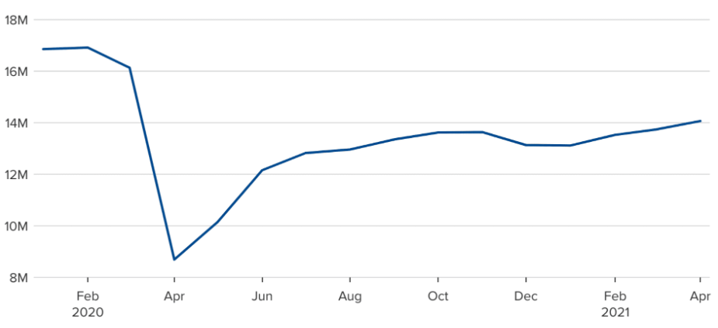
Figure 3: Reduced employment in the hospitality sector
(Source: Cox, 2021)

3.3 Healthcare Sector
The healthcare industry is facing an acute shortage of skills, which is as a result of aging workforce, increased demand of medical services across the world, and extended period of training before medical professions are trained. The pressure increased after COVID-19 as burnout, migration of health professionals, and high demand of patients increased the gap (Gualano et al., 2021). To solve this, a multi-layered approach should be applied to retention, capacity building and international mobility of the workforce. Talent entry can be facilitated by investments in medical education, scholarships, and tracked training programs. Telemedicine, electronic health records (EHRs) and AI supported diagnostics improve Healthcare efficiency and enhance the Patient satisfaction to a great extent. Contemporary Healthcare sector has increased the use of EHRs which has led to $40 billion market size of the technology in 2024 (Stewart, 2024). The workload of the hospital administration is reduced due to the technology-based solutions as they can seamlessly deliver services. Immediate shortages can also be overcome through international recruitment agreements and recognition of foreign medical qualification. To maintain the medical workers with the changing medical technologies and practices, continuity professional development (CPD) programmes are necessary.
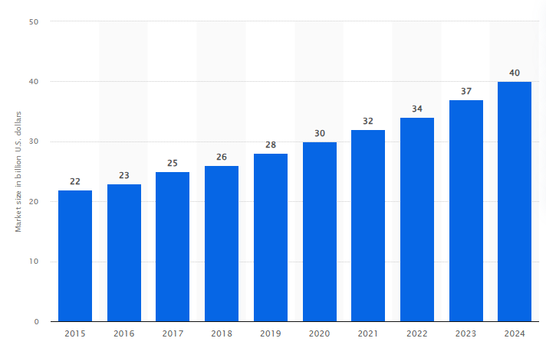
Figure 4: International EHR market size
(Source: Stewart, 2024)

4. Reflective report on current capabilities

4.1 Abilities in technology
I am well-versed with digital teamworking tools, data management systems, and AI-based platforms that are frequently utilized in a global work setting. I am also familiar with remote working software like Microsoft Teams, zoom, and group project management software like Trello and Slack.
Strength
Learning flexibility for digital literacy allows me to be efficient in virtual global work environments as well as facilitate efficient cross-border cooperation.
Weaknesses
Technological fluency in global organisations involves a higher level of digital literacy rather than simple application (Caton et al., 2022). Although I am certain about the daily use of digital tools, I perceive the lack of developed technological competencies, especially data analytics, awareness of cybersecurity, and automation tools.
Addressing areas of improvement
In order to enhance this aspect, I will also take short courses in data analytics and AI applications on such platforms as Coursera or LinkedIn Learning. I will also attend workplace technology training activities to enhance digital confidence and be up to date with technological trends of interest regarding my profession.

4.2 Communication capacity
I have efficient communication abilities which are used to share my ideas to the peers and develop professional reports. The ability helps to establish positive relationships and minimizes the occurrence of misunderstanding when working in a multicultural environment (Armstrong, 2020).
Strength
My cultural sensitivity helps me to participate in diverse group tasks as I can communicate with people coming from different cultural backgrounds and maintain an inclusive environment.
Weaknesses
In particular, my verbal expression in high-stress or international group context cannot be assertive at times. I sometimes feel shy to talk out, particularly when other people control the conversation or when cultural variations dictate communication style to be more aggressive.
Addressing areas of improvement
I will practise structured speaking to the audience using workshops and I will use the think-speak method, which will enhance my assertiveness, making my contributions timely and assertive. Proactive use of clarifying questions and summarisation of important points during discussions will be a way to facilitate better communication in international relations as well.

4.3 Teamwork ability
I embrace diversity with colleagues and promote sharing of ideas. I can be an empathetic listener, respectful of cultural differences and flexible in working styles, which makes the group more united.
Strengths
I am reliable, can work to deadlines, and I can also give constructive contribution to group objectives, making me a reliable team player.
Weaknesses
I tend to have more work than what is required particularly on multicultural teams where I need to be certain that quality work is delivered. This may result in unbalanced distribution of work and the diminishing of a chance of others to contribute which may restrict the collective creativity and shared ownership.
Addressing areas of improvement
I will enhance this by delegating and trusting more effectively through promoting equal participation in the team members. I will apply team charter and effective role assignments to encourage collective responsibility. Requesting the help of peers periodically will also serve as an effective means of refining teamwork strategy and securing an equal contribution (Francis et al., 2025).

4.4 Leadership
My leadership strengths are in the fact that I am able to motivate others, encourage cooperation, and show emotional intelligence. Ethical form of leadership will ensure positive atmosphere, promote innovation and make people feel appreciated (Crane et al., 2016).
Strength
My approach to leadership is transformational style with which, I inspire and empower my peers during group projects.
Weaknesses
However, I lack in prompt decision-making ability when there is a crisis, which delays the mitigation of any issue. I can also tend to be too cautious in giving positive criticism as I am afraid that I would damage professional relationships.
Addressing areas of improvement
In order to develop my leadership capabilities, I will improve the process of decision-making by the use of scenario-based learning and mentoring on leadership. By focusing on constructive feedback, I can become better leader to my team members, helping them to contribute more efficiently to the team for global projects while being respectful.

4.5 Self-directed learning
I have specific development objectives, self-reflect and use various materials to enrich my knowledge. Curiosity and growth attitude allow a person to embrace change and constantly upgrade their skills to make them flexible in changing work environments (Montanari, 2025).
Strengths
I am very active in pursuing learning and am dedicated towards personal development. Peer learning and professional networks help me to maintain my accountability and sharing of knowledge.
Weaknesses
I have the desire to learn but sometimes I have too many learning obligations to do at the same time, this may reduce the focus and completion may be delayed. It is sometimes difficult to balance between the goals of learning and working.
Addressing areas of improvement
I will adopt a systematic personal development process by ensuring that the learning goals are given priority, realistic schedules are developed, and the SMART model is used. I will also promote self-reflection periodically to monitor the progress and revise objectives.

Conclusion
Changes in HRM and IHRM practices consists of digitalisation and ethical actions for the increased productivity and employee welfare. The Healthcare, technology and Hospitality sectors face issues related to skill gaps which are addressed through practical solutions. While working in an international business environment, it is important for an individual to have specific capabilities to handle Technology and team task through proper communication, leadership and learning. One should focus on their strength and identify the areas to improve that can make them better candidates to work in global companies.

References
Armstrong, M. (2020) Armstrong’s Handbook of Human Resource Management Practice. https://e-uczelnia.uek.krakow.pl/pluginfile.php/604792/mod_folder/content/0/Armstrongs%20Handbook%20of%20Human%20Resource%20Management%20Practice_1.pdf
Bhatti, S., Faqirah, M.R. and Ullah, M.S., (2025). The Future of HR: Exploring the Benefits and Challenges of Digital Transformation. International Journal of Engineering, Business and Management, 9(1), p.595779. https://www.academia.edu/download/121905088/6IJEBM_MAR20252_TheFuture.pdf
Binns, R. (2018). 'Fairness in Machine Learning: Lessons from Political Philosophy'. http://proceedings.mlr.press/v81/binns18a/binns18a.pdf
Caton, A., Bradshaw-Ward, D., Kinshuk, K. and Savenye, W., (2022). Future directions for digital literacy fluency using cognitive flexibility research: A review of selected digital literacy paradigms and theoretical frameworks. Journal of Learning for Development, 9(3), pp.381-393. https://jl4d.org/index.php/ejl4d/article/download/818/851
Chen, W. and Wang, L., (2024). The Global Economic Trends and Their Impact on National Economies. International Journal of Accounting, Finance, and Economic Studies, 2(1). https://jurnals.net/access/IJAFES/article/download/7/6
Cox, J. (2021). Restaurants are ‘sucking wind’ but fighting back to reopen amid a worker shortage. [online] CNBC. Available at: https://www.cnbc.com/2021/05/10/restaurants-are-sucking-wind-but-battling-back-amid-worker-shortage.html [Accessed 1 Nov. 2025].
Crane, A., Matten, D., Glozer, S. and Spence, L.J., (2016). Business ethics: Managing corporate citizenship and sustainability in the age of globalization. Oxford university press. https://books.google.com/books?hl=en&lr=&id=fcSbDwAAQBAJ&oi=fnd&pg=PP1&dq=Crane,+A.+and+Matten,+D.+(2016)+Business+Ethics:+Managing+Corporate+Citizenship...&ots=MthdbyoWSA&sig=EO9QyI5EtLg9FCLvs8VmzPX61jE
Ebert, I., Wildhaber, I. and Adams-Prassl, J., (2021). Big Data in the workplace: Privacy Due Diligence as a human rights-based approach to employee privacy protection. Big Data & Society, 8(1), p.20539517211013051. https://journals.sagepub.com/doi/pdf/10.1177/20539517211013051
El Hajal, G. and Rowson, B., (2021). The future of hospitality jobs: The rise of the gig worker. Research in Hospitality Management, 11(3), pp.185-190. https://www.tandfonline.com/doi/pdf/10.1080/22243534.2021.2006938
Francis, N., Pritchard, C., Prytherch, Z. and Rutherford, S., (2025). Making teamwork work: enhancing teamwork and assessment in higher education. FEBS Open Bio, 15(1), pp.35-47. https://febs.onlinelibrary.wiley.com/doi/pdf/10.1002/2211-5463.13936
Gadre, M. and Deoskar, A., (2024). Aligning higher education with industry 4.0: a pathway to achieving sustainable development goals (Sdgs). Madhya Pradesh J. Soc. Sci, 29, pp.233-240. https://www.researchgate.net/profile/Monika-Gadre-2/publication/378876932_ALIGNING_HIGHER_EDUCATION_WITH_INDUSTRY_40_A_PATHWAY_TO_ACHIEVING_SUSTAINABLE_DEVELOPMENT_GOALS_SDGS/links/65f02265286738732d3a9c6b/ALIGNING-HIGHER-EDUCATION-WITH-INDUSTRY-40-A-PATHWAY-TO-ACHIEVING-SUSTAINABLE-DEVELOPMENT-GOALS-SDGS.pdf
Gualano, M.R., Sinigaglia, T., Lo Moro, G., Rousset, S., Cremona, A., Bert, F. and Siliquini, R., (2021). The burden of burnout among healthcare professionals of intensive care units and emergency departments during the COVID-19 pandemic: a systematic review. International journal of environmental research and public health, 18(15), p.8172. https://www.mdpi.com/1660-4601/18/15/8172
Heery, E., (2025). Devolution and industrial relations: An overview. Industrial Relations Journal. https://onlinelibrary.wiley.com/doi/pdf/10.1111/irj.70007
Montanari, S., (2025). Flexibility Competence Assessment: A Systematic Literature Review. Education Sciences, 15(9), p.1118. https://www.mdpi.com/2227-7102/15/9/1118
Natarajan, D.S., Subbaiah, B., Dhinakaran, D.P., Kumar, J.R. and Rajalakshmi, M., (2024). AI-powered strategies for talent management optimization. Journal of Informatics Education and Research, 4(2), pp.1526-4726. https://www.researchgate.net/profile/Sundarapandiyan-Natarajan-2/publication/380277393_AI-Powered_Strategies_for_Talent_Management_Optimization/links/670de1f4fe22924808adaf0c/AI-Powered-Strategies-for-Talent-Management-Optimization.pdf
Pasagi, Y. and Arifin, A.H., (2024, December). The Role of HR Management Practices in the 5.0 Era on Employee Readiness to Change in Realizing the SDGs: A Systematic Review. In International Conference On Research And Development (ICORAD) (Vol. 3, No. 2, pp. 96-107). https://publikasi-adpiindonesia.id/icorad/index.php/home/article/download/266/175
Prasad, D.B., Hamraaia, M.H.Y., Sharma, A., Sahana, B.C. and Pereira, M.C.S., (2024). The impact of technology on human resource management: Trends and challenges. Educational Administration: Theory and Practice, 30(5), pp.9746-9752. https://www.researchgate.net/profile/Muthna-Hamraaia-2/publication/381016944_The_Impact_of_Technology_on_Human_Resource_Management_Trends_and_Challenges_Educational_Administration_Theory_and_Practice/links/6659dac9bc86444c721f392c/The-Impact-of-Technology-on-Human-Resource-Management-Trends-and-Challenges-Educational-Administration-Theory-and-Practice.pdf
Precedence Research (2024). Artificial Intelligence in HR Market Size, Report By 2033. [online] Precedenceresearch.com. Available at: https://www.precedenceresearch.com/artificial-intelligence-in-hr-market [Accessed 1 Nov. 2025].
Statista (2024). Global AI Market Size 2030. [online] Statista. Available at: https://www.statista.com/forecasts/1474143/global-ai-market-size [Accessed 30 Oct. 2025].
Stewart, C. (2024). Total EHR market size worldwide 2024 forecast| Statista. [online] Statista. Available at: https://www.statista.com/statistics/938799/ehr-market-size-forecast-globally/?srsltid=AfmBOopf673tNI9UQ43UrlIXNZEGLY68F5LlUfvVBmuZu6bseuzX52Qg [Accessed 1 Nov. 2025].
Zahidi, F., Kaluvilla, B.B. and Mulla, T., (2024). Embracing the new era: Artificial intelligence and its multifaceted impact on the hospitality industry. Journal of Open Innovation: Technology, Market, and Complexity, 10(4), p.100390. https://www.sciencedirect.com/science/article/pii/S2199853124001847

