

LEVEL 5

SEMESTER 1 & 2

MODULE CODE: SHSS5084
Expedition Skills

aSSESSMENT TYPE: Project
Assessment/Component: 2
COMPONENT WEIGHTING: 70%
WORD COUNT: 5,000 WORDS
MODULE TUTOR: DENISE LEONARD

Expedition Portfolio

Produce a detailed log of the planning for the expedition. This will include comprehensive risk assessments, route plans, emergency procedures, transport arrangements, medical forms, pre-expedition training/ preparation and any other relevant details. Further information related to this assessment can be found on Moodle under Expedition Portfolio Resources as well as on-going tutorial support.

SUBMISSION DETAILS:

Deadline:
Date: 8th February 2019
Time: 3.00pm
Portal: Turnitin

School of Sport, Health & Outdoor Education

Assessment Feedback Sheet

Student No./Name:
Module: SHSS5084
Module Code: Expedition Skills

Personal Evaluation – to support your academic progress please complete the section below BEFORE submitting your work.
What do you consider to be the best aspects of this work? |  |  | I think the best part of my work is the plan of how to achieve my aims, and how the reconnaissance walk aided this planning
Which aspects do you consider could have been improved in this piece of work? |  |  | I think additional route cards, as well as using the handbook, would have added clarity to the plan
What have you found most satisfying whilst undertaking this submission? |  |  | Learning more about English heritage in order to pass on the knowledge to the participants of my expedition
ASSESSMENT CRITERIA | Learning  Outcomes |  | GRADE
ASSESSMENT CRITERIA |  |  | Poor  0 – 25% | Unsatisfactory  26-39% |  | Satisfactory  40 – 49% | Good  50 – 59% | Very Good  60 – 69% | Excellent  70 – 85% |  | Exceptional  86– 100% | %
Produce a well presented and comprehensive expedition planning log with logical format and clarity of purpose | 1,2,4,6 |  |  |  |  |  |  |  |  |  |  | 100%
It is expected that students will present work that is proof read, correctly referenced and adheres to the Assessment Checklist. Therefore a range of 0 – 10 marks will be deducted for non-completion of any of the points on the checklist below.
TUTOR COMMENTS:

Submission date:  via Turnitin |  | Return date:  (at least within 4 weeks) |  |  | Tutor: Denise Leonard |  |  |  |  | Mark:

Assignment Checklist

- Please complete the Personal Evaluation section of the Assessment Feedback sheet, add your name and details, and paste the whole of this assignment document into the front of your assignment

- Submission is a single word file, clearly labelled with your name and module code
- Font style - Times New Roman, size -12 for text and 14 for headings
- Ink colour – black only
- Line spacing – 1.5 line spacing and 2cm- 2.5cm page margins
- Quotations more than three lines to be indented 1 line spacing
- One line space between paragraphs, paragraphs must be left aligned
- Pagination (your assignment should have page numbers)
- All tables and figures are internally referenced and have a title
- Word count checked and written at end of text (before references and any appendix)
- Assignment is within 10% of the word limit (excluding references and any appendices)
- All references in the text are included in the reference list
- Correct referencing following the Harvard style, as described in the Palgrave study skills book ‘Cite them Right’.
- Correct spelling using UK English
- Correct use of punctuation
- Grammar and syntax correct- double check anything that has a green line under it
- I have read my assignment out loud to myself and it makes sense and is easy to read
- Somebody else has read my work and it makes sense to him or her!
- I have checked and I have not plagiarised
Failure to follow these guidelines will cost you marks!
SHSS5084 EXPEDITION LEADERSHIP - Expedition Sign-Off Matrix

Name of Expedition Leader: Imogen Evans

Your Expedition Planning Log is not just a series of lists related to routes, dates and equipment etc. but instead, is a detailed account of your planning process that identifies the range of choices you have considered, as well as the rationales that have informed your decision making.

The titles overleaf form a fundamental matrix on which to base your log. In order for your expedition to be signed off, each title needs to be addressed to a satisfactory level, as deemed by a member of module staff.

Failure to address all of the titles overleaf to a satisfactory level will result in the expedition being cancelled, or deferred until the appropriate planning and preparation has been undertaken.
Statement of Expedition Readiness

I agree that all the titles noted overleaf have been completed and that my expedition is ready to proceed. I also agree to undertake my expedition in accordance with any specific safety conditions noted by the module tutor.

Expedition Leader
Signature: Date:

Expedition Approval

To the best of my knowledge all the necessary safety checks noted overleaf have been completed and the expedition is ready to proceed.
Specific safety conditions governing the undertaking of the expedition are noted below:
1.
2.
3.
4.
5.

Module Staff
Signature: Date:
TITLE | INITIAL | DATE
Expedition Overview
Aim & Objectives
Expedition Leader Profile
Competencies / Qualifications
Expedition Assistant Leader Profile
Expedition Team Profiles
Expedition Support Person
First Aid Provisions
Medical Declaration Forms
Assumption of Risk Forms
Behavioural Expectations
Individual Kit List
Group Kit List
Equipment Request Form
Preparatory Training Undertaken
Reconnaissance of Expedition Route
Campsites
Route Cards
Escape Routes
Contingency Planning
Weather Forecast Sources
Contact With Landowners
Generic Risk Assessments
Site Specific Risk Assessment
Roadworthiness of Vehicles
Drivers Licences
Drivers Insurance
Important Contact Details
Accident Emergency Procedures
Expedition Contact Details

Expedition Overview

Over the course of my three day expedition we will be covering 39.5km on foot along the Shakespeare Way, starting in Brightwell Baldwin and coming down through the Chilterns to finish in Marlow. It is not a physically demanding walk but the route we are going to take passes through some of the most beautiful English countryside and manor house grounds. I will run my expedition beginning on the 12th April and arriving at our end point on the 14th April 2019.

On day one we will travel to England in the early morning and complete the first and shortest leg of our expedition, walking from Brightwell Baldwin to our first campsite in Watlington, 7.5km away from the start of this day. This allows plenty of time to travel to England, get going and have plenty of time to set up camp as I am expecting it to take longer than usual as it’s the first night. Along this section we will see very typical English countryside and have chance to talk about the significance of this route. Once out of the village of Brightwell Baldwin we begin to see view out across the rolling hills of the Chilterns, listed as an AONB because of its rich history and stunning landscapes.

Day two will start at the campsite, walking about a 1.5km back to the waymarked path before setting out on our longest day of walking, travelling 18km to a campsite in Pheasants Hill. This section sees us walking through the Chilterns, but also through manor house grounds, such as the ones we pass at Stonor House. This day will be the most physically demanding, but with an easier day either side I am confident that it is manageable for all abilities within the group. Passing through the grounds of Stoner House will open discussions about English wildlife and native flora. It is important to note the amount of red kites seen in this area specifically, and discuss their reintroduction to the English countryside after hunting almost extinct them.

On the final day of the expedition we will walk the last 14km to our end point in Marlow. Points of interest over this stretch of the expedition are the farmland we pass through and Marlow common, where there are still trenches left from WW2 training. There are also multiple signs and information boards with information about the Shakespeare Way which we will take in. I feel it is a site that is so commonly overlooked, but played a huge part in the British success at war and should therefore be celebrated as such.When we reach our end point there are shops and facilities in the town so we will be able to prepare for the drive back to Wales. We will get back to Carmarthen late in the evening and that marks the end of the expedition.

As I am driving to the start point of the expedition I have arranged for us to be transported back there from Marlow at the end as it is quite a remote location and we would not be able to get back there using public transport.

Aims and objectives

The main aim of my expedition is for the group, consisting of non-English students, to gain an appreciation of English culture, heritage and history. By walking part of the Shakespeare Way I will be able to convey knowledge and discuss ideas with the group in some of the most typically beautiful scenery England has to offer. I also go with the aim to encourage the group to find enjoyment in nature and inspire further participation in outdoor pursuits.

By walking the Shakespeare way we will be able to talk in depth about the influence Shakespeare had not only on literature, but on the English language as well. There are information points along the trail, but in addition to this I have a guide book filled with important points of the journey, as well as interesting facts and sites of interest. Using this, along with other resources such as songs and poetry to be shared at the campsites, and my own knowledge I will be able to give the group a real insight into not only Shakespeare, but how he impacted on English heritage and culture.

As well as this, we will talk in detail, especially on day 2 of the expedition, about the impact people have on nature and the environment and, as a result of this, the importance of AONB’s being protected. This will not only enrich understanding of sites in England, but across England and Wales and has the potential to inspire exploration of other national parks back in Wales.

Expedition Leader Profile – Competencies and Qualifications

Name | Imogen Evans
Mobile number | 07429 686697
Address | 42 Parcmaen Street, Carmarthen, SA31 3DR
Next of Kin | Maria Evans – Mother  07414 713339
Medical conditions | N/A

My expedition will take place in lowland terrain, and whilst I do not currently hold my Lowland Leader qualification I have completed the training, as well as having gathered together logbooks of lowland day walks. These walks have been at a range of locations across the UK where I have been able to improve my map reading skills to a high level where I would say I am very competent to navigate using a map and compass. Although qualifications are a clear cut way to define competencies, it was suggested by Ewert (1989, pg. 194) that “certification is but one way of proving competence”, and I completely agree with this. By keeping DLOG’s (digital logbook) on the Mountain Training site I am able to prove my experience and competencies. I also achieved the bronze DofE award, completing an expedition with similar conditions, duration and terrain as this and having to navigate using maps and compasses. This was one of my first experiences of a short expedition, and since I have been on many more including with friends, parents and university.

I am level three outdoor first aid qualified, and so is my assistant leader. This means in emergency situations we will be prepared and able to give medical assistance if required. It is vital that all group members carry a personal first aid kit with them, even if they have no first aid qualifications.

Although this is the first time I have organised and planned an expedition of this nature I have put in place relevant precautions to ensure the safety of myself and the group. I have done a full reconnaissance of the expedition with friends as if I were leading it. Not only am I now fully familiar with the route, but I have the confidence to lead another group. I have spent days out working on my navigation in all conditions, so I am completely prepared and certain of my skills. Lastly I am taking an assistant leader on my expedition who is at the same level of skill as me, so if I am unsure he can back me up and support with my leading.

Through the process of gathering this experience, I have also picked up and researched a lot of information regarding the countryside code, as well as having a cemented understanding of OS maps and their symbol. The Countryside Code sets out the rules and guidelines for walkers and groups out in the country side, as well as looking at camping restrictions and some relevant legislation, such as the CRoW act (2000) stating out clearly the publics rights and restrictions to walking in the countryside. This wider knowledge enables me to be certain that the route I have mapped out is within the rights of walkers. Knowing and being familiar with the OS maps and all of the symbols put me in a better position to adapt plans and routes and find alternate exits if needs be. This is a reassurance that I am competent to lead this expedition, despite my lack of actual qualifications.

Expedition Assistant Leader Profile

Name | Samuel Sharp
Mobile number | 07572 127077
Address | 42 Parcmaen Street, Carmarthen, SA31 3DR
Next of Kin
Medical conditions | N/A

I have chosen Sam to second my expedition as I have been out and seen his expedition skills and am confident that he is of at least a similar level/standard to me. Like me, he has completed the Lowland Leader training and is collecting more DLOG’s before being able to complete the assessment. I trust him to make informed decisions regarding the safety of the group should he need to.

Expedition Team Profiles

These team expedition profiles are to be completed upon conformation of participants, along with a full medical form, the assumption of risk form and their full contact details.

Name
Mobile Number
Address
Next of Kin
Medical conditions

Name
Mobile Number
Address
Next of Kin
Medical conditions

Expedition Support Person

I have chosen Maria Evans as my support person. This is because she is available for the dates of my expedition, she lives within a 45min drive from the furthest point in my expedition and also because she is familiar with the expedition route as she walked my reconnaissance with me. This makes her the ideal person to support my expedition.

Name | Maria Evans
Contact number | 07414 713337

First Aid Provisions

As group leader I will carry a lifesystems mountain leader first aid kit, contents listed in appendix A, as well as a group shelter big enough for the group. This first aid kit is comprehensive in its supplies and is highly regarded in the outdoors. Each group member will carry a personal first aid kit, see appendix B, which I will ensure they have when I do a kit check the week before the expedition. I recommend using the lifesavers trek first aid kit, but it is also okay if they use the list I have provided to make their own. As I said previously I am level 3 outdoor first aid qualified, as is my assistant leader so I am confident that first aid could be administered properly.

Medical Declaration Forms

A blank copy of the medical declarations form can be found in appendix C. Each participant will fill this out prior to the expedition.

Assumption of Risk Forms

A copy of the assumption of risk form can be found under appendix D. As with the medical declaration form, every participant will sign this form before we leave for the expedition.

Behavioural Expectations

While out on the expedition we will be representing the university, and it is vitally important that the group are aware of this. In order to maintain a high behavioural standard, each participant will sign the behavioural expectations form (see appendix E). In doing this, the members of the group are agreeing to a certain standard of behaviour. This will ensure a pleasant, enjoyable and safe expedition for everyone, not just the participants. Without signing this document the participant will not be allowed to come on the expedition and breaching the rules set out in it will result in consequences.

Individual Kit List

I will provide each participant with an individual kit list, this way ensuring that they are all fully prepared. There is a copy of this as appendix F. I have actually used the recommended DofE kit list, as I feel it covers everything the group may need for this expedition, without bringing unnecessary items that are going to weigh down the bags. I will do a kit check a week before we go, in which time we will also look at the most effective way to pack a bag as well as identifying any kit the participants still need to get or that needs to be signed out of stores.

Group Kit List

As with the individual kit list I have used the DofE group kit list as the basis for the list I am going to give to the participants. Again all of this kit will be checked prior to the expedition day. A copy of this list can be found under appendix G.

Equipment Request Form

A copy of the equipment request form is below (appendix H) which will be completed before the expedition.

Preparatory Training Undertaken

In preparation for this expedition I am going to have 4 meetings with the group, which will be as follows:
- “Get to know you” session where we will meet on campus for a coffee and a chat to introduce everyone, and to lay out the aims and requirements of the expedition. It will be important to make sure the participants are fully aware of what they are signing up for.
- Planning and equipment – during this meeting I will lay out the route for the participants and explain the aims and objectives. I will also use this as an opportunity to give out kit lists as well as ask participants to sign all of the necessary forms and documents.
- The third meeting we will go for a walk, ideally down to Llanstefan from Cynefin. Through doing this I will be able to see everyone’s ability, and see how the group interacts with each other whilst out walking. I will also be able to give tips and advice about walking in the countryside.
- This will be 1 week before the expedition and will consist of kit checks, signing out kit from stores and bag packing. We will also talk in detail about the best food and snacks to take on the expedition.
Having been through these four meetings the group will have bonded, and I will be well informed as to the ability and personalities of each member of the group. It will also give me chance to make any changes to the expedition to better cater to any needs the group may have.

Reconnaissance of Expedition Route

I completed a reconnaissance of my expedition route prior to any of the detailed planning. This enabled me to have a clear picture of elements I have spoken about now, and also meant I could check out the campsites and also carry out a site specific risk assessment.

Whilst doing the reconnaissance I was able to further my knowledge about the history and culture that surrounds the walk. I was able to take not of any points of interest, such as Stonor House which is over 850 years old and is one of the oldest houses that is still lived in. The history around the house can be discussed whilst walking though the estate with views down onto the house. So following on from that, completing the walk has enabled me to gather the information I need to fulfil my aims and objectives.

Checking the campsites was important, as it means I know what facilities the camp sites have and how to get to them from the waymarked path. It also meant I could plan what we are going to do and discuss when at the campsites and means I could structure evenings to better achieve the goals of my expedition.
Lastly the site specific risk assessment was vital in the planning of this route. According to Priest and Gass (1997, pg. 121) A reconnaissance walk “decreases your chances of getting lost, increases the quality of your decisions, enhances accident response”. This ties into the site specific risk assessment as it meant I could practically eliminate the chances of getting lost and I am now familiar with the surroundings so if there was an incident I know where my exit points are.

Campsites

The two places we are camping are both designated camping sites. I chose this over wild camping as here are very strict rules in England about wild camping, involving acquiring permission from the land owner. To avoid any incidents I decided it was best to stay at designated camp sites. These campsites are as follows:

Day 1  White Mark Farm  82 Hill Road  Watlington  Oxfordshire  OX49 5AF  Contact no: 01491 612295  Price: £8p/p each night | Day 2  ‘Pheasants Hill’ campsite  Pheasants Hill  Hambleden  Buckinghamshire  RG9 6NQ  Contact no: 07984274849  Price: £5p/p each night

Route Cards

Route cards are a really good tool to use on expeditions as they highlight tricky parts in the route and points where particular caution or attention is needed, as well as being able to estimate timings. I have not created route cards in the conventional sense, but instead have a detailed guide book with directions clear enough to follow without an OS map (although I will of course take maps and compasses with me). I have included pictures of the pages of this guidebook in appendix I, which contains maps marked with distance in miles and key points of interest along the route, as would be written on a route card.

I will give copies to each member of the group as well as making them readily available for my expedition support person. This way if at any point things go wrong the route cards will act as a guide as to where we should be. They are another safety measure put in place to ensure the safety of the group.

Escape Routes

My expedition route follows a waymarked footpath for the entirety of the journey, which means that at any point along the expedition I won’t ever be more than 3km from a road or exit point. The escape plan is that if we do need to get out, I will locate our exact location on the map and navigate to the closest exit point. This also falls within the remits of the lowland leader award which, although I don’t have yet, I have done all of the training for, meaning that I will be able to successfully manage any situation and fell confident knowing that its within my capabilities.

Contingency Planning

Being such a well maintained path there are no weather conditions that would result in having to call off or change the expedition. This is because it is up on higher ground, so flooding is not an issue and going in April there won’t be any snow or winter conditions. Driving two and from Wales, however, poses more of an issue in the event of a breakdown. If we do breakdown, my expedition support person (in England) or my back up support person (in Wales) will come and pick us up and take us back to Carmarthen. My car is key in the smooth running of the expedition, and if it did breakdown would cause us to postpone the expedition, finding new dates that suit everyone.

Weather Forecast Sources

At this current point, 2 months before I run my expedition, there will be no weather forecast that will be accurate or even correct. Therefore I will be checking the weather forecast closer to the time, starting two weeks in advance monitoring the pressure systems and reading the updates to ensure the group and I are as prepared for the weather conditions as possible. When I do look at the forecast I will not just use one site, but a number of them and pool them together to come up with my own forecast. The first site I will go to is the MET office. They offer detailed and supposedly accurate forecasts for specific regions, perfect for getting a three day report before we head out. I will also use a site called windy.com as comparing and contrasting forecasts is vital in being as well prepared as possible.

Contact with Landowners

The whole of my expedition route follows public footpaths, and we are staying in campsites so there is no other need to contact landowners. I am yet to book the camp sites as I am waiting for conformation from the participants. As soon as I have confirmation of booking it will go in my expedition plan.

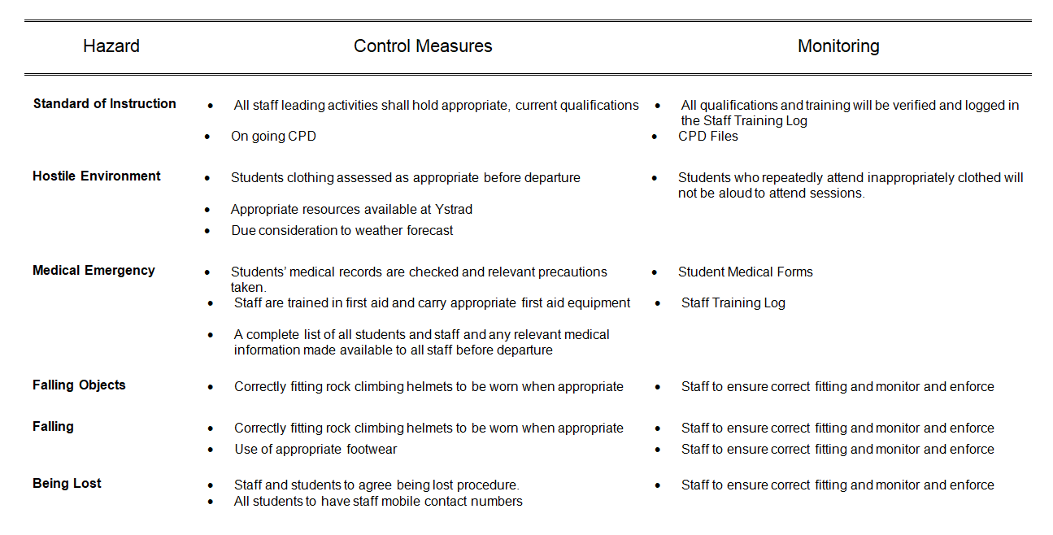
Generic Risk Assessment

Generic Risk Assessments are vital for any activity in the outdoors, and they point out common hazards when, in this case, walking anywhere. Not only is the control measure important for avoidance, but it is also important to monitor the situation afterwards and be aware of any ongoing hazards. It is also important to note that on its own, a generic risk assessment can only prove so useful. When taken in conjunction with a site specific risk assessment we get the best possible information about every hazard we will encounter along the way.

Site Specific Risk Assessment

Hazard | Control Measures | Monitoring
Crossing B4009 | Be especially careful crossing roads. Cross as a group | Ensure there is an understanding of road safety
Crossing B481 | Be especially careful crossing roads. Cross as a group | Ensure there is an understanding of road safety
Exposed tree roots | Take care when walking along the overhung bridleway
Walk along B480 | Orange hi-viz jackets  Walk towards the traffic
Deer gates at Stoner House | Take off rucksacks as gate is too small to fit through | Avoid rips and snags, be careful with all equipment
Narrow overgrown paths | Be aware of low hanging branches and brambles and warn group if found
Electric Livestock fencing that is barely visible | Some of the fencing used by farmers is thin and green so is almost impossible to spot. Stay well away from electrified fencing
Barber wire fences | Avoid fencing | Check equipment for tears or snags
Fallen trees on Marlow Common | Be aware of hazards on the ground and of potential falling hazards
Grazing animals and livestock | When passing through fields of horses take a wide berth around them, leaving at least 3m between you and them | Ensure you’re not being followed and make sure gates are all shut.

I compiled this site specific risk assessment whilst out on my reconnaissance walk, making sure to take pictures of major hazards. It is vital to know about the site you’re walking at in order to prepare the group as well as possible and to lower risk of incidents. I feel this risk assessment is comprehensive in its findings and therefore allows us to prepare properly for the expedition.

Roadworthiness of Vehicles

We are using my car, MJ59 LKU, to get to and from the expedition. My car recently passed its MOT (see appendix J) and is in good working condition. The day before we leave I will check tire pressure, oil levels and other basic checks to ensure it is safe. My car is also taxed.

Drivers Licence

I have a full clean drivers licence. Evidence of this can be seen in Appendix K.

Drivers Insurance

I am fully insured to drive my car so there are no issues with transport to and from th start and end of my expedition.

Important Contact Details

Name | Contact
Tom Moore | 07794 445535
Graham Harvey | 07896 431200
Denise Leonard | 07956 835785
Sian Davies | 01267 225187

These contact details, along with my number and Sam’s number will be giver to each member of the group to be used in an emergency.

Accident Emergency Procedures

SHSS5084 EXPEDITION LEADERSHIP
Accident and Emergency Procedures

Accident and Emergency Procedures relate to the need to deal with any event throughout the duration of your expedition, in which a physical injury occurs to any expedition team member.

You are expected to deal with accidents, to the best of your abilities, and within the recommendations and remit of your first aid qualification. Where recruitment of further assistance (Emergency Services) is essential, you are required to inform a member of module staff, as soon as possible.

If it is necessary to send an expedition member to hospital, you must ensure that at least one other member accompanies the injured party.

To facilitate the processes outlined above, it is essential you complete the following, specific to your expedition:

Emergency Information:

Local Hospital:
Name: Wexham Park Hospital
Address: Wexham street, Slough, SL2 4HL
Tel: 01753 633000
A&E: Yes

Local GP Service:
Name: Rosemead Surgery
Address: 8A Ray Park Avenue, Maidenhead, Berkshire, SL6 8DS
Tel: 01628 622023

Local Dentist:
Name: Linden Dental Surgery
Address: 20 Linden Avenure, Maidenhead, Berkshire, SL6 6HB
Tel: 01628 621810

Media Guidance
If at any point during your expedition, the media approaches you, please adopt a “No Comment” response and refer them to a member of module staff.

Expedition Contact Details

SHSS5084 EXPEDITION LEADERSHIP
Expedition Team Contact Details

Expedition Leader:
Name: Imogen Evans Number: 07429 686697

Expedition Assistant Leader:
Name: Sam Sharp Number: 07572 127077

Expedition Support Person:
Name: Maria Evans Number: 07414 713337

Expedition Team Member:
Name: Number:

Expedition Team Member:
Name: Number:

Expedition Team Member:
Name: Number:

Expedition Team Member:
Name: Number:

Expedition Team Member:
Name: Number:

Expedition Date: 12th-14th April 2019
Venue: Chilterns, Buckinghamshire

Campsite 1 Date: 12th April
Location: White Mark Farm

Campsite 2 Date: 13th April
Location: ‘Pheasants Hill’ Campsite

References

DofE online, available at https://www.dofe.org/shopping/dofe-expedition-kit-list/ (Accessed: 23rd January 2019)

Ewert, A. (1989). Outdoor adventure pursuits. Columbus, Ohio: Pub. Horizons, p.194.

Priest, S., & Gass, M. (1997). Effective Leadership in Adventure Programming. Champaign, IL: Human Kinetics, p. 121

Shakespeare’s Way; a journey of imagination (Edition no. 4 – spring 2014) The Shakespeare
Way Association

Appendicies

Appendix A.
General
1 x Primary Care Leaflet
1 x Tweezers
6 x Safety Pins
1 x Scissors 5.5cm Blade
4 Pairs Vinyl Gloves
1 x Shears 6cm Blade
1 x Glo Stick
1 x Resuscitation Face shield
1 x Spot Check Thermometer
Medication
16 x Paracetamol Tablets (not included in EU kit)
16 x Ibuprofen Tablets (not included in EU kit)
Bandages
2 x Open Woven Bandages 7.5cm x 5m
1 x Crepe Bandage 5cm x 4.5m
1 x Crepe Bandage 7.5cm x 4.5m
1 x Triangular Calico Bandage 90 x 127cm
Preparations, Disposables & Tapes
10 x Hygienic Cleansing Wipes (11 x in EU kit)
1 x Micropore Tape 2.5cm x 5m
1 x Zinc Oxide Tape 2.5cm x 2m
1 x Duct Tape 2m Roll
10 x 4-Ply Gauze Swabs 5 x 5cm
3 x Burn Gel Sachets 3.5g
Dressings
1 x Pack of Assorted Plasters
1 x Medium Wound Dressing 12 x 12cm
2 x Low Adherent Dressings 5 x 5cm
2 x Low Adherent Dressings 10 x 10cm
1 x Small Plaster Fabric Strip 4cm x 1m
1 x Large Plaster Fabric Strip 7.5cm x 1m
6 x Wound Closure Strips (9 x in EU kit)
1 x Small Eyepad Wound Dressing
2 x Blister Plasters

Appendix B.
Primary care leaflet
Vinyl gloves
Small crepe bandage
Micropore tape
Blister plasters
Paracetamol
Small low-adherent dressing
Woven bandage
Gauze swabs
Fabric plasters
Antiseptic wipes
Scissors, tweezers & safety pins

Appendix C
SHSS5084 EXPEDITION LEADERSHIP
MEDICAL DECLARATION FORM

Please complete this form as accurately and truthfully as possible. The information you disclose will be confidential and will only be used to help the expedition leaders respond to an injury or illness.

Name: _____________________________________________ D.O.B.:______________________

Address: ________________________________________________________________________

________________________________________________________________________________

Mobile Number: __________________________________________________________________

Next of Kin/Guardian Name: ________________________________________________________

Next of Kin/Guardian Contact Number: ________________________________________________

If you answer yes to any of the following questions, please give brief details in the space provided.

1. Do you currently suffer from any physical or psychological medical conditions/ailments?
________________________________________________________________________________

2. Are you currently taking any form of medication?
________________________________________________________________________________

3. Do you have any form of allergy?
________________________________________________________________________________

4. Do you currently have any injuries or ailments?
________________________________________________________________________________

5. Do you have history of any physical or psychological medical conditions, injuries or ailments that may affect your participation in any aspect of the programme?
________________________________________________________________________________

If you have answered yes to any of the questions above, please use the space provided on the back of this sheet to give further details, and ensure you discuss this with the expedition leaders.

I declare that the information on this form is as accurate and truthful as possible.
I acknowledge it is my responsibility to keep expedition leaders informed of any information stated here in, or changes to this information, that may affect my participation in the expedition.

Signature: _________________________ Date: __________________

Please use the space provided below to expand on any of the information you have given overleaf.

Appendix D.
SHSS5084 EXPEDITION LEADERSHIP
ASSUMPTION OF RISK FORM

(Please read this document carefully)

Expedition’s that are run as part of module SHSS5084 Expedition Leadership inherent in the Outdoor Adventure Education programme at the University of Wales: Trinity Saint David, can take place both at day and night and in different environments, which might be considered remote or hostile, often without easy access to advanced medical or other facilities.

I (full name) ________________________________________ ____________
acknowledge and accept that participation in an expedition of this nature entails both known and unanticipated risks, which could result in damage to my property, physical or emotional injury, paralysis or death. I understand that such risks cannot be eliminated without jeopardising the fundamental qualities of the expedition. By participating in this expedition I accept these risks and take responsibility for my own actions and involvement.

I accept the fact that I have a personal duty and responsibility to learn and to follow safety guidelines and procedures established by the expedition leaders:
Expedition Leader: _____________________________________________________
Assistant Leader: _____________________________________________________

I undertake to inform those named above, at any point during the expedition process, should I not understand what is expected of me or should I not wish to further participate in the expedition. However, due to the venues being used, I understand that it might not always be possible to simply stop or withdraw immediately from the expedition.

I am physically and mentally fit to participate in this expedition. I have completed a medical form that is accurate and true. I agree to notify the expedition leaders of any changes to my health or fitness. If I become ill or injured I give my consent for first aid to be administered and for provision of other medical treatment or rescue services as required.

Signed: ________________________________ Date: _____________________

Appendix E.

EXPEDITION BEHAVIOURAL EXPECTATIONS FORM

I, ………………………………………… (participant) understand that in signing this document, I agree to abide by the behavioural rules set out below. I acknowledge that I am representing the university and will uphold its reputation at all times.

- All participants will be respectful of the environment and any land we pass over
- All participants will keep to designated footpaths
- All instructions given by your expedition leader will be followed with the knowledge that it is for your own safety
- No participant will leave the group without the permission of the expedition leader
- All rubbish will be taken home or binned at camp sites
- No participant will consume alcohol or illegal substances while on the expedition
- The countryside code and campsite rules must be followed at all times
In signing this document you agree to the behavioural expectations set out above, and understand that breaching any of these rules could result in being dropped from the expedition immediately.

Name ……………………………………….

Signed ………………………………………

Date ………………………………………..

Appendix F.
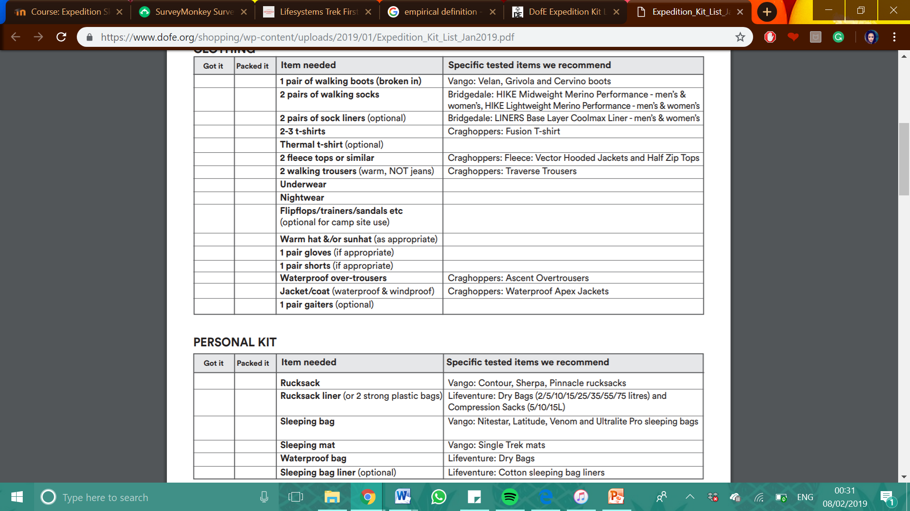

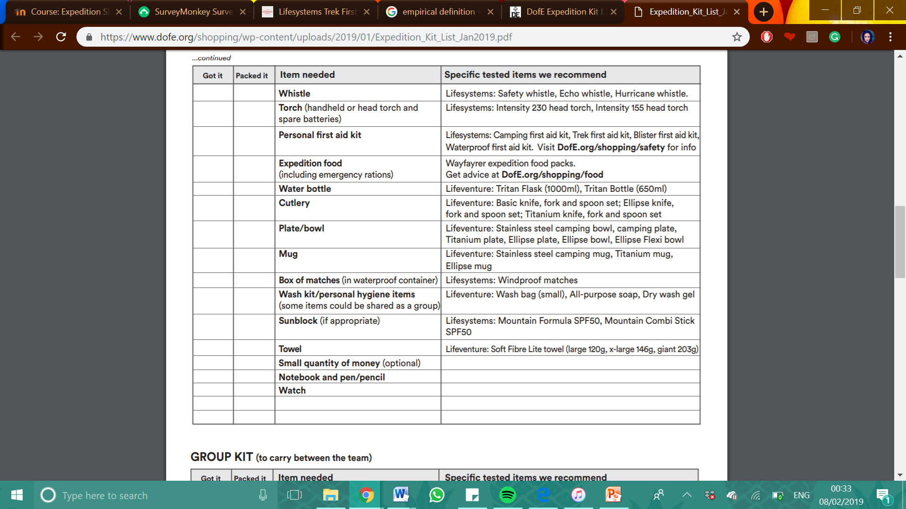

Appendix G
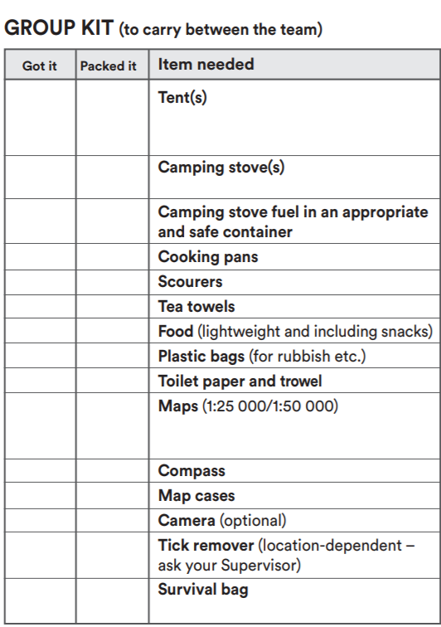

Appendix H.
SHSS5084 EXPEDITION LEADERSHIP
Equipment Request Form

Name:

Dates of Expedition:

Date of collection:

Date of Return:

Item/s | Serviceable check or | Date of Return
I have checked and agree that all the equipment is complete and serviceable.
Signature:
Date:

Appendix I.

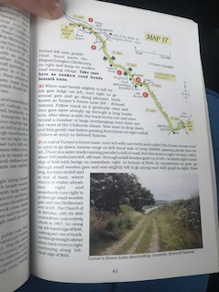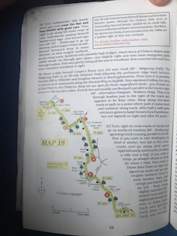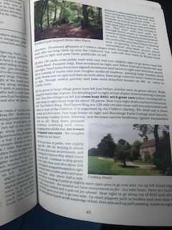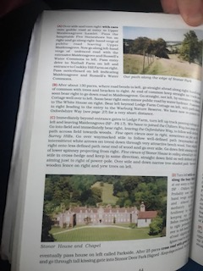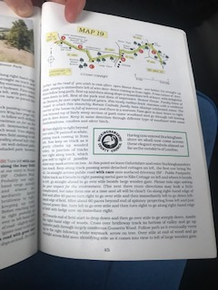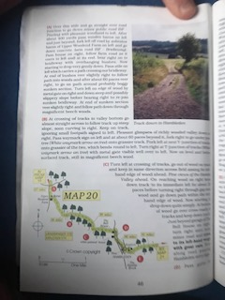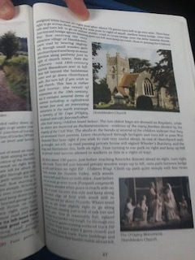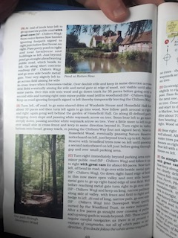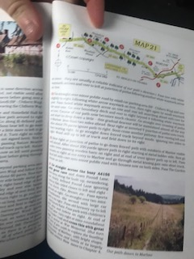

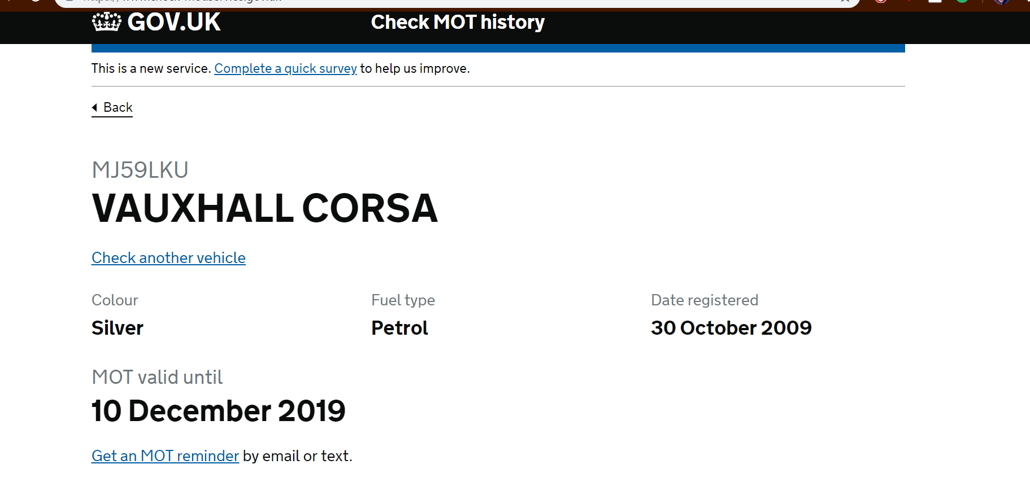
Appendix J.

Appendix K.



