Student name: Hanim Slim
Student ID: 1914720
Lecturer name: Julius Azasoo
Module code: BMSW4004
Module name: Addressing the problem of staff shortages in Proper Care, UK

Addressing the problem of staff shortages in Proper Care, UK
Table of Contents
Introduction 1
Definitions 2
Background (identifying the problem): 2
-Research: 3
Pestle analysis 3
SWOT analysis 3
- Fishbone diagram 4
Solutions: 4

Introduction

In this essay, the problem of staff shortages and how to solve it will be discussed. According to The Guardian newspaper, The British Health National Service (NHS) is facing a deepening staffing crisis, with the number of unfilled posts across health services in England rising to 110,192, the shortages include 39,652 nurses and 8,158 doctors. The nursing shortage is one of the biggest problems for UK hospitals. This suggests that if this huge problem wasn’t addressed as soon as possible the UK’s population will be in danger of not finding a doctor to treat their illness and it’s already happening in some cases that require difficult and long-term treatments. Therefore, management must know what motivates nurses to stay. And from that point of view, many hospitals carry out retention or exit surveys to understand the causes of leaving.

Definitions
1. Problem-solving: It is known as the process of finding solutions to difficult or complex issues.
2. Decision making: the process of making choices by identifying a decision, gathering information, and assessing alternative resolutions.

Background (identifying the problem):

The NHS is on the brink with too few nurses, midwives, GPs, hospital doctors and mental health workers. That is because staff are leaving the service due to low job satisfaction whilst recruitment and retention continue to be a growing problem.

But also, to protect the patients, the NHS must have the right number and mix of staff, provided with the right level of education, qualification, and experience. Several studies had shown that low nurse staffing levels were associated with higher rates of falls and deaths.

Another reason for the shortages in the staff of the NHS is that the second wave of Coronavirus patients has increased the strain on frontline nurses. Which made the RCN concerned that the extra pressures and responsibilities placed upon nurses could lead to staff burnout, in addition to the second wave of Covid patients, the winter season is usually busy, and a growing backlog of cancelled appointments from 2020 still needs to be cleared.

-Research:

Research done by the King’s Fund found that “Staff stress, absenteeism, and turnover in the professions [nursing and midwifery] have reached alarmingly high levels.” The number of nurses and health visitors in England leaving their jobs in hospital and community settings within the first three years has risen nearly 50% since 2013-14, standing at 28%. As Retention continues to be a growing issue with increased pressures on the workforce.

Pestle analysis

- Examines the various external factors such as; Political, Economical, Sociological, Technological, Laws and Environmental.
- This analysis helps to understand the problem of the shortage of staff in the Health care sector.
- Political: Most staff working within the UK left the country because of Brexit.
- Economical: The highly costly advanced equipment required.
- Sociological: The high pressure of working hours in shifts.
- Technological: Lack of advanced medical equipment.
- Laws: The enforcement of new laws due to Brexit.
- Environmental: Unsuitable environment for working staff in some place

SWOT analysis

- Examine internal and external factors which cause staff shortages such as; Strengths, Weaknesses, Opportunities and Threats.
- Strengths: Qualified managers and a suitable environment could be one of the internal elements which attribute that support a successful outcome.
- Weaknesses: Lack of advanced technology could be one of the internal attributes that work against a successful outcome.
- Opportunities: Funding is one of the external factors that the entity can capitalize on its advantage.
- Threats: Brexit is one of the external factors that could jeopardize the entity’s success

- Fishbone diagram
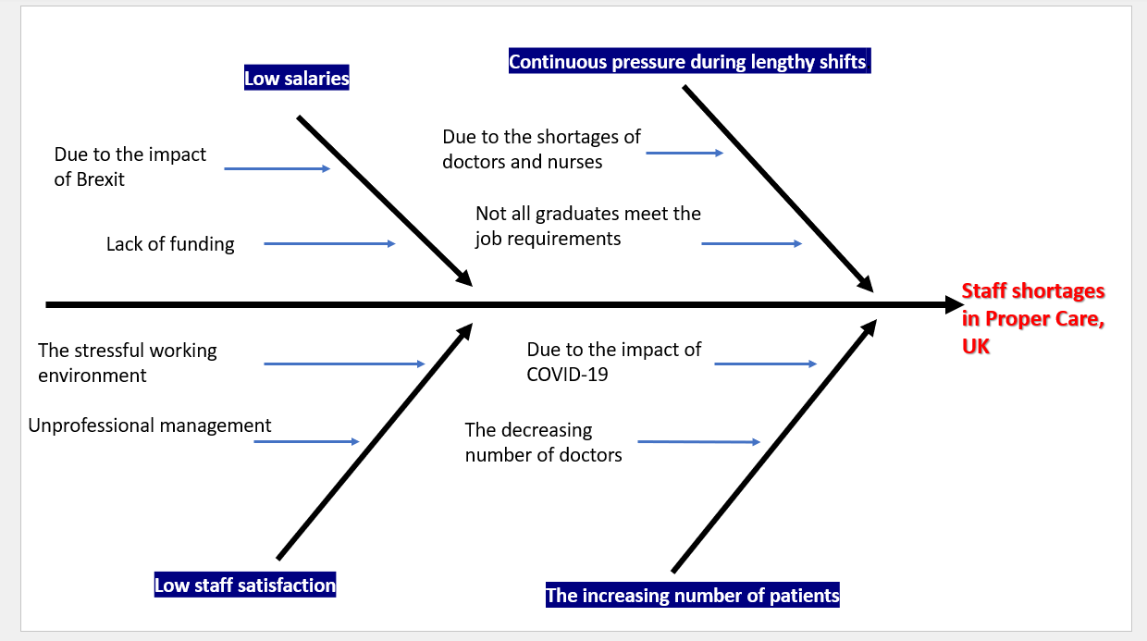
Solutions:
There are 6 possible ways that could help to overcome the problem of the shortages in the NHS’s staff.

- Offering extra hours to current staff
-This is probably the quickest solution for staff shortages. As the NHS and public health services have people who already know the job and may be interested in working additional hours. This could mean paying overtime, however, it’s better than losing clients.

2. Ensure there are good working conditions.
-Two factors impact working conditions. One is the actual job. If managers can’t do much to change the tasks or the environment of a job. The other factor, however, can do e.g., how the team is treated. People stick with employers who treat them well. That means everything starting from thanking them for the hard work to ensuring customers also treat these frontline employees respectfully.

3. Increase wages.
- Money is what people use to pay rent, buy food and live. Improved pay tells employees that management cares about them and wants them to stick with the company. By paying them a good amount of money that covers their need to enable them to continue working with the company.

4. Offer benefits.
- If managers want to attract and retain top-notch employees, they should offer them benefits. Health insurance paid time off, and a retirement plan are just a few common benefits. It’s worth noting, in addition, while some of these staff shortage solutions may take time to implement, sick time can be added as a benefit quickly.

5. The use of technology.
-Technology such as janitorial management software can help streamline the entire workflow. Keep up with inventory, equipment maintenance, staff reliability, checklists, and more when using technology designed to help the business succeed.

6. Train the team to do more.
-If the staff shortage is in a specific skill set, can other frontline staff be trained to do that job? Depending on the skill, this may require a certification course or hands-on training, but it could be well worth the time and investment.

Plus | Minus | Interesting/implication
Offering extra hours to current staff (+5) | Might cause the staff to be exhausted. (6) | Easier to get more staff (+1)
Train the team to do more (+5) | Might prevent them from focusing on the actual job (3) | Specialise extra hours for training (+2)
Increase wages (+3) | Might cost the organisation lots of money from the benefits and the funding (3) | Provide free medical support for the staff (-4)
Total= +13 | Total= -12 | Total= -1

It encourages the participants of the NHS to look at an issue from different perspectives. PMI gives the concept of focal points in a specific area, giving the ability to take two opposing ideas and produce a creative solution is union of the two, but superior of both. PMI is a tool that was developed by Dr. Edward de Bono.

NHS’s long-term plan:

According to HealthTrust Europe ‘, unless staffing shortages are substantially reduced, the recent NHS Long Term Plan can only be a wish list.
The NHS Long Term Plan, which was published in January, outlines its strategy to improve patient care over the next ten years and aims to address the problem by increasing the NHS workforce by training and recruiting more professionals. This will include thousands more clinical placements for undergraduate nurses, hundreds more medical school places, and more routes into the NHS such as apprenticeships, as well as efforts to support improvements in retention.

However, the NHS Long Term plan is just that – long-term – and in the meantime, many healthcare providers have staffing challenges to address today. Faced with this situation it can be not easy to embed the overall workforce aspirations of an organisation and build a strategy that will deliver operationally. However, there are some key actions that providers can take to help mitigate some immediate risks and drive a proactive approach to address market challenges.

- Dr Layla McCay, director of policy at the NHS Confederation, said: “This polling once again confirms that the greatest challenges facing the NHS – an exhausted workforce, growing waiting lists, and a severely under-resourced social care sector – are also the experiences of patients and the public.”

She urged the government to “play its part in restoring public perceptions of the NHS and social care, including levelling with the public about the care they will receive as the health service and the nation recover from the pandemic”.

Both the RCN and the NHS Confederation repeated their calls for a workforce plan to address retention and recruitment.

- According to The Health Foundation: Tim Gardner, Senior Policy Fellow at the Health Foundation, said:

‘This long-anticipated NHS elective recovery plan is welcome, but the challenge is daunting. Even before the outbreak of Omicron, waiting lists reached 6 million with over 300,000 patients waiting longer than 52 weeks.’
‘The plan is realistic about the scale and complexity of the challenge, particularly the unknowns of how demand will bounce back and the future path of the pandemic. Long waits will be with us for a while to come so a commitment to help patients ‘wait well’ and prepare for surgery are welcome. Support will also be needed for services outside hospitals, including social care, to ensure they have the necessary resources to recover.

‘While today’s plan is a step forward, it needed to go further. Notably, it acknowledges the disparities between different parts of England but there is a lack of concrete and targeted action to address them. Over 1 in 10 of those waiting in Birmingham and Solihull have already waited over a year, compared to just 1 in 100 in Southwest London and Surrey.

*Conclusion:

In conclusion from what I have discussed in this report the issue of staff shortages in proper care and the NHS in the UK seems to be a serious problem, however, it can be solved with some of the various solutions that I have suggested which we figured out through PESTEL and SWOT analysis, that enabled us to figure out the actual problem and identify the main reasons for it. Some of the solutions would cost the organization a lot such as training the staff on more advanced technology that would help them to do their job accurately and save more time, which will require a specialist in the technological field to train the staff and that will be expensive. Also offering extra working hours might be a suitable solution because it makes the NHS avoid wasting time on looking for new staff that have the right experience and meets the job requirement. Another way is Improved pay tells employees that management cares about them and wants them to stick with the company. By paying them a good amount of money that covers their need to enable them to continue working with the company.
On the other hand, the NHS’s long-term plan would be the best solution for the issue of staff shortages in proper care and the NHS as a whole in the UK. That is because it’s willing to improve patient care over the next ten years and aims to address the problem by increasing the NHS workforce by training and recruiting more professionals. This will include thousands more clinical placements for undergraduate nurses, hundreds more medical school places, and more routes into the NHS such as apprenticeships, as well as efforts to support improvements in retention.
Therefore, the different types of solutions that we have and are available enables us to overcome this important issue, only if we started at the right time with the right people under good working conditions.

References:
- The King’s Fund
- The British Health National Service
- The Guardian newspaper
- Fishbone/Ishikawa diagram
- Pestle analysis (Addressing the problem of staff shortages in Proper Care and NHS, in the UK. Presentation)
- SWOT analysis (Addressing the problem of staff shortages in Proper Care and NHS, in the UK. Presentation)
- HealthTrust Europe
- The Health Foundation (Tim Gardner, Senior Policy Fellow)
- Dr Layla McCay, (director of policy at the NHS Confederation

