

Academic and Employability Skills
BMSW4001_LON
Lecturer: Dr Alfred Mensah

Student: Meliha Drenk (1922136)
Table of contents

Introduction……………………………………………………………..2
Gibbs model of reflection………………………………………….2
Employability skills…………………………………………………….3
CV writing………………………………………………………………….4
Cover letter……………………………………………………………….4
Referencing……………………………………………………………….6
How to make a presentation? …………………………………..7
Conclusion…………………………………………………………………8
Reference list…………………………………………………………….9
Class activities ……………….…………………………………………10
Appendix 1……………………………………………………………….10
Appendix 2……………………………………………………………….13

Introduction

In my report I will focus on a few topics from both terms – academic and employability skills, how to write good cv and cover letter, how to reference correctly and how to make a presentation. All of them will be presented with my personal reflection via Gibbs model of reflection (1988).
In the beginning I will explain in a few words what is Gibbs’ reflective cycle. This model is developed by Professor Graham Gibbs in 1988. ‘’The model encourages the learners to gain knowledge from their experience.’’ (Devet, 2020). There are six stages (see photo 1).
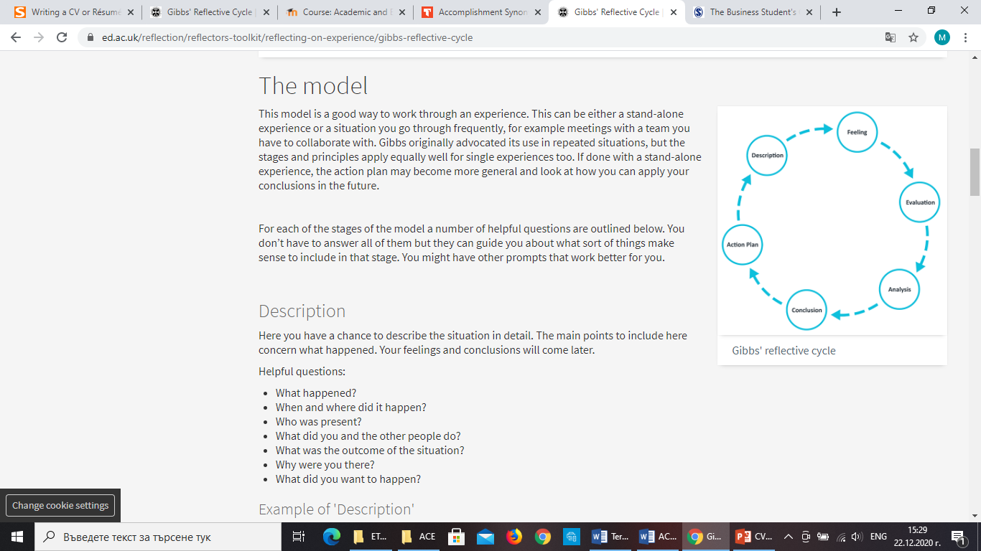
In the first stage of the model we describe what happened, after that we talk about our feelings and thoughts during the situation. Then we evaluate what happened good or bad, next we analyse why the things went well or not. Next is the conclusion stage we ‘‘summarise our learning from the situation’’ (The University of Edinburgh, 2020). The action plan is the last stage that describes what I will do in the future if I am in the same situation.

Photo 1:https://www.ed.ac.uk/reflection/reflectors-toolkit/reflecting-on-experience/gibbs-reflective-cycle

First topics that I will focus on are my academic and employability skills. They can be defined as: ‘’A set of achievements – skills, understandings and personal attributes – that make graduates more likely to gain employment and be successful in their chosen occupations, which benefits themselves, the workforce, the community and the economy” (Yorke, 2006).
Both skills are very important for our career. Nowadays employers want the employees to have a complex of qualities. The job market is very competitive and therefore we have to stand out and have something that makes us special. The education and experience is not enough. Creating a good CV and Cover letter can help you get hired, but are not all that is needed. We need something more to make us attractive for the employers and recruitments. ‘’The ‘soft skills’ or ‘employability skills’ are what makes us employable.’’ (skillsyouneed, 2020). The most important employability skills are ‘good communication skills (verbal and non-verbal), listening, effective team-working, problem-solving and decision-making, emotional intelligence, self-motivation and ability to embrace new ideas’. (skillsyouneed, 2020). First I will focus on the communication skills that I had before and how I improved them in my life as an employee and a student. I can communicate within a few languages, my written communication skills are also very good at all of them. Therefore, I never had problems to communicate effectively with my colleagues. I’m working to improve my speaking skills by watching different Tv programs and taking part in free online courses.
Listening is another significant part from employability skills. Listening is different from hearing, because hearing is our physical ability to hear different sounds, (Maund,2017) listening is’’ how we take in and then interpret the verbal and non-verbal messages sent by others, including in writing’’. (skillsyouneed, 2020). We have to learn to listen, because every person that we meet in our life knows something more that we don’t know and we learn from each other.

Working in a team is very important. ’’The ability to work with other in groups and teams, both formal and informal. Not everyone is required to work in a close-knit-team- despite the language used in many organisations – but the ability to function well in a group is a vital skill in the most jobs.’’ (skillsyouneed, 2020). In our career we have daily challenges and problems that’s why we have to be able to make right decisions and to apply them in our workplace effectively.
Next topic that I will discuss is CV writing. CV is a document that shows our skills, qualifications and experience. (skillsyouneed, 2020). We use our CV to ‘sell’ our self. In the beginning we have to place our contact details. After that are qualifications that we have (with dates), follow by our experience. Membership of different organisations or interests are the next part of our CV. This will give the employers more information about our self. In conclusion are our references (usually two), they should be given only by request. When we start to learn about CV writing I was thinking that I knew enough and there is nothing more than I can learn. But I was wrong. During the classes (see appendix 1) I’ve learned many things which helps me to fill the unknown gaps in my knowledge. Main thing is that we don’t have to use same CV for different jobs and we have to use qualifications that are relevant to the job we apply for.
Cover letter is a document that we provide with our CV. It shows to the employers why we are the perfect applicant for the position and helps them to know more about us. It is better if is written more personal and it has to be unique. Taylor, S. (2019) points that ‘’ Writing an effective cover letter is vital support to your job application’’. Before we start we have to make a research about the position we apply for and how we can be helpful and fit to their company.
Basic cover letter should have four paragraphs. In the begging we don’t have to use ‘to whom it may concern’ instead we have to write the name of the hiring manager. If we don’t know it, we can check online or we can give them a call and ask.
In the first one we have to mention the position that we are applying and where we saw the job application. Second paragraph we describe our self – qualifications, skills, experience related to the job. In the third one we have to tell them what we can bring to their company and how we’ll fit into their vision. At the end of our cover letter we thank to the recruitment and let them know our ability for an interview. Of course we have to check for grammar mistakes. (see app. 2). During our classes we watched a few very helpful videos. One of them is this below:

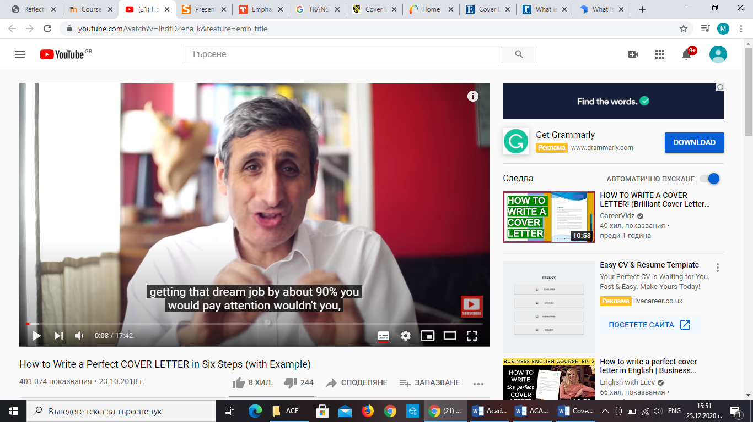

Video credit: https://www.youtube.com/watch?v=lhdfD2ena_k&feature=emb_title

Another part of the things that I’ve learned is how to do referencing. It is one of the most important lessons that I’ve learned. My biggest lack of knowledge was referencing. I knew how to summarise and paraphrase different sources, the easiest for me was using synonyms. During our class activities was very easy for me because the lecturer explained clearly what we had to do and how, but when I applied it on my own I had difficulties to find the appropriate sources. This is the reason that led me to not have a good mark on my previous assignment. Of course this made me feel very disappointed in myself, but also motivate me to work more and improve my knowledge. I’ve watched a lot of videos online on how to refer correctly via Harvard style and it was very helpful. Based on that experience I have to develop my referencing skills. One of the most helpful videos for me was this below:

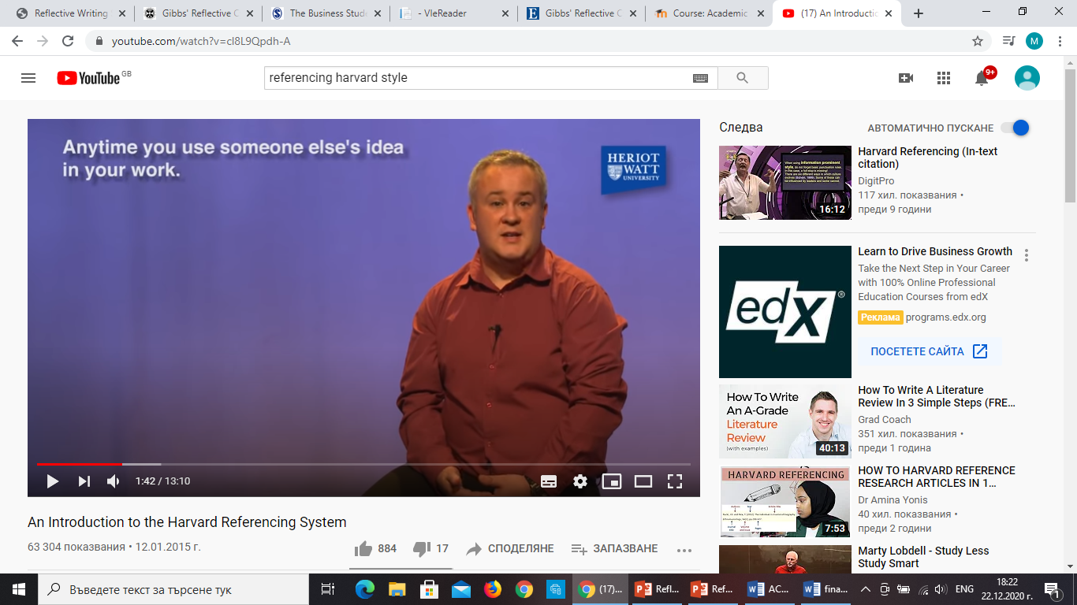

tggggg
Video credit: https://www.youtube.com/watch?v=cl8L9Qpdh-A

Next topic that I will discuss is how to make a presentation. Nowadays, the world is starting to revolve around computers and technologies there for digital skills are very important. However, you need to be good at presenting your digital skills. Creating presentations is the main digital skill that is needed. ‘’Presenting information clearly and effectively is a required skill’’ (skillsyouneed, 2020).
My presentation skills are above average as I am a frequent user. That’s why I was chosen as group leader by my colleagues. In the beginning I was worried about how I was going to perform because I get nervous when having to talk in front of groups of people. But I decided to accept the challenge.
(Hertel, Geister & Konradt, 2005, quoted in Maund, 2017) observes that ‘’The use of technologies can significantly improve team efficiency and increase productivity’’. Because of the situation at the moment we communicated virtually. We had difficulties to communicate via What’s app or email. Live communication can’t be replaced than anything because you see person’s body language and facial expression. They explain more than a lot of words. When making presentations you have to consider who your audience is and you have to be dressed appropriately. Your preparation beforehand increases your chances for a better performance. The speaker has to talk at a steady to fast pace so therefore they do not bore the audience. Our group followed the previously listed rules and tips which helped us perform very well.
When more people work together they can produce better ideas and decisions. Working with others can be difficult because we have a lot of differences like our age, ideas, characteristics, backgrounds and emotions. We act different in some situations.
In the beginning I didn’t tell my colleagues what they had to do I just let them chose what they wanted, maybe because I don’t have good leadership skills. Looking back at it now I realised that this was one of the mistakes that I’ve done. During the making of our presentation we had a lot of disagreements and conflicts. According to me not all conflicts are bad. They can be transform to something positive because help us to understand others perspective. In some moments everyone just kept arguing but we overcame them. The thing that frustrated me a lot was that some of my colleagues did not participate enough and left all the responsibility to me. This was very stressful and intense for me. I tried my best to motivate them but in the end I couldn’t force them to do work that they didn’t want to do. Putting aside the negative things that happened we ended up creating a very good presentation and we’ve learned to accept other people’s view. All of this helped us to get to know each other and get closer as a group. Now I feel more confident speaking in a public. In the future I will make sure that I don’t repeat my past mistakes.

Conclusion
All topics that I discussed in my report were done by personal reflection. In our life as students we learn every day in the virtual classroom. This helps us gain knowledge which will be helpful in our future careers. All tasks and class activities helps us build personal relationships with the colleagues and to collaborate with each other. The ability to communicate and share ideas increases my creativity and productivity. The main benefits that I learned from both terms were that I feel more confident in my skills, my self-motivation increased and I improved my time management. I’ve learned new ways to solve different problems and I became more disciplined and focused on my goals, in addition I’ve learned to never give up and use daily challenges as lessons in life.
REFERENCE LIST

Devet, B. (2020) ‘Gibbs reflective cycle for writing centre training’, Writing Lab Newsletter, Vol.44, (9/10), pp. 18-26. Available at: https://web.a.ebscohost.com/ehost/detail/detail?vid=0&sid=a188df35-b374-41cd-9494-b93340712d42%40sdc-v-sessmgr02&bdata=JnNpdGU9ZWhvc3QtbGl2ZQ%3d%3d#AN=142995242&db=eue, (Accessed: 20th December 2020).

Maund, A., Schriek, M. & Tinkler, P.K. (2017), Certificate in higher education: Skills for the workplace Student yearbook, London: Sage.

Skills you need (2011-2020) Employability skills. Available at: https://www.skillsyouneed.com/general/employability-skills.html, (Accessed: 18th December 2020).

Taylor, S. (2019) ‘Cover letters 101: Writing an effective cover letter is vital support to your job application’ Institution of chemical engineers, (936), pp. 52-54. Available at: https://web.a.ebscohost.com/ehost/pdfviewer/pdfviewer?vid=1&sid=405f36e0-a291-492b-ae86-6c7f6739f3e5%40sessionmgr4007 (Accessed: 21st December 2020).

The University of Edinburgh (2020) Gibbs’ reflective cycle. Available at: https://www.ed.ac.uk/reflection/reflectors-toolkit/reflecting-on-experience/gibbs-reflective-cycle (Accessed: 25th December 2020).

Yorke, M. (2006), 'Employability in Higher Education: what it is- what it is not', Higher Education Academy/ESECT, Available at: https://www.researchgate.net/publication/225083582_Employability_in_Higher_Education_What_It_Is_What_It_Is_Not, (Accessed:21st December 2020).

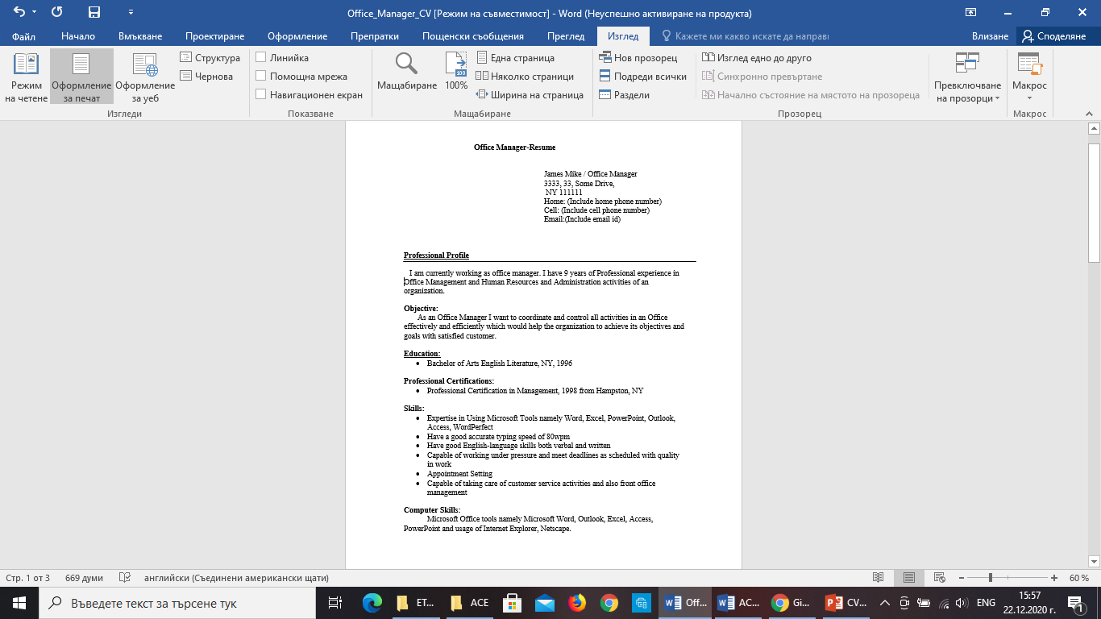
Appendix 1
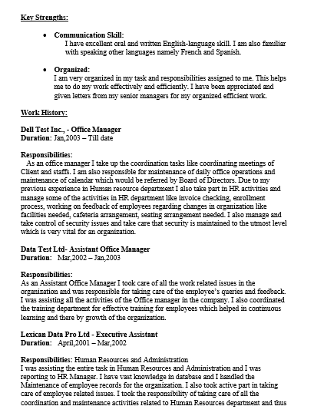
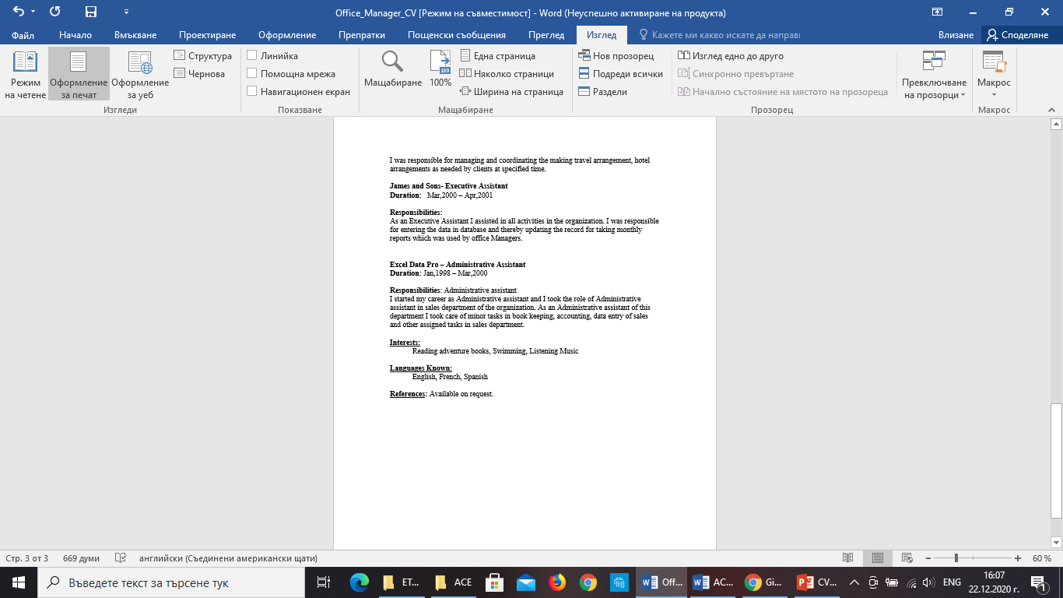
Appendix 2



