Marks & Spencer plc – Developing and Managing Individuals and Teams (LCLM5002)
Recruitment and Selection During Organisational Transformation

Student Name: Xenia-Giorgiana Anghel
Student ID: 2438527
Lecturer Name: Samson Oladejo

Slide 1

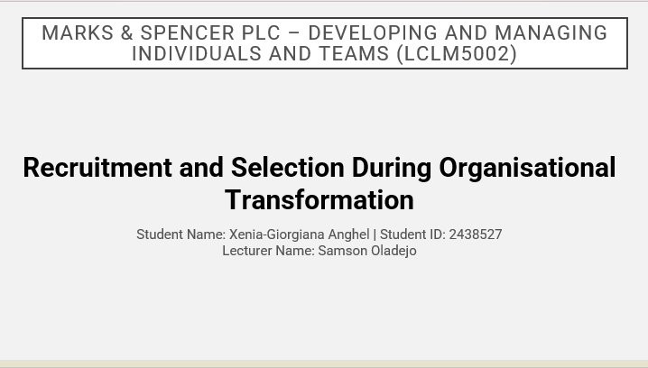

Marks & Spencer is one of the most recognisable brands on the UK High Street and is currently undergoing significant change to become a more digital retailer and to become a more efficient organisation, ensuring that it is able to deliver a truly omnichannel experience to its customers and respond to changing consumer expectations. As Marks & Spencer develops its technology, online and customer focused strategies it is increasingly important that the retailer is able to attract the best people in order to support its plans.

This presentation aims to evaluate the ways in which effective recruitment and selection can support organizational change and looks at job analysis, job descriptions, person specifications, methods of recruitment, types of interviews and questioning techniques. It will examine the benefits of face-to-face interviewing against virtual interviewing for the recruitment of transformation-focused roles. It aims to draw on current HRM practices and supporting CIPD materials and other organizational and industry sources.

Slide 2

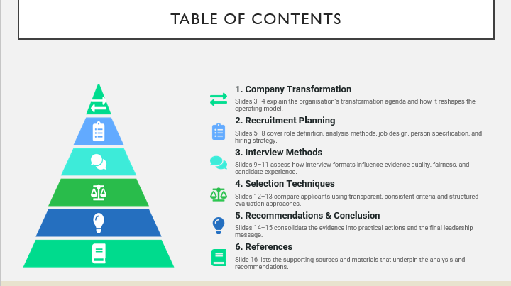

Slide 3

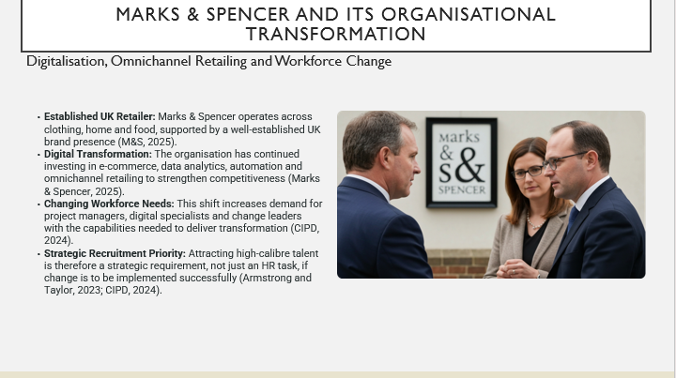

Marks & Spencer is one of UK’s leading retailers and has undergone changes to its retail strategy to adapt to the changes in consumer behaviour, the rapid digitalisation of the retail market and the intense competition in the retail industry. This transformation has required Marks & Spencer to evolve its online retail offering and to overhaul its supply chain, leverage data to inform decision making and deliver an integrated customer experience online and offline, through its omnichannel strategy (Marks & Spencer, 2025).

New skill requirements are emerging for M&S’s future success, relating to project management, digital technology, change and business transformation. As such, recruitment is now a strategic activity rather than a mere administrative process. Using competency-based selection to recruit is events supporting the delivery of required change, while sustaining business performance and long-term competitive advantage (Armstrong and Taylor, 2023; CIPD, 2024).

Slide 4

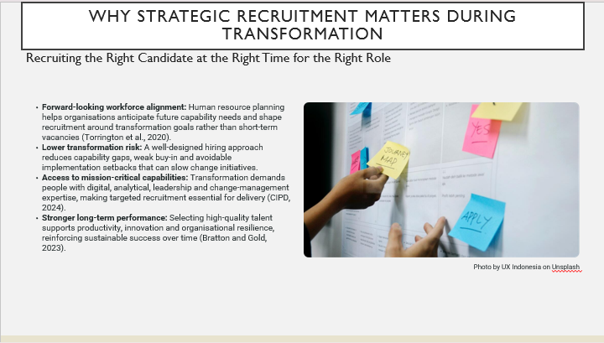

Recruitment that is strategic in nature is key to any organizational transformation being successful. By completing human resource planning an organization is able to identify future requirements of the workforce and then recruit the most suitable people that possess the necessary knowledge, skills and behaviours to meet strategic objectives of the organization (Torrington et al., 2020). By recruiting the correct people at the correct time of organizational transformation the company can avoid delays and severe shortages in capability as well as low performance.

For Marks & Spencer, in order for it to be successful in its transformation, it needs people with skills and experience to manage change, such as managing projects, implementing technology and supporting cultural change. Thus, recruitment decisions should be taken with the organization’s overall strategy in mind as opposed to the organization’s current operational needs. Strategic recruitment can aid in ensuring an organization is agile and able to perform at optimum levels in order to gain sustainable competitive advantage (Bratton and Gold, 2023; CIPD, 2024).

Slide 5

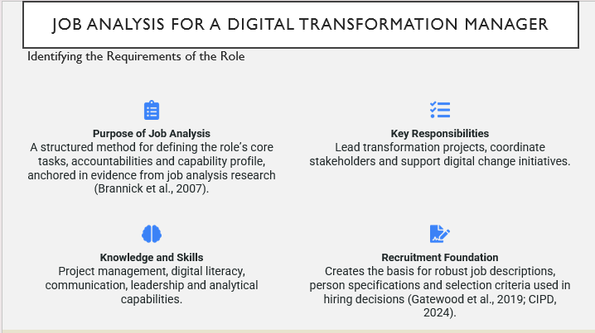

The foundation of a successful recruitment and selection process is job analysis, which identifies the tasks, responsibilities and skills required to perform successfully in a particular role. Job analysis is a systematic process of describing what employees do in their jobs how do you perform those job tasks and what knowledge skills and abilities are needed to successfully complete the dominant tasks (Brannick et al., 2007).

For Marks & Spencer, the job analysis of the role of Digital Transformation Manager identified that the key tasks of the post would be to lead change projects, coordinate between stakeholders and support the implementation of new technologies across the organization. Using the findings from this job analysis allows recruitment decisions to be taken on an evidence-based basis and also provides necessary information for writing accurate job descriptions, person specifications and the criteria to use for shortlisting at interview (Gatewood et al., 2019; CIPD, 2024).

Slide 6

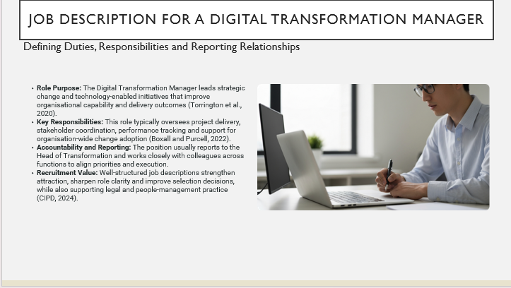

A job description is a written employment document that sets out the purpose of the job as well as the key responsibilities, reporting lines and the required contribution. A job description helps potential applicants to understand what the organization’s needs are and thus helps to attract applicants whose skills and experience are better than others for that particular job, as stated by Torrington et al. (2020).

For Marks & Spencer the job description for the Digital Transformation Manager will outline the role of coordinating transformation programs, aligning stakeholders across departments and supporting the organization in delivering its strategic change. The day-to-day work of this Manager will involve setting up a transformation program and then delivering it, by creating a project plan, monitoring and reporting performance, ensuring communication between functions and adopting new ways of working and ensuring that others do too (Boxall & Purcell, 2022).

Job descriptions also have far-reaching benefits to organizations. A good job description can help create transparency, prevent errors in recruitment and selection, support objective hiring and ensure that all stages of the employee life cycle are supported in a legal and proper manner. The CIPD (2024) advises the use of a well-designed job description as a way to support fair and effective recruitment and performance management by clearly specifying the role.

Slide 7

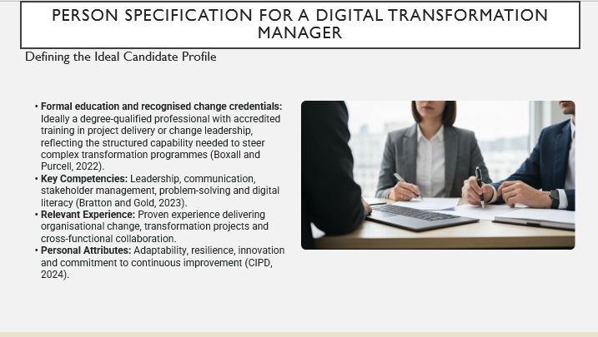

A person specification lists the necessary qualifications, experience, behaviours and personality required to succeed in the role. It is separate to the job description which details the key tasks of the role, but the person specification outlines the criteria that would be looked for in candidates during the selection process (Boxall and Purcell, 2022).

For Marks & Spencer, a Digital Transformation Manager would need to possess the skills of a leader and communicator as well as project management skills and experience of change within organizations. The Manager would also need to possess the personal characteristics of an adaptable, resilient and innovative individual as Marks & Spencer’s transformation is uncertain, politically complex and technically driven. A well-constructed person specification will improve recruitment accuracy as it ensures that the organization is assessing candidates in a consistent and evidence-based way. This ensures that recruitment is fair and reduces bias and ensures that the best people are selected to perform the job (Bratton and Gold, 2023; CIPD, 2024).

Slide 8

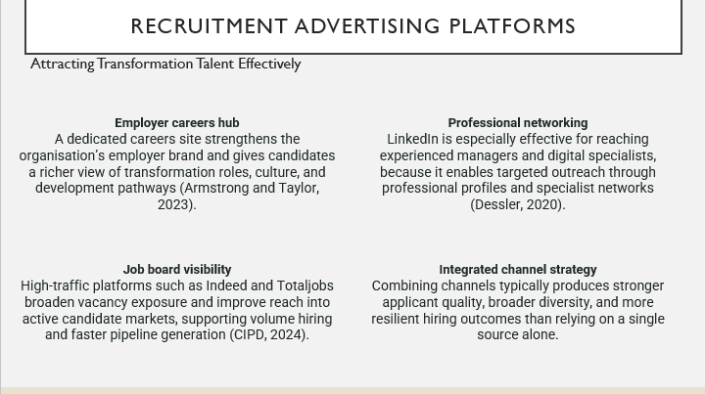

For recruiting during organizational change, it is crucial to choose the right advertising channels. For Marks & Spencer, therefore, the corporate careers website of the company, professional social networking sites like LinkedIn and the main online recruitment platforms would be suitable. In this way, the vacancies are advertised more often and candidates with different profiles can be reached more easily (CIPD, 2024).

In particular LinkedIn is important to be able to target experienced transformation managers and digital specialists with the right experience. Online job boards have a broader reach to attract applicants and also help with employer branding. Using multiple pipelines enhance the chances to attract better quality candidates for the changing organization and help workforce planning and development (Armstrong and Taylor, 2023; Dessler, 2020).

Slide 9

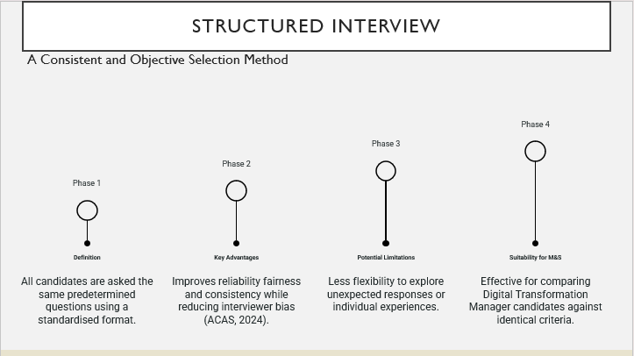

A structured interview is conducted using a number of fixed questions for all applicants, with their answers being scored against a set of criteria. Such an approach enables any organization to compare candidates consistently and ensure that all candidates are judged against the required skills for the job. Research has found that structured interviews have higher reliability and validity than unstructured interviews as all applicants are evaluated against the same requirements for the job.

A structured interview would be particularly appropriate for Marks & Spencer’s recruitment for organizational transformation, as this will allow the interviewer to assess the candidate’s leadership capability, project experience and change-management skills using measurable criteria. This is a fair and transparent way of recruiting the best transformation professionals and whilst it does have a less flexible approach than an unstructured interview, it has the advantage of removing much of the bias from an interview and increasing reliability (ACAS, 2024).

Slide 10

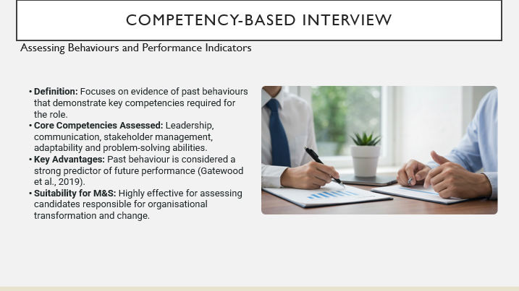

A competency-based interview evaluates whether the candidates have the appropriate behaviours and skills needed to perform a position at acceptable levels. Many of these interviews will ask applicants to share examples of specific situations when they have demonstrated certain behaviours (i.e. past experience to evidence future behaviours). Gatewood et al. (2019) say that past behaviour is one of the best indicators of future performance in work, and so this is the underlying principle of a competency-based interview.

For Marks & Spencer, competency-based interviews are particularly relevant as Transformation Managers will require proven experience of leading change and managing organisational challenges. Although candidates can prepare examples in advance of the interview, this type of interview provides strong evidence of a candidate’s ability to carry out a job and supports an objective selection process when used in conjunction with a set of structured assessment criteria.

Slide 11

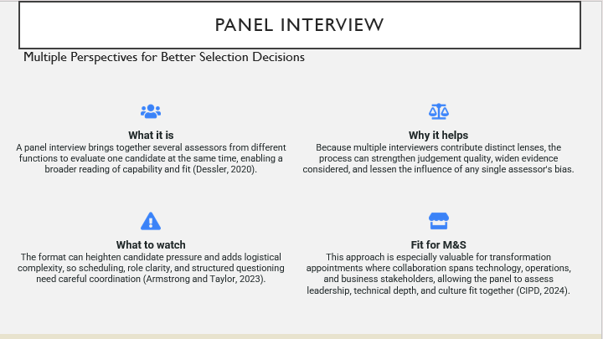

A panel interview refers to an interview in which a candidate is interviewed by a panel of interviewers at the same time. This type of interview is commonly used by organizations as panel members can represent different departments and thus provide a number of different perspectives on candidates. It also helps to minimize bias (Dessler, 2020).

The panel interview is particularly relevant for Marks & Spencer when recruiting Transformation Managers, as these candidates will work with stakeholders from Technology, Operations and other Business Functions. Assessing candidates for technical expertise, leadership capability and cultural fit can be more effectively carried out through a panel interview, providing the organization can manage the process effectively to mitigate the increased anxiety this type of interview can cause for candidates as well as the increased planning required. This type of interview increases the quality of decision making and results in a more balanced recruitment process (Armstrong and Taylor, 2023; CIPD, 2024).

Slide 12

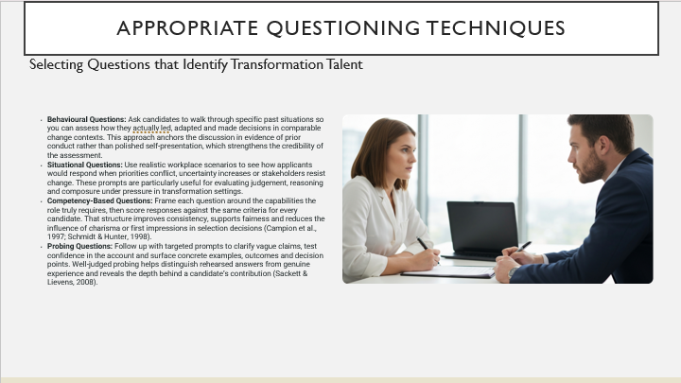

For evaluating candidates in interviews, it is important to use appropriate questioning techniques in order to obtain valid and comparable evidence. For this purpose, behaviour-oriented questions and situational questions are of special value. These types of questions can test a candidate’s leadership, adaptability, and judgment by asking the candidate to describe specific situations and what they actually did. Situational questions especially allow for an evaluation of how candidates would respond in ambiguous situations, situations involving trade-offs and situations involving resistance to change. In the context of selection interviews, questions that are based on competencies are valuable because they keep the content of the conversation closely aligned to the role for which the candidate is being interviewed, and they also enable a fair evaluation by making scores more consistent.

Campion et al. (1997) and Schmidt & Hunter (1998) also supported these findings. Probing questions serve the purpose of obtaining more information from candidates by asking additional questions in order to clarify details, challenge vague statements and explore the substance behind the candidate’s answers. As pointed out by Sackett & Lievens (2008), probing questions help interviewers gather deeper evidence during the interview process.

Slide 13

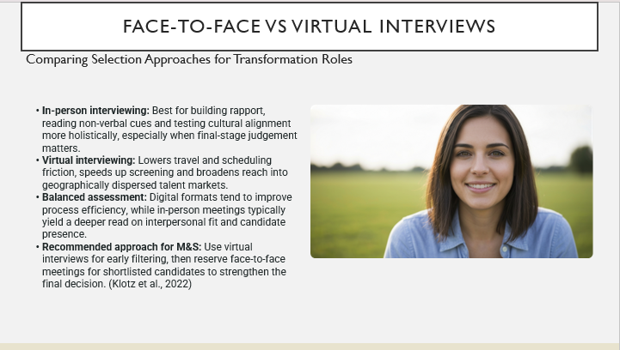

Face-to-face and virtual interviews provide different types of evidence for the transformation selection process. In-person interviews are primarily used to assess a candidate’s relational presence and how they engage in conversation and how they react when under scrutiny by another person. Face-to-face interviews also provide a sense of commitment to the candidate and how they would fit with the team and the organization’s culture.

On the other hand, virtual interviews can support a more scalable and cost-effective recruitment process. Virtual interviews to reduce the burden of travel on candidates which results in a streamlined recruitment process as well. Employers can get a wider, and more diverse range of applicants. Therefore, virtual interviews are most useful in early-stage screening where speed and reach matters more than being able to carry out a highly detailed interpersonal observation of the candidate.

Marks & Spencer would benefit from a hybrid approach using virtual interviews for the initial stages of the process, with face-to-face interviews held with shortlisted candidates. That leads to an efficient process, while still getting the best quality decision. This is consistent with the existing evidence around digital recruitment design and candidate experience (Klotz et al., 2022).

Slide 14

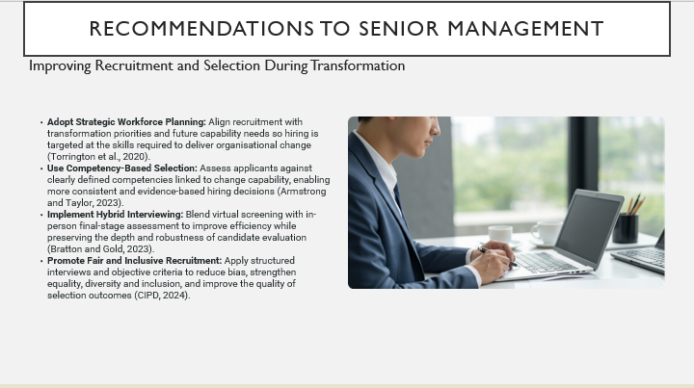

Marks & Spencer should adopt a more strategic approach to recruitment that is aligned with the goals of its transformation. Marks & Spencer should use its human resource planning to plan for future capability requirements, and ensure that all recruitment activity is targeted at the right people with the right skills to help transform the organization to deliver its future objectives (Torrington et al., 2020).

A competency-based recruitment process with structured interviews, utilizing a hybrid interview format to increase efficiency, would be key to Marks & Spencer’s future recruitment. Furthermore, all recruitment processes should promote equality, diversity and inclusion and seek to reduce bias, ensuring that candidates are assessed against the same standards. These recommendations will improve the quality of recruitment at Marks & Spencer, aid the organization’s transformation and ensure future success and performance (CIPD, 2024; Armstrong and Taylor, 2023; Bratton and Gold, 2023).

Slide 15

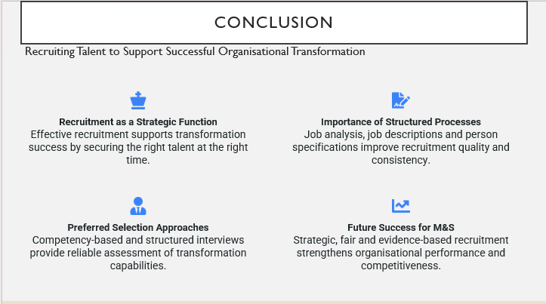

Armstrong and Taylor (2023) state that effective recruitment of employees begins with workforce planning, followed by job analysis. A job description and person specification are then completed, and candidates are recruited whose skills and abilities match the organization’s goals for development and improvement. Therefore, effective recruitment and selection is crucial to organizational transformation at Marks & Spencer.
Using competency-based, structured and panel interviews, the organization will be able to identify the best candidates for transformation roles. This will include using behavioural, competency-based and probing questions to gain suitable evidence of candidates’ ability to meet the organization’s strategic objectives (CIPD, 2024; Bratton and Gold, 2023). Implementing strategic, fair and evidence-based recruitment practices will allow Marks & Spencer to strengthen organizational performance and successfully deliver transformation initiatives.

Slide 16
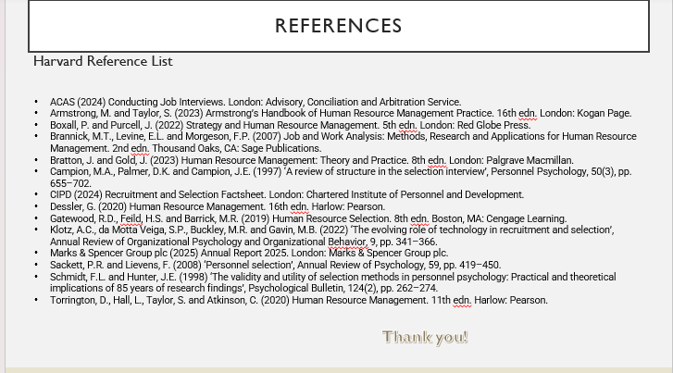

- ACAS (2024) Conducting Job Interviews. London: Advisory, Conciliation and Arbitration Service.
- Armstrong, M. and Taylor, S. (2023) Armstrong’s Handbook of Human Resource Management Practice. 16th edn. London: Kogan Page.
- Boxall, P. and Purcell, J. (2022) Strategy and Human Resource Management. 5th edn. London: Red Globe Press.
- Brannick, M.T., Levine, E.L. and Morgeson, F.P. (2007) Job and Work Analysis: Methods, Research and Applications for Human Resource Management. 2nd edn. Thousand Oaks, CA: Sage Publications.
- Bratton, J. and Gold, J. (2023) Human Resource Management: Theory and Practice. 8th edn. London: Palgrave Macmillan.
- Campion, M.A., Palmer, D.K. and Campion, J.E. (1997) ‘A review of structure in the selection interview’, Personnel Psychology, 50(3), pp. 655–702.
- CIPD (2024) Recruitment and Selection Factsheet. London: Chartered Institute of Personnel and Development.
- Dessler, G. (2020) Human Resource Management. 16th edn. Harlow: Pearson.
- Gatewood, R.D., Feild, H.S. and Barrick, M.R. (2019) Human Resource Selection. 8th edn. Boston, MA: Cengage Learning.
- Klotz, A.C., da Motta Veiga, S.P., Buckley, M.R. and Gavin, M.B. (2022) ‘The evolving role of technology in recruitment and selection’, Annual Review of Organizational Psychology and Organizational Behavior, 9, pp. 341–366.
- Marks & Spencer Group plc (2025) Annual Report 2025. London: Marks & Spencer Group plc.
- Sackett, P.R. and Lievens, F. (2008) ‘Personnel selection’, Annual Review of Psychology, 59, pp. 419–450.
- Schmidt, F.L. and Hunter, J.E. (1998) ‘The validity and utility of selection methods in personnel psychology: Practical and theoretical implications of 85 years of research findings’, Psychological Bulletin, 124(2), pp. 262–274.
- Torrington, D., Hall, L., Taylor, S. and Atkinson, C. (2020) Human Resource Management. 11th edn. Harlow: Pearson.

