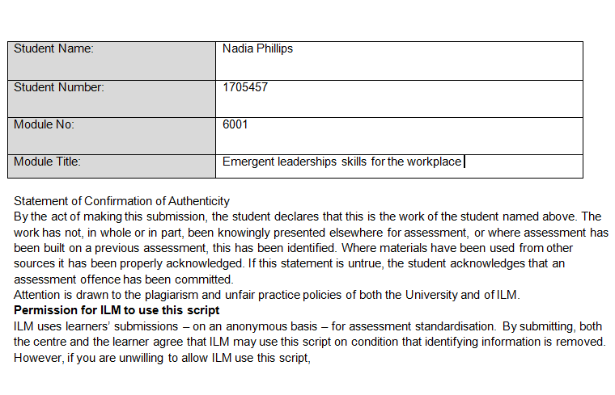

Contents
Introduction 2
Leadership Definition 3
Leadership models and styles 3
Evaluate own ability to use range of leadership styles, in different situations and with different types of people, to fulfil the leadership role 4
Ethical Leadership 6
Does Gender impact leadership 7
Assess your own ability to set direction, motivate, delegate and empower others to bring about workplace change 8
Critically assess a recognized leadership model or theory in relation to its ability to impact on individual workplace performance 10
References 13
Appendix 15

Introduction

This report will determine a summary of definitions of leadership and its styles, whilst considering the skills that direct, motivate, delegate and empower employees, specifically at the Wallich in Llanelli and Phillips of Llanelli a busy car garage, these two occupations is where the author works and recalls to these employments for examples throughout, whilst critically assessing Amazon for its leadership style.

Leadership Definition

“Leadership is a process whereby an individual influence a group of individuals to achieve a common goal” (Northouse 2018, p8).
“Leadership involves developing and articulating a vision for the organisation” (Bush & Middlewood 2006, p.4)
“If your actions inspire others to dream more, learn more, do more and become more, you are a leader” John Quincy Adams

Leadership models and styles

Great leadership equals great benefits, there are many styles that are being educated around business and charity run organisations at present. The main theories and styles mentioned in this report is laisses-faire, autocratic, situational and transformational.
Laissez-faire style is a very well known and developed leadership style that has many advantages and disadvantages within this modern world, the style is having capable and trust worthy employees that will meet deadline, work as a team or as individual fully equipped with skills and knowledge for a particular role. The positive factors from having this type of leadership is being able to treat adults with respect and will respond with respect, however the negative to this is that there are some personalities that may abuse the flexibility and respect with not exceeding expectations, confusion by having little or no guidance to endure tasks, depending on the individual may need pressure to completely thrive rather than just floating along (Maund, 2018).
Autocratic leadership is the opposite to laissez-faire style, Lewin in the 1930s was the first is credited with this style. Autocratic tools are to be direct with employees, does not need input, ideas or creativity and expects deadlines to be met. Even though this sounds overly harsh there have been extremely successful outputs from this type of leadership, according to Sakar and Fletcher, there are a great deal of population that feel successful from having pressure within the workplace, it increases focus and achievement. High pressure jobs recognise this style as necessary for example a surgeon doing open heart surgery does not need the opinions of nurses on what equipment is needed, with autocratic leadership there are not options the decisions are definite, with the outcome being life changing for the patient and the surgeon feel for filled and high job satisfaction.
Hersey and Blanchard situational theory, developing many studies in particular the Ohio study, determined that leaders should be equipped with the skill delegation, the priority is high on task orientation and lower on person orientation, delegation, telling and supervision is the recommendations of this leadership style. The external factors can alter decision making, for example this style would be implemented with nearly all of the jobs in the world when the pandemic aroused in the world, all leaders and management teams would have to consider how to continue businesses, make profits whilst keeping employees and public safe, potentially adding in temporary policies and procedures to enforce all these aspects.
Transformational leadership, in the past thirty years this style has become the most popular academics by far (Kolenda, 2021). This style is to allow innovation and creativity to occur stimulate the mind of employees get people involved in the vision, to motivate keep the wheels turning after ideas have been suggested, leaders are to act as mentors or coaches to support and advise when needed and to act as a role model. Transformational leadership is for people not to be limited on expectations but to have the mentality to dream is to achieve. The negatives of this style, it is often hard to incorporate this is in the everyday life at work, lacks micromanagement on the smaller details that may have big implications, unnecessary risk or costs, however, the positives can be business and profit changing for the organisation with high job satisfaction and personal development.

Evaluate own ability to use range of leadership styles, in different situations and with different types of people, to fulfil the leadership role

The Wallich in Llanelli is a homeless accommodation centre for youth, the leadership style is vital in these environments because the direction of the leadership directly affects employees and service users. The young people that desire this service needs support, the problem varies within the youth service users from not being able to connect with other people, have excruciating trust issues or react very defensively towards youth workers. These factors are derived from having lack of stability and security in childhood which can be related to Maslow’s pyramid of needs (King, 2010), with the additional stigma of continuous negative public perception as discussed in studies that discovered the ‘individualism model’ (Lund, 2019). The leadership style can be detrimental in the process a changing a young person’s life, the role of a youth worker in the Wallich tasks such as cleaning in order to make the service user feel worthy of having a respectful place, administration to record accurate information that creates an individual file to have person centred treatment, welcoming emergency tenants for accommodation, then introducing the rules, aims and goals that need to be met.
Within this facility there are many challenges everyday that can be impacted by age, gender, religion, addiction and sexuality. It is vital to equip the staff with effective leadership for employees to gain the appropriate skills, structure, support, trust, motivation and empowerment from leadership to tackle all the above circumstances at any time of the day or night.
I have found that the best form of leadership is a variety depending on the external and internal factors, to get the best work performance out of people on a daily basis is to adapt the style of leadership to the environment and the employees, for example when facing fast pace and hard situations like a sixteen year old trying to jump out of their window high off drugs, I have reacted in an authoritative manner by using skills such as assertive, straight and clear instructions with high expectancy from colleagues in order to react and prevent situations from worsening. In this situation I suspect that having attributes closer to laissez-faire style by letting others input around this time, could be life threatening to the young boy, aspects like making a team decision, reflecting with little or no guidance, this is time consuming and too laid back for situations that occur like this within the Wallich, there also is no need to use laisses-faire style opinions and ideas as there is one main objective to obtain the boy from jumping out the window and calling the police, following the polices and safety procedures are not up for discussion. Therefore, I state that in high pressured situations it is deemed that Authoritarian style is more efficient clear and fast paced for the ultimate workplace performance.
However, there is a desire for mixed leadership styles, as even though stated above Authoritarian style is efficient it is not always needed, for instants, this high pressured and dangerous environment sometimes a very calm and positive place that holds the original meet and greets, counselling sessions, productivity classes, social activities, film nights, tutorial hours and so on. For these moments I do not consider the Authoritarian style effective to obtain the creativity and growth within staff and tenancies, for these moments the laissez-faire style is more efficient due to letting youth workers with experience follow their initiative in what works best with the youth, I believe it is allowing the employees have the freedom to build relationships and trust is what really creates a person centred and holistic treatment that is the power of life-long change for the young adults and without having the right leadership style to empower the staff this would not be possible. There a always of examples of this in allowing staff have their own preferred skill set, for instants in the meet and greet sessions (when a service users originally comes into give previous history and views the accommodation) it would not be appropriate to have authoritarian style with fast paced, clear cut demands and one style fits all, the laissez-faire would be more appropriate one team member may have one way to greet emergency tenancies like Hi 5 and more bubbly personality whereas another team member may greet by having a calm, soft toned voice with open body language. In my opinion for different scenarios that involves natural connections with tenancies and creative positive flowing environments it is essential to have the laissez-faire leadership style to get the upmost work performance from individuals.
Having reflected and reviewed over my own ability in leadership styles to get the best out of work performance it is evident that by finding the variety of styles useful depending on the circumstance the Hersey and Blanchard the situational leadership (Blanchard, et al, 1982) is what my preferred style is, as there are elements of delegating, supporting, coaching and directing in the authoritarian and laissez-faire style, the delegation would relate to the high pressured moments, supporting the staff for their own case studies, coaching for appraisals and self-development for employees and directing would be acquired throughout all tasks if needed. The combination is what I have found to be the most successful within the Wallich, the staff are react better in situations, seem more motivated, and having success stories from young adults in the emergency accommodation even though in recent years there has been more homelessness through coronavirus yet the tenants have had more struggles with mental health, finances and overall support but are achieving goals and creating better choices this the domino effect of having the correct leadership styles for the right environment, the Wallich’s website online reflects the progress made not only from employees but also community (appendix E).

Ethical Leadership

According to Morgan Witzel, in simple terms ethical leadership gains trusting relationships which equals value (Witzel, 2017). In this day and age it seems with the rise in crime, more specifically rise in UK business related fraud was up by 36% from year 2020 ('Alarming' growth in fraud in the UK as scam adverts dupe victims out of 'large sums of money', MPs warn, 2022) and even the UK’s current PM Boris Johnson breaking his very own laws (Partygate fines: Boris Johnson set to apologise to MPs over lockdown breach, 2022) this reoccurring news outlets continuously demonstrate the lack of ethical leadership. So why is it so important for business and charities to remain ethical, is to gain a competitive advantage through the main foundation of trust (Dames, 2009). Even though Prime Minister is still in leadership, his role has been ridiculed, without the peoples trust he has to constantly try to redeem himself, which is a very time consuming problem when Mr Johnsons should be attending to meetings and dealing with problems of the current financial crisis, the war in Ukraine, rise of ISIS threats and recovering the NHS from coronavirus. Contradictory to this scenario is that Mr Johnson is still in power, which does question whether his ethical stand point has been outweighed by his personality and likeability regardless to his lack of judgements, there has been a sense of forgiveness, even though the media may say different. The opinion on the PM in this situation is the general public have overlooked the errors and taken into consideration his overall ethical and personality due to the extreme pressures that has occurred within the last two years, being an unprecedented pandemic and a war in Ukraine, the authors theory is people just want a sense of stability and safety rather than discuss the PM faults two years ago.
Having said that, even if the leader is an expert at the role, without the support of the employees, consumers or general public it is hard to ‘round up the troops’ and be successful with hitting goals. The learning theory reinforces that the actions and character of a leader can be not only a learning experience but a form of empowerment (Akers, 2017). However, this can also work in a negative aspect for example, seeing a colleague being lazy and not interested in completing tasks may have a knock-on effect and eventually lowering team morale. The Wallich states that the values correlate with the ethical principles of the management and staff across the board, they are courageous to be fearless in leading change, determined not to stop, authentic in having genuine intentions, compassionate be empathetic at all costs and community being inclusive with the belief that everyone has the right to belong somewhere (www.wallichaboutus.com, 2022).
It is fundamentally essential for the leadership to have the same ethical intentions as the organisation, for example, how successful would trying to follow the Wallich’s missionaries aim to reduce homeless be, if the management/leadership team member had no empathy for a young adults that left home due to addiction and became homeless. These are the type of scenarios that face the youth workers at the Wallich every day. The staff that work there need the same ethical compass as the organisation to face and challenge change in the service users and society, the correct way to meet the young adult mentioned above would be to welcome into the accommodation, understand the core reasons for initially trying drugs, figuring out what the young adult wants to achieve from the project and initiating a supported plan to enable the young adult to have the foundations to enhance long term change. With the wrong ethical leadership could lead to not understanding and presuming going back to the parents’ house is the answer, it could be the parents where the ones enabling the drug problem without having the right attitude towards the service user the problem could be worsened very easily. This has a knock on effect, not recovering any homeless people, management not having any temporary accommodation rooms filled, knocked onto government viewing it as an area with not many homelessness, reducing funding for that area, staff loosing jobs which could equals in people not being housed and potentially more homelessness from lack of jobs.
To have the right leader with the right ethical stance that correlates with the organisation, can affect the social learning theory and have the domino effect with employees, not only that it sets an expectation that needs to be met. Transformational leadership works well when reviewing ethical leadership as it is about having the right vision and leading change (Henriksson and Grunewald, 2020), to gain trust within people in general, consumers, service users or employees give the perception of a good morale leader which people will gravitate too and naturally have the positive knock on effect.

Does Gender impact leadership

“Women are the neck that turns the head” (Obama, 2016).
When the greatest leaders are googled, the top seven are men, the eighth is a woman and it is ‘Mother Tereasa’, Appendix. Yet when specifically, googled 2021 greatest leader voted by a public vote, the search brough up ranked first was Jacinda Ardern New Zealand Prime Minister according to a public vote online (World’s 50 Greatest Leaders, 2022). The point is even on a search engine that men are still perceived as most great leaders, even though the public vote in the last twelve months is a woman. Woman trying to be leaders can be referred to as glass ceiling which as an invisible barrier from lack of hire and promotion leading to glass cliff which refers to the aftermath of the barriers with the glass ceiling of lack of confidence. Scientists have discovered women are more naturally maternal with high levels of the oxytocin hormone (Stout, Grunberg and Ito, 2016), maternal meaning caring, which is an emotion related to empathy, empathy is a strong skill for successful leadership. To be empathetic is to have some what person centred approach along with a situational leadership style, both men and women can possess these attributes but in the authors opinion women do relate, can work under changing pressures and have strong visions, by being the minority due to having to showcase abilities for recognition and work harder. Having said that men could argue that women are the minority because men are naturally better at conducting a team by being focused and able to switch off from home life to work life, having financial aims, high awareness of supply and demand and goals creating value to the role.

Assess your own ability to set direction, motivate, delegate and empower others to bring about workplace change

In order to direct, motivate, delegate and empower youth workers there are tactics and techniques that enable workplace change. Firstly it is important that as a leader there is a level of approachability whether it through having charisma or openness, people presume charisma is a negative connotation, however if used in a positive light there is great research that it can attract peoples full attention and allows actively listening to occur, to use a management tool for this is Johari window, self-awareness, to recognize whether the perception of a leader is a positive and has a developmental effect on employees.
To motivate people Locke and Latham’s theory (Locke and Latham's Goal Setting Theory: Set Better Goals - The World of Work Project, 2022) is to set out clear goals and to do this to the optimum level is to create close relationships to discover what is the purpose for them being there for the challenge to be worth it. It is easy to assume that is financial reasons however there could be a deep rooted reason to money, could potentially be well being the mental health of a person to continue on, pension/medical benefits, company car, the hours can affect passing a course or university degree, the list goes on. The point being is it may not always be money, for a leader to assume that is what will get the best out of an employee would be lack of judgement, lack of emotional intelligence and ultimately missing opportunities for work-place development (Locke, 2004). For example within the Wallich there was a lady over sixty years old that had her mortgage paid for grown up children that had moved abroad and loved the routine that comes along with friendship at the Wallich, the money was not an incentive to do courses that was not required but is an advantage to the role. In this scenario it is to review what was important to the lady, what made her get out of bed in the morning to work when there was no overall need, it was people, so the decision was providing the courses where completed firstly then to offer the lady an official mentoring role, allowing her to strengthen bonds already there, offer advice to new people and make the her feel worthy and an important part of the organization. The reason for this, is knowing she does not need to be there but wants to be there, means that the lady is an asset to the organization, the knowledge would be positive and is a good example to new people working there that something is clearly working for employees.
Delegation, firstly identify the task fully, then narrow down to the person/people for the task, identify the interest for the task this is the right time for communication to be open and allow questions to be asked from both employees and the leader/manager, give a deadline that is agreed by both participants and when completed offer feedback (Luecke and McIntosh, 2009) . Delegation is crucial part of a smoothly run day/week or mission, for example if a task delegated to the wrong person within the Phillips of Llanelli car garage, then it will have a knock on affect as the way jobs are performed is like a conveyor belt, for one person to book in a car, next person orders parts, next person fixes the car with the parts, next person sorts the invoice, next person takes payments, next person does the admin to complete payment made on the CRM system and the last person pays parts company and employees. If the person booking the appointment done their part but the person to order the part did not, when the car comes in for the repair the boys would not be able to complete the job therefore car is in uncomplete leaving customer unsatisfied, potentially losing custom, reputation and even worse costing a customer by losing a holiday in work, paying for lifts to pick up the car and so on. These knock-on effects are vital to have smooth run days which ultimately allow the morale to be upbeat within the workplace with high customer satisfaction.
Empowering people is to listen and encourage, making employees feel valued and important part of the business (Yukl, 2012). Allow growth, development, ideas and creativity, for example, working in a place that knocks down suggestions of improvements in specific areas without hearing the full idea, would have the opposite effect to empower, potentially knock a persons confidence and shy away from thinking of better ways to doing something , for example going along with the idea of the conveyor belt above, if an employee was to suggest that the person originally answering the phone to book in could at the same time book in parts to ensure the error of not ordering on time is missed out yet the manager or leader says ‘no we done it like this for years and has always worked’, before even allowing the employee to finish saying about a new software system that expertise in car garages booking in management, then not only has the idea not been revised for potential benefits saving employee time equalizing saving costs, efficiency but at the same time knocking a staff members confidence leading to small and regular errors, having a knock on affect to staff members, negative attitude towards work at home affecting the household and so on.
Empowering is a positive connection, that needs skills like actively listening, caring and considering the outcomes positive and negative (Tress, 2017). Trusting an employee with more responsibility is also empowering if the employees works with pressure, this can be a great push in the right direction to achieve and feel self-worth increasing personal development and workplace performance, emotional intelligence plays a huge part in knowing how to empower the right people in the right way.

Critically assess a recognized leadership model or theory in relation to its ability to impact on individual workplace performance

In order to critically assess a leadership model, this report will compare two different styles, in two different work environments being youth work in the Wallich and Amazon, with two different people. to A recognized leadership is Hersey and Blanchard the ‘situational’ leadership theory that as it states the leader makes decisions based on the situation at present versus James MacGregor Burns ‘transformational’ leadership style, Burns (1978) divided this module into two types of leadership transactional this being an exchange of words, task orientated, the same input for the same output and then transformational being more inspiring, motivational creating an environment or relationship that empowers employees to drive for progression (Gao, et al., 2020).
The founder of Amazon Jeff Bezos is known as one of the most innovative business leaders in the world with a net worth of 194 billion pound, with entrepreneurs, business men and women all interested in the tactics of leadership style, Mr. Bezos states that the best way to get out of people is by the preferred leadership style is transformational (Cassell, 2016). On the Amazon website it declares there are sixteen principles in which it follows, customer obsession, invent and simplify, leader are right, learn and be curious, hire and develop the best, high standards, think big, bias action, earn trust, dive deep, have a backbone, deliver results, strive to be the earths best employer and, success and scale bring broad responsibility (Our Leadership Principles, 2022).
These principles could be considered as transformational leadership in a pragmatic approach, not only is it driven based by dive deep and best employer on the earth, even the words are motivational to exceed expectations. However, does this reflect in the employees on the factory floor in the hundreds of storage warehouses, “With exceptionally high turnover, the company risks churning though available labor pool by 2024” (Amazon could run out of workers in US in two years, internal memo suggests, 2022). Another article states amazon workers treated like slaves and called the ambulance 971 times for fainting incidents (Smith and Phillips, 2022). The principles of Amazon sound almost inspiring especially the background of Bezos success, from selling books online to having a billion pound business, obviously Bezos has had accomplishments and ideas from the team surrounding the business to create this empire which would of needed the empowerment and free space to have development suggestions which is all aspects of transformational style, however is this applicable when trying to uplift employees that are enduring twelve hour shifts doing the same duties over and over.
In the authors opinion, Amazon does not implement transformational leadership as it likes to imply on its website, having zero hour contracts does not give inspiration and a voice to people that have families and cannot afford to have day off due to no contract in place, motivation and creativity does not apply when having to have time consuming security checks in and out of the factory so staff do not see the point in attempting having lunch in the diner, transformational leadership does not consider the incentives for the people to work and try to get the best out of the factory workers that may be over taken by robots and technology. When Amazon considers transformational leadership it belongs to the management team or people in well paid salaries, for ideas like the first all-electric delivery vans, having solar panels on every factory by a certain date, these visions are not for the factory workers that do the same mundane duties every day, in fact it is very autocratic in the least inspiring and motivational way.
In comparison, the Wallich principles are, they are courageous to be fearless in leading change, determined not to stop, authentic in having genuine intentions, compassionate be empathetic at all costs and community being inclusive with the belief that everyone has the right to belong somewhere (www.wallichaboutus.com, 2022). These principles are very person centred, the Wallich believe depending on the character in this organisation will depend on the results desired. Does situational leadership come into play with the charity? The events that take place there has to be different techniques, policies and procedures depending on external factors, for example there is a strict policy that only one person has a guest visit pass for each service user, however, when coronavirus arrived at the UK, there was an instant ban on guests due to the government and protection of employees and service users. The leaders at the Wallich, had to monitor the news and constantly make decisions on the situation, even when all advice was dropped, the manager still had to consider the accommodation setting up a light system with green – all back to normal, amber – anti bac, signing in, no guests, support sessions planned in advance and no social activities, red light – full lock down rules. This was extremely beneficial as it allowed team members to have ideas as it affected everyone’s health and safety at the accommodation, the mental health of the service users not seeing friends and family and the extra demand of staff for cleaning offices, doors and all around the facility as well as extra written work cleaning spread sheets, regular wellbeing phone calls to service users and so on, had it been a different leadership style the outcome may have been different with higher cases within the project.
To conclude, through researching and reflecting, it is evident there is not one leadership that suits all, it does depend on the individuals motivations and incentives are available, combined with the type of job role is undertaken as well as the environment to get the optimum successes out of individuals and companies as a whole. It is having the emotional intelligence as a leader to discover what works best, in the authors opinion the Wallich is highly dependant on the situational leadership for types of skills and tools needed dependent on the time, but when dealing with relationships the management relays on liassez-faire for individual tactics. Yet in highly serious and instant reactions staff are aware of procedures and strict training in how to conduct themselves and others around. When reflecting on Amazon it is evident that Jeff Besoz is a successful man that has charisma in intimate situations and hold transformational style credible for the empire Amazon, yet has no grip on how the thousands of employees feel which is reflective in the incredible high staff turn over that may result in robots taking over with no humans left to employ.

References

Akers, R. (2017). Social Learning and Social Structure: A General Theory of Crime and Deviance. (n.p.): Taylor & Francis.
Assets.aboutamazon.com. 2022. [online] Available at: <https://assets.aboutamazon.com/ac/dc/a47b468a452296ecdc1e9ad4b5c7/amazon-leadership-principles-0701738.pdf> [Accessed 24 June 2022].
BBC News. 2022. Partygate fines: Boris Johnson set to apologise to MPs over lockdown breach. [online] Available at: <https://www.bbc.co.uk/news/uk-61137123> [Accessed 21 June 2022].
Blanchard, K. H., Hersey, B., Hersey, P. (1982). Management of Organizational Behavior: Utilizing Human Resources. United Kingdom: Prentice-Hall.
Cassel, Ian. 2017. Jeff Bezos speaks on Thinking Long-Term, Customer Focus, and Innovation. [online] Available at < https://community.intelligentfanatics.com/t/jeff-bezos-speaks-on-thinking-long-term-customer-focus-and-innovation/271> [Accessed 24 June 2022].
Dames, G., 2009. Ethical leadership and the challenges of moral transformation. Stellenbosch: SUN Press.
Demirtas, O. (2020). A Handbook of Leadership Styles. United Kingdom: Cambridge Scholars Publishing.
Gao, R., Murphy, W. H. and Anderson, R. E., 2020. Transformational leadership effects on salespeople’s attitudes, striving, and performance. Journal of Business Research, Volume 110, pp. 237-245
Henriksson, H. and Grunewald, E., 2020. Sustainability leadership. Cham, Switzerland: Palgrave Macmillan.
Kolenda, C., 2021. Leadership. Blue Ridge Summit: Stackpole Books.
Locke, E., 2004. The Blackwell handbook of principles of organizational behavior. Malden, MA: Blackwell Pub.
Luecke, R. and McIntosh, P., 2009. The busy manager's guide to delegation. New York: AMACOM/American Management Association.
Lund, B. (2019). Housing in the United Kingdom: Whose Crisis?. Germany: Springer International Publishing.
Lund, B. (2019). Housing in the United Kingdom: Whose Crisis?. Germany: Springer International Publishing.
Sky News. 2022. 'Alarming' growth in fraud in the UK as scam adverts dupe victims out of 'large sums of money', MPs warn. [online] Available at: <https://news.sky.com/story/alarming-growth-in-fraud-in-the-uk-as-scam-adverts-dupe-victims-out-of-large-sums-of-money-mps-warn-12530441#:~:text=Financial%20crime%20rising%20at%20'alarming%20rate'&text=Action%20Fraud%20reported%20a%2036,recorded%2C%20according%20to%20the%20report.> [Accessed 21 June 2022].
Smith, L. and Phillips, A., 2022. Amazon workers 'treated like slaves and robots' as ambulances called 971 times. [online] mirror. Available at: <https://www.mirror.co.uk/news/uk-news/amazon-workers-treated-like-slaves-25531239> [Accessed 24 June 2022].
Stanfield, A. W., Stanfield, A. W. (2009). Defining Effective Leadership: Lead in Whatever You Do. (n.p.): Tate Publishing & Enterprises, LLC.
The Guardian. 2022. Amazon could run out of workers in US in two years, internal memo suggests. [online] Available at: <https://www.theguardian.com/technology/2022/jun/22/amazon-workers-shortage-leaked-memo-warehouse> [Accessed 24 June 2022].
The World of Work Project. 2022. Locke and Latham's Goal Setting Theory: Set Better Goals - The World of Work Project. [online] Available at: <https://worldofwork.io/2019/07/locke-lathams-goal-setting-theory/> [Accessed 25 June 2022].
Tress, A. (2017). The Effect of Empowering Leadership on Work Engagement in an Organizational Change Environment. An Investigation of the Mediating Roles of Self-Efficacy and Self-Esteem. Germany: Anchor Academic Publishing.
UK About Amazon. 2022. Our Leadership Principles. [online] Available at: <https://www.aboutamazon.co.uk/news/working-at-amazon/our-leadership-principles> [Accessed 24 June 2022].
Wallich, 2022. [online] Available at: <https://thewallich.com/about-us/> [Accessed 21 June 2022].
Witzel, M., 2005. Fifty key figures in management. London: Routledge.
Witzel, M. (2019). The Ethical Leader: Why Doing the Right Thing Can Be the Key to Competitive Advantage. United Kingdom: Bloomsbury USA.

Appendix

Appendix A



Appendix B


Appendix C
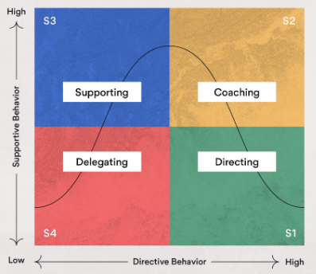

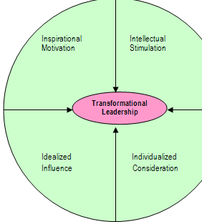
Appendix D

Appendix E
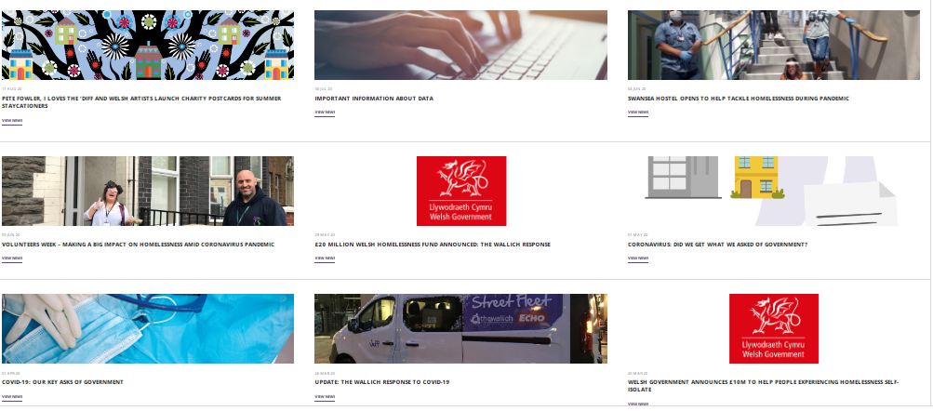
Appendix F
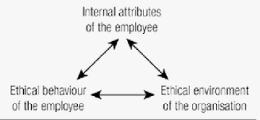

Appendix G
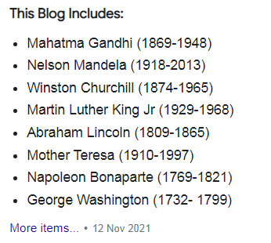


Appendix H

