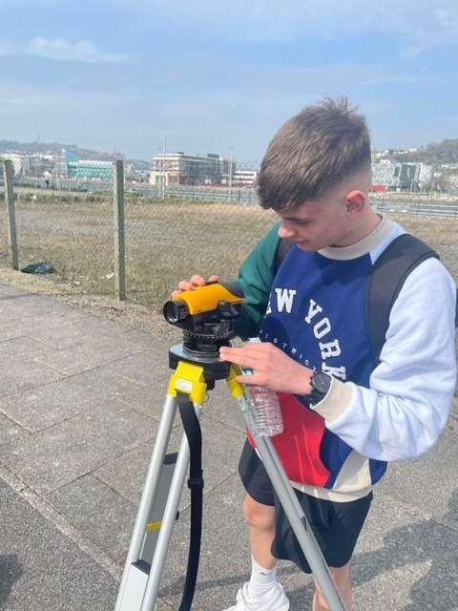
Levelling Exercise

Elliott Lewis 2014602 09/05/2022

Table of Contents
Introduction 2
General overview of levelling surveying 2
Surveying Terms 2
Where can Levelling be used? 3
Equipment 3
Levelling Staff 3
Booking sheet 4
Tape 4
Level 4
Tripod 5
Levelling Exercise 5
Computation 8
Conclusion 12
References 12

Introduction
This report will give a general overview of undertaking levelling and discuss step by step the processes when applying levelling practically within the industry.
UWTSD are planning to construct a new path across the campus and have requested a levelling survey to be conducted between two points in order to calculate the amount of material required to be added or removed as part of the project.
The report will explain the types of equipment and methods used to come to a final conclusion on the volume of earthwork required in order to level the 2m wide proposed path by the University.

General overview of levelling surveying
The process of levelling is determining the height of one level in relation to another. It is used in surveying to determine a point's elevation relative to a datum or to determine a point's height relative to a datum (Chudley and Greeno, 2016)

Surveying Terms
Understanding the right terminology and measurement is critical to the levelling process. Examples include:
Backsight. This is the first reading taken after setting up the levelling instrument or at bench mark on site.
Foresight. Can be defined as the last reading to be taken before relocating the levelling instrument.
Intermediate sight. Describes the reading between backsight and foresight.
Bench Mark. Can be defined as the point where its elevation is known.
Line of Sight. Describes the line which passes through the optical centre of the eye piece and coming out to eye.
Staff Reading. This is the reading taken on the field whilst looking through the optical instrument.

Where can Levelling be used?
Levelling is frequently used in the construction industry and can be used in many different environments. Although, in some instances, accurate levelling is quite challenging. While levelling a ground, a variety of ground conditions, natural formations, structural elements, and other factors can impact on the survey and can make the surveyor and the staff man's jobs challenging.
One situation that can make making levelling difficult is when the staff is close to the instrument. Potentially the staff may need to be close to the instrument due to the circumstances of the site and the survey. When the instrument is close to the staff it loses focus and the reading could become difficult to take as it could appear blurred. White paper can be used to remedy this problem. A white sheet of paper can be slowly moved up and down in front of the staff while it is held upright. Through a telescope, the paper edge can be seen and paused at the point where the collimation line meets the white paper edge.
Another instance is levelling across a river where the levels of the banks change from hight to low, unlike a flatter edged lake where the level can be taken at the water’s edge. In the case of rivers, pegs can be used and positioned at both sides of the river with the first measurement taken from the peg 1. The reduced/elevated level of the 2nd peg position is then measured, obtaining the true, straight-line difference between both pegs using reciprocal levelling (The Constructor, 2022).

Equipment
Having the correct equipment is vital in order to carry out a successful levelling survey.

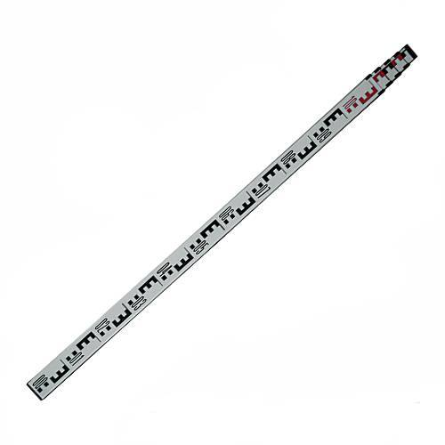
Levelling Staff
A staff is an essential piece of equipment that is required when carrying out a levelling survey, as it’s used to record in meters the level of the surface, at that point which it is standing. This reading is taken by the instrument man.
As seen in the figure opposite, a staff is a rectangular rod with metal shoes at the bottom, their purpose is to prevent damage when in use on construction sites.
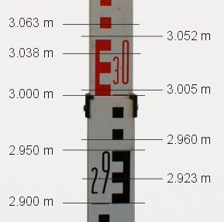
Also known as a E staff, this common type of staff is widely used across the construction industry. Each point of the cubes that form the letter E represent the distance of 10mm. The 'E' on the staff is equivalent to 50mm, see Figure opposite.
The majority of staffs used in the industry are telescopic making them very portable and allowing them to achieve total length of the staff of up to 5M by sliding up each length to the desired height.
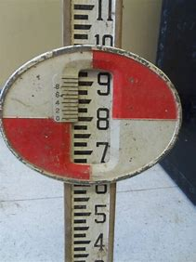
As these staffs are read manually through a lens from potentially a significant distance away, in some cases adding a moveable target to the staff can help ensure more accurate and easier reading of the staff. A circular target with alternate quadrants of red and white paint with a vernier in the centre can added to the staff as seen in figure opposite. The staff person can then be directed by the instrument man to move the target until its centre is in the horizontal line of sight (Civil Engineering, 2022) .

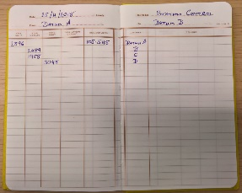
Booking sheet
A booking sheet is a very important item that is required when conducting a levelling exercise. It is vital not only to include the readings from the survey but also to record key information such as locations, date and any other relevant project information.
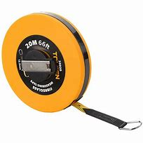

Tape
A tape is vital to accurately measure the distance between each point.

Level
The dumpy level is an optical surveying levelling piece of equipment that consists of a telescope held by two collars attached to the base by adjustable screws. Dumpy level telescopes can only rotate in a horizontal plane. The dumpy level was invented in 1832 by William Gravatt who was an English civil engineer (Pro Civil Engineer, No date). A dumpy level is also recognised in the industry as a construction level or an automatic level.

Tripod
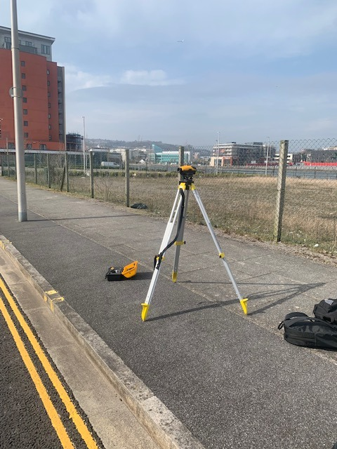
The tripod is made up of three legs and a head that holds the level device. The modern tripod is mainly made of aluminium (Read Civil. 2020) In order to be effective, the tripod head must be adjusted to be as level as possible prior to the addition of the level instrument Accuracy is achieved by setting the tripod legs and ensuring the correct height to suit the Instrument man.
Tripod
Dumpy Level

Levelling Exercise
Firstly, after ensuring we had all the correct equipment, we headed out to our bench mark site to begin our survey. We chose the corner of a kerb line as this was recognisable and permanent meaning if we ever needed to return, we could accurately locate the same position. As there was 3 of us in the group, we each took on an individual role. I was person 1 who was taking the readings through the instrument, person 2 was the staff man and person 3 recorded the bookings and measured the 20M intervals between each point.
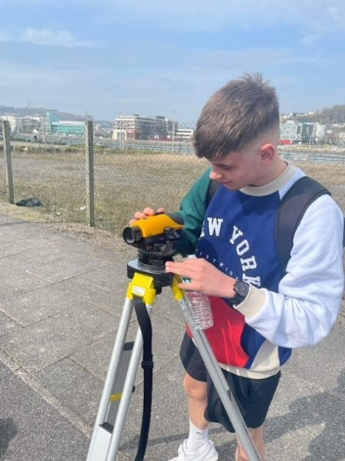
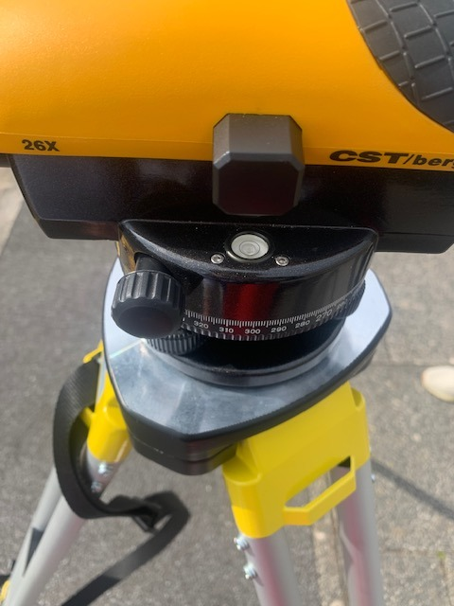
We began by setting up the tripod in position 1, we made sure the position had a clear view of our chosen benchmark point. I adjusted the tripod to my eye level and ensured the base was as accurate as possible. I then placed the dumpy level on top of the tripod and tightened the foot screw to secure the instrument to the stand.
Using the levelling screws, I altered them slightly to ensure the instrument was level and the alignment bubble was in the centre of the marker.
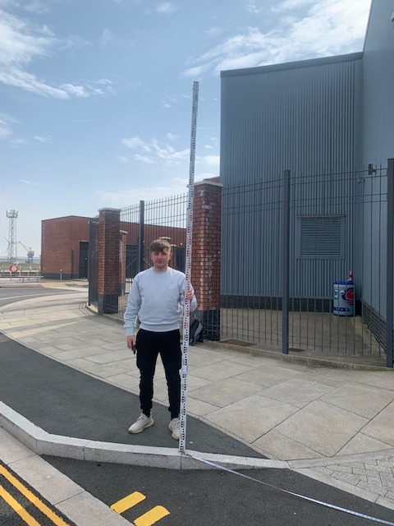
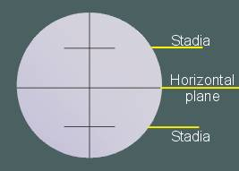
Next, after my instrument was set up and level person 2, being the staff man, stood at our chosen benchmark and held the staff vertically in the direction of the instrument. It is vital that the staff is as level as possible, person 3 was helping to ensure the staff was held as vertical as possible. The first reading was from instrument position 1 and was a backsight reading. I looked through the line of sight and read the staff reading in the horizontal plane. From there I stayed at position A and person 3 measured 20m to point 1 from the benchmark. The staff man moved to the point and I took another reading, this reading was recorded as an intermediate sight.


When changing instrument location, I took a reading and person 3 recorded it as a foresight. After setting up in position 2, I took a backsight towards the same point. I then took 5 intermediate sites before moving the instrument position to position 3. We continued to do this along our survey, only moving the location of the instrument when the distance was too far from the staff to see. When we conducted our survey the weather conditions were very windy which did make it more difficult to take accurate readings.
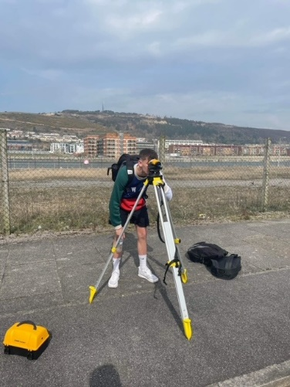
At position 4 we dropped down into a ditch resulting in the dramatic increase in levels. To finish and close off our survey we took a final foresight reading. Person 3 recorded this reading on our booking sheet and we packed up and headed inside after recording a total of 24 Points.

Computation
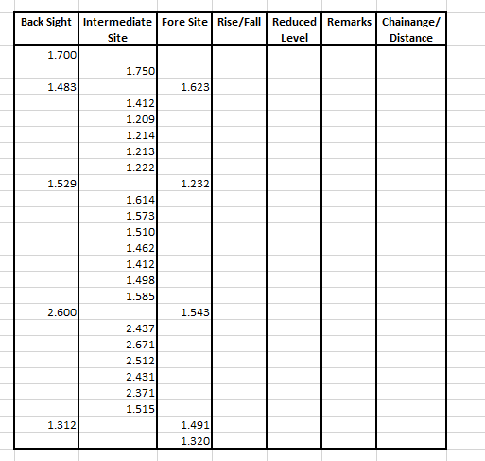
On completion of the survey, I then returned to the lecture room to analyse the data.
Firstly, I set out my findings in a table on Microsoft Excel, see figure above.
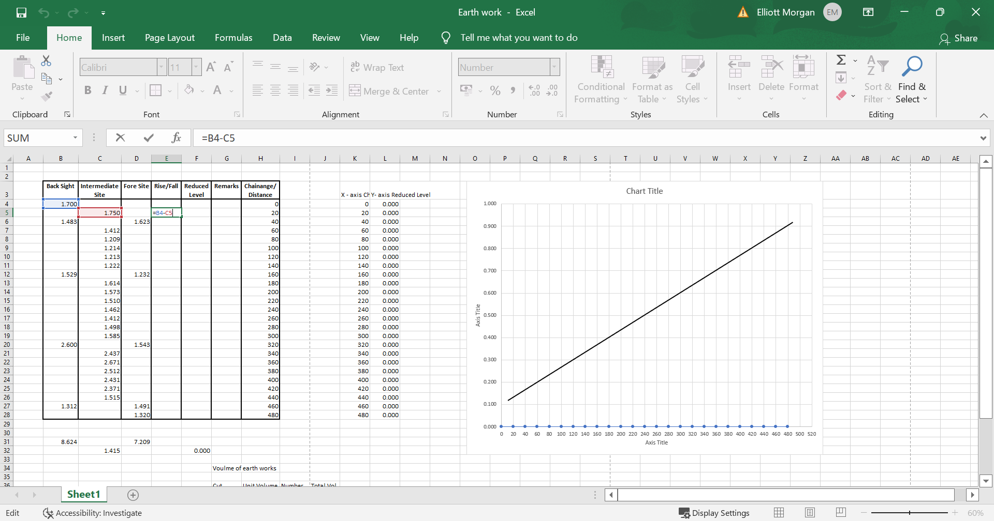
As I chose to use the rise and fall method, I began to calculate the reduced levels by using a excel formula to deduct the back sight from the fore site, see figure below.

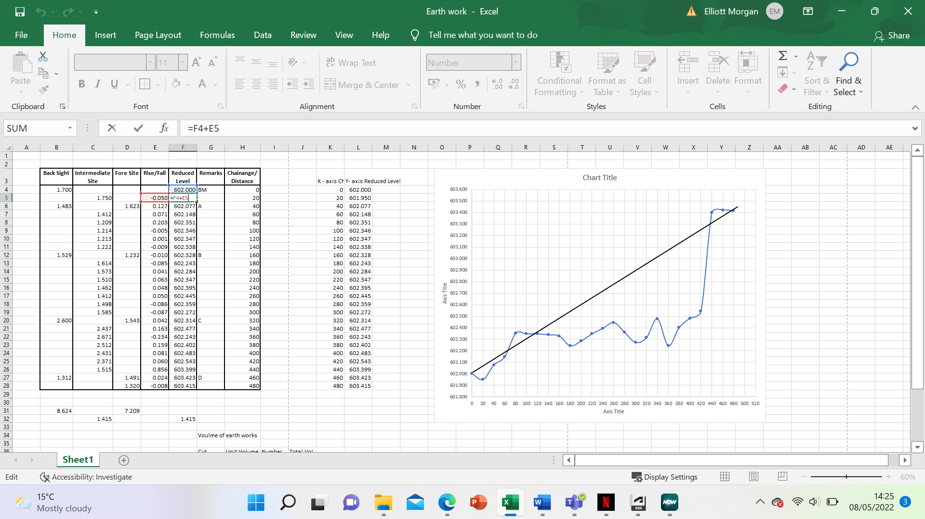
After I had calculated all my rise and fall values, I began to compute my reduced levels by using the last 3 digits of my student number (602). I added the values of my rise and fall column to work out my reduced levels, see figure below.

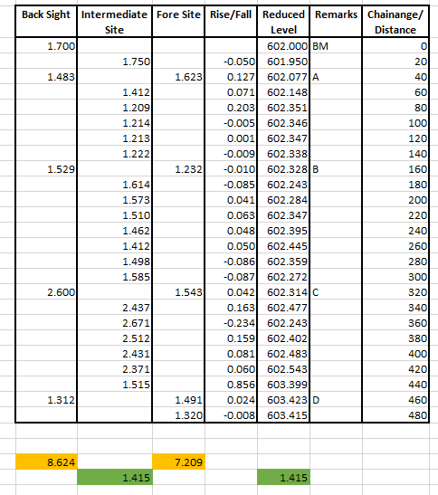
When my table was complete, I undertook a final check to ensure there were no errors. I did this by calculating the total sum of the back sights and then the fore sights and deducting them from each other which gave me 1.45. I then calculated the increase from my original bench mark and found it to match the 1.45 meaning there were no errors present, See figure below.
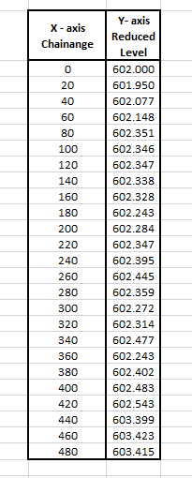
After completing my check, I transferred the relevant data over to my y and x axis table. The x axis is the distance and y axis is the reduced levels, see figure below.
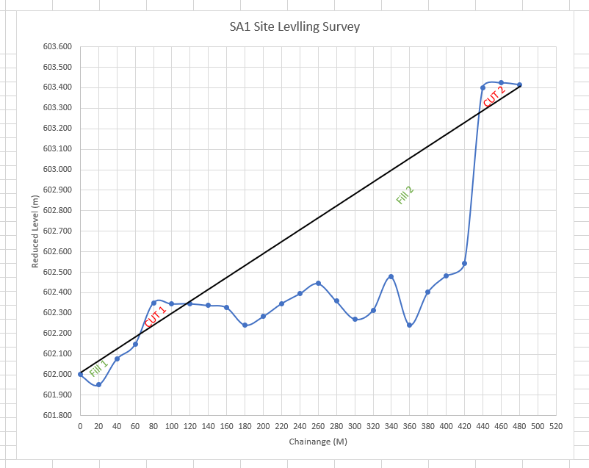
I then used the data in this table to create a graph representing the change in levels at the different points.

Using a line, I then was able to calculate the area of the cut and fill sections on my graph by determining the area of a single box and multiplying it to get a total area per section. Each box was 0.1m x20m meaning the area of each box was 2m^{2.} I then transferred the area into a table in order to calculate the volume of material required to level off the site. As the path in the brief is 2m wide I used this figure to calculate the volume. After deducting the cut from the fill, I concluded a total of 258 cubic meters of material is required to level the site.
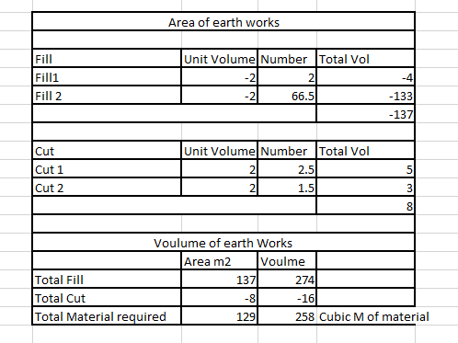

Conclusion
To conclude after completing the survey using the appropriate equipment and methods the total amount of material required to level off the proposed new path is 258 cubic meters.

References
Civil Engineering (2022) Levelling Staff. Available at: Levelling Staff | Civ https://civilengineeringx.com/surveying/Levelling-Staff/il Engineering X (Accessed 8th May 2022)
Read Civil (2020) Levelling instruments in surveying Available at: https://readcivil.com/levelling-instruments-in-surveying-levelling-staff-dumpy-level-etc/#:~:text=%20Instruments%20used%20in%20levelling%20in%20surveying%20,its%20run.%20Move%20the%20third%20leg...%20More%20 (Accessed 8th May 2022)
The Constructor (2022) What are the difficulties faced when levelling in Surveying? Available at: What are Difficulties Faced during Leveling in Surveying? (theconstructor.org) (Accessed 8th May 2022)
Pro Civil Engineer (No Date) Dumpy Level Survey. Available at Dumpy Level Survey – What, Where, How, Parts - Pro Civil Engineer . Com (Accessed 8th May 2022)
Chudley, R. and Greeno, R. (2016) Building Construction Handbook 11th Ed: Routledge

